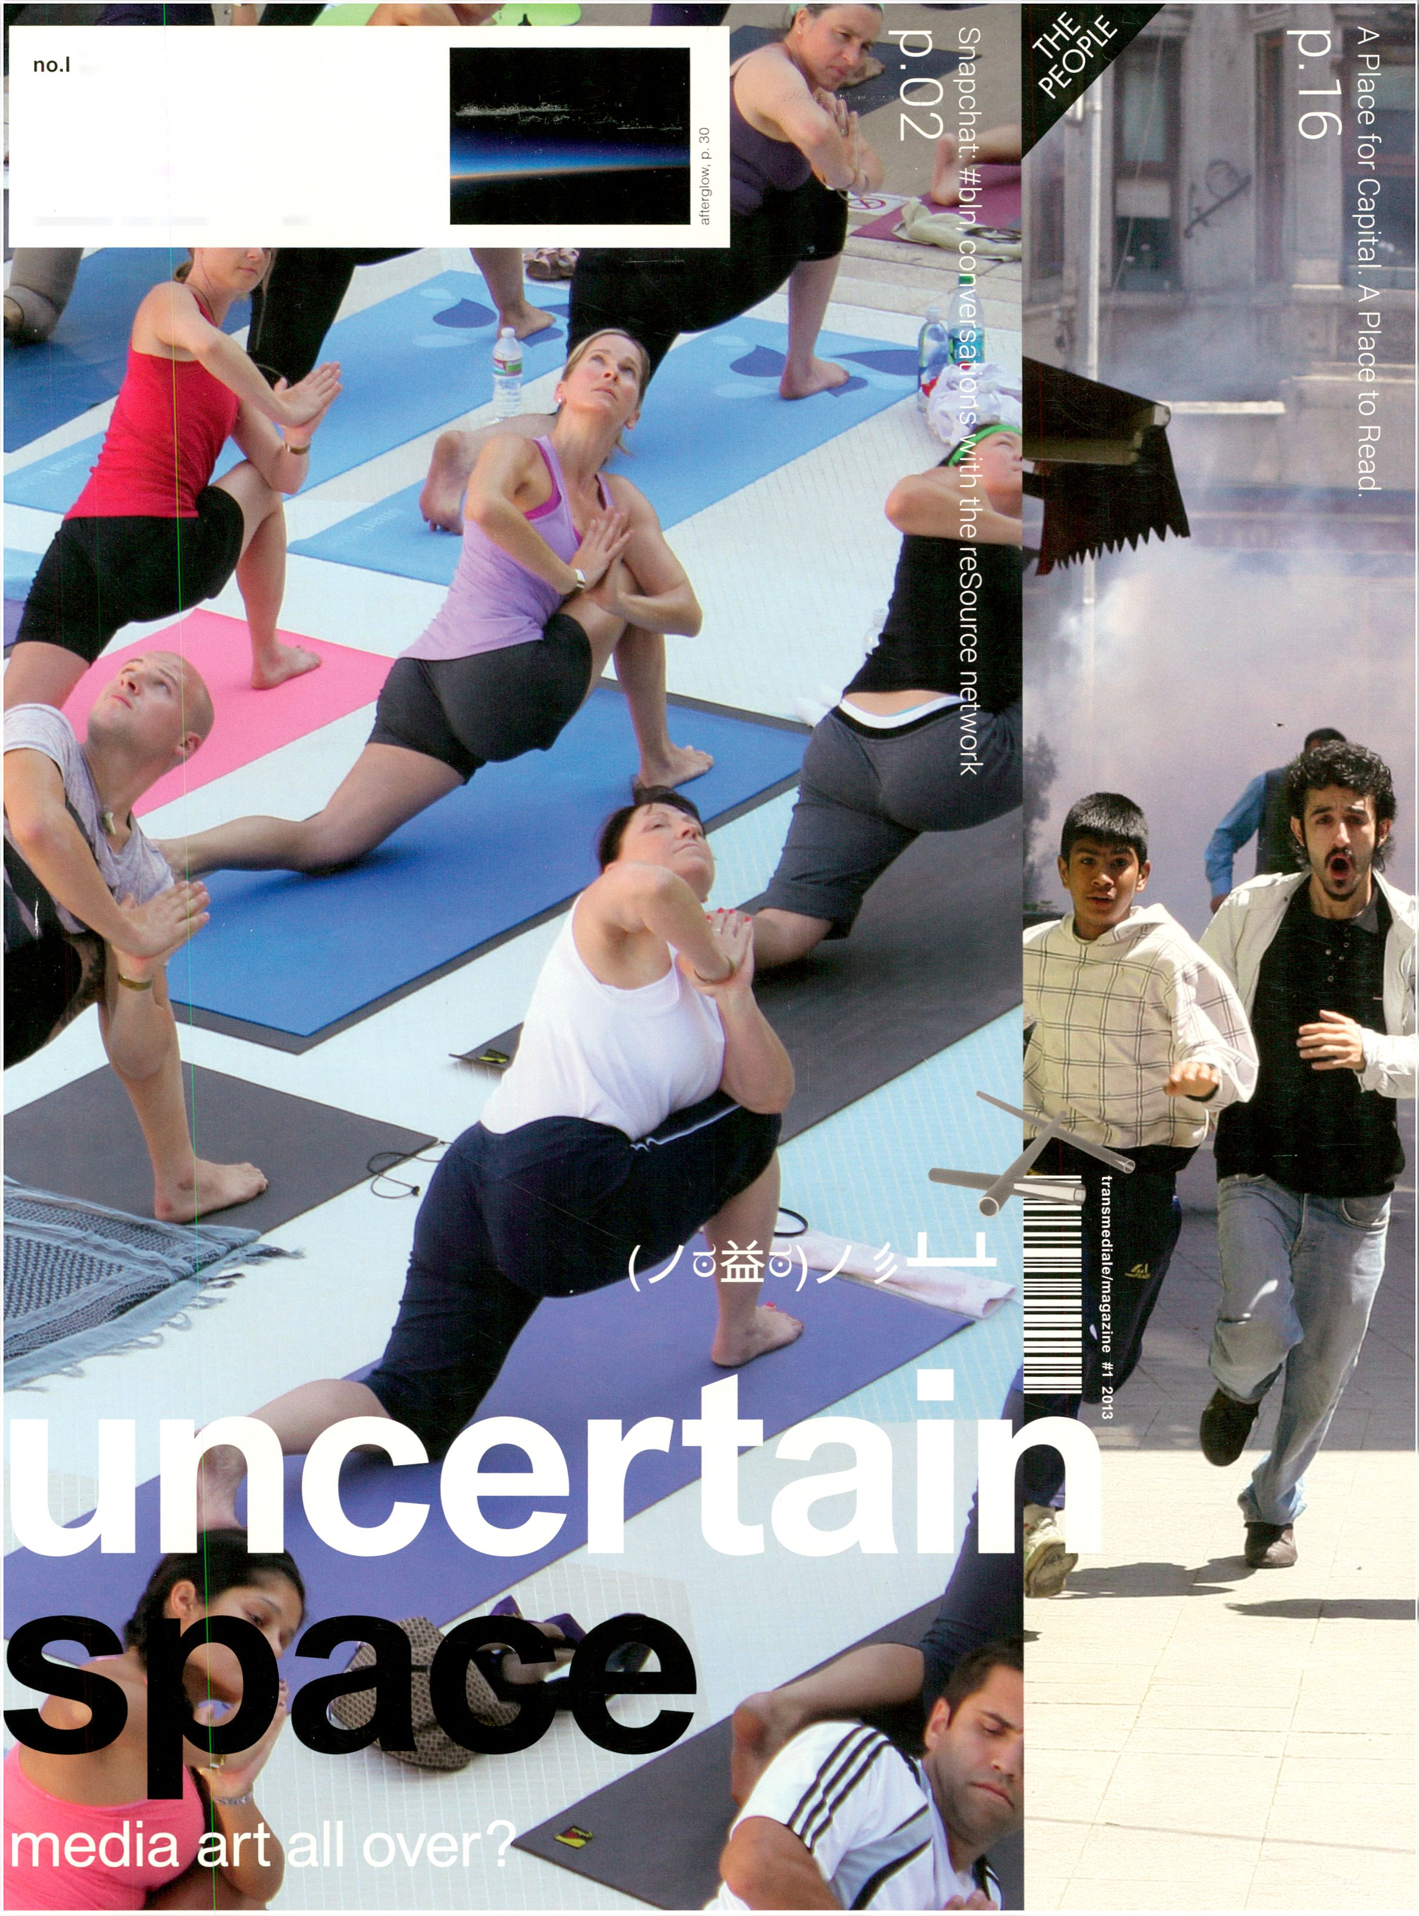transmediale/magazine
2013
“The afterglow is an intense
red glow of the atmosphere
long after sunset (or long
before sunrise), when most
twilight colors should have
disappeared. The afterglow
is caused by dust in the high
stratosphere, which catches
the hues of the twilight arch
below the horizon. The
afterglow is commonly seen
during or after volcanic erup-
tions, which deposit large
amounts of dust and ash into
the high atmosphere. Spec-
tacular twilight phenomena
were reported for years after
Krakatoa’s eruption, around
1882-1885.”

mm
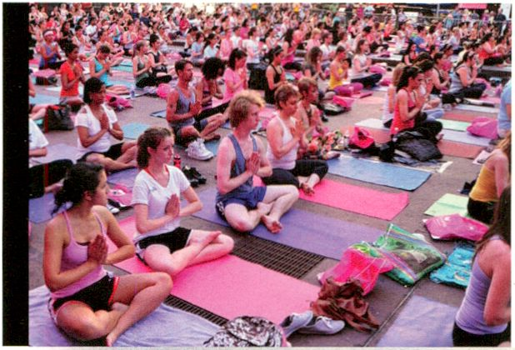

http://www.transmediale.de/archive snapchat: #bln, p. 02
transmediale afterglow, p. 30

Table of Tropicals
transitory space 0
hybrid 2,12
transversality 9,13
cultural appeal 10
networking 3,11
Eutropia 12
trans-genre 3,12
psychogeography 14
invisible intensities 14
austerity 15
patronage 13,15
capital 4,13,18
society of security 18
urban aesthetics 13,18
hermeneutic attention 19
hackery 22
non-utilitarian beauty of technology 22
radical collaboration 0, 22
bioart 28
speculative biology 28
open science movement 28
post-digital 30
trash 30
big data 22, 30
nuclei of change 32
pioneers 32
Imprint
Issue#!, 2013
transmediale/magazine
Klosterstr. 68,10179 Berlin, Germany
http://www.transmediale.de/magazine
magazine@transmediale.de
ISSN: 2197-4276
Publisher: transmediale e.V.
Editors in chief: Kristoffer Gansing,
Filippo Gianetta
Managing editor: Filippo Gianetta
Editor: Lina Zuppke
Art Direction: The Laboratory
of Manuel Bürger
Graphic Design: Manuel Bürger,
Timm Haneke
Authors / Contributors:
Tatiana Bazzichelli, Ryan Bishop,
Christian de Lutz, Daniel Franke,
Kristoffer Gansing, Gregor Hotz,
Ela Kagel, Kai Kreuzmüller, Carsten
Lisecki, Olof Mathe, Diana McCarty,
John McKiernan, Georgia Nicolau,
Francesco Warbear Macarone
Palmieri, Georgios Papadopoulos,
Jussi Parikka, Paulo Podrescu
aka Podinski, Jan Rohlf,
Justas Rudziaskas, Pit Schultz,
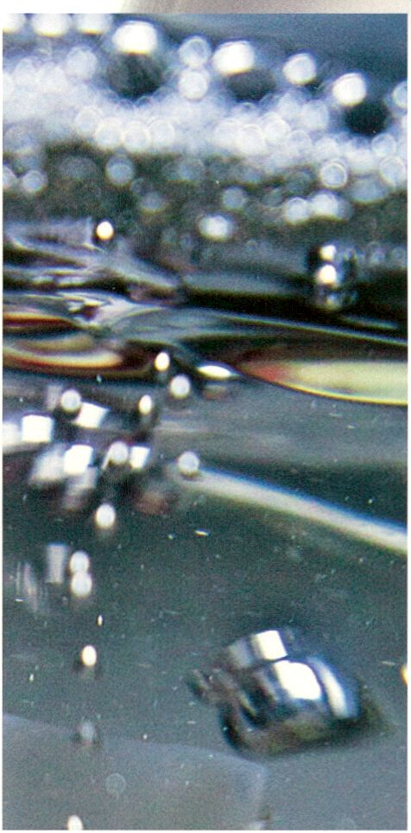

An Ecosystem of Excess,

p.28
Erika Siekstelyte, Daniela Silvestrin,
Allegra Solitude, Heiko Stubenrauch,
John Wild, Florian Wüst, Pinar Yoldas
Thanks to: the whole team of
transmediale, Miez Flor, Christian
Richter/Medialis, Aurélie Steunou-
Guégan.
Distribution: DINAMIX Media GmbH,
available at chosen venues in Berlin.
Print: Medialis Offsetdruck GmbH
Circulation: 5000
Advertisement: Marieke Eilers, Susanne
Bernstein - me@transmediale.de
Cover:
îd Left picture by The Cosmopolitan of
ST Las Vegas/ flickr
c Right picture by Will Cowan/ flickr
Box: High Altitude Sunset by Jonathan,
^ pheochromocytoma/flickr
5' "White Sands" by Ben Hattenbach,
Q)
"Z http://www.benhattenbach.com/
o
Q.
$ All images and texts have some or all
a rights reserved. If you want to use or
S? reproduce any part of this publication,
^ please contact us. Every effort has
been made to trace and acknowledge
copyright. This publication has a
not-for-profit objective.

Editorial
Uncertain Space:
Media Art All Over?

With this magazine, transmediale is adding
a new format for supporting its ongoing
mission to draw out new connections
between art, culture and technology.
Ever since its first appearance,
transmediale has occupied an undefined
and transitory space in the cultural territory
of Berlin, promoting a critical
understanding of contemporary culture
and politics, as saturated by media
technologies. At the end of the 1980s, a
VHS tape could simultaneously represent
the future and the trash of artistic practice:
VideoFilmFest (today transmediale)
presented experiments carried through
with this medium, while its former partner
Berlinale distanced itself from the very
same type of media art practice.
After 26 years, the experimental
approach of transmediale remains, but the
conditions have changed, as the
possibilities and crises generated by new
technologies multiplied into the core of our
society. Everyday, we are confronted with
a continuous flow of newness and
obsolescence, promises and treason,
utopias and fears. Caught between the
never-ending hype of digital technologies
and the utterly mundane character of the
very same, the contemporary actors
engaged in artistic technological
experimentation are searching for new
locations, economies and topics. This
navigation of an “uncertain space” comes
to the fore in our main feature “snapchat:
#bln”. A series of interviews give a picture
of the diverse and precarious nature of
media art as a genre and local scene.
Yet these spaces and their activities have
to be understood in relation to critical
global developments, and here the role
of transmediale as an international
media art festival should be to foster
and provoke such connections.
In this issue, we also move beyond
the local discussions when Jussi Parikka
and Ryan Bishop give two different
interpretations of how ecologies of art,
politics and technology were created
within and next to the Gezi Park protests
in Istanbul. We also talk to our artist in
residence Pinar Yoldas, who engages in
speculative biology, a certain type of
bioart activism in which the uncertainties
between fiction and biology are opened
up and exploited for purposes of cultural
critique. Another interview is carried out
with Olof Mathe, founder of Art Flack Day,
an itinerant project proving that you can
successfully carry the approach of what
was once understood as critical media art
into the creative industries.
Next stop for this project? Berlin, of
course, where the attention of today’s
“creative scene” is currently turned.
Could this actually be a “moment after”
phenomenon as in heads turning in the
same direction following a loud sound?
If the peak of the Berlin cultural hype has
already been reached, then we are settling
in for the afterglow, where we may feel
either engaged in or detached towards
what is still shining despite all the darkness
(see page 30).
In all this uncertainty, one thing does
emerge as certain: art practices that
explore the boundaries of technological
creation are more potent than ever. The
now widespread creative use of digital
technology is not a reason to take a
defeatist stance and declare the once so
futuristic genre of media art as being
outmoded. On the contrary, this post-
digital condition is where media art gains a
wider social relevance, as a reflection and
intervention into our contemporary
technological society in and beyond the
afterglow of the digital. In this issue, we
head off looking for media art all over, and
explore its changing socio-political
contexts in Berlin and elsewhere.
Kristoffer Gansing & Filippo Gianetta
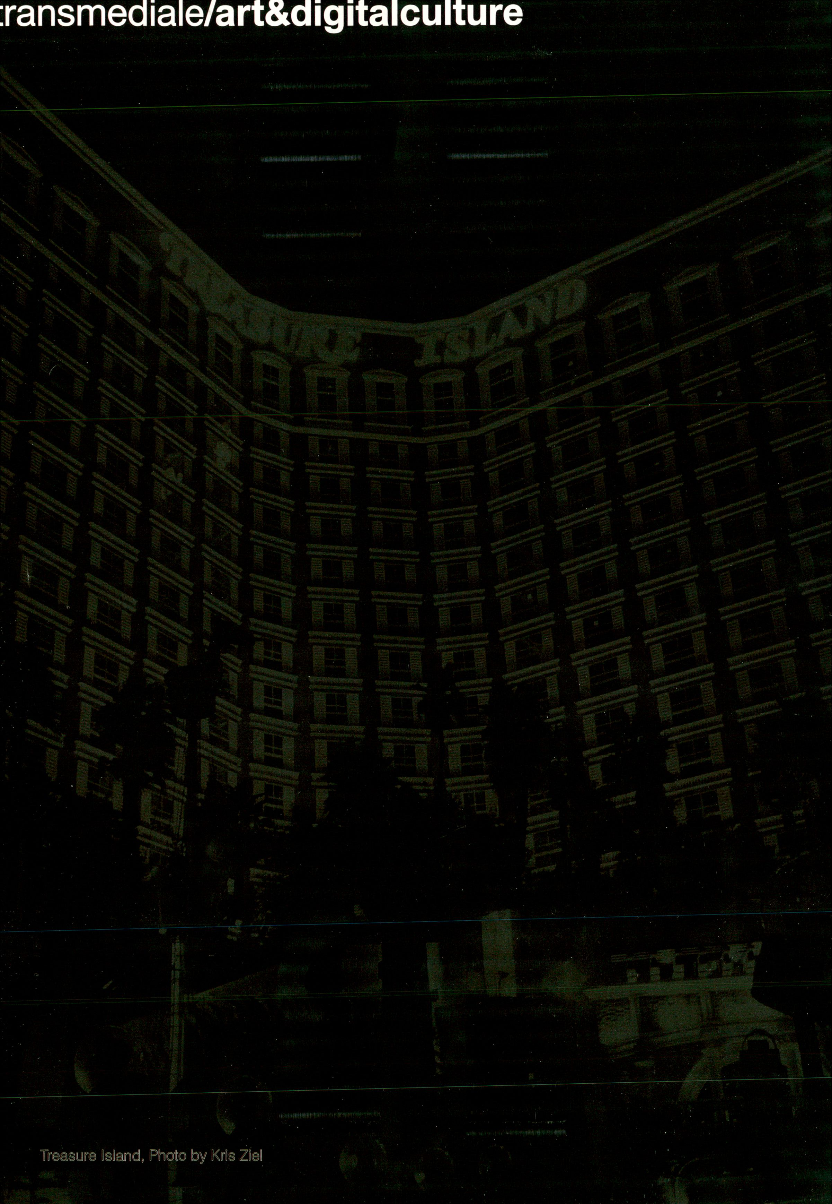

Strenghts and weaknesses of being trans-genre in Berlin’s cultural landscape. The hybrid character of
activities mixing media, practice and languages.
snapchat:
#bln

Short Statements, p.3
Chat Rooms, p.9
resource Chats Commentary p.12

Francesco Macarone Palmieri
Florian Wüst
Erika Siekstelyte
Diana McCarty
Christian de Lutz, Regine Rapp
A thematic cut-up of conversations with
project spaces and participants of the
resource network. Imaginary chat rooms
create three conceptual threads, a
montage of different points of view.
Networking Berlin's transmedial culture:
Tatiana Bazzichelli, initiator and curator
of the resource propgramme, comments
on the resource chats, providing insights
in the methodology and realisation.
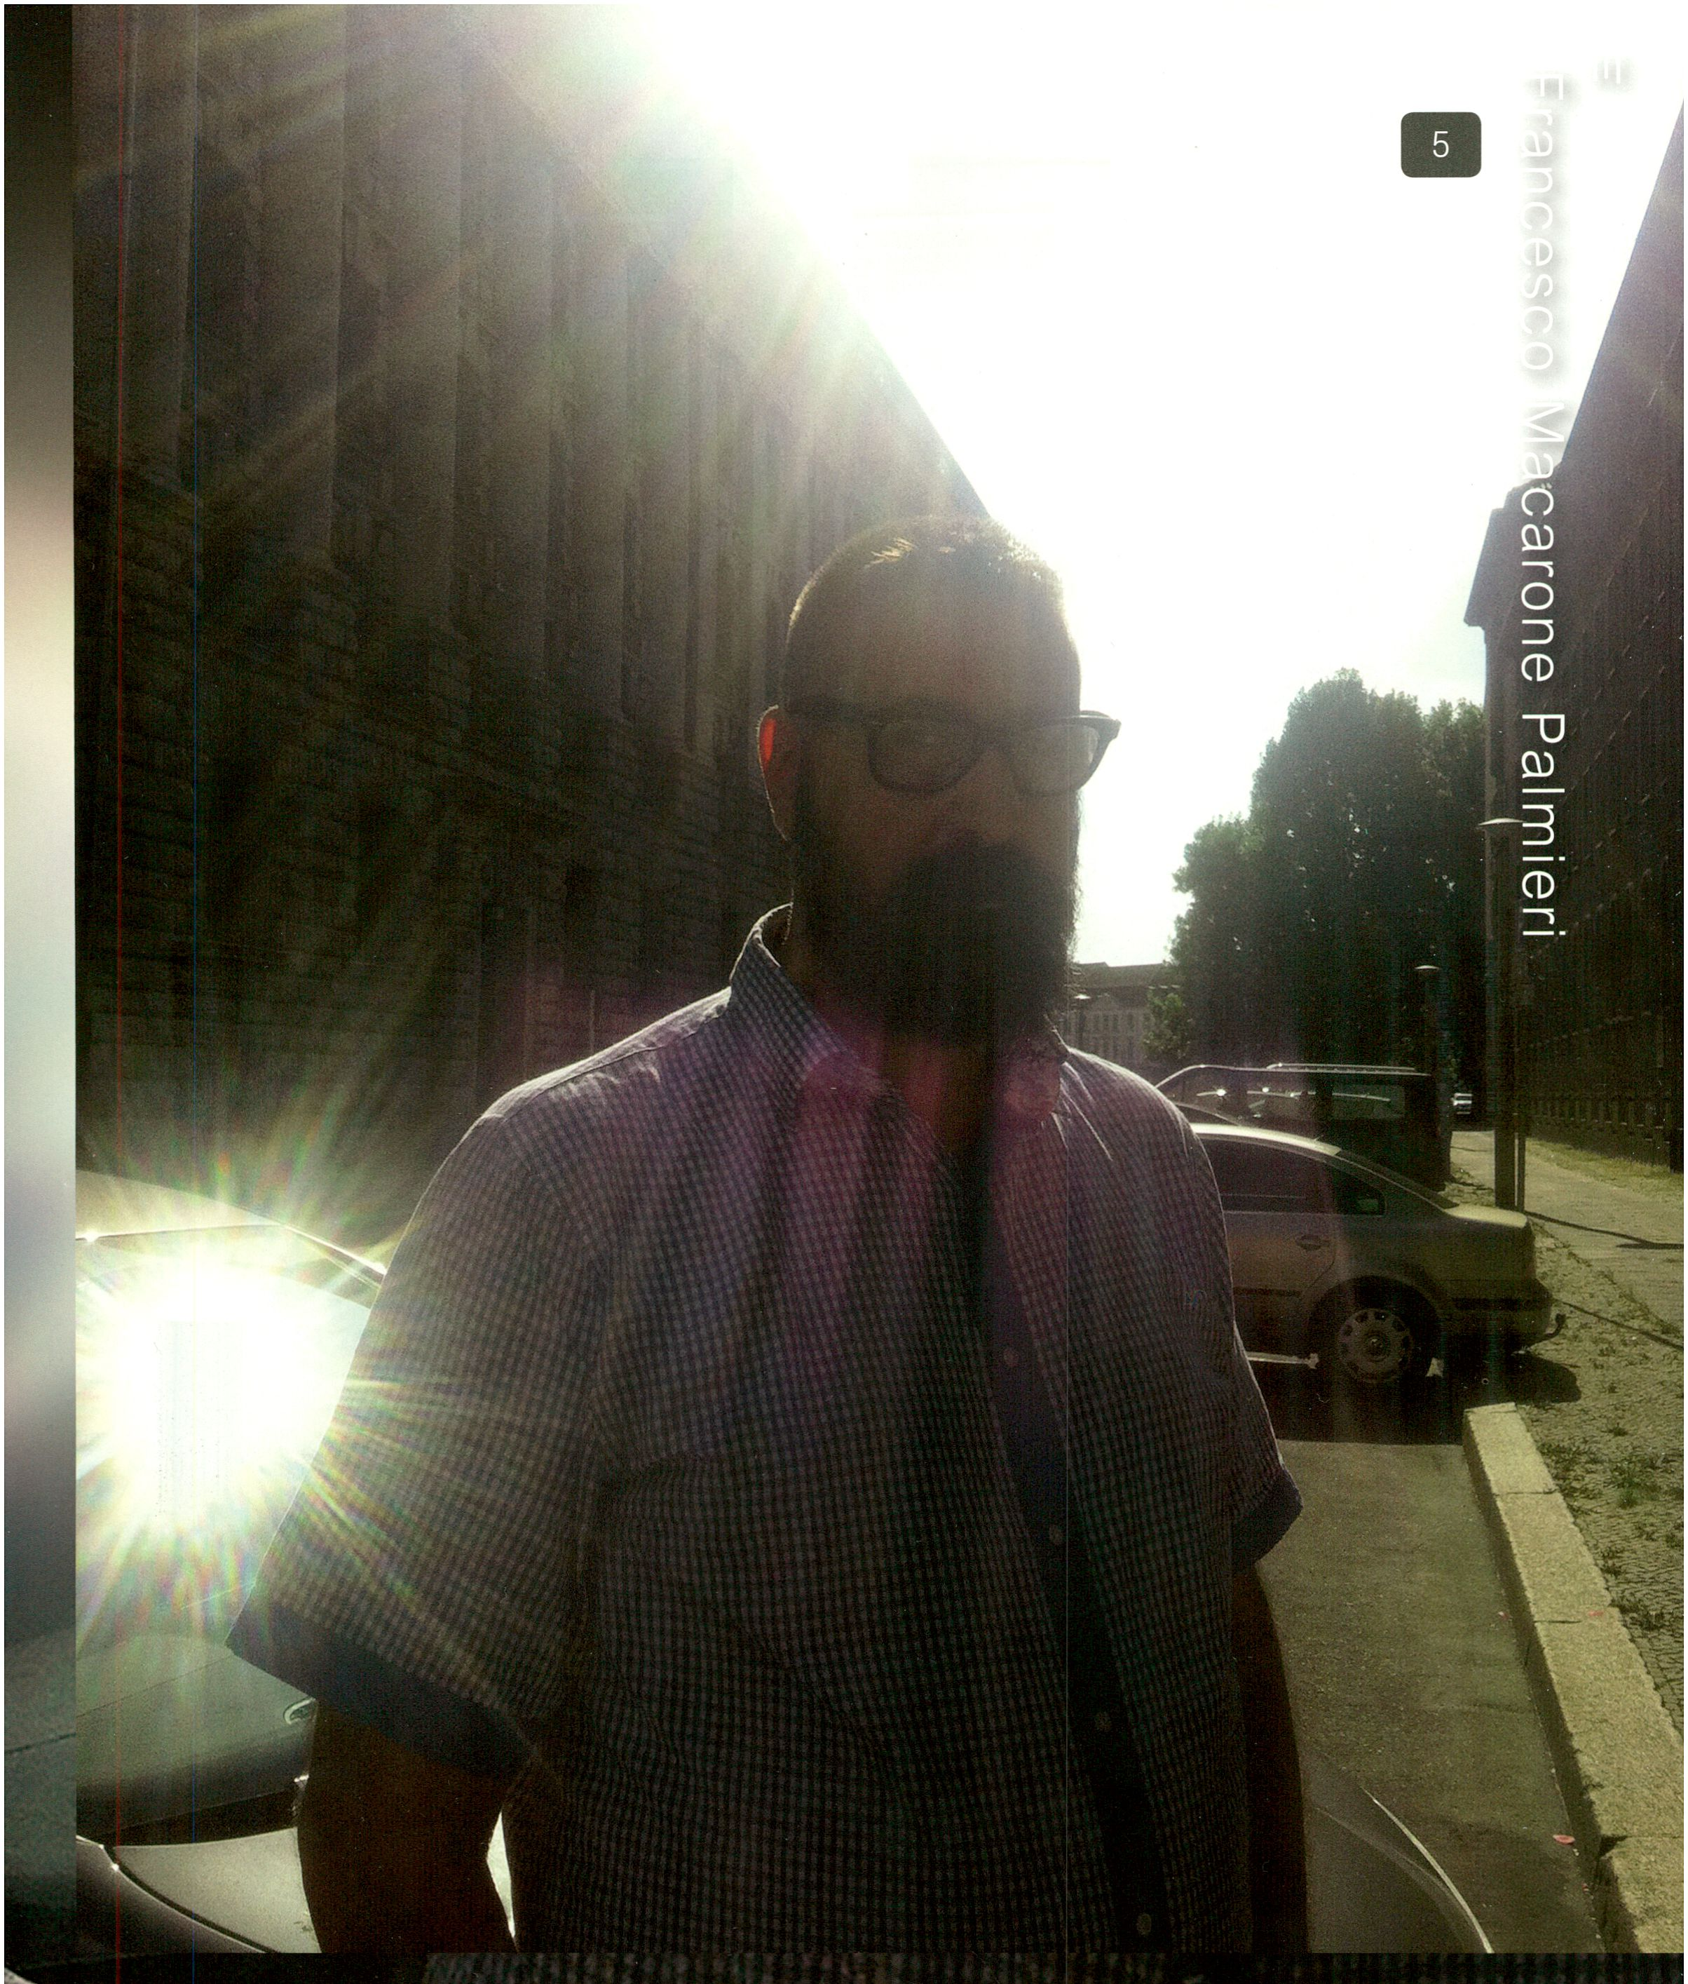

y “Gegen a party - it has the intrinsic desire of being a project of transformation. Being inde-
pendent is becoming.rgPelf in different frames at the same time. I approach different networks and try to be the
irftrg-network myself/iSjnulacrum that converges different networks in a political critical perspective.”
Francesco Macarone Palmieri aka WAJ*3EAR is a social anthropologist, performance artist, curator, festival promoter and DJ. His work is based on Cultural Studies with a focus on Sex
Cultures, Independent Cinema and SoeiplDgy of Emotions.
iPhone shots by Manuel Bürgerand Timm Haneke

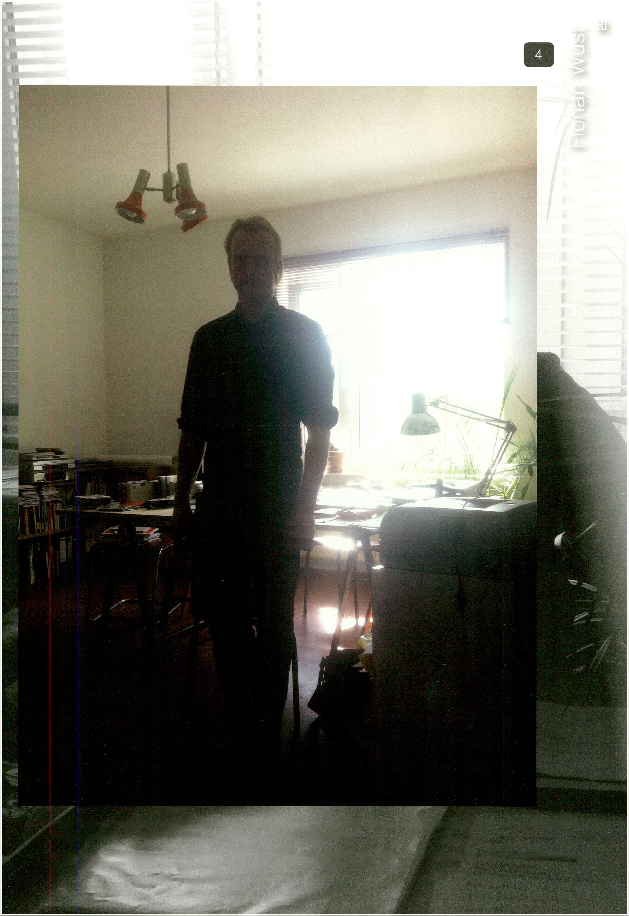“Haben und Brauchen rejects to reduce the relevance of art to a merely economic question, but understands
the production of art first of all as an activity intrinsic to society. ’’
Florian Wüst is an artist and independent film curator living in Berlin. He co-initiated Haben and Brauchen in 2011, a platform for discussion and action, aiming to distinguish the forms of artistic
production that have unfolded in Berlin during recent decades, and how these forms can be preserved and further developed.

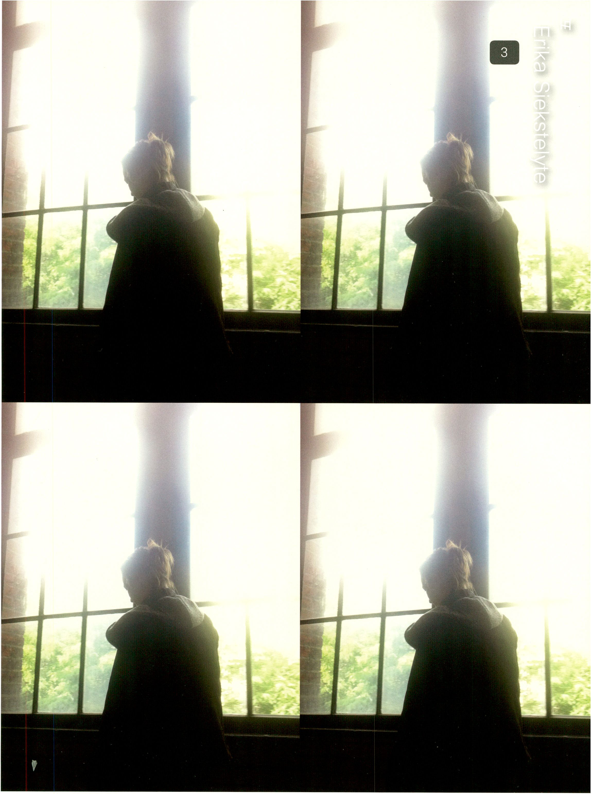“Technology-based art in Berlin Is carried out quite autonomously. The impression that the whole scene of
technology-based art is rather disorganised in the city is prevalent.”
Panke e.V. is a creative multi-purpose space. Its main aim is to promote experimental/fringe creativity in Berlin, as well as to offer an alternative meeting point for the up-and-coming creative
scene of Wedding. Erika Siekstelyte from Vilnius, Lithuania is the CEO and founder.
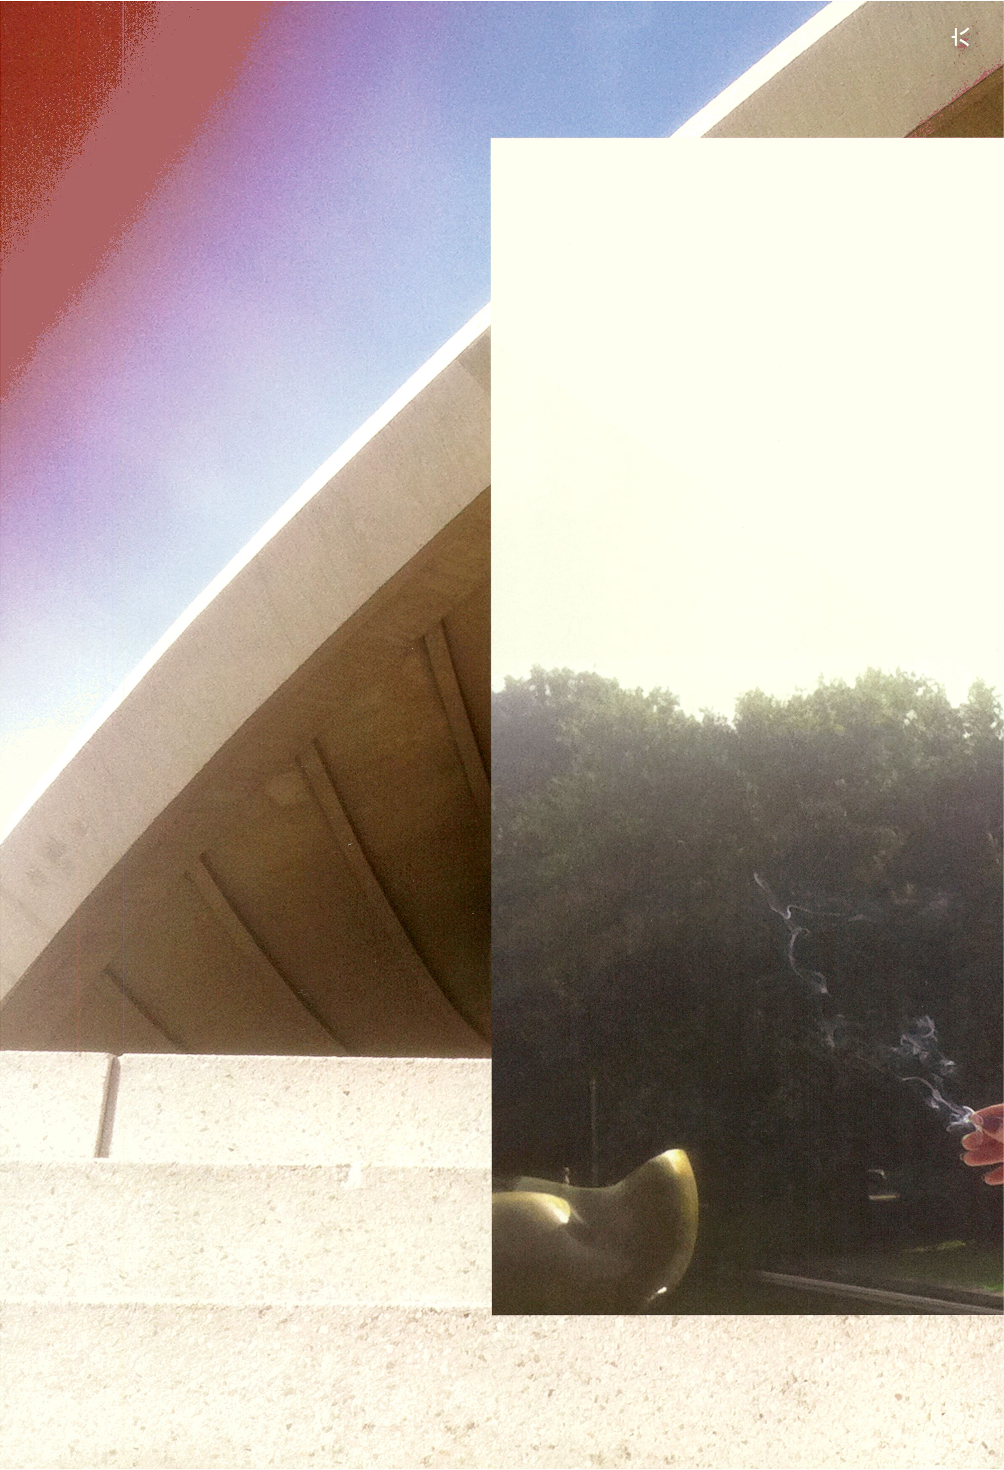

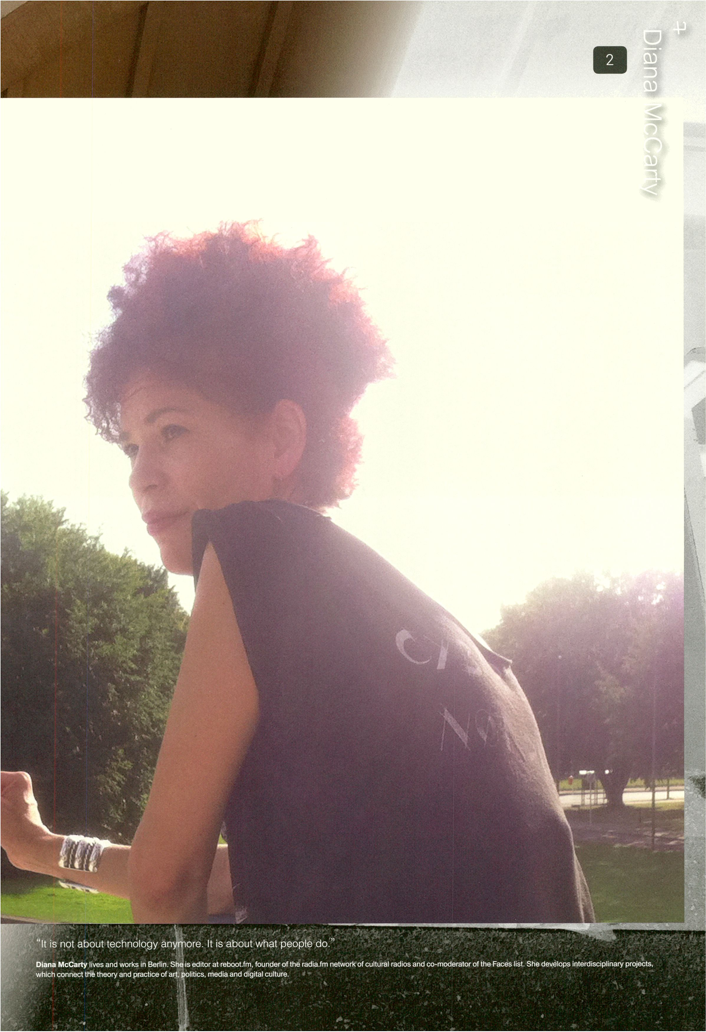

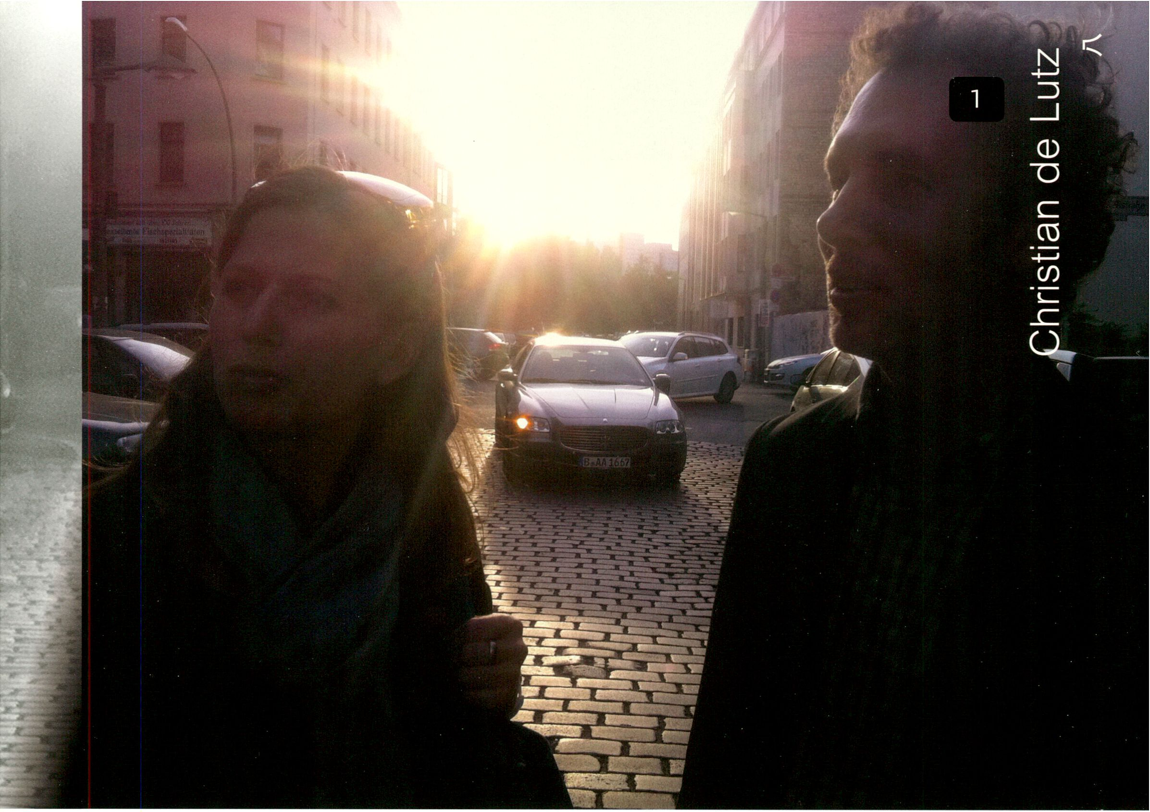

“We don’t focus on a single theme or genre, but we have strong fields of interest like art and science, technology,
new media; from which we develop our own hybrid programme.”
Art Laboratory Berlin was founded in Autumn 2006 by an international team of art historians and artists. As a non-commercial art space, Art Laboratory Berlin was established as a platform for
inter-disciplinary projects in an international context. Christian de Lutz is a visual artist and curator, originally from New York. His artworks deal with social, political and cultural themes, with an
emphasis on technology, migration and cultural borderlines. His curatorial work concentrates on the interface of art, science and technology in the 21st century. Regine Rapp is an art historian
and curator. She works as Assistant Professor at the Burg Giebichenstein Art Academy Halle, where she teaches Art History. Currently she is researching the spatial aesthetics of contemporary
installation art. Christian de Lutz and Regine Rapp are co-directors and curators of Art Laboratory Berlin.

Further participants
Lab for Electronic Arts and
Performance (LEAP) is a non-profit
interdisciplinary project for electronic,
digital media arts and performance that
aims to initiate the dialogue between art,
science and technology. LEAP'S central
concept is based on experimental re-
search in digital technologies and media,
which shape and change our present
and future society and stimulate new
discourses, discussions and questions.
ausland is an independent cultural
Initiative for contemporary music and
arts in Berlin, ausland thrives in a corrup-
tive climate of collateral coincidences,
collective complications, and chaotic
creativity. During the past 10 years,
ausland mutated and mushroomed In
several climatic changes of Berlin's cul-
tural jungle and continuously offered a
frame for artistic relationships and proto
cooperations.
Liebig12 s Allegra Solitude's atelier.
Inspire! I by chemist Justus von Liebig's
empirical approach, the space trans-
forms into a laboratory, hosting artists
and researchers from different disci-
plines, exercising a non-profit attitude.
Paolo Podrescu aka Podinski is a
community organism, writer, vj/dj/xj
and co-founder of the XLterrestrials, an
arts + praxis laboratory. Currently he
produces and performs CiTiZEN KiNO
events, a hybrid of cinema, theatre and
digital culture to encourage new forms
of Media Self-Defense In today's cli-
mate of Big Data and the overwatched.
SUPERMARKT Is a creative resource
centre for the city of Berlin. SUPER-
MARKT presents a programme of
events on digital culture, alternative
economies and social innovation, as
well as providing co-working offices.
Ela Kagel is an independent cultural
producer and curator.
Pit Schultz Is an author, artist, media
activist, programmer and radio maker,
who lives in Berlin. He is co-initiator,
organiser and member of many projects
like Botschaft e.V, nettlme, Mlkro e.V.
Bootlab, backyardradio, Herbstradio,
Artwiki, Datschradio and reboot.fm.

resource Chat 1:

Being within, inside, and outside at once...
A round of introduction of the cultural producers, crossing their motivations
and thoughts by combining their transversal activities, programmes, and
points of view in a collage-form.

CdeLutz: At Art Laboratory
Berlin we don’t focus on a
single theme or genre, but
we have strong fields of
interest like art and science,
technology, new media; from
which we develop our own
hybrid programme.
GrHotz: The core programme
of ausland is very eclectic;
we come from the scene that
was usually named Echtzeit,
experimental, minimalist,
noise and improvised music.
We combine performances,
concerts, improvisations and
lectures.
GrHotz: The fact that we do
not only make music makes
us difficult to collocate into a
specific scene, especially in
terms of funding sustainability.
CdeLutz: In new media, it’s
a recognition problem. It
could be good to connect,
to make a thread through
the scene, because it would
give more attention. If you are
disconnected, little islands,
you get lost.
Pit _Reboot: reboot.fm started
as a project whose aim was
to combine as many people
as possible, and the active
people in and around the
bootlab project. It was meant
as a combination of old and
new media, analogue and
digital, the Internet and the
local culture.
Diana_Reboot: What we
had as a value was lots of
connections with different
social groups in Berlin, such
as different club scenes, ex-
Botschaft people, Kanak Attak,
Indymedia etc.
Pit_Reboot: Radio was a
good way to bring in a certain
Intensity of cultural production
from different fields and to
break certain paradigms of
representation.
DrPodinski: I’m constantly
wrestling with this urge to
escape the digital culture,
net worlds, and make more
tangible, embodied and
confrontational things. There
are tools there to de-colonise
oneself, and possibly one’s
community. And that’s what I’m
trying to mix into Citizen Kino.
It has a lot to do with hijacking
points of view, often playing
with an alien perspective.
Warbear: Queerness has to
do with the deconstruction of
identity. To deconstruct identity
you have to put yourself within,
inside and outside - you have
to be molecular. You have to
be ready to abandon your
position and at the same time
lift it.
Warbear: Gegen is much
more than a party - it has
the intrinsic desire of being a
project of transformation. Its
basic engine is not to resolve
the contradiction, but to keep It
open as a space of crisis and
removal.
Allegra Solitude: The
approach of Liebigl 2 is
to create a laboratory for
experiments bridging between
art and other disciplines
/ sciences presenting an .
organic (referring to chemistry)
programme of events.
Panke: Panke supports edgy
creativity that happens away
from mainstream culture,
such as experimental audio,
interactive installation, non-
narrative film, performance art
and everything else that we
believe needs more exposure.
Combining art, music and
design - we create a common
experience.
LEAP: The central idea of
LEAP was the combination
of art, technology and
performance through the
pairing of physical performers
and media artists to work
together and develop a
project. A lot of the ideas we
are working with are not limited
to the idea of physical space.
LEAP: What is Interesting for
us is the network of artists and
what they are doing, the public
that moves between all these
spaces, the creative scene
rather than a particular space.
EKagel: My work has always
been located at the edge
of art, technology but also
economy. I see so much
nonsense happening in this
Intersection. Nonsense in
terms of labels that start
to spring up like “creative
industries”.
EKagel: I feel it would be so
helpful if we started a real
dialogue about money and
values with everyone, not just
with people from the industry
sponsoring artists, which In
my opinion is not an equal
partnership.
Dr.Podinski: A lot of the
Citizen Kino shows have been
to deconstruct the corporate +
consumer-made Technotopla.
I’m trying to find ways to turn
the corner, make the approach
more constructive, pushing
alternatives, seeking territories
that can be won!
FWuest: Haben und Brauchen
is recognised as a political
voice of cultural producers
in the field of contemporary
art. We aim to establish
a consciousness of what
distinguishes the forms of
artistic production that have
unfolded in Berlin during
recent decades and how these
forms can be preserved and
further developed.
Warbear: Being independent
is not being Inside or outside,
because it is too dialectical
for me. Being independent Is
becoming myself in different
frames at the same time. A
queer event becomes political
when a crisis is produced;
when such an event codifies
its own language, it just
becomes marketing.
GrHotz: With “ausland” we
refer to the idea of leaving
the well-known place, for
the exploration of unknown
horizons. When people go
abroad there is always the idea
of discovering something new,
and this new encounter might
be positive or not.
Pit_Reboot: Diversity is
nothing that happens by
itself. In social organisations,
there is always a tendency
of homogeneity - our
homogeneity is probably the
one of keeping a certain type
of cultural production alive.
Allegra Solitude: Every space
might encounter restrictions
relating to projects and to the
urban context. We can offer
each other the possibility to
exchange spaces, concepts,
capabilities in a very fluid and
spontaneous way.
FWuest: Berlin is well-known
as the number one place
for contemporary art pro-
duction. But this Isn’t to be
taken for granted.
EKagel: I think In Berlin this
idea of belonging to a scene
has always been very strong,
but the energy in a scene can
evaporate very quickly.
Diana Reboot: Berlin was
always a city of many centres.
But now it’s like each centre
has so much going on. It's so
niche-driven. The big question
is how you identify the kind of
affinities that would make a
network effective.
Pit_Reboot: The battle has
been lost on a certain level,
and on another it has been
won. We have to see how
the whole infrastructure is
changing. I don’t see the
radical changes coming
through technologies. Now
it’s about political issues,
copyright, privacy...
Diana_Reboot: It is not about
technology anymore. It is
about what people do.

resource Chat 2:

Berlin: Before it is too late and we turn into a zoo
+-
A montage of various perspectives on the city of Berlin by cultural
producers, artists and activists that reflect on its cultural appeal,
problems and long lasting sustainable plans.

CdeLutz: Funding is the major
problem in the cultural
production scene of Berlin.
The vast majority of the
‘Hauptstadtkulturfonds’ is
given to established pro-
grammes, spaces, and a lot of
it is suggested by some kind of
patronage. A small amount
goes to contemporary art; a
third of the money is going to
institutions like opera, estab-
lished theatres. It’s supposed
to be for innovation, but it is
quite the opposite.
FWuest: Berlin’s international
reputation doesn’t drive on big
museums. When most tourists
say that they come to the city
for culture, then this has a lot
to do with the image of the city
created by the independent
scene, by small art institutions
and project spaces. That's why
there are claims for a fair
backflow of money into the
arts. Haben und Brauchen,
however, rejects to reduce the
relevance of art to a merely
economic question, but
understands the production of
art first of all as an activity
intrinsic to society. Against this
background, we want to think
and talk about public funding.
GrHotz: We should avoid
Berlin becoming a city like
many others, preserving the
possibility of living cheaply,
and having spaces free for
creating art and culture.
Preserving the freedom of
using places for artistic
activities can still be the
normality.
LEAP: In Berlin you can do
whatever you want, you can
find a space, you can produce
art, you can show it, and you
have the audience. But the
moment where you try to move
to a professional setup and
really make a living of it, that’s
really difficult.
Warbear: Berlin promotes Itself
as the city of the possible, but
It is not. It’s the city of the
being, and the city of the being
as capital. You always have
sprawls, new frontiers that are
pushed by Berlin as a social
network market, but which at
the same time are challenging
the structure of it. This
actualises Itself in areas of
urban sprawl, on a double
level between experimentation
and gentrification.
Allegra Solitude: Berlin is an
enormous cultural factory,
based mainly on sub-cultural
realities that often struggle
economically; because of their
independence from any
institution / academy and as a
cultural and political statement,
their visibility and impact
develops via social networks
and peer groups / peer-to-peer
relationships.
Panke: Technology-based art
in Berlin is carried out quite
autonomously, independent
from other agents. Therefore,
the impression that the whole
scene of technology-based art
is rather disorganised in the
city is prevalent.
Pit_Reboot: There is a lot of
incompetence in the cultural
field in terms of online projects,
and probably there is the need
for consulting, for criticism.
Flow is the money for market-
ing being spent by the city
government? What makes
Berlin attractive is really
presented with this budget,
and how much is rather
destroyed through it? More
research would have to be
done on this.
E„Kagel: The notion of price
and value related to cultural
work is still not clear. There is
no alternative matrix to the
business plan. There is no real
honest debate between policy
makers and creative people;
maybe it’s just starting now
in Berlin.
Pit_Reboot: People are
coming up with business ideas
before they are having an idea
at all. I think we are In a late
phase of what made Berlin
really attractive. Now it’s time
to be sustainable and keep
what is alive there. Before
it’s too late, and we turn into
a zoo.
FWuest: The transformation of
the city, how certain neigh-
bourhoods become more
expensive and commercial-
ised, homogenised you could
say, is faster and more radical
today than ten or fifteen years
ago. Those who can’t afford it
are kicked out. Or they leave
deliberately for other places.
People have to take action,
if they understand the
importance of artists living
and working in Berlin.
GrHotz: We have to pay
attention to the real estate
market development. It’s
important to keep enough
cheap space - if this is given;
Berlin is big enough to make it
possible for artists to move
around - there are always
some areas which remain
cheap - but we shouldn’t allow
the government to push us
more and more to the outer
areas.
GHotz: Flow can we get a grip
on the politicians who decide
about cultural budgets and
make them understand what is
actually going on in Berlin,
besides Staatsoper and music
boards? Flow can we improve
the structure of cultural funding?
Dr.Podinski: I started getting
into criticising “gamification",
an industry strategy to suck
you into its platforms. I came
up with the term “gardenifica-
tion”, inspired by a documen-
tary on community gardens
and seed exchange, and
radical land-use resistance.
Our creativity can be utilised
towards expanding public and
collective resources, rather
than succumbing to various
corporate-capture agendas.
Warbear: I approach different
networks and try to be the
intra-network myself, that is, a
simulacrum that converges
different networks in a political
critical perspective.
Dr.Podinski: This city is an
ideal place to experiment with
new arts and practice models,
to develop a network, which
cuts radical new paths to go
against the grain of art as mere
displays. Let’s be real, this will
require some heavy provoca-
tion, some serious coopera-
tion, and dedicated communi-
ty-driven counter-currents.
EKagel: We have to establish
a base for the community to
really share how much they
actually earn, and how much
money they actually live from.
People never talk about that. I
don’t share the attitude that
anything goes, anything Is
possible.
FWuest: We have to be clear
about what we really want.
One crucial question is
definitely how to deal with the
politicians and functionaries in
charge. At the same time we
must do research and foster
discussions that don’t serve
only as networking platforms,
but produce discourse and
knowledge.

resource Chat 3:

Networking transmedial culture
+-
festival like
critical reflection
A combination of thoughts on what could be done by a
transmediale, via the resource network, to strengthen a
on media culture and cultural production in Berlin.

GrHotz: In the creation of a
network, it is important to
reflect on why we do that.
The focus should be narrowed
down, resources shared, and
we should collaborate on
specific projects, clear
motivations, and also find a
common direction. Make a
'lobby' for reaching political
objectives, to make our needs
more concrete and respected.
Create an Internet-based
platform, professional, high-
profile and open to newcom-
ers. Cultural initiatives could
present themselves, linked to a
city magazine representing the
cultural activities of the free
scene in Berlin.
D/P_reboot.fm: The question
is what to network for? What
brings you together? It was
easy in the nineties, because
we all had something to fight
for. The fight has changed
now. It could be more centred
on cultural production in a
general sense, more about
Issues in common: sustainabil-
ity, funding, models on how to
work together on a more
productive way. What was
interesting about the last
resource meetings is that you
had the geeks, and the queer
scene. I think you can mix
things up more, force them.
Find out what they have in
common. Issues get played
out in ideological ways and
from different perspectives.
CdeLutz: We need a central
node, and it could be some-
thing that a community builds,
and then someone else can
take over. I would say the main
thing that transmediale could
do in the next year or two is to
provide a central connecting
point to all these different
scenes. Building an online
platform, a list of places,
and information about them,
upcoming events, is a
wonderful resource.
DrPodinski: It’s really a crucial
time for festivals to think more
about how to facilitate local
gardenification processes,
seeding autonomy, bringing
together artists who are living
here, coming to the meetings,
and wanting to participate in
upgrading the local resources.
The strength lies in the fact
that they aren’t just building
one-off festival experiments,
but ongoing, long-term
community evolutions.
Warbear: A festival has to
produce a space for people to
come out, to produce a
multiplicity. A critical network is
an intra-network. It means
producing different networks at
the same time and thinking
about how they can connect.
This is a concept of resources
for me, because it is taking a
source and It is socialising in
multiple critical perspectives.
To produce a resource, you
have to produce a dialogue.
FWuest: transmediale is a
worldwide renowned festival.
That’s a position of power, to
say It bluntly. You could make
use of it and take a political
standpoint in the city. Why is
transmediale not represented
in the Rat für die Künste (Berlin
Council for the Arts), for
instance? Not least in order to
give media culture a voice
within this round of established
Institutions.
LEAP: The city needs a place
to be open the whole year,
something like a framework to
have discussions and
workshops. It would give the
opportunity to artists to
develop projects through
galleries/project spaces, under
the influence of the festival.
And they would be given the
opportunity to show these
projects in the festival itself or
at least apply. That would also
help the spaces, if some
support from the festival goes
to these exhibitions. The
strength of having a festival of
international quality is about
having the exchange between
you and the spaces in Berlin,
functioning as a “seed
programme”.
Allegra Solitude: Being
present and aware of this
plurality that works on a daily
basis, researching and staying
updated and in contact with
the various initiatives, eventu-
ally publishing links and events
that seem representative of
such a cultural debate. This is
already happening and can be
developed further during the
festival and throughout the
year as well, keeping a very
lively and dynamic dialogue;
the possibility to propose ideas
and further exchanges is
already happening thanks to
the resource.
Panke: The most important
aspect of the network is to join
different spaces and individu-
als and giving them a common
voice. By being the voice of
the technology-based art
scene in Berlin, the network
could be a prominent actor in
shaping Berlin’s artistic scene,
resource can act as a means
of unifying the “islands” of
technology-based art venues
and artists In the city. The
network could help its
members with promotion,
with sharing experience
amongst members, establish-
ing contacts that would be
useful for the members of the
network.
EKagel: Opening up a space
for good questions is really
something I would appreciate,
because I think we have so
many people with ideas, but a
space where people dare to
ask questions is often missing.
Another thing of value is what
you actually do with the
documentation, sharing the
outcome of your findings and
dialogues with the community.
Maybe we can find a way of
mapping what people consider
as resource in a city like Berlin,
who has those resources and
who lacks them. Developing
intelligent questions that have
the power to open up spaces
is one of the highest art forms.

resource Chats:

Networking Berlin’s transmedial culture
by Tatiana Bazzichelli
Curator of the resource programme

I moved to Berlin in the summer of
2003, after having visited it for the
first time in 1998, leaving behind
the city of Rome, where I was born.
I experienced what many people
had before and after me: entering
into a kind of modern Eutropia.
In the “Invisible Cities” (1972)[1 ],
Italo Calvino defines his fictional
Eutropia as the “trading city”: a
city “scattered over a vast, rolling
plateau", a multiple city that is “not
one city but many, of equal size
and not unlike one another” and
where “only one is inhabited at a
time, the others are empty; and this
process is carried out In rotation”.
He writes that when people feel the
heaviness of inhabiting one of the
cities of Eutropia, when for example
they cannot stand their jobs, debts,
families, houses, or lives anymore,
“the whole citizenry decides to
move to the next city, which is there
waiting for them, empty and good
as new”. So the people carry their
life, experiencing one move after
another, renewing it cyclically, and
starting over and over again. “Thus
the city repeats its life, identical,
shifting up and down on its empty
chessboard” and all the inhabit-
ants “repeat the same scenes,
with the actors changed”. Berlin/
Eutropia is the city that changes
constantly, and constantly remains
the same. For many, it is the city of
fluxes, of the precariousness and
the temporary. But it is also the city
where the precariousness and the
temporary are the normativity, they
repeat themselves over and over,
taking different forms in the illusion
of progressive movement, from
decade to decade. The difficulty Is
how to break the spell.
The project Networking Berlin’s
transmedial culture started in
spring 2012 as part of my Postdoc
research project on networking
communities, developed as a joint
collaboration between the Centre
for Digital Culture / Leuphana Uni-
versity of Lüneburg, and transme-
dlale festival. I started working at
transmediale in 2011, running the
resource transmedial culture berlin,
a new initiative of transmedlale that
happens throughout the year in the
city of Berlin, developing ongoing
activities with decisive touchdowns at
each festival (see: www.transmediale.
de/resource). After transmedlale 2012
in/compatible, I felt the need to start
investigating the perception of various
cultural producers, artists and curators,
on the newborn resource project, and
the festival in general. Alongside, I was
interested in knowing considerations
and thoughts of active people within the
scene of cultural producers of Berlin,
and the implications of their activity In
terms of culture politics and networking
models. I therefore conducted ten inter-
views, applying what could be defined
as a “montage method", bringing art-
ists, cultural producers and activists into
a dialogue crossing different practices
and languages: from radio stations to
exhibition spaces, from music venues
to queer parties, from independent
cinema projects to open source cultural
spaces. Thus, I worked on a meta level
on what could be defined as “transme-
dial culture”, blending together various
media and disciplines - applying a sort
of intermedia conceptual practice, as
previously done by artists and cultural
producers from the Fluxus tradition.
Working by converging interdiscipli-
nary fluxes - artistic, mediatic, political,
economical, bodily -1 found out that the
hybrid character of this first research
phase (which obviously does not try
to be representative of the whole city),
is not only the core of my methodol-
ogy, but also of the activity of many of
the people interviewed. In the first of
the chat rooms, created by combin-
ing some extracts of the ten interviews
in a collage-form, it is evident that the
various spaces and projects have
something in common even if they carry
on different activities: their agenda
is hybrid. They do not use only one
language of expression, but they try to
combine different ones: and their pro-
grammes are not only about a specific
field of cultural landscape or a specific
genre, they work by combining them.
I believe that their hybrid character,
the fact of being trans-genre, is their
strength, but also their vulnerability:
strength, because it is what makes
their programmes unique, not only In
terms of contents, but also In terms of
expressing the character of being-in-
flux, that is so much part of the Berlin/
Eutropia life. Vulnerable, because, even
if the Berlin cultural “appeal” - often
fictional - is based on the glocal char-
acter of a city of flows (artistic, mediatic,
political, economical, etc.), this being-
in-between constitutes a real political
problem for many of the interviewed
actors. The fact that their agenda is
hybrid often brings as a consequence
the missed recognition in the cultural
politics of the city, and also missed op-
portunities of cultural funding and
financial support. Paradoxically, many
of the projects I approached contribute
to creating Berlin’s image of being "poor
but sexy", demonstrating the appeal
of always being on the move and in
constant renewal, but such hybrid
character lacks recognition in forms of
sustainability and long-lasting cultural
plans (as we can see by spontane-
ously combining the observations of the
interviewed In the second chat room).
The risk of always being on the move,
of discovering the new empty city of
Eutropia, which has the same problems
and constraints of the last one inhab-
ited, is very real. Finally, in the last chat
room, the montage reflects on what
could be done through a festival like
transmediale, via the resource project,
in connection to a critical reflection on
media culture, transmediale also is a
festival that makes transmediality Its
core of action and content, and there-
fore expresses through the combina-
tion of hybrid languages and practices
the complexity of a city like Berlin. Our
challenge is to find ways of survival and
strategies for the chessboard of Berlin -
or what Calvino called the “ambiguous
miracle” of Eutropia, the city sacred to
Mercury - God of the fickle.
"Their hybrid
character, the fact
of being trans-genre,
is their strength
but also their
vulnerability."
[1] Calvino Italo, ‘Le cittä invisiblli', Einaudi, Torino, 1972.
Tatiana Bazzichelli is programme curator of
transmediale festival and its year-round project resource
transmedial culture berlin. She is Post-doc at the Centre
for Digital Cultures / Leuphana University of Lüneburg.
Her fields of research combine hacktivism, networked art
and queer practices.
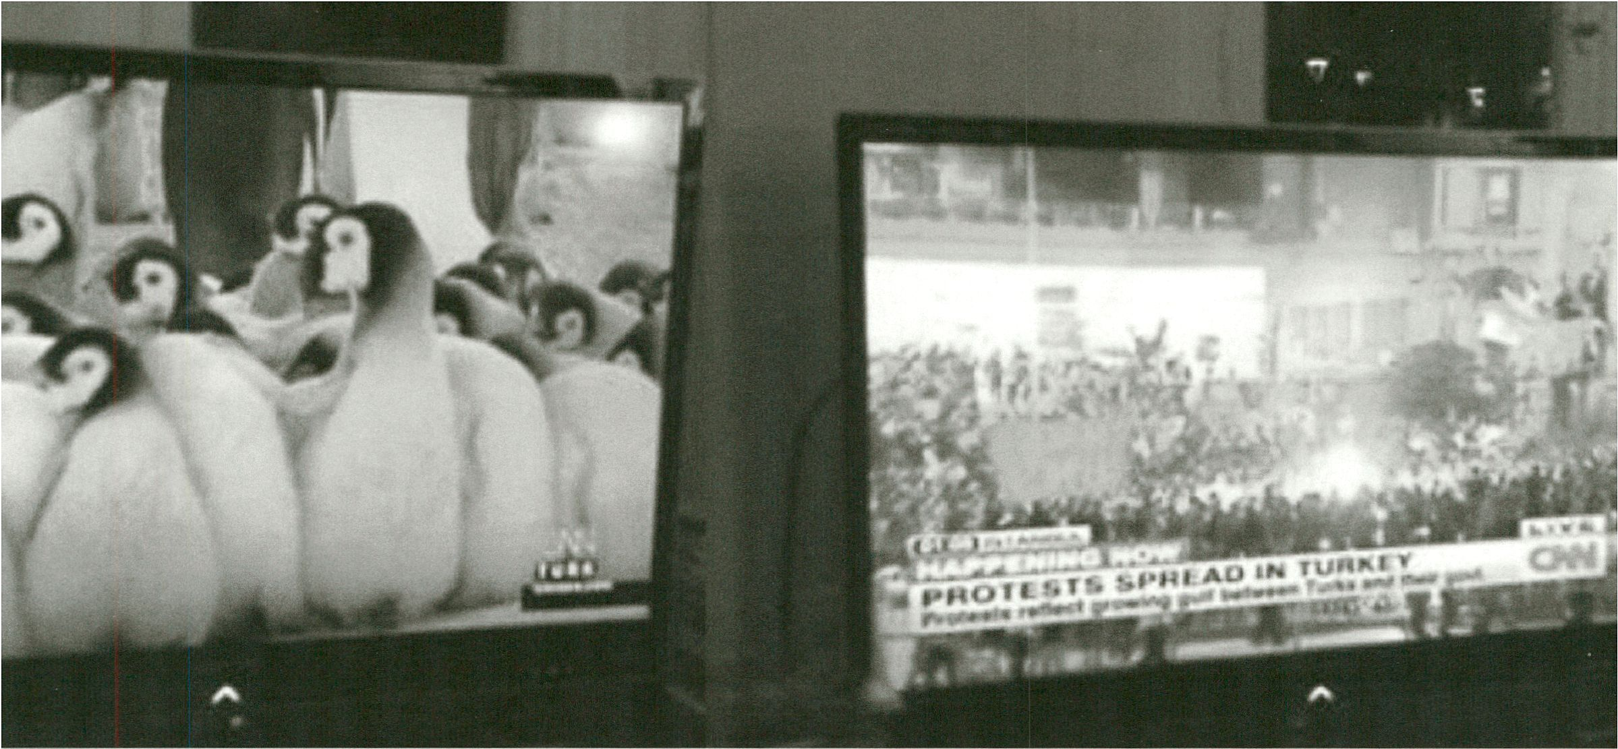

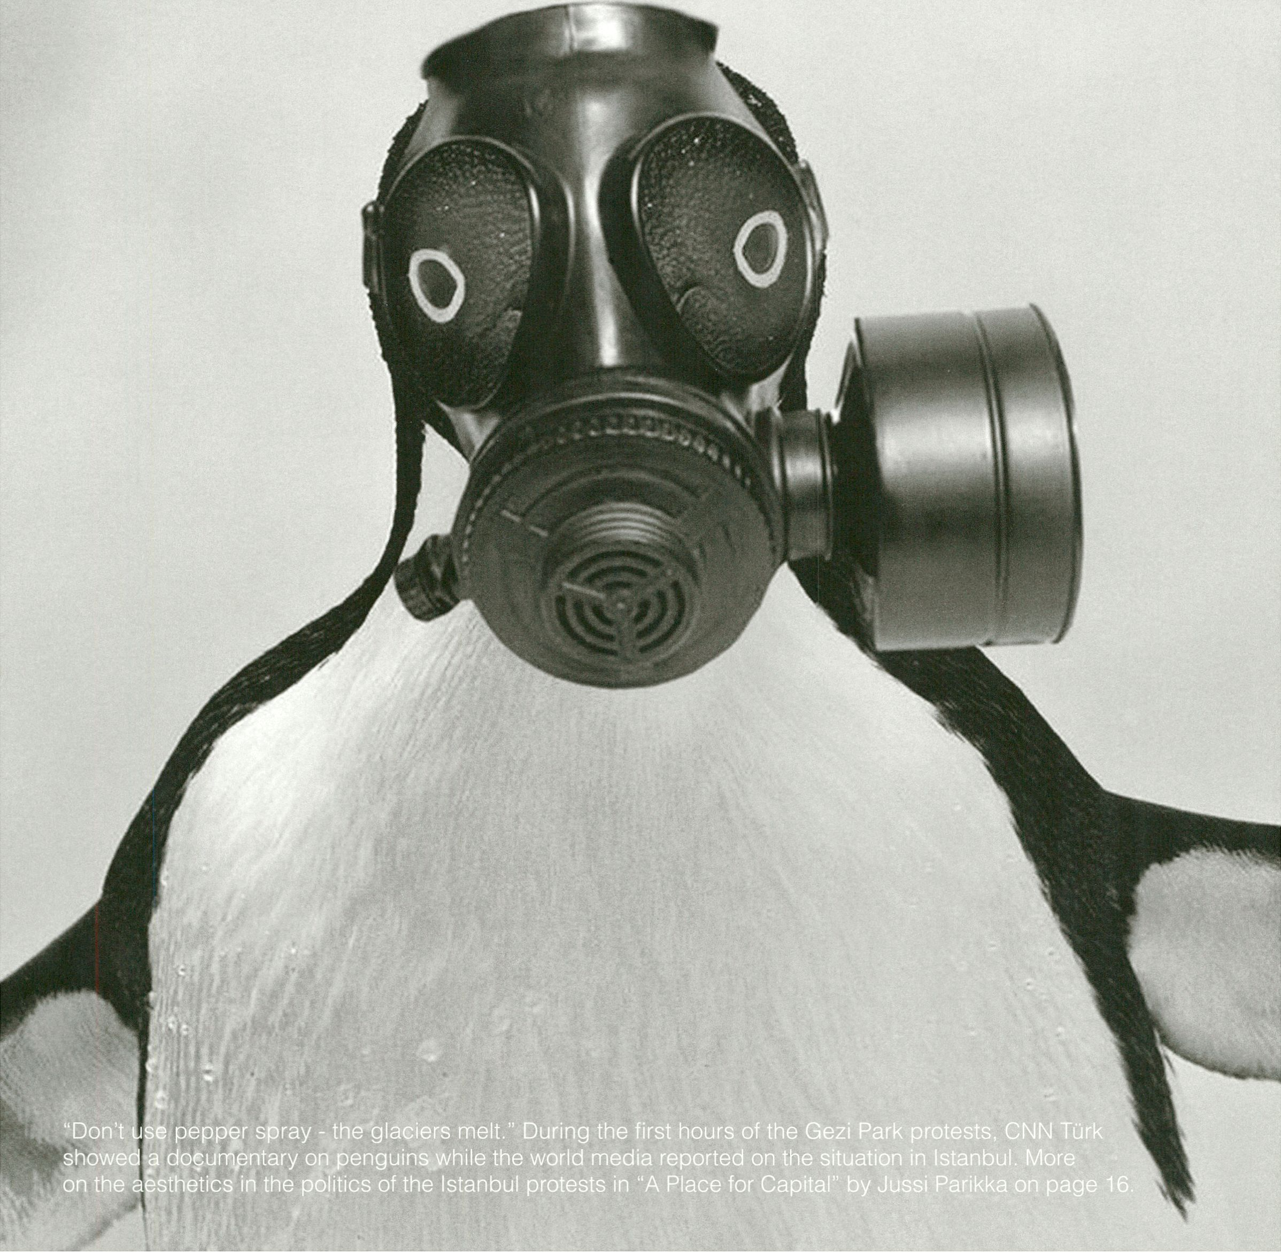

Mapping the resource
network by John Wild

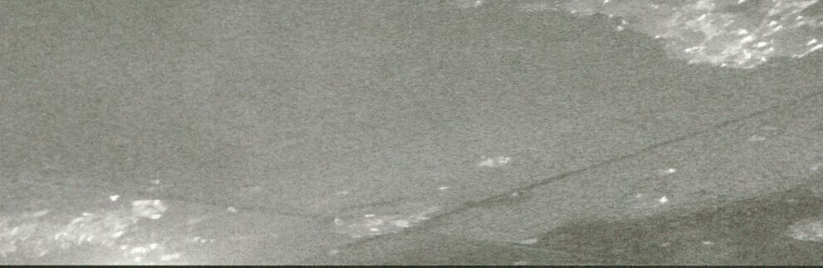

British artist and anti-disciplinary researcher creates sonic abstractions of project spaces.
Photo by John Wild
From May to September 2013 John Wild worked with
Tatiana Bazzichelli at transmediale on a project to
map the resource network of independent
technology-based art and hacker spaces in Berlin.
John Wild is an artist and anti-disciplinary
researcher currently studying for a PhD, evaluating
the impact of ubiquitous computing on the
production of social and physical space, within the
Media and Arts Technology Programme at Queen
Mary, University of London. The mapping project
rapidly developed a Schizoid split between a
practical Cartesian rationalism and a
psychogeographic abstraction that was resolved by
the development of two distinct approaches to
mapping the network.
1) Cartesian mapping: The first approach was to
develop a functional Android mobile phone
application with the aim of increasing the visibility
of the spaces within the city. The app provides an
overview of Berlin with a navigable map of all spaces.
To achieve this, GPS data and map tiles were
sourced from OpenStreetMap. OpenStreetMap is
dedicated to encouraging the growth, development
and distribution of free geospatial data for anyone to
use and share. The map was overlaid with location
markers of the venues. Clicking on a marker reveals
more information about the venue and a web link.
The app has been developed with an online content
management system allowing each space to manage
their own content. Enabling the app to become
a self-organised tool to enhance the visibility of
the city’s vibrant technology-based art scene.
2) Network Noise Drift: A ‘network is a plurality
of (organic and artificial) beings, of humans and
machines who perform common actions thanks to
procedures that make possible their
interconnection and interoperation’ [1], The
second approach was to make audible the usually
invisible non-human aspects of the network’s
technological infrastructure through field
recordings of the machine processes that enable
the social network. A GSM sniffer, electromagnetic
induction coils, similar to those in guitar pickups,
and a broad spectrum RF receiver were used to
record the electromagnetic imprints created by
the spaces’ networked devices. WLAN, cell phone
signals, Bluetooth devices, DECT cordless phone
base stations, and. the internal processors of
laptops were recorded through the practice of
electromagnetic audio drifting; being guided by
the invisible intensities, textures, and ambiances
of a space-specific electromagnetic geography.
These raw field recordings were composed into a
sonic abstraction of each space. With an android
mobile phone app and OpenStreetMaps, these
compositions were geospatially sited at specific
GPS locations and only accessible at these spots.
This sonic abstraction of the resource network is
presented by John Wild at resource 006: Overflow
as a performativity walk, where he will guide
walkers through the streets passing through the
varied ambiences and nodes of the sonified and
abstracted map of the resource network of
technology-based art and hacker spaces.
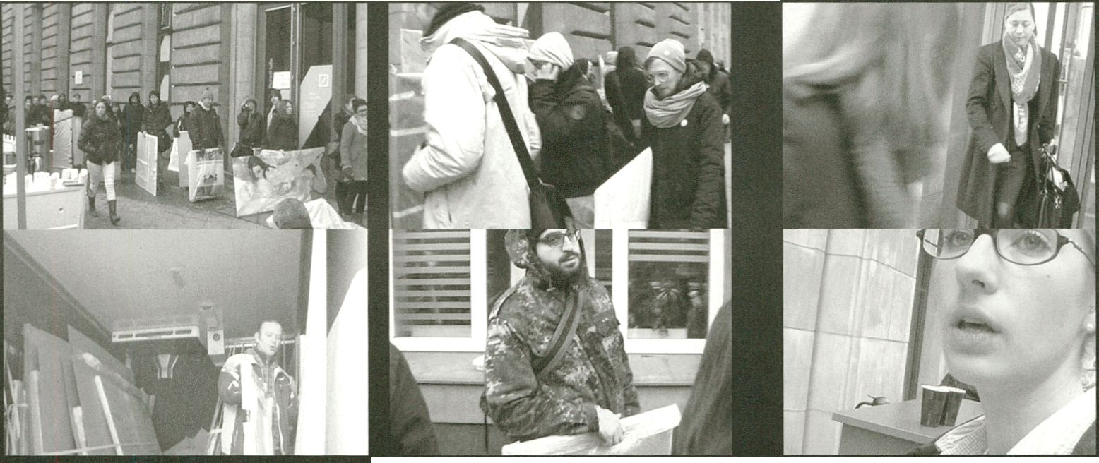Austerity and the End of the
Arts by Georgios Papadopoulos

A reflection on Carsten Lisecki’s film “Art Accounts Deutsche Bank”.
Stills by Carsten Llsecki, 2013
How can artistic practice remain
distinctive given the adversity of
economic environment that limits
the space for experimentation?
Art is celebrated as a practice that
does not need to conform to the
mandates of market and profit but
is rather able to construct alterna-
tive possibilities of participation in
the socio-economic field. In that
sense, art remains a privileged
domain for addressing the social
conditions through new forms of
representation and subjectification.
Obviously this relationship between
society and the arts is mutually
constitutive; it Is not just the artist
that can address or even shape the
social field; her ability to intervene
is compromised by her own
reliance on the market not only for
material support, but also for
recognition. The artist needs to be
acknowledged by society and
market not only to safeguard the
necessary means for survival, but
also to affirm the social significance
of her own practice. The recent
financial crisis and the consequent
cuts in the cultural sector disclose
the contradictions and the adversity
of the socio-economic environment,
where artists have to survive. The
recession has pushed many in
conditions of poverty and depres-
sion, since it raises obstacles in the
participation both in economic and
artistic life. Economic austerity has
led to conservatism and conformism with
the neoliberal ideology of ‘economic
efficiency’. Artistic practice requires
more than before from the artists to be
competitive, individualistic, and keeps
them dependent on patronage, either
from the state or from private organisa-
tions and collectors, reducing the
autonomy of artistic production to an
illusion that only exacerbates the adverse
post-fordist conditions of existence.
A recent, vivid example of the self-de-
feating relation between artist and
market was the opening of the Deutsche
Bank Kunsthalle in Berlin in April 2013,
on the occasion of which artists were
invited to bring an artwork to be
exhibited in the new Deutsche Bank
(DB) venue at the Linter den Linden
boulevard in Berlin. Every artwork
submitted would be exhibited for 24
hours and the best work would get the
artist a solo show sponsored by DB.
Hundreds of artists of all ages, back-
grounds and nationalities, queued for
hours in the cold to have the ‘opportu-
nity’ to show the work in an ‘established’
gallery and get some visibility. What is
the reason for the artists coming in such
large numbers to act as cheerleaders of
the DB, despite their supposed distance
from the commercial values that a bank
represents? The situation seems even
more problematic and hopeless, since it
was only shortly after the financial
collapse, when banks were blamed for
their irresponsibility and at the same
time this event brought some of the
same artists to Berlin who had been
fleeing the economic depression in
their own cities as migrants.
The problem is not the gullibility of the
artists but the very conditions of artistic
production that lead to such desperate
and uncomfortable choices, following
from a very vulnerable position. The
question remains if art can stay distinc-
tive and relatively independent given the
adversity of economic environment or
even if it needs to bother with such
questions. Collective action is a
necessary first step, but not without its
own problems. The realisation of the
forms of domination that feed on the
misery of the artist and their ideological
justifications is imperative. The cultural
industry is not unlike other sectors of
employment, where the boss - here in
the figure of the curator - the state
administrator, the professor, or the
master-artist, benefits economically and
symbolically, by exploiting the artist as
(often unpaid) worker. Ironically the
degree of exploitation is greater in the
arts, where equality, meritocracy and
solidarity supposedly regulate the
relations of the ‘community’. Unfortu-
nately such principles, along with myths
of creativity, authorship and artistic value
are used to cover the reality of exploita-
tion and domination in the arts. As
cultural workers, we should not abrogate
our rights to serve art, because at the
end of the day we will end up serving an
exploitative economy and do a disser-
vice to culture and to ourselves.
K
-h
A Place for
Capital
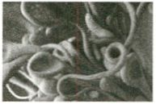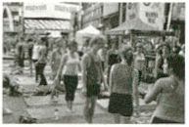A Place to
Read
<
snapchats #bln
chatrooms
P-2
An Ecosystem of Excess
Interview with Pinar Yoldas
p. 28
transmediale/festival
afterglow
p. 30
>
e has built a
Il
virtu
a
ren ica
or a cottcg
OUSG
overook
orus
ava
a
where his
r wa ks
tA

A Place for Capital: Urban Art
& the Society of Security
Late May 2013, Istanbul turned Into a different sort of a
city. The touristic streets of Istlklal, and the surround-
ings of Taksim square, turned Into an atmosphere not
meant for breathing. The public space turned Into tear
gassed space of exception, and the Gezi park, at the
centre of the events, into a critical, contested question
that ran through the whole of Turkish society.
The park was to be turned Into a shopping mall
alongside other building projects proposed by the
government. In a way, a lot of the events escorted an
Interesting sort of discussion concerning politics and
art of public space. The Istanbul biennale planned to
launch In September 2013 had already earlier decided
its theme slogan as “Mom, am I barbarian?”. The
themes included public space, democracy and the
possibilities of reimagining social relations in the midst
of the ongoing neo-liberal urban restructuring. Already
in 2012 the Amber platform had organised its confer-
ence, festival and a range of workshops around the
theme of “urban commons”.
After May the 2013 Biennale were according to some
critical voices as if pre-empted by the demonstrations
at Gezi Park. The Gezi events became quickly per-
ceived In Turkey and internationally as a social
movement that was expressed In visual culture,
design and slogans that showed an aesthetic sense
of politics. This meant not an aesthetisation of politics
but a critical stance that governance of sensation
and perception is essential to managing a social
movement. This movement is not only about specific
ecological details, like protecting a city park, but about
civil rights across heterogeneous clusters of groups
from the LGBT-community to Kurds, from anticapitalist
Muslims to hackers and environmental activists.
In a way, the sentiment In some circles was that the
Istanbul Biennale was almost made redundant.
Perhaps this sort of critique itself mlspercelves what
art Biennals are about, but it raised some interesting
points about, the global status of them in relation to
urban public space. Design-thinkers/practitloners
such as Ed D’Souza have already earlier argued that
the Biennales are globally odd events that live off
urban regeneration but often negotiate a safe distance
from the actual social life of cities. Now, in 2013, the
Istanbul Biennale had to reorient Its original interesting
mission to the emerging politico-aesthetic situation.
It was forced to get involved In the odd mix of political
economic-measures, security regimes, government
pressure, civil society actions and a discourse of urban
aesthetics that seemed suddenly radically distributed.
The theme of “occupy” at Berlin Biennale of 2012
was one sort of staging of social movement in
relation to the art institution. It was perceived as an
articulation of contemporary art in relation to new
forms of politics. But it was also criticised for
its artificial nature of objectifying social move-
ments Into a prefabricated brand that can be
exported like any consumer object: politics
as performance art. The uncontrollability of
Istanbul and other Turkish cities' urban envi-
ronments was a very different situation that
included grim casualties, violations of civil
rights and constant overuse of state legitimat-
ed violence. But it also spurred an aesthetic
discourse and practice that brought new
angles to activism.Whlle the infamous TOMA-
water cannon units were spicing up their
liquid measures of crowd control with chemi-
cals to burn the skin, the security measures
were turned into images and slogans that
travelled from street corners to the digital.
Also software practitioners and artists were
involved, demonstrating the topological
connections that concrete lived spaces have
with the algorithmic realms.
But it was not necessarily just another
Twitter revolution, or any other global brand of
activism. People I spoke with in Istanbul were
often critical about the early comparisons to
the Arab Spring for instance: some interna-
tional commentators, Including intellectuals
such as Alain Badiou and Slavoj Zizek, had
difficulties in getting a sense of what is going
on in this particular case, and hence had to
refer to already existing models of radical
politics. For some, the “occupy Gezi” was
just a sign of the global revolution to come.
In the more interesting analyses, the
aesthetic questions tied space to security,
place to police actions. The issues of
politics were inherently connected to
questions of architecture and urban
regeneration. For years, Istanbul was
prepared and built as the model city of
financial capital. Various projects - such as
the probable third bridge across Bosphorus
and the new airport project - ignored envi-
ronmental concerns and warnings that such
projects might actually kill the natural water
resources of the whole city of some 14 million
people. The liquidity of TOMA-water was
matched by the liquidity of financial capital
investment projects, which from urban housing
to housing of capital was not even meant to last.
The time span of such planning was emblematic
of the systematic dismissal of professional
warnings. Adding insult to the Injury, the govern-
ment rushed to ratify a law to curb the powers of
the Chamber of Architects involved in urban
planning. It Is no wonder that an attachment to
an aesthetic of streets and the urban space
became such a key theme for the events:
questions of natural ecology became practices
of ecologies of art and politics.

Jussi Parikka, Winchester School of Art
Dr Jussi Parikka is a media theorist and Reader at Winchester School of Art, UK. His books have analysed accidents and dark sides of network culture as well as
the entanglement of biology and digitality. Parikka’s Insect Media-book won the 2012 SCMS Anne Friedberg award for Innovative Scholarship. He writes on media
archaeology and his most recent book What is Media Archaeology? has just been published by Polity Press.

A Place to Read: Victor Burgin,
Space, Memory & Digital Politics
"He has built a virtual replica of a coffee house
overlooking the Bosphorus, where his avatar walks in
the garden. All that remains of the real coffee house
is a restaurant overlooking a rooftop tennis court
with advertisements for telephone companies."
and still images along with a tracking
camera that searches empty structures for
signs of human presence beyond the built
environment. An uncanny aura fills the film
as he digital imagery allows Burgin to
animate specific portions of any given shot
while keeping other parts still, such as the
revolving aerial shot of the coffee shop with
the Bosphorus in the background, its waves
frozen as in a still photograph.
The title evokes several meanings including
descriptive (a place where one can visit to
read quietly and have a cup of tea), cultural
(the Turkish term for coffee house coming
from an Ottoman word meaning a place to
read) and imperative (a site that demands
interpretation, a space not self-evident and in
need of hermeneutical attention). The Taslik
Kahve was built by Sedad Hakki Eldem in the
middle of the 20th century and manifested a
locally-inflected global modernism, synthesis-
ing Ottoman and modernist elements. The
shop stood for several decades until in the late
1980s, the building and its grounds - a park -
gave way to the newer tourist-oriented hotel
i-A
- Victor Burgin, "A Place to Read”
Victor Burgin was artist in residence for the Lives and
Works in Istanbul project undertaken during the city’s
year as the European Cultural Capital in 2010. The
work he produced when living in the city. “Bir okuma
yen” / “A Place to Read” is a digital textimage projec-
tion. The piece is silent with text presented on the
walls of the gallery (or inserted as intertitles depend-
ing on the venue) and involves a film loop shifting
between black and white and color imagery. Created
using virtual camera technology, the loop deftly and
hauntingly weaves black and white imagery of a
coffee house from Istanbul’s past and a modern
hotel that now occupies the same site. Reminiscent
of the Alain Resnais/Chris Marker film “Nuit et
brouillard” (“Night and Fog”), the film merges moving

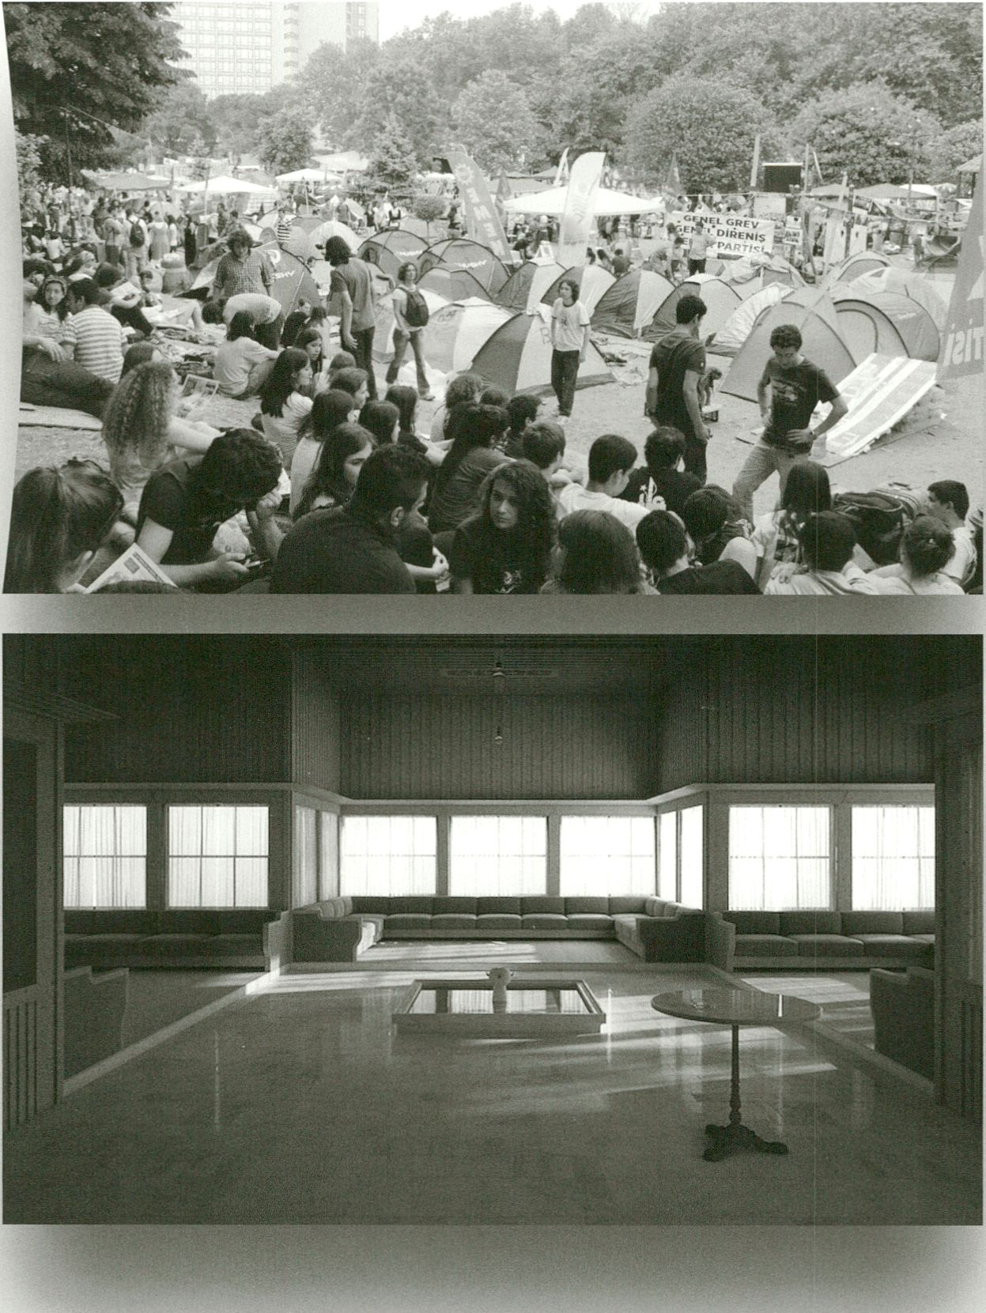

Top: Photo by Olcay Öztürk / Top next page: Photo by Shaan Paton
Bottom/ Bottom next page: Still from A Place to Read’. Copyright by Victor Burgin
catering to global travelers. The partially-destroyed,
partially-rebuilt coffee shop became a portion of the
hotel’s restaurant, the appropriation of the past into
the present through destruction. The park in which
It sat has all but completely disappeared. In a very
straight forward manner, the site offers a meditation
on the position or not of the local within the forces of
neoliberal global capital and serves as a metonym for
processes of development that have overrun Istanbul
for decades and which have now become points of
contention In the streets. The process of creating
a 3-D model of the building from archival Images
allows Burgln to manoeuvre his virtual camera
through a built environment that no longer stands,
a simulation of the place he is reading and where
he once read. The virtual camera process allows
Burgin to occupy and explore still photographs,
to blur the distinction between still and moving
image, rendering them both uncanny. The film
and text bear witness to the excavation and
salvage work that Burgin gestures too through
its content. The piece, somewhat aptly, was
first installed at the Istanbul Archeological
Museum, allowing the exhibition space to
echo the political themes obliquely gestured
to in the work’s evocative text. The piece
seems firmly rooted in the past, to loss, the
seductive power of nostalgia and the actual
pain of losing public space. The text, however,
indicates otherwise, and it is the more futural
and proleptic dimensions of the installation that
strike one in the present. Its prescience more
than doubles the overall effectiveness and
power of the piece. When the ruling Justice and
Development party (AKP) passed a bill during a
midnight session of parliament on 10 July 2013
banning the involvement of the Chamber of
Architects and Engineers from consulting on
government development plans, Burgin’s piece
leapt from the past into the present and moved
from the Archeological Museum directly into
Gezi Square. That the midnight manoeuvre was
widely interpreted as payback for the support
provided by this chamber to those protesting
plans for the square, highlighted the roles of
justice and development as articulated In the
AKP’s name.
“A Place to Read” in its descriptive, cultural,
imperative meanings now expands to in-
clude ones of geopolitical struggle around
definitions of spatial justice. Burgin’s
haunting and haunted installation consid-
ers temporality while slipping Its trappings
and making past, present and future
simultaneously present.

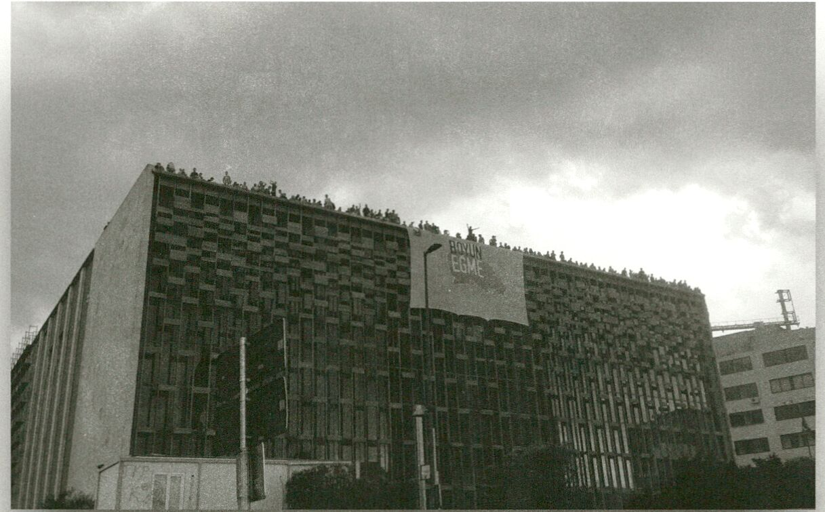
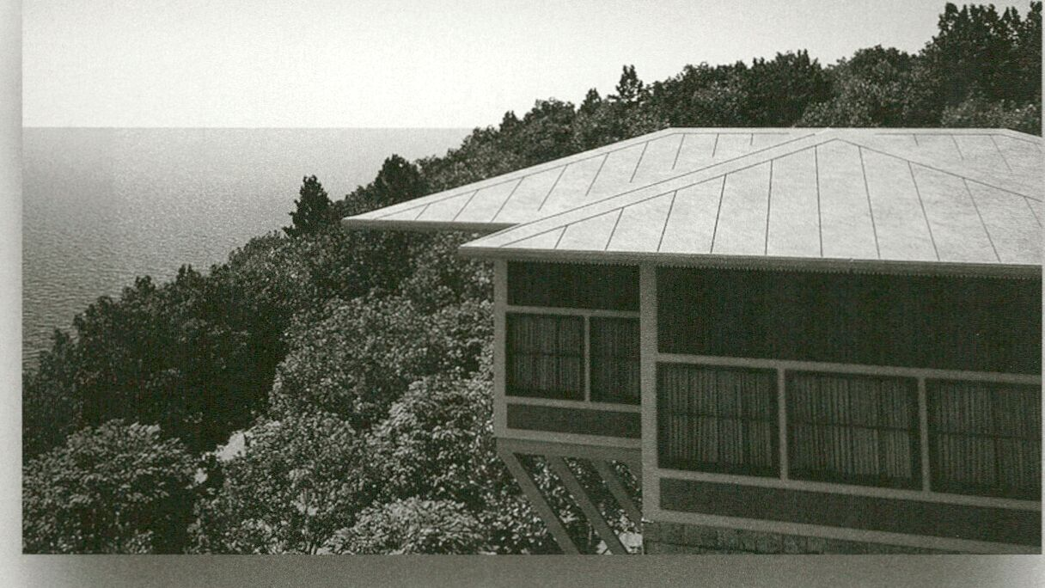
Ryan Bishop, Winchester Centre for Global Futures in Art Design & Media
Ryan Bishop is Professor of Global Arts and Politics, Winchester School of Art, University of Southampton (uk). He is co-director of the Winchester Centre for Global
Futures in Art Design & Media. He has published on critical theory, urbanism, media, visual culture, modernist avantgarde aesthetics, and critical military studies.
Along with John Armitage and Doug Kellner, he co-edits the journal Cultural Politics (Duke University Press).

all that remains
of the rea
cotree nouse
is a rest
d
r
an
overooking a
rooftOD tennis
co
ve
w
d
d
r⁻
r~
ro
r
co
sements
eleohone
n
d
ies.
a
Victor Bürgin,
“A Place to Read

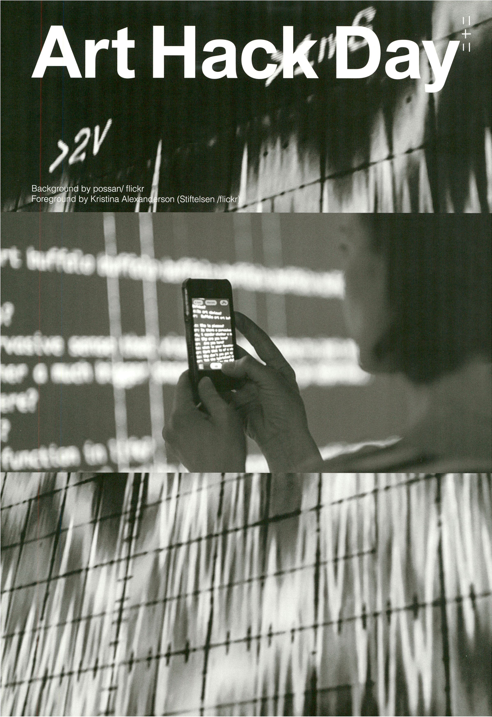

Art Hack Day / LEAP and transmediale
present the two-part project Art Hack
Day Berlin. Close to 100 artists and
hackers will inhabit LEAP and Haus der
Kulturen der Welt to create Instant
exhibit ons and live performances on the
themes of 'Going Dark" and "afterglow".
Art Hack Day Berlin : Going Dark
Our actions are ncreasingly mediated by
data. Previously we formed our artifacts,
now they form us. Woven into a
seamless network, they quantify our
lives, affect our thinking and become
ntrinsic to our being. As such the urge
to go dark has never been greater.
26-28 September 2013 LEAR
Berlin Carré 1. floor,
Karl-Liebknecht-Str, 13,10173 Berlin
more info: http://www.leapknecht.de/
Art Hack Day Berlin : afterglow
29 January - 2 February 2014
transmediale 2014 afterglow
Haus der Kulturen der Welt,
John-Foster-Dulles-Allee 10,
10557 Berlin
Kristoffer Gansing in
conversation with Olof Mathé, the
initiator of Art Hack Day.
Tell us about yourself, your back-
ground and what led you to organise
Art Hack Day? Ennui’. Creating on
your own is lonely. So It seemed like a
good idea to rally other digital aficiona-
dos, deep computer heads and
professional pranksters and create an
exhibit from scratch in barely 48 hours.
There was nothing else out there for us.
It was immediately apparent that the
format works beautifully for making and
exhibiting art. I’ve probably always
inhabited the grey area between art and
hackery. Whereas I lacked the academ-
ic resolve to go to art school, I instead
pursued engineering and philosophy at
Kungllga Teknlska Hdgskolan and the
École normale supérieure instead.
One of the eye-catching statements
that you use to describe Art Hack
Day is: “We believe in non-utilitarian
beauty through technology and its
ability to affect social change for
public good. “ Can you elaborate on
this? There are so many ways in which
I could speak to this statement. We’re
proponents of the intrinsic beauty of
technology, but not in a futurist sense.
We uncover its expressive potential and
write poetry with it. Technology tends to
be utilitarian in the most pedestrian way.
It is employed to ‘solve problems’, even
when it ventures to create beauty. Of
course most problems are socio-eco-
nomic and political before being
technological, so resolving issues with
technology often just reinforces existing
power structures rather than disman-
tling them. We however use technology
not as a means to an end but as a
means to eloquence, as a way to
examine the discursive environments
we’re in, to help us understand the very
notion of ‘solving a problem’. As such,
every Art Hack Day explores a theme
that’s artistically, politically and
technologically relevant. For example, in
San Francisco last year the theme was
“Lethal Software”, a topic we had until
then only tangentially approached as
hackers and artists. In this sense the
work that is created promotes public
good. Admittedly, this didactic ambition
makes our mission statement oxymo-
ronic. But that’s just a healthy reminder
that it’s virtually impossible to be fully,
internally consistent. ‘Public good’ also
alludes to the beauty we experience
when we co-create among our peers,
which is at the heart of the event.
With the recent surveillance scandal,
‘hacking’ has become an even more
controversial and debated activity.
What is your approach to hacking
and do you address these debates
and the hacker scene as such? The
theme of “Art Hack Day Berlin: Going
Dark” for sure seems to move in this
territory. Hacking’ as a term is nearly
60 years old, yet still retains most of its
freshness. Historically we’ve come full
circle: computers arguably owe their
existence to the military, and hackery in
part arose as an attempt to de-militarise
computer use and to empower ordinary
people. So in a way we’re back where It
all started. It’s just ironic the govern-
ment has brought the term into the
limelight, all the more so that blanket
mass surveillance is probably not artful
enough to be called hacking. It’s also
worth noting that AFAIK neither
Manning nor Snowden ‘hacked’
anything. As whistleblowers they simply
exposed questionable practices by
sharing documents they had access to
in their line of work. In any event I don’t
think we engage in these debates other
than through our actions. Ideas are
interesting in so far as they temporally
precede action.
In the 1960s, EAT - “Experiments in
Art and Technology” was a pioneer
project of bringing together artists
and engineers to collaborate in
artistic projects with a technological
edge. Is there perhaps less of a
polarity between art and technology
today than in those days and if so,
what do you want to achieve with
your project in terms of linking art
and technology? Yeah, this isn’t about
artists or hackers but about people who
are indistinguishably both. Asking if
you’re more of one or the other is like
asking a parent which of the children
he or she loves the most. As anyone
with a bicultural upbringing can attest
to, there are weird and wonderful ways
in which your heritages can interact.
You have the liberty to identify with
both cultures and with neither. So
taking the risk of appearing too
sophisticated, I’d say it’s less about
linking art and technology and more
about exploring its confluence. To riff
on this: art proves how expressive
technology can be, it highlights ways in
which we shape our tools and they
shape us dialectically. Hackery
demonstrates the value of radical
collaboration. At Art Hack Day,
participants work in teams, carry out
other people’s ideas and open-source
their work: a piece is there to be
improved. It’s a gift economy, and
sharing and exchange are its core
principles. It hopes to provide a
transition to new forms of artistic
being. People often ask if we’re trying
to hack the art system as much as
we’re about hacking technology, but
we’re really just in it for the incredible
vibe, the community and the compel-
ling art works that get created. Any
collateral damage is secondary.
Art Hack Day is a nomadic project.
How much does it change from
venue to venue and from city to
city? Ultimately, Art Hack Day is
nomadic, because it’s grassroots. It
brings the burgeoning hacker-artist
community together to create AFK (no
pun intended). While the local
community in each city gives the event
a unique quality, the theme influences
the outcome more. Interestingly, the
venue also turns out to be Inspiration-
al: every time a couple of pieces are
site-specific and exploit quirks of the
exhibit space for artistic umph.
Why Art Hack Day Berlin? Because
Berlin is awesome. The community of
hackers whose medium is art and
artists whose medium is tech is really
strong there. A couple of them have
even participated in prior events.
What can we expect from Art Hack
Day Berlin? Cathartic euphoria. I can’t
wait to play.
+ El

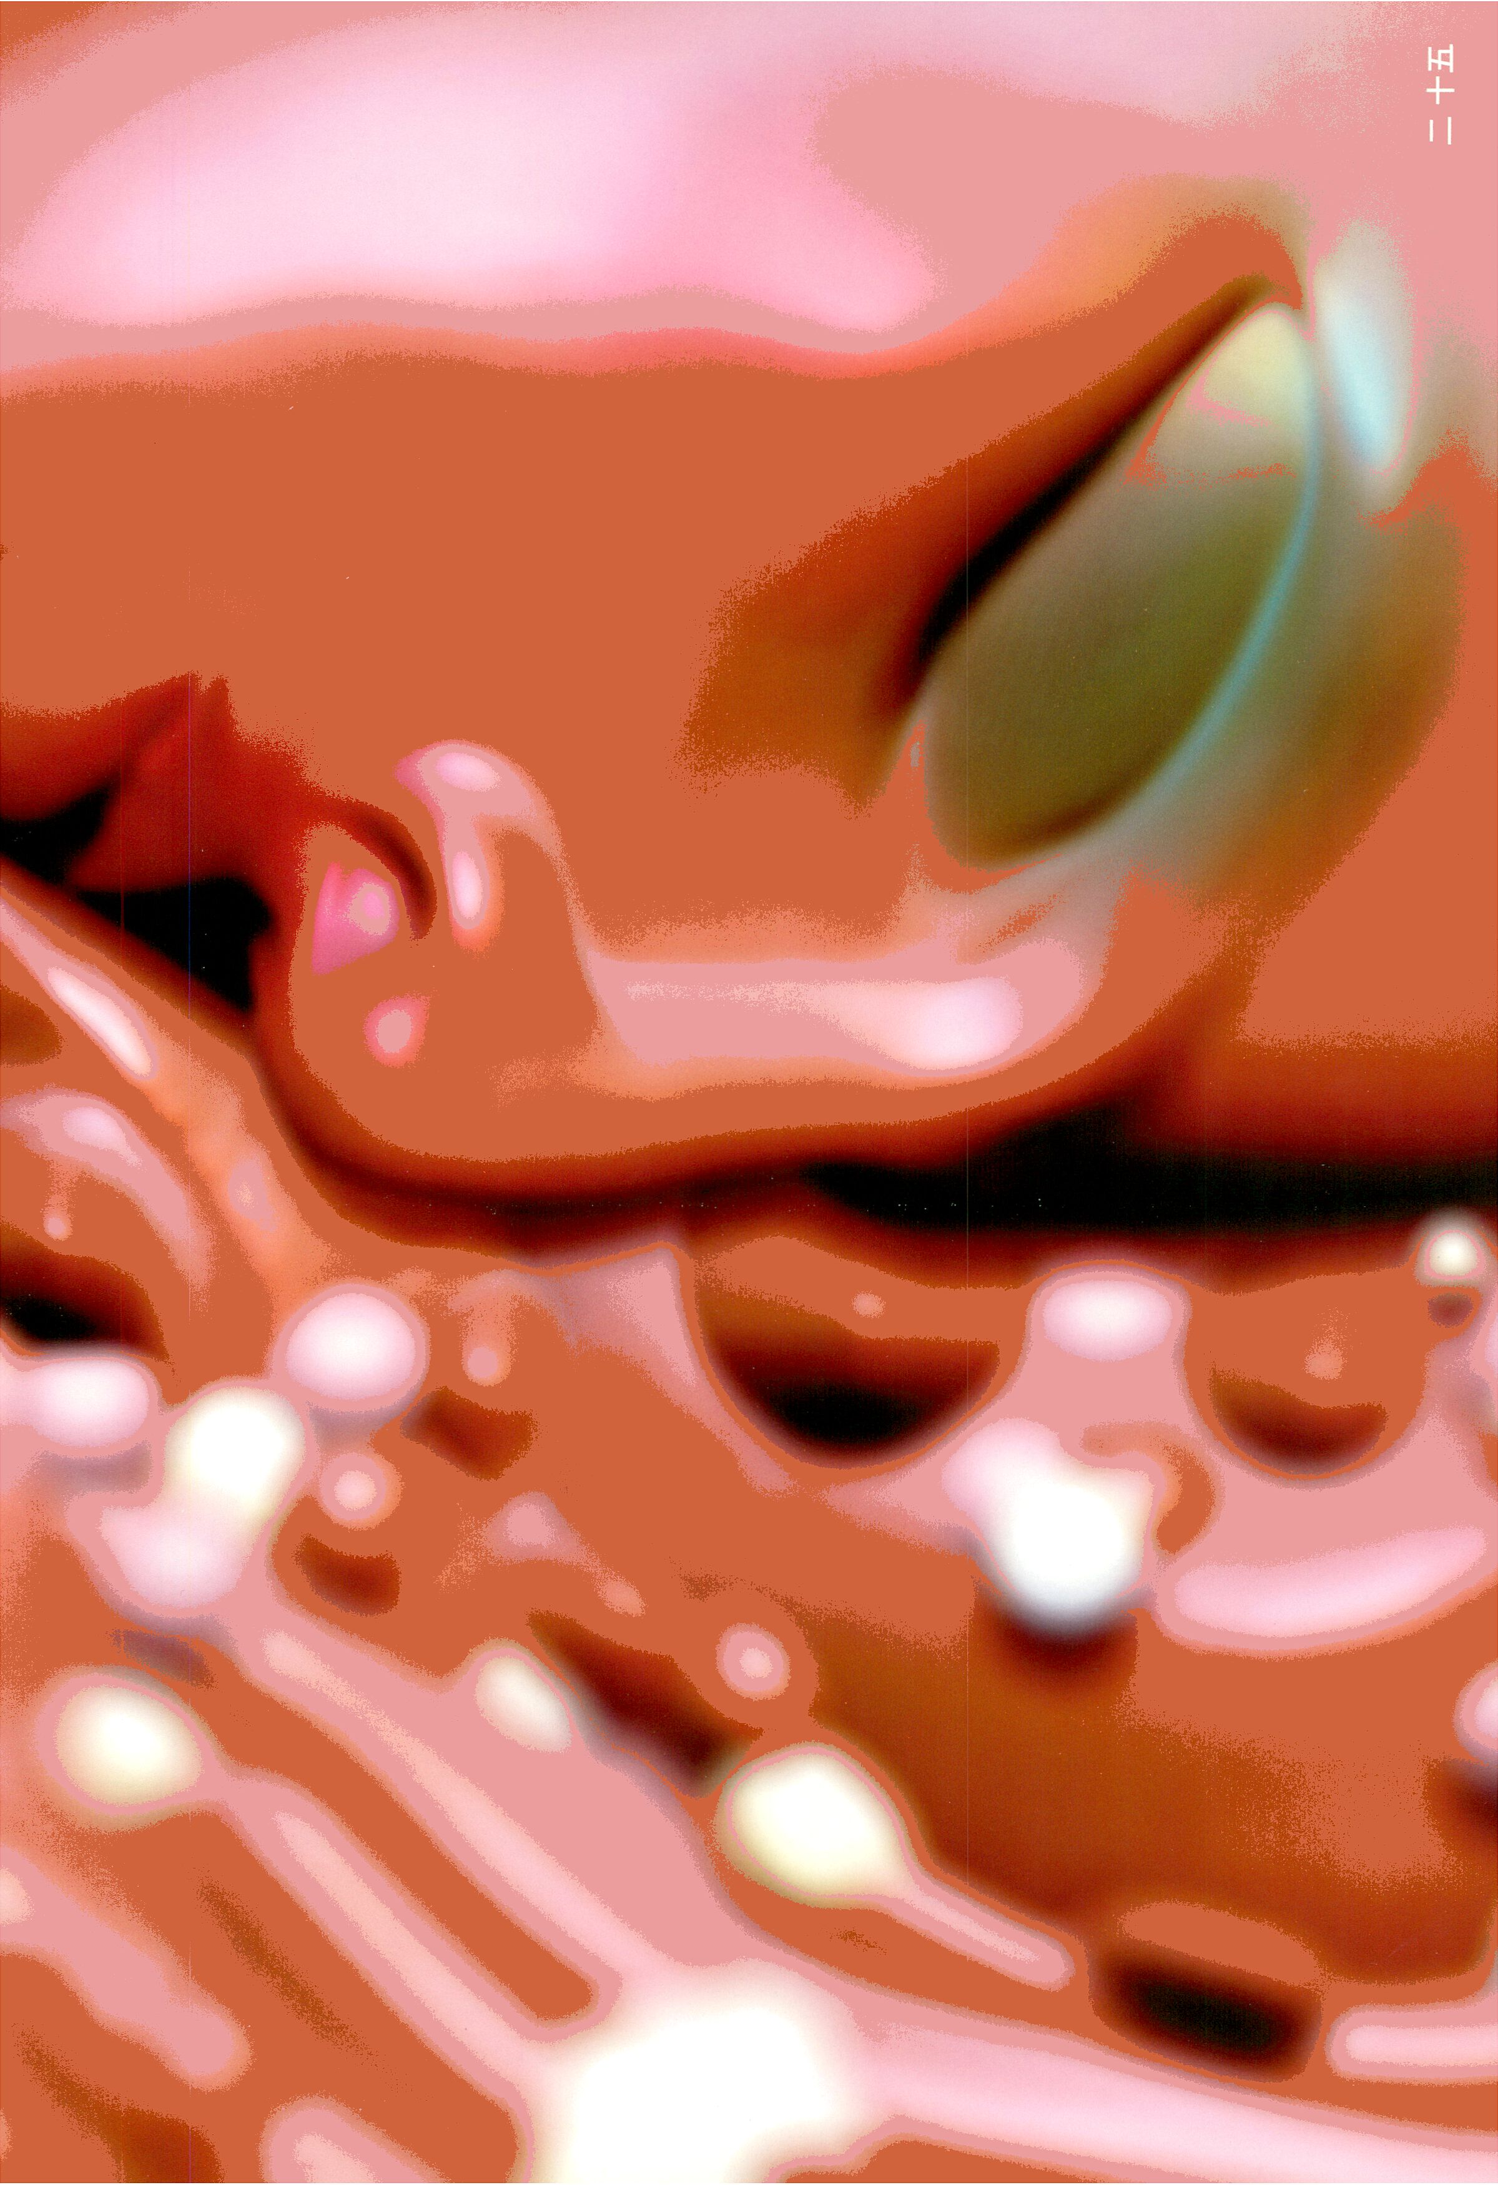

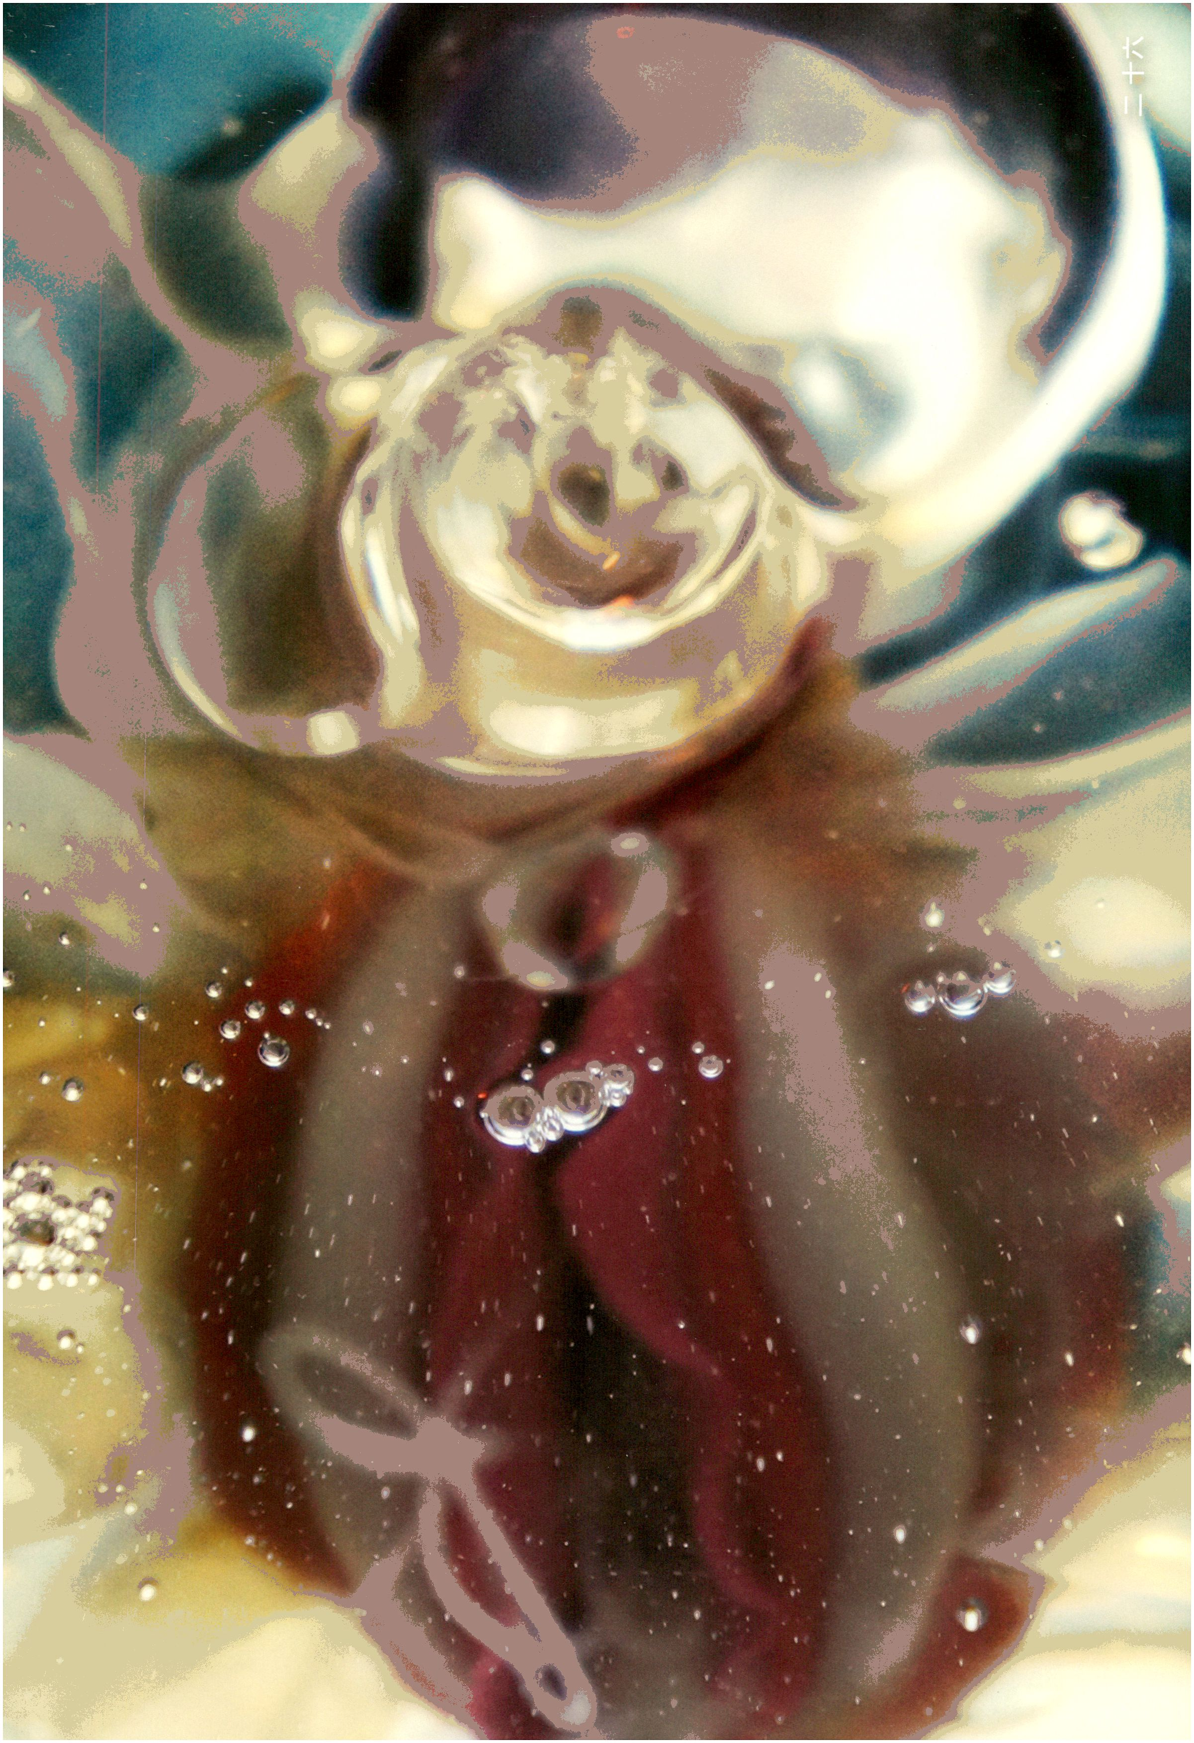

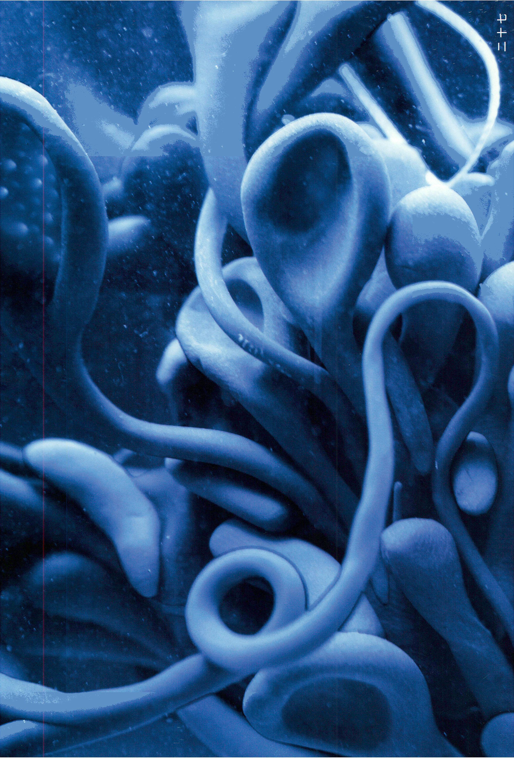

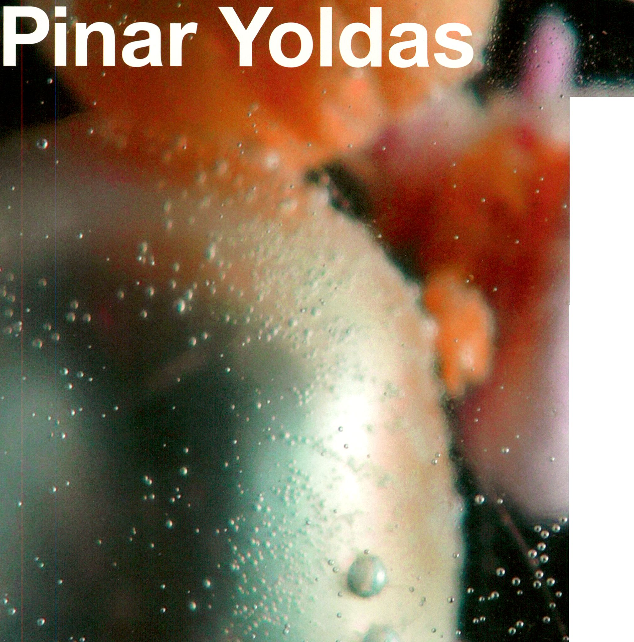An Ecosystem
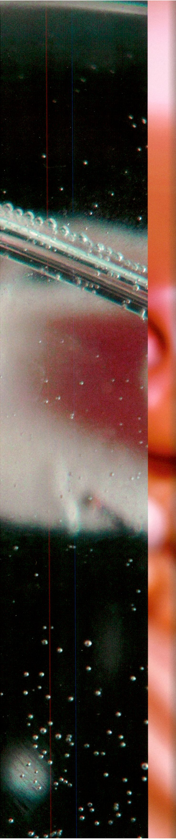
Daniela Silvestrin talks to Pinar Yoldas,
selected artist in the Vilem Flusser
Residency Programm for Artistic
Research 2013. The programme is
offered by transmediale in cooperation
with the Flusser Archive at the University
of Arts (UDK) in Berlin. Pinar Yoldas is a
cross-disciplinary artist and researcher,
who will continue her work in speculative
biologies through the project “An
Ecosystem of Excess”, a work exploring
the possible evolutionary consequences
of the Pacific trash vortex.
To what extent is your work influenced
and led by scientific research in general
and biotechnology in particular? My work
is heavily influenced by biological sciences
or biology as the study of life. The term
‘biological arts’ used by lonat Zurr and Oron
Catts is very appealing to me as it embraces
a vast array of scientific research topics.
Biotechnology is the craft, biological tool
making so to speak. Right now I am more
interested in understanding nature rather
than modifying it for human purpose. Yet,
according to Marx we can only know what
we make [1]. I guess the question boils down
to the difference between to know and to
understand.
In your research and resulting artworks
you primarily investigate the two-sided
dynamics between cultural and biological
systems. Do you work with biotechnology
yourself in order to produce your works?
What is the methodology you use when
translating scientific data in to artworks?
I haven’t yet worked in a biotech lab, but I will
in the near future. In the “Very Loud
Chamber Orchestra of Endangered
Species,” I worked with a variety of environ-
mental pollution data sets (which is abun-
dant, trust me). The nature of data allowed
us to convert numbers into sound and
movement. The result was an orchestra of
non-human animals screaming out C02
data, water pollution data and so on. For
“Limbique”, the goal was to reveal the
subcortical structures of the brain, which
generate / process emotion, so I followed a
more spatial approach. Overall, my goal Is to
orchestrate the human sensorium for a
meaningful and memorable affective
experience. What I do is an interplay
between facts and affect [2].
Would you consider yourself a so-called
“bioartist”, or where would you position
your works in relation to bioart works
such as Eduardo Kac’s famous
fluorescent bunny Alba? Eduardo Kac is
the brilliant mastermind behind the world’s
first and most successful advertising
campaign for a glow-in-the-dark bunny.
According to Kac, bioart is the invention or
transformation of living organisms with or
without social or environmental integration
[3]. I find this definition hegemonic and
problematic in that it imposes a hierarchical
order of how bioartistic your project is,
limiting it with the use of living tissue.lf you
can recruit a biotech lab to add GFP for you,
you are the ultimate bioartist, but if your work
addresses the changing definition of life,
nature and the natural without paying a lab,
you are not? Does the bioartistry of a project
measured by the length of the DNA se-
quence changed? Or is it measured by its
contributions to scientific knowledge
production? How about the cultural impact it ^
has? I do not consider myself a bioartist in
Kac’s sense, I’d rather call myself a synaptic T"
sculptor or speculative biologist, if I’m to use | i
some biobabble. After all, what we need is
intellectual tools to catalyse rigorous critical
thinking, not categorical neologisms to mark
one’s territory.
In how far can and does your work
contribute to the knowledge production
regarding the state of the art of scientific
discourses? Let’s start with Flusser, “to
awaken the political and aesthetic con-
science of the scientist and technician is one
of the most urgent jobs with which the
intellectual (philosopher, critic, essayist, etc.)
is confronted” [4]. Flusser doesn’t count the
artist among these intellectuals, but I’m not
personally offended.:) Today scientific
knowledge production is highly Institutional-
ised with institutionalised ways of evaluating
contribution such as peer-reviewed journals.
But then there is the citizen science or open
science movement, which operates outside
the borders of the scientific Empire. I would
like to think that my work contributes to the
first by creating an affective framework for
scientists, and to the latter by demonstrating
that a scientific understanding of the world
can exist anywhere.
Coined by Dunne & Raby, “critical design”
is a term for design that uses designed
artifacts as an embodied critique or
commentary on consumer culture. In how
far do you use or integrate this technique
in your work in order to reflect on existing
values, ethics and practices in today’s
culture and change our perspective on
scientific research? I try to exploit critical
design to the max!
- Flusser, Vilém, and Louis Bee. Vampyroteuthis Infernalis: A
Treatise: with a Report by the Institut Scientifique De
Recherche Paranaturaliste. Minneapolis: University of
Minnesota Press, 2012.
- Deleuze, Gilles, Félix Guattari, Hugh Tomlinson, and Graham
Burchell. What Is Philosophy? New York: Columbia University
Press, 1994.. n.d.
- Kac, Eduardo. Signs of Life Bio Art and Beyond. Cambridge,
Mass: MIT Press, 2007.
- Flusser, Vilém, and Louis Bee. Vampyroteuthis Infernalis: A
Treatise: with a Report by the Institut Scientifique De
Recherche Paranaturaliste. Minneapolis: University of
Minnesota Press, 2012.
All Images by Pinar Yoldas:
p.25 pukepillow
p.26 Neolabium
p.27 Sensory colony, plastisphere
p.28 Angelika
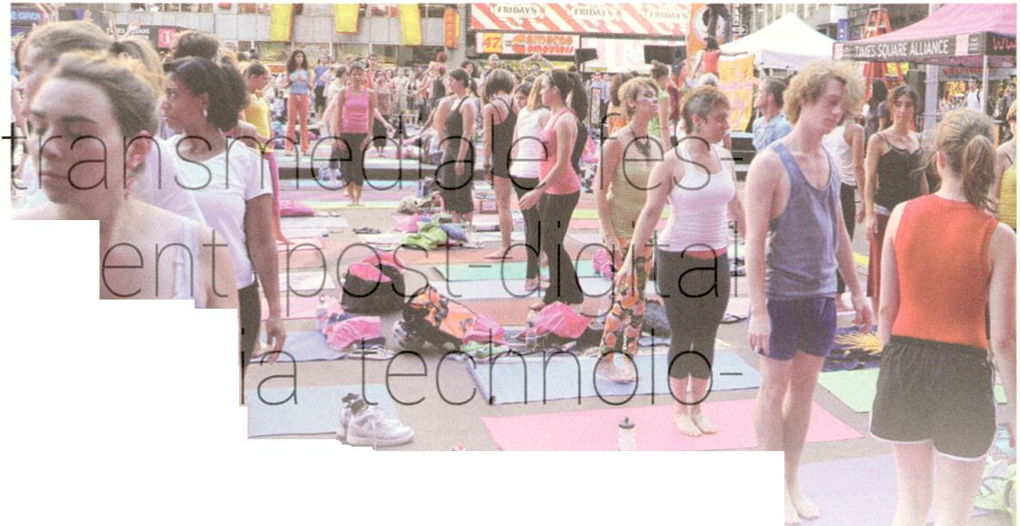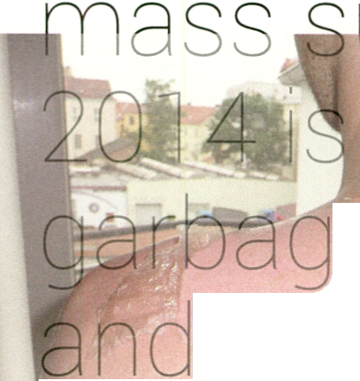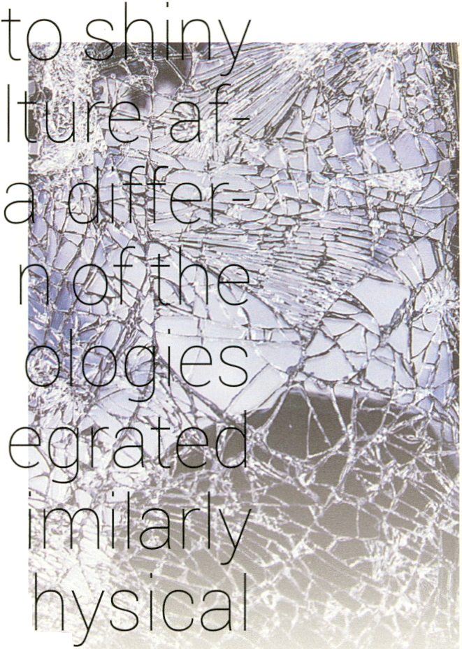

t ra n s m ed i a I e/f esti va I
afterglow
“afterglow refers to positive physical and mental effects that linger after the main
effects of a drug have subsided, or after the peak experience has subsided. This state is
often characterized by feelings of detachment or increased psychological clarity.”™
The next edition of the
tival will explore our pres
moment as one where m&_{r}
gles and mediatic practices that were once
treasure(d) are turning into trash. While
the '
cycle of the digital seems stuc<
ess repeat, perpetua y tied
Tech, it is clear that digital cu
ter the hype of social media is of
ent nature than that of the dlslllusio
aost dot.com years. As media techn
nave now become completely int
Into everyday life, they function s
to natural resources, producing p
and immaterial waste products that get
appropriated in such diverse contexts as
e-waste dumps, big data businesses anc
schemes, transmediale
interested In this junk, detritus anc
e hovering between the margins
centres olaost-digital culture.
^{r} The starting point is to consider this
In between state as an afterglow’ of the
on end
hi

digital: afterglow being that moment o
deep twilight when the c^t ,
risen from the earth into the affncfsf)
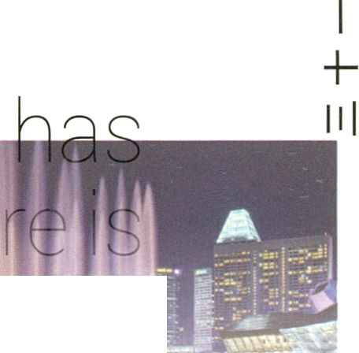temporarily lit up; as well afffemg a term'
positive or negative
men⁺w . e. effects of drua use. afteralow
fl|s of drug use. afterglow
■yite up the ambivalent state
cuimejwhere what seems to
JPfiT^frôm the so-called digital revolution
is a futuristic nostalgia for the shiny high-
tech it once promised us, but that is now
crumbling in our hands. The challenge that
this moment noses is how to use that state
culture in between trash and
of
m
of post-digita
treasure as a chance from which to invent
new speculative practices. These should
resist nostalgic or defeatist ideas, yet still
use waste as a starting point from which
to deal with the burning issues of today.
The afterglow is the moment aftamhe digi-
tal revolution, that is no j nt&dust
as we struggle to find new pathways li the
wastelands of its aftermath. ' ™
“The afterglow is an intense red glow of the atmosphere long after sunset
(or long before sunrise), when most twilight colours should have
disappeared. The afterglow is caused by dust In the high stratosphere,
which catches the hues of the twilight arch below the horizon. The afterglow
is commonly seen during or after volcanic eruptions, which deposit large
amounts of dust and ash into the high atmosphere.” pi
transmediale/festival/afterglow 29.01 - 02.02 2014 Haus der Kulturen der Welt. For further information, see http://www.transmedlale.de/
CTM.14
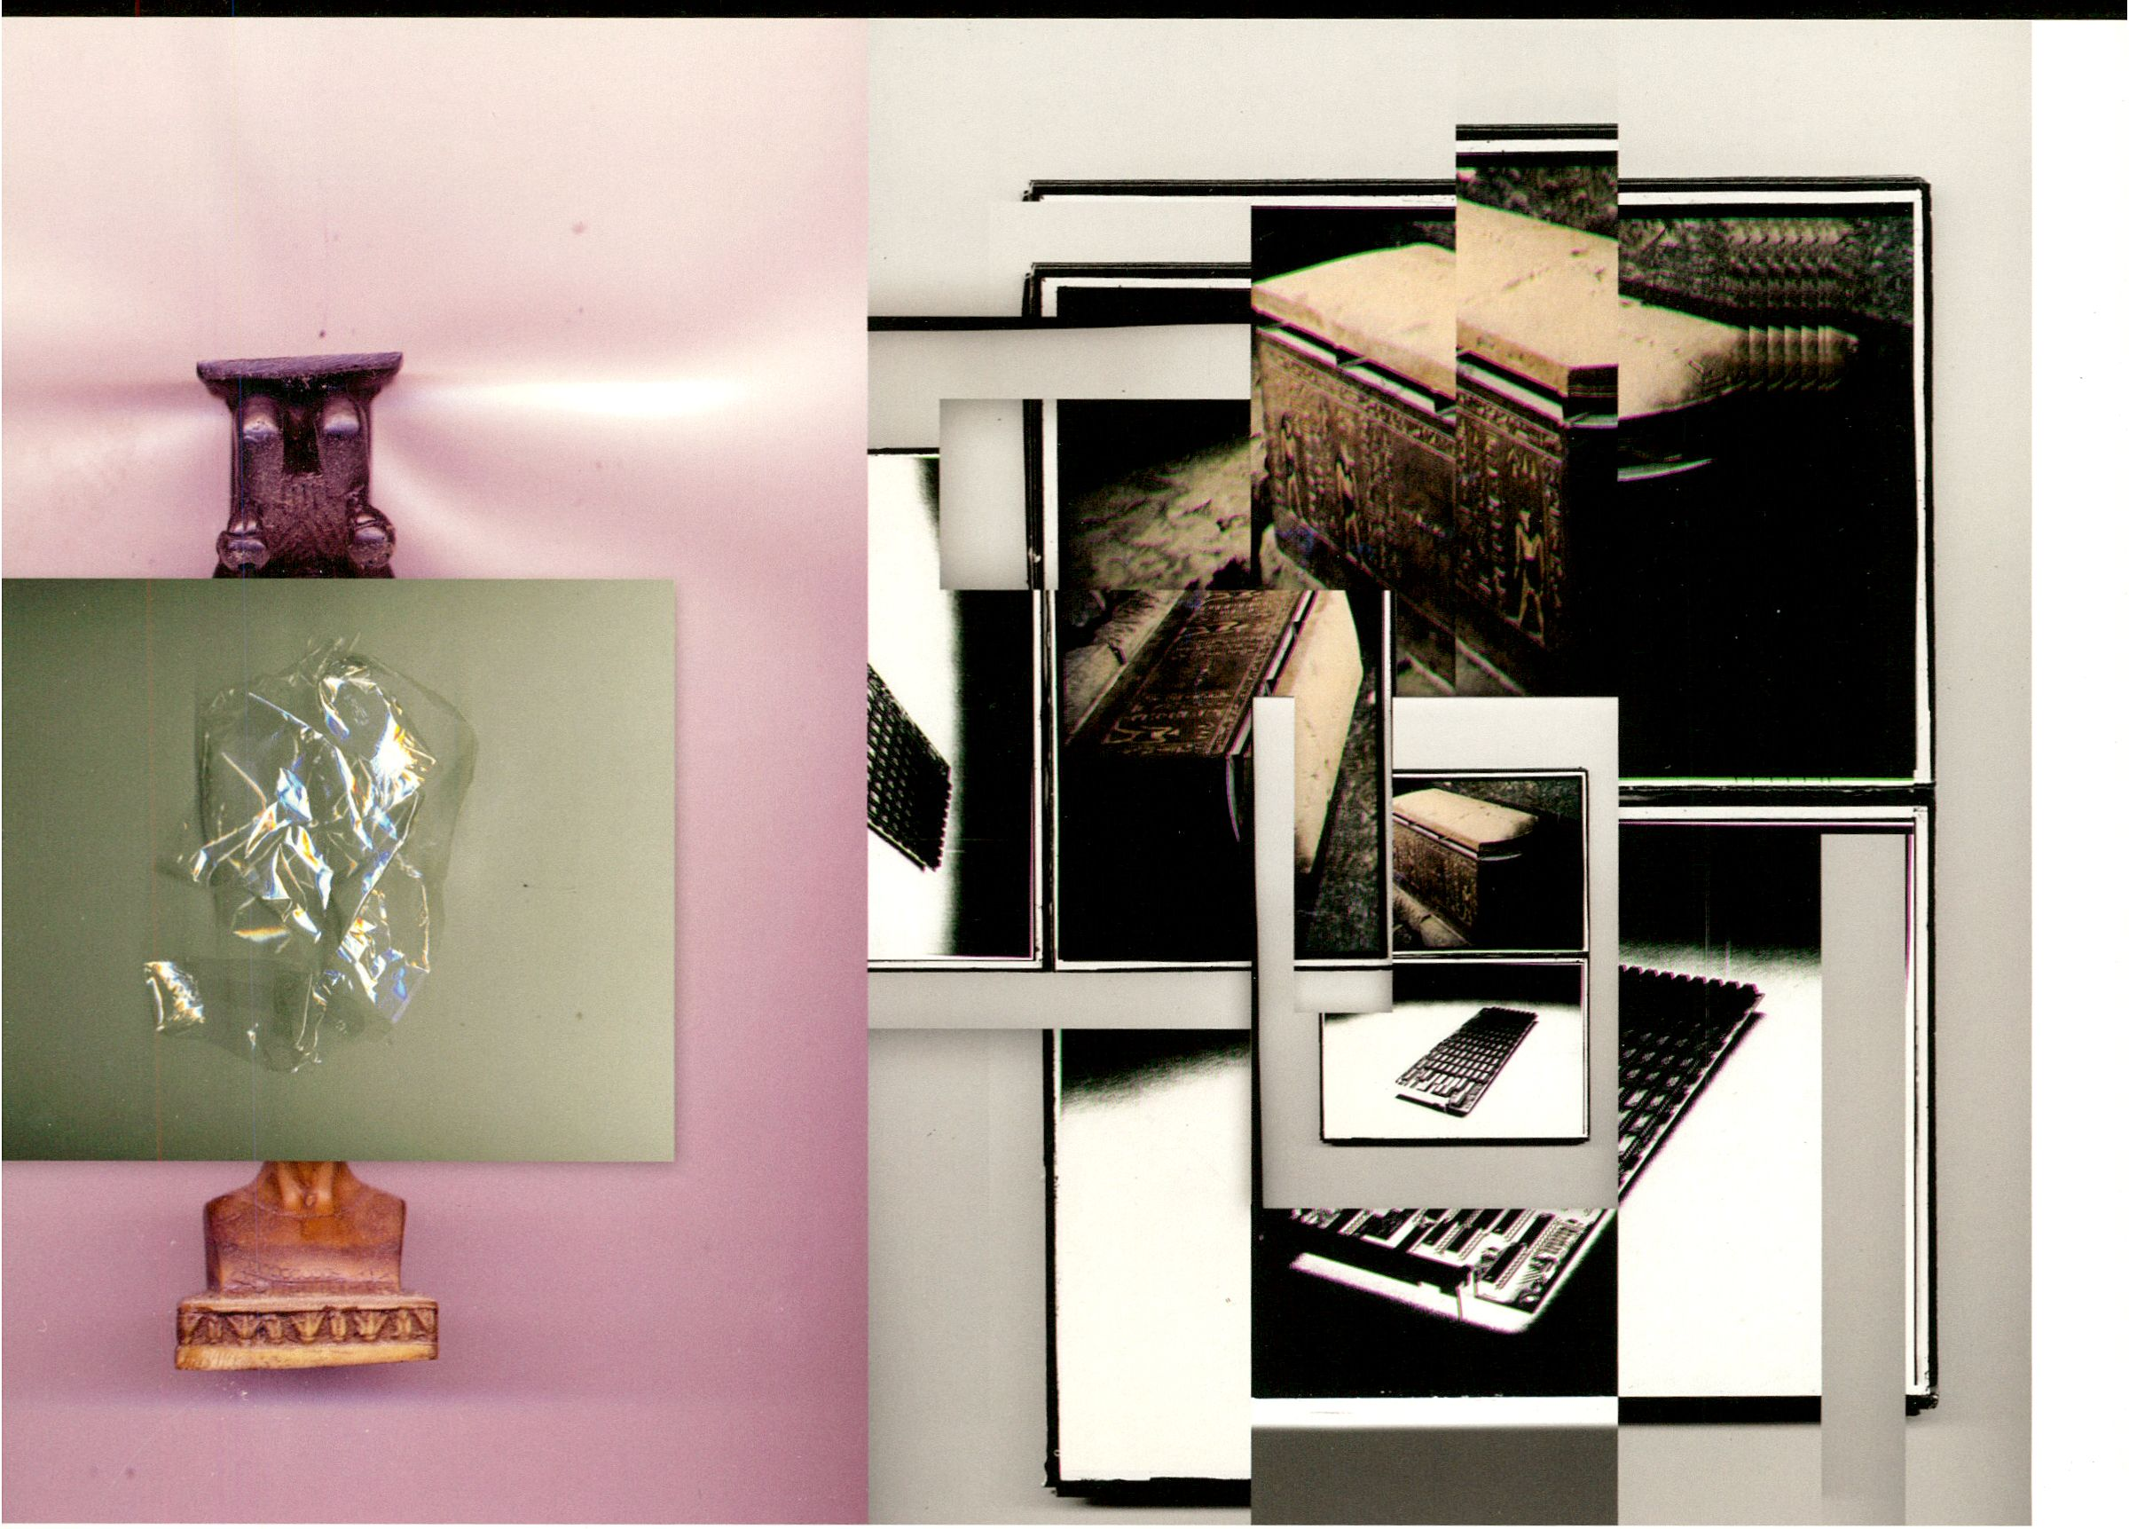Dis Cont

next issue: January 2014
Images by Studio Grau

Festival for Adventurous Music and Art
15th Anniversary Edition
24 January - 2 February 2014
CTM Festival’s 15th edition attempts to
explore and map fragments of an alternative
or neglected history of electronic and
experimental music that still waits to be fully
written. Under the title DIS CONTINUITY, the
festival will highlight select trajectories of past
artistic experimentation, protagonists, and
movements offside well-beaten paths, and
explore how their ideas have evolved
throughout different generations of artists, into
the present-or how, when arising in an
unreceptive or even antagonistic environment,
their ideas were ignored, suppressed,
sometimes even purposely destroyed, and
eventually forgotten.
Common narratives of music’s radical
evolution over the past century usually favour
a few exceptional individuals whose achieve-
ments are undisputed, and whose stories are
used to exemplify music’s major revolutions
and transitions in bold strokes. But the fabric
of music is of course far more complex; the
conspicuous threads of its agreed-upon
luminaries are interwoven with countless
individual and collective achievements. No
less inferior, these achievements spark, carry,
and support the main storylines of the history
of music, criss-crossing and feeding into one
another or running in parallel, and forming
nuclei of change and innovation within their
own communities and networks. Within this
vast interconnected fabric that stretches
across times and places, the simultaneous
invention of similar ideas in different
locations, the local appropriation of new
ideas and the resulting broad variety of
explorations play an equal role to the sudden
jumps of singular discoveries triggered by
chance, synchronicity, and serendipity, or to
the slow processes of laborious experimenta-
tion. In adopting a less hierarchical perspec-
tive and in acknowledging this complexity, the
number of pioneering figures that have
shaped today’s music multiplies rapidly.
By zooming in on a range of musical
pioneers, whose curious enthusiasm and
pursuit of new, idiosyncratic forms have kept
them somewhat off the radar, even as their
explorations and discoveries continue to exert
a too often unacknowledged impact on how
we create and experience music today,
CTM.14 aims to encourage dialogue between
past experimentation and a younger
generation of artists and creative minds. In
re-evaluating and re-imagining select threads
of experimental and electronic music history,
DIS CONTINUITY illuminates and contrib-
utes to music’s gradual evolution towards an
increasingly open and dynamic concept of
sound and music that transgresses the still
only semi-permeable barriers between
scientific research and art, pop and
academic culture, and various forms of art
and artistic practice.
The festival’s 15th anniversary is also an
occasion to reflect on the conditions and
threads of its own history, and to address the
increased desire for historic references felt at
the dawn of a post-digital era.
www.ctm-festival. de
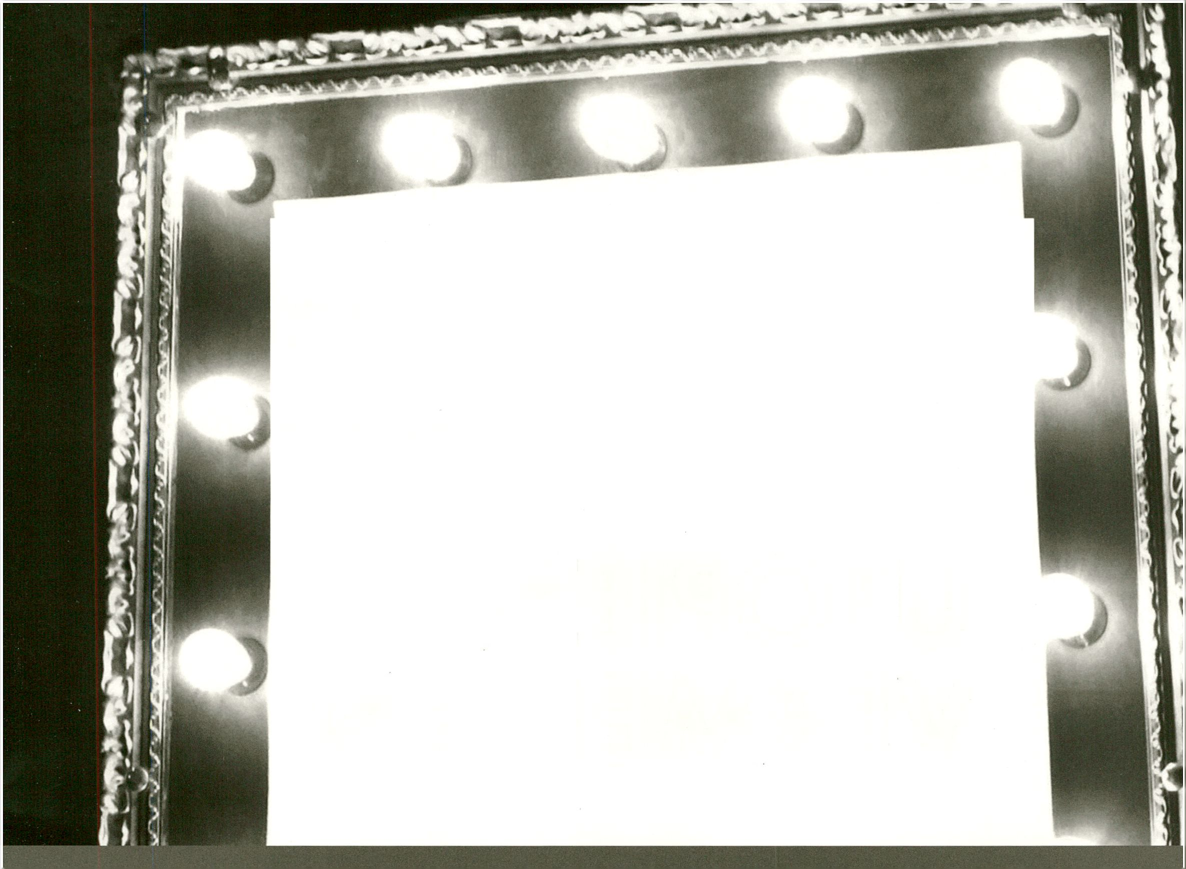WERKLEITZ
retune takes place at
THE WYE
Skalitzer StraBe 86
10997 Berlin
JUBILÀUMSFESTIVAL 2013
12.-27. OKTOBER
HALLE (SAALE)
WERKLEITZ.DE/UTOPIEN
M3HOTU
M3QI3M5I3V
retune.
CREATIVE TECHNOLOGY CONFERENCE
27. 28. 29. SEP 2013
Around the world new technologies and new
means of production and distribution enable
unprecedented innovation and creative
expression; while the sharing, forking and
remixing of knowledge blend traditional
fields in a way that informs and inspires new
questions, theories and methods.
The retune creative technology conference
is a gathering of artists, scientists, designers,
hackers and entrepreneurs who are engaged
in these developments, and looking to
exchange their ideas and questions on new
ways of working, thinking and expressing with
technology.
retune, is a single-track conference of hand-
picked workshops and talks, with limited
participants, and generous time fordiscussing
and connecting.
