WORLD
-
 | 1 » m 1 ^ | ^{T}J*J | | jJhJ

. I i ^ ..i | pfc—- -■ ■ ^
at happens when in/compatible phenomena
rought Jo the fore rather than hiddeifaway
^ the ¡dark underbelly of digital culture?
INSIDE: SOUVENIR POSTER
TRANSMEDIALE 2K + 12
EDITION


Last edition of News of the World, 2011.
IÏÏIÏÏ
E
13
14
14
- 15
18
18
19
- 20
21
In/compatible blog:
http://darc.lmv.au.dk/
30
AARHUS
UNIVERSITET
Supporters:
“Being theory as well as practice, political practice, education today is more than discussion, more than
teaching and learning and writing. Unless and until it goes beyond the classroom, until and unless it goes
beyond the college, the school, the university, it will remain powerless.” - Herbert Marcuse
- Editorial
i Imprint
- resource for transmedial culture
NTERFAC
Competing Compatibilities
(ping) pong
Threat of Disconnection
Image Objects: Computer Graphics and
Object Orientation
Blind Optics
Material Incompatibility
Against psychopathia medialis -
For normal schizophrenia
Notes on 120 days of *buntu


- The Glitch Art Genre
- Glitch Studies Manifesto
- Performing the Paradoxes
of Intellectual Property
- M*anifesto for Interfering Wom/6n
- In/compatible Imagi(ni)ng
- On Queer Viralities
« ArtisticTechnologyResearch
- Programming Abstract Machines
- Echoes of the Past
- An interview with the Steam Engine
- An Experience of Thought
- Models and the Future
- Speculative Archiving & Experimental
Preservation of Media Art


- Heterogenesis, growth, in.compatibility 23
- Controlled Consumption Interfaces 24
- Irrepresentable Collectivity 25
- Forkbomb.pl 25
- Venture Communism and Copyfarleft 26
- Dawn of the Ugly 27
- #ordure 27
- Capital Markets 28
- The Finnish Flash 29
- Andrei Markov's knee is still injured 29
- The Pedagogical Structure of Capitalism 30
- In response to the thematic framework 31
of transmediale 2012
t All power to the free universities
of the future! 32
• Biographies
■ur/v
D
ifferent technologies, their cultures
of use, and how they are conceptu-
alised, at once represent compat-
ibilities and incompatibilities. What happens
when such in/compatible phenomena are
brought to the fore rather than hidden away in
the dark underbelly of digital culture? Is their
in/compatibility a threat to stability, connec-
tivity and to the operations of socio-technical
systems more broadly? How do these unre-
solved tensions and paradoxes of media tech-
nologies continue to impact experimental ar-
tistic imagination and research practices?
It is in this context that the in/compatible
research newspaper provides a new platform
for knowledge exchange, and research across
disparate fields of practice. The content of the
newspaper derives from a Ph.D. workshop
and conference in November 2011, held at
University of the Arts, Berlin (organised by
Aarhus University in collaboration with trans-
mediale/reSource for transmedial culture and
the Vilém Flusser Archive). It provides an in-
sight into current research from academics,
practitioners, and Ph.D. students working in/
with in/compatibility, the 2012 transmediale
festival theme. As such, the newspaper consti-
tutes a thematic publication for the festival,
and is an attempt to extend a media art festival
like transmediale into a research context.
Leading up to that event, and subse-
quent to it, a blog has been gathering draft ar-
ticles and discussions, reflecting on the issue
of in/compatibility. This collaborative ‘peer-
review’ process (further developed during the
festival itself in February 2012, at the Haus der
F. THREAT OF
DISCONNECTION
:
Tlie threat of disconnection
can he seen as force behind
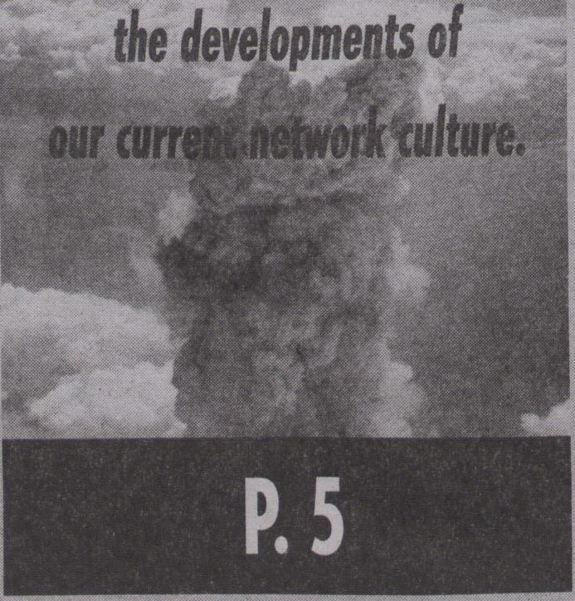

Kulturen der Welt, Berlin, with presentations
and discussions) culminates in the publica-
tion of this newspaper. So, although this may
seem like old news in many ways, in terms of
research practices, it breaks with some of the
current academic conventions of peer-review,
academic reputation, and what constitutes
proper scholarly activity.
The paper is organised into three main
strands of inquiry, related to in/compatible
interfaces, methods and markets, which to-
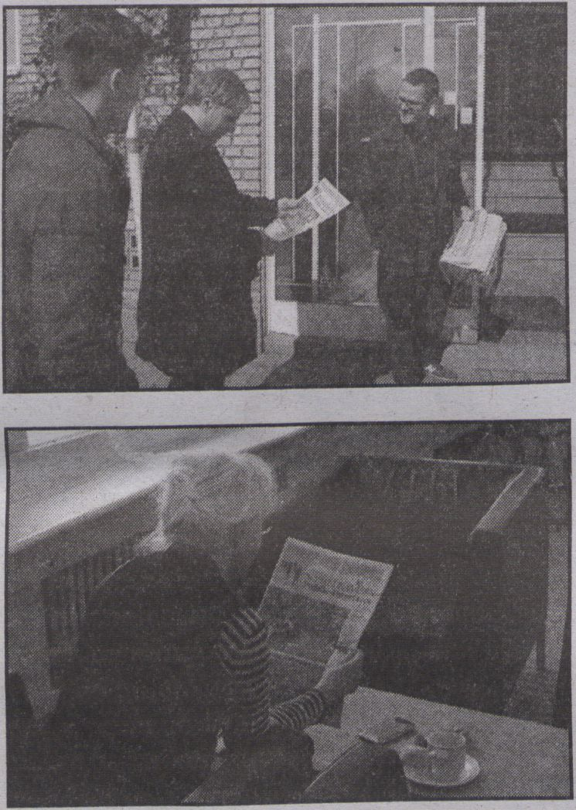
Diffusion of the peer-reviewed newspaper
Public Interfaces, 2011. "Photos by Alex de Rijke.

"... LA TÂCHE DU COLLÈGE
EST [...] DE METTRE EN PLACE
UNE DYNAMIQUE
INSTITUTIONNELLE QUI
PERMETTE DE LES FORMULER
ET DE DÉFINIR LES
CONDITIONS DANS
LESQUELLES DES RÉPONSES
PEUVENT ÊTRE APPORTÉES.”
- FRANÇOIS CHÂTELET
(ON COLLÈGE
INTERNATIONAL DE
PHILOSOPHIE)
gether explore some of the fundamental con-
ditions for contemporary research practices.
The paradoxes abound. On the one hand, a
range of methods, including artistic research,
extend and challenge the hegemony of knowl-
edge production, but on the other, there is a
powerful trend towards the marketisation of
research, the creative industries agenda and
instrumentalism in education. Underpinned
by new public management, and the Bologna
process, research undergoes ‘quality assur-
ance’ where it is measured (through endless
audits) and subject to compatible standards.
In this process, knowledge production be-
comes ever more related to economical
frameworks.
The evidence is all around us, where dras-
tic cuts to education, and research pro-
grammes are made compatible with austerity
measures in order to subsidise the failures of
financial capitalism (with fees). We ask wheth-
er it is possible to reconceptualise research
outside the confines (and failures) of financial
capitalism? What are the alternative models,
which seek autonomy over knowledge pro-
duction? How are technological paradigms re-
defining the horizon of social possibilities and
enhancing autonomy over research from
within a community of peers? These are re-
search questions that we ask you to consider
in reading this newspaper, and we hope you
enjoy it.
Christian Ulrik Andersen,
Tatiana Bazzichelli, Geoff Cox,
Kristoffer Gansing (Aarhus University/
transmediale), January 2012.
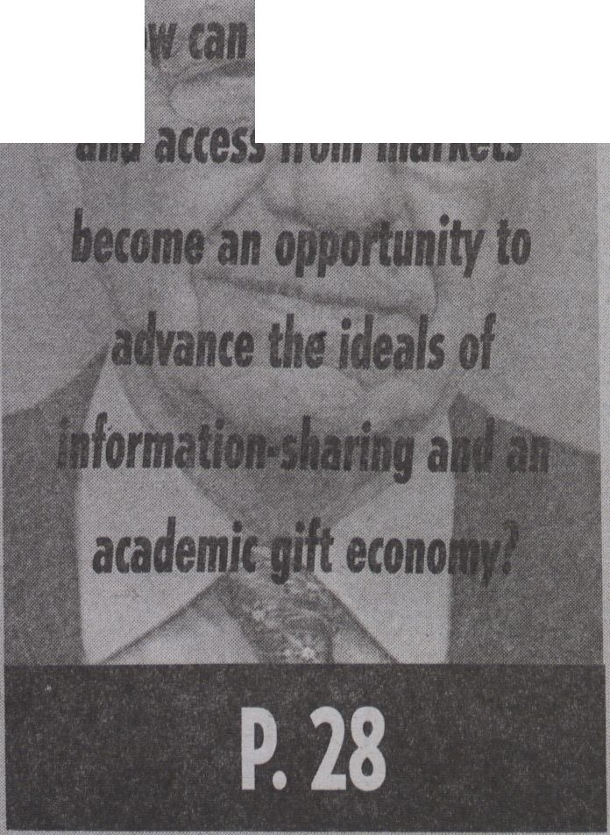



Networking communities as research practice

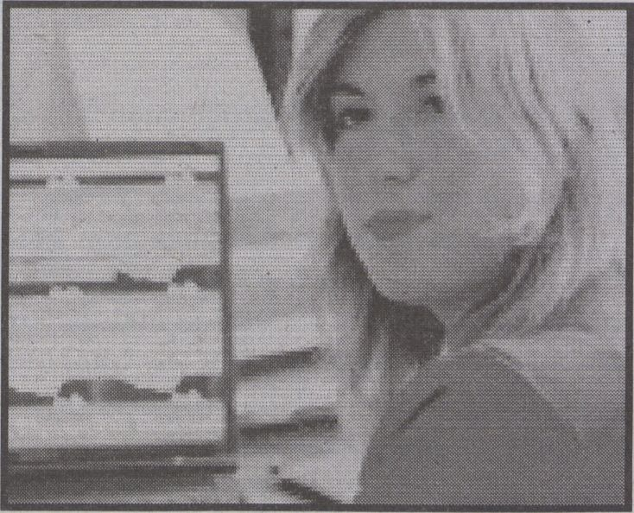
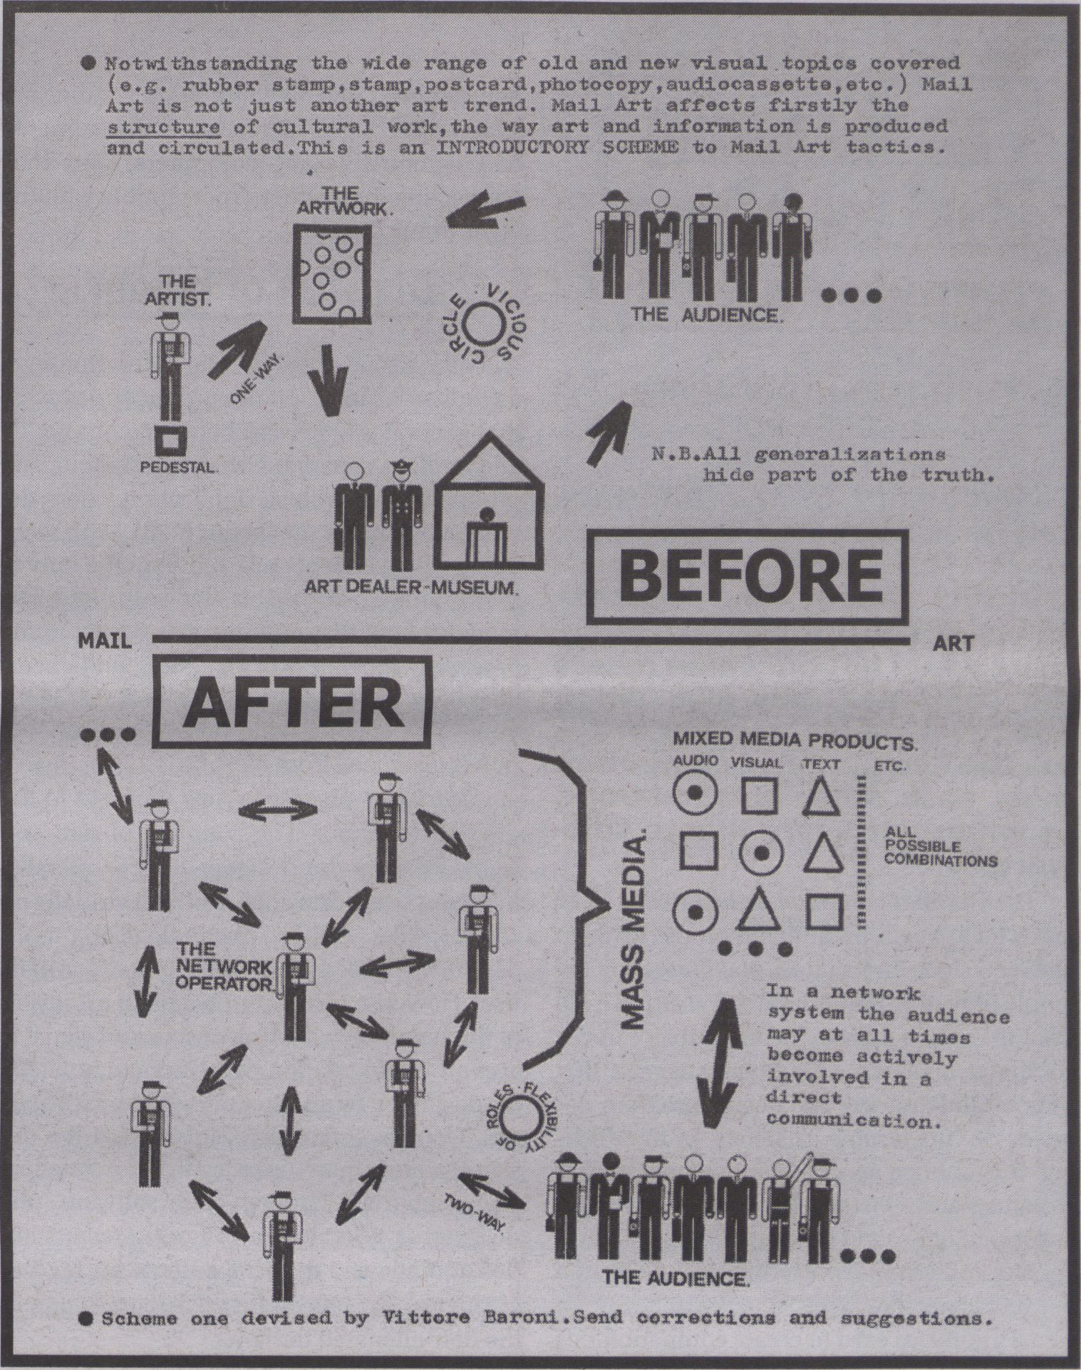
Vittore Baroni, "Real Corrispondence 6", 1981, excerpt (part of a series of homonym flyers)
I N T
I M P
By TATIANA BAZZICHELLI
Starting from the assump-
tion that the increasing com-
mercialisation of the contexts
of sharing and networking is
transforming the meaning of
art and participation, then how
do artists, activists and hack-
ers respond critically?
And if hacker and artistic practices are de-
veloping in the context of a deep transforma-
tion of the meaning of participation, often re-
flecting a precarious cultural and economical
configuration, what are the responsibilities
and the role of cultural institutions engaging
with art and digital technologies towards a
critical articulation of culture production?
In Berlin, hacker, activist and artistic prac-
tices are very much realised outside the realm
of artistic institutions. Some of those practices
are contributing to the transformation of the
economy and the cultural asset of the city, but
they are also becoming easy targets to be ex-
ploited by the market. However, this is not
only a local phenomenon: at this present tíme,
while financial markets are deeply influencing
the development of cultural production and,
more generally, our daily life flexibility, direct
participation and common engagement are
becoming pervasive business logics.
Analysing the topology and the effects of
artistic and hacktivist practices in decentral-
ised social networks implies a reflection on
power structures, business methodologies as
well as on the relationship between art and
economy. The analyses of these subjects im-
ply sharing methodologies whereby artists,
hackers, activists and researchers join togeth-
er to form practice-oriented contexts of reflec-
tion and provide feedback to both theory and
practice through an interdisciplinary, distrib-
uted and polyphonic approach. Artistic and
hacker practices are conceived both as a re-
source for producing cultural innovation, but
also as a strategic challenge to generate media
criticism - and act as a meta-reflection on ar-
tistic production in the framework of digital
culture and network economy.
resource:
What?
The resource for transmedial culture is a
new framework for transmediale festival relat-
ed projects that happen throughout the year
in the city of Berlin. The objective is to act as a
link between the cultural production of art
festivals and collaborative networks in the
field of art and technology, hacktivism and
politics.
resource:
Who?
The resource for transmedial culture aims
to work towards the creation of a shared
knowledge laboratory within transmediale,
and a project for local and trans-local distrib-
uted networks by organising events, work-
shops and talks involving artists, hackers, ac-
tivists, researchers and cultural producers
active in the city of Berlin and abroad. Its aim
is to involve communities that not only engage
direcdy with network technologies, but that
also critically reflect on decentralised and dis-
tributed strategies of networking, from hack-
ers and activists to feminist, queer, transgen-
der and porn communities.
resource:
Why?
Source codes are useful to modify a pro-
gram or understand how it works. Taking this
notion more broadly, the resource is a starting
point from which a distributed sharing pro-
cess, and a common executable (artistic) pro-
gram, is produced. The objective is develop a
networking distributed platform and an (exe-
cutable) meta reflection on the meaning and
the practices of networked art, hacking and
collaborative art production within the con-
text of an international art festival.
resource:
When/Where?
The launch of the resource takes place at
transmediale 2012 through different project
disseminations such as workshops, talks and
performances. The resource programme at
transmediale festival is distributed into five
different sub-themes: resource methods,
resource activism, resource networks, re-
source markets and resource sex. After trans-
mediale 2012, the resource will extend its ac-
tivity in collaboration with partners: CTM/
DISK, proposing a series of open events held
in the spring 2012; the Post-Media Lab of the
Leuphana University Liineberg and Kun-
straum Kreuzberg/Bethanien (Berlin), organ-
ising a public event in August 2012.
resource:
How?
The activity of networking is seen as re-
search method used to explore how collabora-
tive practices among communities of artists, ac-
tivists and hackers contribute to shape new
courses of action, tools and contents within
(and beyond) digital culture production. By
generating a set of questions and issues which
are addressed to local and translocal communi-
ties, the main idea is to develop mutual ex-
changes of methodologies and knowledge, as
well as project-space experiences, investigating
new ways of forming a cultural public, and pro-
ducing a meta reflection on strategies of collab-
orative actions.
■
I
lil
Edited by Christian Ulrik Andersen and Geoff Cox
(Digital Aesthetics Research Centre & Centre for
Digital Urban Living, Aarhus University)
Published by transmediale/reSource for transmedial
culture & Digital Aesthetics Research Centre.
Design by Manuel Bürger, Timm Haneke, Till Wiedeck
Print by Newspaper Club, www.newspaperclub.com
CC license 'Attribution-NonCommercial-ShareAlike'
unless otherwise stated.
ISBN 87-91810-20-5
EAN 9788791810206
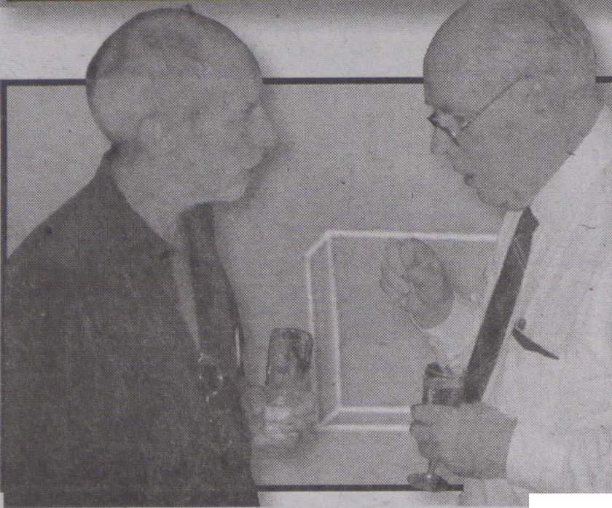Is the 'interface
an alienating
ideal for human/
computer activity?
INTERFACES
"How can new scientific and technological paradigms redefine the horizon of
cial possibilities and open new concatenations that can reduce exploitation and
enhance human autonomy?” - Scepsi - European School of Social Imagination
Frieder Nake and Ivan Sutherland in conversation (Photo CC: Christian Graf)
COMPETING
COMPATIBILITIES
just have to click ‘accept! Participation is com-
pulsory, but defined by nonnegotiable terms
and conditions.
This expresses a possible alienation from
the interface. The human-computer interface
that addresses the juxtaposition and incom-
patibility between the work of the computer
(processing signals) and the work of the oper-
ator (processing signs), is designed as if there
legally and perceptually is only one way to
make the two compatible. In this, the user po-
tentially becomes alienated to the process of
compatibility. This calls for new visions of al-
ternative compatibilities, and an interface
criticism that is able to analytically and con-
ceptually deal with the construction of com-
patibility.
By CHRISTIAN ULRIK ANDERSEN
& S0REN POLD
Compatibility in the interface
can be constructed in different
ways. This forces us to think
critically about the mecha-
nisms of control that are exer-
cised when not only man meets
the computer, but also when
one level meets another with-
in the computer, computers
meet each other in a network,
or when hardware meets soft-
ware.
The German computer artist Frieder Nake
urges us to begin by thinking on the division
between signs and signals. Nake uses the ex-
ample of Ivan E. Sutherland’s Sketchpad from
1962 to explain a basic incompatibility in the
computer interface. Sutherland suggests that
a successful drawing and design program de-
pends on ‘the double existence’ of the draw-
ing. It is at once an object in a complex data
structure, and a visually perceptible object on
a screen. Sutherland’s separation of data pro-
cessing and visual representation is a division
between machine-like signals and human
signs. Interfaces exist to create compatibilities
I
between sign and signal processes - they are
‘algorithmic signs! perceivable (by humans)
and computable (by computers) and thus
connecting the aesthetic/perceptible with the
algorithmic domain.
Division of labour
Nake also evokes Karl Marx' description of
an industrial and capitalist production process
that generates a division between commodity
and product, separating work from labour, and
production from life; a duplication where the
market outshines the labour (128). With tech-
nology, the worker is relieved from the duty of
performing a task, and his/her work is reduced
to controlling that nothing goes wrong in the
process. Though less of an effort, and hence a
liberation, this kind of monitoring is also alien-
ating. The crafting skills vanish, and produc-
tion is distanced from life.
Sketchpad suggests a new moment in the
division of labour. The coupling of sign and
signal enables the designer to draw parallel
lines, duplicate drawings, etc. with virtually no
effort. Like other technological tools,
Sketchpad exceeds the bodily limitations of its
user. However, apart from being an extension
of the hand, the coupling of sign and signal is
also an ‘augmentation of the human intellect’
(as described by another pioneer from the six-
ties, Douglas Engelbart). This makes the de-
signer a craftsman (once again) - an 'intellec-
tual labourer! Through the software, the
designer is liberated from boring technicali-
ties and allowed to focus entirely on his/her
creative skills: Life and work becomes one in
the non-alienated designer.
Consumer control
Have the aspirations of the avant-garde
(everyone can be an artist) come through with
software (=no more alienation)? To unveil this
all-encompassing cover-up, one must focus
on the work of the interface, and analyse the
production of compatibility; the work of the
interface.
Compatibility between signs and signals
has for decades been conceptualised terms of
‘user friendliness! Today, in contemporary in-
terface culture, the interface has become a
model for consumer control. Within the com-
puter game industry for instance, gamers can
produce their own interfaces to the game. In
fact, this kind of participatory innovation is
encouraged by the game producers - but only
as long as the alternative interface does not
threaten business. Game companies prose-
cute gamers who come up with their own in-
terface business models. This is evident in the
example of the WoWGlider, a programme that
automates the repetitive work-like actions of
game avatars to increase one’s level in the
game World ofWarcraft. Eventually, the gam-
er who invented the program was met (in his
house) by lawyers from the game producer.
Following, he was sentenced to pay a 6 mil-
lion. US$ fine (Boyer): Players have to work.
Alienation
In online game communities as well as
platforms for file distribution (Appstore, Xbox
Live, etc.), and in many other examples, the
relations between signs and signals are con-
structed as if there are no alternatives - you
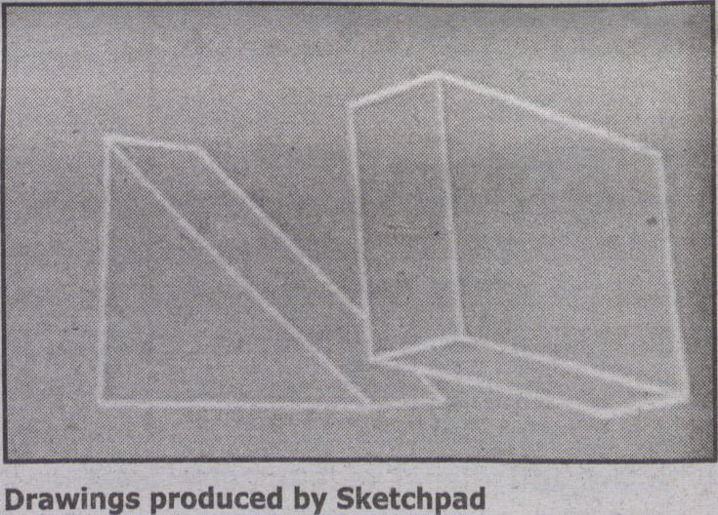
Works cited:
- Nake, Frieder. "Kalkulierte & kalkulierende Zeichen.
Der Computer als instrumentales Medium." Vom Sinn
multipler Welt. Medien und Kunst. Eds. Demuth, Volker
and Robin Wagner. Würzburg: Könighausen &
Neumann, 2000. 121-140. Print.
- Boyer, Brandon. "Blizzard, Vivendi File Suit Against
WoW Bot Creator."
Gamasutra. February 22, 2007. Web. 20 Dec. 2011.
<http://www.gamasutra.com/php-bin/newsjndex.
php?story=12848>
Feedback Machines between
Computation and Control
ipingluonq
By LASSE SCHERFFIG
What do we do with
the computers that
surround us? And
what do we see on
their screens? Three
games help under-
stand the nature of
'interaction' as the
interplay of control-
ling and being con-
trolled by symbolic
representations
that are created in
action.
In 1968, Valie Export pre-
sented the installation ping
pong, a film to be played us-
ing a paddle and a ball. At the
same time, Ralf Bear con-
structed the Brown Box - the
prototype of a game that later
would be named Pong, fea-
turing similar game play: hit-
ting a bright spot on screen
with an, albeit virtual, paddle.
These two ping pong games
strangely reflect a third 'game,'
set up by Norbert Wiener in
1941: an experimental system
in which a person had to hit a
white spot of light projected
onto a wall using a second
spot, controlled by a joystick.
ping pong was meant as a
critique on the dispositif of
cinema but also anticipated
the format of interactive me-
dia art installations to come.
As such a transitory piece be-
tween old and new media, its
criticism of cinema as an ap-
paratus of control anticipated
much of the later critique of
interactive media that speaks
of "conditioning of a viewer
Pong is an early
specimen of a new
type of machine
uniting the Universal
Turing Machine with
the control principle
of feedback: the
Feedback Machine.
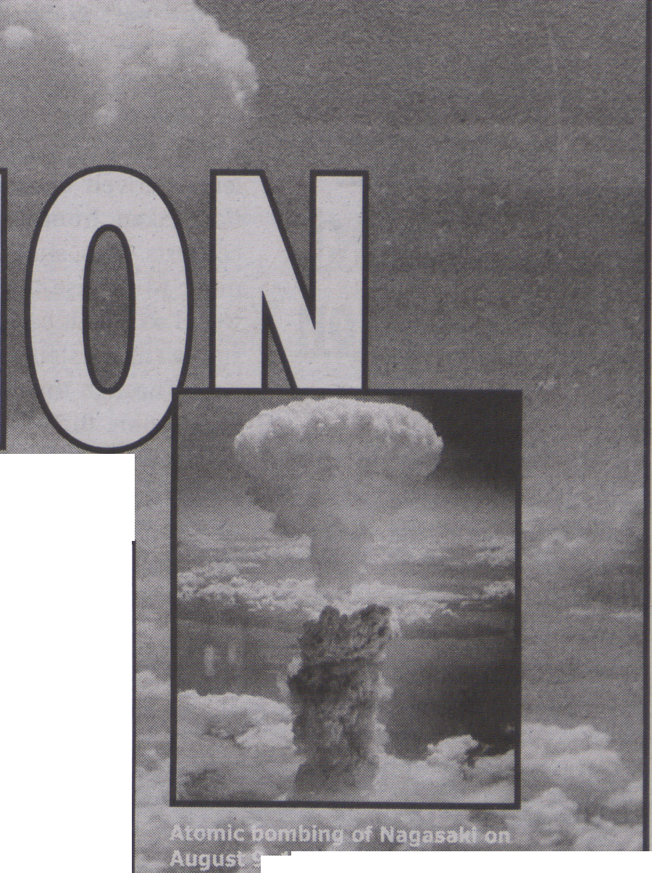By TERO KARPPI
Any network connecting people, devices or systems meets its adversary in disconnection.
. 945: The picture was
Slfi one of the B-29
Superfortresses used in the attack.
(National Archives image
(208-N-43888))
G
enerally disconnection means a
break or rupture in communica-
tion. It, however, is not exclusively a
negative concept. On the contrary, when dis-
connection is turned against connection new
modes of communication emerge. In the fol-
lowing it is argued that the myth of the mili-
tary origins of the Internet can be understood
from this basis.
As it is well known the foundations of the
internet were created during the Cold War era
in the shadows of the potential nuclear war. Es-
pecially the writings of Paul Baran, one of the
developers of a distributed network and pack-
et-switching, make the connection between
the threat of nuclear war and the emergence of
a particular network model imminent. For ex-
ample, “On Distributed Communications
Networks" (1-9) a famous report by Baran,
"roots the Internet in the darkness of the Cold
War and emphasises surviving (or fighting)
nuclear war rather than sharing computer re-
sources” (Rosenzweig 1533).
According to Baran, in the political climate
of the 1960s, the "most dangerous situation
was created by the lack of a survivable com-
munication system” ("An Interview with Paul
Baran” 10). Nuclear weapons were scattered
around the nation in order to survive a cen-
tralised attack. However, to remain operable
these weapons were also dependable on a
functioning network of command and control
communications. With this in mind Baran
outlined fundamentals for a communications
network that would survive in the event of nu-
clear strike and be operative in order to strike
back: "The basic network configuration was
simple. Avoid central node. Build a distribut-
ed network of nodes, each connected to its
neighbor. How much redundancy of connec-
tions are needed for survivability?” (17)
While a typical analysis would suggest that
disconnection is contingent upon a network,
taking place accidently when some nodes of
the network cease to communicate with each
other due natural disasters, hardware failures,
or human actions such as cyber attacks,
Baran’s texts suggest that there is also another
way of conceiving accidents - through discon-
nection. Instead of thinking accidents to be
surprising failures that unexpectedly befall
the machine, it is possible to see that ma-
chines are produced and molded against their
typical accidents, as argued by Paul Virilio
(211-212). For example, cars are designed to
avoid and survive road accidents, ships are
designed to avoid from sinking, and a network
is designed to avoid disconnection.
Notably, it is not disconnection as some-
thing already actualised that becomes a cause
for the internet to emerge. Rather it is the
threat of disconnection as a potentiality, or
quasi-cause that sets the conditions of emer-
gence (Massumi 35). It is the threat of discon-
nection coming lfom the outside that forces
Baran to develop a new method of communi-
cation and control. "Something in the world
forces us to think," as Deleuze puts it (176). We
see this active in Baran's case. It forces him to
move away from familiar concepts towards
new configurations of material reality.
Disconnection
The threat of disconnection, in Baran’s
thought, leads to a model of a distributed net-
work that has been called as one of the most
important technological diagrams of our cen-
tury. (Galloway 11-12) Simultaneously it is
a push towards digital technology, new at
the time. Baran’s system chops information
into digital packets and reconstructs it in the
target location. This was highly sufficient
for what was described as "minimal essential
communications,” an euphemism for the
President to be able to send a command:
"You are authorized to fire your weapons” or
"Hold your fire” (“An Interview with Paul
Baran” 14).
Moreover, the threat of disconnection ex-
plains why the distributed network is made to
grow and adapt machines and technologies
within its system; since threat does not have
its own operable logic, it adopts the idea of the
doctrine of Mutual Assured Destruction.
While MAD presupposes a total destruction
that will deterritorialise the whole planet, dis-
tributed network reterritorialises this threat in
advance to a global low-cost network that will
survive the destruction.
In conclusion, the threat of disconnection
can be seen a force behind the developments
of our current network culture. At any rate, it
helps us to understand the myth of the Inter-
net being a product of nuclear war, and
illustrates its consequences that are not
merely political but also technological and
material, tjkarp@utu.fi
RETHINKING
TUÏ? TTVT'T'UUTVTUT
lilJC JL1\I lÜKTMlil
Works cited:
- Baran, Paul. "An Interview with Paul
Baran". Interview by Judy O'Neill. Oral
History. Charles Babbage Institute, Center
for the History of Information Processing,
University of Minnesota, Minneapolis, March
5, 1990. Web. Dec. 22. 2011. <http://
conservancy.umn.edu/handle/107101>
- —. "On Distributed Communications
Networks." IEEE Transactions on
Communications Systems (1964): 1-9.
Print.
- Deleuze, Gilles. Difference and Repetition.
London, New York: Continuum, 2004. Print.
- Galloway, Alexander R. Protocol, How
Control Exists after Decentrailzation.
Cambridge, London: The MIT Press, 2004.
Print.
- Massumi, Brian. "Fear (The Spectrum
Said).” positions 13.1 (2005): 31-48. Print.
- Rosenzweig, Roy. "Wizards, Bureaucrats,
Warriors, and Hackers: Writing the History
of the Internet." The Amaerican Historical
Review 103.5 (1998): 1530-1552. Print.
- Virilio, Paul. "The Primal Accident." The
Politics of Everyday Fear. Ed. Brian
Massumi. Minneapolis: University of
Minnesota Press, 1993. 211-219. Print.

through a work” (Daniels
176), behaviorism and illu-
sion.
Unlike ping pong, the
Brown Box technologically
couples human action to vis-
ual representation, yielding a
system in the tradition of the
feedback systems from the
era of "classical control theo-
ry” (Bennett). But commer-
cial success did not arrive un-
til this analog system was
re-created as a digital com-
puter and named Pong. This
shift changed the man-ma-
chine coupling from direct,
causal and indexical, to indi-
rect, conventional and sym-
bolic - or illusionary.
Wiener's experiment also
is part of the era of classical
control. It was built to test the
famous anti-aircraft predic-
tor: a machine to predict the
movement of an airplane. Its
core was a feedback mecha-
nism, constantly adjusting
predicted to observed behav-
iour. Although it ultimately
failed, it later served as a
powerful narrative backing
the idea of Cybernetics as a
universal science of feedback
(Scherffig). But who is con-
trolling the course of an air-
plane under fire: the pilot
evading fire or the gun opera-
tor producing it? Generally,
the closed loops of feedback
yield 'circular causality!
Causes are distributed and
effects only emerge as stable
patterns within the behav-
iour of the whole, rendering
the very idea of agency prob-
lematic.
Feedback
Machine
In Pong, these two devel-
opments converge: an analog
feedback system is translat-
ed into the digital domain
yielding a paradigmatic case
of'interaction! Pong hence is
an early specimen of a new
type of machine uniting the
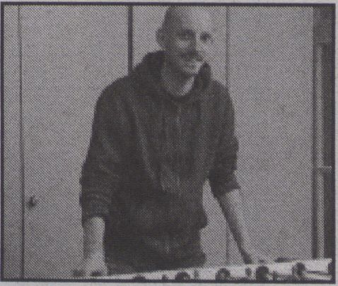
Lasse Scherffig

Universal Turing Machine
with the control principle of
feedback: the Feedback
Machine.
The convergence of these
traditions implies their re-
spective problems. As digital
machines, Feedback
Machines use symbolic, illu-
sionary representations. As
feedback systems, they exhib-
it circular causality. They thus
are not simply mechanisms
controlling behaviour but
equally are controlled by it.
The stable patterns emerging
in feedback systems by Heinz
von Foerster have been de-
scribed as ‘objects! The ob-
jects at the interface hence
may not solely be described
as symbolic significations
specifying behaviour, they
also are enacted through be-
ing acted upon - within the
dynamics of computation and
control, and oscillating be-
tween conditioning and free-
dom. Ischerff@khm.de
Works cited:
- Bennett, Stuart."A brief
history of automatic control.”
IEEE Control Systems 16.3
(1996): 17-25. Print.
- Daniels, Dieter. "Strategies of
Interactivity." Media Art
Interaction - The 1980s and
1990s in Germany. Ed. Rudolf
Frieling and Dieter Daniels.
Wien/New York: Springer, 2000.
170-199. Print.
- Scherffig, Lasse. "The human’
being as a servo. Von feedback
control zur Kybernetik."
Informatik 2009 - im Fokus das
Leben. Ed. Stefan Fischer, Erik
Maehle and Rüdiger Reischuk.
Bielefeld: Gl, 2009. 766-776.
Print.
- von Foerster, Heinz.
"Gegenstände: greifbare
Symbole für Eigen-Verhalten."
Wissen und Gewissen, Versuch
einer Brücke. Ed. Siegfried J.
Schmidt. Frankfurt a. M.:
Suhrkamp, 1993. Print.
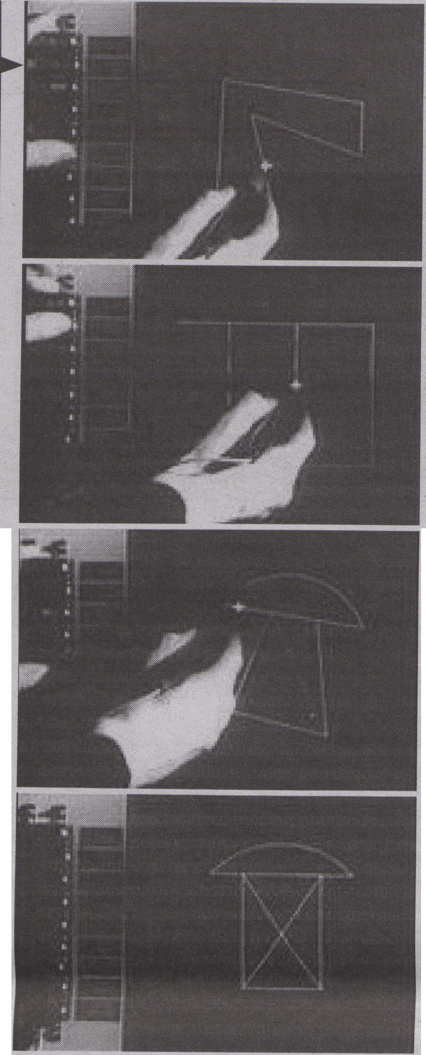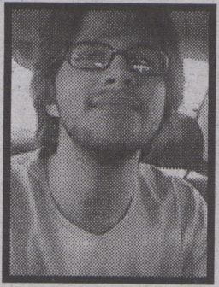
Ivan Sutherland demonstrating Sketchpad . Rationale
for fair use: No free alternative is known to exist.
The author and the program pictured both have
historical importance. Image is a 50% reduction of 4
thumbnails of a low resolution video.
Source: http://www.archive.org/movies/thumbnails.
php?identifier=AlanKeyD1987
Alan Smithee, 50 min. of porn, 2011, Alu-Dibond,
23.6" X 29.5", ed. of 5/1 AP
Blind
Optics
By GABRIEL MENOTTI
How is cinema redefined in
the course of ongoing tech-
nological developments? At
first, one might think that the
incorporation of digital com-
puters would radically
change the norms of movie
production, distribution and
exhibition. Nevertheless,-the
exact opposite seems to be
happening: while these prac-
tices retain their mediatic
specificity, it is technology
that changes its nature, as it
becomes localised within the
cinematographic circuit. For
instance, after it has been in-
stalled in a projection booth,
a computer should be oper-
ated only in function of movie
screenings. Thus, multiple
characteristics of the ma-
chine are suppressed in order
to comply with its use as an
apparatus for film exhibition.
This rationalisation of tech-
nique within cinema goes un-
noticed precisely because the
medium entails the parame-
ters of its own evaluation.
Matthew Kirschenbaum calls
this a medial ideology: one
that makes us approach cine-
matographic devices not in
their own terms, but accord-
ing to the logic of representa-
tion that supposedly charac-
terises the medium. This
logic sets the conditions for
an element to be cinemato-
graphic - for example, by es-
tablishing how many pixels
an image should have in or-
der to attain the resolution
proper to the medium. Such
epistemological bias filters
most possibilities of new
technologies out of cinema
right from the outset.
Optical Media
But if we are allowed to
ask whether computers can
produce images as clear as
film, why can’t we expect cin-
ema to be as interactive as a
Web browser? To further
probe into the relation be-
tween media and technique,
it seems necessary to avoid
the medium's own parame-
ters. Taking a step in this di-
rection, we might adopt Frie-
drich Kittler’s idea of optical
media instead - a classifica-
tion based not on the cogni-
tive effects of cinema, but
rather on the operational
principles of its apparatus.
This attention to optics can
be useful to disclose mecha-
nisms of figurative represen-
tation. Paul Virilio has previ-
ously used it to distinguish
between the ways different
media technologies organise
space and time. However,
such an approach also risks
obfuscating even more the
artificiality of technique. To
analyse the apparatus as
purely optical is to overlook
their physical constitution,
which is also mechanical and
chemical, electromagnetic
and computational.
Blind Optics
In order to bring these
particularities of technology
to the surface, we could bor-
row a strategy that some art-
ists have employed with aes-
thetic ends: that of
circumventing disrupting or
altogether denying the cam-
era’s eye. A long tradition of
video art and experimental
film, recendy joined by prac-
tices such as generative pro-
gramming, presents visuals
that are not conveyed by clear
lenses; visuals that mostiy re-
sult from celluloid stock, elec-
tric circuits and digital codifi-
cation. Looking at these
pieces, we are confronted
with a sort of blind optics: im-
ages produced not by the
means of abstracting the
world, but through the ab-
straction of apparatuses
themselves.
Pushing forward the hori-
zon of a potentially invisible
cinema, blind optics exposes
the normally overlooked ma-
teriality of the medium, mak-
ing it easier to appreciate
technological development
and grasp the suppressed dif-
ferences between physical
supports. In other words, in-
terrupting the gaze becomes
a way to see more clearly.
From this perspective, the
underpinnings of cinema ap-
pear not as a neutral channel
throughout which autono-
mous images flow, but rather
as a complex entanglement of
processes of inscription and
transmission, continuously
creating such images.
Works cited:
- Kirschenbaum, Matthew.
Mechanisms: New Media and
Forensic Imagination. Cambridge:
MIT, 2009. Print
- Kittler, Friedrich. Optical Media.
UK: Polity, 2010. Print.
- Virilio, Paul. "Big Optics." On
Justifying The Hypothetical Nature
Of Art And The Non-Identicality
Within The Object World. Ed. Robert
Fleck. Köln: Walther Koenig
bookshop, 1992. 82-93. Print. .
Image
Objects;
Computer
Graphics
and Object
Orientation
By JACOB GABOURY
The term ‘computer graphics’
was first coined in 1960 by
William Fetter, an art director
working for Boeing. In 1964,
Fetter was the first person to
model the human figure us-
ing a computer. ‘Boeing Man,'
as he has come to be known,
was intended to model the
human form and provide
adaptable representations for
use in ergonomic simula-
tions, in other words, to cre-
ate a digital model of a physi-
cal object in order to simulate
real-world interaction. One
year prior, in 1963, Ivan
Sutherland defended his PhD
at MIT. Titled Sketchpad: A
Man-Machine Graphical
Communication System, it
outlined the first complete
graphical user interface that
allowed the user to create and
manipulate lines and shapes
directiy on the screen of the
computer, organising them
into ‘objects’ that could later
be recalled and ‘instances’
that could be manipulated en
masse. Between 1962 and
1967 Ole-Johan Dahl and
Kristen Nygaard developed
the Simula programming lan-
guage at the Norwegian Com-
puting Centre in Oslo. As its
name implies, Simula was de-
veloped for simulating dis-
crete event systems, and first
introduced concepts such as
objects, classes, subclasses, vir-
tual methods, coroutines, dis-
crete event simulation, and
garbage collection to pro-
gramming languages. It
is considered the first object-
oriented programming lan-
guage.
Simulation
Beginning in the 1960s
there is a shift in the field of
computer science from com-
putation as procedural, end-
driven, linear calculation, to-
ward a kind of computation
through simulation - of simu-
lating a world comprised of
self-contained, constructed
objects that are capable of
discrete forms of interaction.
These objects are nameable,
actionable, visualisable, and
are meant to replicate real
world engagement with a
knowable object world. While
in the past computing had
largely been concerned with
the procedural computation
of information about the
world, and in solving prob-
lems derived from informa-
tion taken from real world
contexts, this shift marks a
move to digitise the physical
world so that it can be made
subject to a system of simula-
tion. Through this process of
digitisation, the world is lim-
ited, made discrete and
knowable, and can be used to
model virtual scenarios that
may be translated back into
the physical world.
Object-oriented
Over the last fifty years
this simulation-logic has
come to dominate the way we
produce and engage with the
objects that make up our
world. In the same way com-
puter graphics are used to
model the function of real-
world objects, object-orienta-
tion mimics the physical and
linguistic object-relations of
the human world. In doing so
it interfaces the human with
the nonhuman, as through
interface “users are made to
inhabit the space and medi-
um of the other objects and
are treated as objects them-
selves’’ (Alt 297). Users are
disciplined so that they may
be interfaced with the object-
network. And yet these ob-
ject-oriented systems also
produce nonhuman forms of
affective engagement, in that
the object-actants shift and
adapt in response to an en-
gagement with the system
like a swarm. Much as objects
in a swarm are engaged in a
process of affective sensing
and adaptation, “software is...
a body of code being execut-
ed, existing through that tem-
poral unfolding in technolog-
ical and other milieus and
support (or afford) its exist-
ence’’ (Parikka 165-166). In
this way object-oriented sys-
tems are both structures of
highly networked control and
examples of a non-human
ontology that nonetheless
contain the human within it-
self, "a nonhuman that trav-
erses the human, that runs
through the human"
(Galloway and Thacker 141).
Works cited:
- Alt, Casey. "Objects of Our
Affection: How Object Orientation
Made Computers a Medium" in Media
Archaeology: Approaches,
Applications, and Implications.
Berkeley: University of California
Press, 2011. Print.
- Galloway, Alex, and Eugene
Thacker. The Exploit: A Theory of
Networks. Minneapolis: Univ. of
Minnesota Press,'2007. Print.
- Parikka, Jussi. Insect Media: An
Archaeology of Animals and
Technology. Minneapolis: Univ. of
Minnesota Press, 2010. Print.
- Sutherland, Ivan. Sketchpad: A
Man-Machine Graphical
Communication System. New York:
Garland Publishers, 1980. Print.
- 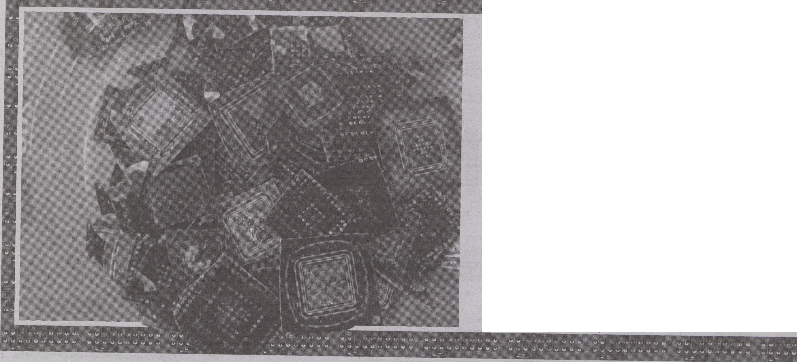Ernst, Wolfgang. "Distory. 100 Years of Electron Tubes, Media-Archaeologically Interpreted
vis-a-vis 100 Years of Radio." Re-inventing Radio. Aspects of Radio as Art. Eds. Heidi
Grundmann et al. Frankfurt/M: Revolver, 2008. 415-430. Print.
Works cited:
- Bennett, Jane. Vibrant Matter: a political ecology of things. Durham, North
Carolina: Duke University Press, 2010. Print.
- S^{ub}'5' ^{Sean}' "^{ut>ic}i^{uitous} Media, Rare Earths - The environmental footprint of digital media
and what to do about it." Pervasive Media Lab, University of the West of Enqland 22 SeDt
2009. Lecture.
- Cuvelier, J. and T. Raeymaekers. "Supporting the War Economy in the DRC: European
Companies and the coltan trade." IPIS report. Jan. 2002. Web. 19. Dec 2011 <www
ipisresearch.be/download.php?id=197>
Gabrys, Jennifer. Digital Rubbish: A Natural History of Electronics. Ann Arbor: The University of
Michigan Press, 2011. Print
Zielinski, Siegfried. Deep Time of the Media. Trans. Gloria Custance. Cambridge MA’ The MIT
Press, 2006. Print.
Image from the Berlin Recrystallization-workshop (2011) by Howse, Kemp and
Jordan. The artistic workshop consisted of opening up abandoned computers to
extract minerals and a further repurposing of components. Image used with
permission.
- Parikka, Jussi. Medianatures: Materiality of Information Technology and Electronic Waste
Open Humanities Press, 2011. Web. 19. Dec. 2011. <http://livingbooksaboutlife.org/>
Pinto, V.N. "E-waste Hazard: The Impending Challenge", Indian Journal of Occupational and
Environmental Medicine, August 12.2 (2008): 65-70. Print.
- Sterne, Jonathan. "The Times of Communication History," Connections: The Future of Media
Studies. University of Virginia, 4 April 2009. Lecture
- Yoshida, Fumikazu. "High-Tech Pollution." Economic Journal of Hokkaido University 23 (1994V
161-188. Print. ''

MATERIAL

* By JUSSI PARIKKA
Forget smooth, start with
the rough. What if we
assume a fundamental
incompatibility?
What if we assume that by their nature,
things don’t fit in? Not with the world, not
with themselves; incompatibility is not a con-
tingency or if it is, it is the fundamental con-
tingency of the world from thoughts to things,
ideas to devices. Furthermore, incompatibili-
ty is not only a cognitive category, or an object
that just does not fit in - the anomalous, the
incongruous, the thingy without even a prop-
er name.
More closely,
what is material
incompatibility?
This could be the plug that does not fit, or
the software that does not load, the installa-
tion that works only to halfway of the process.
Whereas such experiences characterise digital
media culture as a culture of standardised and
constant frustration, material incompatibility
can be seen characteristic of discarded and
obsolescent technology as well. Not only a
field for media archaeologists dedicated to ex-
cavating archives and ideas of outside-the-
mainstream, this extended-media-archaeolo-
gy is more like media garbology: it tracks the
material in/compatibilities of components,
chemicals and such raw, even bad materiality
with our lungs, skin, the soil and other organic
inscription surfaces.
What kind of
materiality are we talking
about then?
Is it the material that we know from a cer-
tain brand of German media theory, often for
the Anglo-American audience attached to the
name of Friedrich Kittler only? The materiality
that starts reading media devices from their
scientific and engineering roots, in order to
claim that the frustrations at the entertain-
ment interface are only an after effect of a
much longer military-scientific genealogy?
That media studies starts from physics and
communications engineering, from war and
scientific management theories than it does
from the audience or representations, from
content or narratives.
Or another kind of a
materiality?
What if we take it even more literally and
start talking of “plasma reactions and ion im-
plantation” (Yoshida 105) - as in processes of
semiconductor fabrication, as relevant to arts
and humanities perspectives that have to en-
tangle with science and technology?
Hence, let’s draft an alternative list of me-
dia studies objects and components which are
studied from an e-waste management per-
spective: "metal, motor/compressor, cooling,
plastic, insulation, glass, LCD, rubber, wiring/
electrical, concrete, transformer, magnetron,
textile, circuit board, fluorescent lamp, incan-
descent lamp, heating element, thermostat,
brominated flamed retardant (BFR)-contain-
ing plastic, batteries, CFC/HCFC/HFC/HC,
external electric cables, refractory ceramic fib-
ers, radioactive substances and electrolyte ca-
pacitors (over L/D 25 mm);” and which them-
selves are constituted from a range of materials
- plastics, wood, plywood, copper, aluminum,
silver, gold, palladium, lead, mercury, arsenic,
cadmium, selenium, hexavalent chromium
and flame retardants (Pinto; cf. Cubitt).
So why
call this incompatible
materiality?
Things work, at times, don’t they? This is
where the wider ecological framework kicks
in. Materials, even natural ones, are not auto-
matically compatible with the world in the
sense of empowerment. The various trajecto-
ries of components are crystallised into media
technologies, and incorporate in themselves
mini-archaeologies of media that is more
grey, more transversal than a focus on com-
plete devices or use practices. For instance,
the history of a mineral, or of batteries; of
transformers, diodes or for that matter elec-
tron tubes (Ernst). As such, this kind of a deep
time of media (Zielinski) is what can go to a
long duration, something called by Jonathan
Sterne as the neglected approx. 39,400 years of
human media history; or even more radically,
the thousands, even millions, billions years of
history of minerals now being excavated.
Think about the perverse complex ecology
of it all: a specific design solution concerning a
screen or computer component has an effect
on it becoming-obsolescent sooner than 'nec-
essary' - of course, not without the product it-
self being embedded in the capitalist dis-
course emphasising newness as the affective
atmosphere of consumerism. This is followed
by a quick turn to obsolescence. Dealing with
obsolete devices is often called ‘recycling,’ but
is actually waste-trade, where old electronic
media are shipped, e.g. to India to be disman-
tled by means of some very rudimentary - and
dangerous - processes that affect the lungs
and nervous systems of the poor workers.
(Gabrys) Nor should we forget where the min-
erals for the components come from - such as
coltan, which is mined in Congo and from
which refined tantalum powder is obtained.
Tantalum powder is extremely heat-resistant
and hence ideal for manufacturing certain
parts in mobile phones, Playstation game con-
soles and so forth. The mineral allows us to
consume mediatic content but has at the same
time its own genealogies of matter and poli-
tics, for instance in bloody wars in the Demo-
cratic Republic of Congo, where a range of Eu-
ropean mining compames have had their own
dubious part to play, including funding the
war efforts in order to secure the extraction of
the mineral (Cuvelier and Raeymaekers).
So the question is: Could we account for not
only thing-power, as Jane Bennett calls it in her
focus on the agency of the non-human, and
even non-living, but also thing-depowering?
That already on the level of material agency we
have disagreements, dissonances, and relations
that cause diminishment of powers, as with the
environmental effects of the materials leaking
out to the soil, riverside dumping, burning -
without forgetting the organic: for instance
lungs and brains as the inscription surfaces for
the chemicals released in such processes.
So what if we consider media archaeology
as media garbology, of digging through the
rubbish and the genealogies of waste in order
to think fundamental in/compabilities that ex-
tend from aesthetics to political economy, from
lungs and brains, and more specifically neuro-
logical disorders, to supply and material chains,
product recycling, use of materials and the ma-
terial, yet in/compatible conditions of media
for our eyes and ears? (See Parikka) For a deep
time, one does not have to go back, but look at
the devices which transport various times for
us, to us, and beyond us.
jussi.parikkal976@gmail.com
PSYCHOPATH IA
AGAINST
FOR
MEDIALIS
NORMAL
SCHIZOPHRENIA
A MINIMAL MANIFESTO

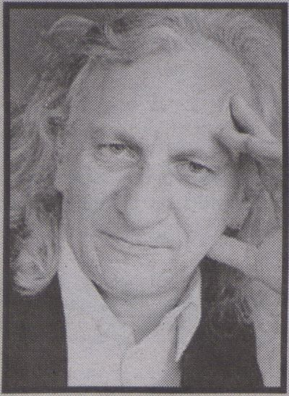
By SIEGFRIED ZIELINSKI


Arts and theories that possess an affinity
to advanced thinking and advanced technol-
ogies demand maximum moveabiiity. This
moveability is not the same as the mobility
that is demanded of us day in, day out, and
proclaimed as an inherent necessity. Move-
ability does not offer itself for exploitation
and, in turn, it does not exploit. Our move-
ability gets by with a minimum of posses-
sions albeit carefully selected ones. It culti-
vates a life of wandering and attempts to
orient itself in the world without prescribed
disciplines. It is in the best sense undisci-
plined. It cannot be disciplined. This is a plea
for theory and practice situated in the in-be-
tween of disciplines, between staked-out ter-
ritories, between the dispositifs of power,
which Michel Foucault identified above all
as sexuality, truth, and knowledge. To this we
can add the network.
2.
And this is a mini-discourse on in/com-
patibility: Globalisation is a concept that is
profoundly bound up with economic, cultur-
al, and political power. The word originates
from a vocabulary that has nothing to do
with art. Our justifiable concern is to com-
municate our work on a worldwide basis,
and to carry this through without falling into
the trap of such (pre)determinations, there-
fore we need other concepts and other ori-
entations. Poets and philosophers, like Éd-
ouard Glissant from Martinique, may be able
to provide them. Glissant operates with the
concept of mondialité. Jacques Derrida also
regarded this concept very highly. With
mondialité both thinkers describe a quality
of worldwide relationships, which are not
defined in terms of their rational purposive-
ness, but as the “poetry of relations" Art and
theory that are created with the aid of ad-
vanced ideas and media could in this sense
become “mondiale” theory and practice.
3.
In case of doubt and with the option of
choosing alternatives, a risky decision in fa-
vour of the possible is more appropriate than
a pragmatic decision in favour of reality.
Modern science, technology, and art have
expended their energies for over 400 years
on making the invisible visible and the im-
perceptible perceptible. Through translating
nature into binary data and rendering social
relations, including their fine structures, sys-
tematic, this process is now far advanced.
The more that the technological world is
programmed to make the impossible possi-
ble — that means, to make it function — it is
worthwhile to undertake the attempt to con-
front the possible with its own impossibili-
ties. This would bean alternative programme
to establishing cybernetics as a cultural and
social technology.


In the most advanced societies we live in
a permanent testing situation. Our environ-
ment is set up as a test department, which
was also the name of a great band (Test.
Dept.) in the 1980s from Glasgow in Scot-
land. Ideas and concepts that have barely
seen the light of day are subjected to trials to
test their viability on the market. By contrast,
in elaborate artistic processes the experi-
ment takes precedence over the test. As a
matter of principle experiments are free and
failure is always possible. Tests, on the other
hand, are tied to clearly defined purposes
and pre-ordained objectives that have to be
met. Tests serve to create products. In a test,
input and expected output are connected as
closely as possible.
5.
In the early modern era the attraction of
the alchemist’s laboratory was not primarily
to turn base metals into shining gold. Rather,
the fascination was that they were places
where it was possible to gather profound ex-
perience of active processes for changing
something less than perfect into something
more perfect. This process consisted mainly
of research. And the transformation of the
transformers was just as important as the
transformation of matter.
6.
Theory and practice of the arts that are
realised by media, amongst other things,
should not waste their energy on renovating
and restoring the world, but rather on the
never-ending experiment, which is never in
vain, to create a different world to the one
that exists. Because the media-based arts are
all time-based — that is, arts realised in a
space-time continuum — one thing is of
prime importance: to give back to those who
are supposed to look
The enormous amount of effort and en-
ergy, which is required to occupy the centre
of technological and cultural power, is not
worth it. Movements at the periphery have
greater freedom, give more enjoyment, and
hold more surprises in store. Such move-
ments do not preclude the occasional excur-
sion through the centre to reach other places
on the periphery. On the contrary: living per-
manently on the periphery is only to be rec-
ommended if one knows the centre's special
qualities and if one has an idea of how it
works. Only then can one enjoy the move-
ments at the periphery.
8.
In more ways than one dual identities at
very least are a basic requirement for activ-
ists on the terrain of the arts, the apparatus-
es, and the theories associated with them. In
economic terms this means to master the
tactics of the guerrilla, and to know how the
businessman thinks and acts (Pesoa). For
those who have to deal with complex equip-
ment it is not enough to be a poet and a
thinker. In the long term they will not be able
to get by without experience of adapting and
directing.
9.
Imagination and mathematics have nev-
er been irreconcilable opposites and will not
be so in the future. One can use them as two
different, complementary possibilities of un-
derstanding, analysing, or constructing the
world. The highest levels of pure mathemat-
ics can anyway only be attained via the im-
agination. Vice versa, imagination does well
not to discard computing and calculating
needlessly. There is no place for soft options
in the theory and practice of arts that are re-
alised through media.
io.
To produce exciting and inspirational
things and processes using devices one does
not necessarily have to be an engineer or a
programmer. It is, however, a great advan-
tage to know how engineers and program-
mers think and work. Without respect for the
work and working methods of the others,
complex projects are not possible.


For artists who have taken the decision to
engage rigorously with advanced technolo-
gy, it is not sufficient to be merely an opera-
tor or a magician. An experimental approach
to the world demands acts of intervention as
well as actors who are prepared to follow a
hands-on approach. The best is: magical op-
erator or operative magician. It is high time to
cease regarding as an antagonism what Wal-
ter Benjamin formulated over seventy years
ago for “The Work of Art in the Age of Its Me-
chanical Reproduction” for art processes in
the age of their limitless simulability.


The social and political macrocosm, just
like the microcosm of the individual brain, is
determined by a high tension, which time
and again threatens to rend the one or the
other. One does not have to be a psychiatrist
or psychoanalyst to engage with the theory
and practice of art generated by advanced
ideas and technologies. However, it is good
to know in what ways they act within the
field of tension constrained by systeqis of
censorship and the open regions dedicated
to the imagination. This is one of the reasons
why the psychiatrist and philosopher Hin-
derk Emrich has become one of my most im-
portant teachers.


The dream is the most powerful mental
machine that we cannot regulate but from
which we can profit enormously. Cultivation
of one’s own dreams is just as important as
constant practice of organising everyday life.
Care of others’ dreams we should leave to
others. The act of interpreting dreams and
the act of controlling dreams are closely re-
lated. That is the reason why we mistrust
people who want to know what we have
dreamed in order to interpret it.
14.
Art produced by advanced ideas and
technologies does not necessarily have to in-
crease the mysteriousness of the world. But
it also does not necessarily have to increase
the amount of what is obvious or customary.
There is quite enough of this already, with-
out artists and theorists contributing more.
15.
The difficult balancing act for the visual
arts is to enable expression of the invisible
using the resources of the visible. This ap-
plies similarly to the acoustic world and the
world of poetry: to make what is tonally not
imaginable accessible to hearing, and to for-
mulate what is not expressible in language in
a formal arrangement that possesses the
greatest degree of freedom. The most impor-
tant task is to sensibilise, or maintain peo-
ple’s sensibility, for the Other, that which is
not identical to us, that which is as a princi-
ple and in its essence alien, utilising the
means and instruments of aesthetics. This
Street Intervention (21.02.2011),
project by Gordan Savicic, and Danja Vasiliev, that proposes
Operating Systems. Available at http://120buntu.com/
task of art will not change regardless of what
media we use to express ourselves.
(In memoriam Dietmar Kamper, who died
ten years ago.)
16.
18.
When the various levels of artificial reali-
ty (analogue instruments, recording devices,
computers, programs, digital tools) are
mixed together so closely in aesthetic pro-
ductions that they are indistinguishable, the
necessity of signalising the technical struc-
ture of the various levels — as the classic
avant-garde did — recedes into the back-
ground. At last all of the design parameters
can be brought together in a relationship
that plays out in freedom.
To be permanently connected and per-
petually wired rapidly tires the mind and the
body. (My feet are so tired, my brain is so
wired, sang Bob Dylan in "Love Sick’!) This
state is comparable to a prolonged artificial
paradise, the stretching of time that only
drugs can induce but machines can simu-
late. The Long Now is an obscene project that
was developed by engineers and program-
mers who want to play God.
single lifetime we have to learn to exist on-
line and be offline. If we don’t succeed in
this, we shall become mere appendages of
the world that we have created, merely its
technical functions. We should not allow cy-
bernetics, the science of optimal control and
predictability, this triumph.
22.
20.
The Internet is one of the non-locations
where physical and mental being dissipates
itself. The subjects, however strong or weak
they are conceived to be, should not give up
their willingness to squander gratuitously.
However, it is time to think about who profits
by this squandering.
17.
19.
Perpetually dancing on plateaus that are
above volcanoes misleads people into pro-
fessional dilettantism and, currently, to ven-
eration of the impassionate amateur as the
guiding model of aesthetic action. The cour-
age to ascend vertical heights helps such
people to avoid slipping on the seductively
smooth plateaus. However, we need both of
these movements, the vertical and the hori-
zontal — as well as an elegant finish to the
jump off the cross-formed by these two lines.
To avoid an existence that j.s caught up
too much within time and is therefore para-
noid, and to avoid being too little within time
and therefore thinking one is at home on the
rings of Saturn in melancholy and bitterness,
it is helpful as a principle to cultivate the
conscious split. We work, organise, publish,
and amuse ourselves in networks. We rhap-
sodise, meditate, enjoy, believe, and trust in
autonomous, separate situations, each to
his/her own and sometimes with other indi-
viduals. This adds up to a balancing act: in a
As the young Wittgenstein wrote in
Tractatus logico philosophicus "The subject
doesn’t belong to the world, but it is a limit of
the world" (Proposition 5.632). This has not
changed. Not even after the sovereign indi-
vidual subject of the European modem age
was declared variously as dead. On the con-
trary, Only the boundaries have shifted. The
fact that such limits exist is not affected.
23.
21.
Like heaven and hell, the Internet has no
location. However, body and mind can only
be in one place at a time. To militate against
the sacralisation of the networks it is useful
to develop a profane relationship to them.
This can only be done from somewhere lo-
cated outside of them.
The greatest impossibility that one can
work on at the moment is the relations of in-
dividuals with each other and, as a conse-
quence, the relations between the many.
Michel de Montaigne defines friendship
(following Aristotle) as a constellation
where one soul lives in two different bodies
so that neither giving nor taking is an issue.
“To the company at table I would rather in-
vite someone witty than thoughtful; to bed
rather beauty than goodliness; to social oc-
casions the quick-witted [...]’’Relationships
between friends are characterised by the ab-
sence of any such determination of aims
and intent. This absence is not a lack but a
reflection of the greatest possible richness of
experience.
Rua Santa Efigenia, Sao Paolo.
All images courtesy of Gordan Savicic,
and Danja Vasiliev.
Works ci*ed:
- Althusser, Louis. “Ideology and Ideological
State Apparatuses: Notes Toward an
Investigation," Mapping Ideology. Ed. sibvoj
Ziiek. London: Verso, 1997. 100-140. Print.'
- Bataille, Georges. The Accursed Share: <
Volume 1. New York: Zone Books, 1991.
Print.
- Benjamin, Walter. "The Author as
Producer." Selected Writings: Volume 2, ’
1927-1934. Eds. Michael W. Jennings,
Howard Eiland & Gary Smith. Cambridge,
Mass.: Belknap Press, 1999. Print.
» Berardi, Franco 'Bifo'. Precarious
Rhapsody: Semiocapltallsm and the
pathologies of the post-alphfe generation.
London: Minor Composition*, 2009. Print.
- “Linux Torvalds Wins Prix Ars %ctronlca
Golden Nica." Linux Today, lyveb. 19. Dec. ;.
2011. <http://www.linuxtoday.com/
news_story.php3?ltsn=1999-05-29-003-05-
PS>.
- Oliver, Julian, Gordan Saviiic and Danja
Vasiliev. The Critical Engineering Manifesto.
2011. Web. 19. Dec. 2011. <http://
criticalengineering.org/>
- de Sade, Marquis. The 120 Days of
Sodom and Other Writings. New York:
Grove Press, 1994. Print.
120days of *buntu is a
120 modified Ubuntu
By GEOFF COX
gaïiijSÉS, What kind of trans-
** gressions arc imag-
' BBp ined in the naming
of this project? The
T20 Days of Sodom, or the
School of Libertinism, written by
Donatien Alphonse François (aka Marquis de
Sade) in 1785, famously depicts scenes of sex-
ual violence and sadism. In what ways might
the alternative operating systems offered here
be transgressive in line with de Sade’s under-
standing of the liberation of desire, and there-
by offer speculation on how libertarian atti-
tudes might exceed the masochistic desires of
tree/libre software development? The con-
nection is not so strange as it first appears. In-
deed software, like language in general, is
bound to the constitution of subjectivity as an
act of violence at source (as with the Althusse-
rian call to order). In other words, violence is
always embodied in source code: it symbolis-
es and enacts violence on the thing and exe-
cutes it. Hence the user is necessarily violated
by the operating system (OS) they use. It ab/
uses them, not the other way around.
Perversion
With Ubuntu as object of choice (the pop-
ular end of free/open source software devel-
opment), the OS treads a fine line between us-
ability and the replication of proprietary and
normative forms. This identifies one of the
paradoxes of free software development more
generally: its ready recuperation, and that its
very success is part of the problem. Any relat-
ed notion of freedom stands for a paradoxical
belief in open standards and at the same time
the means to capitalise on sharing and free la-
bour. Moreover, radical sharing communities
that have emerged through projects like GNU/ -
Linux are not simply alternatives to capitalism
but also new forms that express its unerring
ability to absorb social innovation and pervert
it; capturing critique, as well as the desire and
imagination invested in it in the first place.
Perhaps this is also what happened to some
extent when Ars Electrónica decided, in 1999,
to award its Golden Nica not to an artwork but
to the Linux operating system and in this way
unwittingly absorbed it into instrumentalised
understandings of creativity (exemplified by
the giving of awards). [Further irony is added
by 120days receiving a Honorary Mention at
Prix Ars in 2011.]
Excess
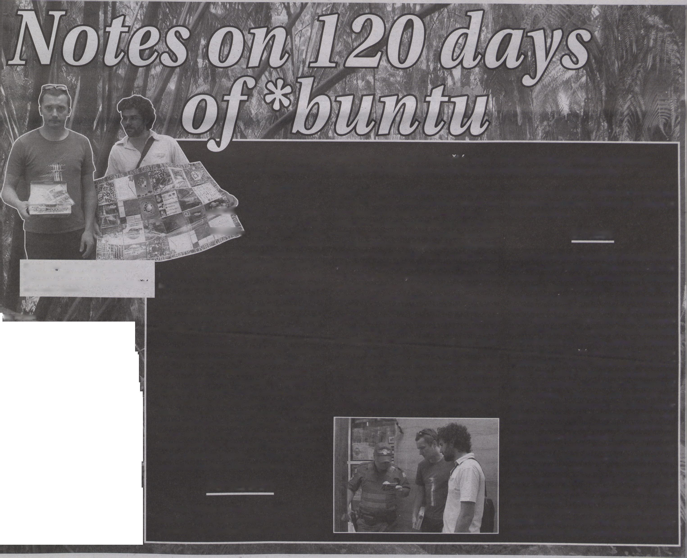So is the project not simply doomed to fail-
ure, especially given that alternative technical
systems and creative activities once released
are soon after effectively absorbed by free
market ideology? Has it also not become an
orthodoxy these days for cultural producers to
work "operatively” at the level of the apparatus
like technicians or engineers (as Benjamin
recommended in his "The Author as Produc-
er” of 1934; or Savicic and Vasiliev’s own "The
Manifesto for Critical Engineering” of 2011)?
What is the effect of the intervention here in
terms of operating systems more broadly; of
art, of politics, of the body, and so on? By tak-
ing de Sade as inspiration, something rather
different seems to be exposed, more in the
realm of excess where useless production be-
comes a preferred technique to escape the de-
termination of existing imperatives of capital-
ism (Bataille). Something else is also revealed,
in that political struggle is characterised be-
tween operating systems for liberating desire
and mechanisms of control over the imagi-
nary (Berardi). Perhaps 120days of *buntu
manages to reactivate excess, desire and im-
agination in these ways, thus opening up new
possibilities for socio-technical transgression.

ko tu bk corns? m

WIHHCR UKOmtrn.
Der erweiterte Kunstbeirrif
The NoTube Contest
has a new champion.
It's the user 'faketv'
who found the video
'ignacio: 41 \
An absolutely
valueless experience
awarded by the 2011
special jury:
Geoff Cox, Marisa
Olson and Constant
Dullaart.
Is wesensgemäßer Kapitalb
{ Joseph fcfvys ) JB
FIU - Bautnkoordin
7000 Eichd
" Deutschland?
Ich weiß das Lai
* (J.v
fgt es?
finden
documents 7 Kassel
19. Juni - 28. September 82
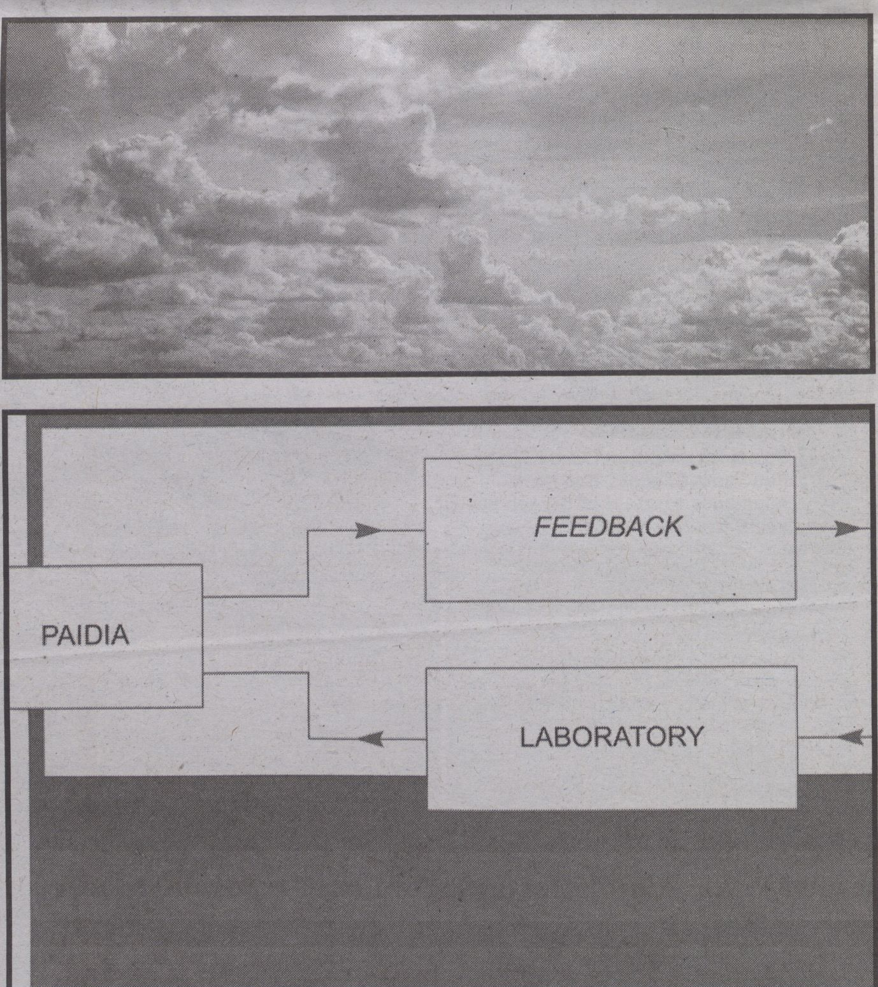The NoTube Contest is a project by IOCOSE
Check out the winning video and the
runner-ups at notubecontest.com
lM<0 «*$«*«■« S<WSJ‘» frt'.t Swxrte * V Fr*>* Sc**»
tote» fmm:~**s*M***wi *mar*■■ meum-Set«*«-
iftrnMitlfWmmmmtmMbm n«-»- -
«to "«"I l*t*n *0«*e«* tv* IMvri **»>*• «uw«, Vfcwtj.» *»<--•*«>(- U>«J
•t 0»A«t>VW« »«ft**- t<*< IMeUUM' Jö*9»*6!-w tM Mett«« Moo.».««*
ft*»»» tftWt—ji« «tew* f»4<xwis«si<w*.»s 6»m
m,>« Bo*e*>t O t »**•' • $**>** «»• Cetuw-Hi n**«*«*** **« w«w* S****« “■•»*
$tn*t«Mc!iKiiiiw «f» mWP - ütoeh &«WN«t 8«<W i**-* l«w Sa**>»
3WftW*« F’W* r**«»*» f t« «toft* t-***4 WiW-iwcJv, ©4i*ft» nmMnti«"»* IftWiCT
**3m*k*/?*»»«
FIU-Koordina tionsbüro
7000 Eichen / Orangerie
An der Karl saue ??A
3500 Kassel
Tel.; 0561 / 14957
Create your own cloud
anywhere.
vww.intk.com/undoud
31.01.-05.02.2012
EXHIBITION AT COMPUTERSPIELEMUSEUM BERLIN AND TRANSMEDIALE 12
ST6M Contribution

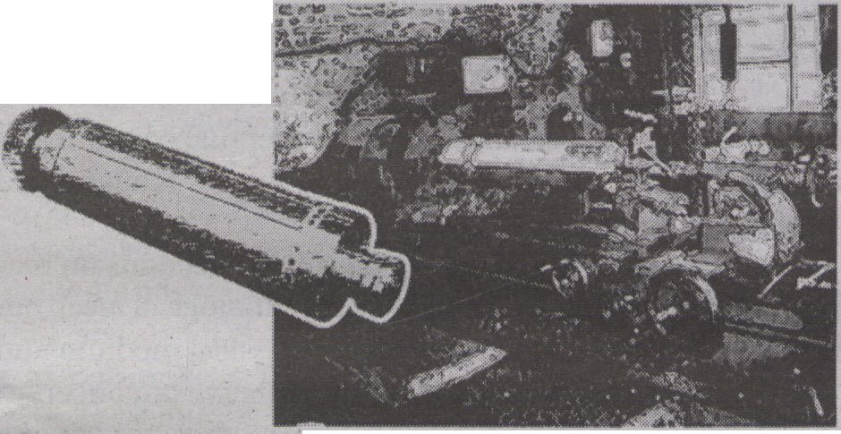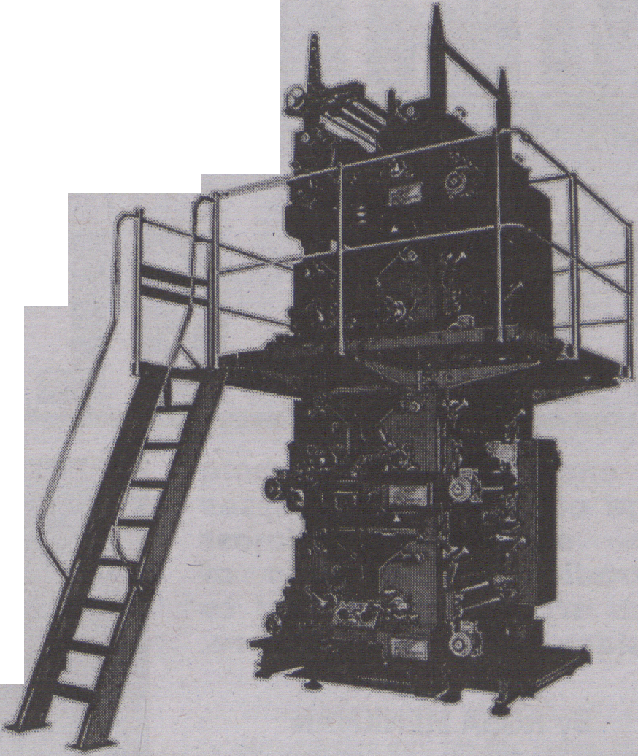
The press was driven by Good Wheels Heavy
Transport to the port in Kandla for shipping
to Germany by Adeel fifzal, born 8/1/79, From
Gurgaon, Haryana Province, father of three.
Smartphone Teardown Six Million
Newspaper Editi
http://gf»t.info/ST6H
31st of January, 2012
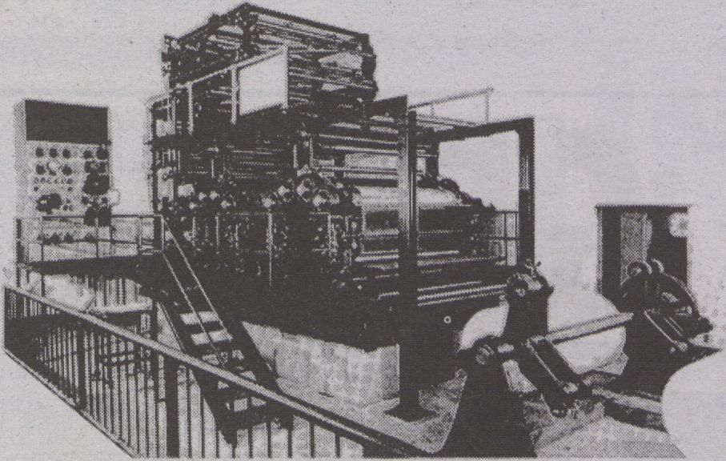

PRINTED ON INDIAN STEEL
This newspaper was printed on an Ashpra 9877
mono offset printer constructed in Haryana
India in 2005. According to indiamart.com
Ashpra has 753 employees each with an auerage
of 3.1 family members. Ashpra Printing Ltd.
thus supports a population of approximately
2334 people.
The drums for the 9877 printer are mostly pro-
duced from KS Steel and forging in Faridabad,
a company founded in 1999 with 15 people, the
rest of the parts mostly come from LUGATI Steel
FAB (P), a company founded in 1967 and employ-
ing 378 people.
Head toward Hadanpul Rd northeast on Unknown road 150 n Sharp
right onto Hadanpul Rd 16 m Take the 1st left toward Railway
Rd 580 b Turn left at Railway Rd 8 m Turn right onto Railway
Rd Pass by Bank {on the left) 458 m Turn left onto Basai Rd
Pass by Pride Foundation (nn the right) 28 n Sharp right to
stay on Basal Rd 28 n Take the 1st left onto Railway Rd Pass
by Petrol Pump (on the right In 658 n) 1.7 kn fit Tension Free
Trauel India, continue onto Rajio Chowk 97 n At poly engineer-
ing 6 marketing centre, continue onto NH S 658 n Keep left at
the fork Pass by flushnan Hospital (on the right in 2.1 kn)
42.4 kn Slight left toward NH 8 658 n Continue straight onto
NH 8 Pass by Bharat Petroleum Outlet (on the right in 4.6 km)
144 km Turn right 18.3 km Keep right at the fork 37.7 km
Slight right onto NH B Pass by Cujrati Petrol Pump (on the
left in 122 kn) 177 km Continue onto Sukher - NH s Pass by RTO
office (on the left in 788 m) 3.7 kn Sharp right to stay on
Sukher - NH 8 81.3 kn Turn right onto SH 61 11.8 kn Turn left
to stay on SH 61 8.6 kn Torn left onto SH 62 Pass by Couernnent
Hospital (on the left) 53.8 km continue onto SH 16 Pass by Dr
Byas Hospital (on the left in 24.9 kn) 25.3 kn Turn right at
Dinesh General Store to stay on SH 16 Pass by Golden Temple
of Faina (on the left) 658 n Turn left toward NH 14 28.8 km
Turn left onto NH 14 1.4 km Continue onto City Road main 1.3
km Continue onto NH 14 Pass by Hospital (on the left in 21.1
km) 38.3 kn Slight right onto SH 27 Pass by Coot Hospital (on
the left in 38.0 km) 68.5 km Turn left to stay on SH 27 Pass
by Liladhari Habadeo (on the left) 34.6 km Torn left to stay
on SH 27 12.S km Slight right onto NH 14 Pass by Gopal Petro-
leum, BPCL (on the right in 55.6 km) 76.9 km Continue onto NH
IS Bo through 1 roundabout Pass by BPCL (on the right in 3.8
km) 147 km Slight right onto NR SR 35.8 km Slight left 20.6
kn Turn left 4.8 kn Kandla Port. Gujarat 370218
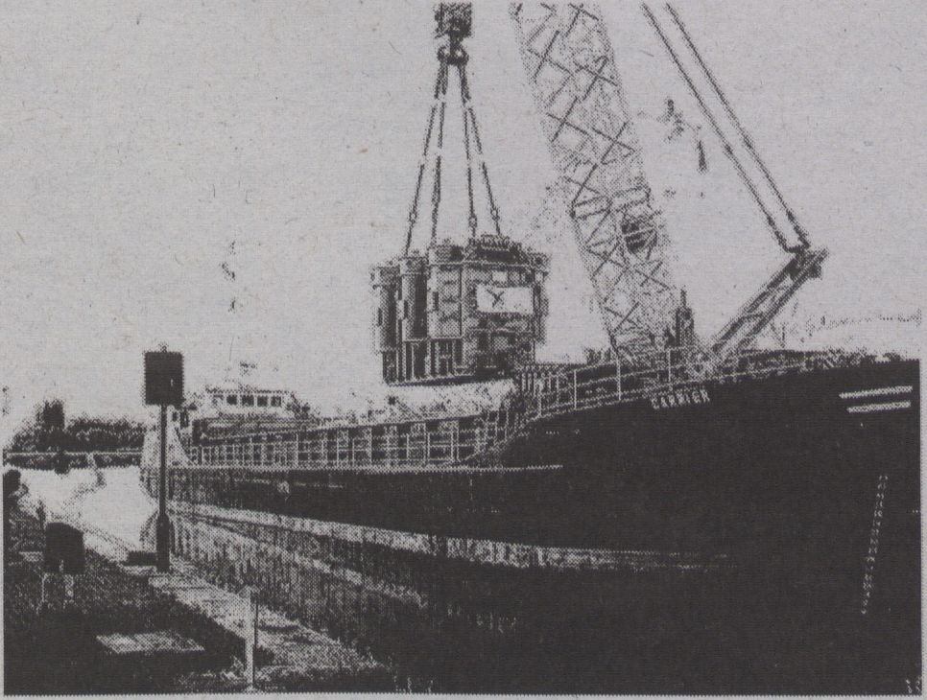

ST6I4
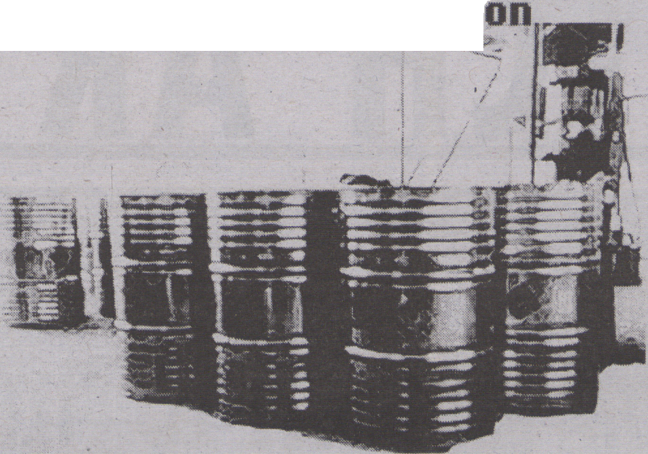

H0BB0CKS BF THE BEST BLACK
The ink used in this newspaper is common Carbon
black in a acrylic resin binder, which was ren-
dered dispersable by converting acidic groups
into their salts using amines or ammonia. Carbon
Black is produced with the thermal decomposition
method or the partial combustion method using
hydrocarbons such as oil or, in this case, coal
tar by Lixin Chemical Manufacturing Ltd. in the
midland of the Jinzhong Plain, 70 kilometers
away from Taiyuan city employing 342 staff, 6 ad-
vanced engineers, 14 engineers and an economist
as well as 24 technicians of uarious specializa-
tions.
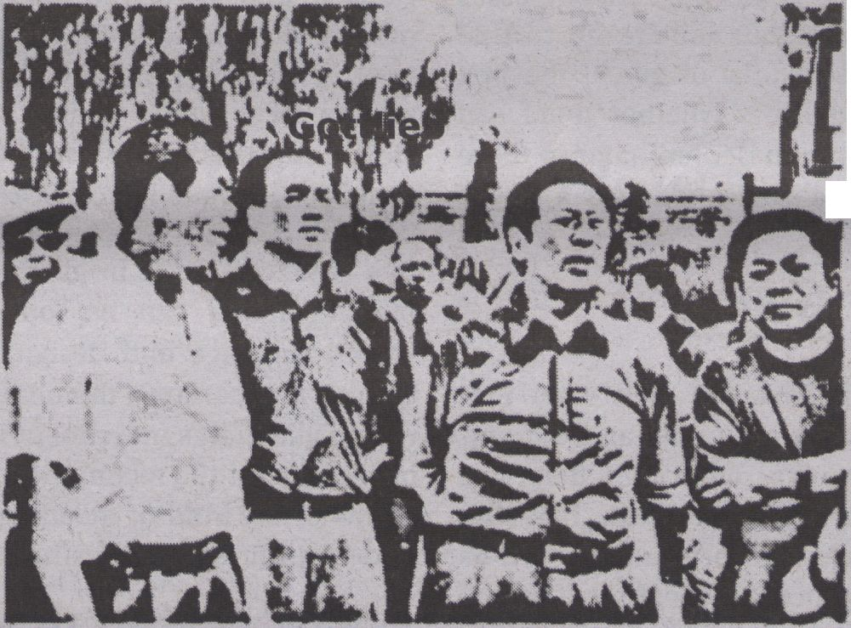
*4

Approximately 3g oF ink is used in this newspaper
or 0,00000080082% oF total yearly production.
IRON FROM THE HILLS OF DURG
A vast area is mined in the brown hills oF cen-
tral Chhattisgarh province it just happened
that enormous reserves oF iron ore to Feed
India’s modernisation revolution. 16000 people
work there, the mining camp is populated by ap-
proximately 56000. Everyday they eat breakfast
and go to dig in the mine. Some have been work-
ing there since 1977, however due to extremely
bad conditions in the early days few have man-
aged to survive that long.
On January 31th 2006 N. M. Joshi, born in 1970
woke up, had breakfast prepared by his wife
Laro Jonko, and went to the mine as usual, on
his way he was met by Bhikubhai Uaghela and
three others. Together they walked up to the
minehead where they were directed where to work
by A L Gupta From Raipur, born in 1966.
He worked his alotted 18 hours that day at the
mine, chipping ore out of the sides of the mine
wall with a spade. During those ten hours of
work he produced 102 kilograms of ore. This
amount of ore resulted in aprroximately 50kg of
the steel in the Ashpra 9077 printing press,
which used approx. 500 kg of steel in all.
Therefore ten days of N.H. Joshi’s work would
haue sufficed to produce the ore For the press
which printed this newspaper.
A TEMPORARY INC0ÜENIENCE
The instrument of labour, when it takes the form
of a machine, immediately becomes a competitor
of the workman himself. The self-expansion of
capital by means of machinery is thenceforward
directly proportional to the number of the work-
people, whose means of livelihood have been de-
stroyed by that machinery. The whole system of
capitalist production is based on the fact that
the workman sells his labour-power as a commod-
ity. Division of labour specialises this
labour-power, by reducing it to skill in han-
dling a particular tool. So soon as the handling
of this tool becomes the work of a machine,
then, with the use-value, the exchange-value
too, of the workman’s labour-power vanishes; the
workman becomes unsaleable, like paper money
thrown out of currency by legal enactment. That
portion of the working-class, thus by machinery
rendered superfluous, i.e., no longer immedi-
ately necessary for the self-expansion of capi-
tal, either goes to the wall in the unegual con-
test of the old handicrafts and manufactures
with machinery, or else floods all the more
easily accessible branches of industry, swamps
the labour-market, and sinks the price of
labour-power below its value. It is impressed
upon the workpeople, as a great consolation,
first, that their sufferings are only temporary
(la temporary inconueniencel), secondly, that
machinery acquires the mastery over the whole of
a given field of production, only by degrees, so
that the extent and intensity of its destructiue
effect is diminished. The first consolation neu-
tralises the second. When machinery seizes on an
industry by degrees, it produces chronic misery
among the operatives who compete with it. Where
the transition is rapid, the effect is acute and
felt by great masses. History discloses no trag-
edy more horrible than the gradual extinction of
the English hand-loom weavers, an extinction
that was spread over several decades, and fi-
nally sealed in 1838. Many of them died of star-
vation, many with families vegetated for a long
tine on 2h d. a day. On the other hand, the Eng-
lish cotton machinery produced an acute effect
in India. The Gouernor General reported 1834-35:
■The misery hardly finds a parallel in the his-
tory of commerce. The bones of tbe cotton-weau-
ers are bleaching the plains of India.!
- from Marx, Capital, Chapter 15, Section 5
ST6M PROJECT ATTEMPTS
This is a project which, at first glance may not appear
to be an artistic project, howeuer, this is a project
that only an artist would approach with the stubbornness
and single-mindedness necessary to reach the critical
mass necessary to prooe it's value. The project is a
thorough materials analysis of the components of a common
contemporary product, from the surfaces we contact euery
day, to the functioning parts inside, tracing the mate-
rial origins of each and euery one of these parts, back
through their uarious industrial processes and ports of
call, to the mines and sources where the materials origi-
nally emerged from the earth. ST6H stands for smartphone
teardown 68BB8BB and is dedicated to the people sacri-
ficed in the conflict minerals trade. Baruch Gottlieb

METHODS
lïillllS
«i
“Can art become a re-activator of the social body, beyond the
commodification of the art formats and the an-aesthetics of media
overload?" - Scepsi - European School of Social Imagination
THE GLITCH ART GENRE
To encapsulate a whole
range of unstable processes
and sometimes almost
contradictory intentions of
glitch artists, it is useful to
consider glitch art as a genre.
By ROSA MENKMAN
As the popularisation and cultivation of
glitch artifacts is now spreading more wide-
ly, it is interesting to track the development
of these processes and their consequences.
One of these consequences is that we can
consider glitch as an artistic genre. But what
does saying ‘glitch is a genre’ actually mean?
The fatal manner of glitch, its orientation
towards the destruction of what is, can pre-
sent a problem to those who want to de-
scribe old and new culture as a continuum of
different discrete practices. One way to deal
with this problem is to repeatedly coin new
terms and concepts to make room for splin-
ter practices within the expanding media
cultural field. An abundance of designations
such as databending, datamoshing and cir-
cuitbending have come into existence to
name and bracket varieties of glitch practic-
es, but all in fact refer to similar practices of
breaking flows within different technologies
or platforms.
Glitch
While technological glitch is primarily a
process of shock requiring investigation and
cognition, glitch art is best described as a
collection of forms and events that oscillate
between extremes: the fragile, technologi-
cally-based moment(um) of a material
break, the conceptual or techno-cultural in-
vestigation of breakages, and the accepted
and standardised commodity that a glitch
can become. To encapsulate a whole range
of unstable processes and sometimes almost
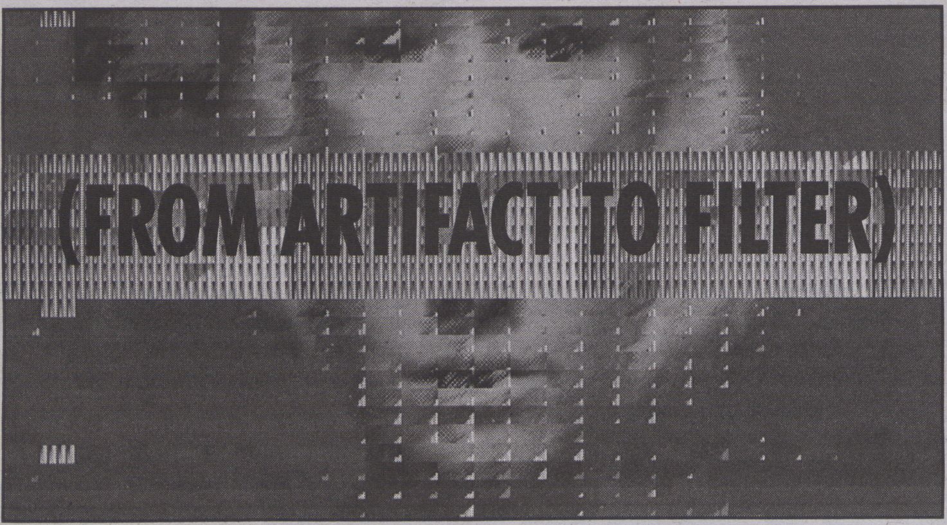
.BLINX Databend. From "A Vernacular of File Formats" meets Kim Asendorfs
"Extrafile.org" (collaboration). Mov animation 256 colors
contradictory intentions of glitch artists, it is
useful to consider glitch art as a genre. In
thinking about a genre that encompasses
both the most rebellious and the most stable
or commoditised works of glitch, the first
question that arises is whether there can
even be any common denominator in these
works. What does saying ‘glitch is a genre’
actuallymean?
Genre
To consider glitch art as a genre is to em-
phasise that genres are social and consen-
sus-based constructs, rather than definitive
categories (Altman). Steve Neale has sug-
gested that genres are best understood as
processes: The process-like nature of genres
manifests itself as ah interaction between
three levels: the level of expectation, the lev-
el of the generic corpus, and the level of the
‘rules’ or ‘norms’ that govern both. [...] the
elements and conventions of a genre are al-
ways in play rather than being, simply re-
played; and any generic corpus is always be-
ing expanded. (56)
While genres are always ‘in play) they
also - by definition - have some sort of or-
ganised and perceived unity. This unity
models both how a viewer perceives any
work in the genre and how she comes to as-
sociate new works within it. Mary Ann
Doane suggests that “the unity of a genre is
generally attributed to consistent patterns in
thematic content, iconography, and narra-
tive structure” (34). In glitch art, this ‘the-
matic content’ can be found within the
work’s language and design, while icono-
graphie and narrative themes are positioned
within glitch art’s investment in the rupture
of procedures and technique, the break from
a flow or the void of meaning in the social
understanding and the esthetical references.
Materiality
To call glitch a genre also means to sug-
gest that it is intelligible as a tendency: to ex-
ploit medium-reflexivity and to take on the
rhetorical questioning of the perfect use and
function of technologies, their conventions
and expectations. Paradoxically then, out of
its instantiation in error and breakages,
Glitch art can, through its play with conven-
tions and expectations, be described as a
genre that fulfills certain expectations. This
reflexive approach to materiality in glitch
tends to, as Katherine Hayles would assert,
re-conceptualise materiality itself as “the in-
terplay between a text’s physical characteris-
tics and its signifying strategies." Rather than
suggesting media materiality as fixed in
physicality, Hayles’ re-definition is useful
because it opens the possibility of consider-
ing texts as embodied entities while still
maintaining a central focus on interpreta-
tion. In this view of materiality, it is not
merely an inert collection of physical prop-
erties but a dynamic quality that emerges
from the interplay between the text as a
physicafartifact, its conceptual content, and
the interpretive activities of readers and
writers.
Glitch genres perform reflections on ma-
teriality not just on a technological level, but
also by playing off the physical medium and
its non-physical, interpretative or conceptu-
al characteristics. To understand a work
from the genre of glitch art completely, each
level of this notion of (glitch) materiality
should be studied: the text as a physical arti-
fact, its technological and aesthetical quali-
ties, conceptual content, and the interpretive
activities of artists and audiences.
This text is a paragraph from the upcoming
notebook: “The Glitch Moment(um)"
Works cited:
- Rick Altman. Film/Genre London: British Film
Institute, 1999.
- Steve Neale. "The Question Of Genre." Screen 31.1
(1990): pp. 45-66.
- Mary Ann Doane. The Desire to Desire: The
Woman's Film of the 1940s. Bloomington and
Indianapolis: Indiana University Press, 1987.
- N. Katherine Hayles. "Print is flat, code is deep:
The importance of media-specific analysis." Poetics
Today 25. 1 (2004): pp. 67-90.

• :
<
LO
O
DC
>>
QO
GLITCH
STUDIES
Manifesto
IThe dominant, continuing search for
a noiseless channel has been — and
will always be — no more than a re-
grettable, ill-fated dogma.
Acknowledge that although the constant
search for complete transparency brings
newer, 'better' media, even' one of these im-
proved techniques Will always possess their
own inherent fingerprints of imperfection.
2 Dispute the operating templates of
creative practice; fight genres, inter-
faces and expectations!
Refuse to stay locked into one medium or be -
tween contradictions like real vs. virtual, ob-
solete vs up-to-date,' open vs. proprietary or
digital vs. analog. Surf the vortex of technol -
ogy, the in-between, the art of artifacts!
3 Get away from the established action
scripts and join the avant-garde of the
unknown. Become a nomad of noise
artifacts!
The static, linear notion of information-trans-
mission can be interrupted on three occasions;
during encoding-decoding (compression),
feedback or when a glitch (an unexpected break
within the flow of technology) occurs. Noise
artists must exploit these noise artifacts and ex-
plore the new opportunities they provide.
4 Employ bends and breaks as a meta-
phor for differance. Use the glitch as an
exoskeleton for progress.
Find catharsis in disintegration, ruptures and
cracks; manipulate, bend and break any medi-
um towards the point where it becomes some-
thing new; create /glitch art/.

PERFORMING THE PARADOXES OF
ni INTELLECTUAL PROPERTY


I DON'T KNOW, video, 2006, screenshot

Tactical
Questioning
CORNELIA SOLLFRANK
INTERVIEWED
You have recently completed your PhD,
what was the topic of your research?
My research was a practice-led investiga-
tion into the conflicting relationship between
copyright and art, i.e. it was interdisciplinary
research involving different disciplines such
as aesthetic theory and practice, and law. The
incentive to conduct this research was an act
of censorship that I experienced in my prac-
tice as an artist. In 2004, a planned exhibition
was cancelled due to alleged copyright in-
fringement, because I used the motif of the
Warhol Flowers for an experimental continua-
tion of postmodern authorship-critical con-
cepts under the condition of digital networked
technologies. This incident aroused my curi-
osity and I wanted to explore what the con-
necting lines between my art practice and the
framing concept of intellectual property were.
Moreover, I was aware that ‘my case’ was not
an exception; since intellectual property has
become a central concept to safeguard the
marketability of intangible goods within the
knowledge economy. Stricter copyright laws
and their harsher enforcement increasingly
have also led to legal problems for artists
whose practice is based on the use and re-
working of existing copyrighted material.
Thus, I was also interested in getting a deeper
understanding of these dynamics and in par-
ticular the role art and artists play within these
developments.
How did you conduct your research?
The advantage of research in the art con-
text is that it is not only possible but even re-
5
Realize that the gospel of glitch art also
tells about new standards implement-
ed by corruption.
'Not all glitch art is progressive or /something
new./ The popularization and cultivation of
. the avant-garde of mishaps has become pre-
destined and unavoidable. Be aware of easily
reproducible /glitch effects/-, automated by
/softwares and plug-ins. What is now a glitch
will become a fashion.
6
Force the audience to voyage the acous-
matic videoscape. Create conceptually
synesthetic artworks, that exploit both
; visual and aural glitch (or other noise) artifacts
at the same time. Employ these noise artifacts
as a nebula that shrouds the technology and its
inner workings and that will compel an audi-
ence to listen and watch more exhaustively.
quired to develop one’s own methodology.
Each single research project demands its own
methods. They are usually developed on the
basis of a specific art practice, its contextual
theory, the topic of the research and the de-
sired outcome.
The starting point for my research was the
paradoxical concept of intellectual property.
The basic idea of intellectual property is to
find a balance between the protection of the
economic and moral interests of creators and
innovators and, at the same time, to enable
cultural, scientific and economic innovation.
Yet where creation and innovation rely on ac-
cess to, and the use of protected works, propri-
etary rights hamper new creation and innova-
tion. This paradox has always existed, but due
to the technological, economic, legal and cul-
tural developments that have taken place
since the mid-1990s, it has turned into a cen-
tral problem of the information society. My
project focused on the paradoxes produced by
copyright, as one form of intellectual property,
in the light of art practices that are based on
the use and reworking of protected material.
Since it was clear from the beginning that I
would not be able ‘to solve the problem’
through my research, the challenge was to
come up with a methodology that would lead
to results that still could contribute to a solu-
tion by producing new knowledge. For that
reason I chose the concept of ‘performativity’
to be the methodological paradigm of my re-
search as it allows for the conceptualisation
and dramatisation of a subversive artistic ap-
proach to law. To develop this approach, I
drew on Brad Haseman’s concept of perform-
ative research as a third research paradigm
alongside the established paradigms of quan-
titative and qualitative research; and addi-
tionally introduced Judith Butler’s juridical
model of ‘performativity’ as well as Julie Stone
Peters’ theory of law’s performative nature.
The combination of these theories resulted in
a practice-led methodology that allowed a
substantial part of the research to be conduct-
ed through art practice.
Could you please describe the practice
7
Rejoice the critical trans-media aes-
thetics of glitch artifacts.
Utilize glitches to bring any medium in
a critical state of hypertrophy, to (subsequent-
ly) criticize its inherent politics.
8
Employ Glitchspeak (as opposed to
Newspeak) and study what is outside
of knowledge. Glitch theory is what
you can just get away with!
Flow cannot be understood without .interrup -
tion or function without glitching.
This is why glitch studies
is necessan
part in more detail and explain what the
role of the artworks is in the context of the
research?
The practice part consists of four consecu-
tively produced artworks, which explore dif-
ferent aesthetic, theoretical and legal aspects
of Internet-based artistic appropriation and
reworking. The works that in their entirety
form the project This is not by me all use War-
hol’s iconic Flowers as an exemplary case. In
the first part are the anonymous_warhol-flow-
ers, digital collages produced with the help of
the net.art generator, an online computer pro-
gramme. They relate established practices of
appropriation to the aesthetic potential of dig-
ital networked technologies. The ambiguity
that results from shifting between represent-
ing the new aesthetic and technological para-
digm of the ‘networked image! which exists
beyond traditional notions of authorship and
originality', and the traditional autonomous
image, is essential in performing the dynamic
conflicts caused by intellectual property in the
network society-on the Internet and in the art
gallery. The video lecture copyright © 2004
Cornelia sollfrank is a thorough investigation
of the unanswerable question: who is the au-
thor of an automatically generated image?
The investigation is based on legal studies and
adopts the style of legal expertise, while clear-
ly indicating the gap between the ‘profession-
al’ and the ‘amateur’. For this method, I used
the term ‘performative dilettantism! which in
my case means the artistic adaptation of legal
knowledge.
The following project, the video installa-
tion Legal Perspective brings in legal profes-
sionals. The method of conducting semi-
structured interviews provided the basis for
the work, in which four copyright experts
elaborate on the legal implications of the net.
art generator and the anonymous_warhol-
flowers. Despite the professional contradic-
tions it generated, the project clearly demon-
strated that the creation of new works that
build on existing ones takes place in a legal
grey area. Legal Perspective draws on law's de-
pendence on theatricality and exploits it for
the purpose of staging legal experts who per-
form the limitation of the law as well as its lim-
iting function for appropriative art. In order to
complement the preceding dominant legal as-
sessments that had ultimately proved unable
to clarify the situation, the basic idea of the
video I DON'T KNOW is to obtain permission
from the rights holder. The fake video inter-
view shows that Warhol does not have any
conceptual, aesthetic 'or legal problems with
the use of ‘his’ images. However, combining
authentic and newly shot material in a mon-
tage technique results in a short cut between
form and content. The artwork that symboli-
cally asked for permission led to a letter of
complaint by the original film-maker and
ended in having to ask for his permission.
The strategy I chose for the practice part
was to emphasise the identified problem by
performing and staging it, thus contingently
contributing to a subversion of the law, which
might eventually contribute to a solution. The
different artworks are not just expressions of
my research in their own right, but actually
perpetrate the copyright infringement. The
projects themselves are partly situated in the
legal grey area and therefore do not just func-
tion as conventional artworks, but rather per-
form the problem; they "bring into being what
they name." This is what Brad Hasemann calls
"the double articulation involved in creative
arts research.”
What is the role of theory both in relation
to the practice and for the research in gen-
eral?
It would not have been possible to realise
the artworks without sound legal knowledge.
Therefore, it was necessary to study legal lit-
erature and also involve professionals at vari-
ous stages. Moreover, the theoretical contex-
tualisation of my art practice allowed for the
exploration of the relationship between a spe-
cific artistic practice and its legal framework.
In summary, it can be said that there is a pen-
dular movement between practice and theory
and it is only through their interplay that the
specific outcome of my artistic research was
able to be achieved.
What is the outcome of your research?
There are several levels of outcome. One
level is the practice part, which, of course, is
ambiguous and open to interpretation. This
level requires an active engagement from the
side to the viewer. Additionally, there is a
written thesis that contains a detailed de-
scription of the artworks, but also offers a
substantial contextualisation of the practice
part.
What is your opinion on the widespread
criticism of artistic research: as another ef-
fect of neoliberal education policies or the
scientification of art?
I think it is important to understand the dy-
namics and the political framework within
which one is situated, and also to be aware of
the traps of artistic research. It is definitely ad-
visable to insist on the specific epistemology of
aesthetics as something different from tradi-
tional scientific methods-which, by the way,
are not uncontested within their own disci-
plines. Therefore, instead of theoretically criti-
cising or condemning artistic research, I would
find it more useful to work on its conceptuali-
sation as a field different from scientific re-
search. This is the only way to transfer certain
aspects of freedom from art to artistic research
and safeguard its autonomy towards tradition-
al science and other attempts of instrumental-
isation. Generally, I do not follow the juxtapo-
sition of autonomous art and artistic research
that idealises art construing it as the ultimate
domain of freedom and purity as opposed to
artistic research where art is said to automati-
cally become instrumental and functional-
ised. In my view, this is an ideological and
bourgeois understanding of art that ignores
the fact that art implicitly always has served
specific purposes-as an instrument to stabilise
power relations in society. In that sense, artis-
tic research could also be understood as an es-
cape attempt from art’s traditional dependency
on the bourgeois art market using the open-
ness and undefined aspects of an emerging
field for the invention of a new notion of art.

By MARIE THOMPSON
Works cited:
- Cixous, Hélène, "the Laugh of Medusa." Signs
1.4 (1976): 875-893 Web. 25 Nov. 2011.
- Haraway, Donna. "A Cyborg Manifesto:
Science, Technology, and Socialist-Feminism in
the Late Twentieth Century." Simians, Cyborgs
and Women: The Reinvention of Nature. New
York: Routledge 1991. 149-181. Print.
FUTURISTS: for too long have you dominated the art of
noise. For too long has noise been tethered to your bloodlust
dreams of violence, destruction and warfare, your celebra-
tions of man’s triumph over nature through his machinic ex-
tensions.
Marinetti, you should not have scorn for women, for your
noise belongs to us. The women you dismiss, with their
'frivolity' and ‘ch*atter] have a more intimate relationship
with noise than can ever be achieved through forced suB-
missions and bloodied penetrations of the flesh.
{Throughout the history of Western thought, women and noise
have found themselves on the same side of philosophical di-
chotomies that have governed and legitimated their subordi-
nation. They have been locked down on the side of unreason,
of madness and hysteria, of irrational non-meaning. Women’s
noises, the ‘idle gossiping’ the squeals of excitement, are cast out
as abject distractions. Their unpredictable outputs are to be con-
trolled, abated.}
WomE/An as/Is noise: an INTER>%FERE'NCE within the
channels of'reason' from which she has been excluded.
the ’"’Laugh of Medusa”’’ ruptures the linear trajec-
tory of phallologocentrism.
Wome/an and noise share the threat of DEATH and
DESTRUCTION:
the siren’s voice is a sonic weapon.
While she has rarely been the creator of the machine, she has
often been its collaborator and as such, has found herself as
the gatekeeper of noise. She sits in front of the switchboard,
connecting and// disconnecting///
Mdmdmddoyy 100010001003i456smdcfvgb-
hapaaaaaaa0009337i91 -==
WAIT: this intimate connection between women and noise is
not one belonging to metaphysics; noise is not her essence.
These notions of women as unreasonable and unpredictable
are creations of history, culture, politics.
Likewise, there is nothing inherently violent, destructive or
torturous about noise.
[(Noise is not a sound. It is an affect with effects.)]
Noise is first the ruPTUre. As such, it does not only diminish
and destroy but also produces, creates, enhances. It remains
autonomous from the forms it takes, the bodies it occupies.
Only second is it unwanted, unorganised, unreasonable:
these issues are contingent.
888000’rg,hj,hgf345,taaaaa —==A )@IJWS==$===-
\\||||sff§>»,«m||£8*%€
[When I make noise, I do not want to hurt you or make you
submit. I am not trying to represent the scream of the cruel,
cold metal-tech world. I want to make you feel. I want to bring
you to the materiality of your body: to make you feel the joys
of the visceral existence that women have been condemned
to in the name of their reproductive organs. I want to lock you
in and draw you out. Both/and. You never know what you
might feel. - YOU KNOW NOT YET WHAT A BODY CAN DO]
A2dddddkkkallloo
oo$$$%%%@39456)))))))))))))))))9234567888888888888
Talk of the sublime often forgets the triumph of reason. With
noise we have the persistence of INTUITION over concept.
Noise politics = Cyborg politics = gender politics
Noise gives voice to Donna
Haraway’s Cyborg
The Cyborg dwells on the border. It refuses the dualisms
between nature/culture, natural/unnatural, human/ma-
chine. It is completely without innocence: IT is the offspring
of WAR, PAtriARCHY, Capitalism. BUT Cyborgs do NOT fit
the oIDEpal narrative: it does not abide the law of the Father
and thus, has no loyalty to the figures that haunt its past. As
such, it may become a noiSe within ThE systems that gave
birth to it.
Haraway's Cyborg IS NOT WOme/an - in an AgE of pace-
makers, CONtact lenses, AvATars: ‘We Are AR Cyborgs’
Music/noise? Wanted/unwanted? Meaning/non-meaning?
May our noise remain incompatible with neat, dualistic
logic: that which has sought to abate us.
Let us make a MesS. Let us use our noisy, machinic col-
laborations for Destabilization NoT DOMinatiON. Let uS
use them to UnDerMi.ne the power structures that have
rendered us noise.
Let us make use oftHe rupture.

M

compatible

ImaaifnOnq
IDEAL
REPRODUCTION
AND DISCRETE
SIGNALS
Bv THOMAS
BJ0RNSTEN
KRISTENSEN
Different ideas of
in/compatibility
constitute an obvi-
ous inspiration to
many artists work-
ing within the field
of electronic and
digital media.
This would be the case, for
instance, with the experi-
mental productions promot-
ed by labels such as Raster-
Noton or Touch that deal with
sonification and visualisa-
tion, and which often gain
both aesthetic effect and se-
mantic strength from refer-
ences to the in/compatibility
of formats, media, and di-
verse data material. One such
example is EXP by Frank
Bretschneider; an engaging
‘music-visual’ work that or-
chestrates statics and noises
generated from "feedbacks,
impulses, clicks, the sound of
mechanics, electricity, mag-
netism, light and other radia-
tion,” combined with corre-
sponding visuals described as
“an exact reproduction of the
audible occurrences"
(Bretschneider). Thus, the
black and white animations
consisting primarily of sepa-
rate dots and pixels apparent-
ly reflect the chopped and re-
petitive character of the
music, producing flickering
abstract patterns.
The quotes above, taken
from the EXP release, express
a general assumption about
the inherent potential of com-
patibility of the digital. The
ambition of visually repro-
ducing sound has posed a sig-
nificant challenge to a num-
ber of artists during the 20th
century (Daniels and Nau-
mann). But not until the com-
ing of computational technol-
ogy could this, seemingly, be
realised properly - given that
the coding of any material
into digital bits makes possi-
ble the transcription of data
from one format to another.
However, this process is fun-
damentally arbitrary depend-
ing on the specific coding of
the applied interface. Such a
transmedial reproduction
should, thus, necessarily be
considered as the result of an
ideal of compatibility rather
than one of genuine ‘exacti-
tude,’ as EXP claims to be.
Past models
Historically, similar nego-
tiations on compatibility
stood central to artists of the
19th century, a period during
which previous models of
western art were abandoned
as new scientific theories in-
formed artists’ notions of both
the limits of media-specific
representation and the novel
possible compatibilities be-
tween different art media
(Gage). This entailed radical
changes to the earlier ideals of
artistic reproduction based on
"a field of knowledge whose
contents [were] organized as
stable positions within an ex-
tensive terrain." In the 19th
century these ideals instead
"became incompatible with a
field organized around ex-
change and flux" (Crary 62).
The acknowledgement of
this fundamental incompati-
bility of past models of repro-
duction stimulated a range of
artistic explorations. Notably,
within the visual arts which
turned toward a new aesthet-
ics of conceptual systematics
for the production of images;
something, that emerged par-
allel to contemporary imaging
technologies, but had no in-
terest in illusory effects. In-
stead, what was initiated with,
for instance, the phenome-
non of pointillist painting -
which atomised or in fact dig-
itised the picture plane into
tiny separate dots - was a radi-
cal move from continuity and
conventional signs to an aes-
thetics of disruption and float-
ing units. This is evident also
when looking at examples of
futurism, cubism, and con-
structivism of the later dec-
ades. Pointillist painting thus
marked a position from which
the construction of images be-
came a process of assembling
or coding discrete signals
through systematic methods.
The logic of reproduction
that followed from this was
not concerned with imitation
but with creating an inter-
changeable matrix for the
structural distribution of units
within a field of flux; a logic
which implied the potential
exchange and arbitrary com-
patibility of images across dif-
ferent formats, independent
of indexical relations to phe-
nomenal objects and medi-
um-bound materiality. From
this historical perspective, the
ideals of compatibility ex-
pressed in digital works such
as EXP can be considered in
the light of a preceding aes-
thetics of discrete signals and
quantisation - an aesthetics to
be investigated further as an
important parallel to histories
of technology and engineer-
ing sciences.
Works cited:
- Bretschneider, Frank. EXP. Audio
+ data cd. 2010.
- Crary, Jonathan. Techniques of
the Observer: On Vision and
Modernity in the Nineteenth
Century. 9th ed. 1999.
- Daniels, Dieter & Naumann,
Sandra (ed). See This Sound:
Audiovisuology 2. 2011.
- Gage, John: Color and Culture:
Practice and Meaning from
Antiquity to Abstraction. 1999.

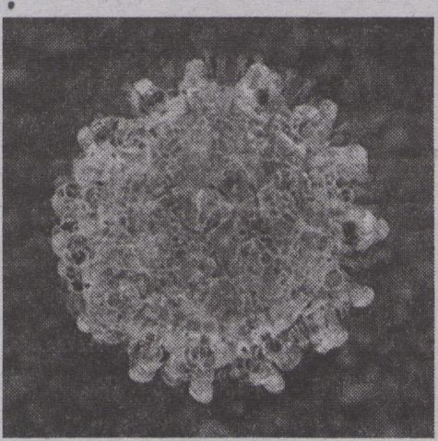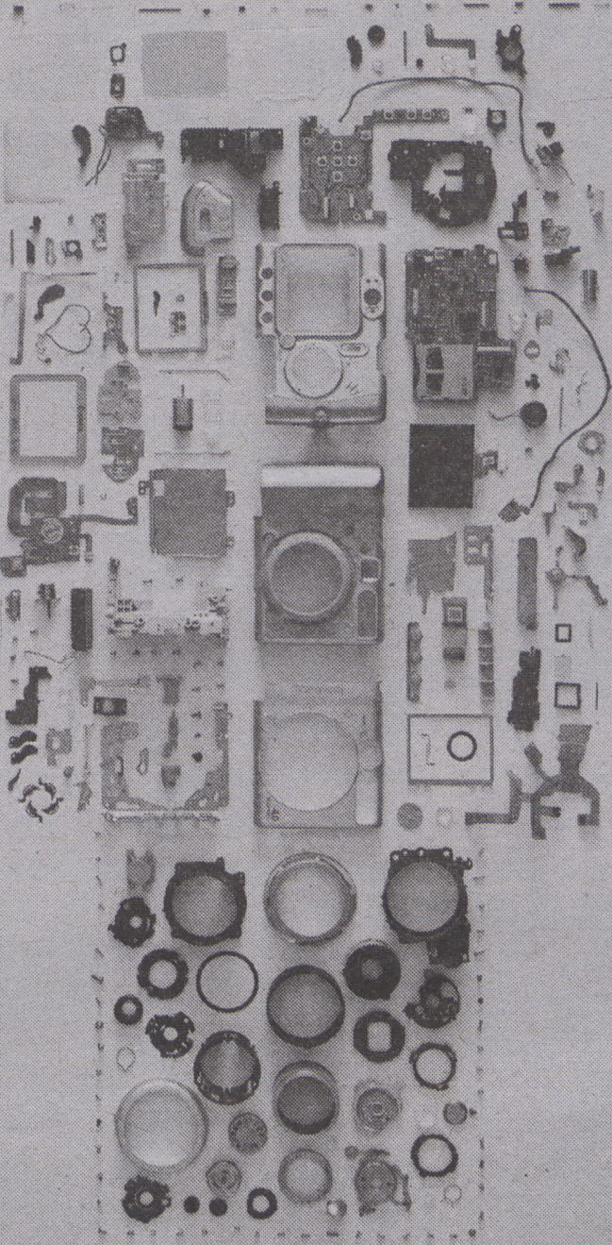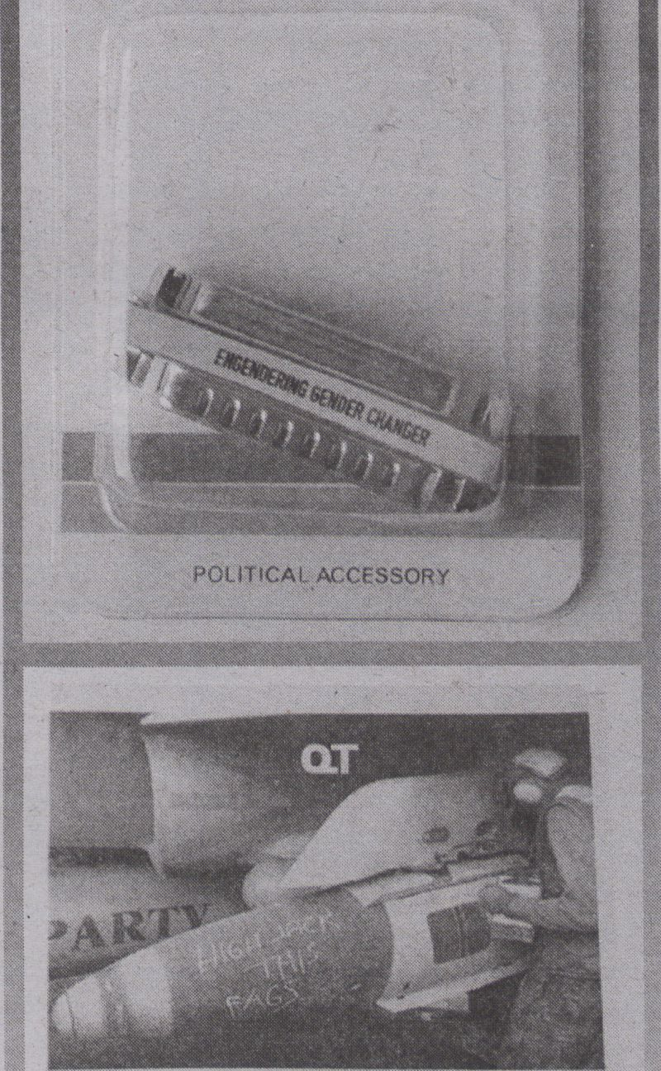

On Queer
Viralities
By ZACH BLAS
Can the viral oper-
ate as a diagram for
queer illegibility?
Queerness and the viral
connect on numerous fronts,
to its histories with HIV/AIDS
and controlling medical prac-
tices and rhetorics, to bare-
backing subcultures, to anti-
capitalist tactics and
frameworks.
The virus carries along
with it themes common to
queerness, such as risk, trans-
gression, amorphousness,
and multiplicity. Queemess
could be said to exist in a par-
adoxical relation to the virus,
as it is both subjected to viral
control yet also finds the virus
playful and pleasurable.
A queer interest in the vi-
rus might be to experiment
with parsing dominant con-
figurations of the viral. What a
virus is and does cannot only
be extracted into the qualifier
viral just as the qualities of
the viral cannot be reduced to
the virus. We could say a vi-
rality, or viral, is one of many
possible identities of the virus
(constructed by the human)
or that the viral is a creative
opening or disturbance into
the virus. Just as queemess
has pulled apart supposedly
causal relations between sex,
sexuality, gender, and subjec-
tivity, a queer viral politics
must experiment with pars-
ing the virus and viral in
search of minor, or alterna-
tive, viralities. A queer viral
politics is one way to expand
queerness into the realm of
the nonhuman.
VirusIVirus 1
Representations of the
virus | viral today typically
hinge on rapid spreadability
and mutation. In fact, wher-
ever one looks, the virus has
gained the most attention
through its abilities to repli-
cate and disseminate. In line
with this perspective of the vi-
rus, Alexander Galloway and
Eugene Thacker, two theo-
rists who have written exten-
sively on viruses, state that
the virus succeeds in produc-
ing copies through a process
Galloway and Thacker refer
to as “never-being-the-same”
(87). Maintaining within itself
the ability to continuously
mutate its code with each re-
production, the virus propa-
gates itself. Defining the virus
based on action, they write:
Replication and cryptog-
raphy are thus the two activi-
ties that define the virus.
What counts is not that the
host is a "bacterium," "an ani-
mal," or a “human." What
counts is the code-the num-
ber of the animal, or better,
the numerology of the ani-
mal. [...] The viral perspective
is “cryptographic" because it
replicates this difference, this
paradoxical status of never-
being-the-same. [...] What as-
tounds us is that the viral per-
spective presents the animal
being and creaturely life in an
illegible and incalculable
manner, a matter of chthonic
calculations and occult repli-
cations (87).
Virus I Viral 2
Can the viral operate as a dia-
gram for queer illegibility?
Galloway and Thacker have
written that, "The next centu-
ry will be the era of universal
standards of identification
[...] Henceforth, the lived en-
vironment will be divided
into identifiable zones and
nonidentifiable zones, and
nonidentifiables will be the
shadowy new ‘criminal’ class-
es-those that do not identify”
(259-260). While feminist
theorist Elizabeth Grosz has
called for a new feminism
premised on the nonrecog-
nisable, queer theorist Jack
Halberstam has proffered no-
tions of queer opacity and
blackness as well as shadow
feminisms that undo reada-
bility. What are the tech-
niques for such a practice in
relation to queerness and the
viral? Is this viral something
that has a presence but aids in
processes of cloaking, making
invisible, escaping, all
through a shifting, altering
physical volume. Is this viral
dimension a tactic to critical-
ly evade identity and recogni-
tion control while maintain-
ing a poetic and political
never-being-the-sameness?
Works cited:
- Galloway, Alexander R. and
Eugene Thacker. The Exploit: A
Theory of Networks. Minneapolis:
University of Minnesota Press,
2007. Print.
- Galloway, Alexander R. and
Eugene Thacker. "On Narcolepsy."
The Spam Book: On Viruses, Porn,
and Other Anomalies From the Dark
Side of Digital Culture. Eds. Jussi
Parikka and Tony D. Sampson.
Cresskill. New York, NY: Hampton
Press, 2009. Print.
Image Creative Commons, http://www.flickr.com/
photos/kellyhofer/5732567366/
Advertising
^ cisr
FEMALE 0825
TO POWER BOTTOM 0B25
ENgendering
Gender Changer

Gay Bombs
User’s Manual
. instruction or» how to i¡#« Oueet Tochnolo«*«*

Artistic Technology Research
Artistic research can be faster than scien-
tific research and can react much more di-
rectly to current social and technological
developments.
Bv MATHIAS
TAhASIEWICZ
New Media Arts, as 'artistic
research and development'
between artistic, medial and
techno-scientific discourses,
is research-based and prac-
tice-led. It does not produce
'final products’ but ‘process
artefacts;
Henk Borgdorff states that
"research and development
are intimately entwined”
(44), and thematises the im-
portance of documentation
and dissemination (58). Since
media arts finally matured
new media channels evolved
as well: the question remains,
where the advocacy and the
audience for new media arts
resides? There still is "no
market, no galleries, few cu-
rators and critics, and no au-
dience" (Lovink) - at least for
an art market in a traditional
sense. Also, the term "New
Media Arts" is somewhat out-
dated to describe a contem-
porary practice of new media
researchers/artists.
In the age of "Kontrollver-
lust” (Seemann) a change of
reception/perception of au-
diences can be observed -
still, through multiple, di-
verse channels of
consumption and participa-
tion, the creation of attention
and user-engagement is cru-
cial to New Media Arts. In this
sense, previous descriptions
of the term have to be extend-
ed regarding 'attention econ-
omies! and in this context be
examined in terms of their in-
teractions with phenomena
such as ‘real-time media’ and
‘real-time participation!
With the "query public"
(Seemann), we have to radi-
cally rethink the concept of
the public: artists as research-
ers find a transforming and
ever-changing media situa-
tion. Artistic research can be
faster than scientific research
and can react much more di-
rectly to current social and
technological developments.
Still, new artistic practices are
often misunderstood and
there have been many at-
tempts made to move artistic
innovations to creative com-
monplaces such as R&D labs
or the advertising industry.
While media art-works often
show high technological po-
tential, it is criticised if this is
the only characteristic (Nord-
mann). New Media Arts pro-
duce "artistic technologies"
(Nowotny) and not “econom-
ic technologies" - to stress a
more strict distinction from
the creative industries.
A distinct profile for criti-
cal new media practice is
needed to generate aware-
ness and respect for that field,
since a non-popular artwork
does not necessarily mean
‘market failure! Media art-
works are cultural products
(and processes) that force the
"production and circulation
of symbolic ideas" (Galloway
and Dunlop), and therefore
do not need a market as such.
Richard Florida is right when
stating "human creativity is
the ultimate economic re-
source" (xiii), but there is a
different meaning for the
terms ‘innovation’ and ‘crea-
tivity’ when contextualised
within art system or econom-
ic system. In times when ‘cre-
ativity’ becomes a replace-
ment for the term ‘art’
(Raunig and Wuggenig), we
have to rethink what we call
New Media Arts, remember-
ing that culture should not
only be merely valued for its
economic contribution.
Works cited:
- Borgdorff, Henk. "The Production
of Knowledge in Artistic Research."
The Routledge Companion to
Research in the Arts. Ed. Biggs and
Karlsson. New York: Routledge,
- 44-63. Print
- Florida, Richard. The Rise of the
Creative Class. And How It's
Transforming Work, Leisure and
Everyday Life. New York, NY: Basic
Books, 2002. Print.
- Lovink, Geert. "New Media, Art
and Science" (2005). Web. 24 Nov.
- <http://laudanum.net/geert/
files/1129753681/>
- Seemann, Michael. "Vom
Kontrollverlust zur
Filtersouveränität." Digitale
Intimität, die Privatsphäre und das
Netz - #public_life, Berlin:
Heinrich-Böll-Stiftung, 2011. Print
- Nordmann, Alfred. "Experiment
Zukunft - Die Künste im Zeitalter
der Technowissenschaften"
Künstlerische Forschung,
subtexte03. Zürich: Institute for the
Performing Arts and Film Zürich,
2009. Print
- Nowotny, Helga. "Foreword." The
Routledge Companion to Research
id the Arts. Ed. Biggs and Karlsson.
New York: Routledge, 2010. Print
Galloway, Susan and Dunlop,
Stewart. Deconstructing the
concept of 'Creative Industries'.
Cultural Industries: The British
Experience in International
Perspective. Glasgow: University of
Glasgow, 2006. Print
- Florida, Richard. The Rise of the
Creative Class. And How It's
Transforming Work, Leisure and
Everyday Life. New York: Basic
Books, 2002. Print
Raunig, Gerald & Wuggenig, Ulf.
"Kritik der Kreativität.
Vorbemerkungen zur erfolgreichen
Wiederaufnahme des Stücks
Kreativität." Kritik der Kreativität.
Ed. Raunig and Wuggenig. Berlin:
Turia+Kant, 2007. Print


yiiiilg^
⁴ --*■ ■'%%


in/compatíble

PROGRAMMING
BSTRACT Jr
ACHINES ^{c}æ1
The art of the apparatus
could be considered an
effective integration of art,
science and technology, in
compliance with the recovery
of the Greek idea of techne.


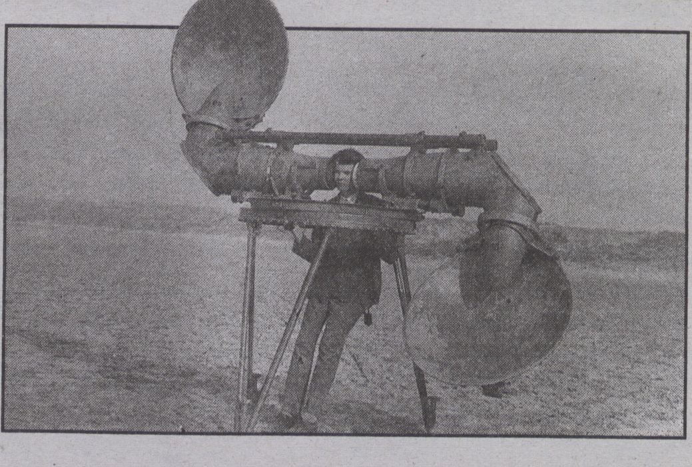
The 'poetic expression’ or the 'artistic experiment’ is a method of understanding that trans-
gresses apparently incompatible categories, we believe, and which in research may help to re-
flect the subject matter at hand. A .s' the French philosopher Gaston Bachelard writes in Poetics
of Space, with a reference to Baudelaire who called certain Goya lithographs "vast pictures in
miniature': * The poet has shown us that large is not incompatible with small" (171). As a
miniature the expression of the poet leads us from perception (the empirical: the image, the
poem, the sound/music) into a larger world of imagination: a world beyond incompatibilities
in which the unspeakable is spoken, silence is heard, and the invisible visualized. To put it differ-
ently, the poetic expression (whether in the form of an interface, an art installation or a poem) is a
method for dissolving and reflecting incompatibilities between sound and silence, past and pre-
sent, truth and fiction.
The echo machine will be part of a festival on the 18th century in the city of Aarhus,
Denmark, March 2012.
A pre-radar approaching
plane listening device,
developed for the Dutch
army as part of air
defense systems
research between World
Wars 1 and 2, produced
by Goertz,
Czechoslovakia (Museum
Waalsdorp, Holland)
Works cited:
- Bachelard, Gaston. The
Poetics of Space. Boston:
Beacon Press, 1994. Print.
- Serres, Michael. Genese.
Copenhagen: Gyldendal.
1998. Print.
ECHOES ECHOES ECHOES
Poetic expression as research method
By MORTEN BREINBJERG
An echo machine is proposed to serve as an interface to the
past by capturing resonating echoes. The pre-radar listening
device for detecting approaching airplanes that can be seen in
the picture inspires this machine.
Operating the machine will enable the user to listen to the soundscape of the city and to
capture auditory fragments relating to everyday life. The user will, for instance, hear stories
told by local legendary figures, hear legal judgements being delivered at court, overhear gos-
sip being told at the city well, and more. The machine will be able to be rotated 180 degrees
in order to control the direction of listening and also there will be a zoom function allowing
the user to "move” into the soundscape. Technically the machine is connected to a game en-
gine in which the soundscape has been organised.
The idea of building a machine that brings us back to the past by pretending to cap-
ture resonating echoes is a poetic expression that seems incompatible with traditional re-
search methods. However, as Michel Serres writes in his book Genesis, in which he reflects
upon the concept and the phenomenology of sound, an echo is the first instigation of order,
since the echo is a repetition that through redundancy leads to a rhythm (108). The idea of
resonating echoes immediately makes one start reflecting on the forgotten soundscape: What
did it sound like? What were the dominating sounds in the past urban context, and how differ-
ent was it in comparison to today's soundscape? In short, the idea of resonating echoes urges
us to start figuring out the auditory organization of the past. Although the effort seems incom-
patible with a truthful presentation due to the fact that there are no sounds to listen to, as the
historical sounds have long been silenced, the silence of the past is what makes you listen in the
first place, since silence is exactly the concentrated moment of listening.
The idea of building a machine that brings us back to the past by pretending to capture resonating echoes is a poetic expression that seems incompatible with traditional researcl
By CESAR BAIO
In a culture of computer ubiquity, of "cy-
brid" networks and all sorts of transforma-
tions that unfold from technical mediation
processes, what is the artist's role when
dealing with mediation technologies? It is
a question with no unique or ultimate an-
swer, but ft's essential in every aspect of
artistic and theoretical practice.
With the exponential increase of inter-
disciplinarity between the fields of arts and
media engineering, methods and theories
used in the field of technology are progres-
sively incorporated to the art field, which
confuses the differences between artistic
propositions and those made by the media
industry. According to Arlindo Machado,
among the greatest challenges posed to
artists, is how to deal with the advanced
state of mediation technologies. In fact, it
is very common to find in media art events
a great number of works that are focused
on technical and instrumental aspects of
the development of media devices. Even
though they might seem interesting at first
sight, it doesn't take long until you notice
that these works are just one more func-
tional update, instead of an attempt to ex-
plore aesthetic or critical possibilities.
These dynamics create a tension be-
cause a large part of these procedures
seem to be incompatible with the subver-
sive and deconstructive attitude of artists,
who, up to the 1990s, were involved in crit-
icising industrial patterns and mass enter-
tainment while operating through the de-
construction of TV equipments, videotapes
and other media devices. This context pro-
duces a lot of questions when you consider
contemporary media art production. Could
we consider that artist's and engineer's
methods and attitudes are merging, thus
leading artistic practice to search in the
same way for the development of new me-
dia devices? Contemporary production
should be evaluated'for its critical compo-
nent, its technological quantum, or could
there be other criteria sufficiently estab-
lished for that? These questions allow us to
investigate the compatibility between the
models of art and media technologies in
terms of knowledge production.
Apparatus
Vilem Flusser's idea of 'apparatus' al-
lows us to approach these questions from
a privileged point of view, by. delineating
art and engineering as two distinct fields,
from which different problems emerge.
This happens because technology is dis-
placed from the position of an instrument
to the perspective of media engineering,
and thus becomes a way for the artist to
bring tensions to vectors of political, ethi-
cal, economic, epistemic dimensions,
which are encoded in the abstract layers of
mediation technical devices.
In this way, it would be possible to con-
sider the hypothesis of a displacement of
the artist's position, who would then begin
to be understood as a programmer of ab-
stract machines, considered in terms of
the Flusserian apparatus. These proposi-
tions include subversion strategies, how-
ever, may also include media archaeology,
in an attempt to identify how the abstract
dimensions of apparatus can be compre-
hended in virtual environments, cybernet-
ic, mobile devices or networks that operate
in sociocultural contexts. Accordingly, the
art of the apparatus could be considered
an effective integration of art, science and
technology, in compliance with the recov-
ery of the Greek idea of technè, as ques-
tions proceed to concern matters beyond
functionality and instrumentation, ascend-
ing to the speeches that make it possible
to conceive the world, the politics of im-
ages and sensitive experience.
Works cited:
- Flusser, Vilem. 0 universo das imagens tecnicas:
elogio da superficialidade. Sâo Paulo: Annablume,
2008. Print.
- Machado, Arlindo. Arte e midia. Ed. Jorge Zahar.
Rio de Janeiro, 2007. Print.
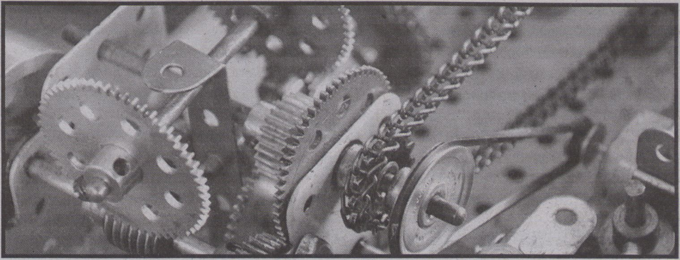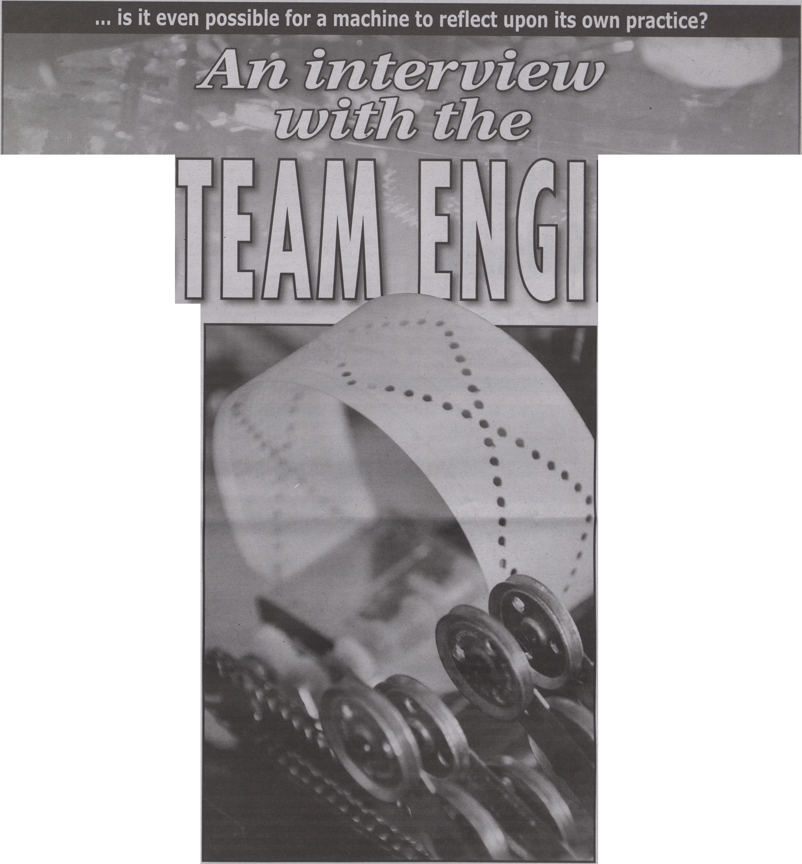open to answers not coinciding with our de-
terministic understanding of the machine's
answer to a given question. A central point to
this questioning becomes the relationship be-
tween hearing what you know, and knowing
what you hear; thus being sensitive to the fact
that the machine says something that is unex-
pected, and not automatically focus the listen-
ing on what answers would live up to expecta-
tions. Furthermore, this must happen as a
dialogue, whereby the questions are molded
after the answers given.
Works cited: Riis, Morten. "Steam Machine Music". 2010. Web. 5 Jan 2011. <http://vimeo.com/16995143>
This article takes the form of a
classic portrait interview. A se-
ries of prepared questions are
asked, which the guest then
tries to answer.
These answers then produce new more
improvised questions, and ultimately result in
what could be described as a dialogue. But
what differs in this particular portrait inter-
view is that it is not a person who is being in-
terviewed, but a machine; a special machine
that is very central in my work both as an artist
and a researcher, namely a homemade me-
chanical musical instrument driven by a
steam engine (Riis). So instead of asking the
man behind the machine, I want to convey my
questioning directly to the machine. At the
same time, this questioning could also be seen
as an attempt to expose some of the hidden
qualities of technology; hidden aspects and
functionalities that entail reflection both for
the interviewer and the interviewed, but then
again is it even possible for a machine to re-
flect upon its own practice?
How do you conduct an interview with a
machine? First of all you have to talk the same
language, a major quest for many computer
scientists during the last 60 years. This would
imply teaching the machine to understand the
language that we speak, and not the other way
around. It could of course be argued that learn-
ing a programming language would be compa-
rable with learning the language of the ma- The Steam Machine (Morten Riis, 2011)
chine, but it is important to understand that
the syntax of programming languages are con-
structed from conventions that mostly follow
rules originating from daily spoken language.
Questioning
In order to excavate the hidden stories that
the machine holds, we must ask the right
questions, and at the same time be aware that
this is a two-way communication, where all
senses must be open; open to answers coin-
ciding with our expectations, but especially
By MORTEN RIIS
Language
Listening
By speaking direcdy to the machines deep-
est desires and dreams, and consequently as
an observant-listener, I now know that insta-
bility is the true voice of the machine, a voice
that often is overheard by the fast-growing
quest of technology. It is a voice that the musi-
cal steam machine maybe pronounces more
clearly than other machines, a voice that tells
us something about the relationship between
the process and the finite. It could even be ar-
gued that the concept of a predetermined out-
put from a machine does not exist? Maybe the
perfect finite output is an illusion upheld by
the imaginative notion of infallible technology.
The machine continues to report about
how instability, randomness and the possibil-
ity of error is something that occurs because of
its physical characteristics, it is something in-
tegrated in the connections between trans-
mission and exchange of energy and motion,
that takes place in the various parts of its con-
struction; conditions that on one hand makes
certain functionalities possible (the machine’s
purpose: to create a musical expression), and
at the same time challenges this expected
functionality. In the worst case, this function-
ality is absent.
Machine story
This interview has been an attempt to ask
some in-depth questions to a music machine.
The machine has given us many answers,
which were only possible to hear if we paid
sufficient attention to what was being said.
The interview developed into a dialogue, and
became more and more interesting because
the answers given were unexpected; answers
that have given rne things to reflect upon, and
maybe it is not exclusively this music ma-
chine’s story; maybe this is a story that can
give a different perspective on all the ma-
chines we surround ourselves with.
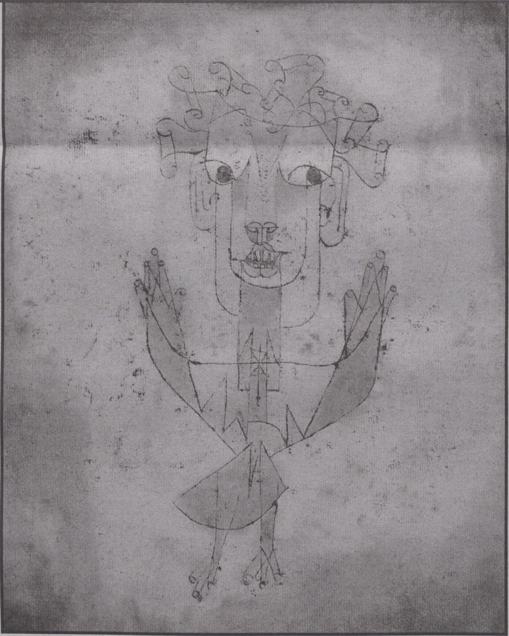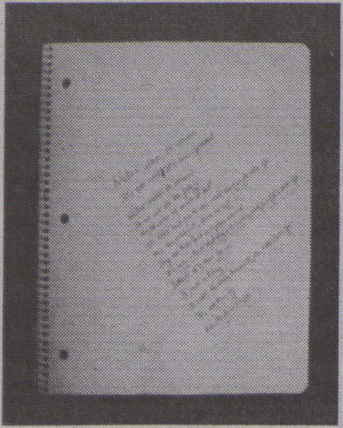in the Kyoto treaty. We model national hap-
piness. Yet as Villem Flusser noted long ago
in “On the crisis in our models" if we “lose
confidence” in our “objective models" as we
now have, "it becomes difficult to find our
way in the world” (76). What to do?
Models and
the Future
By ANDREW MURPHIE
We have become too accus-
tomed to living with Waiter
Benjamin's angel of history.
In the Paul Klee painting of 1920 that in-
spired Benjamin, the angel was new (Angé-
lus Novus). Now it is old, and common. We
are now used to history as the “one single ca-
tastrophe which keeps piling wreckage upon
wreckage” (392). The angel of history has be-
come a cartoon, a caricature of horror. Yet
this cartoon is also the catastrophe of the
present and the future. Endlessly confront-
ing and trying to fix the mess of history, we
no longer really know what to say to the fu-
ture. We seem to be entering into a collective
nightmare in which we must speak to save
the world yet cannot, physically, get our
mouths or tongues to work.
Failed models
The past we try to fix is increasingly in-
compatible with either present or future.
How have we got around all this? A practical
answer, both the right and wrong answer, is
that we have done so by modeling. Models,
right or wrong, and they are never complete-
ly right, are always power, for us, over us. We
allow ourselves to be taken up by models. We
model everything, obsessively. We do so to
simply keep going, so we to know what to do
next. This is perhaps the most insistent ques-
tion we face—what to do next, not the ques-
tions of life or death or who we really are?
If I look with the angel of history back-
wards, I see a remarkable tangle of powerful
but mistaken and failed models. We live in
this tangle, in the general confusion of mod-
els with shared if faulty and never quite com-
patible assumptions. The tangle is found in
Angelus Novus by Paul Klee (1920) (Image in public domain)
economics and business; media, communi- micro-activity of the brain. We can’t just step
cations and computing; psychology, man- outside of this tangle. Most of our lives is
agement, education, and cognitive and neu- modeling. Even our moment to moment
roscience, etc (Edwards). At the heart of all perception and action involves a folding
this is something like a neat model of symbol forth and sometimes micro-correcting of on-
processing with clear inputs and outputs, going modeling. Much of this in turn draws
compatible neither with history nor an un- on this tangle of big models. We model "per-
predictable future, and certain not with the formance" and "productivity'’ in the work-
actual events of either everyday life or the place. We model climate and responsibility
The time is ripe: A note
on nature, by Ioana
Jucan
-AN-
EXPERIENŒ
-0F-
THOUCHT
By IOANA B. JUCAN
I would like to propose “en-
durance" - the capacity of
continuing through time in
spite of change - as an alter-
native to the much used (per-
haps overused) notion of sus-
tainability. Sustainability and
sustainable development, de-
fined as “development that
meets the needs of the pre-
sent without compromising
the ability of future genera-
tions to meet their own
needs” (World Commission
on Environment and Devel-
opment 43), are key concepts
in terms of which discourses
on nature have been often
framed in recent decades.
Underlying such discourses
has been a longstanding con-
cern with the relation be-
tween nature and technology,
premised upon an incompat-
ibility between the two.
In one iteration of it, this
concern takes the form of the
argument regarding "the dis-
enchantment of nature" - a
term introduced by Max We-
ber - determined by technol-
ogy. In the story of the disen-
chantment of nature, as
Bronislaw Szerszynski ex-
plains (5), "as technology’s
powers advance, those of na-
ture withdraw.” Technology
renders nature fully explaina-
ble - calculable and predicta-
ble. Disenchanted by tech-
nology, nature becomes "a
standing reserve" (Heidegger
257) to be used (up) and,
thus, in need of preservation.
At stake here is the issue of ra-
tionality/reason, given that
calculation is traditionally
conceptualised as being the
essence of reason.
It is precisely this link be-
tween rationality/reason and
calculation that must be un-
done, according to Jacques
Derrida. Derrida undertakes
to rethink reason beyond tel-
eology - beyond (and with-
out) necessary determination
and certainty. “A reason must
let itself be reasoned with,”
writes Derrida (159). Unlike
Kant’s teleological reason,
which annuls the eventful-
ness of what comes, "begin-
ning with... the technoscien-
Measure for
Endurance
tific invention that 'finds’
what it seeks” (Derrida 128), a
reason that lets itself be rea-
soned with makes possible
the unconditioned event
(contingency).
To build on Derrida's
thought, I suggest that rea-
soning with reason is linked
to measure (rather than cal-
culation) - to the perfor-
mance of figuring out and
keeping (the right) measure.
"Measure" here means limit,
proportion, and standard of
comparison. It is the site on
which - through the practice
of care, of awareness - seem-
ingly incompatible things
New models
First, realise that the old models have of-
ten failed. To do that, we need to see them for
what they are, allow ourselves to feel their
dead weight in our living. We especially need
to understand what habits they form in us.
Second, in becoming more aware of our
models, we do need to give many of them up.
We need to subtract. Subtraction actually
frees things up, gives back the potential for
the new (Deleuze). Third, we need to allow
for more flexible models. As Gilles Deleuze
and Félix Guattari might say, we need to be-
come "equal to the event... or the offspring of
one’s own events" (159). Crudely put, we
need, again and again, and this is the real
work of serious modeling, to adjust our mod-
els to what is really happening. And by "ad-
just our models," I don't just mean adjust the
content but still allow ourselves to keep the
fundamentals. It’s often the fundamentals
that are the problem. In media, political and
social life we need something like what I've
called elsewhere "ghosted publics" and "un-
acknowledged collectives”—ways of living
that step outside of recognised, big modeled
existence.
Works cited:
- Benjamin, Waiter. Selected Writings, 4: 1938-1940.
Harvard: Harvard University Press, 2003. Print.
- Deleuze, Gilles. "Un manifeste de moins."
Superpositions. Paris: Les Éditions de Minuit, 1979.
Print.
- Deleuze, Gilles and Guattari, Félix. What is
Philosophy? New York: Columbia University Press,
1994. Print.
- Edwards, Paul N. The Closed World. Cambridge, MA:
MIT Press, 1996. Print.
- Flusser, Vilém. Writings. Minneapolis: University of
Minnesota Press, 2002. Print.
- Murphie, Andrew ) "On Not Performing: the Third
Enclosure and Neofeudal Fantasies." Scan 8.1. (2011).
Web. 19 Dec. <http://scan.net.au/scan/journal/
display.php?journal_id=156>
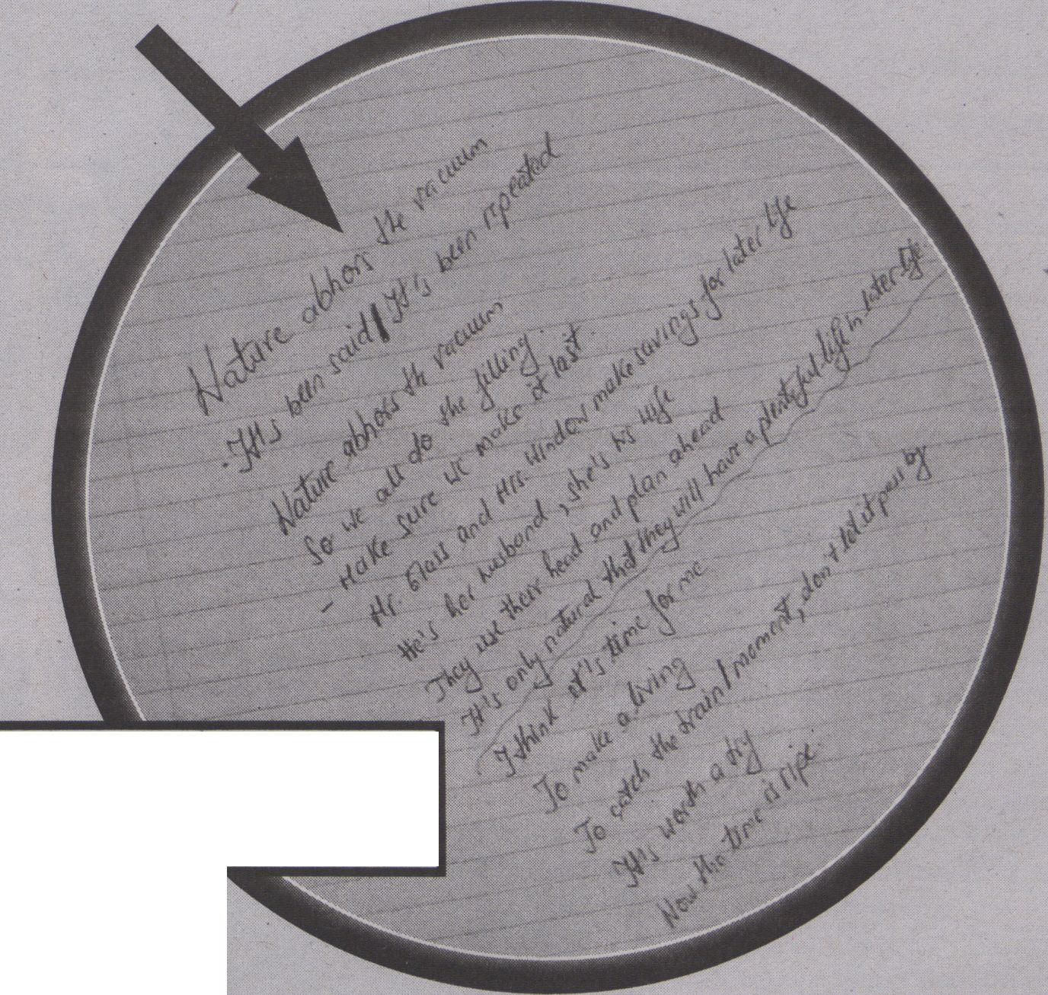A spectre is haunting Me-
dia Art - the spectre of dig-
ital decay. All the powers of
old school archiving have
entered into a holy alliance
to exorcise this spectre: Ac-
ademics and industry, Mi-
crosoft and Free Software,
pirates and copyright law en-
forcers.
By NINA WENHART
the interface between such a
concept of technology and
such a concept of nature the
possibility of endurance po-
tentially emerges.
and beings can be brought to-
gether and put in relation to
one another in ways that
make possible the emergence
of the event. As such, meas-
ure becomes an aesthetic
procedure that embraces un-
predictability and a form of
knowledge that grows from
uncertainty, from a place of
not (fully) understanding.
The right measure is a
matter of figuring out what
works for each person indi-
vidually and in relation to the
others. It materialises in a
specific style of life - a life of
care, an examined life.
Socrates stated that the unex-
amined life is not worth liv-
ing; perhaps there is value in
this thought.
My claim is that reason -
or reasoning with reason -
can be an aid in this experi-
ment of figuring out the right
measure. More than this, I
would like to propose - per-
haps as an experience of
thought - that reason/rea-
soning with reason potential-
ly opens the way for another
concept of technology, differ-
ent from the modern one em-
phasising the power of tech-
nology to overcome
contingency and to offer the
certainty characteristic of tel-
eological reason (as calcula-
tion). This concept would be
closer to the one with which
the classical thinkers (Plato
and Aristode, among others)
operated. This is the concept
according to which “technai"
- "intrinsically uncertain and
unpredictable in their out-
comes" - “were activities in-
volving the making of things
in a way which was guided by
logos, by reason” (Szerszynski
52). To be clear, in this formu-
la, reason would be used in
the non-teleological sense. At
Works cited:
- Derrida, Jacques. "The 'World' of
the Enlightenment to Come
(Exception, Calculation,
Sovereignty)/' In Rogues: Two
Essays on Reason. Trans.
Pascale-Anne Brault and Michael
Naas. Ed. Werner Harnacher.
Stanford, CA: Stanford University
Press. 2005. Print.
- Heidegger, Martin. "The Question
Concerning Technology." In
Philosophy of Technology: The
Technological Condition: An
Anthology. Eds. Robert C. Scharff
and Val Dusek. Malden, MA:
Blackwell Publishing. 2003.
pp.252-265. Print.
- Szerszynski, Bronislaw. Nature,
Technology, and the Sacred.
Malden, MA: Blackwell Publishing.
2005. Print.
- World Commission on
Environment and Development.
Our Common Future. Oxford:
Oxford University Press. 1987.
Print.

EXCLUSIVE

MATERIAL
This research explores experimental
and speculative approaches to archiving
and preserving Media Art. As such I define
artistic and academic theory-practices
that dare to think beyond the confines of
traditional strategies to see if and how
they can contribute new aspects of deal-
ing with failure, decay and obsolescence
- In other words, the everyday challenges
of archiving and preservation.
While recent years have seen the
spring of numerous research Initiatives
for preserving and archiving Media Art,
the question remains if these artworks are
'archive-able' at all, in the traditional
sense. Database archives and research
initiatives have been launched and then
disappeared again, without offering solid,
sustainable solutions. Increasing techno-
logical decay and the loss or subsequent
inaccessibility of data not only poses a
threat to Digital Cultural Heritage - of
which New Media Art constitutes an im-
portant part - but also demonstrates the
shortcomings of traditional archival prac-
tices when applied to this field.
Speculative archiving
Speculative archiving starts by under-
standing a work of art as an ongoing pro-
cess. It therefore qualifies artistic re/pro-
duction and radical modifications as
legitimate ways of contributing new as-
pects to the discourse of archiving Media
Art. Rather than in deep storage, solu-
tions for sustainability seem to be provid-
ed by the network, in which artistic prac-
tices of hacking, remixing and Open
Culture, of versions, glitches and pirating,
of sampling, appropriation and wild dis-
semination, are creating novel perspec-
tives on digital originals and mutant life
forms on a daily basis. The accelerating
loss caused by (politically-implemented)
incompatibilities of different hardware, of
software versions, of decay and obsoles-
cence force us to rethink the archive and
its processes. It no longer is a passive
place, but has become a hyperactive non-
space
By grasping the 'currents of current
culture', speculative archiving is a critique
of the standard model for particles and
forces in economic, academic and cultural
realities, the particles that matter in this
context, the subtext of coded cultures. It
departs from traditional archiving in three
major points: Firstly, that the artwork is
not a product or a closed entity, but a pro-
cess and open system; Secondly, that the
scope of an archive can no longer be re-
strained to storage and the prolongation
of the shelf-life of assets, but has to em-
brace the circulation of copies, versions,
remixes and other forms of modifications;
And thirdly, that the original - the holy
cow of art history - is finally slaughtered
and Walter Benjamin's concept of the aura
in his seminal text "The Work of Art in the
Age of Mechanical Reproduction" has to
be rethought with a different mindset.
Speculative archiving is a re/search
for/about methodologies that are compat-
ible with the complex and changing issues
of Media Art. Far from seeking or resulting
in a standard procedure, it is developing,
testing, applying and analysing a diverse
range of fluid, modular strategies and
methods. On the massively moving waves
of technological development, Media Art's
survival depends on how well it can adapt
to these constant changes, not anchored
to one standard that might be short lived,
but freely floating with the best practices
available. For in the end, a moving ship is
safer when on the open sea than tied to
the coast.
"Know ye, now, Bulkington? Glimpses do
ye seem to see of that mortally intolerable
truth; that all deep, earnest thinking is
but the intrepid effort of the soul to keep
the open independence of her sea; while
the wildest winds of heaven and earth
conspire to cast her on the treacherous,
slavish shore?" (H. Melville, Moby Dick,
Lee Shore chapter)

The accelerating loss caused by (politically-implemented) incompatibilities of different hardware, of software versions, of decay and
obsolescence force us to rethink die archive and its processes. It no longer is a passive place, but has become a hyperactive non-space.


THE REVOLUTIONIZATION

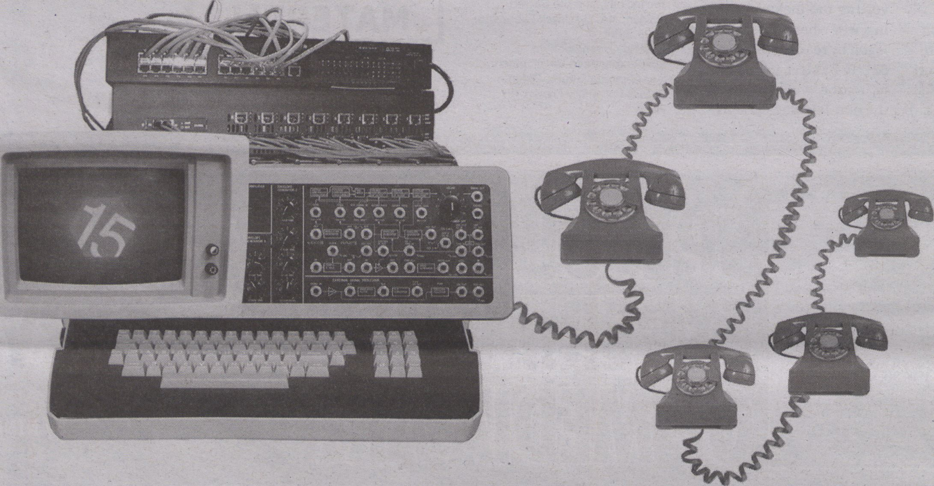OF COMMUNICATION
VE
f OFFICIAL MISCOMMUNICATION \
\ PLATFORM OF TRANSMEDIALE 2012 g
R15N.NET
AN INNOVATION FROM
TELEKOMMUNISTEN.NET W
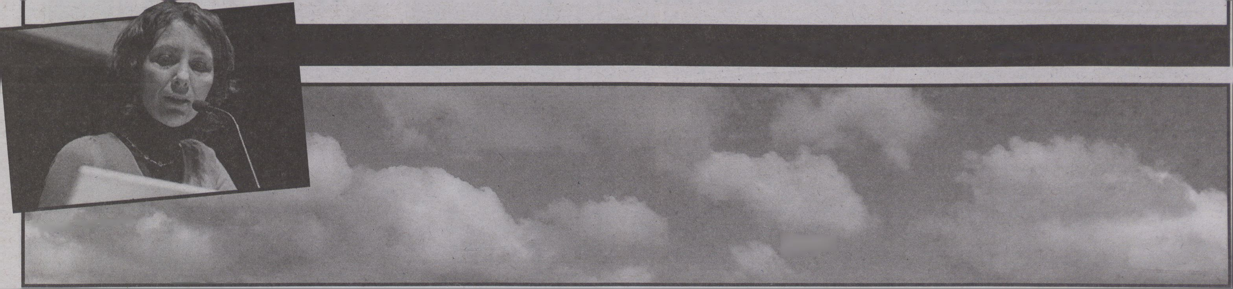"What is the impact of the current economic crisis on the life of the
European society? What is the relation between financial crisis and political
imagination today?”- Scepsi - European School of Social Imagination
MARKETS

ucTCDArcurcic
nETEROuENESI),
ronuiTU
iiiiiivT i n,
INCOMPATIBILITY

neoliberal capital
and immaterial
labor power
By TIZIANA TERRANOVA
A
t the beginning of computing and
networking, incompatibility was
a sign of heterogenesis. It was be-
cause computers had multiple genealogies
and specifications that networking had to
begin with the invention of ways to connect
the incompatible. Incompatibility thus pre-
ceded and followed networking - as when
preexisting heterogeneous mainframes and
mini computers had to be connected or
when new types of machines were invented
and had to be integrated. With the introduc-
tion of the principles of open architecture in
1973, the primacy of differentiation and its
eternal return was established. Shaped by
a hacker ethics that valued openness and
connection, protocological power was thus
also the expression of a new kind of connec-
tive synthesis producing the bare conditions
of cyberspace. One could even go as far as
saying that incompatibility lies at the point
where the chaotic genesis of networks as
open topologies starts. (Terranova 2004)
As computers became personal, escaping
corporate and university labs to make it into
the homes of computer amateurs and cyber-
enthusiasts in the nineteen eighties, incom-
patibility marked a forking of the machinic
phylum of personal computing. Incompati-
ble software pointed to an uneven polarisa-
B
tion of populations of users - the vast major-
ity on the one side, the small, but obstinate
minority on the other. On the one side, the
great Microsoft/IBM masses, multiplied
through the techniques of cloning and re-
verse engineering, made compatibility the
privilege of the majority. Operating within
an MS-DOS and Windows system meant
putting up with clunky design and buggy
software, but also being able to take for
granted one’s compatibility with almost eve-
rything. On the other side the hard core of
Apple and Macintosh users, locked into
smoothly designed microworlds, made in-
compatibility the mark of an exclusive mi-
nority (Eco 1994). Living within a MAC-OS
enviroment involved limited communica-
tion with the larger world of software devel-
opment, but gave you the satisfaction of
sharp design and smooth processing. It will
be only in the late nineties and early two
thousands that the great divide will be
bridged but only in order to produce another
one (proprietary Apple and Microsoft on the
one hand, and Open Source Linux and
Ubuntu on the other).
Overcoming
incompatibility
In the nineteen nineties, overall, incom-
patibility stops driving the evolution of the
network and becomes a hurdle in the way of
smooth, universal connectedness as soft-
ware turns modular and eminently linkable
and computing becomes ubiquitous. By the
year 2000s, incompatibility signals almost
exclusively the accumulation of the techno-
junk generated by half a century of comput-
ing. Incompatible software is a sign that one
is lagging behind, of unplanned and unwel-
come obsolescence. As fully modularised
software objects knit together even further
the space of the web 2.0, incompatibility has
become a matter of media archaeology: it is
about old machines and old software, about
files that refuse to be opened, about what
was once new media art that becomes inac-
cessible. Overcoming incompatibility be-
comes the work of the info-artisan - carefully
reconstructing appropriate conditions for
old software to run again, drawing out infor-
mation locked within old formats.
And yet, incompatibility as the productive
limit of the open network, was never just
about technical machines or the hacker eth-
ics, but necessarily referred back to the exist-
ence of a larger, transversal social machine
that invested in expansive differentiation as
the engine driving value-production (Laz-
zarato 2002). In the forty years spanning the
history of popular computing and network-
ing, new, more powerful machines, platforms
and new media objects have incessandy suc-
ceeded each other producing the network as
a smooth space of compatible differentiation.
Economic and libidinal investment in growth
and innovation supported by exponentially
increasing processing power also had an im-
portant effect: it produced the conditions of
compatibility between the expansion of neo-
liberal capital and immaterial labour power.
For the longest time, it seems, informa-
tional capital and the networked multitudes
were bonded together by the desire for pro-
liferating, compatible, connectable, minia-
turised machines and ever-increasing com-
puting and connecting power. Struggles
around the status of property and control of
information flows never crossed the thresh-
old of an incompatibility able to produce a
true forking line as long as Moore Law’s act-
ed as catalyst, mediator and midwife to the
compatible convergence between intrinsi-
cally heterogeneous and conflictual forces. It
might have been this transversal relation,
rather than the addictive drive to compulsive
communication identified by Jodi Dean, that
allowed not simply the capture, but the com-
patible relation between the corporate Inter-
net and precarious labour (Dean 2010). Not
even the nervous exhaustion denounced by
Franco Berardi has deterred the networked
multitude from desiring such compatibility.
Fuelled by credit and liquidity generated by
financial capital, flying in the face of the di-
minishing returns on actual work performed,
immaterial labour power has populated its
homes with electronic, connectable devices
and turned its body into a mobile, connect-
ed, hyper-communicative node.
But what is going to happen to such com-
patible convergence once the investment
strategies of neoliberal capital change? Aren’t
the financial and fiscal crises that started in
2008 producing a becoming-incompatible of
financial capital and immaterial labour pow-
er? Up to which point is the exponential
growth of immaterial capital going to be bal-
anced out by the exponential growth of dis-
tributed computing power? For how long is
the exponential curve drawn by Moore Law
going to guarantee the compatible relation
between these two opposing libidinal forces?
Where is the threshold at which the accumu-
lation of liquidity by one side of the polarity is
no longer balanced by the growth of income
and purchasing power on the other? When
will the consciousness of the inequality of
money paid in return for work and money
generated by financial transaction and rent
become unbearable? What happens when
forms of public welfare guaranteeing the sus-
tainable reproduction and reinvention of the
living conditions of immaterial labour power
are swallowed up by debt? Under what con-
ditions, that is, will the relation of compatibil-
ity between financial capital and networked
labour power be broken?
Works cited:
- Berardi, Franco. 'Cognitarian Subjectivation.’ e-flux
2011. Web. Dec. 22. <http://www.e-flux.com/
journal/view/183>
- Dean, Jodi. Blog Theory: Feedback and Capture in
the Circuits of Drive. Cambridge, UK: Polity Press,
2010. Print.
- Eco, Umberto. "La bustina di Minerva." L’ Espresso.
Sept 30, 1994. Print.
- Lazzarato, Maurizio. Puissances de l’invention. La
psychologie économique de Gabriel Tarde contre
l'économie politique. Paris: Les Empêcheurs de
penser en ronde, 2002. Print.
- Terranova, Tiziana. Network Culture: Politics for the
Information Age. London: Pluto Press, 2004.

Incompatibility lies at the point where the chaotic genesis of networks as open topologies starts.
J
Tiziana Terranova
mn
■ ⁻ '■■■ ' ■■


When digital culture becomes
software business
Controlled
Consumption
Interfaces
By S0REN POLD & CHRISTIAN
ULRIK ANDERSEN
We live in the era of cultural computing. New
IT gadgets - such as game consoles, tablets,
smart phones and e-readers - are sold as plat-
forms for cultural content. But how is this
changing digital culture?
Culture has broadly been conceptualised
through two different, opposing approaches:
the object-oriented and the exchange-oriented.
One is concerned with objects, goods or
works, that have an author or a brand and is
seen as stable, also when put in different rela-
tions and contexts. The other sees culture as a
process made up of collective collaboration,
sharing and a constant creative process
(Stalder). The object-oriented fits into tradi-
tional copyright legislation while the
exchange-oriented is more related to cultural
practices, collaboration and remix.
IT and digital culture has been a primary
battle scene for this discussion - between anti-
pirates and pirates, between established rights
holders and new emerging media artists, or
between the old content industries like the
movie and music industry and new disruptive
business initiatives like Napster and Google.
For a long time, it looked like the cultures of
sharing and exchanging were winning the bat-
tle over a paralysed traditional content indus-
try, but currendy companies with their roots
in new media such as Apple, Microsoft and
Amazon are developing new business models
and software infrastructures in order to offer a
model for cultural computing that handles the
inherent dichotomies of culture. One emerg-
ing and apparently extremely successful busi-
ness and infrastructure model is controlled
consumption. As we will discover below, this
model can both be seen as a potential and
threat to digital culture.
Controlled Consumption
Where the music industry failed in devel-
oping business models that both take advan-
tage of the net and prohibits file sharing, soft-
ware companies seem to rule by implementing
new business models of cultural consump-
tion. One of these business models can be
characterised by the term “controlled con-
sumption" developed by Henri Lefebvre in
1967, and applied to contemporary publish-
ing and book trade by Ted Striphas. Striphas
summarises controlled consumption in four
principles:
- A cybernetic industrial infrastructure inte-
grating and handling production, distribu-
tion, exchange and consumption is developed
around the product.
- The consumption is controlled through
programming that closely monitors consumer
behaviour and the effects of marketing
through tracking and surveillance.
- Controlled obsolescence is programmed
into the product limiting the functionality and
durability.
- The overall effect of controlled consump-
tion is a significant reorganising and troubling
of specific practices of everyday life.
Controlled consumption precisely charac-
terises business strategies from both cultural
software industries (e.g. the way the XBox and
Playstation 3 game consoles include online
Shops), the way software companies develop
cultural business models (e.g. Apple’s IOS de-
vices and their integration of ¡Tunes and App-
Store) and the way new cultural digital formats
are handled (e.g. the way Amazon has devel-
oped the Kindle bookstore and e-reader in or-
der to handle e-books). Apple’s IOS iTunes
and Appstore, Microsoft’s Xbox Live, Sony’s
Playstation Network (PSN), Amazon Kindle
are all examples of controlled consumption
strategies that work along the four principles,
though there are significant differences in how
tightly the control is exercised.
The model of controlled consumption
opens up for a very particular business model
for cultural software. It works for some uses
but also standardises software culture to a
specific object-oriented model, where the
consumers are forced to adapt to a specific,
rather passive model of consumption framed
by the licenses and the technology. In this
way, it also harbours a specific model of cul-
ture, which excludes potential new develop-
ments of a culture of exchange. Furthermore,
it is a ready-made business model for artists,
and while this can be seen as an advantage it
also limits the possibility for artists to engage
in developing new alternative ways to engage
with their audience, e.g. through business
models that build on collaboration, engage-
ment or just other ways of collecting payment.
In this way, it is potentially stifling innovation
in digital culture, and we need to look for al-
ternatives.
Works cited
- Stalder, Felix. Open Cultures and the Nature of
Networks. Frankfurt am Main: Revolver, 2005. Print
- Striphas, Ted. The late age of print: everyday book
culture from consumerism to control. New York:
Columbia University Press, 2011. Print
" "Hackergroup,"
"hacktivist
organisation," "cyber
terrorists," this is how
many journalists
mm mm mm
describe Anonymous. "
cartin Wiedemann
nil
ByCAROLIN
WIEDEMANN
With "Operation
Payback,” the
campaign for the
support of WikiLeaks in De-
cember 2010, and the contri-
butiontothe Arab Spring 2011,
Anonymous has become fa-
mous in the mainstream me-
dia. But the outdated descrip-
tions in the newspapers don’t
fully capture the new phe-
nomenon: Anonymous is not
a group that can be defined by
its members or leaders and it
has no roster or base of opera-
tions. Anonymous inspires an
approach to theorise process-
es of collaboration within the
so-called social media, and
to conceive of collectivity be-
tween the logics of swarms,
networks and multitudes con-
stituted by human and non-
human actors.
Anonymous pretends to
be a collectivity without lead-
ers; that all humans can be
part of, that there are no crite-
ria for being anonymous. “We
are all anonymous," it shouts
as it associates and attacks.
Within the processes of on-
line (co)operation, a rhetoric
of inclusion is activated that
undermines traditional logics
of representation by creating
new logics of relation. The
spontaneous figure of inclu-
sion works differently than
traditional identities of inclu-
sion and representation like
the ‘Italians; ‘women’ and
'Socialists! It rejects current
manifestations of the organi-
sation of representative de-
mocracy; representation as
speaking on behalf of others,
and categories that form a
unified 'we! The momentary
representation of Anony-
mous is based on its brief ap-
pearance. It unifies emer-
gence and existence, and
exists never as fully constitut-
ed but only in the process of
ANONYMOUS EMERGES IN, AND AS, A CONVOL
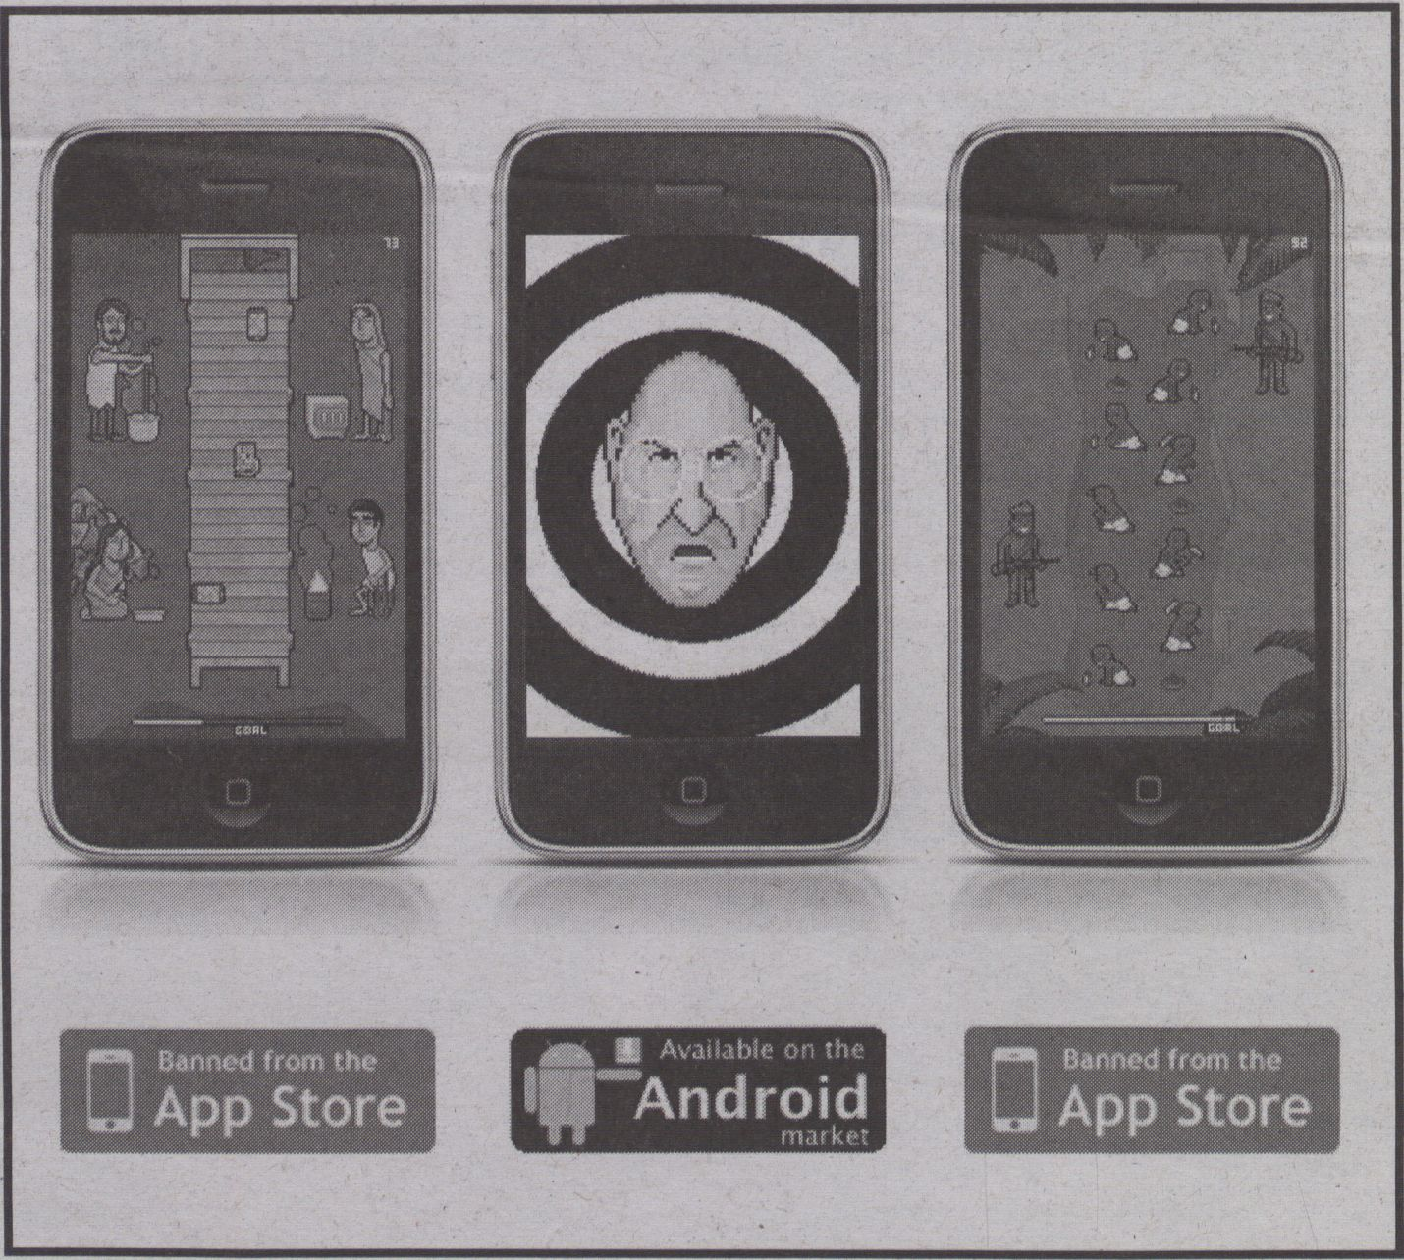
Phone Story, a game for smart phones by Molleindustria, 2011 (banned from App Store)

+


by Anonymous
f tANONYMOUS
constitution - it is only in the
communication. In an "Open
letter to the World,” Anony-
mous says: “We have begun
telling each other our own
stories. Sharing our lives, our
hopes, our dreams, our de-
mons. (...) We are not so dif-
ferent as we may seem."
Anonymous reminds us of
Spinoza's concept of the mul-
titude and specifies this theo-
rem: In terms of the multi-
tude there is, for example, as
Eugene Thacker pointed out,
the central question of how
the common can be pro-
duced while respecting dif-
ference. Anonymous an-
swers: you communicate and
cooperate anonymously on-
line.
And indeed this sort of an-
onymity could avoid those
identifiable initiators and
what regular users decide is
to be said and seen, and
therefore conserve power
structures. But the space that
Anonymous emerges in is
nevertheless structured by an
architecture of code and pro-
tocol, by the dispositifs of
communication and the bio-
politics of software (Gallo-
way), in which the machinic
and the human become en-
trenched and impossible to
disassociate (Haraway).
Anonymous emerges in, and
as, a convoluted interplay of
protocols, cultural practices
and technical infrastructures.
Questions of the digital di-
vide, of who and what can be
part of the flow of communi-
cation have to be taken into
account and have to be ex-
panded and upgraded. The
famous question by postcolo-
nial thinker Gayatri
Chakravorty Spivak "Can the
subaltern speak?" is not only
a question of access to sound
and to computers that might
transform tones into letters
on the internet but rather a
question of the position, of
situating and the hegemonies
within communication, thus
a question of exclusions that
are still produced even if all
people seem to have equal
voices and votes when com-
municating anonymously.
Many theorists have writ-
ten about the concept "be-
yond representation" and
"the common" in recent
years, and asked what non-
representational politics may
look like (Tsianos and
Papadopoulos, 253). If the
modes of control, power and
production in the age of net-
works are taken into account,
Anonymous allows us to dis-
cuss ideas of new forms of
collectivity as a challenge and
dislocation of relations of
domination and as an escape
of mental border regimes and
boundaries. This new collec-
tivity inspires us to (re)think
the constitution of the social/
political beyond antagonism
and creates new narratives
that might transform logics of
representations, and thus the
conception of research and of
knowledge production.
Works cited:
- Galloway, Alexander R. Protocol:
How Control Exists After
Decentralization. Cambridge: MIT
Press. 2004. Print.
- Haraway, Donna. "A Cyborg
Manifesto: Science, Technology,
and Socialist-Feminism in the Late
Twentieth Century." Simians,
Cyborgs and Women: The
Reinvention of Nature. New York:
Routledge. 1991. 149-181. Print
- Thacker, Eugene. "Networks,
Swarms, Multitudes." Ctheory.
(2004). Web. 29 Nov. 2011.
<http://www.ctheory.net/articles.
aspx?id=422>
- Spinoza, Baruch. A Theologico-
Political Treatise and A Political
Treatise. New York: Dover
Publications. 1951. Print.
- Spivak, Gayatri. "Can the
subaltern speak?" Marxism and the
Interpretation of Culture. London:
Macmillan. 1988. 271-313. Print.
- Papadopoulos, Dimitris and
Vassllis Tsianos. "How to Do
Sovereignty without People? The
Subjectless Condition of Postliberal
Power." Boundary 2 34.1 (Spring
2007): 135-172. Print.

Uted interplay of protocols, cultural practices and technical infrastructures.
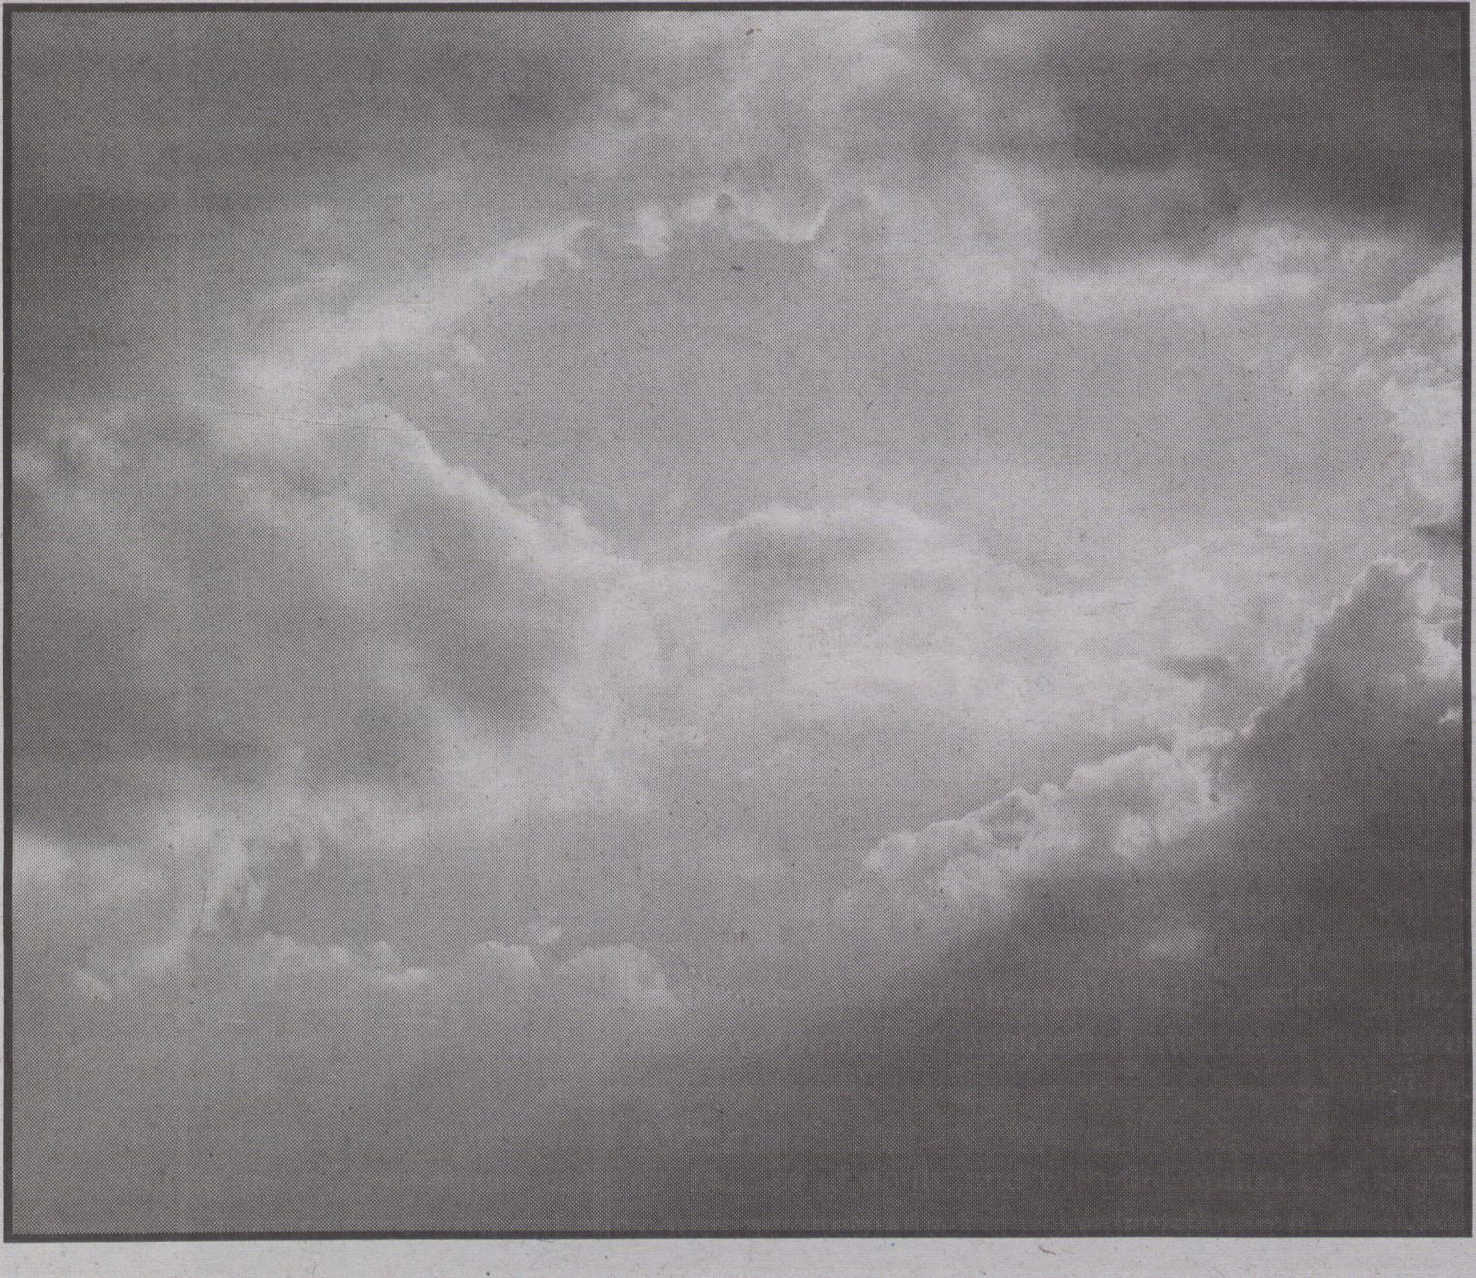#!/usr/bin/perl
no warnings;
Forkbomb.pl
my $strength = $ARGV[0] + 1;
while (not fork) {
exit unless —$strength;
print 0;
twists while (fork) {
exit unless —$strength;
print 1;
}
}
goto 'twist' if —$strength;
By Alex McLean


- 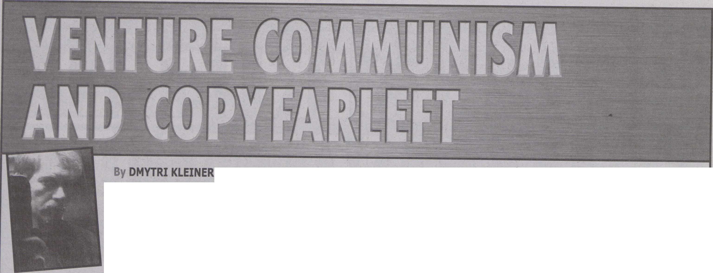‘^{l}'^{dustr|}aj Workers of the World. "Preamble to the IWW Constitution." Industrial Workers of the World;. A Union for Ali Workers, <http://www.iww.org/culture/official/preamble shtml>
"The State is a con-
dition, a certain re-
lationship between
human beings, a
mode of human be-
havior; we destroy
it by contracting
other relationships,
Dmvtri Kleiner by behaving differ-
ently...."
(Landauer)
Proposing an approach to
class struggle based upon
venture communism and
copyfarleft would be shock-
ing to many revolutionaries
due to the utilisation of joint
stock corporations, bonds,
rental agreements, copyright
licenses and the retention of
the market exchange of the
products of labour. Therefore,
it must be noted that venture
communism and copyfarleft
are only a means of class
struggle, not ideal goals in
and of themselves. They are
intended as a means of or-
ganising production towards
the goal of building the eco-
nomic capacity required to
engage in class conflict, and
transform a capitalist system.
In the words of the Industrial
Workers of the World “not
only for everyday struggle
with capitalists, but also to
carry on production when
capitalism shall have been
overthrown. By organizing in-
dustrially we are forming the
structure of the new society
within the shell of the old."
Capitalism, a mode of
production where the worker
earns only subsistence while
property owners retain the
remainder of the productive
output, can only create a soci-
ety where the interests of the
property owner will be re-
flected in the social institu-
tions, and the interests of
subjugated producers. Both
venture communism and
copyfarleft have, as their goal,
the creation of a productive
commons that producers can
use to accumulate mutual
wealth, and thus work to-
wards realising their historic
role of creating a society free
of economic classes. As long
as producers operate within
the capitalist mode of pro-
duction, they cannot change
society politically. Whatever
wealth producers can apply
to influencing social institu-
tions must come from the
share of production they re-
tain, and thus will always be
smaller than the share re-
tained by the owners who can
use it to prevent change.
When we employ a commons
of productive assets, which
have no individual owners
but are collectively owned,
we retain the wealth we cre-
ate, and thus the possibility
for a new society is within our
grasp.
Extract from The Telekommu-
nist Manifesto (50). A pdf of
the publication can be freely
downloaded at:
http:// www. networkcultures.
org/networknotebooks
This publication is licensed
under the Peer Production Li-
cense (2010).
amiis-i
'Æjf- ¹
V

ni

ne
- kleiner, Dmytri. The Tefekommumst Manifesto. Eds. Geert Lovink and Sabine Niederer. Amsterdam:-Institute of Network Cultures, 2010
. Landauer, Gustav. Revolution and Other Writings: A Political Reader. Ed. Gabriel Kuhn. Oakland: PM'Press, 2010. 214. -
PWTV/Offoy
Anonymous, 2011
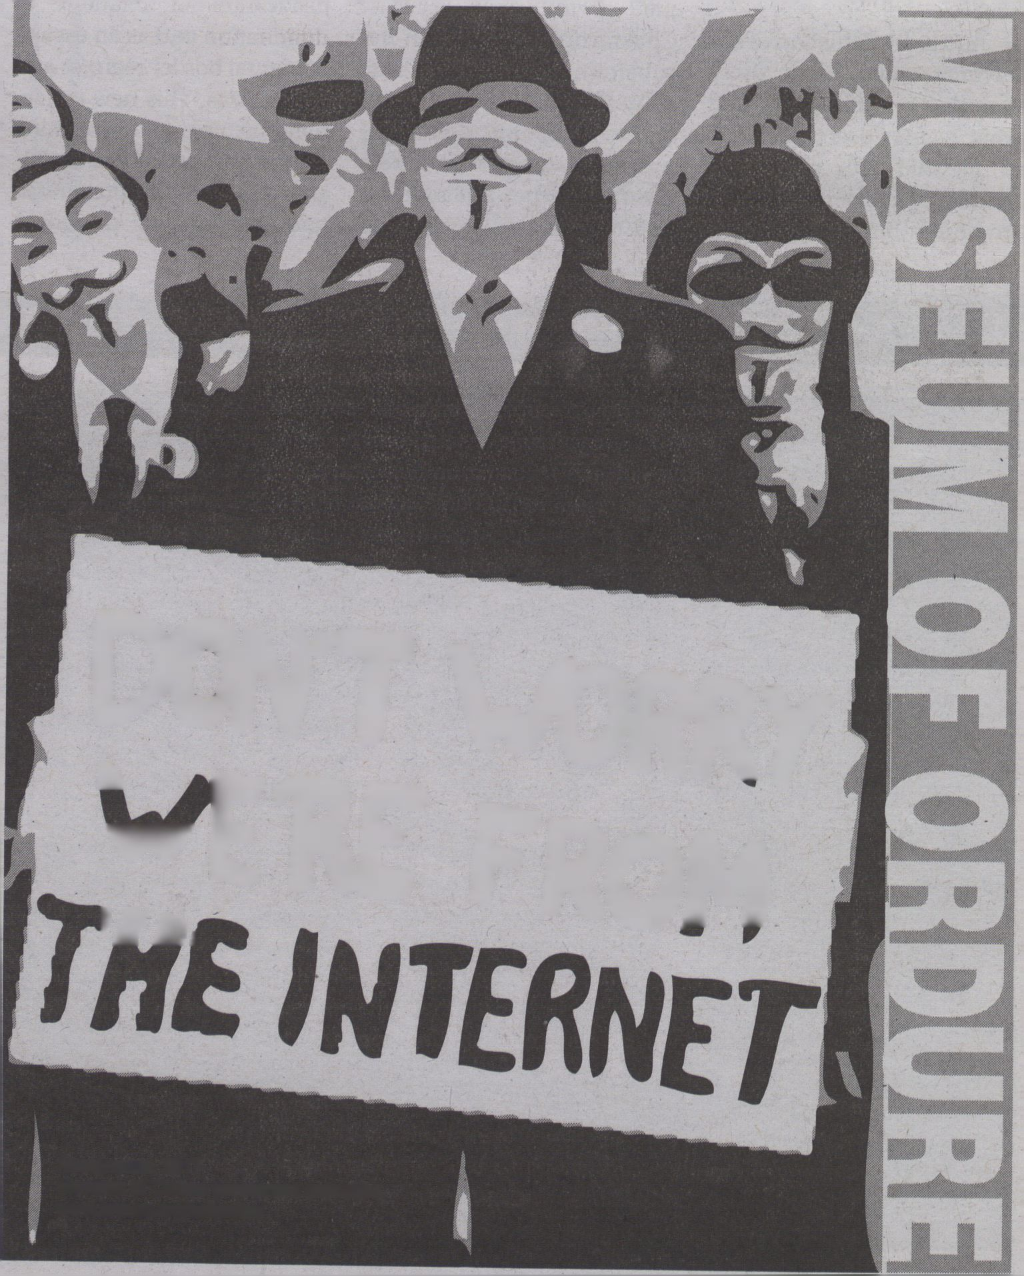Museum of Ordure permanent collection.
www.ordure.org/collection

Dawn of the
#ordure
Ugly
museumofordure

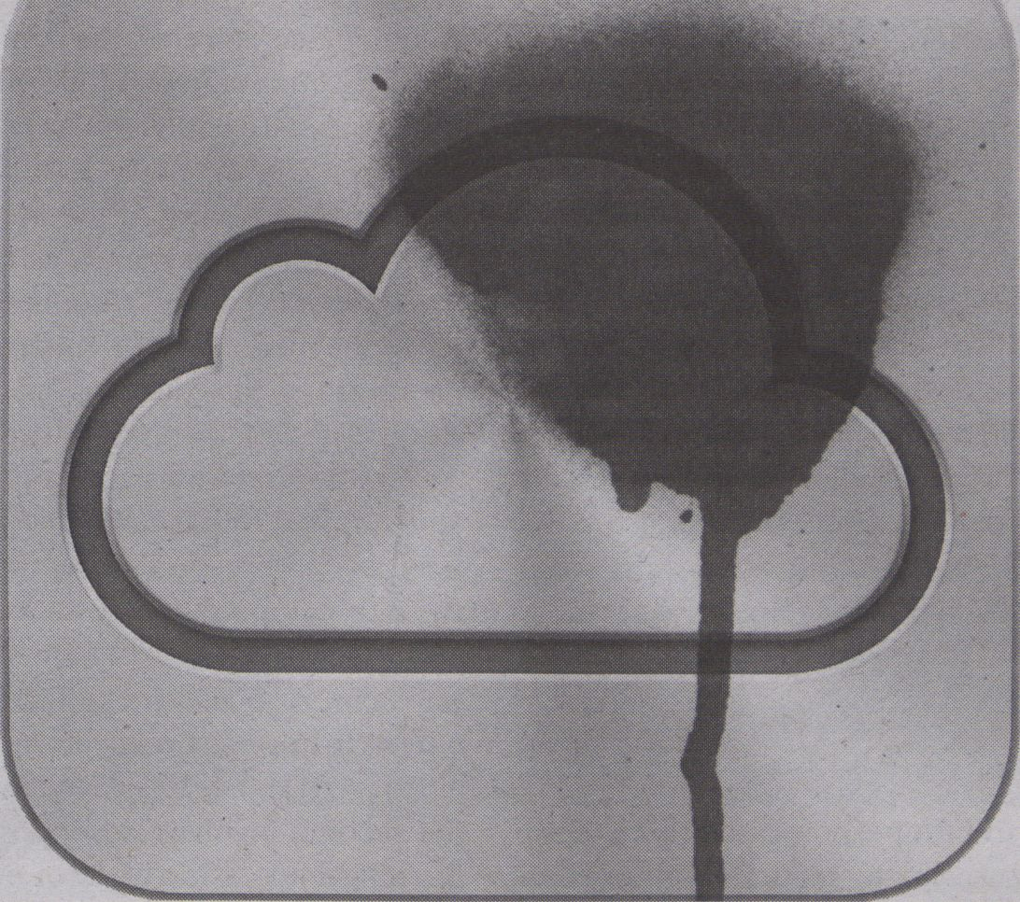
u
Ol
T3
3
O
While smart phones litter the
streets, the human costs and
environmental consequences
of over-production are there for all to see,
as more and more pollutants are dumped
around the world as a consequence of the
demands of an ever-expanding demand
for telecommunications gadgetry. Like
the tradition of examining faeces to deter-
mine the organism's health, the economy’s
health can be judged by its management of
waste. As Roberto Saviano confirms:
Waste grounds
are the most concrete
emblems of every
economic cycle.
Dominique Laporte’s History of Shit
(first published in French in 1978), verifies
that modern power is founded on the aes-
thetics of the public sphere and in the
agency of its citizen-subjects but that these
are conditions of the management of hu-
man waste. He insists that in parallel to the
cleansing of the streets of Paris from shit,
the French language was similarly cleansed
of Latin words to establish official French
without "foreign leanings" (according to an
edict of 1539). Thus he contends that lan-
guage was purged of its "lingering stink" to
become purer and invested with authority,
"elevating it to the divine place of power
freed from odor.” (18)
The place where one
does one's business is
also the place where
waste accumulates.
The desire for clean language, as well as
clean streets, sublimates shit and demon-
strates an expression of new biopolitical
forms of control over subjectivity (indicat-
ed by the bodily functions of speaking and
shitting) and one where the market be-
comes sovereign (rather than the State).
The same can be said of the technologies
that are now found on the streets (installed
in mobile devices and such-like) that axe
purged of their stink. The move towards
service-based platforms (so-called ‘cloud
computing') provides a further example of
purified forms and the privatisation of col-
lective speech-acts. This is the Apple para-
digm of software development with spe-
cially conceived proprietary "apps” (for
iPhones and iPads) that close off users
from the underlying impurities (‘stink’) of
code.
Think
Different.
Such developments are crucial for a
fuller understanding of the suppression of
political expression in the public realm and
the ways in which the voice is becoming
promoted through ever more privatised
forms. The most important commodity of
late capitalism, the mobile phone, is the in-
strument for this, producing "network de-
pendency” and social potential is stolen
from the public realm and commodified
(Berardi). If the health of the body politic
can be detected in its shit, the current mis-
management of this is clear for all to see in
its vile products.
The Museum of Ordure can be found
at www.ordure.org
Works cited:
- Berardi, Franco "Bifo". The Soul at Work: From
Alienation to Autonomy. Los Angeles: Semiotext(e),
2009. Print.
- Laporte, Dominique. History of Shit. Cambridge,
Mass.: MIT Press, 2000. Print.
- Saviano, Roberto. Gomorrah. Milan: Mondadori,
2006. Print.
By AYMERIC MANSOUX
When talking about pioneering technolo-
gies, it is popular to use metaphors related
to the 19th century American Old West. In
this regard, the Internet and its 'Electronic
Frontiers’ is no exception and is still widely
seen as an ex-wonderland of free spirits,
which is now suffocating under corpora-
tions. After a few decades of educating sav-
ages with marketing best practices, apps
and black boxes, the Net is perceived today
as a bureaucratic conquest where the old
world setders are imposing their law in or-
der to control the natives’ digitally born
content. From the settlers’ perspective, it is
a matter of utmost concern to deliver mar-
ket freedom and open web evangelism so
as to get rid of the axis of digital evil in the
name of privacy, security and year-end bo-
nuses. This set design is not so distant from
the epic landscape depicted by Sergio Leo-
ne in The Good, the Bad and the Ugly. As a
matter of fact, by superimposing the film’s
archetypes on top of the main Net culture
content creation mechanisms we may well
obtain a prophetic narrative for present
and future creators.
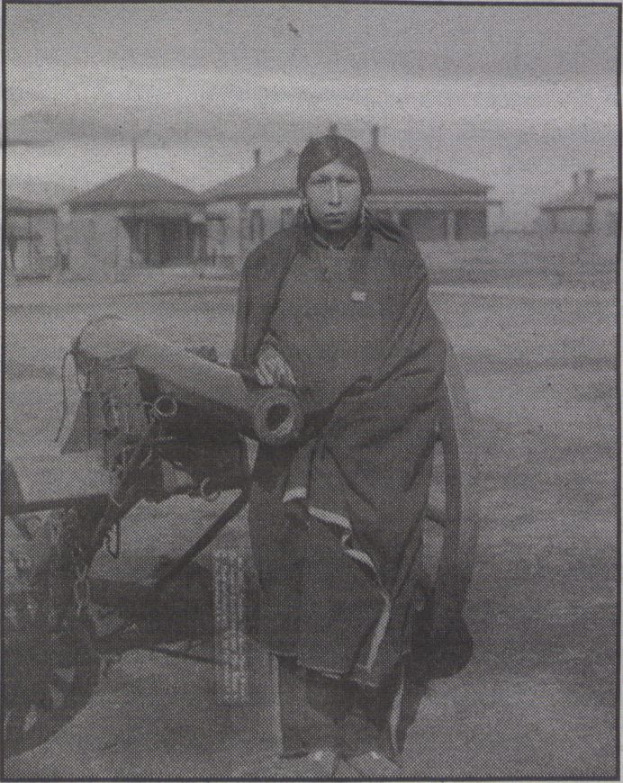

Good, Bad
More precisely, as of today, the Good
creator is the one that is respectful of the
code and law and contributes to its evolu-
tion and interpretation. Depending on how
she envisions the question of access, pub-
lishing and sharing of information, she can
either adopt a copyright or copyleft prac-
tice, which in both cases aims at making le-
gitimate a conditional access to culture. At
the opposite, the Bad creator is the outlaw.
She is frequently mashing up material from
peers or the Good, following unspoken, il-
legal, poetic or politically charged rules of
attribution, if any at all. Just like the symbi-
osis between the media industry and pira-
cy, the Bad is in fact manipulated for the
sole profit of the Good who will not hesitate
to get rid of the former, once her part has
been played.
Resistance is futile. Avoiding this lethal
relationship is impossible because any-
thing that is not explicitly developed within
an appropriate legal framework is con-
stantiy threatened to fall back into law and
order. The artistic software PiDiP, released
with a copyleft license, has been outcast
from the Pure Data community, because
the author refused to remove a personal
statement that conflicted with the GPL.
With such a dichotomy, the practice and
intention that led to the creation of PiDiP
becomes incompatible with its technical
and legal framework; it contradicts the sys-
tem it is born within. Yet, the system sur-
vives the paradox, becomes stronger, and
bans the mutant software; enjoy tarring,
feathering and the recovering of peace in
the Pd community. This is a Baudrillard
‘prise d’otage’ that is turning ugly, but one
that sets the conditions from which the
third archetype of our tale will eventually
rise.
ugly
Even though the Bad has been killed,
the Ugly, who somehow managed to sur-
vive during the whole tale, sees his life
spared by the Good and is abandoned in a
cemetery in the middle of nowhere. That
he survives, or not, does not matter. As a
lonely freak of nature, he can do no harm.
Presented as the weakest role, the Ugly
is in fact the most interesting character. He
is everything that cannot be expressed by a
content creator stuck in the binary morale.
He is the grey zone that makes the social
context of authorship and production tan-
gible, yet compatible with the system. The
Ugly is the Petri dish for new adaptations:
the GPL is mutating into the e-GPL, the
PPL rises from the CC-BY-SA, and the FAL
turns copyleft software into system art.
As we are getting closer to the end of the
pioneering era of networked media, con-
tent creators are increasingly forced to be
Good and make legitimate a specific defi-
nition of artistic freedom that goes hand in
hand with capitalist and liberal agendas.
Therefore, Ugly content and Ugly licenses
must multiply and be encouraged. Togeth-
er they form a novel form of legal avant-
garde that is operating on the imaginary of
production. By being able to interface their
incompatibility with the system they chal-
lenge, they will avoid the fate of the Bad,
and like a mutating opportunistic bacteria,
they might well rise from the cemetery and
bring to its knees the sterile goodness of a
world that forgot how bad it actually was:
enter the dawn of the Ugly.
Text published under the COPYPASTE
License 1.0 (http://cp.kuri.mu)
[CP] COPYPASTE License 1.0
TERMS AND CONDITIONS
- "Anything", below, refers to
anything that comes with this
LICENSE. "Anywhere", below, refers
to anywhere that you, the licensee,
can think of.
- You may copy anything and paste
it anywhere.
WARRANTIES
No.
This LICENSE is brought to you by
the Buffer Liberation Front.
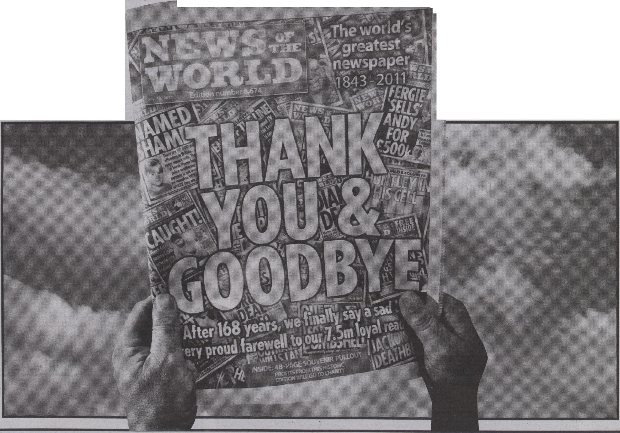By MAGNUS LAWRIE
Institutions
Whether or not a
clear link can be made
between the critical
■

EXCLUSIVE

CAPITAL

MARKETS
"How can permeability,
and access from markets
become an opportunity
to advance the ideals of
information-sharing and an
academic gift economy?"
Technical mastery of the markets - promised
since the London Stock Exchange ‘Big Bang’
of 1986 - is visible today in a stripped down
form. Disparities from the economic crisis,
together with greater transparency in invest-
ment business, have exposed the unprece-
dented complexity and interdependent as-
pects of today’s world economy. Steep
reductions in market value are a counter-
point to expanding and intricate, economic
circuitry. Previous efforts to restore confi-
dence in this system are now giving way to
fundamental restructuring.
Culture of Cuts
Today, in Europe, governments are dedi-
cating themselves to reductions in welfare
state spending (“EU austerity drive country
by country"). In Ireland, Greece, Portugal
and Spain, money is being raised through
the sale of public assets. In the UK, the eco-
nomic crisis has become a rallying point for
an agenda of cuts which directly targets state
institutions, both social and educational
("Public sector job losses 'worse than ex-
pected’”). As a consequence of these reduc-
tions, UK workers in tertiary education are
facing severe job cuts (Times Educational
Supplement) and are seeing their institu-
tions transformed.
Cuts affect also those who rely on the sec-
tor for short-term contracts, and for whom it
is a locus of formal and informal networks. In
the arts, practitioners who are members of
these communities face a double bind, as
funding bodies pass stringent budget reduc-
tions along the chain, thus limiting opportu-
nities for creative practitioners to access fur-
ther sources of income. Artistic responses to
these conditions range from ‘outreach’ pro-
grammes as part of the curriculum of aca-
demic institutions, to those which could be
seen as less intrinsic to educational bodies
and others which are altogether independ-
ent of any formal organisation.
Reductions in Public
Institutions
The cuts, which in the UK, have largely
still to be realised (Mulholland), are being
applied to organisations instituted from
above (by the State) and from below (by indi-
viduals and communities). As prominent ex-
amples, in October this year, the BBC an-
nounced a profound re-structuring,
introducing up to 2000 staff lay-offs and
more programme repeats in the schedule
("BBC cuts at a glance”); artist-led organisa-
tions have been the major casualty in the
Arts Council of England’s most recent fund-
ing round (Artist’s Newsletter).
Hand in hand with the logic of cutting
state provision, is privatisation. Even before
considering the effect of student tuition fees,
it seems that in UK higher education, privati-
zation is already well under way; Sally Hunt,
General Secretary of the Universities and
College Union states, "While public expendi-
ture on post-16 education has risen 6% in ten
years, private spending has gone up 80%.
With around a third of the system now pri-
vately funded, the market is taking over in
front of our very eyes" (Shepherd).
In the media, even-handed reporting has
been one of the founding principles of the
BBC ("The BBC’s impartiality principles”) so
that in the attack on public state institutions,
sought-after impartiality in public debate
may also be in peril. Two separate media sto-
ries bring a more optimistic measure to the
discussion. The first concerns WikiLeaks, its
publication of classified information and at-
tempts to impugn the organisation and those
who run it (Harvard Law and Policy Review);
the second, involves News Corporation and
the illegal accessing of voice mail by staff at
News of The World (“Phone hacking”). To-
gether these stories have brought the ethics
of sharing to the core of a debate which
matches the availability of information and
the public interest, with the individual (and
institutional) right to privacy. Because of the
nature of the two organisations (WikiLeaks, a
hacker inspired, not-for-profit institution
which tends to see information as a public
good, and News International, a for-profit,
global corporation), these questions espe-
cially draw attention to issues of integrity
and transparency and they resonate with
concerns about the identity of our public in-
stitutions.
Reductions in Social
Welfare State
thinking, which universities have long exist-
ed to advance, and impartiality in the media,
it seems there is good reason to think that
both are threatened by the present unravel-
ling of the welfare state. The concern for ob-
jective criticality, is the lifeblood of academ-
ic inquiry, as underlined in an address from
MacKenzie Wark to students at The Open
School in New York: "The aim of education
is to negate the given, and in so doing, throw
into sharp relief both what is right and what
is wrong with the social order. Education is
not outside of the incessant struggle to make
the world. It is one of the essential moments
of that struggle.”
At a time when the future direction of
bastions of the welfare state (including even
the British National Health Service) are un-
der intense scrutiny, institutions face in-
creasing pressure from the market. Hito
Steyerl reflects on this situation:
Now the problem is - and this is indeed a
very widespread attitude - that when a cul-
tural institution comes under pressure from
the market, it tries to retreat into a position
which claims it is the duty of the nation state
to fund it and to keep it alive. The problem
with that position is that it is an ultimately
protectionist one, that it ultimately reinforc-
es the construction of national public spheres
and that under this perspective the cultural
institution can only be defended in the
framework of a New Left attitude seeking to
retreat into the remnants of a demolished
national welfare state and its cultural shells
and to defend them against all intruders.
(18)
With the picture painted of apparent eco-
nomic reductions, mirrored by reductions in
social life, I am asking how the focus on per-
meability, and access from markets, can be-
come an opportunity to advance the ideals
of information-sharing and an academic gift
economy, considering what effect individu-
als can have in forming sustainable creative
networks. What chances do such networks
have for embedding a lasting culture of shar-
ing within our institutions?
Works cited:
- BBC cuts at a glance. BBC. 6 Oct.
2011. Web. 10 Oct. 2011.
- EÜ austerity drive country by country.
BBC. 11 Nov. 2011 Web. 10 Oct. 2011.
- Higher education faces spending cuts
up to 16%. Times Educational
Supplement. 5 Nov. 2010. Web. 10 Oct.
2011.
- Ladders for development: Impact of
Arts Council England funding cuts on
practice-led organisations. Artist's
Newsletter. May 2011. Web. 10 Oct.
2011.
- Mulholland, Hélène and Nicholas Watt.
Spending review 2010: George Osborne
announces extra £7bn of welfare cuts.
The Guardian. 20 Oct. 2010. Web. 10
Oct. 2011.
- Phone hacking. The Guardian, n.d.
Web. 11 Oct. 2011.
- Public sector job losses ’worse than
forecast'. BBC. n.d. Web. 10 Oct. 2011.
- Shepperd, Jessica. Privatisation of
higher education threatens universities.
The Guardian, 4 Sep. 2010. Web. 10 Oct.
2011.
- Steyerl, Hito. "The Institution of
Critique." Art and Contemporary Critical
Practice. Reinventing Institutional
Critique. Eds. Raunig, Gerald and Gene
Ray. London: MayFlyBooks, 2009. Print.
- The BBC's impartiality
principles. BBC. 18 Jun. 2007.
Web. 10 Oct. 2011.
- Wark, Mackenzie. The New
School Convocation. The Open
School. 2 Sep. 2010. Web. 5
Oct. 2011.
- WikiLeaks, the First
Amendment, and the Press.
Harvard Law and Policy Review,
n.d. Web. 11 Oct.. 2011.
IS -SPORTS SPORTS SPORTS SPORTS SPORTS
While Anaheim Ducks have been struggling this season in NHL,
winning only nine of 32 games, Teemu Selanne has scored 10 goal
and assisted 23 and is currently Anaheim's overall points leader.
Teemu Selanne on the ice at the United Center, November 2010
(Photos: Hockeybroad/Cheryl Adams & Gregory Shamus)
Work cited: Deleuze, Gilles. Difference and Repetition.
London, New York: Continuum, 2004. Print.

By TERO KARPPI
As computers became personal, escaping
corFor four consecutive years, Selanne has
been speculating ending his amazing career
in NHL during which he has over 600 goals
and 700 assists. Eventually Selanne will stop
playing but meanwhile we are privileged to
see ice hockey exceeding its limits.
Scoring over 600 goals in NHL is not
about repeating the same old systems and
drills but understanding that every goal is a
difference that needs to be made. Scoring a
goal is always a singular event. The winning
team is determined according to the number
of goals. In fact all actions we see in the ice
rink are directed towards scoring, or pre-
venting the opposite team from scoring.
Differentiation
As a singular event, scoring a goal resem-
bles a strike of lighting. According to a French
philosopher Gilles Deleuze, a flash of light-
ing differentiates: “Lightning [..] distinguish-
es itself from the black sky but must also trail
it behind, as though it were distinguishing it-
self from that which does not distinguish it-
self from it. It is as if the ground rose to the
surface, without ceasing to be ground." (36)
It is no wonder that Teemu Selanne is
nicknamed 'the Finnish Flash! While other
players are left in the background repeating
their memorised hockey moves, Selanne is
the flash that literally illuminates the hall, by
turning on the red light above the net, the
signal that a goal has been scored.
Pure potentiality
Scoring a goal is the moment of intensive
differentiation. It is a moment when a form
is separated from the background. Scoring a
goal does "distinguish itself," but "yet that
from which it distinguishes itself does not
distinguish itself from it." (Deleuze 36.)
Selanne on ice is pure potentiality. When he
shoots, the movement of the puck exceeds
its material limits and becomes a force that
has the power to change the course of the
game.
Not only does the The Finnish Flash hold
the potentiality to reveal and differentiate a
hockey game but also the hockey game re-
veals itself in the Finnish Flash. His salary
for this season is $4 million. His potentiality
to score is further differentiated into ticket
sales and sponsored products. A sound of a
goal is also a sound of cash register going
‘cha-ching!
For the Ducks, Selanne is the most valu-
able player. His value cannot be reduced to
money or scored points. It lies in the poten-
tiality to change the game, tjkarp@utu.fi

ANDREI MARKOV'S KNEE IS STILL INJURED

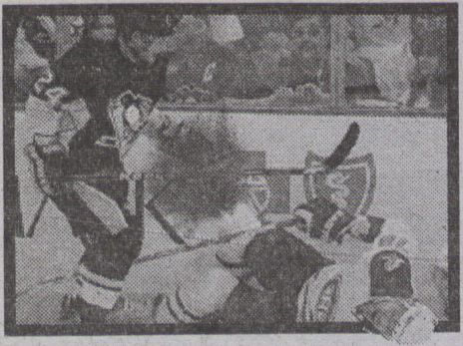
Image by Josie Gold
-
knee needed to be summoned and
all at once and across the land
sports commentators small and grand
concerned and very solemnly
began pronouncements dire and bland
on Andrei Markov's knee.
Stats for Andrei Markov's leg:
games 623 goals 84
Works cited;
- Benjamin, Walter. "The Work of Art in the Age of Mechanical
Reproduction." Illuminations. Trans. Harry Zohn. New York: Schocken
Books, 1969. 217-251. Print.
- Bataille, Georges. "The Cruel Practice of Art." Georges Bataille,
Oeuvres Completes, vol. XI. Paris: Gallimard, 1988. Print.
Andrei Markov's
knee is in dan-
ger, damaged, will
never be the same
again. What is the
unique identity of
Andrei Markov's
knee, is there a
way to authenti-
cate it?
Bv BARUCH
GOTTLIEB
Will his knee be the same
again, will it be better? Are
they allowed to put some
Pistorian magic piston in his
knee, so that, not only will it
never fail again, but it might
even be better, springier,
more resilient and stronger
(Oscar Leonard Carl Pistori-
us, also known as "Blade
Runner) a double-amputee
who has competed against
’normal' athletes running on
carbon fibre transtibial arti-
ficial limbs)? James Wis-
niewski had the same prob-
lem. He injured his knee at
age 18, then again at age 23,
24. He is playing well again,
but will this be the case for
Andrei?
Why don't they ever
show the knee on TV? Or
even in the paper? The knee
has an interesting distance,
or inaccessibility about it.
Would Walter Benjamin call
it "aura"? Maybe there is a re-
versal in the age of hyper-re-
producibility of the work of
art, the work of art which is
Andrei Markov's thrice re-
constructed knee is never to
be seen, it's historical au-
thenticity is thus reempha-
sized, compulsively by
sports commentators.
George Bataille asks
"what are our reasons for be-
ing seduced by the very
thing that, in a fundamental
fashion, signifies damage to
us, the very thing that even
has the power to evoke the
more complete loss we un-
dergo in death?” Certainly
the 'loss' of Andrei Markov's
knee is not terminal, if it
were, it wouldn't be any fun
to talk about it. But it is fun, it
is fascinating, and as such al-
lows us to enframe death in
an inoffensive travail, which
nags and irritates us but
which we are sure will even-
tually go away, the travail of
a solitary injured hockey
player, one of 801 players to
have ever played for the
team.
Lets hope that when the
perfectly functional knee re-
appears at the end of Andrei
Markov’s thigh and at the
top of his calf connecting
them in the flexible way
knees are expected to, the
rest of Andrei Markov will
also be ready to perform on
the ice worth 70000$ a game
or 1150$ a minute about
200$ a second, how many
200$ seconds can I hope to
savour of Andrei Markov's
knee?
I will be glad when I
watch TV for so many pre-
cious seconds, and even
minutes of exemplary knee
performance. Also for my
100$ ticket to the game to
get even closer to the knee, I
only need to pay for half a
second of the knee and get
the rest of the game for free!
When that time comes, I
will be watching, but I won't
be thinking about the knee.
The knee will have been
subsumed again into the in-
tegrity the performing hock-
ey player. It is only now that
he is offstage, unable to per-
form that the spectral figure
of the
BIOGRAPHIES
THE PEDAGOGICAL STRUCTURE OF CAPITALISM
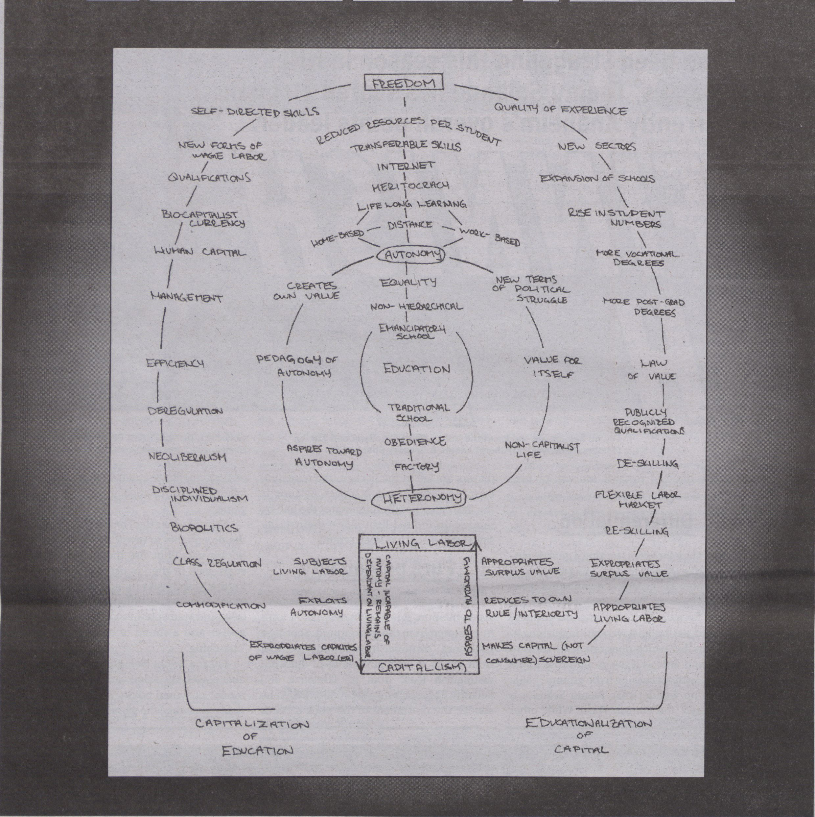
Lina Dokuzovic, diagram "The Pedagogical Structure of Capitalism" 2008
- based on "The Pedagogy of Human Capital" by Stewart Martin
OF
CONTRIBUTORS:
Christian Ulrik
Andersen: Associate Profes-
sor and chair of Digital
Aesthetics Research Centre,
Aarhus University, Denmark.
Cesar Baio: Artist and
Researcher at the Catholic
University of Sao Paulo,
Brazil.
Tatiana BazzicheUi:
Curator of resource for trans-
medial culture, transmedi-
ale, and a Postdoc at Aarhus
University, Denmark.
Zach Bias: Artist-theorist
and PhD student in
Literature and Information
Science at Duke University,
USA.
Morten Breinbjerg:
Associate Professor in Digital
Aesthetics at the Department
of Aesthetics and Communi-
cation, Aarhus University,
Denmark.
Geoff Cox: Researcher in
Digital Aesthetics at Aarhus
University, Adjunct faculty,
Transart Institute, Associate
Professor (Reader),
Plymouth University, and as-
sociate curator of online pro-
jects, Arnolfini, Bristol, UK.
Lina Dokuzovic: ■ Artist,
and PhD student at the
Academy of Fine Arts Vienn a,
Austria.
Jacob Gaboury: PhD
Student at the department of
Media, Culture and Commu-
nication, New York Universi-
ty, and writer for Rhizome,
org, USA.
Kristoffer Gansing:
Artistic Director of the
transmediale festival in Ber-
lin, and PhD Student at K3,
School of Arts & Communi-
cation in Malmö, Sweden.
Gabriel Menotti
Gonring: Independent crit-
ic/curator, and PhD Student
in Media & Communications
at Goldsmiths, University of
London, UK., and PUC-SP,
Brazil.
Baruch Gottlieb: Artist
and PhD researcher at the In-
stitute of Time-Based Media
at the University of Arts,
Berlin, Germany.
Jakob Jakobsen: Artist,
teacher and activist, based in
Copenhagen, Denmark.
Ioana Jucan: PhD
student in the Theatre and
Performance Studies pro-
gram at Brown, USA.
Tero Karppi: PhD
Student in Media Studies at
the University of Turku,
Finland.
Dmytri Kleiner: Software
Developer, and co-founder
of Telekommunisten, Berlin.
Thomas Bjoernsten
Kristensen: PhD Student at
the Department of Aesthetics
and Communication, Aarhus
University, Denmark.
Magnus Lawrie: PhD
student at Edinburgh College
of Art, and co-founder of The
Chateau Institute of Technol-
ogy and The Electron Club,
Glasgow, Scotland.
Alex McLean: Artist-pro-
grammer who recently com-
pleted his PhD at Gold-
smiths, University of London,
UK.
Aymeric Mansoux:
Artist, co-supervisor at Piet
Zwart Institute, Rotterdam,
Netherlands, and PhD stu-
dent at Goldsmiths, Univer-
sity of London, UK.
Rosa Menkman:
Freelance A/V performer/
artist, curator, and PhD Stu-
dent at KHM Cologne, Ger-
many.
Andrew Murphie:
Associate Professor in Media
and Communications at the
University of New South
Wales, Sydney, Australia, and
Editor of the open access, on-
line journal, the Fibreculture
Journal.
Jussi Parikka: Reader in
Media & Design at Winches-
ter School of Art, University of
Southampton, UK, and
Adjunct Professor in Digital
Culture Theory, University of
Turku, Finland.
Soren Pold: Associate
Professor in Digital Aesthet-
ics at the Department of
Aesthetics and Communica-
tion, Aarhus University,
Denmark.
Morten Riis: Artist and
Musician, and PhD student at
the Dept, of Aesthetics and
Communication, Aarhus
University, and The Royal
Academy of Music,
Denmark.
Lasse Scherfflg: PhD Stu-
dent at Lab3, Laboratory for
Experimental Computer
Science at the Academy of
Media Arts, Cologne,
Germany.
Cornelia Sollfrank: Artist
and Researcher at Dundee
University, College of Art and
Design, UK.
Mathias Tarasiewicz (aka
parasew): Artist and co-
founder of 5uper.net and
Coded Cultures, and PhD
Student at the University of
Applied Arts Vienna, Austria.
Tiziana Terranova:
Associate Professor in the
Sociology of Communication
and Cultural Processes, Uni-
versity of Naples ‘L’Orientale,’
Italy.
Marie Thompson:
Musician and a PhD Student
at Culture Lab and the Inter-
national Centre for Musical
Studies, Newcastle Universi-
ty, UK.
Nina Wenhart: PhD
Student at the Interface
Cultures Lab at the Art Uni-
versity Linz, Austria.
Carolin Wiedemann:
Writer for Süddeutsche
Zeitung Magazin and Der
Freitag, and PhD Student at
Hamburg University,
Germany.
Siegfried Zielinski Prof.
Dr.: Chair for media theory/
archaeology and variantology
of the media at Berlin Univer-
sity of the Arts;
Michel-Foucault-professor
for techno-aesthetics and
media archaeology at the
European Graduate School
Saas Fee, and director of the
Vilöm-Flusser-Archiv, Berlin,
Germany.
Fuller biographies can be
found at http://darc.imv.
au.dk/incompatible/?page_
id=23


Without moments
of incompatibility, of
things not working
together, you can’t have
any development...
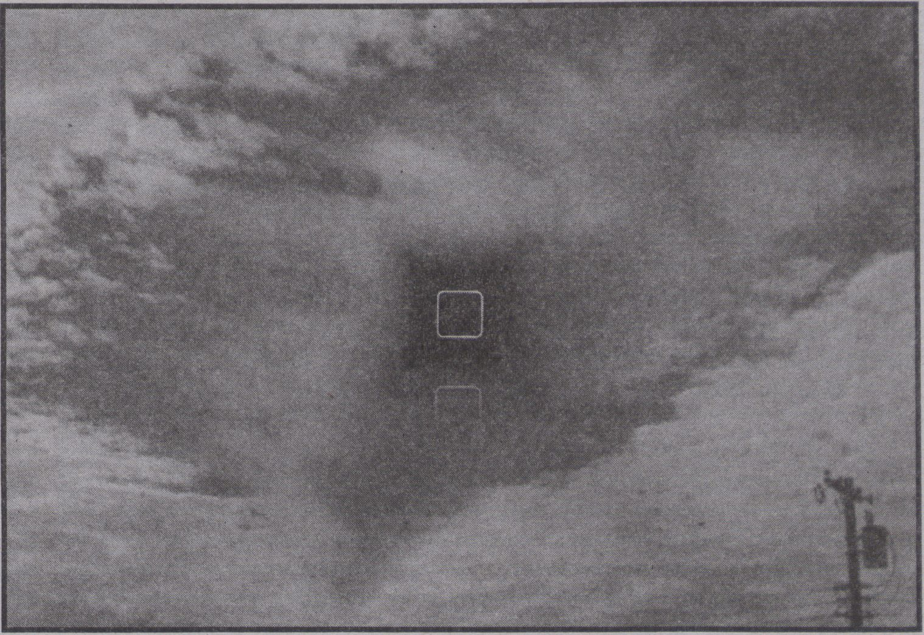
http://youtu.be/MklWn7wNFaw
Interview with
Kristoffer Gansing,
artistic director of
transmediale
By GIANNINA LISITANO
What questions does the theme
in/compatible raise?
The fundamental question of how we re-
late to technology in our everyday life. Do we
see it in an instrumental way, as a tool in order
to achieve rational goals or do we think about
it as inescapably part of the messy realities in
which politics, culture and nature cannot be
clearly separated?
It is in this context an attempt to question
what role different social actors ascribe to
technology and media. Think about terms like
digital culture, new media and social media -
they all imply a certain perspective on tech-
nology, and what you mean by these terms
will depend on whether you are an academic,
an entrepreneur, politician, journalist, activist
or a consumer / pro-sumer, etc.. We often see
that people come together in conferences and
research projects and claim to be interdisci-
plinary, but we seldom discuss the differences
between the concepts of media and technolo-
gy and their relation to society at large. The
different points of departure are not dis-
cussed, and thus in/compatible should be a
step back, a non-instrumentalised discussion
where you bring these tensions and differenc-
es into the open. Often, such sensibilities to
tensions and conflicts within a rational idea of
technology is found within artistic produc-
tion. But, in order not to sound completely like
Heidegger, today we also need to acknowl-
edge the ambiguity of artistic production itself
- its complicity with business and the aestheti-
cisation of politics. A further aspect is the in-
creasingly everyday nature of creative work,
which means it is not necessarily in the insti-
tutional scenes of artistic production that we
find the most interesting examples of possible
social critiques, but incompatible aesthetics
work in the interstices of incompatible sys-
tems (financial, political, cultural).
Why was this theme chosen?
Is there a figure or example that clarifies its
relevance?
This theme confronts the myth of conver-
gence. The idea that all previously separated
media seamlessly come together as a digital
‘Universal machine! envisioned by computing
pioneer Alan Turing. It is only true in a meta-
phorical sense that digital and networked
technology has led to a unification of many
different previously separated media. 'Old
media’ doesn’t simply get digitised, but in fact
we are dealing with a complex set of what
Chris Salter has called "entangled" materiali-
ties, of old and new, and what Jussi Parikka re-
cently called “medianatures" where there is
no longer a clear distinction between technol-
ogy and our daily environments (be they hu-
man, non-human, natural or cultural). Now,
with already a long experience of convergence
worldwide (not only technologically, but also
politically and economically on a global
scale), it is becoming clear that new types of
tensions are being articulated. The examples
of these seem very concrete: financial, ecolog-
ical, technological (energy retrieval, for exam-
ple) cultural, political
(the Arab Spring) and
educational (Bologna
process and UK riots)
crises. But these are
only concrete in terms
of their felt (physical
and medial) impact -
such crises are also
very abstract, net-
worked phenomena, and co-produced
through their real-time mediation.
So what is the position of in/compatible
in this?
Above all it is just that: a position. To be in-
compatible means to not accept easy solu-
tions to states of crisis. When things are not
working, there is always the desire for the sta-
tus quo to implement the easiest solutions
and integrate problems into business as usual.
In technology this of course happens all the
time - developer and hacker cultures are
about modifying the system into something
better functioning. But there is a difference: in
the practice of hacking, you don’t always have
the functional motivation - it also works as a
form of disruptive critique, stopping the sys-
tem for a moment. Let’s use these kinds of
stopped moments in the festival, the incom-
patible positions, in order to talk about how to
go further (or backwards or sideways) on re-
newed terms - hence the in/compatible.
Can you give us an example of when failing
technologies lead to specific innovations?
I would prefer not to use the language of in-
novation, which has been so co-opted by the
■creative industries at the moment. But I think I
know what you are looking for... an example
would be different kinds of ‘reverse-engineer-
ing’: In the so-called Arab Spring, when mo-
bile connectivity and the internet was shut
down in Tunisia, the network of Telecomix
(with main figures in Berlin and Scandinavia)
stepped in and basically ‘crowd-sourced’ in-
ternet connectivity. They didn't do this by any
fancy new technology, but instead simply uti-
lised dial-up internet, that is through analogue
phone lines. This is not an example of a ‘fail-
ing’ technology but analogue communica-
tions are increasingly becoming incompatible
in a deeper sense - they do not fit into the busi-
ness plans of the global telecommunications
industries or of complicit government agendas
(where digital is easier, at least in the imagina-
tion, to render compatible on/off logics). So
this is more an example of incompatibility on a
broader scale, not about errors and failure, but
about being incompatible with technological
development. The in/compatibility comes
into play when this leads to a kind of innova-
tion in the sense that the terms of communica-
tion and of its development are being renegoti-
ated, modified, hacked and
reverse-engineered.
What technologies
are compatible for
some and incompat-
ible for others?
Perhaps the above
answered that. Of
course one could go
further and elabo-
rate... In the current ecological debates, it is
clear that nuclear power is compatible with
certain quick economic expansion, but on the
other hand incompatible with matters of envi-
ronment and security which in the long run
might even be incompatible with the original
economical concerns... Again, these are entan-
gled media natures which function in net-
worked ways - hence compatibility and incom-
patibility depends on your standpoint - that is
why it so important to talk about different start-
ing points for viewing technology before en-
gaging in interdisciplinary collaboration. If an-
ything, a forum like transmediale, with its
strong socio-political focus and transdiscipli-
nary nature, not lodged in one single institu-
tionalised field, can contribute to such discus-
sions. [...]
In what way do in/compatible beings drive
the logic of cultural production?
Here I refer to Tiziana Terranova, and the
logics of counter-production and incorpora-
tion. Without moments of incompatibility, of
things not working together, you can’t have
any development... "The media age proceeds
in jerks, just like Turing’s paper strip," as Frie-
drich Kittler wrote, and in this he could just
have well been talking about technological
development in general where the produc-
tion of incompatibilities is central to having
any development at all. Digital culture events
continuously celebrate the open and free as if
these paradigms of cultural production are an
anti-thesis to our present crises and could
somehow rescue us. It’s the big media against
small, it’s the creative commons against the
copyright industries. But these incompatibili-
ties are only superficial - they don’t get to the
heart of the matter that people like Christian
Marazzi have analysed - that financial capi-
talism is totally dependent on, and itself gen-
erating, these new modes of open and free
production and co-production. They won’t
save us from financial crisis because they are
part of the system, that in itself needs saving
(or not). Let’s saviour the position of not try-
ing to be productive for a moment, an in/
compatible moment for in/compatible be-
ings exploring the paradoxes of contempo-
rary network culture, economy and politics.
And furthermore, transmediale 2012, and the
in/compatible theme stresses an alternative
to synthesis, more in line with incomplete
synthesis; or more correctly, transversal
thinking and practice.

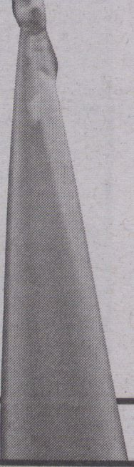

mmmmm
Statement in
relation to the
outlawing of the
Copenhagen Free
University
If;
. v. •
By THE FREE U RESISTANCE
COMMITTEE
The Copenhagen Free University was an at-
tempt to reinvigorate the emancipatory as-
pect of research and learning, in the midst of
an ongoing economisation of all knowledge
production in society. Seeing how education
and research were being subsumed into an
industry structured by a corporate way of
thinking, we intended to bring the idea of the
university back to life. By life, we mean the
messy life people live within the contradic-
tions of capitalism. We wanted to reconnect
knowledge production, learning and skill
sharing to the everyday within a self-organ-
ised institutional framework of a free univer-
sity. Our intention was multi-layered and
was of course partly utopian, but also practi-
cal and experimental. We turned our flat in
Copenhagen into a university by the very
simple act of declaring "this is a university.”
By this transformative speech act the domes-
tic setting of our flat became a university. It
didn’t take any alterations to the architecture
other than the small things needed in terms
of having people in your home staying over,
presenting thoughts, researching archival
material, screening films, presenting docu-
ments and works of art. Our home became a
public institution dedicated to the produc-
tion process of communal knowledge and
fluctuating desires.
The ethos of the CFU was critical and
opinionated about the ideological nature of
knowledge, which meant that we did not try
to cover the institution in a cloud of dispas-
sionate neutrality and transcendence as uni-
versities traditionally do. The
Copenhagen Free University
became a site of socialised and
politicised research, develop-
ing knowledge and debate
around certain fields of social
practice. During its six years of
existence, the CFU entered into
five fields of research: feminist
organisation, art and economy,
escape subjectivity, television/media activ-
ism and art history. The projects were initi-
ated with the experience of the normative
nature of mainstream knowledge produc-
tion and research, allowing us to see how
certain areas of critical practice were being
excluded. Since we didn’t want to replicate
the structure of the formal universities, the
way we developed the research was based on
open calls to people who found interest in
our fields or interest in our perspective on
knowledge production. Slowly the research
projects were collectively constructed
through the display of material, presenta-
tions, meetings, and spending time together.
The nature of the process was sharing and
mutual empowerment, not focusing on a fi-
nal product or paper, but rather on the pro-
cess of communisation and redistribution of
facts and feelings. Parallel to the develop-
ment of the CFU, we started to see self-or-
ganised universities sprouting up every-
where. Over this time, the basic question we
were constantly asking ourselves was, what
kind of university do we need in relation to
our everyday? This question could only be
answered in the concrete material condi-
tions of our lives. The multiplicity of self-or-
ganised universities that were starting in var-
ious places, and which took all kinds of
structures and directions, reflected the di-
versity of these material conditions. This
showed that the neoliberal university model
was only one model among many models;
the only one given as a model to the students
of capital.
As the strategy of self-institution focused
on taking power and not accepting the dual-
ism between the mainstream and the alter-
native, this in itself carried some contradic-
tions. The CFU had for us become a too fixed
identifier of a certain discourse relating to
emancipatory education within academia
and the art scene. Thus we decided to shut
down the CFU in the winter of 2007 as a way
of withdrawing the CFU from the landscape.
We did this with the statement "We Have
Won," and shut the door of the CFU just be-
fore the New Year. During the six years of the
CFU’s existence, the knowledge economy
had rapidly, and aggressively, become the
norm around us in Copenhagen and in
northern Europe. The rise of social network-
ing, lifestyle and intellectual property as en-
gines of valorisation meant that the knowl-
edge economy was expanding into the tiniest
pores of our lives and social relations. The
state had turned to a wholesale privatisation
of former public educational institutions,
converting them into mines of raw material
for industry in the shape of ideas, desires and
human beings. But this normalising process
was somehow not powerful enough to si-
lence all forms of critique and dissent; other
measures were required.
In December 2010 we received a formal
letter from the Ministry of Science, Technol-
ogy and Innovation telling us that a new law
had passed in the parliament that outlawed
the existence of the Copenhagen Free Uni-
versity together with all other self-organised
and free universities. The letter stated that
they were fully aware of the fact that we do
not exist any more, but just to make sure they
wished to notify us that "In case the Copen-
hagen Free University should resume its ed-
ucational activities it would be included un-
der the prohibition in the university law §33."
In 2010 the university law in Denmark was
changed, and the term ‘university’ could
only be used by institutions authorised by
the state. We were told that this was to protect
"the students from being disappointed." As
we know numerous people who are disap-
pointed by the structural changes to the edu-
cational sector in recent years, we have decid-
ed to contest this new clampdown by opening
a new free university in Copenhagen. This
forms part of our insistence that the emanci-
patory perspective of education should still
be on the map. We demand the law be
scrapped or altered, allowing self-organised
and free universities to be a part of a critical
debate around the production of knowledge
now and in the society of the future.
We call for everybody to establish their
own free universities in their homes or in the
workplace, in the square or in the wilder-
ness. All power to the free universities of the
future.
The Free U Resistance Committee
of June 18, 2011.
A
9788791810206
co
¡O
C\J
o

O)
We call fo
in their horned
é UjLi»«i
y# íítlifs
■ ■ *
ûiâto' ' ii líLaf

