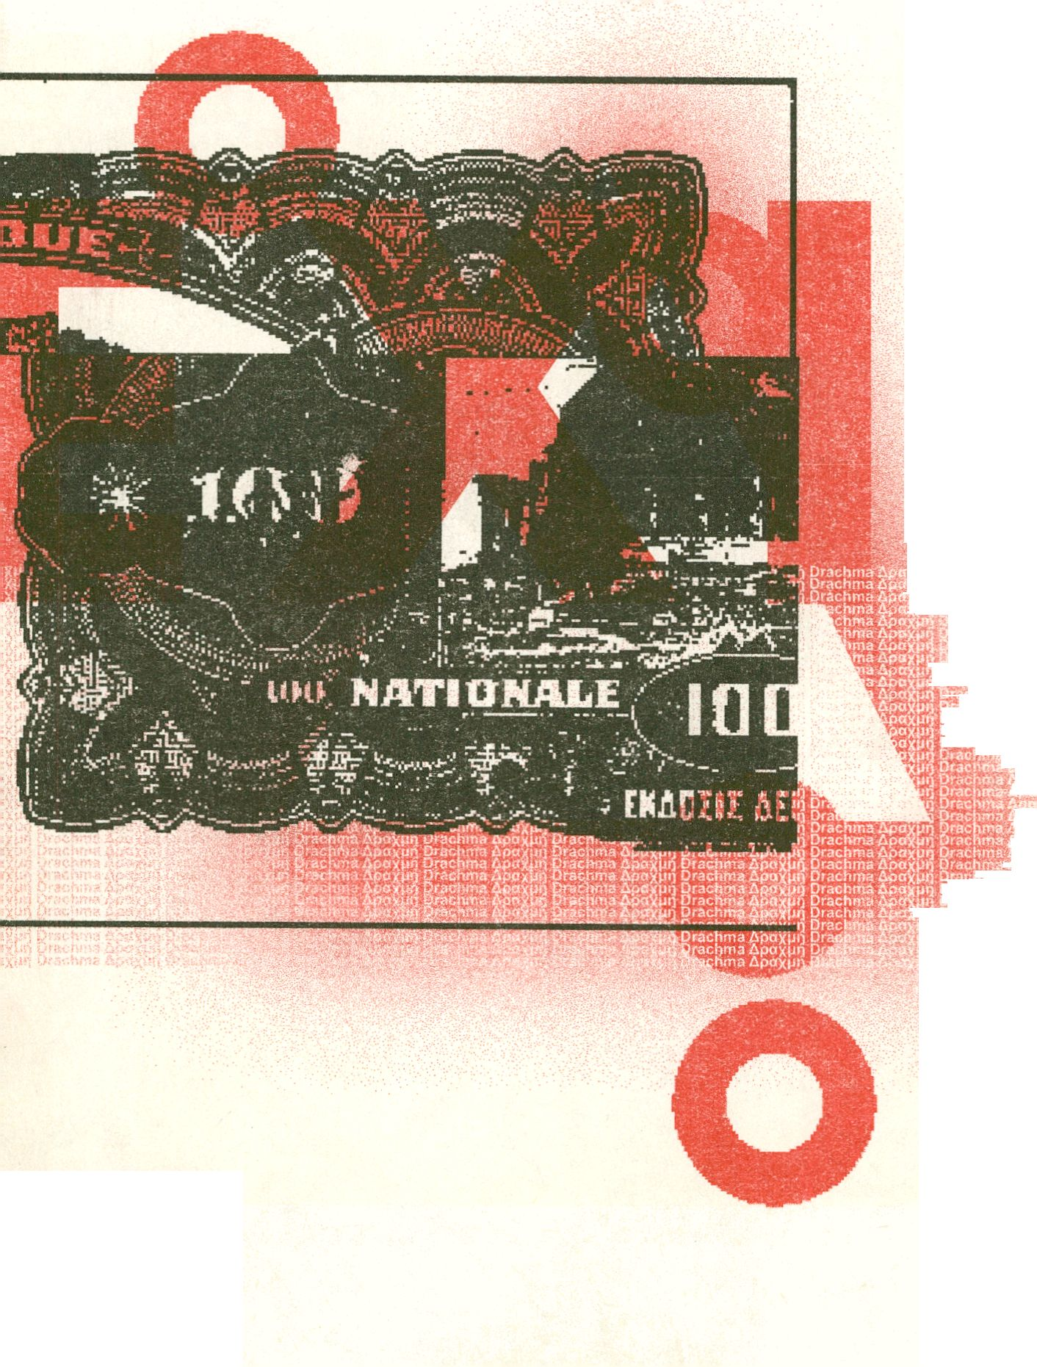
O







7
Foreword

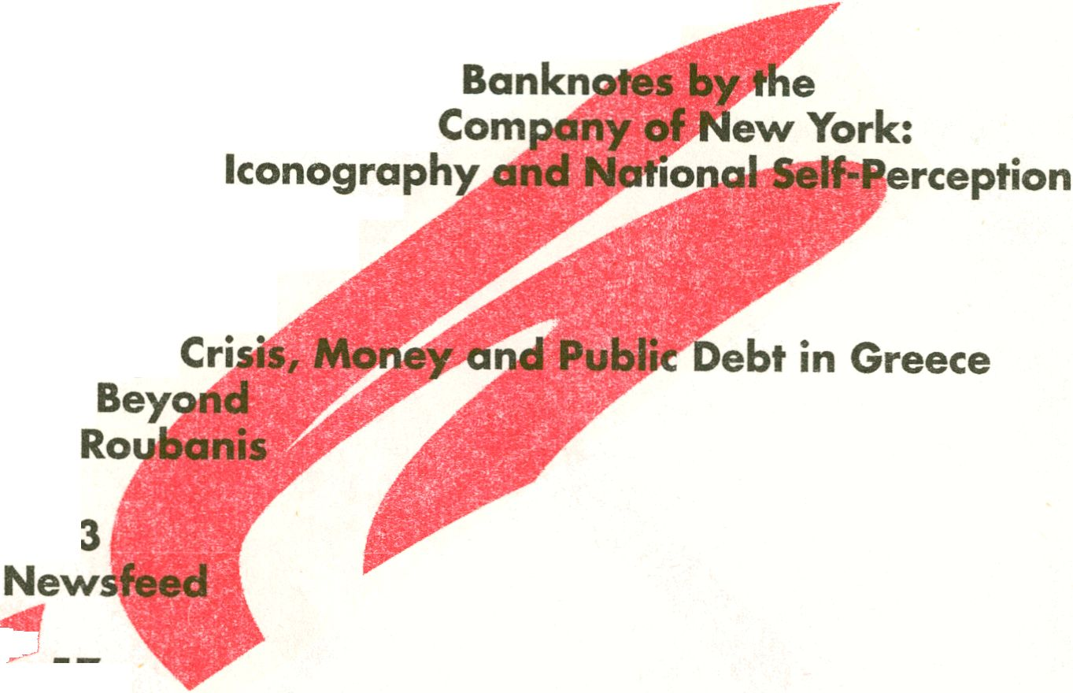
and the Euro: From Vision To Despair
s Tsakaloyannis
11
The Creation of Greek
American Bank Note
Aspects of
Virginia Mavrika
27
Identity,
and
Ilia

79
"Grexit"; Disengaging from the European Project
Georgios Papadopoulos
99
Figures
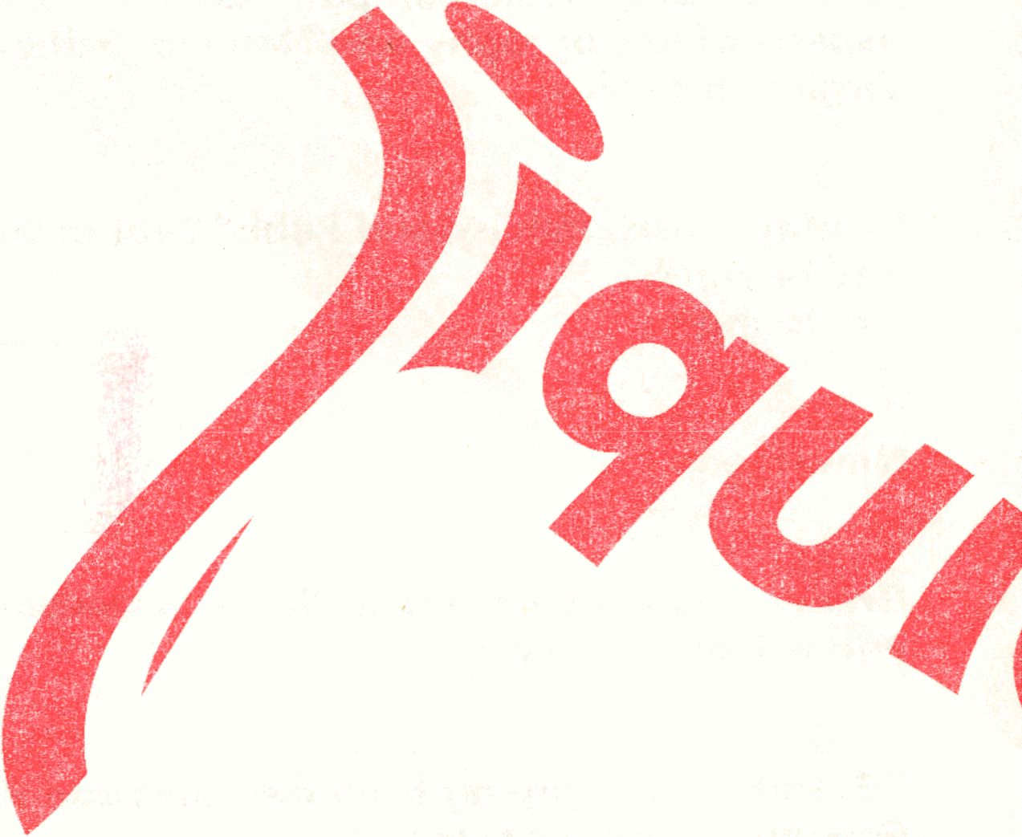

Foreword
Grexit is the culmination of a two year long research
project on the cultural significance of the iconography
of the Drachma, in the context of the unfolding
financial crisis (2008 — ?). When I started the research
in 2010, I could not anticipate that the departure
of Greece from the Monetary Union, and even from
the EU, would empire as the main scenario for the
future of the counflHk StH^ sometimes reality is more
unpredictable and spectacular than our imagination.
Grexit has not occurred as yet, but especially in the
last stages of the production of this book, it seemed
likely that we would be overcome by the course of
events, something that remains still a possibility, even
though we are exactly four weeks before the official
launch of the book in Berlin.
The ppbliéà|^n consists of four independent articles
and a short chponology of the »reek Crisis comprised
of media reports. With the exception of the paper
by Parsol Tsakaloyannis, whose contribution frames
the analysis by explaining the root causes of the
collapse, earlier versions of all the other papers
were presented and discussed during a symposium
held atWhe Historical Archive of the National Bank of
'wiwie on April the 5th, 2011. The idea behind the
symposium and also behind the publication was to
bring together these distinct, but also complementary,
1 Citigroup said there’s now a 90 percent chance that Greece will leave the euro
in the next 12 to 18 months, with prolonged economic weakness and spillover
for the currency bloc. In an analyst note, Citigroup updated its forecast for a
Greek exit from the 17-nation currency union from a previous estimate of 50
percent to 75 percent, and said it would most likely happen in the next two to
three quarters. Specifically, the bank assumes a Greece exit would occur on
Jan. 1,2013, while saying that is not a forecast of a precise date. Bloomberg,
26.7.2012
arguments about the construction and the operation
of the Greek banknotes, in an attempt to indicate,
but also to deconstruct, their cultural significance. To
that effect we tried to develop a visual language that
would supplement and challenge the textual analysis
of the Drachma. Grexit has two layers; red and black,
printed on white paper. We used black for the text
and red for the security features of the banknotes that
intervene in the linear development of the argument,
adding a parallel visual narrative to the argument. The
selection of these three colors black, red, and white
(indicative of the :podernist allegiances of the design,
as it was rightly pointed out by Kenneth Reinhard) is
contingent upon our printing tec
constraints of the.publication, <
banknotes, or more dicurdtefy
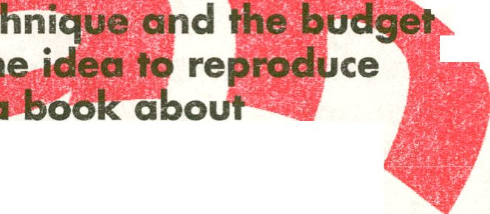banknotes, with one of the cheapest and 'roughest'
printing methods is both a choice and an accident.
¡§k
A lot of people contributed to this book, consciously,
or unconsciously. First of all the designers and the
authors; Jack Henrie Fisher, Neda Firfova, Virginia
Mavrika, ilia Roubanis, Panos Tsakaloyannis.
Nevertheless, the publication is not just due to
their efforts but also the outcome of a long term
collaboration between artists, theorists that
participated in the Drachma research project: Nikos
Arvanitis, Robin Bhattacharya, Juliana Borinski,
Danilo Correale, Assaf Gruber, Adelita Husni — Bey,
Yota loannidou, Dia Kytta, Mo Y, Catalina-Amalia
Ravessoud, Amelie Rydqvist, Société Réaliste, Liv
Strand, Anna Tsouloufi-Lagiou, Elizabeth Ward, and
Olav Westphalen. Extra thanks for Jean-Baptiste
Naudy from the Société Réaliste, for energizing and
almost destroying the project in its early stages.
The support of the Historical Archive of the National
Greece, in Athens has been invaluable; some of the
articles of this publication were first presented at a
symposium organized in its building in Athens, while
its collection of Greek notes and coins has been an
indispensable resource for our research. Special
thanks to the director of the archive Dr. Gerasimos
Notaras for granting us access to the archive but
also for the warm hospitality and the constant
encouragement. Further thanks|&p to the staff of the
archiv^^id in particular to Zisifhps Synodinos, Dia
Kytta,^ ■" ‘ ‘ “
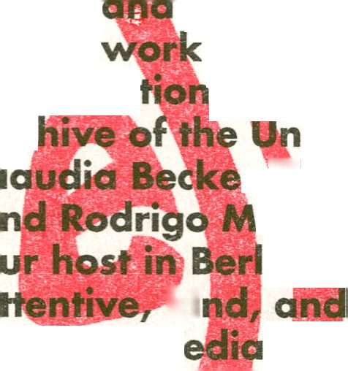Our
of in&Htu
Arc,
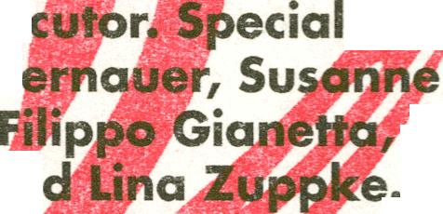Apart from our instfflitional support, a network
of friends and colleagues in Berlin and from abroad
made this projetf not only possible but also great fun.
We would like to thank Fatma Aydemir, Pophana
Brandes, Eleninja, Simone Haverland, Carsten Lisecki,
the Maiden Monsters, Alexander Negrelli, Henning
Sedlmeir, Fani Sofologi, and Kenneth Reinhard.
ki
the Transm
and interlo
Christine B
Gansing,
Nicolau, an
Maria Lempesi.
in Berlin has been supported by a series
s%nd colleagues; the V|)em Flusser
iversität der Künste« and especially
r,^chard Fürlus, Jennie Goh, Anita Jori,
altez-Novaes. Professor Zielinski was
in, offering a space to work; very
_ supportive. Our other partner,
le festival, was tr great co-conspirator
ks to Tatiana Bazzichelli,
Benrstein, Kristoffer
Markus Huber, Georgia


The Creation of Greek Banknotes by the American
Bank Note Company of New York: Aspects of
Iconography and National Self-Perception
Virginia Mavrika
The cooperation between the National Bank of
Greece and the American Bank Note Company of New
York is the longest ever between a Greek bank and a
foreign banknote printing company. It lasted longer
than 70 years until the beginnings of the 1930s. The
present text examines issues of iconography on a
number of Greek notes¹ issued by ABNCo., aiming at
tracing their ¡conographic prototypes, their creators,
bs well as the historical frame which determined
significantly their form. The text focuses on the three
first decades of the 20th century.
The National Bank placed its first order to ABNCo
to create (namely to engrave and print) notes in 1859
(figurl 1). The correspondence between the two sides
yields fhat the American company was responsible
until the end of the first decade of the 20th century for
choosing the iconographic subject-matters of its client.
The Greek side holds a neutral, almost distant attitude
during this phase of the construction procedure. Turning
point to this attitude was the employment of the
painter Michael Axelos in 1918 for the design of the
notes for the National Bank of Greece and later for the
Bank of Greece. Since that year, the correspondence
mounts between the two sides on issues concerning the
selection of subject-matters, the supply of prototypes,
the agreement on colours, printing etc.
In a document dated to 1888 (figure 2) it is explicitly
highlighted the importance of the portrait of the Bank's
- The reference to banknotes follows the numbering system compiled by Albert
Pick as in th¿Standard Catalogue of World Paper Money published by Krause
Publications.
Drachrr.r Asur
ApcxM'1 Ora
Drachma Ap;s»:>
Apcixpr, Dm*.!⁻» ’■.<>
Orachm* &p->v. ’■
ApoxMH Drachma !
Drachma Apox-^l ^{r}
ApaXM*i Drjchr:.; ;
Drachma Ai •
ApoxMH Drachma
Drachma Apv/..■ -
ApcxMO Drachm. t
Drachma L
ApaxMH Drachmc •
Drachms Apo
Apo'/pn Drachmj i
Drachma Ac.,
Apoxp»1 Drachm..
Drachma Apavv.h -
Apnxpr, Orach :
Drachma Ap;:v:
ApoXPh Draehr: • t.
Drachma Aprt^-
ApaxMH Drachma i
Drachma L cc/pq £
ApaxMH Drach;-.*« f
Drachma Apcrxi"
• ■- • 1*1 •.Apoxpi^Df
vignettes, in which it*...
Drachma ApctXP'i X.
Apaxpi) Drach«>a C
Drachma ¿ptr* vq
, Apaxpr, Drachi
I D ach- ■ .
Apoxpn Drachma /
Drachma Apni.: fj
Apaypn Omcnmy ’
Drachma
Apuxpi'i Drachm,: t
Drachma Apo_{A}-.i.j •"
ApaxpO Ora;h; m
Drachma Lp'-iv., r;
Apaxpn Drachm . i
Drachma Apoxi.-i- -
ApeXp.i Drachma l
Drachma Apaxv
ApoxMH Drachm,.
Drachma Apavpn i
Apoxuii Drachm;? I
Drachma Apaxurj
Apaxpn Drachma i
Drachms
Apoxtiil Drachm»
Drachma Apavy ;
Apnxpn Drachma ¡’
Drachma ApaxP‘i -
President Georgios Stavros, and the Greek royal
crest to be included on the notes' decoration, however
the rest of the composition, namely allegorical
figures, motives and guilloche patterns, are left on
the judgment of the manufacturer². The Greek side
focuses on security issues and protection methods
against counterfeiting and its observations were
I* •. I ■ flpaxpn Drachma ■
limited on spelling
The American
that takes initiative
historical facts of
iconography of its
practice arises right
created by ABNCo
central vignette of
25-drachma note
from the company's
Twins" (figure 4).
compiled in volumes
of prospective
while the company
their copyright,
buildings depicted
background (figure
by the temple
and composition,
company is the one
on correlating the
its client with the
banknotes. This
from the first note
for Greece. The
the reverse of the
(figure 3) derives
collection of
bares the title "The
These vignettes were
for the information
customers (figure 5),
had established
The factory
in the vignette's
4) were replaced
of Hephaistos in

Athens (figure 6)⁵. The pre-designed vignette's original
form has been printed on banknotes manufactured
by ABNCo for North American and Mexican banks
(figures 7-9).
The selective reformation of a ready-made vignette
was a typical method followed during the first period
of the collaboration between ABNCo and National
Bank. It was certainly by far a more inexpensive and
less time-consuming solution than perceiving and
engraving an entirely original vignette. Similarly,
the figure of a reaper (figure T 0) (apparently the
allegorical presentation of agriculture) had been used
three times on Greek banknotes after alterations of
its components. On the 10-drachma note (figure 11),
the rural building in the background was replaced by
the remains of the temple of Olympian Zeus and the
Gate of the emperor Hadrian in Athens. Later, on the
reverse of the 500-drachma note (figure 12) and the
reverse of the 500-drachmal(figure 13), it was the
Parthenon depicted in the background. The original
vignette by ABNCo had repeatedly been used on other,
foreign banknotes and bonas (figure 14-15). It is
noteworthy that later on, during the design of a new
500-drachma note in 1919, ABNCo was considering
a vignette for the note's reverse that showed "a
characteristic Greek pastoral scene"⁶. Although the
composition of this non-executed design has not being
preserved, the face of the 500-drachma note provides
us with some idea of how ABNCo's artists perceived a
Greek pastoral scene. Apparently, they were not far
away from the typical Romantic vision of the Greek
- This alteration is also stated on a three-page undated document with
observations on iconographic and technical issues for the manufacturing of
the 25-drachma and the 100-drachma notes, Museum of American Finance,
New York, file “Greece”, which includes 19th-century correspondence between
ABNCo and Greek banks.
- HANBG, series “Nomismatika”, file 48, doc. 23/17.9.1919.
landscape enriched with ancient ruins, as depicted in
the works by European artists-travellers in the late 18^{,h}
and 19th centuries⁷.
Allegorical subject-matters adorned all the sixteen
banknotes manufactured by ABNCo until the first
decade of the 20th century. The 100-drachma note
was the first note for which an original vignette with
a Greek subject was created (figure 16). It was also
suggested, for the first time, that a plaster cast should
be manufactured as a starting point for the incision
of a vignette. In fact, ABNCo presented a head of
Minerva reproduced in a medallion effect⁸. Although
this particular subject was not finally selected, this
process inaugurated the search of authentic models
for the creation of the vignettes as well as the
collaboration between the two sides for the discovery
and selection of prototypes. This new mentality led
to the selection of the statue of Eirene and Pluto by
Kephisodotos, which was actually proposed by the
National Bank of Greece, after ABNCo had persistently
asked the Greek Bank to express its preferences
regarding the note's iconography⁹. The National
Bank suggested as central subject-matter of the
reverse the Late-classical statue of Eirene and Pluto
by Kephisodotos and sent a photograph to New
York¹⁰, from which a smaller scale vignette was
produced. The vignette's engraving required six to
seven weeks¹¹ and was executed by Robert Savage
Hessler (1993, 260). The Greekness of the iconography
was to be emphasized with a frame in Ionic style
around the statue of Kephisodotos (eventually not
- About European landscape painting of 19th-century Greece see Tsigakou
(1991).
- HANBG, series “Nomismatika”, file 28, doc. 66/21.5.1906.
- HANBG, series “Nomismatika”, file 28, doc. 28, ¿wq. 81/1.7.1908.
- HANBG, series “Nomismatika”, file 28, doc. 85/11.8.1908, doc. 115/23.4.1909.
- HANBG, series “Nomismatika”, file 28, doc. 89/9.11.1908.
included in the composition)¹². This late use of ancient
Greek artwork for the decoration of Greek notes
brings us to the following question: given the fact
that since the establishment of the modern Greek
state, the Greek society was imbued with the need
to be associated with the ancient Greek past, and
therefore encountered Classical (and Neo-Classical)
art as the means to confirm its role as heir of the
Classical heritage, why indeed the relevant references
in the notes⁷ iconography emerged as late as the
first decade of the 20th century? The answer to this
question is partially related to the developments
redound in terms of organizing archaeology in
Greece, protecting, managing and promoting cultural
heritage. The restoration works which were being
carried out gradually reinforced the country's image
as worthy successor of the ancestral heritage that
contributed to the European civilization. The depiction
of monuments that were being displayed through
restorations, or artworks that were being exhibited in
newly established museums, on the surfaces of tokens
of everyday use, diffused these activities throughout
the Greek territory and familiarized society with the
new look that gradually acquired the celebrated
archaeological sites and museum collections.
It should be pointed out that the rendering of ancient
Greek artwork followed the aesthetic of recreating the
missing parts. E.g. the statue of Eirene and Pluto by
Kephisodotos which is depicted on the 100-drachma
note was an image of the Roman copy kept in the
Munich Glyptothek, which was extensively restored by
Bartolomeo Cavaceppi in the 18th century¹³ (figure 17).
- HANBG, series “Nomismatika”, file 28, doc. 113/113.1909.
- Further information about the statue and its restoration in Vierneisel-Schlorb
(1979).! thank Dr. Florian Leitmeir of the Staatliche Antikensammlungen und
Glyptothek in Munich for this reference.
This statue was also one of the six terracotta replicas
of important ancient statues, which adorned the
balustrade at the top of the propylon of the National
Archaeological Museum in Athens, inaugurated a few
years earlier, in 1889.
The same mentality for aesthetic amendment
of the Classical works of art in their rendering as
vignettes can be recognized on the reverse side of
the 10-drachma note (design: 1911-12) (figure 19),
for which ABNCo looked for an archaic subject.
The National Bank sent a photograph of the statue
of Hermes by Praxiteles and explications about the
composition. This statue was exhibited in the second
oldest provincial museum of modern Greece, in the
emblematic archaeological site of Olympia (1883-
1886). In fact, it was placed.in a special hall of the
so-called Syggreion (namely the first archaeological
museum of Olympia, which was named after its
benefactor Andreas Syggros) since the first museum
setting in the late 19th century (Chatzi 2008, 30).
The two sides came to th^ agreement that the child's
figure held by Hermes be oifjitted from the vignette's
composition, yet Hermes’^ralsed right arm remained,
despite the initial opposite directions of the Greek
side (figures 20-21).
Eleftherios Venizelos' ascent to power in 1910
was followed by a series of reconstruction and
modernization measures which included changes
in terms of the cultural heritage and museum
management. A 1910 decree ordains that all the
archaeological finds from Attica as well as the most
important finds from the rest of the country were
deposited in the National Archaeological Museum
(1912-1913) and the First World War (1914-1918)
interrupted the supply of Greek subject matters
from the National Bank to ABNCo until 1918, when
the design of a new 100f^|||chma banknote (P55)
started¹⁶ (figure 22). It was the first time that the
Parthenon became the s<|le subject of a vignette on
a Greek banknote. The monument was rendered
after the first restoration works of 1898-1902. The
intervention was carried out on the entablature of the
opisthodomos colonnade and the west front (August
1901-December 1902), (Mallouchou-Tuffano 1998
99-102). namely the side from which the temple was
depicted. The vignette's engraver was Charles Skinner
(Hessler 1993, 275).
In 1919 began the design of the 500-drachma
(figure 23a-b) and the lti0G|drachma notes¹⁷ (figure
24a-b), which stand out for their rich ornamentation
and inspired structure. Their design was the work of
Michael Axelos (figure 2$), and revealed his dynamic
of Athens. Outstanding priyate donations began to
enrich the museum's collections. Two laws at the same
year reorganize and reinforce the Archaeological
Service by increasing the number of the Ephors and
by establishing a treasury for financing its projects
(Kokkou 1977, 138 ff.). j|ielFirst International
Archaeological Conference which took place in Athens
in 1905 was covered extilftlvely by the press and had
been perceived as an event of national importance.
Furthermore, a wave of consolidation and restoration
works in monuments and archaeological sites initiated
in the turn of the century, began to bear fruit in the
first decade of the 20th century.
The involvement of Greece in the Balkan Wars
- HANBG, series “Nomismatika*TKre 47, doc. 94/30/13.12.1918, with reference to
the order for the new type 100-drachma note since January 1918.
- HANBG, series “Nomismatika”, several documents in file 48.
and enthusiastic start as designer of the National t
Bank's notes¹⁸. By that time, the nolion of Greeknesi
recurred in the correspondence between the two ski
According to the ABNCo artists, the notes' faHi wer*
modeled along "the
relation to the design of the
particular, the National Bank
to an artist specialized in Greek Art (namely
Axelos), while in the same letter it was also stated
that a "general character of the Greek style" was to
prevail in the notes of all denominations. Indeed, the
prototype for the capitals of the columns rendered on
the obverse of the 500-drachma note derived from
capitals of Epidauros, as published in H. Luckenbach,
Kunst und Geschichte²⁰ (figure 26). In addition,
photographs of ancient decorations were sent for the
of the note's obverse²¹ and reverse sides. It is
Axelos combined allegorical subjects
academic style vignettes of ABNCo) with
towards ancient artwork. The figure
) on the obverse of the 500-drachma
by Edward Gunn (Hessler 1993,
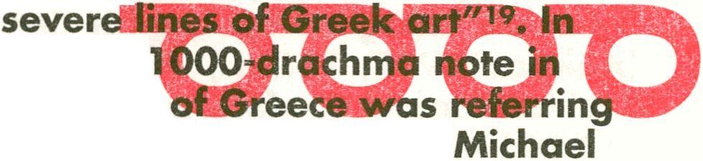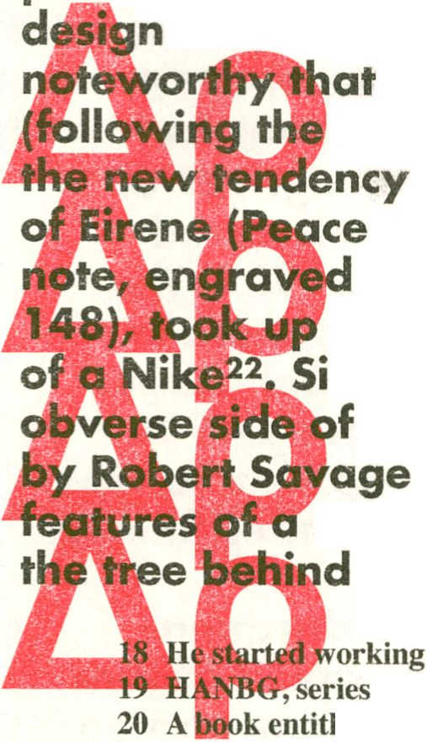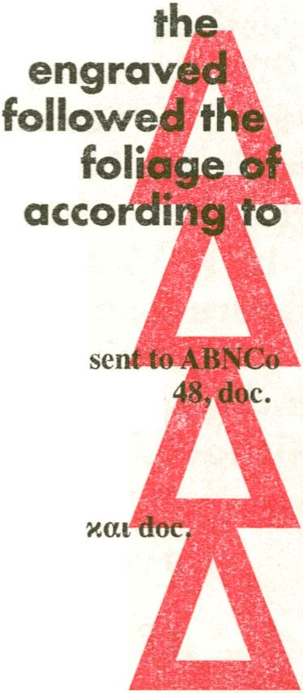Greek facial features, as in the head
milarly, the allegorical figure on
the 1000-drachma note,
file
(Hessler 1993, 260),
statue of Demeter²³. Even the
the figure was executed
for the National Bank of Greece in 1918.
“Nomismatika”, file 48, doc. 23/17.9.1919.
led Kunst und Geschichte is mentioned as source
from the National Bank, see HANBG, series «“Nomismatika”»,
59/25.5.1920.
- HANBG, series “Nomismatika”, file 48, doc. 65/15/28.10.1920.
- HANBG, series “Nomismatika”, file 55, doc. 38/8/21.9.1921.
- HANBG, series “Nomismatika”, file 55, doc. 39/11/24.9.1921
63/3.11.1921.
photographs of cypress trees from Athenian parks²⁴.
Further photographs sent to ABNCo included those
of the statues of Athena Varvakeios (figure ^8)
and Poseidon (figure 30)/ both kept iiyffië National
Archaeological Museum of Athen^^fffwvignette of
the colossal statue of Poseidon, engraved by Marcus
Wickliffe Baldwin (Hessler 1993^40), is tke1^S||
example of pictorial récréatif of the missing parts of
an ancient artwork on a Greek hof. A photograph
of the temple of Poseidon iri Sounio by the^Swiss
photographer Fred Boissonrias^f was the prototype
for the vignette's engraving by Delnose,
(Hessler 1993, 103) (figure 31). For that photograph in
particular, the Greek side asked the artists of ABNCo
to have the sunset's golden shades in the sky and the
sea reproduced, and pay extra consideration on the
sea's rendering²⁷. Emphasis is given on a thoroughly
Greek style, therefore models were being provided
by the National Bank of Greece, ornamental security
designs were outlined in a Greek style, and any kind
of paraphony was being rejected e.g. an oblong
design above the two columns on the reverse of the
500-drachma note, which affected the character of
the Doric order, according to which the architrave
should be placed exactly on the head of the columns²⁸.
The temple of Poseidon was depicted after the
consolidation works in 1898-1899, and the restoration
of the stylobate in 1898-1900 (Mallouchou-Tuffano
1998, 106). Similarly, the^teigfple of Bassai,
was rendered on thé rendered op the 1000-drachma
note after the restoration intervention in itsstereobate
- HANBG, series
- HANBG, series
- HANBG, series
- HANBG, series
- Op. cit.
and the s

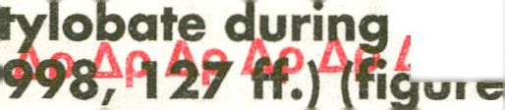ApTÔffàwat
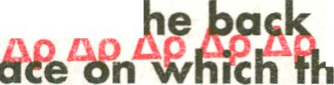The rendering of ancient Greek subjects on the
banknotes' entire surface reached its peak in the
design of the 50-drachma note (figure 36), which
bore ancient Greek motives even on t]
tip A ¡side's background, f or th&^fr
Zip Ap Ap Ap
signatures by the Bank's Governor, the Cashier
and Royal Commissioner were to be affixed, were
to appear a design taken by a Greek vase²⁹. The
columns followed those from the Erechtheum on the . ,
Ap t. Athenian Acropolis, pi«te bf ^{&p Ap}
was selected part of the relief decoration of the so-
called Alexander sarcophagus that presented the
battle of Alexander the Great at Issus. The prototype's
faithful reproduction, namely without additions or
Ap baiic eon&*r#*\^4iicto! &n^itute^{i}c£^{> i} ^
d basic difference in comparison to the previous
renderings of sculpture pieces. The subject matter
was drawn from a plate published in Osman Hamdy
Bey's and Theodore Reinach's, Une Necropole Royale

a_{p} 4&&&&& 4#*? ªP ^{Ap}
the final result in terms of drawing as well as colour
was remarkably close to its prototype: the photograph
published in 1892. Furthermore, there was no
drawing reconstruction of the missing parts from the
from a Tarsus coin in Cicilia which adorns the note's
back side was drawn, apparently, from the same
publication (figure 38). The subject's engraving was
to be engraved in order to be used as a banknote
29 HANBG, series “Nomismatika”, file 55, doc. 59/8/25.10.1921.

Ap Ap
Ap Ap

Ap Ap
from medals and coins. A prototype in as much a
clear and deep relief as possible was preferably being
used for the construction of the cast. A photograph

Athens (Notaras 2005, 166). The basic goal of the
procedure was the negative which came from the
cast's photograph. On its surface, the image's most
important lines-shadows were incised. Theses incisions
&P ^{A}Pi^^%sVfi^fb^^ehgiWer 4.4e*d#r fo hdVei Ap
the impression of the relief accurately executed³⁰.
The issuing of the 50-drachma bank-note (design:
1921-23) coincides with a short, yet historical period
of the Greek Archaeological Society. During the Greek-
Ap Ap Turkish^ War >of 4920-1922, Greek archaeologists Ap Ap
reside in Asia Minor, collect ancient remains and
moved them to Smyrna³¹. Choosing the relief
decoration from the Alexander sarcophagus with the
Macedonian king defeating the Eastern enemy, which
Ap Af was in fact kept at the Archaeological Museum inp Ap Ap
Istanbul, reflected the expansive course of the Modern
Greek state, especially the redoubling of its territories
after the end of the Second World War. Apparently,
it was not accidental that in contrast to the up to that
Ap Ap tioid^kooograph« Ap
this note expressed the dash of a country that had
recently been successful in a number of diplomatic
parleys, such as the Peace Conference in Paris (1919),
the Venizelos-Titoni Agreement (1919) and the Treaty
Ap Ap Ap Ap Ap Ap Ap Ap Ap Ap Ap Ap Ap Ap Ap
- I thank Mark Tomasko for explaining to me this procedure. A negative from
the cast of a medallion with the head of Alexander the Great produced for the
50-drachma note (P66) is included in his collection.
- Kokkou (1977), 139-142; Mallouchou-Tuffano (1998), 165.
The gradual turn to more and more faithful
reproductions of ancient remains on the Greek
banknotes was continued with a remark in a 1923
document from the National Bank to ABNCo, according
to which no decorative border should surround
the coins. Indeed, from the 10-drachma note P88
onwards the ancient coins bore no framing and
maintained their original appearance (figure 39).
Once again, a photograph by Fred Boissonnas was
used as prototypeJbr the engraving of the central
vignette for the reverse of the . 1000-drachma note
(figures 41 a-b^HK The first phase of the restoration
works that altered decisively the appearance of the
Acropolis hpd already been completed. By the time
this note was engraved, the 1902^ 909 restoration
of the Erechtheum (figures 43-45) ailj| the cleaning of
the Carydtides nave been performed (figures 47-49).
The 191 l-l9l7|(nterventions of theWop^dpia had also
come to an endr(Mallouchou-Tuffang> 1998, 166-174)
(figures 45-46).
The gradual annexation of new terr
the Greek state is also reflected on the b<
iconography, e.g. on the composition of the
10-drachma note that bore subjects from the ancient
remains in Crete. The two coins depicted on tne®*
reverse, Labyrinth and Minotaurus, as well as the
motives around them derive from the archaeological
finds in Knossos which were recently published by the
excavator, Arthur Evans (figure 40). On the obverse
stood out the motives from the acclaimed inlaid ivory
draught (figure 50) which Evans described as "the
most magnificent relic discovered in the whole course
of the excavation" (Evans 1921, 387). A spiralifrom
51-54).
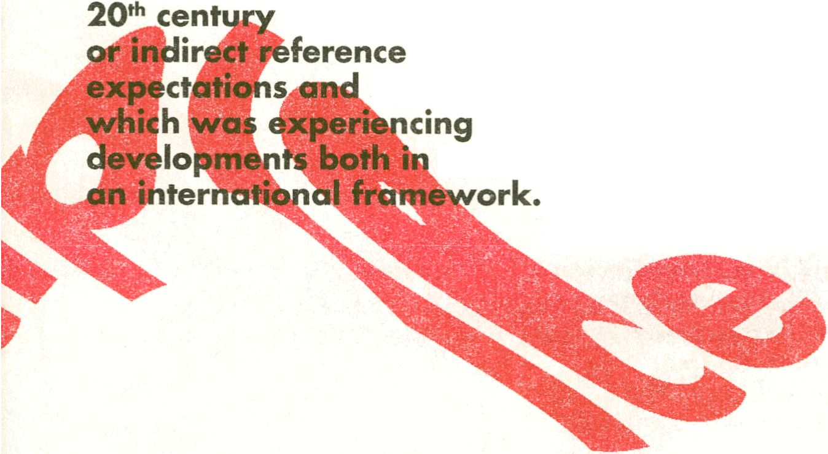The banknotes⁷ iconography is perforce formed
within a thematically conservative and stylistically
academic frame, since it addresses all the citizens
of a country. For Greece in the early decades of the
tfoecame the platform for either direct
to historical facts, national
self-perceptions of a country
intense and conflicting
its interior as well as in terms of
pattern at the periphery of the reverse reproduced the
decoration of the painted stucco fragments found in
an area above the so-called loom-weight basement
(Evans 1921, 371-372). Not only its design, but also
the colouring derived from Evans/ description (figures
References

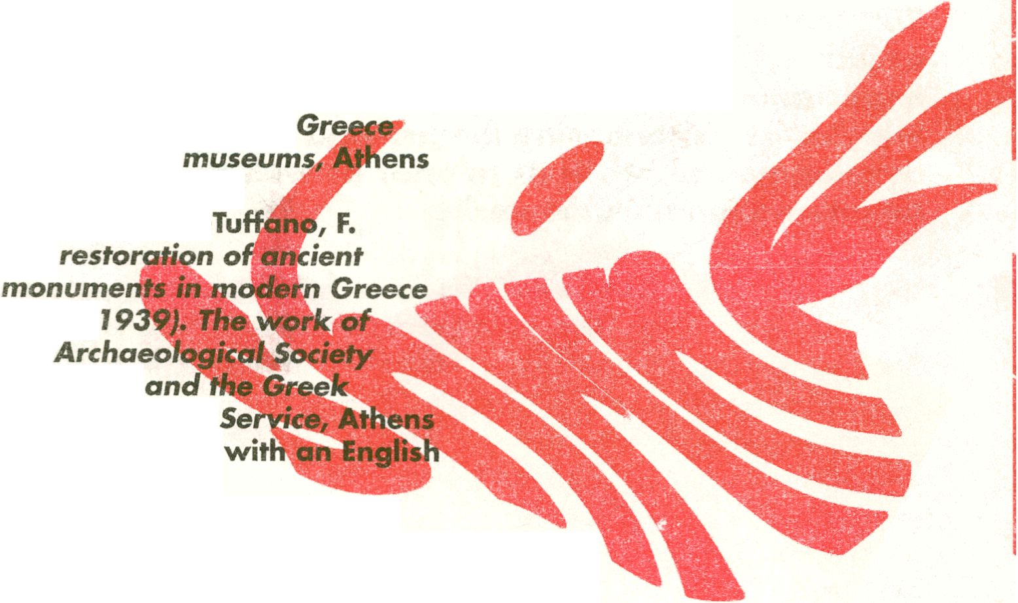
Chatzi, G. The Archaeological
Museum of Olympia. Athens
2008 (in Greek).
Evans, A. The Palace of
Minos I. London 1921.
Hessler, G.. The Engravers'
Line. Port Clinton: BNR Press,
1993.
Historical Archive of the
National Bank of Greece,
Nomismatika, Collection
various files and documents.
Kokkou, A. The concern
for the antiquities in
and the first
1977, (in Greek).
Mallouchou
The
(1834-
the
at Athens
Archaeological
1998 (in Greek
summary).
Notaras, G, Greek
Banknotes, A Journey: 1822-
2002, Athens 2005.
Pick, Albert et all. Standard
Catalogue of World Paper
Money. Ohio: Krause
Publications, 2000.
Tsigakou, F.-M. Through
Romantic Eyes, European
Images of Nineteenth-Century
Greece from the Benaki
Museum, Athens. Exhibition
catalogue Vriginia: Art Services
International, 1991.
Vierneisel-Schlörb, B.
Glyptothek München. Katalog
der Skulpturen, BdL I,
Klassische Skulpturen, München
1979, 255, Nr. 25.




Identity, Crisis, Money
and Beyond
Ilia Roubanis
□ If politics is the continuation of war by other means
nd vice versa, then the managements of the assets
of a polity is as cohesively totalitarian as war. In
fertaii circumstances, this has to bethe case. Indeed,
in a state of war, j^pry government, every political
authority, must try to maj&|hiz# |fle human and
material resources it can draw from sqcléty, since
there is a direct correlation between weblth and
power. And such "emergency situations," generated
by military mobilization, drive by necessity innovation
in governance. Of course such innovations will often
outlive the emerge^y, for once political authority gets
its hold on the pbwer to amass wealth and power,
hereby acquiring a strategic "edge," it is hard to let
go. And in this scheme one may claim that banknotes
are precisely such Én innovation in governance,
created in the context of war, laying the foundations
for novel administrative practices, that is, a technology
of power a la Foucault (MacKinley, Strakey 1998)
permanently changing the relation between state
ublic Debt in Greece
and society. This infrastructure might even be called
"national," as in the natjgfcq^ate.
Let's place banknotes in context. We may call
this a "historical context" but it is unfortunately the
underlying theme of vefete. "curhignt-affaiatoJssues
emerging currently in Europe's public debt ai
coextensively, monetary crisis. For the real question
at hand is the relation between pul
mobilization of societal resources and goverr
And, starting a story from the beginningTwe should
begin with Renaissance Italy. Decades or even


finances, which forced the emblematic Renaiss<
City-State to innovate. Florence issued bonds,
no guaranteed margins of returns, which its c
were forced to buy. From that point onwards, tl
future of the polity was irrevocably connected \
a considerable share of th#citizen's personal w
(Coleman: 2005: pp. 458-460). In time^this link
between pubnc debt and private assets transformed
the nature of the Florentine politiMrs^stemas such.
Florence evolved from being a Corporatist Republic
to being a de facto a Banker's Monarch^ where the
Medici prevailed.
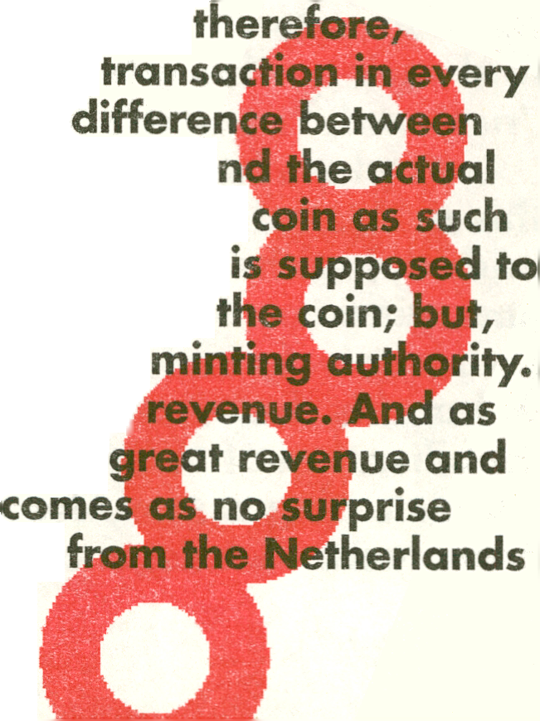An even more ancient link betwee^K^ate
wealth and public assets is the
Florence's greatest rival, Venice, c
was for centuries considered the ^^¥eliable in the
world, ^he Ducat was characterized by an unmatched
alloy purity of gold (0,99), which meant that it was
perceivings j^blp, trustworthy and,
unreservedly acceptable in every
part of the worldTOf course the
the inherent value of the coin as gold a
exchange-value or nominal-value of the
is called "the seignorage tax." This tax
prevent the bearer from melting down
it also replenishes the coffers of the
Widespread use thus leads to hefty
"great coins" were a reflection of
equivalent to great power, it
that many kings and emperors,
centuries before the first nation-states of Europe/
were established, between 1340 and the middli
of the 1400s, Florence was engaged in a series of
expansionist wars. Such a prolonged state of
came hand-in-hand^vith a prolonged crisis in
h of the coin,
la coin that
to Saxony and from there tothe Ottoman realms,
attempted in vein to mint coins that would compete
with an^^Hmie replace the Ducat, to the benefit of
their coffers and their prestige (figure SSÎ^Butthe
Ducat was a brand beyond com petition)! dominating
high value transactions until Napoleon stomireci Venice
M1797.
At this point, what became clear was that
■ __ --„^^^^ izen's army, which
although France did not have the great coins of the
Venetian Republic, it did have a ci
seignorage charges simply could not buy. This
new era. While the troops of Napoleon entered
streetl of Venice, the problems forme Bank o
were ju|t beginning to emerge. In 1797,
planned invasion of the British Isles by F
caused a relatively new phenomenon known as "run-
for-the-bank," with citizens storming the pre-ATM
bank outlets seeking the fulfillment of a promise: "w
promise to pay the bearer in gold."
Much like Venic^fBritain was a naval power withou
a citizen's army. Of course, unlike Venice, it did have
the protection of |besea. But, what the troops
Napoleon could not achieve could be made
nic, as thb noted #| the Bank of England the
fpfiill purposes been treated until 1797 as promi
that were 'as good as gold/ could now be
i
^{,5t} P.^{ie<}
>f finely printed paper. And if everyone
their promise at the same time, just in case
I
>l<
Apd so thè governors of th^Bank of England
ting unprecedented: the "temporarily" called
iromise off by conniving|with the government,
tessage from the bankers and the government to
rthe citizens was one^'we are In this together, we sink
or float together, the paper ^>u hold in your hands,
it, the banking system would
collai
did so
their
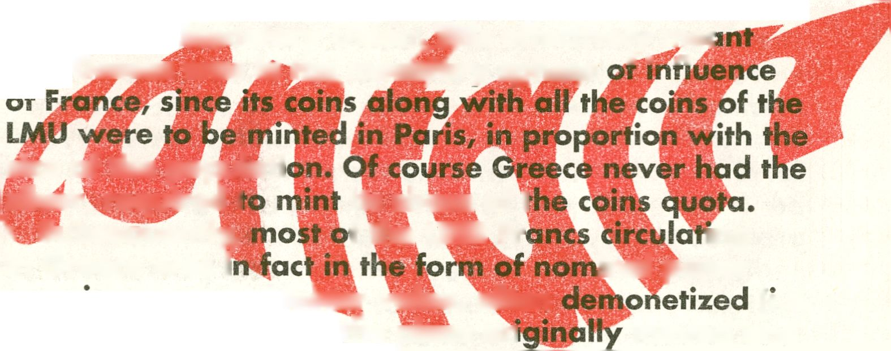dear investor/citizen, is worthless beyond these isles,
especially if Napoleon's troops come marching in."
And for 22 long and temporary years, banknote
convertibility was suspended (Fetter 1965). For better
or worse, the suspended promise of the Bank of
England was now tied with national destiny.
In Greece, as in Britain, the bank note was initially a
privately issued corporate tender. And, coextensively,
the value of these notes had nothing to with trust in
the state. In fact, during the last quarter of the 19th
century the Greek banknotes were directly conyc^ble
in French Five Franc silver pieces, that is, the
of the Latin J^pnetary Union. This effectively me<
that Grace was in th^mon^ry spher.e '* "
ase
size of the popular!
silver required 1
its share of t
f the LMU Fr
1 Subsequently,
in Greece was i
mg
inal paper
(i.e.
minted and
promises. Coins of leiier value, often
not official currency in the place ori
retaining only their value as silver) made their way
into the coffers of the National Bank of Greece. There,
they were turned into reserves, against whom, the
bank would issue sound LMU Francs, albeit, nominal.
In reality, these nominal paper promises dominated
monetary circulation from the end of the 19th century
until well into the interwar period, since the state three
times attempted to establish and three times failed to
establish a national currency based on "sound" coins
(figure 56).
Moreover, there was a less obvious dependency
of the social contract we call currency from the Great
Powers of that period. For the soundness of the
"promise to pay the bearer" was always connected
with the quality of their engraving and printing.
Because paper is a material of relatively insignificant
exchange value, from the moment paper currency is
issued, the issuer finds himself in a technological race
w||||^he shadowy "private sector" of falsifiers. And
ise .cutting edge printing technology was nog| |
railable in T9'^{h} century Greece, but Paris, Vienna,
indon and New York, this is also where Grelpf
banknotes were printed. Consequently, printiSyl
companies such as Bradbury & Wilkinson, Thomas de
La Rue and the American Banknote Company ipade a
good client of the National Bank of Greece and, later
on, the I lank of Greece, until the state acquired its own
prHrfnhg capacity, well after the Second World War.
This fact also had^rtain aesthetic consequences.
One could say this one of the omitted chapters in
Said's "Orientalism" or Todorova's "Balkanism" thesis
or, more geri^Mly^#hc narrative of incorporating the
image of the ^westefn other" into the West's image of
itself. ABNC is still around today in the security printing
industry. The company takes pride on its long history,
dating back to 1823, when it was founded by the
brothers Cyrus xai Asher Durant. Cyrus is considered
the iniwilpi^f several security features that we use
to this date. Asher on the other hand, has a different
claim to fame, since he was one of the aesthetic fathers
of monetary iconography.¹
Aesthetically, neoclassicism was a traditi«
interwoven v&th the naturalist tradition, th<
notion that rai object of scientific knowledge
— was also the source of a higher aesthetic
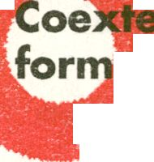jJllilvefy, the celebration of nature in its k
, as represented in ancient Greek art, was also
H|P^ www.abncompanv.com
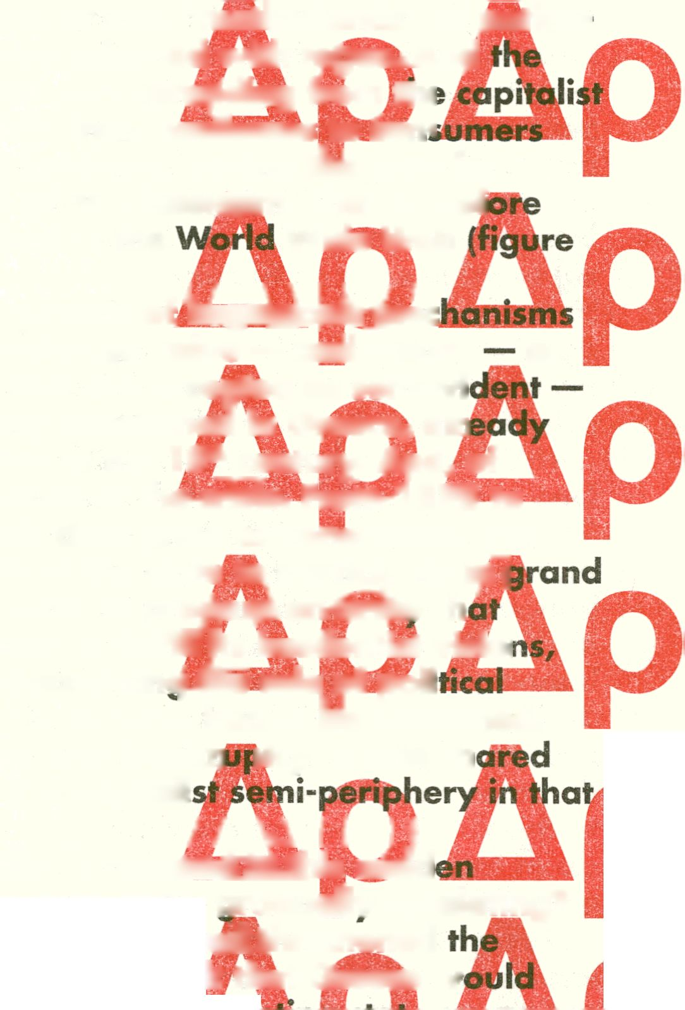the dominant cultural mode
century Europe, or indeed,
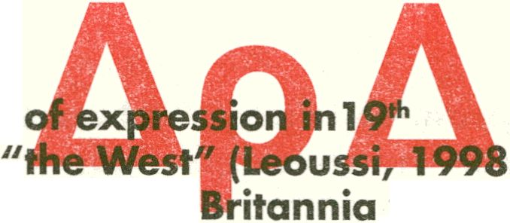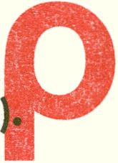Therefore, it is hardly a surprise that
was
Hollywood, television of the
depicted as Minerva, or that "motherlands" of fiation-
states in Europe were adorned with t^gas*J\nd
same aesthetic motif was spreading from tin
core to the periphery, from producers to dsn«
of high technology products, paving t&fe way for a
high global culture of neoclassic|Sm. That is, bef
Wide Web
⁵⁷⁾* M m hl m
But, the parallel growth of hegeMojnieiiTOc
of value — as in exchange value — and values
as
in beliefs in truths that are accepted as self-evi
was gradually being questioned in Greece/ air
since the last quarter of the 19th century. And, of
course, it is all because of the&fPPs; FromW878 to
1893 Greece's public debt grew exponentially. The
reason was the will of the state to participate iqT
modernization projects, to prebaifkarbiift^fr th
would allow the state to fulfili^ts irredentist visioi
without of course discountincpllé role of poli
clienteles which then, as now, had to He nourished.
The end of this road was bankrj
)tcy; a fate sh
by many states of the capitali
period, as now. I li |
How was the state to respóÉHÉMlhis sudd
liquidity and public debt crisis, gradually escalating?
Already since 1868 the state hgdlthreatened
privately owned National Bank that Greece w
emulate the Ottoman's lead ii^pri.^
storming the market and competing with ihe
banks, but also threatening to discredit paper-credit
as a medium altogether. This isfhe equivalent
threatening to issue state cred^lftds jfiese d
a compromise was reached,
was suspended/ following the
with roughly a century's delay. And
tic relationship was build between
s<|ciety,i harnessed in Britain much
raruSreece, as in Britain/ the
d have to trust the bank as
e state. Not much/ that is/ but
other options available,
private confidence did
aterial foundation since
%t petty-currency notes
. These small in size and petty-
issued by issuing banks
e)/ in volumes proportional
ced to lend the state. In the
uTbond of trust expanded/ since
forced more and more to make their
le to the state for lending. We were
nJpnlible bond of trust/ binding
citizfjni and investors/ taxpayers/
aepted politically/ normatively and
umHowards the end of the 19th
the emergence of national monetary
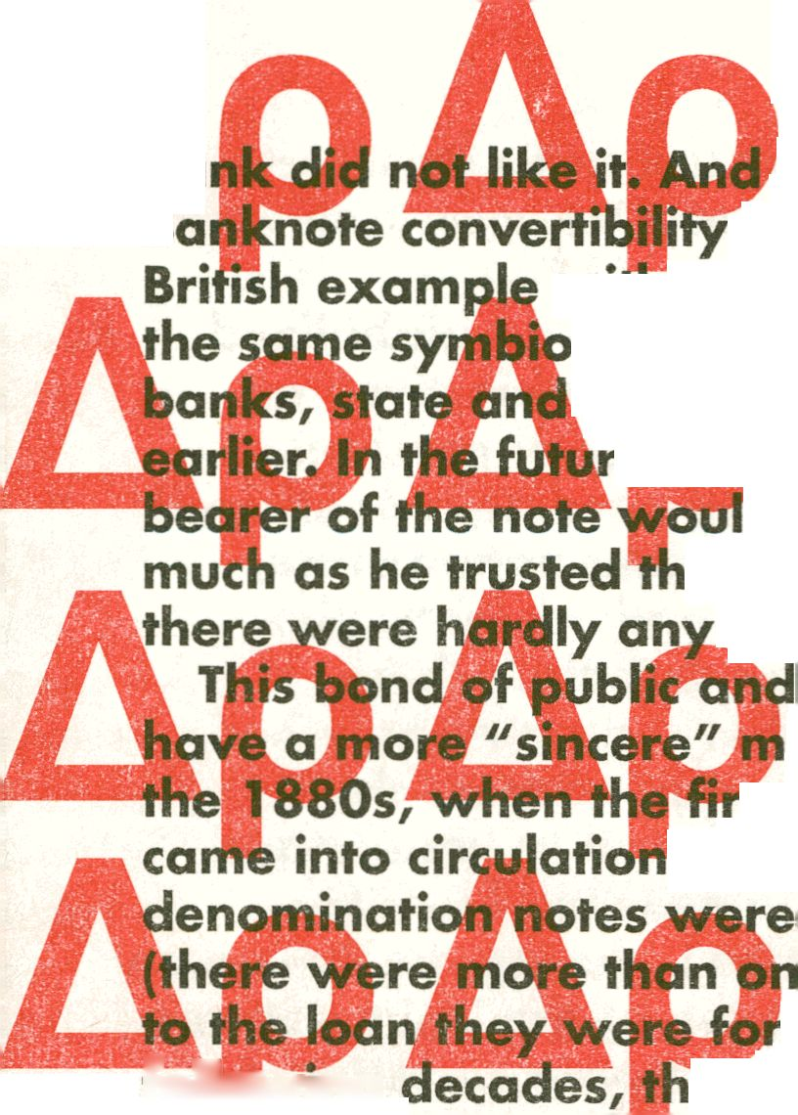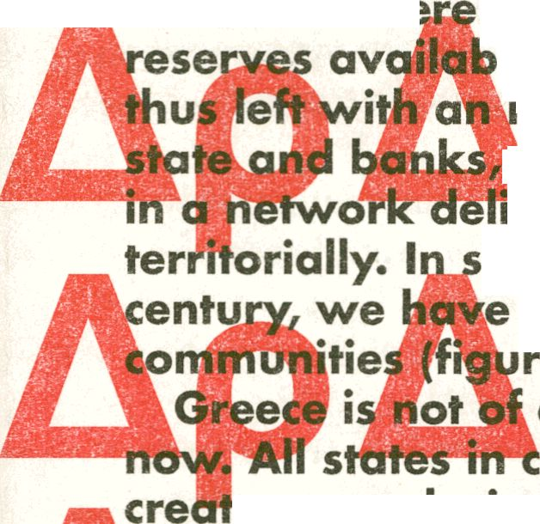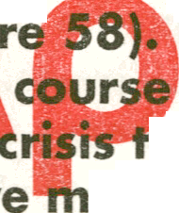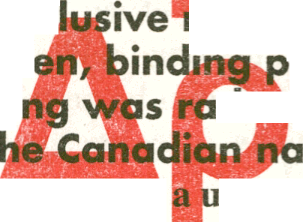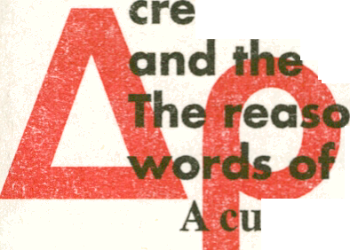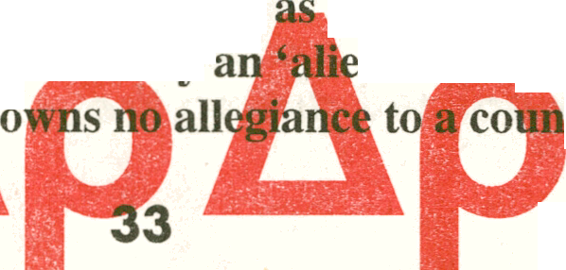a special case. Not then, not
ried at one point or another to
onetary bond between the state
rivate and public wealth,
thljr simple, and reflected in the
tionalist Buchanan in 1882:
niversal form of money such as gold
‘disloyal’ and ‘unpatriotic’ one because it would
n’ class “whose boast is that money capital
following
the &anks wc
e an exc
citiz
ni
tl
rrency based on
(...) was seen
serx&onlv
try.’As he put it ‘patriotic’ policy
should thus be governed by the idea that money should
thing of or belonging to a country, not of belonging to the
(Helleiner 1998).
As currencies were gradually being de-globalized
and nationalized, striped from their "objective" or
cosmopolitan exchange#diue quality of precious
metallic content, as value in itself became a
notion in the realms^Ijthe ascending nation-state,
the banknote was alsb transformed aesthetically.
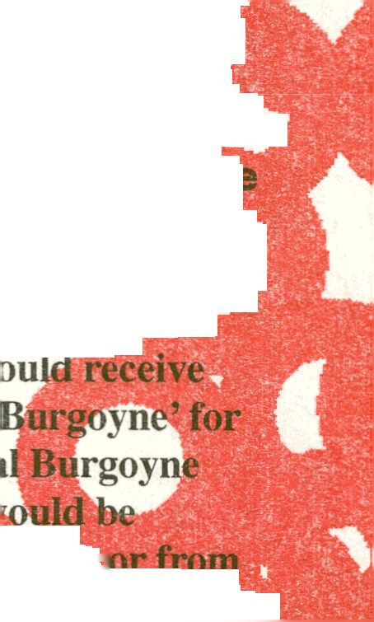In a world without television and radio, >vhere
education was a privilege rather than a right, whe
communication media could hardly address the
masses, those in power could not fail to understand
the instrumental utility b||jknotes could have for
propaganda. Specifically, in 1863, during the'^jiterican l
Civil War, the Federal gov&rnmentjafjhe United States
is forced to issue non-«
did
urren
icy. At
which point, a clerk of
seemed as a "desperate
times, could, potentially, be a blessing in disguise with
collateral benefits:
te that what
in desperat«
“{They} would tcntf to teach the masses the prominent period ^{J}
in our country’Jpltory. The laboring mail who w
every Saturday flight, a copy of the‘Suffiender of
his weekly wages, would soon e||||re who (jenen
was and to whom he surrenderel^^pcuriosity w
aroused and would leamAa^tsllbm a fellowmh®r%™
his employer. The same would be true o| other National pic tures,
and in time many wo*
Spe taujBjk leading incidents in o ur
lev would soon be familiar to those
country’s history, so tl
who would never read
imbu
(Hell
Inde
bankn
•jp books, teaching **' *“ ¡¡jr*““
h a national feeling.”
ure 59)
rule rather than the exC
aphy is nationalized during
on that
the
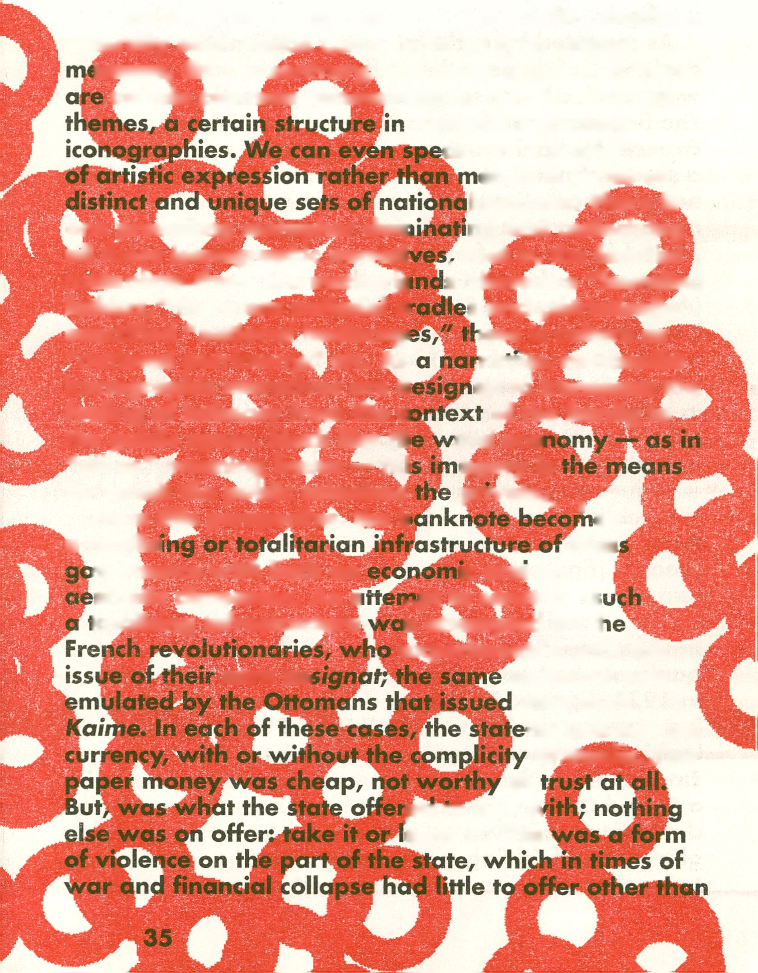course of a war. However, banknote imagery does
not simply serve the purposes of nationalist catechism,
whereby each nation comes with its own unique
issage. On the contrary, one could argue that there
certain common denominators, certain recurring
national banknote
ak of "a school"
erely a series of
I pictures. There is
ng and underlying
. that is, the familial
s, there are "founding
s and patriotically
¡ere is culture as
ran^,mati(»ialist
ed to transpose the
of the family to
ord ecoi
agery is
one prevailing metaphor dorr
all these iconographie narrati
metap^Sl^rere are mother^
fathers," there are national a
sanctified "national landscape
"national patrimony/' etc. As
iconographie narratives are d
feeling of intimacy from the o
the public space. Much like th
"oikos" meaning house — thi
by which the public colonizes
From this perspective, the b
a totalisi

prival^L
es
mas
vernance with both an
sthetic dimension. An c
totalising infrastructure
own as;
ic and an
..pt to construct s
is attempted by tl
experimented with the
example was
their own
-issued debt as
ofjjonks. Jhis
of
pa to pay w
eave it. This
"promises/' while citizens had no option but "to take
it" (figure 60).
As revealed by archival sources, the national
designers of these rather inflated and cheap currencies
were perfectly conscious of their "patriotic mission."
The first national designer of banknote imagery in
Greece, Michael Axelos, operated as a member of
a series of networks devoted to the construction of
national narratives: he consulted with archeologists,
museum curators and librarians; he supervised and
picked fights with foreign engravers for their failure to
produce "authentic GreekJ.U't," whatever that means
(Angelopo|§jos 1984, Estia 1928). And as soon as his
images ended up upon Banknotes, they acquijggd a
life of their own, becoming part of the narrative that
people, institutions and companies took ownership of
in order to express themselves in a patriotic manner.
Take for example the images designed by Axelos,
originally copied from a museum exhibit, ending up as
an engraving for money/proliferating its presence in
the public space by making its way onto d corporate
logo, that is, Health Services consortium called Ygeia
(health) (figure 61). There are dozens of similar
examples.
It is no accident that Axelos himself was hired by
the National Bank of Greece in 1918, whilst the first
banknote he had designed was delivered by ABNC
in 1921 (figure 62). During those years Greece was
just coming out from the First World War and was
looking to expand against the defeated Ottoman
Empire. These first banknotes, celebrated the idea of
a Grand Greece, which might have been economically
devastated, but was nevertheless celebrating its own
glory while building a new language of patriotism
to be shared by its newly acquired subjects. That is
why the most interesting part of the archives of the
National Bank of Greece is the "Numismatic Series"
and, more specifically/ referring to the designs of
banknotes that would have circulated had Greece won
in the Near East campaign against Turkey in 1921-
1922 (Roubanis 2010).
What is of interest is that Axelos himself was
not specifically trained for the design of banknote
vignettes. At the time/ he was one of the few painters
I in Greece trained in Paris/ having the credentials of
a modern artist. The companies he was dealing with
Were not accustomed to having their designs amended
by their clients or to be responsive to their national
aesthetic preferences. And these exchanges of letters
between Axelos and those elite engravers/ reflect an
early stage of nation-branding discourse that is open,
blunt, sincere and truly unique. And what comes
out clearly from these discussions is that the familial
metaphor is a clearly an underrated dimension of
national identity.
The
nknote is in this sense an ideal obiect of
study fo. ■ this material culture/archeological approach
to the study of nation-state modernity, because as
a financial and pontical infrastructure it evolved in
parallel with the develbpment of jyhe nation-state. In
general, the administration of public confidence has
not been treated as a fundamental dimension for
the emergence of what Anderson calls "imagined
communities" (1983). Imagined here does not denote
"fake" but rather impersonal, meaning societies being
able to mobilize militarily, politically and financially
individuals completely unknown to each other, who
nonetheless feel intimate with each other, since they
are bound both normatively and aesthetically by ties
approximating very closely those of a family.
And at this point it is worth noting a paradox in
modern liberal tradition. While the liberal tradition
places an emphasis on the separation of the public
and the private, presenting essentially the state as a
"necessary evil," that is, a "contract guarantor," the
aesthetic and economic history of banknotes reveals
an altogether different narrative. For only the state
could historically bridge the gap between the private
and the public, that is, to create a society that may be
impersonal, normatively regulated, butjpt the same
time familiar. And this familiarity becomes erer more
evident when contracts, such as currencies, collapse.
It is precisely when the national tender is not the
reliable facilitator of a Qationm community, that peo
become disoriented, turning their loyalty towards
the next available reference community, that is, the
farm, the school, the <^|incil, the Church, etc. Look for
example at proi^ss^^notes flourishing when the
Ottoman curredigycollapsed with hyperinflation during
the last quarter of the 19th century (figure 63).
One of course may argue that not too much
should be made of national currencies. After all, how
many of us could bring to their minds the images of
banknotes circulating merely one decade ago, prior
to the emergence of the European Monetary Union.
But, this is the wrong question, since by the same
token very few of us can immediately bring to mind
the advertisement of the products we daily consume,
not merely we like them or need them, but because
we have associated this product with a specific aspect
of our identity. And the analogy is valid, because
banknote iconography, much like advertising, does
not transmit specific knowledge, but aims at affecting
perception as such, that is, the way we see ourselves
in this world. Gottschalk explains the issue at hand:
“...Scientific observation, like so-called ‘practical’ activity,
employs perception as a means to a further end, in its case the
verification of a description or an explanation of features of
observed situations. Knowledge is the end — grounded and
tested information — and perception is incidental to this. (...)
Now aesthetic experience reverses this pattern of scientific
observation as fully as it does that so-called ‘practical activity.
Knowledge, like action, is a means, and aesthetic experience
employs knowledge, some times large stores of it, to light up
points of within the perceptual field and to help to establish a
full and amplified perception of all that is perceptible there. But
perception is the end” (Gottschalk 1962).
Therefore, the point is not to remember the sequence
of images of an advert, like Coke. The point is to
»ociate Coke with youth, care^
thing moments. By the saj
tenon is not placed .or
the Greeks to learn abou^
ife, exciting and
n, a picture of
e in order for
, or to familiarize
themselves with the d
landscape ~
is globa
heritage,
once again
than any Euro-
icture on the Athenian
to|seejthe Parthenon because it
remind the Greeks of their great
to make them feel
IfpFeat family, which is less
every achieved.
mous,
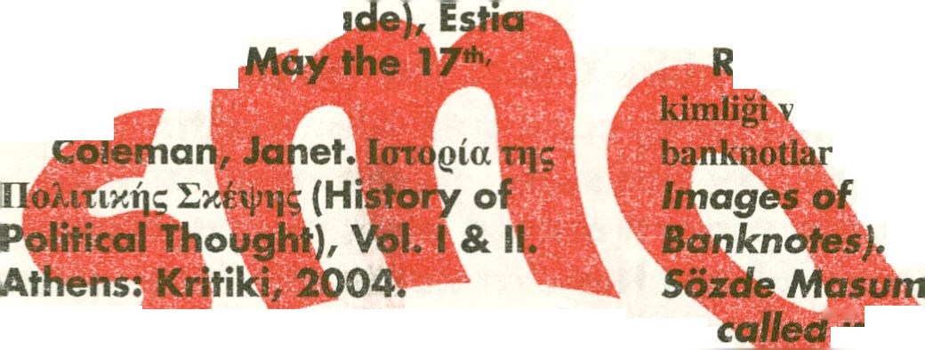References
Angelopoulos, John. KaXcg
TEXVEg xai to xaQTOvdpiapa
(Painting and the Banknote).
Athens: Thirida, Bank of Greece,
1984.
Anderson, Benedict.
Imagined Communities:
Reflections on The Origins and
Spread of Nationalism. London:
Verso, 1983.
Anonymous. "Ilibg <jmdxvovtai
ta xaQTOVOfnanam" (How
Banknotes Are Me
Newspaper^
1928,
Fitter, Frank W. The
Development of British
Monetary Orthodoxy: 1797-
1875. Cambridge (MAS):
Harvard University Press, 1965.
Gottschalk, D.W. Art and the
Social Order. New York: Dover
Publications, 1962.
Leoussi, A.S. Nationalism
and Classicism. Basingstoke:
McMillan Press Ltd, 1988.
MacKinley A. & K. Starkey.
Foucault Management and
Organizational Theory. London:
Sage Publications, 1998.
Petraki, P.E. Ta oi]|aEia xajiJti|g
atri bpaattiyioTr^ra tijg cXXi]vixr|g
oixovojiiag (The turning points in
Greek Economy). Athens: MIET,
1992.
Prontzas, E. H av0Evtia
tot) voftianatog otrj vEoeXXrjvixri
xoivema: t] JiEpioftog Siataxtixtbv
xeQpdttov 1885-1910. (The
authority of the Greek currency
in modern Greek society).
Athens: Modern Greek Studies
Institute, 1995.
Helleiner, E. : "National
Currencies and National
Identities". American
Behavioral Scientist. Vol. 41,
No. 10 (August 1998).
|oubams I. (2010), Yunan
e kamusal alanda resim:
(Greek Identitty and
the Public Space:
In Millas H (ed)
so ""'™
Istanbul: Kitap
Said,V^J|
London: Peng
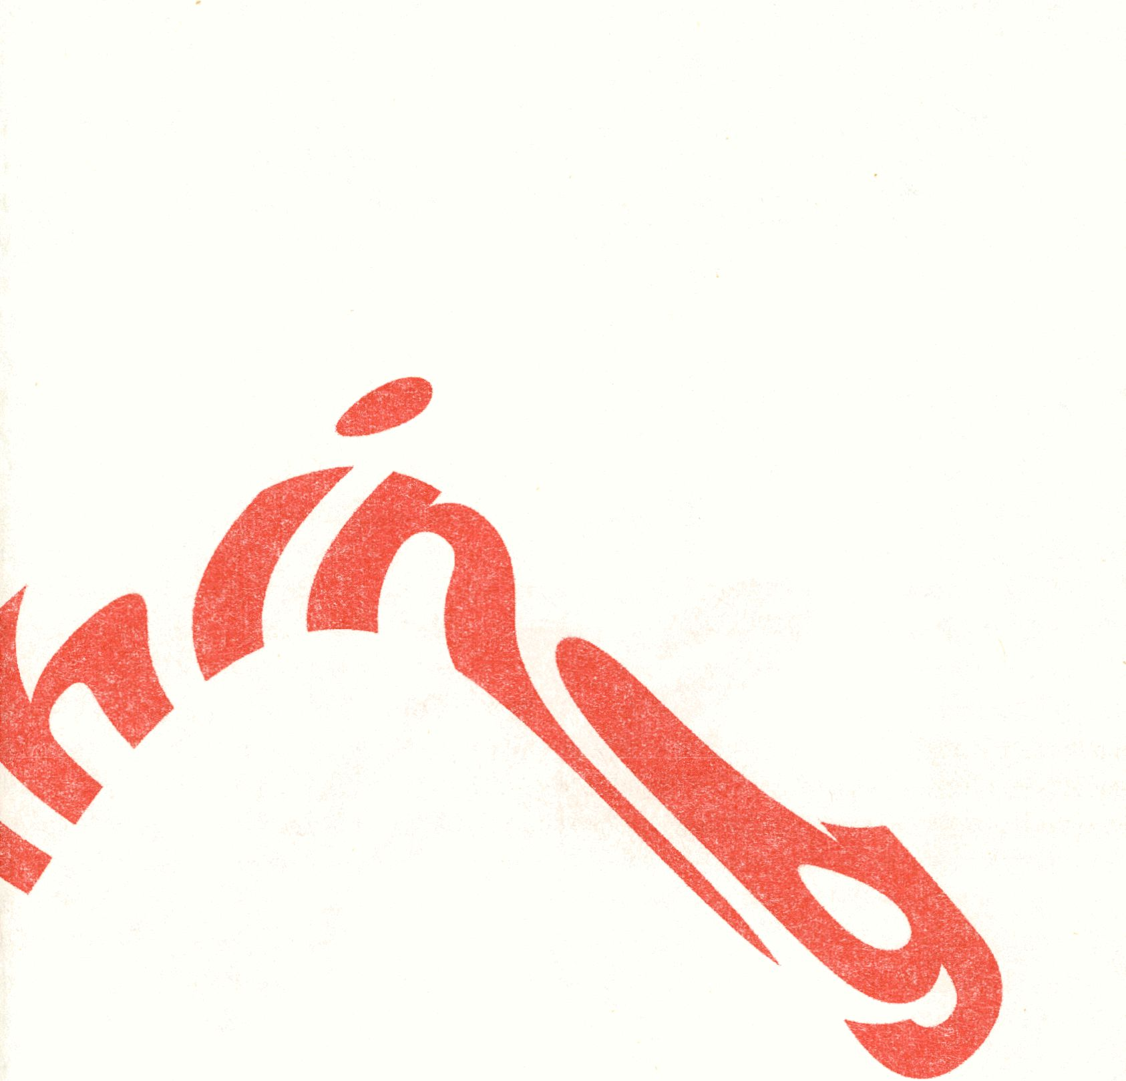

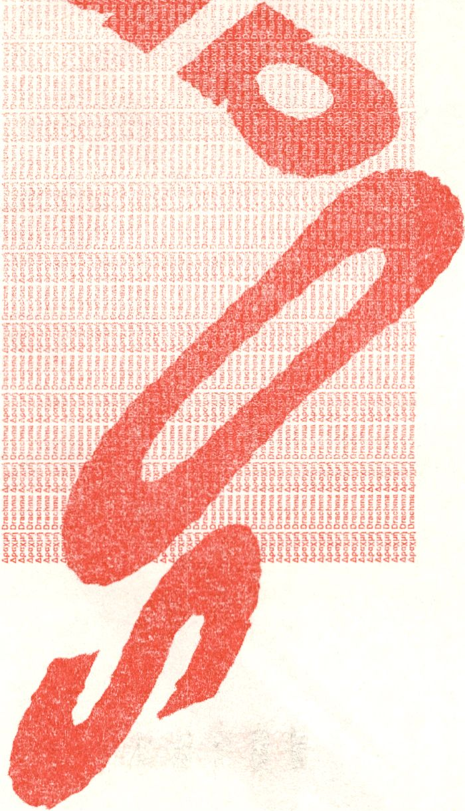

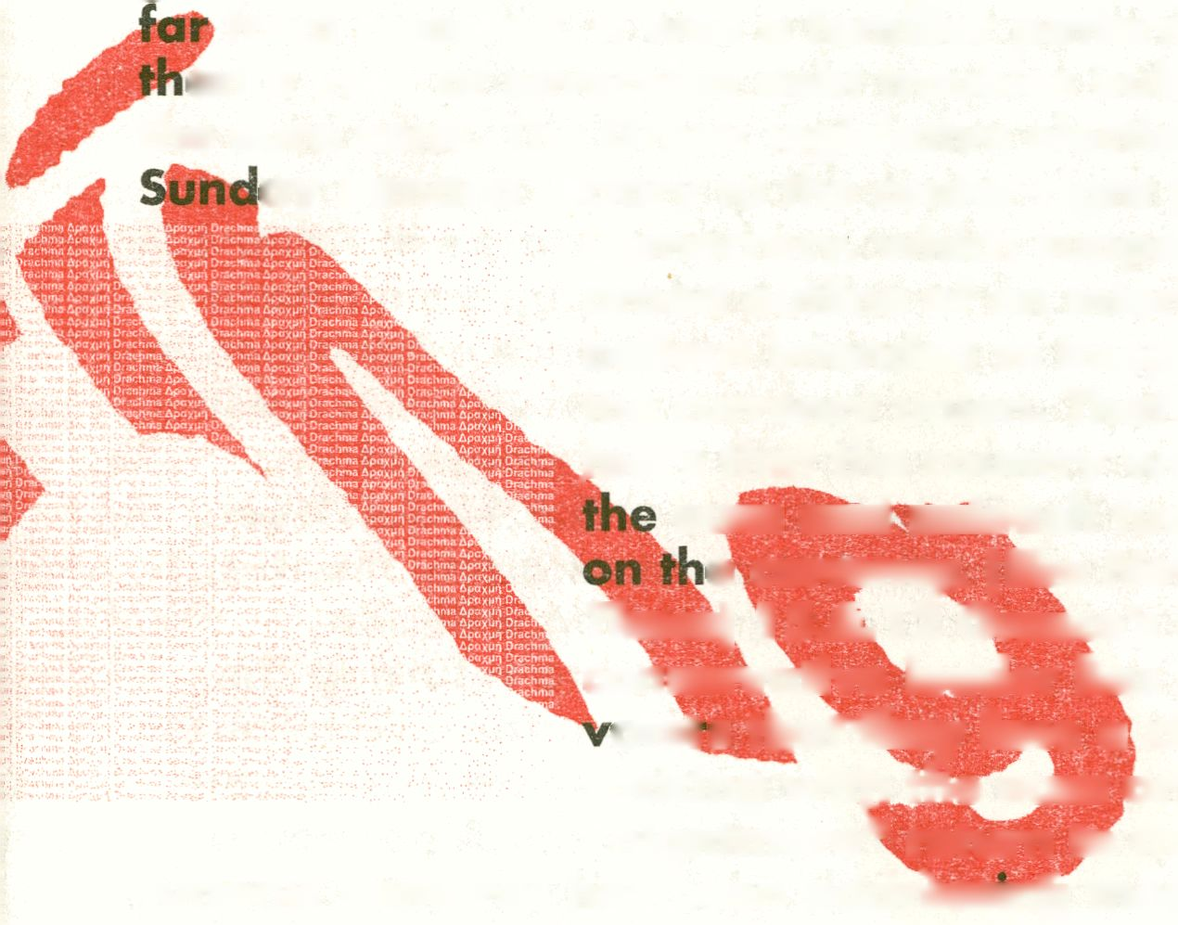Newsfeed
18.6.12 The financial markets initially responded
with relief on Monday as elections in Greece ushered
in a party that supports the outlines of an
international bailout. But the reaction was short-lived
as borrowing costs in Spain and Italy reminded
investors that the troubles facing the euro zone were
from resolved. It was a familiar pattern after more
an a year of sovereign debt troubles bubbling up in
the euro zone. The Greek legislative election on
ay handed victory to the center-right party; New
Democracy, which supports the
broad outline of an international
bailout intended to keep Greece in
the currency union. That had eased
.fears that the country would leave
euro and unleash further turmoil
e currency. (The New York
Times) 15.6.12 Greece's
conservative leader has warned
otets tharfhey face a choice of
sticking witji the euro or a
"nightmare*' return to the drachma.
Antonis Samaras has been addrJiSmi|) thousands of
supporters ahead of Sunday's parliamentary election
re-run. His New Democracy party, which backs the
country's international bailout, is running neck and
neck with the radical left Syriza party. Syriza's fresh-
faced leader is threatening to tear-up the strict terms
of the 130 billion euro debt deal. No party is expected
to come away with an outright win. There will be
negotiations to form a pro or anti- bailout coalition.
(Euronews) 13.6.12 Golden Dawn has risen in profile
after it won just under 7% of votes, or 21 seats, in
parliamentary elections on 6 May, amid deep anxiety
about recession, unemployment and high levels of
illegal immigration. The party's staunch anti-
immigration policy has led to accusations of racism
and instigating violent attacks against immigrants.
Golden Dawn's leader, Nikos Michaloliakos, has also
denied the existence of gas chambers at Auschwitz
and questioned the Holocaust, but he rejects the label
neo-Nazi. Polling data seen by the Daily Telegraph
shows that Golden Dawn is on course to perform just
as well or even better in the new election^ which was
called after the first failed to produce a government.
Immigrants groups have said that attacks ih Athens
have risen in recent weeks, ^q^cin^yjp an inci%ase in
anecdotal reporting, and fear that once established in
parliament the party's blacpt-fsmrted vigilantes will
feel further emboldened in their campaign oTdik
intimidation. (The Daily Telegraphy 2 As Greece
gears up for its second election in as many months,
companies and citizens are grapplfhg^With th,? ^ ^f/:
possibility the nation will be forced to refiBrn to the
drachma, 11 years after swapping it for a German-
designed single currency meant to be an irrevocable
step in European economic integration. A post-euro
Greece may face defunct banks, collapsing businesses,
skyrocketing import prices, soaring national debt,
food rationing and even violent demonstrations,
according to a dozen economists, analysts and
professors. "A moonscape scenario, one where
everything that is mobile leaves, is certainly one you
can anticipate," Michel Spence, a Nobel laureate in
economics and professor at New York University's
Stern School of Business, said in an interview in Milan.
.6.12 There's a lot of buzz in the City
ter traders discovered that there is
rcoHWiiWBrac«
EE££S=£E
I results this morning, but
ekecutive Tim Cobbojd wouldn't be drawn on
ei- Athens had askecf his firm to prepare for a
new ci^rency to be issued. (The Guardian) 22.5.12
Worries that Greece might default on its debts or even
’ ave Europe's currency union have deepened since
.^jy 6, when Greeks voted in shocking numbers for a
left-wing party willing to tear up Greece's $170 billion
rnational bailout agreement. These days, even
gh 80 percent of Greeks say they want to stay
With the euro, talk of "drachmageddon" can be heard
*in conversations all around Athens — in executive
suites, at mom-and-pop shops and even in nightclubs.
Any departure from the euro, if it did occur, would not
come quickly, even if a new government repudiates
Greece's bailout terms; orchestrating the exit would
be legally complicated and lengthy. European leaders
may also move to prevent a Greek default or exit at
the 11th hour, considering the almost unending
uncertainties. (The New York Times) 21.5.12 We keep
hearing that Greece cannot impose exchange and
capital controls — as Iceland did — to contain the
damage from Drachma Day, restore stability, and
prevent a devaluation overshoot. We hear too that
now a code for the Greek drachma on Bloomberg. The
code in question is 'XGD CURNCY', which is described
as "Greek Drachma Post EUR spot". It doesn't appear
to actually link to a tradable currency unit — the
message "Access to this security is restricted by its
supplier" appears if you click on it. It's also not clear if
it's just been created, or if there's another reason why
it's just been spotted today. (The Guardian) 29.5.12
Banknote printer De La Rue has refused to comment
on speculation tl|at it has drawn up plans to print
drachma notes again if Greece quits the eurozone. De
La Rue reported finan<
Greece would have to leave the EU if it is ejected
from/withdraws from the euro. Both assertions are
wrong. The danger for EMU is that Greece's trajectory
may look tempting to others once the dust settles. By
then Portugal, Spain, and Italy will be further into
their austerity death spirals, and further into self-
feeding debt deflation. Their own internal Greek
tragedies — less extreme perhaps, but equally
relentless — will be unfolding. It is not contagion. It is
replication. (The Telegraph) 20.5.12 If or when
policymakers finally decid&&jr£ece »should leave the
euro, the exit could happen so cuicllk that "new
drachma" currency notes might not printed in time.
In principle, somp of the long-term consequences of
Athens leaving the currency bloc are not unappealing.
The euro zone would no longer have to worry about
what has always been its weakJI| Inlk^ But the short-
term effects would be brutal, both'domestically, and
on the global economy. A post-euro Greece could fihd
itself struggling to import food and fudl, with
everyday life reduced to barter in goods
and the government unable to pay workers-Ip
anything they would want to receive. The cosf%f¹
managing what is increasingly being termed "GrexTr*
— with its resulting global market turmoil and colossal
financial pressure on Spain and Italy — could dwarf
the cost of keeping Greece on financial life support.
World leaders meeting at the G8 at Camp David
recommitted themselves to keeping Greece in the euro
zone, underlining worries over the costs of an exit.
Not everyone believes that will prove enough.
(Reuters) 11.5.12 Banks are quietly readying
themselves to start trading a new Greek currency.
Planning behind the scenes has been underway since
Europe's debt crisis erupted in Greece in 2009. The
elections threw into doubt the EU/IMF aid package
that came at the price of harsh austerity measures,
and was reached only after much haggling between
banks and politicians over a 100 billion euro debt
reduction. A Greek departure from the euro would
create legal and practical problems for the banks
which would dwarf the relatively straightforward
technical job of dealing in a new currency/ For Greece
itself, it certainly vh>n'tIpose a problem.
The country's national bank has its own
banknote printing press and mint and
nnued to print euro banknotes
ice joining the single currency in
(Reuters) 5.4.12 He lived, said
fghbours, an 'everyday' life. But in
ath Dimitris Christoulas has become
an extraordinary symbol of how
Greeks are struggling to cope as their
country falls apart under the burden of
austerity measures. On Wednesday
morning, the 77-year-old former
pharmacist walked into Greece's
Syntagma Square, where he shot
himself, just yards from the nation's
parliament. His death has shocked
Greece, even though the nation has
already seen suicide rates increase by
around 20 per cent in the past two
years. Yesterday, police clashed with demonstrators
for a second day at the site where Mr Christoulas
killed himself in downtown Athens.The public suicide
quickly resonated in a country where successive
rounds of salary and pension cuts have created a
mood of national despondency, and one in five adults
is unemployed — twice the European average. (The
Daily Mail) 13.2.12 Over the weekend/ more than 45
buildings across Athens were set ablaze by violent
protesters. The fires began as the Greek Parliament
passed a new strict package of austerity measures, in
an effort to meet demands by the European Union and
the international Monetary Fund. The measures, which
were prerequisites for a $ 170 billion bailout, included
steep public-sector job cuts and a 20 percent reduction
in the minimum wage. More than 80,000 Greeks
reportedly demonstrated in the streets of Athens ~
among them, a small, violent group that hurled
firebombs at riot police and set dozens of fires. More
than 120 police and protesters were injured. (The
Atlantic) 15.11.11 Following three days of anti-
immigrant violence in Athens, questions are being
asked about possible far-right involvement in the
murder of Bangladeshi migrant worker Alim Abdul
Manan. The attacks on immigrants started on Tuesda
man, died after a stabbing in what appeared to be a
street robbery in the Kato Patissia neighbour!?«
downtown Athens. Residents blamed the killing <
institutional neglect of their neighbourhood and •
'immigrant crime wave', although to date,
10 May after Manolis Kantaris, a 44-year-old Greek f
evidence has emerged that immigrants stabbed
Kantaris. On 12 May, following a 2,000-s
demonstration which was quickly overrun
nationalists, riot police were called in as far
youths rampaged through immigrant neighbourhoc
clubbing and pummelling victims to the ground. On
the same day, in the Patissia district, 21-year-old
Bangladeshi worker Alim Abdul Manan was chased
by two men on a motorbike who then stabbed him
and fled. (Athens News) 5.11.11 Greek prime minister
George Papandreou has abandoned his plan to hold a
referendum, amid scenes of open warfare in his own
Pasok party. Finance minister Evangelos Venizelos
forced the move in an early morning speech, saying
Greece's eurozone membership was too important to
risk. Opposition leaders are resisting Papandreou's
efforts to create a caretaker government of national
unity and are calling for his resignation instead. A
vote of confidence will still take place on Friday night,
but Papandreou may quit even if he wins. (The
Guardian) 31.10.11 Papandreou flies to France today
to face European leaders surprised by his decision to
put the bailout plan to a national vote and call a
confidence vote in parliament. Papandreou's decision
to seek the support of Greek voters is a fresh
challenge to a European Union-led bailout agreed last
week that involves a 50 percent write-down on Greek
ibt and further austerity measures in that country.
"jHsk is that rejection by a referendum would spark
disorderly default and call into doubt Greece's
membership of the euro. The new round of political
|| turmoil throws into doubt Greece's ability to access the
emergency funding that's keeping its finances afloat.
^{,l}*^{f}^'>mberg) 10.10.11 The impact of cuts on medical
ices appears particularly troubling. HIV infections
nificantly in 2010, with injecting drug users
for half of the rise. The numbers are on
rise by 52% this year. Many new infections
iso linked to rises in prostitution and unsafe sex.
Heroin use reportedly rose by 20% in 2009, according
to estimates from the Greek Documentation and
Monitoring Centre for Drugs. Budget cuts in 2009 and
2010 have meant the loss of a third of the country's
outreach programmes. Since January 2011 we have
seen a more than 1000% rise of HIV among
intravenous drug users. Overall, the picture of health
in Greece is concerning. In the efforts of the
government to cut the budget ordinary people are
paying the ultimate price: losing access to care and
preventive services, facing higher risks of HIV and
sexually transmitted diseases, and in the worst cases
losing their lives. Greater attention to health and
healthcare access is needed to ensure that the Greek
crisis does not undermine the ultimate source of the
country's wealth — its people. (The Guardian) 5.9.11
The suspension of an EU, International Money Fund
and Ed|ppean Central Bank mission to Greece late last
week has raised questions over whether Greece can
cut its|§»«jdget deficit enough to secure the next
instalment of bailout funds. The head of a Financial
Crisis Special Committee, MEPWolf Klinz, told
euronev^js: "Greece is not meeting the conditions
the (austerity) plan and the Greeks need to put si
convincing proposals,pn the table on how to com
back to the plan they had created before — and which
"""it
meeting its austerity targets, but in Brussels and at
thelMF they are growing frustrated at delays in the
implementation of reforms. (Euronews) 29^6.11 The
Greek parliament lias voted in favour of a drastic
package of austerity measures' intended to Save the
country from defaulting on its debts. The proposed tax
hikes and spending cuts have been deeply unpopular
with the Greek public. A nationwide 48-hou§ strike is
under way and violent clashes are continuing in the
streets of the capital, Athens. The EU welcomed the
bill's passage, by 155 votes to 138, as a "vote of
national responsibility". Greece is heavily in debt and
the package is needed to win the latest tranche of a
1 lObn-euro (£98bn) loan from the EU and IMF. Once
news that the vote had passed trickled out to the
streets of Athens, fighting broke out with a new level
of brutality. The air outside parliament was thick with
plumes of tear gas and smoke as clashes continued
near the square between masked protesters — armed
with rocks and sticks — and riot police firing tear gas
and stun grenades. (BBC News) 23.5.10 Greece has
^{as}*^{cec}^ f°^{r} the activation of an EU-IMF
financial rescue package to help pull the debt-ridden
economy out of its crisis. It hadJioped that just the
P^{r}°iM°f EU support, agreed last month, would
have been be enough to reassure markets and help its
recovery, ^ut Greece's problems hdv^pg^nued to hit
investoriii|fidence in the Huro and odier European
economic. Earlier this month, a deal was agreed
under which eurozone nations would provide
emergency^oqi|! of up to 30bn euros ($40hn; £26bn)
in the first year, with a farther lObn euros coming
from the International Monetary Fund (IMF). The ~
European Comihisston and the IMF said they were
optimistic that the%xact details of a loan could be
worked out quickly. Greek Prime Minister George
Papandreou, on a visit to the Aegean island of
Kastellorizo, said the markets had not responded
positively to the austerity measures designed to
reduce the country's debts, as he had hoped.
Confidence in the Greece economy has continued to
fall, pushing its cost of borrowing to record levels in
recent days. (The New York Times) 14.5.11 The New
York Police Department arrested Mr. Strauss-Kahn at
2:15 a.m. Sunday "on charges of criminal sexual act,
attempted rape, and an unlawful imprisonment in
connection with a sexual assault on a 32-year-old
chambermaid in the luxury suite of a Midtown
Manhattan hotel yesterday" about 1 p.m., Deputy
Commissioner Paul J. Browne, the department's chief
spokesman, said. Mr. Strauss-Kahn, a former French
finance» minister, had been expected to declare his
candidacy soon, after three and a half years as the
leadef of the fund, which is based in Washington. He
waj? considered by many to have done a good job in
a period of intense global economic strain, when the
institution itself had become vital to the smooth
running of the world and the European economy. His
apprehension came at about 4:40 p.m., when two
detectives of the Port Authority suddenly boarded Air
France Flight 23, as the plane idled at the departure
gate, said John P. L. Kelly, a spokesman for the
agency. (The New York Times) 5.5.10 Swarms of
violent groups overtook a general protest against
austerity measures in Athens city center on
Wednesday, lashing out at the government and
security forces and hurling gasoline bombs that,
according to the police, set fire to a bank building an
killed three workers. In midafteri|oon, a firebomb
was flung into the Marfin Egnatia Bank, trapping at
least 20 people. Firefighters worked to evacuate
them, but the police said a man and two women
stranded on the second floor died from smoke
inhalation. Colleagues sobbed in the street. The deaths
shocked many in Greece, where demonstrations have
been a way of life for decades and ptiyed a pivotal
role in the overthrow of military rule inl974. (The
New York Times) 7.8.04 A week before the Olympic
Games come to town after seven problem-plagued
years of preparation, Greece has a new set of
landmarks and the punters are staying away.
Greece's new emblems are the glittering sports venues
where 10,500 athletes will perform after next Friday's
opening ceremony. All have become the temples to
modern Greek achievement. They are undoubtedly
spectacular, but Greece's determination to stage the
Olympic Games has also come at a spectacular cost.
Official government figures show that the initial £3
billion budget has increased by half as much again.
But government economists admit in private that the
end figure may be nearly £7 billion. (The Telegraph)
s£.8.04 "The Olympics are a brand — a brand which
stems from Ancient Greece, but which in 2004
will provide the new images that Greece
needs. For so long Greece has been a funny
little country between Europe and the Middle
East, with a little bit of the Balkans thrown in.
But these Games will push Greece definitively
west, to Anglo-Americah attitudes. After the
Games, Greece will be in p great position, not
financially, but in the regard of the people
around the world looking cit us with new
eyes." (Theodoras Grigoriadh) 3.1.02 It has
been a long fight but the battle is finally over.
The Euro and the Greeks have won, and the
drachma will again slide into obscurity. As
one of the major coinages of the ancient
world, it enjoyed an extraordinary run until
Ottoman tim^ when it was removed from
circulation. In the 1830s, with the restoration
of Greek independence, the drachma was
restored as flhe official currency of Greece.
Now, after a determined battle by the Greek
government to stabilize the country's economy
sufficiently to become a full financial partner in the
European Union, something that was initially denied
Greece, the Greek Euro yearning is fulfilled. Merchants
in Greece will officially accept drachmas at least
through February, 2002, though there may be
individual variations as individuals favor either euros
or drachmas. Expect continued use of drachmas to
linger longest in more remote areas, and to clear out
of more popular tourist destinations earlier than the
target date. Greek financial institutions are expected
to continue exchanging drachmas for Euros through
July 2002, but it would be unwise to wait that long to
take care of any outstanding exchanges. While some
versions of the Euro will feature images of Greek
cultural objects, the rich array of Greek historical
figures which now adorn various denominations will
disappear. The Euro is determined to be politically
acceptable, and any images which another nation
might be uncomfortable about are excluded from the
design process. As can be imagined, this leaves the
number of acceptable subjects rather limited. The
average traveler won't see much of a difference. Prices
are officially supposed to shift to Euro-only in January,
but expect drachma-equivalent price listings (and old
price tags) to persist beyond that time. While the Euro
is a stabilizing influence for Greece, its own up and
down swings have been greater than expected. But
both EU and non-EU travelers will still find excellent
bargains on travel in Greece. The prices aren't going
up — they're just being expressed in a different, more
stable currency. In financially volatile periods, visitors
to Greece could see a 20% swing up or down in the
value of their home currency against the drachma
during an average trip. Those wild, sudden changes
should be a thing of the past. The changes in the value
of the Euro tend to be much less drastic. Finding out
"Today's Exchange Rate" won't be as crucial a part of
making major purchases in Greece, since it will
generally be pretty much what it was yesterday, or
last week, or next week. (Business Today)


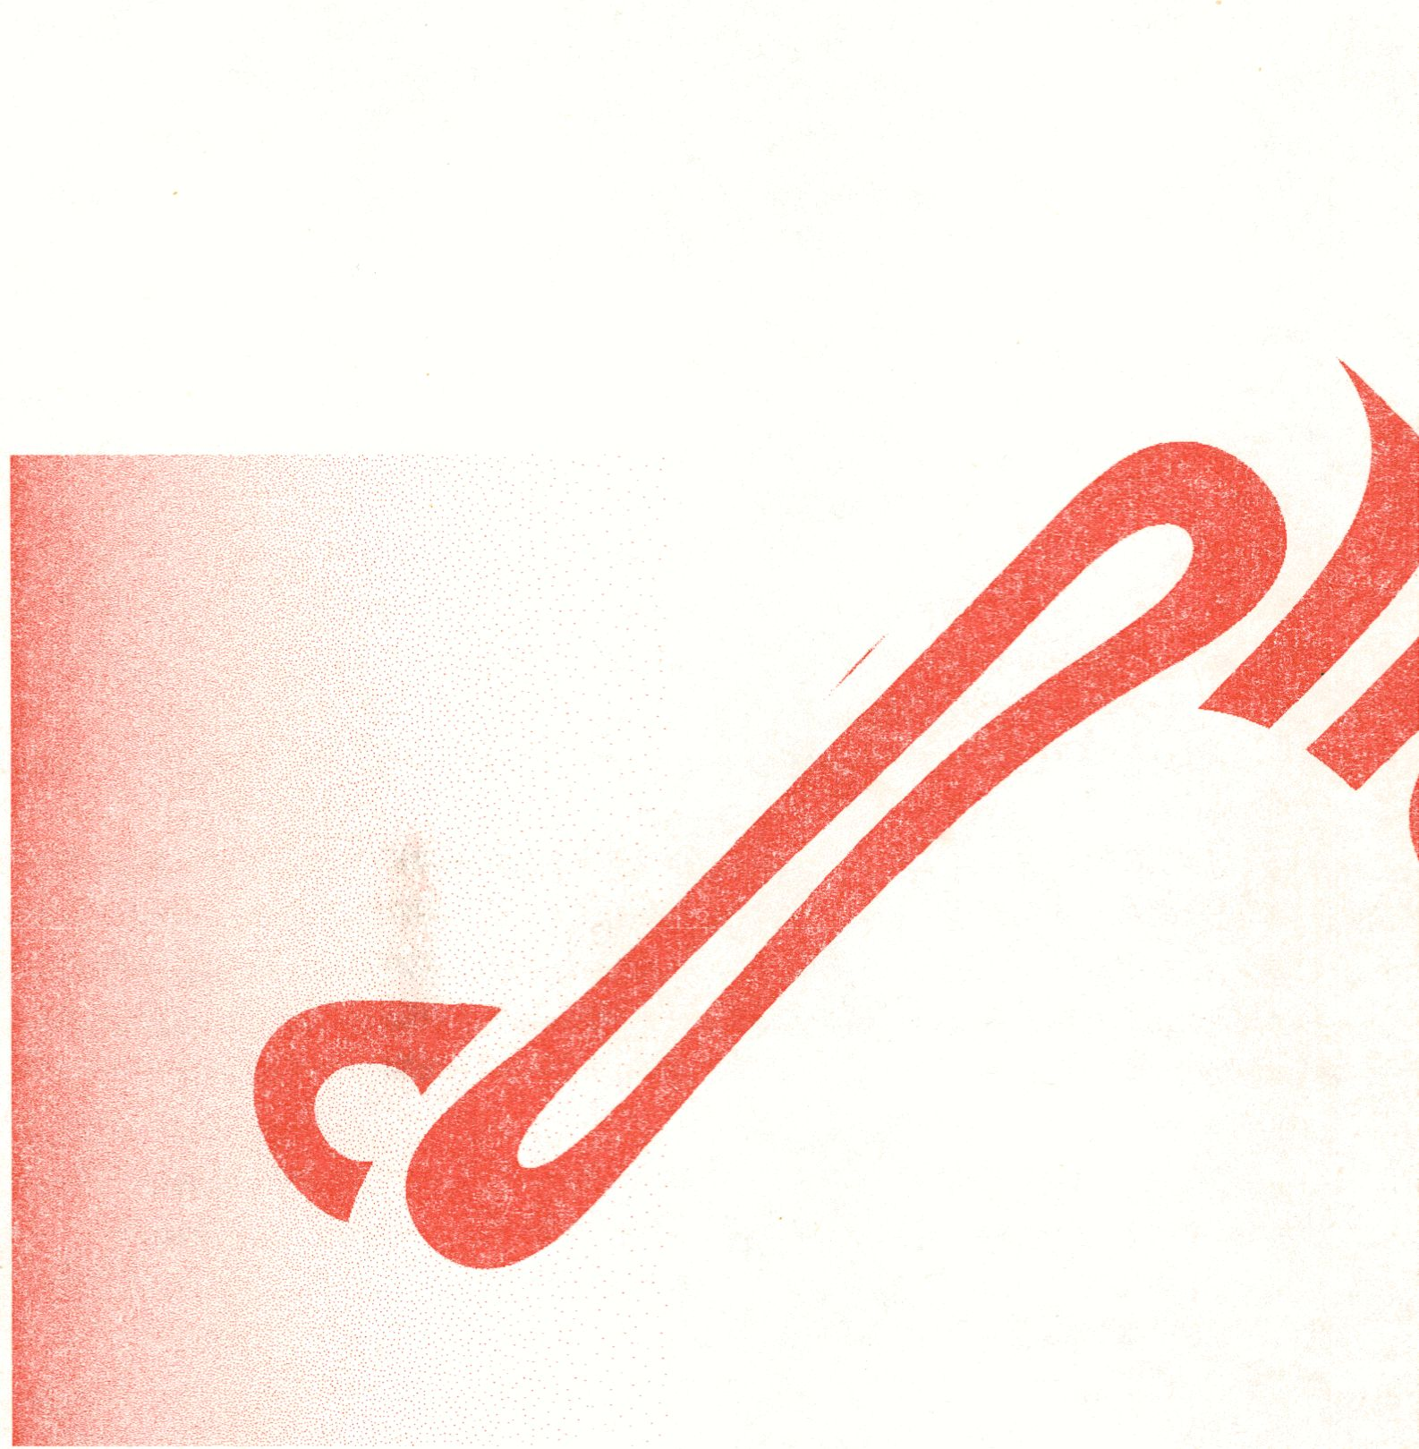

Greece and the Euro: From Vision To Despair
Panos Tsakaloyannis
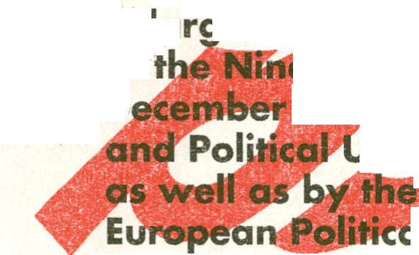In April 1973, Constantinos Karamanlis, self-exiled
in Paris since 1963, made a scathing public attack
against the Greek military regime in the form of an
"open letter" published in the Greek daily Vradyni, on
23 April, 1973. The gist of this dramatic appeal was
that the military Junta bore the responsibility before
the nation for Greece's ostracism from the European
Community. It should be recalled that at that time the
latter appeared to make impressive strides — such
as its first enlargement — from Six to Nine (with the
dhesion of Great Britain, Denmark ancM|eIand).
lement was accompanied by the commitment
>er-states at the Paris summit of
1972 to complete Economic, Monetary
Inibn (EMPU) by the bmf of that decade
ir initiation of mechanism of
«Cooperation (EPC); a stepping stone
towards political union. Last, but not least, as far as
Greece was concerned, was the Nine's commitment
to map out a "Global" Mediterranean policy. The
realization of this objective would have left Greece
in the cold, since the EC had "frozen" its Association
Agreement with Athens, following the seizure of
power by the Colonels, in April 1967.
Hence, for Karamanlis, Greece's European vocation
had assumed the proportions of a near-destiny. As he
put it in his "open letter", Greece's accession to the
EC would have fulfilled three fundamental objectives:
Economic parity with the rest of "Europe"; the
country's social and political modernization; and last,
but not least, the safeguarding of her national security
that would terminate the ever present nightmare of a
military confrontation with Turkey. The Turkish threat
had compelled Greece in the past "to seek strong
protectors, to the detriment of her independence".
Accession to the EC would have anchored Greece
into a European system of inter-dependence among
equals, which would have ended a long history of
subservience to foreign powers. In other words,
Karamanlis concluded, "the Europeanization of
Greece", could have become "the nation's new
Great Idea". The previous "Great Idea", it should
be recalled, had been shattered in the killing fields
of Asia Minor, following Greece's disastrous military
adventure of 1919-1922.
What is striking, is the ^raordiqar^x^cK^ons
Karamanlis, and his supporters, placed on Greece's
adherence to the European venture. And if Karamanli
a politician with a reputation for a down to^earth
practical bend, could se| Greece's EJfiiipean aspirator
at such a high pitch, one can imagine the kind of ^
day-dreaming most ordinary Greeks were indulged
in. Such expectations feached new heights over the
following fifteen monfhs — as the political crisis in
Greece deepened,'reaching a crescendo with the
events of the Students' occupation of the Polytechnic
School of Athens, in November 1973, and Turkey's
invasion of Cyprus, in July 1974. Those events
provided the backdrop for the ensuing debate
concerning Greek accession to the EC, following the
return to democratic rule. Cumulatively, a number
of factors moulded Greek attitudes to the EC/ EU.
One of them had to do with the enormous socio-
political transformation that Greece had undergone
since the 1950s. Rapid urbanization had gone hand
in hand with political radicalizaron — fed by the
legacy of the Greek Civil War (1946-49) and the anti-

Communist backlash of the early post-civil war era.
The radicalization was facilitated by the experience
of hundreds of thousands of Greeks (most of them
of rural background) who emigrated to Western
Europe, North America and Australia in the 1950s
and the 1960s. Those immigrants were exposed to
the political radicalization and the anti-Americanism
of the 1960s and early 1970s, (due to the Vietnam
War, anti-colonialism, and American support for
dictatorial regimes). The May events in Paris, in 1968,
represented the apogee of such political radicalization
and youth revolt.
For Greece the cumulative effects of those processes
were far reachinq^fhe year 1974 was the anus
mirabilis for modern Greece. Political radicalization
had affected the Vast majority of the pecwpll and
contributed to the blurring of the ideological
divide between the Communist Left and the anti-
communist Right. Such convergence was manifested
in fundamentaiiisues, including Greece's Constitution.
The abolition of the Monarchy was Coupled with the
legalization of the Greek Communist Part (KKE) and
the adoption of a "progressive" profile in domestic
politics. This was in stark contrast to Karamanlis's anti-
communist past- that is to his Premiership during the
pre-Junta period (1955-63)¹.
Another turn around by Karamanlis in 1974,
which proved to have more lasting effects, had to
do with Greece's economic orientation. In the early
1950's Karamanlis introduced a package of economic
reforms, under American guidance, whose aim was
first to stabilize and gradually to liberalize the Greek
economy, as a plank to sustained elonomic growth
1 It may be recalled that it was under Karamanlis’s premiership of that era that
a left wing Member of Parliament was murdered by right-wing thugs, an event
which formed the theme for Kostas Gavras celebrated movie “Z”.
and development. The aim of those policies was to
stabilize prices, to improve competitiveness and to
liberalize the Greek economy. The results of those
reforms were impressive. Over the following twenty
years (1953-1973) the Greek economy registered
impressive rates of growth -ona par with those
of Japan — which pulled it out of its perennial
poverty trap and provided the material conditions
for Greece meeting the European Community's
"aquis economique". Noticeably, this economic
course introduced in 1953, was followed by all Æ
Greek Governments, up to 1974, irrespective off
political twists and turns. Those economic advances
enabled the Karamanlis's government, in the mid-
1970s, to make a bid for membership in rare EC,
the gap between Greece's per capita ¡aÉj»rne to
EC average had narrowed considérai
Greek economy, in the mid-1970s,ap.
in a better shape compared to rn^t countries 1
EC, as the latter were beginning to jpel the effects of
the oil crises and "stagflation". However, after 1974,
Karamanlis embarked upon a policy o|"etatism",
nationalizing private banks, key industries, public
utilities and transport (including Olympic Airways).
Karamanlis' embrace of "Socialomania", as the
Financial Times labeled it in 1977, was in tune with the
public's radical sentiment, which was hostile to private
initiative and entrepreneurship. Hence, since 1974,
we observe the following paraijox: at a time Greece
was embarking upon its ambitious goal to join the
European Community — a largely economic grouping
whose main thrust was the abolition of internal
tariffs among its members and the introduction of a
common external tariff, which implied that Greece
had to streamline her economic structures and become
more competitive so that it could be able to withstand
economic competition from the most advanced
economies of Northern Europe and from third
countries, it was embarking upon economic policies
which were to lead it to other pastures. Under this
new frame of mind the state's role in the running of
the economy was extolled, whereas private initiative
and market competitiveness became an anathema.
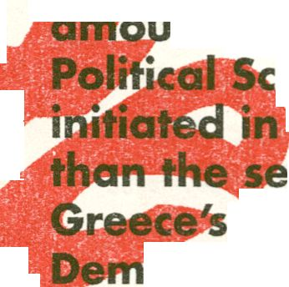The cumulative effects of such changes in policy j
- nted to a "systemic change", to use the jafgorf of
ience. The radical departure from the past
‘ 1974, carried by far greater significance
emingiy irreconcilable differences between
two major political formations: The N<
ocracy founded by Constintinos Karamanlis and
PASOK, founded by Andreas Papandreou, whk
monopolized power from 1974 till the elections
6th of May, 2012\
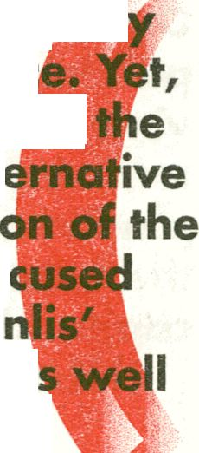Between 1974 and 1981, the year Greece joined
the European Community, the reins of power were
held by Karamanlis (1974-1980) and by his successor
George Rallis (from May 1980 to October 1981).
Rallis's tenure in office^was a transition phase marked
by a number of paradoxes and ambiguities. The
starkest ambiguity loncemed the Greek public's lack
of orientation as regards its place in the world. To
be sure the resentment towards the United States
allowed the Soviet Union and its satellites, especial!
East Germany, to make certain inroads in Gree
for historical, geo-political and economic reasons,
Soviet bloc, did not appeal as an attractive alt
to the West, for most Greeks, with the except!
pro-Moscow Communists. Hence the debate fo
between the "EC option", pursued by Karama
New Democracy and the parties of the Center a
ApexuA
Apon-'l
ApcXn-1
APOXV) Oo'.n-..- M
rw-x
ApOKiMI r.nMW«
AMOqOrastoMAt
ApaxiinC-.';»*«.-.-
«Win»«" - -•<
Apexun Brrt*™ £4
by the splintered Communist Party of
the Interior (of Eurocommunist leanings),
on the one hand and the option of an
independent and self-reliant national
growth policy, supported by Andreas
Papandreou populist PASOK, on the
other.
The thrust of Andreas Papandreou's
platform during his years in opposition
was to appeal to the xenophobic reflexes
of the "non-privileged Greeks", most
of them of rural background who had
recently become politkjny radicalized.
Papandreou's form o' <
ApoXJA OfKbi-w '4
4poXW Os-jit* •-:
Apoi • -.-
ApoXl^l .-n :l»Tr 8₍
Ape»«) Drutau 4
AAHti' < a A;
Apaxu-I >»c-vw t\
Apoyv“ O ietin. t.
ApoXiHO.A-.~rit:
Apoxu | O.rcnw-1 ».:
Ape, - ' • no A
Ap..xi«i>»u.'*oj
Ape,,o o~ .'j
Apo»w,^{r}
ApoxuO C v V>i
Apax^i OrotA-w
ApOJlH 0<iCAAJ
ApjxunOri.Vj-
Ap«xw-
Apo»^, a,~ Aii
Ap'J . , , 1
Apo,D**.*,..
At iju 1
Apoxt-n o*»ej> j*«
Apc»-|’.8‘ »'i
resembled most agn
Its clarion call was, encapsulated by a
American agraria^ populist in early 2
century by theory to "grow more hell
than corn". In o*herivords its goal was
dismantle the post-war political edifice and to replace
it with one based on his ''hen-privileged Greeks". The
operative world was "Champi" (Alagi), which in effect
meant the re-moulding Greece's social, economic and
political structures and the creation of a new class to
cater for the "non-privileged Greeks" — the hitherto
victims of local and foreign exploitation. The driving
force was self-reliance, under the guidance of PASOK.
Only thus Greece could escape from the economic and
political dependence that reduced it to an "unfenced
vineyard" (xefrago ambeli) at the mercy of foreign
exploitation and tutelage. Translated into a political
platform self-reliance and autarchy meant breaking
the fetters of American and West European monopoly
capital dependence.
Hence during the transition period (1974-1981)
when PASOK was in opposition, Andreas Papandreou
pursued an anti-European rhetoric. Greece, according
to this narrative, shared more characteristics with
the under-developed economies of the "periphery"
than with the advanced industrialized economies
of Northern Europe. Therefore, the accession to the
European Economy would have impeded the economic
development and perpetuated Greece's dependence.
The same applied, to varied degrees, to the other
southern European countries, namely to Spain and
Portugal. As Andreas Papandreou put it in his speech
at the first Congress of the Socialist Parties of the
Mediterranean countries, held in Malta, in June 1 977,
"the countries of southern JUgiape had better not join
the European Common Market", because the latter
wasjithe common market of monopoly capital, hence
their participation in it would have assured their long
term dependence as peripheral and marginal regions
of international capitalinl^rapandreou 1977, 26). It
would be impossible for such countries to have their
owilifèonomic policies, if they lost control of their
reign trade and of capital movements.
Yet, Papandreou's seemingly uncompromising
stance was moderated by the caveat that the above
constraints would have ceased to apply "once
Western Europe achieved her socialist transformation"
(Papandreou 1977). Such a proviso, as subsequent
developments showed, offered Papandreou a
safety valve to extricate himself from this seemingly
uncompromising posture vis-à-vis the EC. A change of
course did not take long to become evident; on October
the 25th, 1981, one week after PASOK's landslide
electoral victory, Papandreou, in an interview with
the American ABC TV Network, reassured Greece's
Western allies that he had no intention of pursuing
an "adventurist" policy and sever the ties with NATO
or other Western structures (Papandreou 1981).
As regards Greece's pulling out from the European
Community, a theme on which PASOK had taken
an unequivocal stance when in opposition, his new
take was that this issue should have been settled
by a Referendum, so that the Greek people could
decide. However, since the prerogative for calling such
Referendum rested with the President of the Republic —
that is with Karamanlis, the man who had staked his
political reputation on anchoring Greece into the EC —
Papandreou could do little on this.
The practical significance of Papandreou's, artful ^
casuistry was that the issue of Greece^membership «
the EC was downgraded and befor%iong buried. The
reasons for this change of track were multiple, related
to domestic and international facj0i^Ori the domestic
front the most obvious reason for PASOK's soft-
pedaling was that, once in power, it cmild capitalize
on the economic benefits Greece
Iraw from EC
membership, especially from the CdM^on Agricultural
Policy (CAP) — which in the early 1980s absorbed
nearly two thirds of the Community's budget.
Considering that at that time Greece's agricultural
sector accounted for about one third of its labour force
and that a large part of the population was of rural
background, plus the fact that it was in this part of the
population that PASOK's appeal was stronger, it is no
surprise that Papandreou could not afford to take ru
decisions and forfeit those people from the benefits
of EC membership. At the same time membership
of the EC implied the filling-in by Greek nationals of
hundreds of jobs in Community institutions. As Greece
had joined the EC only nine months before PASOK
had assumed power, most of those positions were still

vacant. Hence/Shfe EC offered a unique opportunity
for PASOK functionaries and sympathizers to secure
jobs at the EC with salaries and other perks which
far exceeded those in Greece. Generally Greece's
accession to the EC opened up new vistas to Greeks,
especially to those of the nascent political class of
the PASOK era. Hence, for those sections of the
Greek population the incentive now was bn how to
maximize the economic benefits stemming from the EC
participation. i§S|lilk
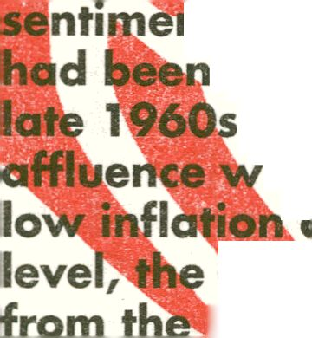At the same time developments in the late 1970s
and early 1980s on an international as well as on
q European level rendered the political discourse of
974 period somewhat passé. The political
t in Greece in the early post-1974 period
moulded by the political climate of the
, early »70s, as well as by the economic
hé^Pchief features were full employment,
id high consumption. On a European
period coincided with high expectations
^jropean Community, following De Gaulle's
departure, the first enlargement and an ambitious
agenda which was endorsed in the early 1970s.
However, by the late 1970s, the situation, domestic
and international, had been transformed. The Soviet
invasion of Afghanistan and Moscow's troubles with
its east European satellites, not least with Poland's
"Solidarity" movement, coupled with the Islamic
Revolution in Iran and mounting tensions in the Middle
East, Africa and Central America, had delved a blow to
détente and paved the way for a "Second Cold War"
that intensified with the advent of Ronald Reagan to
he American Presidency.
I
the
Mn Europe the effects of those developments were
far-reaching. On the economic level, the oil crises of
BM ffrni,; y
1974- 79 spelled the end of post 1945 prosperity
and the advent of "stagflation" — high inflatio§,
high unemployment and negative rates of growth.
The effects of the crisis on the EC were crippling —
namely the onset of "Euro-sklerosis" and institutional
inertia. In spite of repeated attempts to provide new
dynamism to the EC, those endeavors at institutional
reform- from the "Tindemans Report" (1976) to the
"Genscher-Colombo" Plan (1981-3), or the "Spinelli
Report" by the European Parliament (1982-1984) —
failed to produce tangible results. On the contrary, the
trend in the EC was towards drift and "going along".
The most remarkable divergence concerned their
economic policies. Beginning with Margaret Thatcher,
the economies of the EC North (Great Britain, tile
Federal Republic of Germany, the Netherlands and
Denmark) switched from Keynesian economics to Neo-
liberal "Reganomics". However, in Southern Europe
the opposite trend was fashionable. By early 1981 the
nascent democracies of Greece, Portugal and Spain
had gone through their "teething" phase — that is
their transition from authoritarian rule to democratic
consolidation. Democratization was accompanied
by the advent of Socialist parties to power in those
countries and signaled the departure of the Socialists
from radical rhetoric and a toning down of the earlier
anti-Western posturing to the endorsement of the
European project².
In the early 1980s the common stance among
the Socialists of Southern Europe was confined to
ideological utterances and to displaying political
solidarity. On a European level, however, there was
little common ground amongst them for addressing
- It may be recalled that the most passionate advocate for the anti-N ATO vote
in Spain, in the Referendum campaign, was Xavier Solana, who later became
Secretary General of the Atlantic Alliance.
the Community's acute problems. That was the case
till 1984, when the French Government embarked
upon the realization of its "great European project".
President Mitterrand announced in his NewSYear
message for 1984 was going to be "the year of
Europe". The reasons for what was tantamount to a
complete U-turn by the French President had to do
with the failure of his Socialist programme iMiich
he had striven to implement since May 1981. By
March 1983, the deterioration of the French economy,
manifested by a sluggish growth, widening budget
and trade deficits and by high inflation, had eroded
the value of the Frank. The most dramatic ifionetary
crisis occurred in March 1983, marked by a running on
the French currency and a drastic devaluation, which
in turn caused an "agonizing reappraisal" pot only
with regards to France's economic policy but also to
her overall European strategy.
The crisis in March 1983 split the French Socialist
Party into two fractions, the ideological wing, led by
Chevenement, who urged for the Party's adherence
to its Socialist principles, even if that meant France's
withdrawal from the European Monetary System or
even the introduction of protectionist steps ip order to
shield the French economy from harsh competition.
The other wing calling themselves the "modernizers"
— headed by Michel Rocard, the Prime Minister,
Laurent Fabius, the Budget Minister, and Jacques
Delors the Minister of Finance — called for an end
to the Keynesian policies of the previous 22 months
and the adoption of tough economic policies, in
order to win "the economic battle" (March 2009, 98-
102). Mitterrand, after same vacillations, backed the
"modernizers'. Undoubtedly this, as David March
observes, marked "a turning point" in European
integration, not
least with regards
to monetary union.
Mitterrand's U-turn
meant "the death knell
of the slogan 'Europe
will be Socialist or
nothing'". (De la Serre
1996, p. 25). A
ApaxMH Drachms Apaxp-
Drachma ApaxjJi^ Drachn
¡SK Grexit
Drachma ApaxMO Draci-'i
ApaxPH Drachma Apax'J!
Drachma Apaxpr'l Orach»
ApaxPT Drachma Apcxt"
Drachma ApaxM<‘i Drachn
ApaxpM Drachma Apoxpi
Drachma AoaxPO Drachn
Apaxph Drachma Apr [<:
Drachma ApcxPO Drac:- n
Apaxpq Drachma Apoxp!
Drachma ApciXMO Drachn
ApaxMH Drachma Apexi-i
Drachma ApaxMh Drachn
Apaxwn Orachma ApoxM-
Drachma ApoxPM Drachn
ApaxMH Drachma ApaxPi
Drachma Apaxpi¹) Orach.-;
ApaxMh Drachma Apoxu;
Drachma Apaxpn Dra* h.-c
Apaxpn Drachma Apaxp¹
Drachma Apaxpii Drachn
Apoxun Drachma ApcxM¹
Drachma Apaxprj D- erhr;
ApaxMH Drachma Apaypi
Drachma Apcixpi¹) Drachn
Apaxpi'l Drachma Apavtn
Drachma Apaxpi) Orachn
Apaxun Drachma Apcxp!
Drachma ApaxPH Orach-⁻
ApoxMO Drachma Apagpi
Drachma Apa;<po Drachr
Apaxpri Drachma Ap<*XP
Drachma Apavun Drachr
The effects of those
developments on tlm
Socialist Governments of the other Mediterranean^?
countries of the EC were far-reaching. Mitterrand's
change of tack was accompanied by an ambitious
bid to reclaim France's leading role in European
integration. Hence, 1984, "the year of Europe", was
the year of bold French initiatives which aimed at
infusing new momentum to the faltering EC. To that!
end Jacques Delors was appointed President of the
EC Commission (De la Serre, 1996)³. The EC was
reinvigorated by a number of institutional initiatives,
especially by the adoption of the Single European Act
in 1986,which set the ambitious goal of completing
the "Internal Market" by 1992. The impressive success
of the "1992" project was that it promised pecuniary
rewards to all parties, including Margaret Thatcher,
who could not resist the attractions of "1992",
promising the creation of a bona fide EuFbpean-wide
Internal Market along new-liberal lines⁴.
For Greece those developments at European level
were of particular significance. The EC's rejuvenation in
- For Delors’ role in those developments see (Rose, 1995).
- The attractions of the “1992” project were so tempting that they had had a
magnetic effect to the peoples of Eastern Europe, even to reformers in the
Soviet Union, including Michael Gorbachev who became a convert to the idea
of the construction of “a common European House” whose foundations would
rest not on the crumbling Communist system but on the European Community.
the mid-1980s coincided with signs of serious strains
in the Greek economy, manifested by high inflation,
growing budget deficits, a widening of the trade
deficit and a sharp increase of foreign debt. Hence
Papandreou was compelled to clip his spendthrift
proclivities. He appointed in the Ministry of Finance
Constantinos Simitis, whose first act, in June 1985,
was to devalue the Drachma by 15 percent and to
introduce an austerity programme. In this context,
the developments in the EC such as the inception of
the Integrated Mediterranean Programmes and of the
"Cohesion Funds" were of great value to Athens. Not
surprisingly PASOK's anti-EC rhetoric of earlier years
had evaporated by the mid-1980s. Henceforward
different kind of "battles" were to be fought in
Brussels aiming^ at extracting maximum pecuniary
benefits from me |C, necessary to keep the Greek
economy afloat and to sujtdin the unsustainably high
standard of RvmgiMiich PASQK had promised.
Papandreou's resolve, iiCTy85, to address Greece's
economic malaise proved short-lived and by 1988 he
relapsed to his familiar populist style, plunging Greece
to political instability and to a further deterioration
of the economy. Hence, at the time the Berlin wall
was about to crumble Greece was in the throes of
econom|c collapse. Between June 1989 and April
1990 three General elections were held. The first
two failed to produce a clear majority, leading to the
formation of a hybrid Government comprised by the
Centre-flight New Democracy Party and the Parties of
the Communist Left, that is the Stalinists Communist
Party of Greece (KKE) and the Euro-communists, who
assumed key Ministerial Portfolios. At a time when
Soviet Communism was about to be consigned to
"the dustbin of history" in Europe, in Greece it was
gaining access to power. These political exigencies in
1989-90 encouraged further inroads by the state on
the economy, at the same time as the newly liberated
countries of Central-Eastern Europe were embarking
upon strenuous efforts to streamline their economies
and rid themselves off the shackles of the "state-
planned economy". The contrast in political trajectory
was also discernible in the perplexity most Greeks felt
for the demise of Communism.
These developments coincided with the time
that Greece had to respond to the new exigencies
in Europe, not least to the ambitious goals set in<.
April 1990 for the realization, by 1992, of
Economic, and Monetary Union, in the EC. This set ¡Egi
motion the so-called "Maastricht project". For most
Greeks, especid/ly for Mitsotakis' Government, who
assumed power in April 1990, this development¹
offered a unique opportunity for Grefecg to extricate
herself from her dire situation. There are in fact
some simi|||ritifes in the way most Greek politicians
responded m European developm&nlfp? the early
1990s to their response two decides before — that
is in the early 1970s. In both cases fftrope appeared
to be the deus ex machina, which miraculously could
have taken care of Greece's intractable economic,
political, and social problem^fThe only difference
— and an extremely important one — was that
whereas in the early 1970s the problems were
largely confined to the political realm — namely to
the restoration of democracy and to Greece's socio-
political transformation — in the early 1990s the
economic dimension was paramount. If anything, the
Greek version of a 'historical compromise' in 1989-90,
with the creation of an Ecumenical Government, meant
the granting of pensions to hundreds of thousands of
Communists (and their extended relatives) who had
fought against Government forces during the civil
war (1946-49), or they were accused of "subversive
activities" between 1949 and 1974.
As Greece was reaching the point of economic
insolvency the only salvation could come from outside
— in this case by embracing the cause of the common
European currency — formed the backdrop for
embracing the latest "vision", namely Greek accession
to the common currency. Before long this assumed
the character of a "national crusade". Stefanos
Monos, the Minister of Economy and Finance, and a
politician renown for his pragmatism, smartened up
reece's prospects during the parliamentary debate
n the ratification of the Treaty of Maastricht and the
option of the coih0|iui European currency:
iterest rates, and
fish what we have
been trying to sinceHf&JPIation of theJ^eek state: a
country of economic and monetary stability".
In short, Greece's Euro-enthusiasm in the early
1990s, was propelled by the determination of the
Greek political class to preserve its privileges with a
European support mechanism. The fact that Greece's
accession to a common currency would have entailed
"We will then substitute our drachmas for ECU. As a
result of that Greece will become overnight a country
of low inflation, stable prices, U ‘ ' ¹
currency stability.’ We will aitc<
severe limitations to the exercise of her
economic and fiscal policies did not seem
to matter⁷, for it was crystal clear that 4
the economic foundations on which tefv
power rest were crumbling. If anything,
by the early 1990s, in spite of huge
transfers of funds to Athens from Brussels
the economic gap which separated
Greece from the advanced economies of
Northern Europe was greater than of the
time of her accession,. The most disturbing
feature was that the Greek economy
had lost the dynamism of the earlier
years and wa^lfecoming more and more
depended on hand outs from Brussels,
or on foreign borrowing, in order to
preserve an artificially high standard
of living which did not correspond to
the country's real productive capacities. To be sure,
in the early 1990s, some half-hearted attempts were
made to come to grips with these problem. However,
the vested interests that felt threatened by the
implementation of the drastic economic reforms were
so entrenched that they aborted initiatives of that
kind. The obstacles became evident during Mitsotakis'
tenure in 1990-93. His attempts to reform the Greek
economy, especially to streamline the ailing public
sector, failed to produce tangible results.
- Indeed a common currency, according to some Euro-skeptics, like
¿twit--)
jjgjj
AeoS-n
•V •
Margaret Thatcher, could have “posed a more immediate threat” to national
sovereignty, especially for the weaker economies which faced the threat of
being “devastated” by the adoption of a common currency. Nevertheless, the
attraction for Greece of joining this exclusive club, and the temporal benefits
which it held out, not least the ability to borrow cheap money, fueled the
enthusiasm of the Greek political class, In fact the Greeks’ enthusiasm was
so unrestrained that caused Mrs Thatcher ite. As she puts it in her Memoirs:
“I became all too used to a Greek chorus of support for whatever ambitious
proposals (in the IGC) Germany made”. Thatcher (1993,765).
The tenure of his successor, Andreas Papandreou,
was beset by health and personal problems.
Nevertheless Papandreou made some efforts to set
Greece on a new course. On external relations he
proved to be quite astute — not least by realizing
quite early that the United States was emerging
as the undisputed arbiter in European and Balkan
affairs. Hence his successful openings to President
Clinton, which implied reduced expectations from the
EU's political capabilities, especially in the Balkans.
Papandreou became less enthusiastic than his
predecessor about the EU's blueprints. On the economic
front Papandreou was aware that Greece's most acute
problem was the spiraling foreign debt, whose effects
could have been catastrophic, if it not checked. This,
he likened to a beast, which if it was not tamed, was
bound to devour the country. However, Papandreou's
belated conversion to more sound economic policies
and his admission for Greece's economic predicament,
were not enough; his populist legacy combined with
his poor health set limits to what he could achieve.
Constantinos Simitis, his successor, had built over the
previous years a reputation for being a "Europeanist"
and a "modernizer". The epoch-making events in
Europe and the high expectations they galvanized for
the creation of a new "European architecture", gave
him a further fillip with the issue of EMU providing
an ideal platform for promoting his political project
of modernization (Simitis 1992, 29- 46). For Simitis,
"modernization" was the only cure for tackling
Greece's mounting problems as well as for joining the
common currency. To that end a European strategy
was urgently needed, the contours of which he
analyses in his next article entitled "For a European
Strategy" (Simitis 1992). However, while he seemed

mií
f
to be aware of the long-term adverse implications for
the Greek economy by joining the common currency,
his policies were largely confined to, "creative
statistics" and to the streamlining of the necessary
legislation in Greece, order to achieve its "financial
liberalization"; ciS orte of the proponents of this policy
put it⁸. By 1996, When Simitis assumed power, it had
become abunddntfy.cleqr that the prospects for the
common European currency vyere determined more
by political than by economic imperatives, and in the
view of the sorry state of the Greek econop^y political
manipulation was the only means available to Athens|§|0|||
for getting an entry ticket.
David Marsh has'
idle ftp⁴
history of the making of the EURO,
has been marred by "political tantrums" (Marsh
2009, 186- 205). The antagonism that plagued
establishment of the EURO reached a crescendo in
May 1998, in Brussels, where the leaders of the
EU gathered to work out the final touches for the
inauguration of the common currency, set for the
following January. It was taken almost for granted
that the first President of the ECB would have been the
Dutch Wiitipuisenherg, who enjoyed the full backing
and trust of the German Government. Jacques Chirac,
8 According to Pagoulatos the implementation of Greece’s ‘‘financial -1
liberalization” would have had “momentous implications”. On a “state
sovereign level”, it would have completed “the alignment of the domestic
economy to European and global financial markets” and on a macroecono^Btc
level, “the erosion of expansionary policies”. On a “socioeconomic level”, “a
significant reallocation of economic (and thus one might sayvpolilicalXresources
from ... manufacturing industry, SMEs, agriculture, to an increasingly
emboldened linanc^i sector and mobile, globalized business capital. On a
»•political 8Ild Ua^ui nnnnnisfn/l' fnHnno
■éÊÊM
.„■¿'-i
'•;^{v}k
primacy of politics that had dominated the postauthoritarian era (sic) to the \ %
primacy of policy and the constraining impact of economics” < Pagoulatos 2003,

2oi). tBBfle- ^ -


WÊÊÊÊÊÈ

ijÈËÈIÈêÊ
howe\
party
Frenchmi
confirmée
of room
■HKfö

mm
^ v-îs: ,-j
8»«3fi55^-.t î-iÎÂ'Ci-„
&%£■'•••.' • a’
ical defiance/ spoiled the
; own candidate for the job, the
ichet. Such a political setting
that there was plenty
so that Greece
>. The "Maastricht
®^^nditions for accession/
deficit and foreign
couia ensi
criteria" defined the ec<
;riiw^jr$h inflati
debftÿpt, few EU members met the Maastricht criteria
for membership of the EURO. Hence, since the mid-
1990s, there was a proce« **
, a—js*j_{ons} f_{or} accessiem^i
down the
1998, all
-in did so, with the
Greece's exclusion
ances than as a proof
re taken seriously,
was nonetheless
^ih its second
lie EU members will
exception of Greece,
s more for the sake of
at that the Maastricht err
ence, while Greece was exi
offered the opportunity to jol
stage", due to begin in 2001,she completed
two years in the EMS without devaluing, the
parity of the drachma became the sole criterion for
Greece's joining the Euro. In 1998 Athens entered the
EMS mechanism with a central rate of 357 Drachmas
to the ECU. By the time of Greek accdssion td fho
- - - - -
rm
EURO, in 2001, the Drachma had been revalued and;
it was irrevocably locked at 340.75 Drachma^ to the
EURO. This was hailed as evidence —**B^^**28&&
its finances in order and that had gained it entry ticket
in her own right. ll#Bi®!§ii
In Greece the celebrations for joining the -
reached the level paroxysm. In no other country^'' \
of the Eurozone there was such ecstatic joy likp||i^^ ^y:

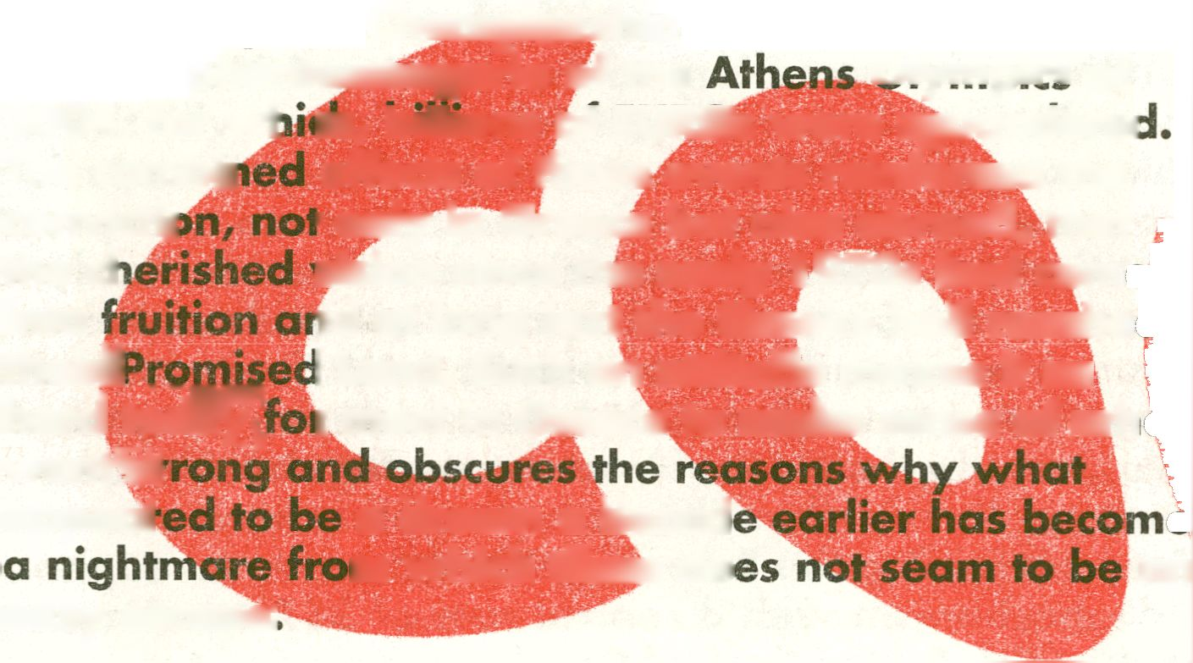in recent Greek history, marked by unrestrained
consumerism, spiraling budget deficits, foreign debt,
and a dramatic drop in Greece's productive capacities.
The real effect was a transformation of Greeks into
the best consumers of luxury goods, but also to the
slackest producers in the Union. Such adverse effects
were presumed to be offset by Greece becoming
part of the "globalized business capital". A sense of
unreality was fed by parallel developments which
boosted the Greeks' megalomania, like the winning
of the European Championship in soccer, in 2004,
and the phantasmagoria of the niymplrc ₀f
2004, for w|
The combi«
convictij
the cl
into
theiii^^^
hard today
wentW™¹
appeal
:n, billions of EUROs were squanderer
effects of those events reinforced the
' only in Greece but also abroad, that
vision since the early 1970s had com
id at long last the Greeks had reache
I Land. Such an attitude makes it so
r most in Greece to make sense of wh
a dream a decad
m which there do
an
easy escape"
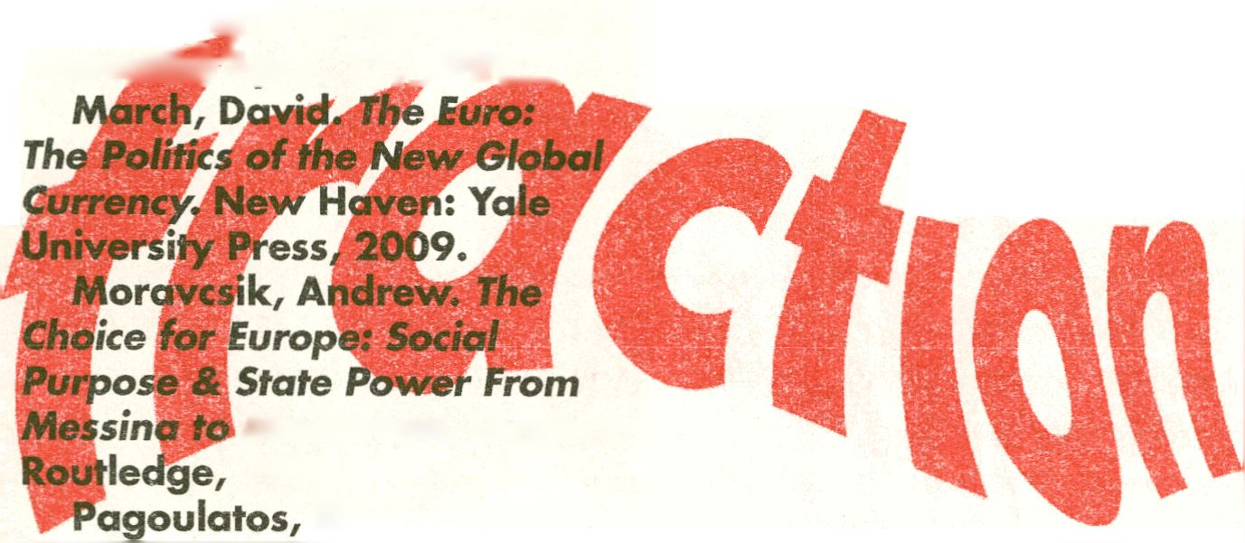De la Serre, Françoise.
"France: the Impact of Francois
Mitterrand" in Hill, Christopher
(ed). The Actors in Europe's
Foreign Policy. London:
Routledge, 1996.
Delors, Jacques. Report on
economic and monetary union
in the European Community.
Committee for the Study of
Economic cy»d Monetary Union,
Prese«fiii*April, 17,J989_
Simitis, Constantinos.
Nationalism, Populism or a
National Strategy? Athens:
Gnosy Publications, 1992.
Thacher, Margaret. The
Downing Street Years.
London: Harper Collins, 1993.
Tsakaloyannis, Panos. "The
Limits to Convergence" in Hill,
Chrisyopher (ed). The Actors in
Europe's Foreign Policy. London:
Routledge, 1*

Maastricht. London:
1998.
George.
"Greece's New Political
Economy: State, Finance and
Growth from Postwar to EMU.
London: Macmillan, 2003.
Papandreou, Andreas.
Rantevou me tin Istoria, Athens:
Kaktos, 1981.
Papandreou, Andreas.
"For a Mediterranean Freed
and Socialist", Address at the
Congress of the Socialist Parties
of the Mediterranean, Malta, 20
June, 1977. PASOK Pamphlet
No A18/79. p. 26.
Rose, George. Jacques Delors
and European Integration.
Oxford: Polity Press, 1995.


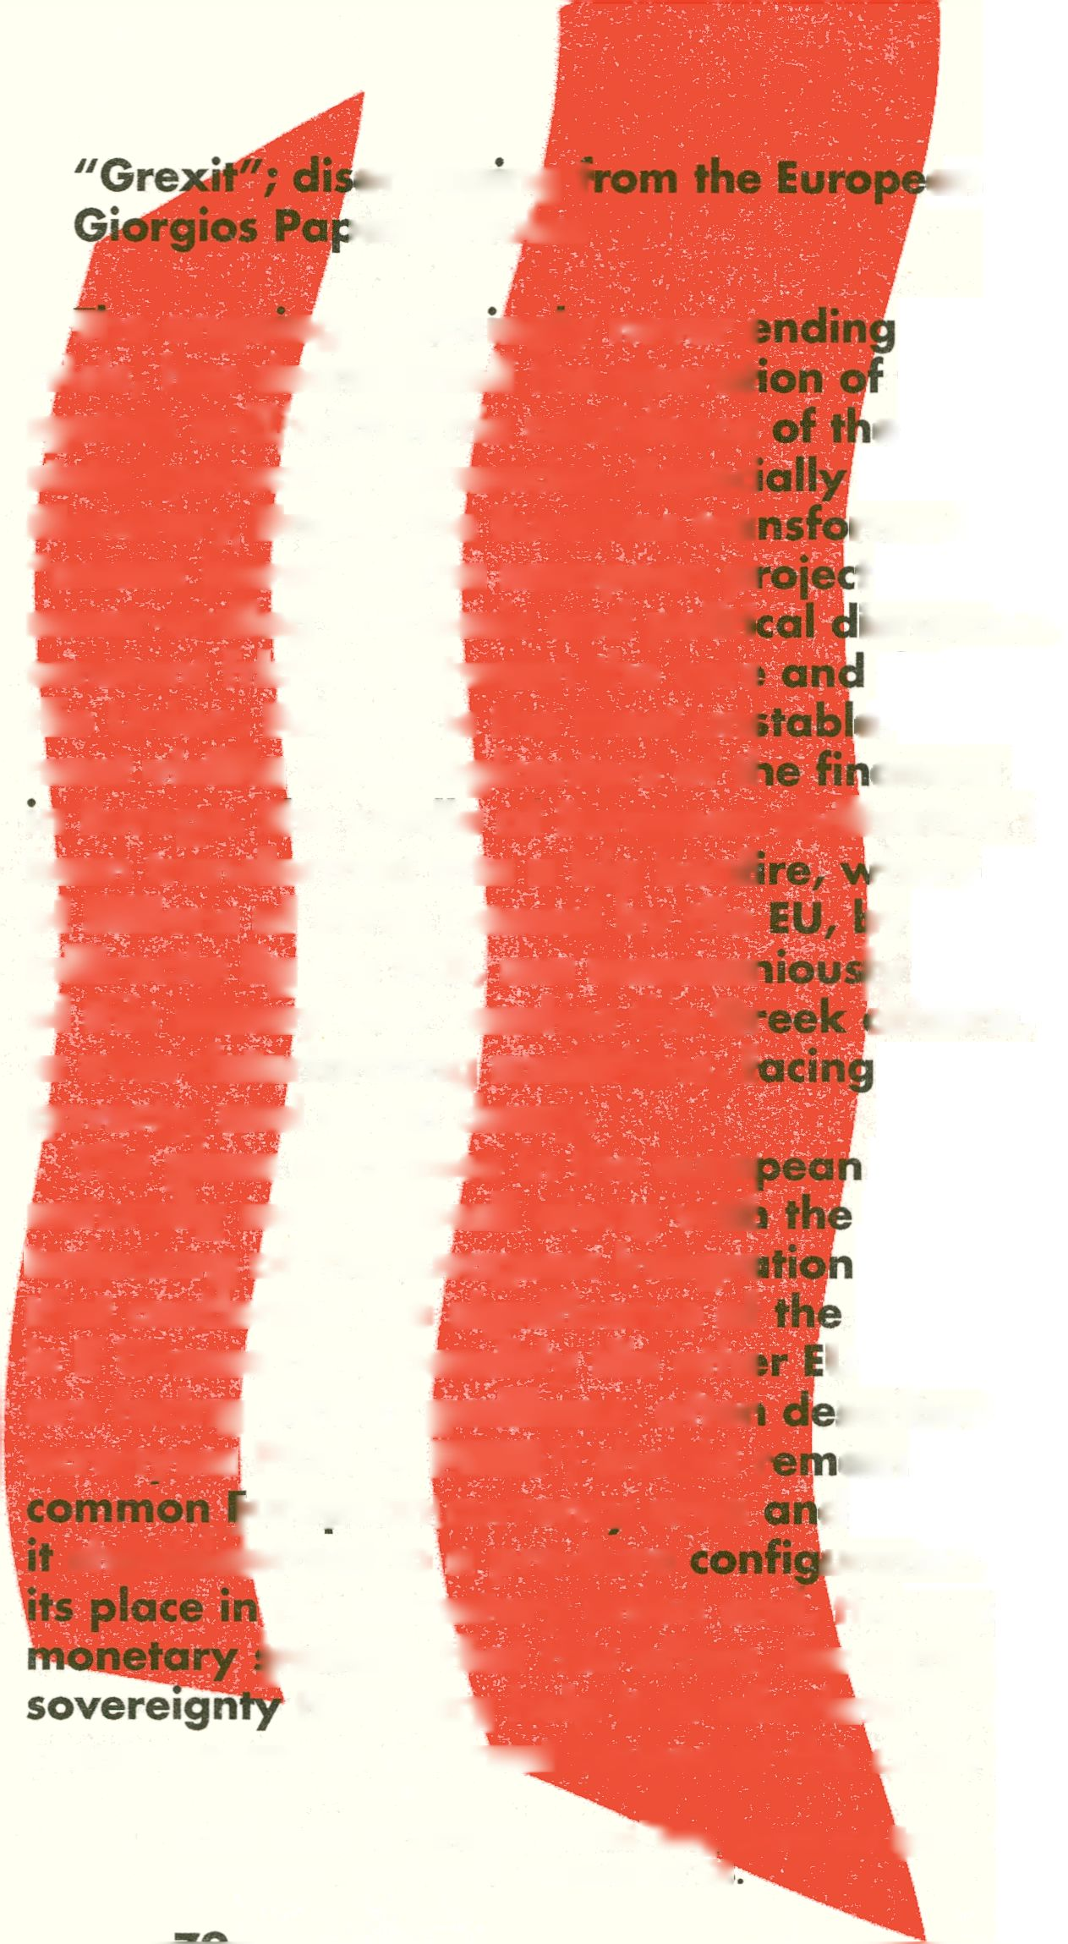engaging t
tadopoulos
an Project

The ongoing, seemingly never i
crisis, has destabilized the operat
system and/with it the confidence
state sponsored currencies. Especi
Monetary Union, the Euro has tra
"crown jewel" of the european pi
never-ending economic and politi
constant friction between the core
the Union. Athens, is the most uni
most visible of the epicenters of tl
in Europe. The cradle of European
been transformed into a big bonfi
of billions of Euros poured by the
indirectly by the ECB, are ceremoi
of this money ever reaches the Gi
in ever-deteriorating conditions, f
poverty; ancf social decay.
financial
the monetary
e public in
in the European
rmed from the
t to the locus of a
isruption, fueling
the periphery of
e, and thus the
ancial turmoil
rhere hundreds
)y the IMF and
jly burned. None
citizens, who live
unemployment,
project is
direction of the
. The question
financial crisis
U countries that
scribed by the
ain part of the
d the Union, or if
uration, trading
European civilization has
The place of Greece in the euro|
naturally reconsidered along wit!
trajectory of the european integre
that condenses the significance of
is if Greece (and possibly the ©the
are facing similar problems, offer
acronyms PIGS or PUGS) should i
>') should r
luropeaniBprrency area
shoyH^btreat to a pre-Euro
the monetary union and, the supposed
^ability that this offers, fw a monetary
that may help it to alleviate its debt and
resolve some of the root causes of the crisis that has
plagued the country for the last five years that the
economy is in recession. The relation of Greece with
the EMU (European Monetary Union)/ has been widely
discussed by economists, politicians, journalists; it has
been up for a referendum that when was announced
has caused mayhem in the financial markets, only to
be cancelled a few days later²; and was in the centre
of the recent election campaign in Greece (May 6th and
June 17th 2012).
Qgqexit, a combination of the words Greece and exit,
is'ia term coined to describe the possibility of departure
(vofofi|ary or not) of the country out of the EMU and
the domestic and international turmoil that will for
sure accompany it. We decided to use this world as the
title of the publication, both as a provocation and as a
signal, of the motivation of our analysis. The task we
set for ourselve| in this publication, is not so much to
evaluate the economic and social consequences of a
possible disengagement of Greece from the European
Union, but to speculate on the unconscious attachment
to money, predominantly to the drachma, but latently
also to the Euro. Cheney is studied as a node of
affective tension, a screen for the projection of desire
and through desire of subjectivity. Representation is
central for the psychological investment in currency,
and so is the illustration of the idea of value in the
iconographic and symbolic elements of money. Such
- “Greek Prime Minister George Papandreou touched off a firestorm last week
when he proposed putting the austerity package designed by the “troika” (the
IMF, the European Central Bank, and the European Union) up for a popular
vote. The idea that the Greek people might directly be able to decide their
future terrified leaders across Europe and around the world. Financial markets
panicked, sending stocks plummeting and bond yields soaring. However, by
the end of the week, things were back under control. The leaders of France and
Germany apparently laid down the law to Papandreou and he backed off plans
for the referendum. While the government is in the process of collapsing in
Greece, the world can now rest assured that the Greek people will not have an
opportunity to vote on their future.” The Guardian, 8.11.2011
representations legitimize and enforce to an extend
the dominant ideologies of state, market, and culture.
We intend to investigate, analyze, explain, and,
hopefully de(con)struct the legitimizing operation of
currency, but also to speculate on the possible means
of disengagement of Greece from its attachment
to the western economic ideology, of productivism,
consumerism, economic growth, and free market
enterprise. To that effect we try to investigate but
at the same time to "deconstruct" currency, as it is
instantiated in the relationship between the Euro and
the Drajdima, not only as qp economic institution,
but more as a cultural object and as an apparatus of
subjectification; the sithome³ of the Greek tragedy.
^®*®®tWex/f focuses on currency, and in particular on
the Greek banknotes, asking economic as weMas
ontological, social, and aesthetic questions that
address the Drachma as a cultural object, a mirror-
image of the Greek society. There is a contingency
that informs the method of research; a quäsi-random
reencounter with the work of Vilem Flusser through
the residency at the Flusser archive in the Universität
der Künste in Berlin, supported by transmediale. Vilem
Flusser has been a constant source of inspiration; both
through reading and discussing his texts to develop
concepts for the analysis of the banknote, but also in
the different experiments in designing this publication,
in (ab)using the visual material, and in speculating on
new forms of visual-textual expression.
The publication is build upon two research
hypotheses that come from the Flusserian theoretical
corpus. The first is Flusser's claim that technical
- The sinthome is point of affective investment that designates “a kernel of
enjoyment immune to the efficacy of the symbolic. Far from calling for some
analytic ‘dissolution’, the sinthome is what ‘allows one to live’ by providing a
unique organization of jouissance”. Evans (1996,191)
images open a window to the functioning and the
logic of the apparatuses that produce them⁴; Grexit
presents some impressions of the Greek monetary
apparatus from looking through this window. At
the same time, Flusser is constantly struggling with
the relation between technical images and texts,
and the impact that this relation has on our being
in the world, on our experiences and on our mode
of thinking. The realization of thj^jmportance of the
mode of production, dissemination, and reception of
images in their relation to the diScourle that frames
them suggests the second research question of this
publication, on how the arrangement of imagery
and discursive representatlbns^ntervene and support
socio-economic re|p|if^^||he answer to this question
is developed theoretically fn the text, in respect to
the visual languages? the drachma banknotes and
in the relation between symbolic, iconographic and
security elements, al it is applied in the design of the
publication. ^{v}^'
We could assume, as a working hypothesis, that
the monetary system ’is indeed an apparatus in the
Flusserian sense of the wp>rd. Money is a media
technology to the extend thai st represents reality bjfeg
reducing all phenomena to the absolute quantity of
“If one looks more closely at the technical images, it turns out that t|
at all in fact images, but rather symptoms of chemical or electronic f
A photograph indicates to a chemist, which reactions have been caused by*
specific photons on specific molecules of silver compound. A television screen
indicates to a physicist, which paths specific electrons have followed in a tube.
‘Read’ in this way, technical images are objective representations of processes
in the point-universe. They make these processes visible, like the path of a
particle is made visible in a Wilson chamber. However this ‘objectivity’ gives
rise to familiar epistemological difficulties. One is only able to see the particle
when specific devices (media) are used, such as sensitive surfaces, cathode-tubes
or Wilson chambers, which gives rise to the problematic question of whether
these devices do not in fact influence the phenomenon that they make visible.”
Flusser (2011,41)
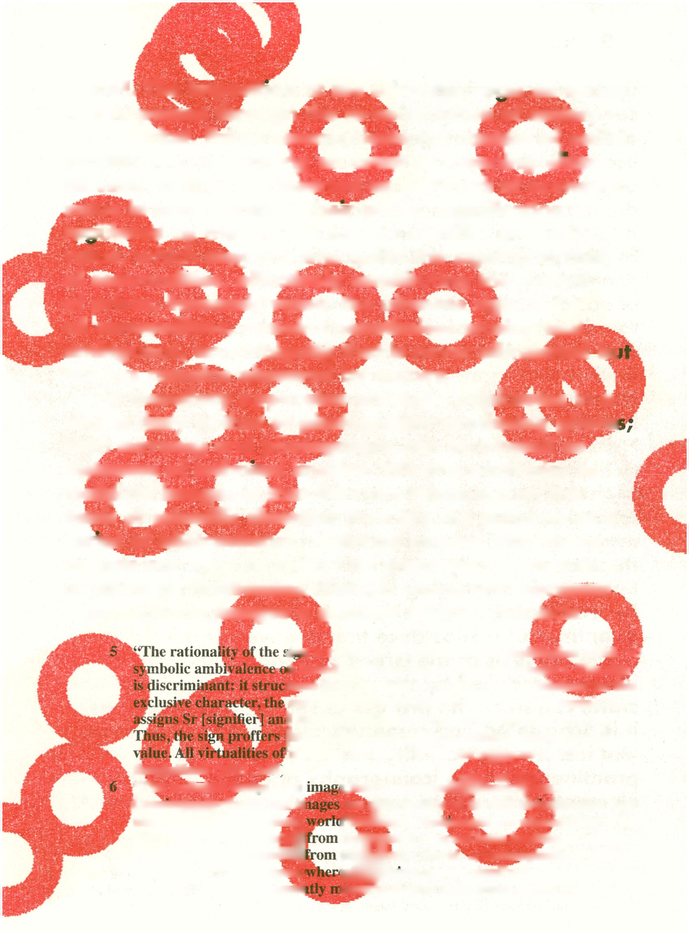of commodities, effectively constituting the system
of prices. Economic value, the ultimate signified of
all commodities, remains nonetheless elusive and
ambiguous, an ambiguity that is never eliminated bi
always remains obscured by money.
The mofr^aty apparatus produces banknotes in a
similar #by to that pf photography producing photo:
both currency and photographs can be treated as
instances of tedimeal images. What is particular to
fecNjjpical images is /hat they are produced on the
basis pf scientific theories; they are the outcome of a
series of abstractions⁶. Technical images essentially
change our view of reality by imposing theories and
concepts as mediatiap^ through which we represent
reality, giving images a peculiar agency thatiacts
value⁵. The imposition of the economic laaijc on social
reality passes through the re-constitution of society
as a market. Prices communicate the cpnipnt of social
constitution, organizing an ordpr of meaning vjpire
all commodities are inerted as signifierl of economic
value in accordance to their prices. Signification is
reatflated by money, the master signifier of economic
value, which supports and quilts the signifying chain
>i«n is rooted in its exclusion and annihilation of aMBm
n behalf of a fixed and equational structure. The sign
turiS itself through exclusion. Once crystal ¡zed on this
sign aligns its fixed field, resigns the differential, and
| Sd [signified] each its sphere of systemic control.
Jself as full value; positive, rational, exchangeable
'meaning are shorn in the cuU»|g|^stnicture.'’
Baudrillard (1981,149 i
“The technical image is an
jOntorefglgiptFaditionalk
abstract from the concrete
third order: They abstggj
which themselves abstiWB
images signify phenomwj
technical images consequti
Flusser (2000,14)
iLthat is produce#^^p|^r^^w....
are abstractions of the first (I|h| insofar they
RMfefechnicalMwges are abstractions of the
tejSKMiich abstract from traditional images
th^tjjiicrete world....Ontologically, traditional
iglllPfmcal images signify concepts. Decoding
Hnrto read of their actual status from them”.
upon our experience of the environment. Banknotes,
seem to share some of the same ontological attributes
of the technical images; they mediate between
economic theory and the constitution of the system
of prices, regulating our experience on the basis of
the maxims of economic value. At the same time they
try to incarnate economic value, providing a screen
for the projection of desire and the constitution of
subjectivity. This claim anticipates that an analysis
of social reality via money may be possible through
the deciphering of the symbolic and iconographllp
elements in banknotes and coins. We could a|gue
further that money promote^the same kind of
magical thinking as other types of technical images,
but this time in relation to value. We could rephrase
Flusser and claim that "the function of banknotes is
to liberate their receivers by magic from the necessity
of thinking on economic value, at the same time
replacing historical consciousness with a second-order
magical consciousness and replacing the ability to
think conceptually with a second order imoljination"⁷.
Currency is mystifying the reality of economic value,
by translating economic relations into absolute
quantities of a substance that is always absent.
The analysis of the Greek banknotes, as technical
images produced by the money-apparatus of the
state, can trace the process of self-representation as
it is articulated and communicated in currency. Issues
like history, territoriality and nationality feature
prominently in the iconography of money and these
elements are used to communicate trust and value. At
7 “The function of technical images is to liberate their receivers by magic from
the necessity of thinking conceptually, at the same time replacing historical
consciousness with a second-order magical consciousness and replacing the
ability to think conceptually with a second-order imagination. This is what we
mean to say that technical images displace texts.” Flusser (2000,17)
the same time the investigation and understanding of
the visual architecture of the banknote/ as exceptional
as its is kitsch, is important determinant on how all
these elements function and as a precondition for
the affective disengagement from currency. Grexit
is an experiment in theory, as it is an exercise in
design, but more importantly an attempt to intervene
in the political debate, to articulate a critique of the
neoliberal ideology, but also to point to a different
kind of cultural criticism, which even though
relevant does not reaffirm the maxims of rationality
and efficiency but offers a new representation of
ipfobjectivity^ndjdesire.^ggB^^Hk ^
f Grexit is an attempt to reflect on how
comnfufmfy and value are articulated
represented on the Greek currency, ai
these social coordinates play out in a nef
economic cohesion. The history of the drachma if¹
intricately connected with the establishment and
the development of the Greek state, shaped by the
struggle of liberation from the Ottomans, the hope
for self-determination, but also from the heritage of
the classical Greek civilization. Despite the aspirations
stemming from the classical antiquity, the modern
drachma remained a relatively weak and unstable
currency, a shadow of it glorious past, constantly
devaluating and suffering from more than one
bankruptcies in the short history of the modern
Greek state. It is no wonder that Greeks were happy
to see the Drachma go, hoping that along with
the Drachma a few other economic problems will
magically disappear. The participation of Greece in the
European Monetary Union and the substitution of the
Drachma by the Euro has not terminated the economic
hardships of Greece, it just masked them for a short
period of time. On the contrary it lead a wave of
mindless consumerism and institutionalized corruption
encouraged by the destabilization of the system of
economic and social values that the new currency
brought about. The consequent financial collapse of
the Greek state and the deep economic and political
crisis has created a context where identity) value and
nationality are reconsidered. An investigation on
the iconographies of the Drachma today is in itself a
comment on national-identity and self-perception in a
very particular historical juncture.
For Fiusser/ photography and techgucal images in
general are not jusfeq reproductive imagmg technology
but rather the cultural trope through which
reality is constituted and underltboa. As long as
technicalimages substitute discourse as thetmain
vehicle of representation and communNratkj^^^
kire transforming our mode of thinking iiva
as typography and written languagjcF
r. The cultural shift is not just a matter of
sheer amount of images produced and disseminated/
but rather on the ever increasing importance of
apparatuses/ i.e. camera/ computers/ and other media
that regulate social interaction via the production
of technical images. The flood of technical images is
just a symptom of the ever-increasing importance
of such apparatuses that now tend to be the
dominant paradigm for techno-social institutions. The
realization of this ongoing cultural transformation has
inspired Flusser in his effort to engage critically with
photography; effectively initiating the development of
a philosophy of technical images.
The Flusserian prophecy about the cultural
dominance of images has not been fully vindicated.
The proliferation of social media has for sure
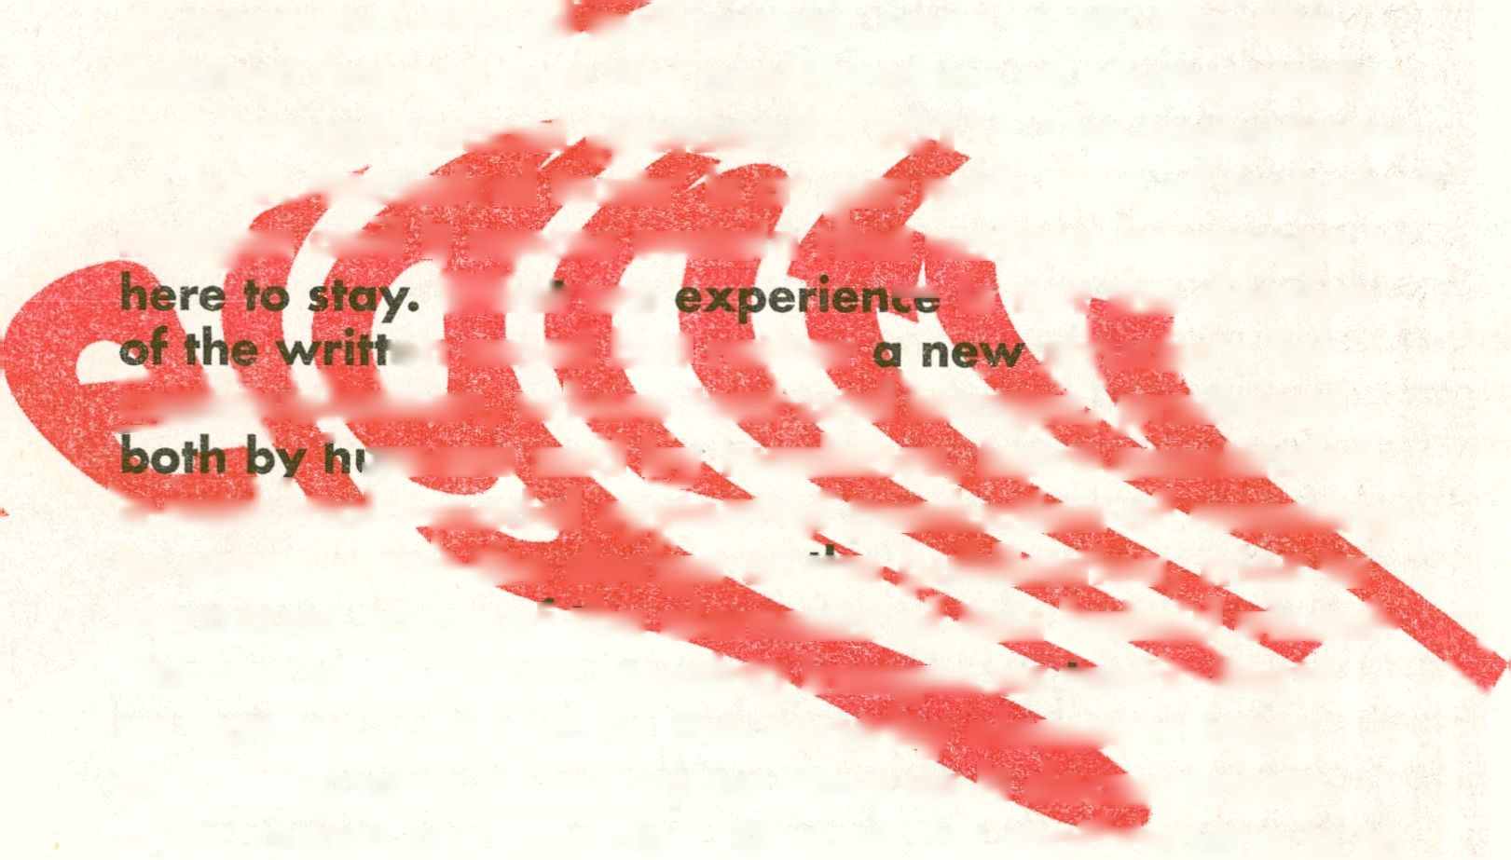— is not the demise
_sti^»|ure for
®M^*tion, where teJkmMma9|s, produced
. ' mians and by machines, hqvPconstituted
IPtiir multi-modal syjtemspf production of meaning.
increased the production and the dissemination of
technical images, mainly photographs, but at the
same time has further encouraged the use of text.
The substitution of television, and of the cinema
by the network and computer technologies has
enhanced rather than reduced the importance of
texts. Furthermore, and possibly more importantly,
machines have now the capacity to imitate humans
in the production of texts. Text is now produced
not just to be read, but in order to be circulated,
shared, copied and pasted, creating new possibilities
of meaning and pf authorship, very much like the
cultural impact that the proliferation of photography
has brought about goldsmith 2011). The importance
of suchJjechnical texts' is at par with that of technical
images and it seems certain that written language is
Wdwe - “*■
en word but rather
In some wayPfhe design of me publication, trieS fo
introduce some otrhe elements of fhishybrid visual^
textual form, often treatingimage^asrext^Sfrxts %
as images, replicating the security elements from
the banknotes at the same time as it deconstructs
their visual composition. One of the moffifations is to
try to map this in-between space between text and
image, reflecting on the antagonism and the synthesis
of technical images and printed word following the
experimental spirit of Vilem Flusser's philosophy.
Banknotes fulfill their function by going the long
way. They are carriers of the conservatism of the state
and of the monetary system; relics of a glorious past
that oppresses a dispossessed present, promising an
of the visual composition,
always elusive future. Their design, as
clear by now, legitimizes political and
through imaginary representation
and cultural identity. The face of power
a repulsion that nonetheless is
perversion, fetishism, fear, awe, and
Banknotes look like tombstones; dead
and quiet landscapes, emblems of a
which is called to oppress the ores
an excuse to the supposed
design. Sophistication
but also to inspire
line between origir“¹
of the elaborate puncn
the idiosyncratic
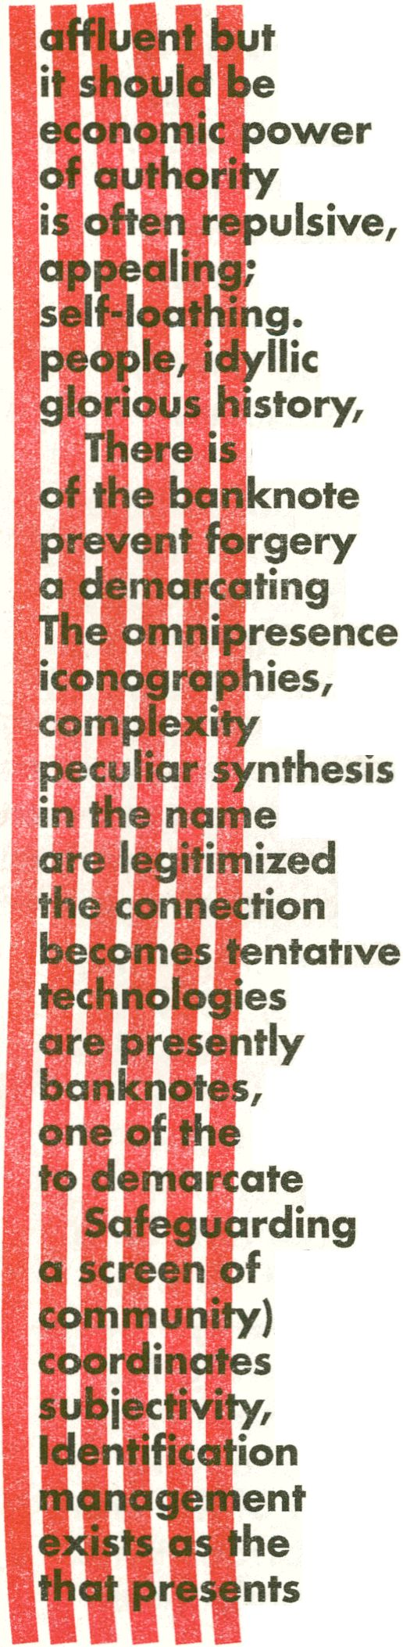between style and funct
of trust and security (as most sto»e wr
in the name of security). Nonetheless,
between adornment and purpose
as more advanced anti-counterfeil
emerge. The very fact that such tecnhiqi
used along with the baroque design of
suggests that ornamentation is at best just
possibilities available to signal authority and
the genuine from the counterfeit,
the authority of currency constructs
identification with the issuer (state, law,
, at the same time as it articulates the
that regulate the market mechanism;
community, power, desire and value,
is regulated by the fantasmatic
of enjoyment, while economic value
mirror image of a promise of enjoyment
itself as a justification of value. The
content of money, if any, is the being-there of a desire,
a crystallization of all the imaginary enjoyment
that money can promise. Exactly because currency
operates as the intermediary between the subject and
its commodified object of desire, currency becomes
the signifier of value and enjoyment. The elaborate
design p an attempt to allude to the desire of the
subject, tojnvest consumption and employment with
a surplus of enjoyment. The subject needs to identify
and to invent in the money form in the process of
becoming an economic agent. We can recognize the
condensation of desire in the markings on notes and
coins as well as in the associations of the symbolisms
of power that are omnipresent in money. Value is
represented as enjoyment; the power to command
commodities as well as the desire to be subjected by
the power of the state.
The subject p|rceives itself in the market in term
of prices, income and money, both in relation to
production/ work and to consumption/ enjoyment.
The ascription of prices to all what it does, produces,
or consumes, creates a matrix of meaning and
consistency according to which it makes sense of itself
and of its social reality. Prices provide the position
of the subject and the meaning of social existence.
Money arises ds the prototypical case of a signifier
in the constitution or the economic symbolic order.
The general equivalent of all commodities, including
the subject, represents the subject in the market and
it is the signifier for which all commodities represent
the subject. Money, and through money price, signify
the subject qua producer in terms of economic value
and insert it in a chain of relations to all the other
producers and commodities that inhabit the symbolic
order. Conversely, money enables all commodities to
represent the subject;
and symbolic ide
the subsumption
connects the pro
desire of the Othe#<
ego to its immedi
Value is a struct
provides an orderi
quantification⁹. UnK
embodiments of tl
money nor currency
to represent it. Ecorioi
relations and curran
substitute for the '
economic value; tl
currency is nothin
value in market e
same principle. Th
but the content ca
allowing the signi
Currency is materij
value-less, fiat; it
commands all eco
Currency incarn
to-day transactio
the signifier of ec
- 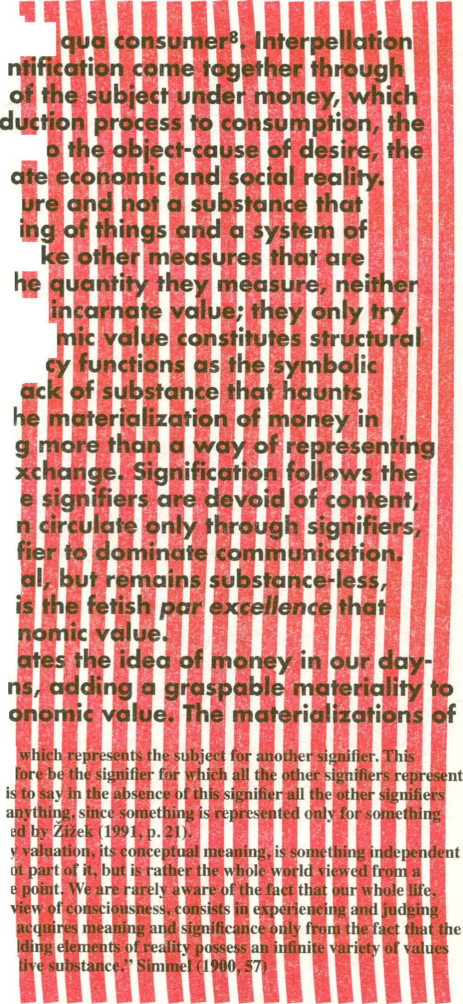“A signifier is thatj
signifier will there!
the subject; that
do not represent
else.” Lacan quoti
- “what we mean b;
of this world; is ni
particular vantagi
from the point of
values, and that it
mechanically unfol
beyond their objcc]
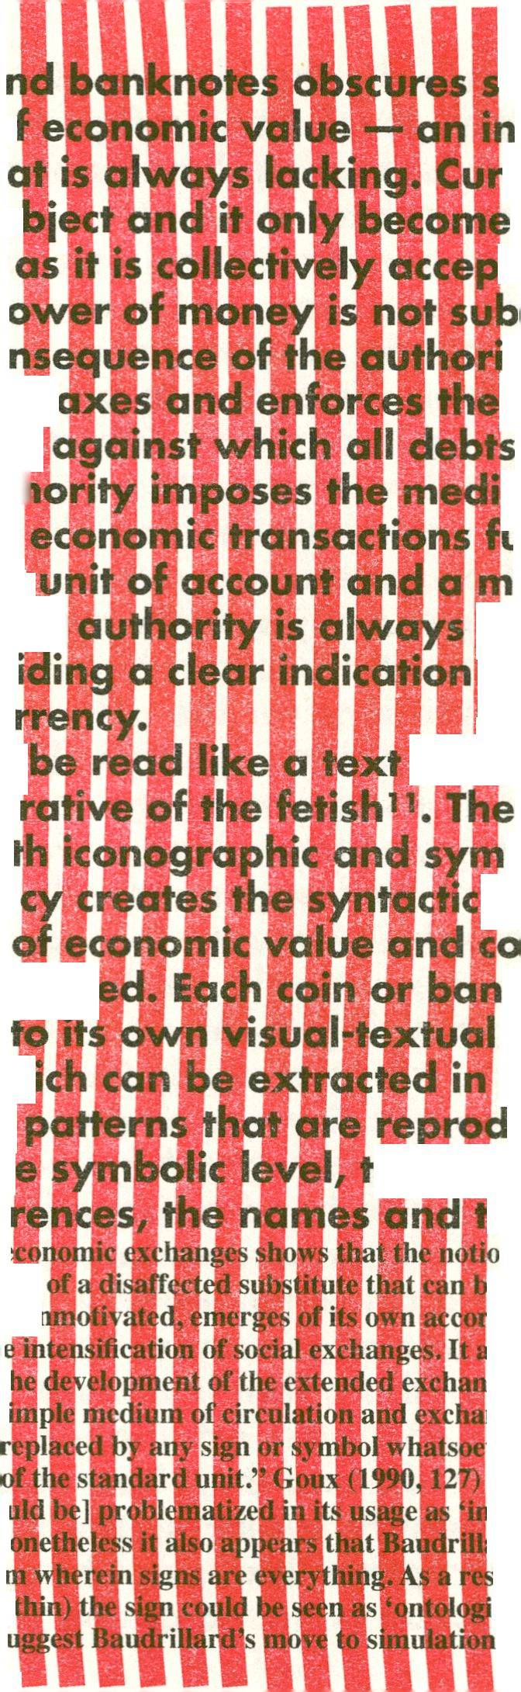
money in coins a
same mysteries o
of a substance th
worthless as an o
payment as long
The purchasing p<
but political; a co
state that imposes#'
as the legal tender
remunerated. Autf
should be used in
the market with a
exchange. Symbolic
the currency provi
of the value of cu
Banknotes can
constructs the nar
of the signs — bol
that define curren
where the issues
identity are repres&rtt
be broken down
the analysis of wl|
and iconographic
historically. On th
the date, the refe
- “The analysis of e
symbol, in the sci«£|
conventional, and ui
and thus from th
turning point in tl
its function as a si
currency can be
certain quantity
- “fetishism is [shoi
consciousness’. N<
universal fetishist
reality behind (wii
that it begins to si
ome of the
carnation
rency is
s a means of
¡ted as such¹⁰,
stantive
ty of the
currency
are to be
um that
irnishing
eans of
represented in
of the source
y§<! the text
analysis
bolic —
Icontext,
llective
knote can
elements,
symbolic
uced
^alphabet,
he titles
n of the pure
e perfectly arbitrary,
d from the circulation
ppears at a precise
ge form. Indeed,
ige, gold or silver
cer that represents a
ferior or false
ird is offering us a
ult, our belief in any
cal fetishism’ in a way
.” Hegarty (2003 ,25)
express linguistically the identity of currency. On
the iconographie level, human figures and space
references (landscapes and monuments), as well as
secondary ornamental elements, supplement language
with a pictorial narrative that is communicating
the imaginary construction of economic power and
national identity. An assortment of national and
corporate emblems is added to instill the notes with
the symbolic and imaginary authority of the state,
suggesting direct references to power and community.
Associative, unconscious relations between signifier
and signified, between currency and value, based
on origins, on culturally specific meaning and on
shared presuppositions about historicity and tradition
create the foundations for the affective investment
in currency. The recomposition of all these textual
and symbolic signs facilitates the investigation
of the pictorial narrative of the currency and the
interpretation of the imagery of value.
The iconographie elements that communicate
the value and the authority of the official currency,
effectively legitimizing money, construct a text that
can support the associations between monetary
and political power. Currencies can be analyze
a proxy in the process whereby a homogene
identity is constructed and communicated. A
used the term "imagined communities" to
construction of a collective identity (Anderson
If by imagination we can understand the propenl
to perceive something that is absent, then moneta
media facilitate the mass orientation of imagination
towards a common and therefore objective perception
of value and identity, replacing the necessity of social
familiarity. Perception that is not based on immediate
physical interaction is based on the re-cognition of
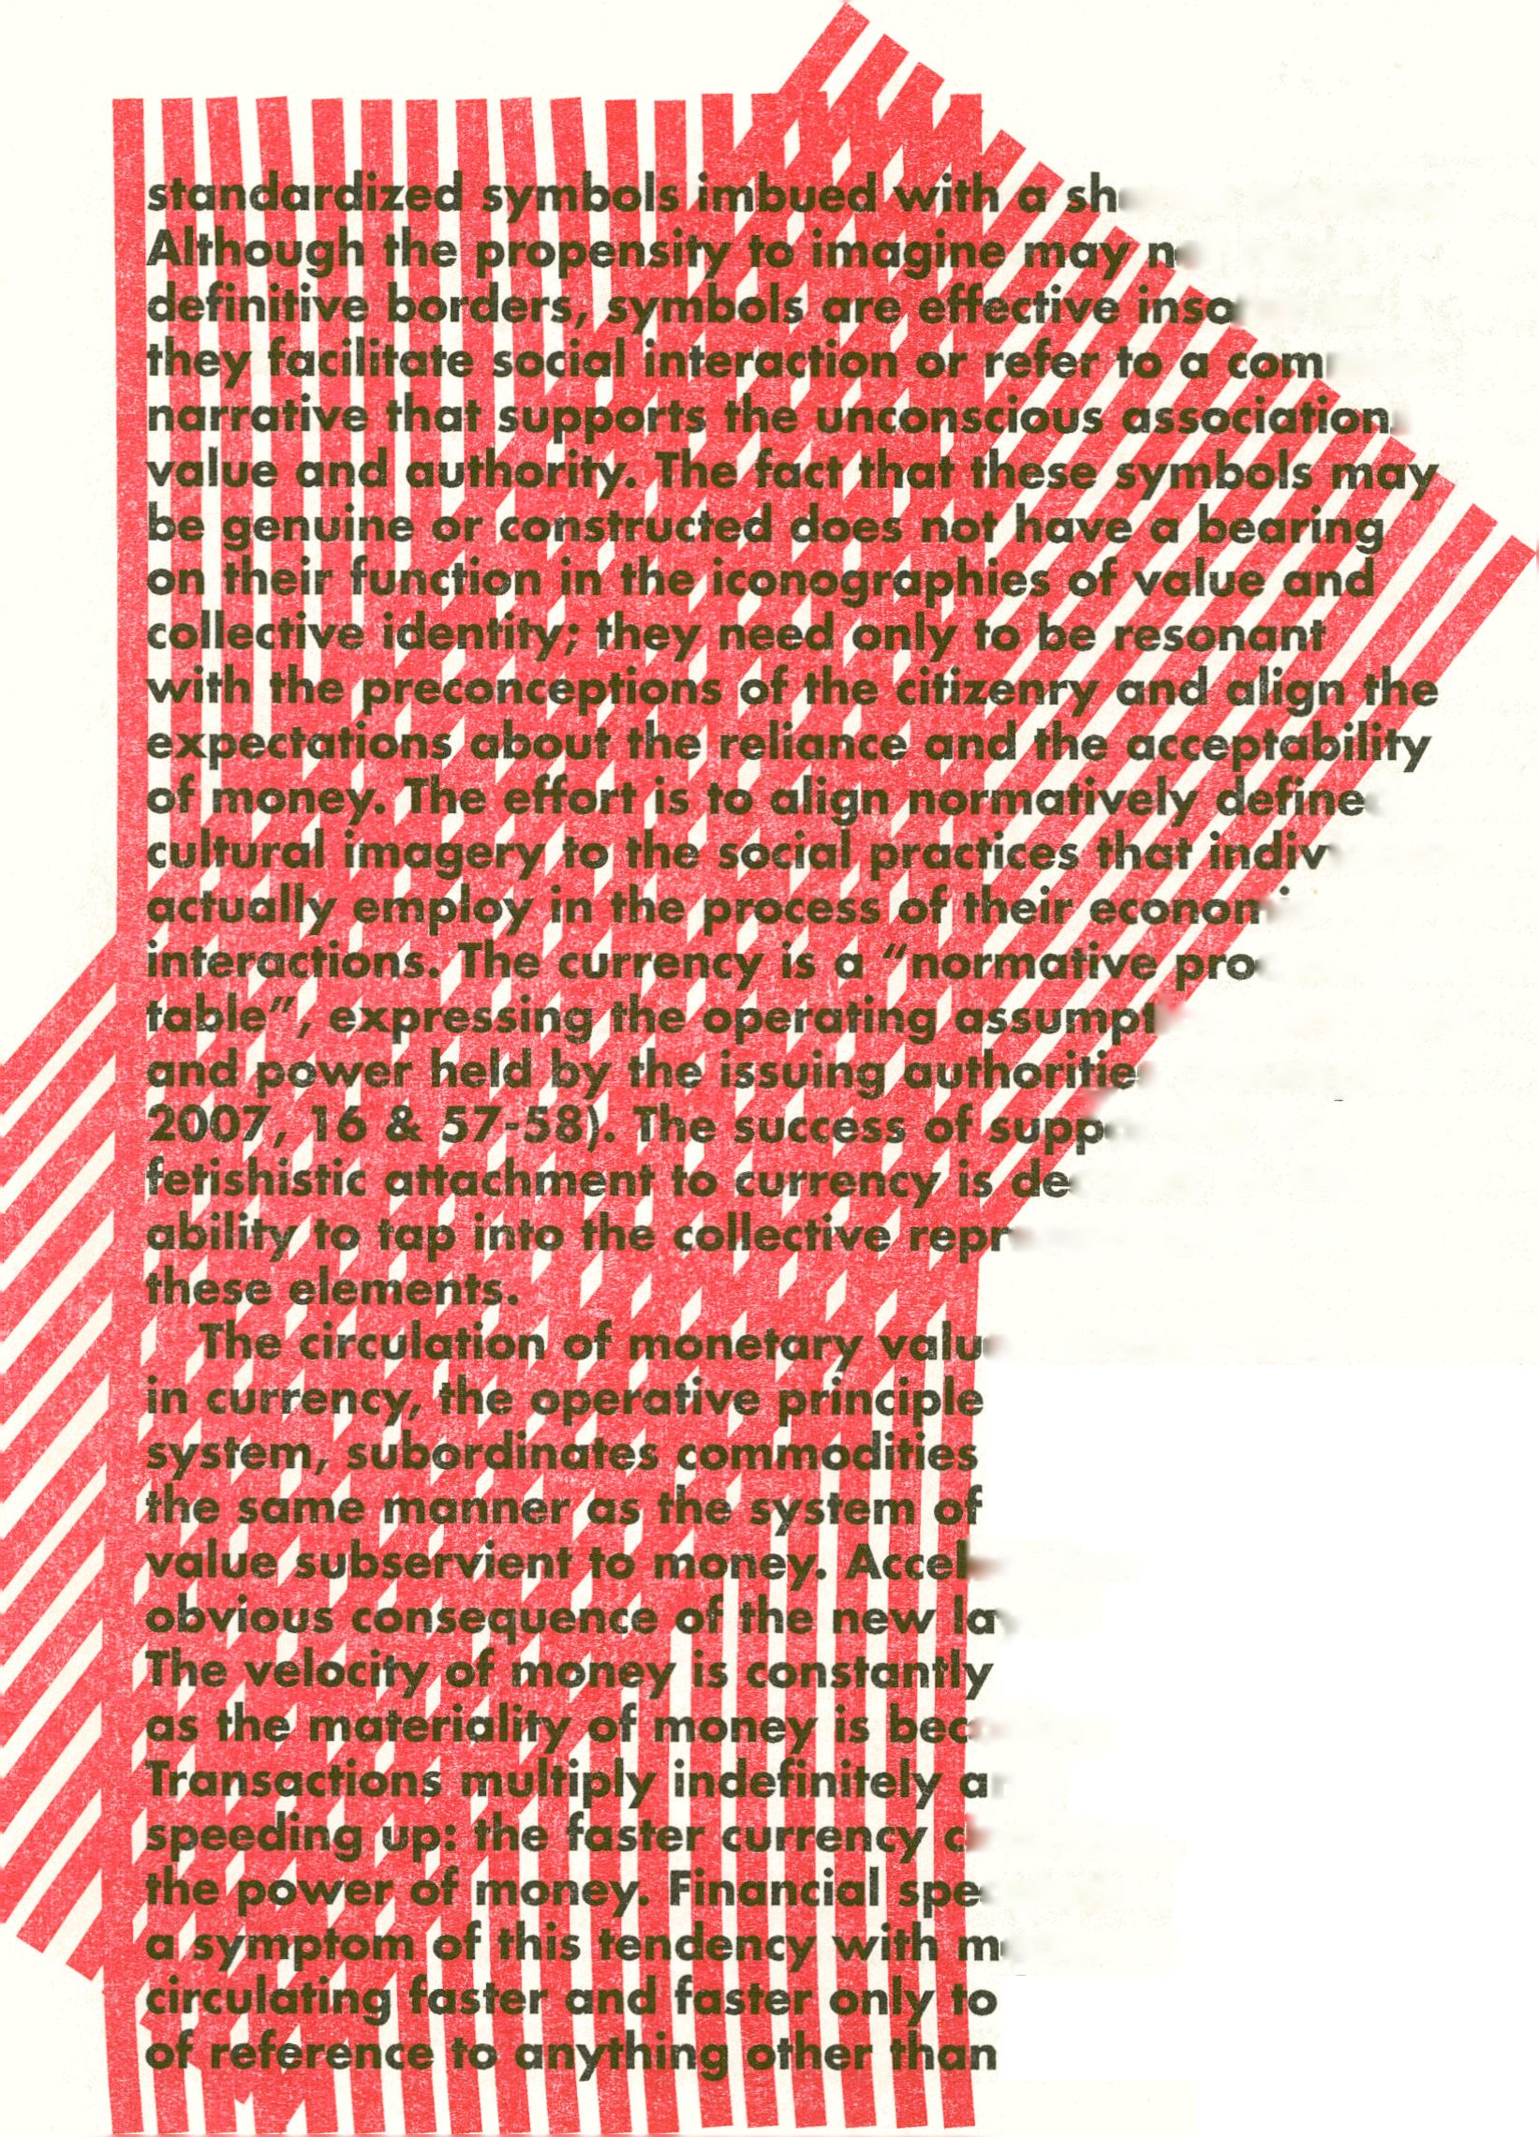ared meaning,
ot have
far as
mon
s to
d
iduals
lie
crustean
Ians on value
„ s (Roumpanis
^orting the
tided by the
esentations of
e remunerated
of the market
to currency in
prices makes
ieration is the most
yers of mediation,
accelerating,
oming obsolete,
nd currency is
irculates, the greater
culation is only
onetary value
lose any pretense
itself, at the
,m»«tiin§pa?.p?E^{rrenc}y disappears in virtual reality,
completeiyjm^pterialized as it reaches for the speed
^{of} iig^EfWplsA'C attachment to velocity replaces the
fetish of money. Actually, what we experience today,
is the passage from object, to image, to symbol, to
pApApApApApApApApApApApApApApApApApAp
ApApApApApApApApApApApApApApApApApApA
pApApApA^^pO^^XoilOi^tp^
ApApApApi
pApApApApi
ApApApApi
pApApApAp
ApApApAp^iSpSp&pApSp&papifp£pjpApFpip!
pApApApApApApApApApApApApApApApApApAp
ApApApApApApApApApApApApApApApApApApA
%teimpto^{chm}a is virtually here ... ¹²
ApApApApApApApApApApApApApApApApApApA
pApApApApApApApApApApApApApApApApApAp
ApApApApApApApApAoApApApApApApApApApA
pApApApApApApApApApApApApApApApApApAp
ApApApApApApApApApApApApApApApApApApA
\pApApApApApAoApApApApApApApApApApApAp
ApApApApApApApApApApApApApApApApApApA
pApApApApApApApApApApApApApApApApApAp
ApApApApApApApApApApApApApApApApApApAp
ApApApApApApApApApApApApApApApApApApAp
ApApApApApApApApApApApApApApApApApApAp
ApApApApApApApApApApApApApApApApApApAp
ApApApApApApApApApApApApApApApApApApAp
ApApApApAoApApApApApApApApApApApApApAp
ApApApApApApApApApApApApApApApApApApAp
ApApApApApApApApApApApApApApApApApApAp
lApApApApApApApApApApApApApApApApApApAp
ApApApApApApApApiipApApApApApApApApApAp
lApApApApApApApApApApApApApApApApApApA
LpApApApApApApApApApApApApApApApApApApA
IpApApApApApApApApApApApApApApApApApAp
the world have been staring at their Bloomberg screens,
hardly believing their eyes. The electronic information platform has been
Greek Drachma trading. The Bloomberg help-desk
described it as ‘an internal function which is set up to test’. The news comes
in the wake of the heated discussions over the future of the euro zone and the
membership of Greece.” Russia Today, 1.6.12, http://rt.com/business/news/
greek-drachma-bloomberg-trades-769/ accessed 19.7.12.
Anderson, Benedict.
Imagined Communities;
Reflections on the Origin and
Spread of Nationalism. London:
Verso, 1983.
Baudrillard, Jean. For
a Critique of the Political
Economy of the Sign. St. Louis:
Telos, 1981 (1972).
Deleuze, Gilles. "What is
a Dispositif?" In Armstrong,
Timothy J. Michel Foucault
Philosopher. London:
Routledge, 1991.
Evans, Dylan. An
Introductory Dictionary of
Laconian Psychoanalysis.
London: Routledge, 1996.
Fink, Bruce. The Lacanian
Subject: Between Language
and Jouissance. Princeton:
Princeton University Press,
1995.
Goldsmith, Kenneth.
Uncreative Writing. New York:
Columbia University Press,
2011.
Goux, Jean-Joseph.
Symbolic Economies; After
Marx and Freud. Ithaca:
Cornell University Press, 1990
(1973).
Hegarty, Paul. Jean
Baudrillard: Live Theory.
London: Continuum^ 2003.
Lacan, Jacques. Ecrits.
London: Routledge, 2006
(1966).
Laclau, Ernesto.
Emancipations. London: Verso,
1996.
McLuhan, Marshall, The
Gutenberg Galaxy. Toronto:
University of Toronto Press,
1963.
Nancy, Jean-Luc and Thomas
C. Platt. "The Two Secrets of
the Fetish", Diacritics. 31, 2
(Summer 2001): 3- 8.
Papadopoulos, Georgios.
Notes Towards a Critique of
Money. Maastricht: Jan Van
Eyck Academy, 2011.
Roubanis, Ilia. Nation
Building as Perception
Building; The Case Study of
The Banknote in Greece and
Turkey. PhD Dissertation.
Florence: European University
Institute, 2007.
Searle, John. Making the
Social World. Oxford: Oxford
University Press, 2010.
Simmel, Georg. The
Philosophy of Money. London:
Routledge, 1990 (1900).
Stavrakakis, Yannis.
"Subjectivity and the
Organized Other: Between
Symbolic Authority and
Fantasmatic Enjoyment".
Peripheral Vision, 29 (2008):
1037- 1059.
Stavrakakis, Yannis. The
Lacanian Left. Edinburgh:
Edinburgh University Press,
2007.
Flusser, Vilem, Into
Universe of Technical
Minneapolis: University
Minnesota Press, 2011 {.™^,
Flusser, Vilem, Toward^^m$~'
Philosophy of Photography.
London: Reaktion Books; 2000
(1983).
Zizek, Slavoj. For
Know Not What They Do:
Enjoyment as a Political
London: Verso, 1991.


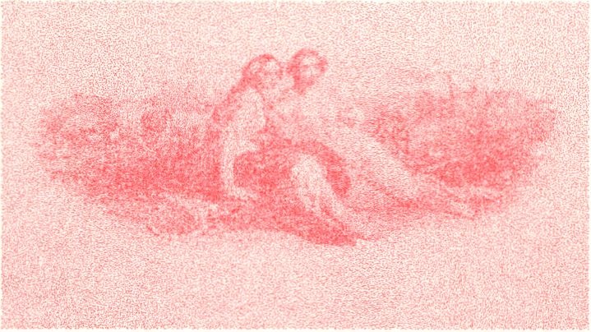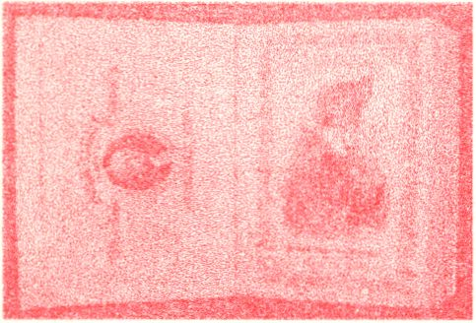1 - Document dated 16/28 February 1859 sent
by the National Bank to ABNCo ordering the
construction of the 25-drachma and the 100-drachma
notes (source: Museum of
American Finance, New York) . i.
2 - Greek draft of a document
sent to ABNCo by the National Bank
(source: Historical Archive of the National
Bank of Greece, series "Nomismatika",
file 11, doc. 1 /[ 1888])
***** .
L-i' 2*f**'^{v} ’
—^{v}**^{i}"/‘* ->cc'
■Ï. U ■; ;iv> - - *'X'
* 'AX
■¿CXs
*v
^ j».
? -'S- '•;
•A/.
:T7
3-The
25-drachma note
(first circulation:
23.3. I860)
(source: Notaras,
G., Greek Banknotes, A Journey: 1822-
2002, Athens 2005)
‘ft-*-;
4 - Vignette included in Bank
Note vignettes: American Bank
Note Company vol. I -9, New
York [l 850-1889;] (photo by
the author)
5 - Title
page of
the first volume of Bank Note vignettes:
American Bank Note Company vol. I -9,
New York [1850-1889;] kept in the Public
Library of New York (photo by the author)
- - The vignette on the front side of the
25-drachma note (source: Notaras, 2005)
- 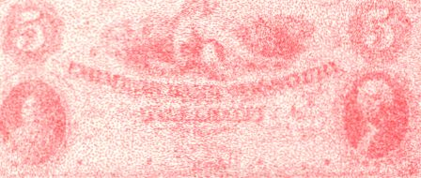- The Farmers Bank of Missouri, 5-dollar
note, late 1850s (source: Ancient, foreign
and United States coins together with bank
notes from the archives of the American
Bank Note Company, Christie's Auction
Catalogue, Jun 5, 1991)
"rfS:g
- 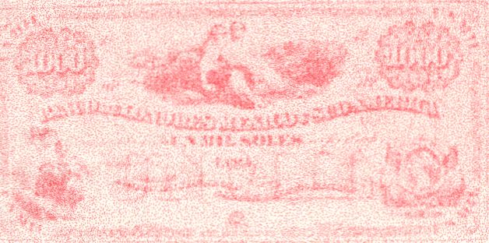- The Lewisburg Bank, 5-doliar
note (source: Important early
American bank notes, 1810-1874,
from the Archives of the American
Bank Note Company. Christie's
Auction Catalogue, Sep 14-15,
1990)
- 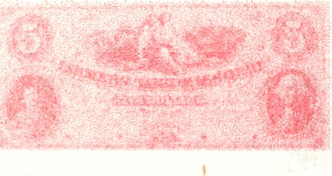- Banco de Londres Mexico y Sud
America, 1000-sole note, 1870-1880
(source: Magan, R.M., Latin American
bank note records: American Bank Note
Company archives, 2005)
- - Vignette
depicting Agriculture (source: Bank
Note vignettes: American Bank Note
Company vol. 1, New York [ 1850-
1889;]
10- Vignette depicting Agriculture (source:
Bank Note vignettes: American Bank Note
Company vol. 1, New York [ 1850-1889?]
- 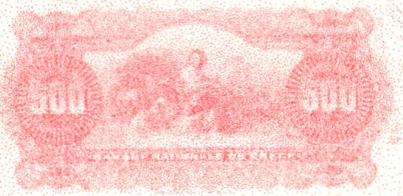- The 500-drachma note (first
circulation: 1.1.1902) (source: Notaras,
2005)
- - The 500-drachma note (first
circulation: 1914) (source: Notaras, 2005)
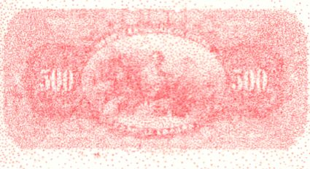14: El Banco
Nacional Hondureno, 1889 issues
printing plate (source: American Bank
Note Company Archives part II: featuring
stocks, bonds banknotes, banknote
printing plates and production material, Harmer Auction
Catalogue, Oct 17-19, 2007)
15 - Caja de Credito Hipotecarion, Chile,
4 different specimen bonds, circa 1890-
1900s) (source: American Bank Note
Company Archives part III: U.5. and
worldwide banknotes, stocks, bonds
and security printing ephemera, Harmer
Auction Catalogue, Jun 2-4, 2008)
- 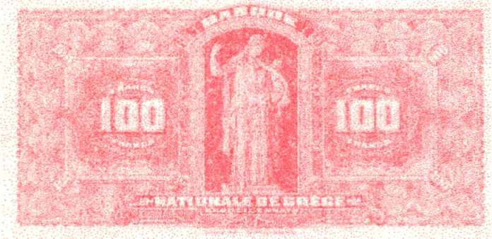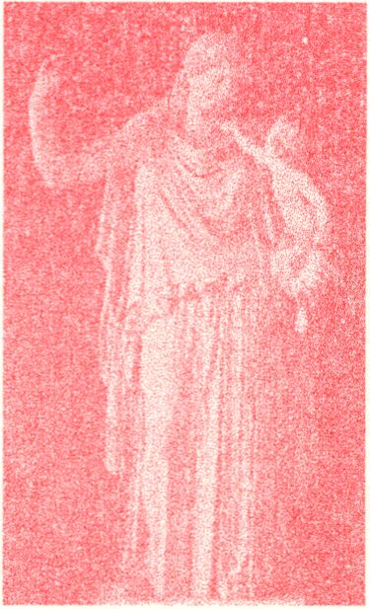- Eirene
and Plutos
16 - The 100-drachma note (first
circulation: 15.12.1910) (source:
Notaras, 2005)
by Kephisodotos with the restorations by
Cavaceppi (source: Collignon, M., Scopas et
Praxitèle, Paris 1907)
- 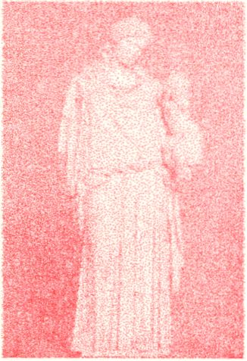- Eirene and Pluto by
Kephisodotos after the removal
of the Cavaceppi restoration
(source: Beck, C.H., Glyptothek
München, München 2005)
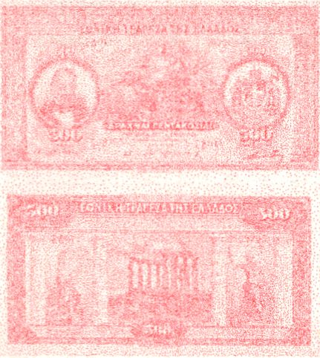23a-b - The 500-drachma note (first
circulation: 22.10.1922) (source: Notaras,
2005)
- 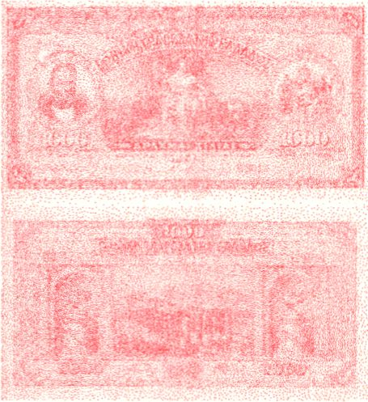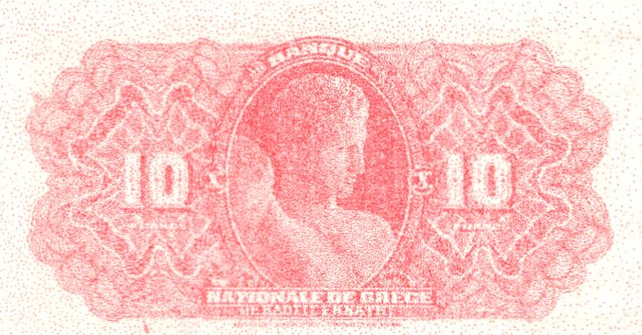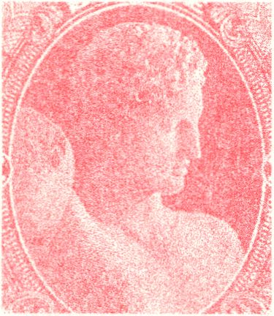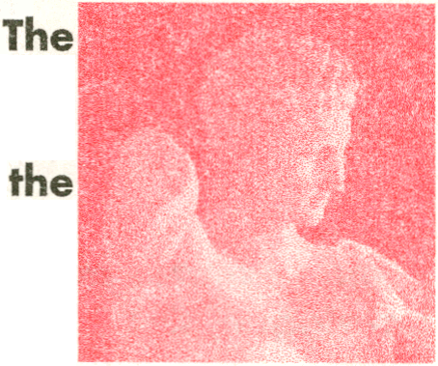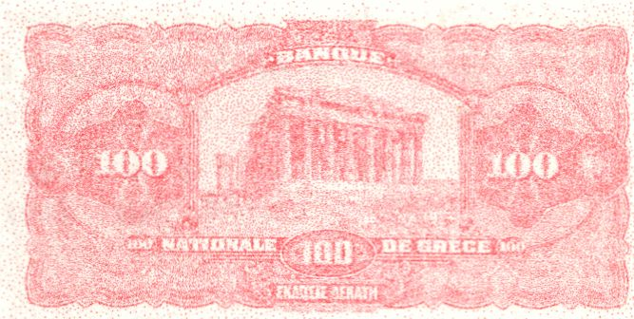- M. Axelos, Model for the front
side of the 500-drachma note (source:
Notaras, 2005)
24a-b - The
1000-drachma note
(first circulation:
11.4.1922) (source:
Notaras, 2005)
10-drachma note (source:
20 -
vignette on
the front
side of
Notaras, 2005)
21 - Hermes by Praxiteles
(source: Collignon, M.,
Scopas et Praxitèle, Paris 1907)
22 - The
100-drachma
note (first
circulation:
31.5.1921) (source: Notaras,
2005)
- - The 10-drachma note (first
circulation: 11.2.1913) (source:
Notaras, 2005)
- - Capital from Epidauros (source: Luckenbach,
H., Kunst und Geschichte, München & Berlin
1906)
- 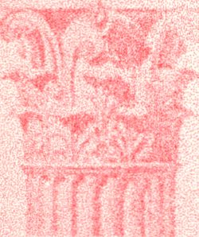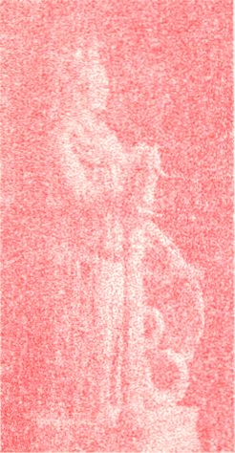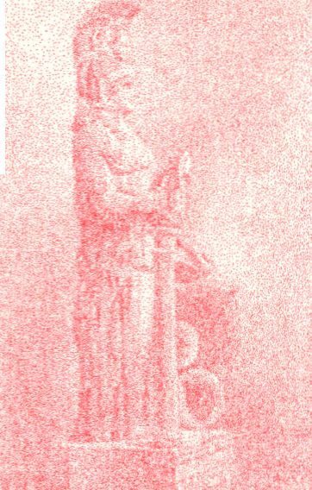- Vignette from the reverse
of the 500-drachma note
(source: Notaras, 2005)
- 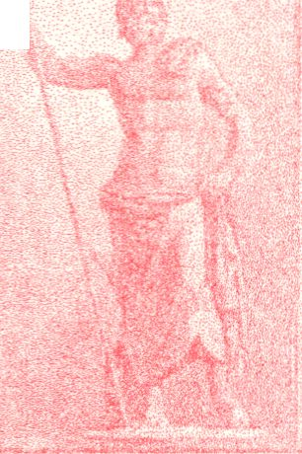- Vignette from the reverse of the
500-drachma note (source: Notaras,
28 - The statue of Athena
Varvakeios (source: Luckenbach,
H., Kunst und Geschichte,
München & Berlin 1906)
2005)
- 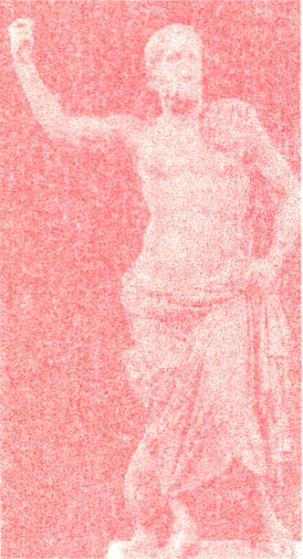- The statue of Poseidon with
its missing parts (trident, part
of hair and beard, tail of fish)
restored (source: Richter, G., A
Handbook of Greek Art, London,
New York 2006)
- 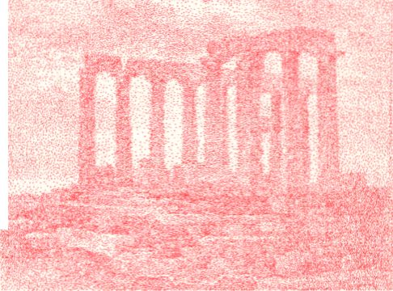- Vignette from
the reverse of the
500-drachma note
(source: Notaras, 2005)
- 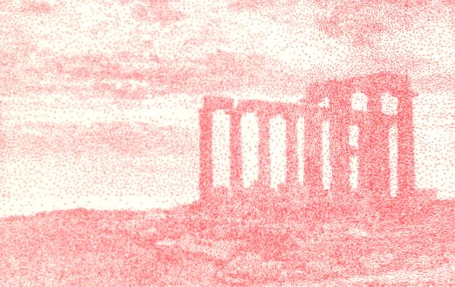- The temple
of Poseidon
in Sounion
photographed
by Fred Boissonnas (published in Wells,
H.G., A short History of the World,
New York 1922)

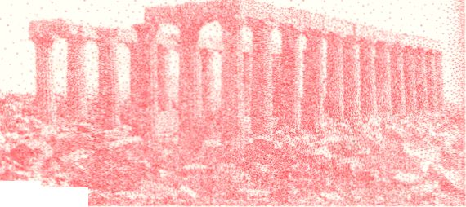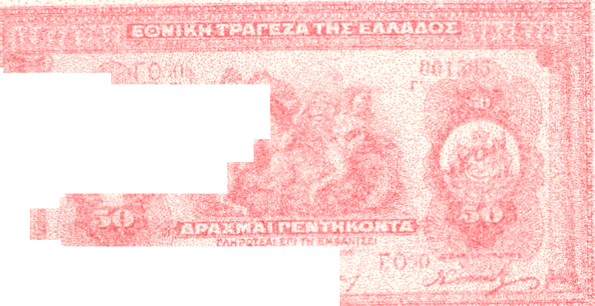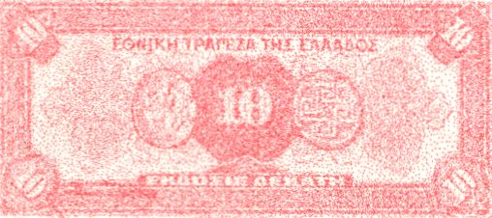
33 - The temple of Apollo in Vassal
(source: Mallouchou-Tuffano, 1998)
¡s^3®*a«ù
34 - The
temple
of Apollo
in Vassai after 1902-1908 (source:
Mallouchou-Tuffano, 1998)
*\
£ I ¡1m teiS I
35 - Vignette on the reverse side
of the 1000-drachma note (source:
Notaras, 2005)
I 1 . MC -is%<
36a-b - The 50-drachma note
(first circulation: 6.10.1922)
(source: Notaras, 2005)
|, I, - • ™" Wini-M*’"'"
v.j»| A ■ A****r'*‘ / y *-~
37 - Plate from the relief decoration of
the Alexander Sarcophagus published in
Osman Hamdy Bey and Théodore Reinach,
Une Necropole Royale à Sidon, Paris 1892
38 - The head of Alexander from a Tarsus coin
in Cicilia published in Osman Hamdy Bey and
Théodore Reinach, Une Necropole Royale à
Sidon, Paris 1892
39 - The 10-drachma
note (first circulation:
1.1.1927) (source:
Notaras, 2005)

40 - Coins from Knossos published in Evans,
A., The Palace of Minos vol. 1, London 1921
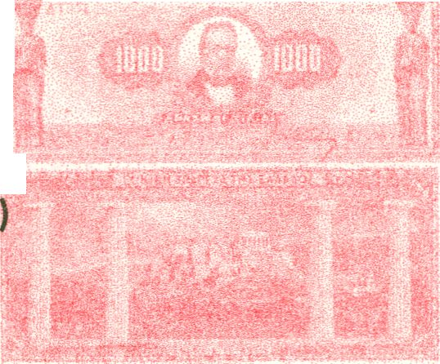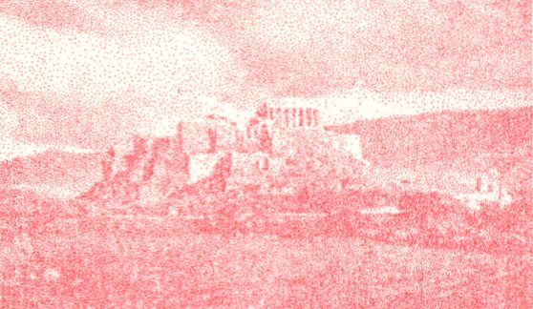41a-b - The
1000-drachma
note (first
circulation:
/&■>:*■:■
mm
. .
' .v.» ,?•<
flft®
■ * '
19.9.1925)
(source: Notaras,
2005
42 - The
Acropolis
of Athens photographed by Fred
Boissonnas (published in Wells, H.G.
A short History of the World, New
York 1922)
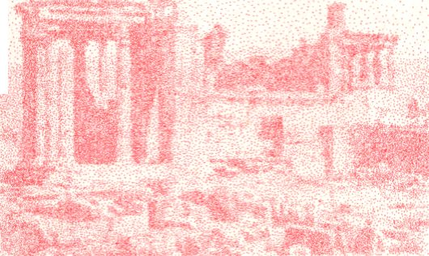43 - The Erechtheum before 1902-1909
(source: Mallouchou-Tufanno, 1998)
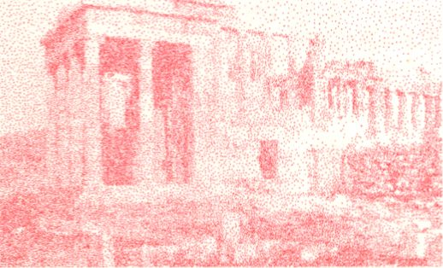

- 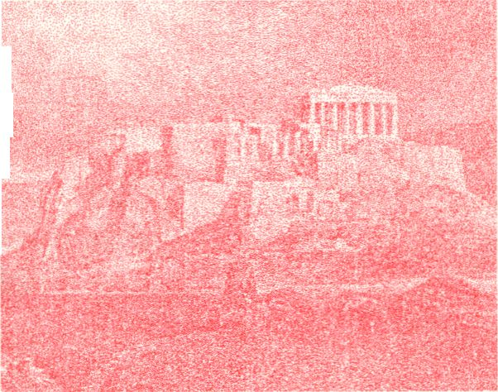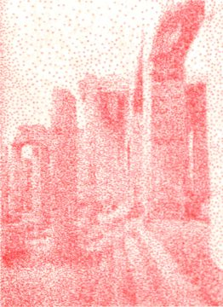- Vignette on the reverse of
the 1000-drachma note (source:
Notaras, 2005)
44 - The
Erechtheum
after 1902-
1909. The upper drum of the left column
of the west propylon has been restored
(source: Mallouchou-Tuffano, 1998)
- - The restored roofs
of the Propylaia from
the South after the
1911-1917 restoration
(source: Mallouchou-
Tuffano, 1998)
- - The Southern
propylon of the
Erechtheum before the
1902-1909 restoration
works (source:
Mallouchou-Tuffano,
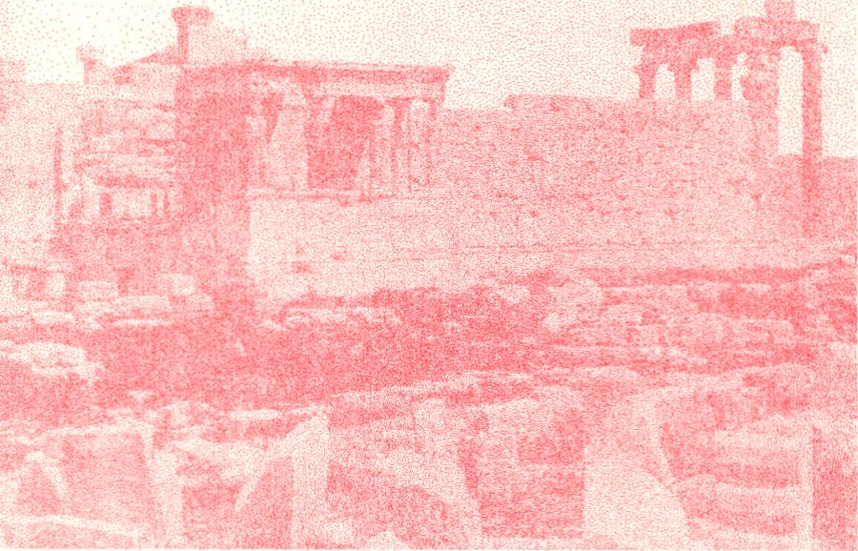¹ ^®) :f|pap
_...
- - Vignette
from the
obverse of the
1000-drachma
note ((source:
Notaras, 2005)
- 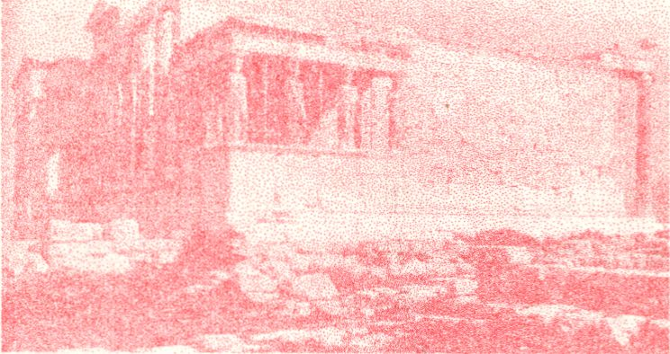- The Southern
propylon of the
Erechtheum after the
1902-1909 restoration
works (source:
Mallouchou-Tuffano, 1998)
- - Inlaid ivory draught from Knossos (source:
■
, h’,/ !
s r -
i tv»' - ' §
Evans, 1921)
- 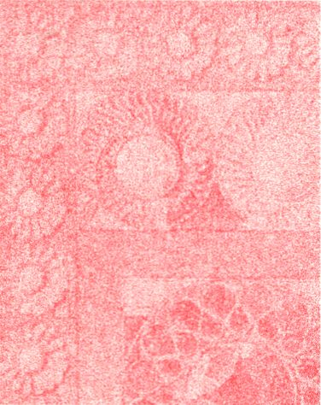- Detail of the inlaid ivory
draught (source: Evans, 1921)
- 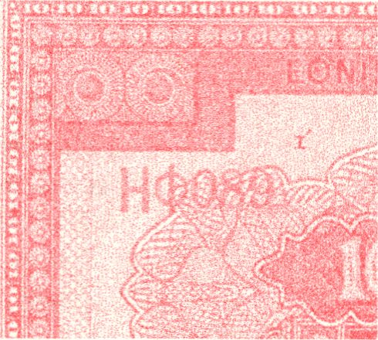- Detail of the 10-
drachma note (source:
Notaras, 2005)
- - Decoration from stucco
fragments found in Knossos
(source: Evans, 1921)
- 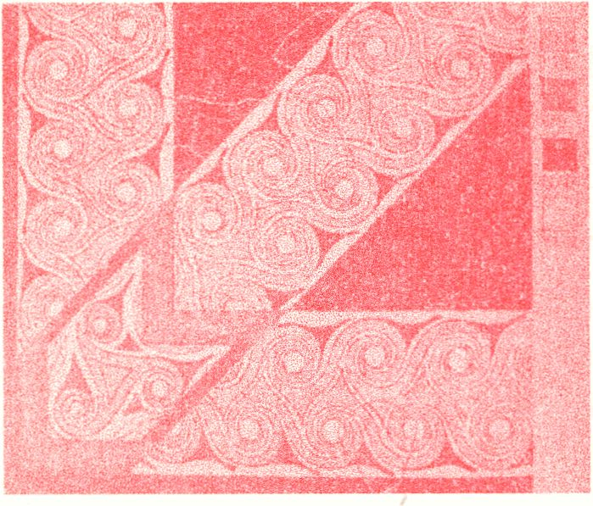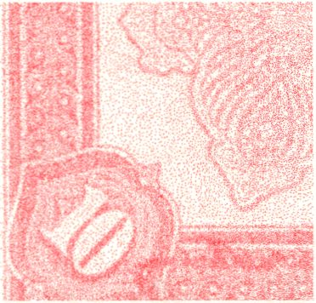- Detail
of the 10-
drachma
note (source:
Notaras,
2005)

- 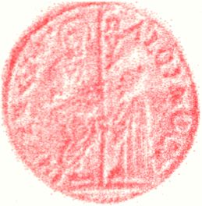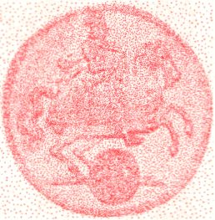- The Ducat and its Rivals
Venitian Ducat
(1284-1797)
Dutch
Commercial
Ducat 1586
Saxony Ducat
1711
Sultani,
Mehmet III
1595-1603
56 -10 Latin Monetary Union Drachmas (Francs)
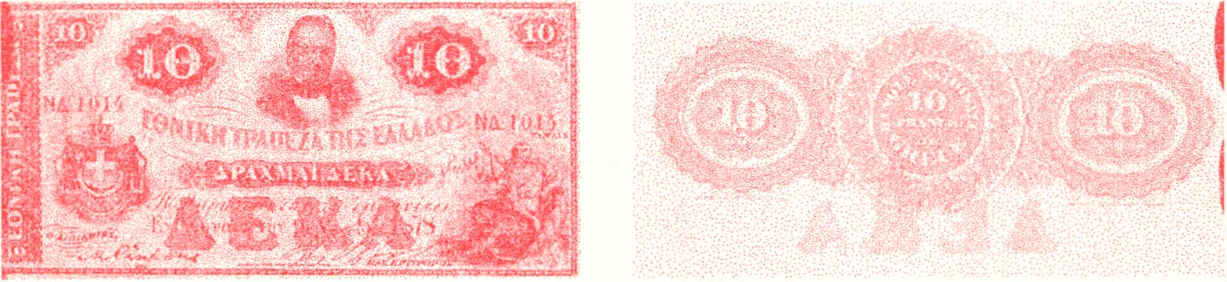
Issuer National Bank of Greece (private bank)
Issued 05.10.1874,
Production of the Note: American Banknote
Company New York.
57 - Classic Motherlans

I fi

100 DM Note, 1910
25 LMU
Drachmas, 1887
58 - Petty Currency Paper Notes,
Towards National Monetary Communities

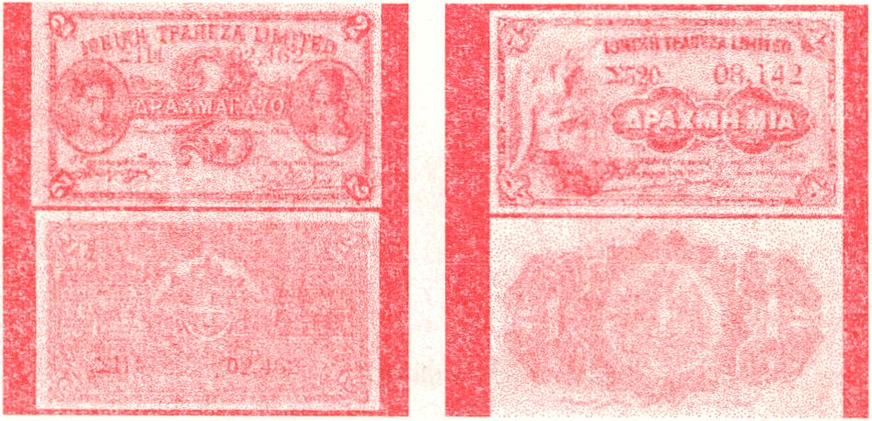
59 - The Surrender of General Burgoyne, 1777
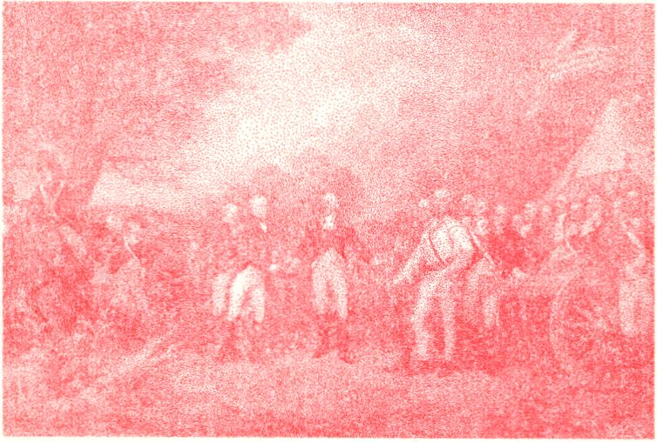


fr*
¡-•’V- ?-• »¡y-y-,■. •
- Wi-!.

French Revolution
Note
Ottoman Paper
Currency, 1861

61 - The National Discourse Network
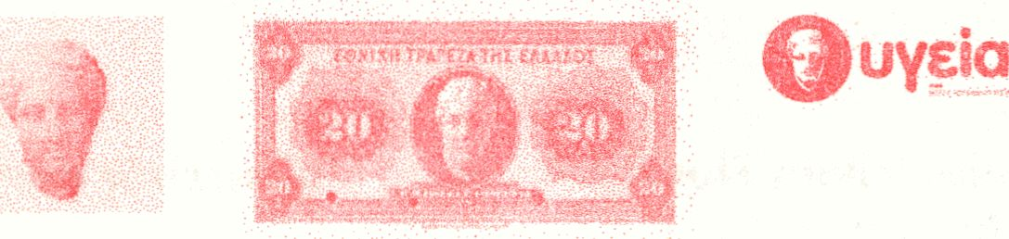

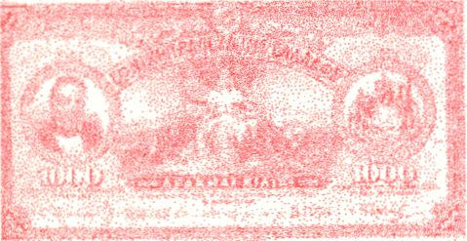62 - The First Nationally Designed Banknote
"We beg now to advice you that we have prepared by an
artist specialized in Greek art a design for 1000 drachma
notes, which we are forwarding to you by registered and
insured parcel post (...)
In making and engraving the model, all the proportions
should be kept, and all tints, of the whole and each part
separately, be exactly given, without deviation from the
general character of the greek {sic} style, which we wish to
prevail hereafter in our notes of all denominations."
August 1920
Editing
Georgios Papadopoulos
Design
Neda Firfova, Jack Henrie Fisher
Printing
Berlin Risographique
Edition
50
Institutions
Transmediale, Vilém Flusser Archive, Universität der
Künste Berlin
Date
August 2012
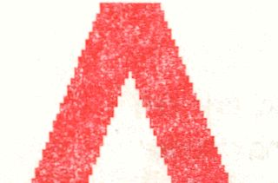:e at will
The research and publication of this book was made possible
through the Vilém Flusser Residency Program for Artistic
Research. The residency programme is a cooperation between
the _vilém_Russer_archive at the University of Arts (UDK) and
transmediale, festival for art and digital culture Berlin. The
programme supports projects and activities which are
simultaneously conceptual and practice-based, and it is geared
towards the initiation of new research or to the further
development of existing projects.
ocrvun
lawn
run
yufi¹
Drachma ApB
Drachma Apo;
Drachma Apa)
Drachms Apa)
Drachma Apa)
Dracnma Apa;
Drachma Aouj
Drachma ¿.‘pci
Drachma Aogj
Wi Vjjri Drac
Dracnma
Drachma
Drachma
Drachma
Drachma»
Drachm/C
DrachnCl
DrachifSE
Drac ¡MBS'
DraqfiBS
_> A&crn
fflWprj Drac. ima Apr.<xun Drec
A*
¡c-; jr; Drac • m- ^ooym-ySfca..
joy ;q Drac
)av jQ Drachma A^BdHygBS
>c>XMQ Drachma bo
)OXMQ Drac tsna Apaxpffnrat
^paxPQ Drachma ApoxMO Drat
ApcxMQ Drachma Apaxpn Drac
¿paypo Drachma Apaxprj .Drac
Aoax iq Drachma Apaxj-'Q Diat
Shma ApaxpQ Drachma Apayun Drac
:hma ApaxMQ Drachma Apaxun Drac
:hma ApaxMQ Drac ima Apr«x ¡0 Drat
;nma Apax IQ Drachma Apaxpn Drat
:hma Apa’xpq Drachma Aptmm Drac

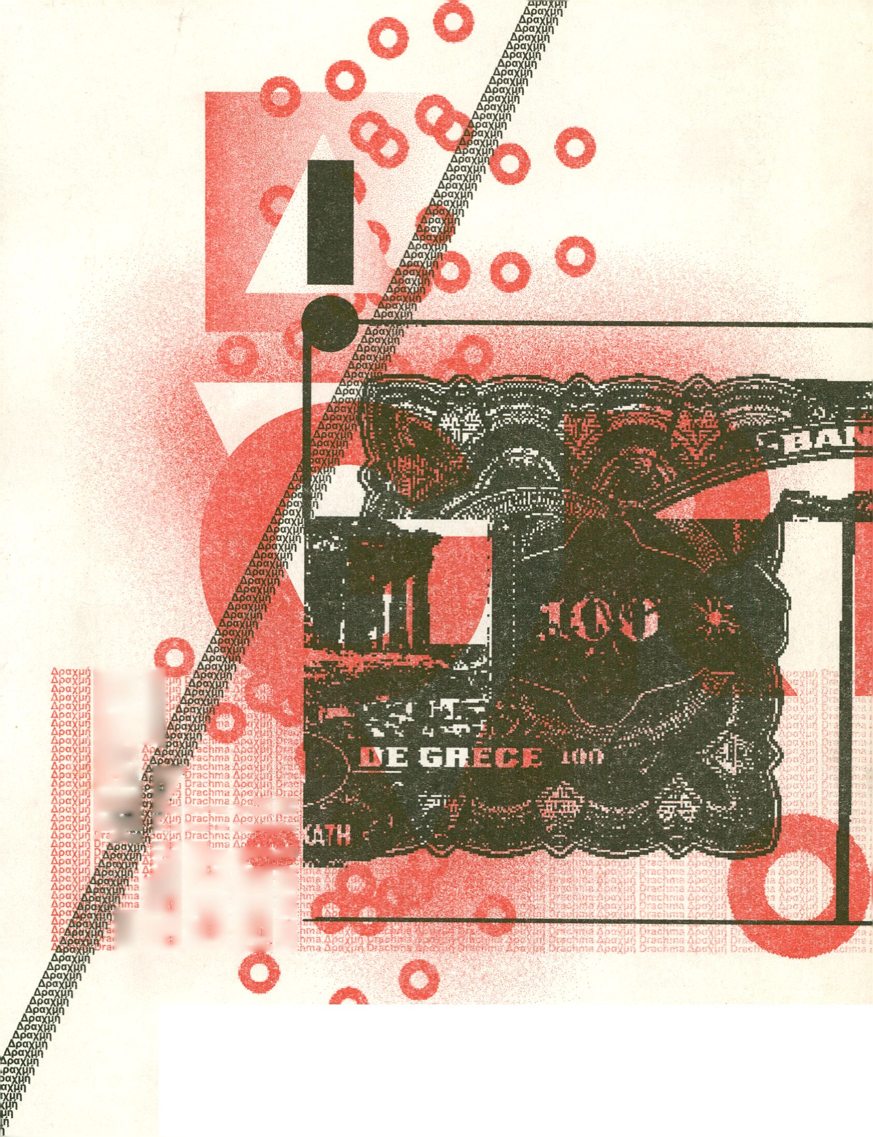
o

Historical Archive of the National Bank of Greece, series “Nomismatika”, file 11, doc. 1/[1888].
This observation is owned to Mark Tomasko to whom I remain indebted for his versatile support; he allowed me to look at his collection of ABNCo banknotes and records, discussed with me several aspects of banknote manufacturing and introduced me to the archives of the Museum of American Finance in New York.
At the bottom of the vignette entitled “THE TWINS“, it is inscribed: “Entered according to Act of Congress in the year 1859 by BALD, COUSLAND & Co in the Clerks Office of the Eastern District of Pennsylvania”.
HANBG, series “Nomismatika”, file 36, doc. 3/9.12.1911.
HANBG, series “Nomismatika”, file 36, doc. 4/15.12.1911, doc. 7/24.1.1912.
HANBG, series “Nomismatika”, file 60, doc. 18/193.1923.
The island of Crete was united with Greece in 1912.
Government Gazette 204A/18-9-1989. Noticeably this Law, which in effect supplants PASOK’s Law 1295 of 1982- which granted pensions to veterans of the National Resistance against the Axis powers between 1941-44- bears the signatures of Antonis Samaras, currently Prime Minister, then Minister of Finance and Photis Kouvelis, currently leader of the Party of “Democratic Left” who shares power with New Democracy and PASOK). This new round of extravagance was hailed as proof of Greece’s democratic transformation. In effect it was race between New Democracy and PASOK for ensuring the good will of the Communists.
Hellenic Parliament, Minutes of Parliamentary Session, II, 27 July 1992, p. 19, cited in (Tsakaloyannis 1996, p. 205).
PUGS stands for Portugal, Ireland,TRly. Greece and $pain, while PIGS do not include Italy, incidentally a member of G8

