ur
tiansmediale.il
RESPOnSE: ABILITY
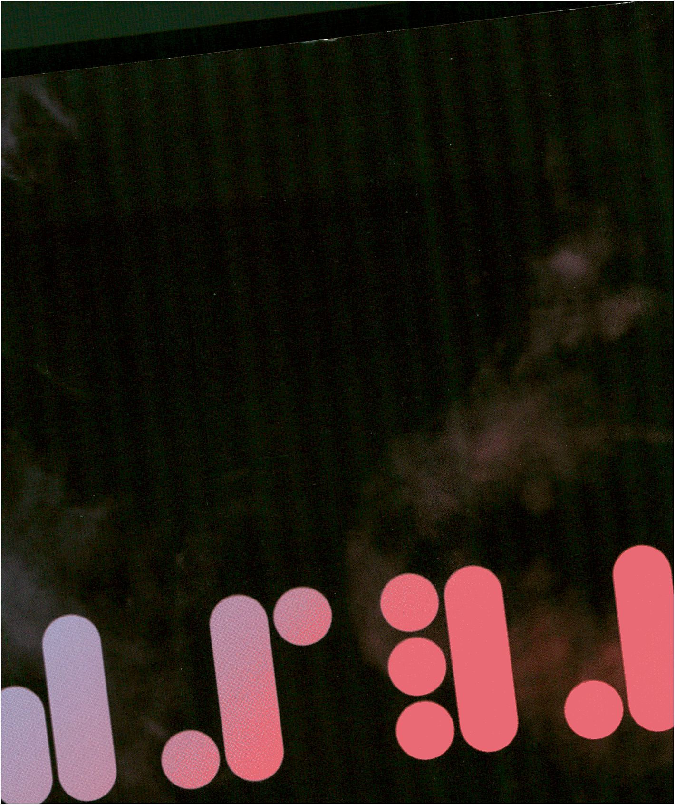

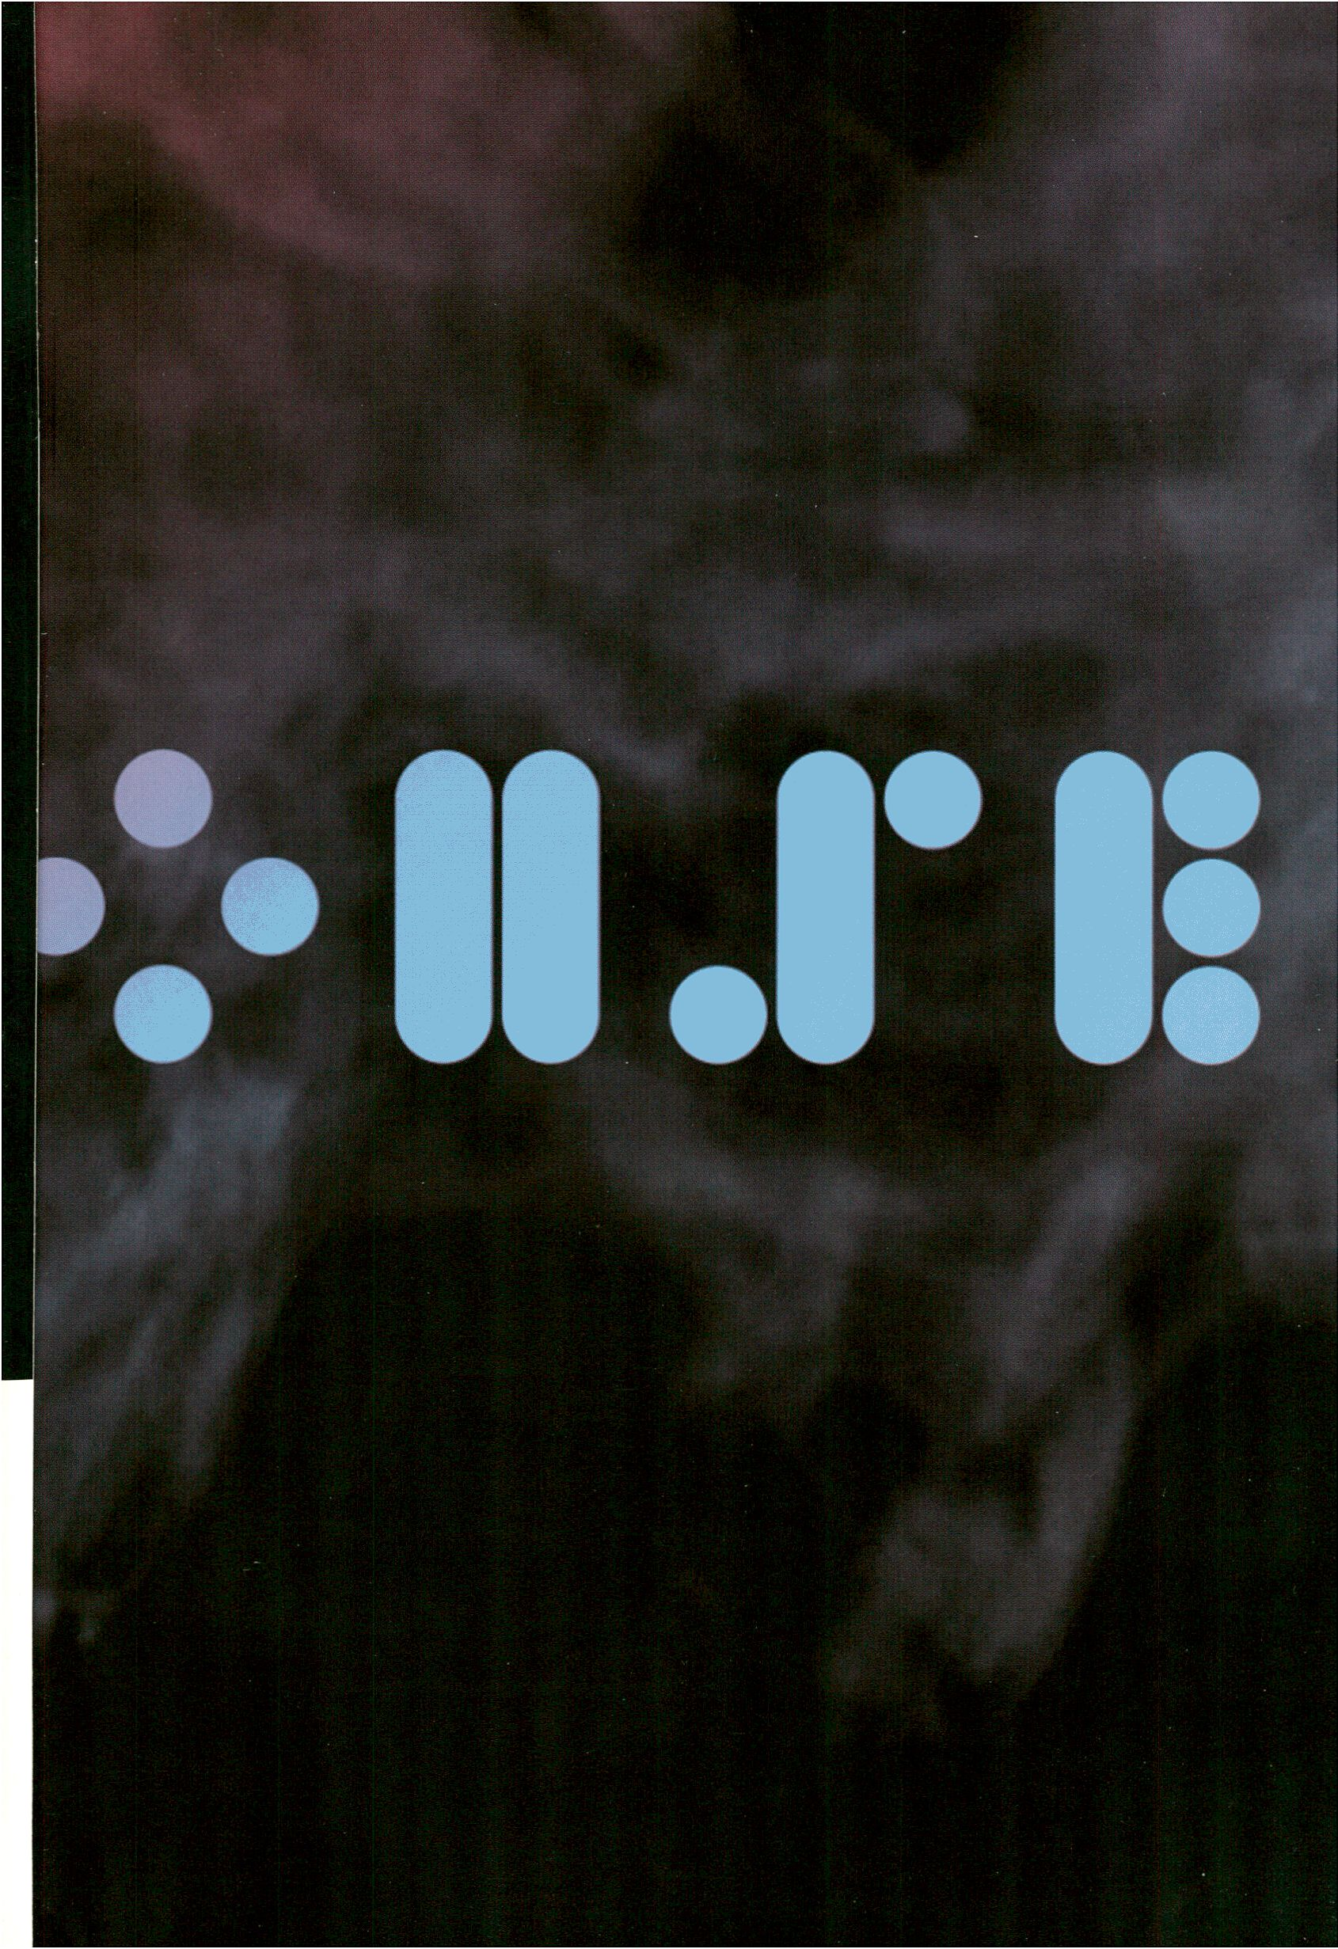

In the electric age, when our central nervous system is technologically
extended to involve us in the whole of mankind and to incorporate the
whole of mankind in us, we necessarily participate, in depth, in the
consequences of our every action.
Marshall McLuhan, Understanding Media, 1964
tiansmediale.ll RESPOnSE: ABILITY
In our post-future era of acceleration and densification of information, the state
and nature of being live and online becomes one of the crucial definers of our
social presence. Response and action are compressed into an existential here
and now triggering a durée of continuous digital stimulation.
With RESPONSE:ABILITY transmediale.11 explores the qualities of liveness that
are fundamental elements of our digital culture and discusses the abilities re-
quired to respond to the social, political and economic processes formed by the
intensity of our participation and interaction. Our desire to enhance freedoms of
expression and expand boundaries of open user-defined technologies also
implies ethical considerations inherent to the power of data and personal
identity.
THETT1E
RESPONSE:ABILITY is therefore also a call to action - to jump out of 'stand-
by' mode and grasp the moment of our own individual liveness within the caco-
phony of digital communications density. Today’s convergence of media, inter-
faces and the accelerated feeds of private data being merged into massive
social media repositories with little oversight risks turning what theorist Derrick
de Kerckhove has called ‘the greatest republic on earth’ - the internet - into an
empire of control and freedoms lost. The abilities required to enact and steer
collaborative energies become the means with which to co-opt the tools and
systems of our live culture. How do we adapt network practice to daily life, en-
trench the assertiveness of individual thought and expression, and ultimately
move toward the forms of open structures and flows that visionaries such as
Marshall McLuhan and later the pioneers of the early internet envisaged? In an
equally open competition for resources, attention and sensory stimulation the
ability to fuse the desire for digital emancipation with the necessity to act is our
task.
The Net has itself become a living entity, built by others. Now it is up to our
RESPONSE:ABILITY to put it to use!

!

tiansmediale.il
1. - B. 2. Eoll
Haus der Kulturen der Ufelt Berlin "LTT
The 24th edition of transmediale, Berlin’s festival for art and digital culture is a
pivotal moment in the event’s rapidly evolving history! With a greater focus
on open systems, process oriented and collaborative technologies the festival
addresses the crucial roles we as individuals play within the firmly entrenched
landscapes of digital and network media. How we do this in trans-local and
emancipatory ways is both a challenge and a goal for artists, researchers,
designers and activists defining the practice of communication across a broad
range of technology and socio-political fields. With RESPONSEiABILITY we
explore these scenarios with an open participatory structure, responding to
the shape the culture of our contemporary digital and network environment.
Taking the materiality of communication as the primary mechanism of artistic
expression we reflect, on the centennial of his birth, on Marshall McLuhan’s
impact on what is now an intrinsically cacophonous and poetically unruly glo-
bal community of instant, live and wholly interdependent net of cultural, social
and economic activity.
Together with our partner Drumbeat/Mozilla we have launched the Open
Web Award to push and more radically pursue, at a time when it is under threat,
the ideals of the internet as they have been envisioned by its pioneers who
sought to create a truly non-proprietary universal space for the movement and
exchange of great ideas.
PREFACE
We are grateful to the support of the KSB for securing transmediale’s core
funding until 2017 as well as to our many strong international and local
partners including the BpB (Office for Civic Education), the Medienboard
Berlin-Brandenburg, the Goethe Institutes worldwide, the Marshall McLuhan
Salon (Embassy of Canada), the _Vilem_Flusser_Archive (UdK), the Collegium
Hungaricum (.CHB), the Haus der Kulturen der Welt (HKW) and our technical
supporters serve-u who secure the scope and depth of transmediale’s
programming. At a time of hesitation and stagnation in the political attitudes
towards critical and challenging forms of art and culture our partners recognise
the role and value of transmediale in advancing Berlin’s own cultural identity
on an equally unique international platform. Together with our dedicated and
impassioned team, and many further local supporters and sponsors
transmediale will continue to push the envelope of an open landscape of
art and digitally induced creative inquisition!
Stephen Kovats
artistic director

‘t

Die 24. Ausgabe der transmediale, Berlins Festival für Kunst und digitale Kultur,
ist ein Höhepunkt ihrer eigenen, sich rasant entwickelnden Geschichte. Mit einem
besonderen Blick auf offene Systeme, prozessbasierte und kollaborative Tech-
nologien widmet sich das Festival der wichtigen Rolle, die uns als alltäglich in
einer Landschaft aus digitalen Medien und Netzwerken verankerten Individuen
zukommt. Die translokale und emanzipatorische Weise, mit der wir als Künstler,
Wissenschaftler, Designer und Aktivisten die gegenwärtige Kommunikations-
praxis unter Einbezug einer großen Bandbreite von Technologien und soziopoliti-
schen Bereichen definieren, ist gleichermaßen Herausforderung und Ziel.
Mit RESPONSE:ABILITY untersuchen wir diese Möglichkeiten mit einer offenen,
partizipativen Struktur und entwickeln Handlungsoptionen, um die Beschaffen-
heit unserer gegenwärtigen digitalen und vernetzen Umwelt weiter zu gestalten.
Ausgehend von der Materialität der Kommunikation als primärer Mechanismus
künstlerischen Ausdrucks, reflektieren wir - anlässlich des 100. Jahrestag der
Geburt von Herbert Marshall McLuhan - seinen Einfluss auf das, was hier und
heute eine intrinsische, kakophonische und poetisch widerständige globale Ge-
meinschaft geworden ist, ein unmittelbares und gänzlich voneinander abhängiges
Netz kultureller, sozialer und ökonomischer Aktivitäten.
UORUJORT
Zusammen mit unserem Partner Drumbeat / Mozilla haben wir den Open Web
Award gestartet, um damit gerade jetzt, wo sie unter Beschuss geraten sind,
die Ideale des Internets - wie sie von den Pionieren dieser Technologie visioniert
wurden, nämlich als einen nicht eigentumsdefinierten, universellen Ort für die
Entwicklung und den Austausch großer Ideen - fortgeführt und auf radikale Weise
weiter entwickelt werden.
Wir möchten uns besonders bei der Kulturstiftung des Bundes (KSB) bedanken,
die mit der Verlängerung der jährlichen Hauptforderung bis zum Jahr 2017 die
Grundsicherung der transmediale gewährleistet. Ebenso möchten wir unsere
zahlreichen großen internationalen und lokalen Unterstützer hervorheben.
Dazu gehört die Bundeszentrale für politische Bildung (BpB), das Medienboard
Berlin-Brandenburg, die Goethe Institute weltweit, der Marshall McLuhan Salon
der Botschaft von Kanada, das _Vilem_Flusser_Archiv (UdK), das Collegium
Hungaricum (.CHB), das Haus der Kulturen der Welt (HKW) sowie unser techni-
scher Partner serve-u, der den Umfang und die Intensität der transmediale über-
haupt erst möglich macht. In Zeiten zögerlicher und stagnierender politischer
Haltungen gegenüber kritischen und provokativen Formen von Kunst und Kultur,
begreifen unsere Partner die Rolle und den Wert der transmediale als einzigartige,
internationale Plattform gerade auch im Hinblick auf die kulturelle Identität
Berlins. Zusammen mit unserem engagierten und leidenschaftlichen Team und
zahlreichen weiteren lokalen Unterstützern und Sponsoren wird die transmediale
auch weiterhin die Grenzen einer offenen künstlerischen Landschaft erweitern
und das in der Digitalisierung liegende künstlerisch-kritische Potential ausloten!
Stephen Kovats
Künstlerischer Leiter
THEME 2
24
tn
h-
o
u
E
PREFACE 4
HKW MAP 0
SCHEDULE 10
ABILITY : ZOnES
HacKaWay
BODY:RESPONSE -
Biomedial Politics in the Age of Digital Liveness / Conference 2E
The Open Zone - Model of a Responsive City SB
LIVE : RESPONSE / Performances 32
SyncExistence / Film & Video 34
transmediale.11 Collaboration Projects 38
McLuhan in Europe 2011 33
Test Signals 40
V2_Agency & NIMk Distribution 41
Reynold Reynolds: The Secrets Trilogy, Labor Berlin #4 43
Ludic Interfaces: Design of Media Environments for the Homo Ludens 43
RUJflRDS
transmediale Award 45
Intelligent Bacteria - Saccharomyces cerevisiae (2010) -
HONF (House of Natural Fibre) (id) 41
MACHT GESCHENKE: DAS KAPITAL - Christin Lahr (de) 48
Newton (2009) - Ho Tzu Nyen (sg) 43
Seppukoo.com (2009) - Les Liens Invisibles (it) 50
Spatial Sound Sculpture (2009) - Christopher Warnow (de), Daniel Franke (de) 51
Serendipitor (2010) - Mark Shepard (us) 52
Wikipedia Art (2009) - Scott Kildall (us), Nathaniel Stern (us) 53
Vilem Flusser Theory Award 54
_Social Tesseracting_: Parts 1 - 3 (2009) - Mez Breeze (au) 54
GATHERINGS 1: EVENT, AGENCY, AND PROGRAM (2010) - Jordan Crandall (us) 55
Digital Anthropophagy and the Anthropophagie Re-Manifesto
for the Digital Age (2010) - Vanessa Ramos-Velasquez (br/us) 5E
Zombie Media: Circuit Bending Media Archaeology into an Art (2010) -
Garnet Hertz (ca), Jussi Parrikka (fi) 51
Open Web Award 58
Graffiti Analysis / Graffiti Markup Language (GML) (2010) - Evan Roth (us) 59
Booki - FLOSS MANUALS: Adam Hyde (nz),
Douglas Bagnall (nz), Aleksandar Erkalovic (hr) 50
thimbl (2010) - Dmytri Kleiner (ca/ru) / Telekommunisten El
FESTIUflL WEEK - detailed daily programme 55
TUESDAY 1 FEB - transmediale.11 Opening BE
WEDNESDAY 2 FEB 58
THURDAY 3 FEB ⁸⁵
FRIDAY 4 FEB ⁸⁸
SATURDAY 5 FEB 11°
SUNDAY 6 FEB 124
ART:ZOnES
133
SATELLITES iss
CTÏÏ1 ne
DAS WEEKET1D iso
PARTICIPANTS A - Z 1“
BERLIN MAP ¹⁸⁸
TICKETS & SERVICE I⁸⁸
CREDITS ¹⁸⁸

T

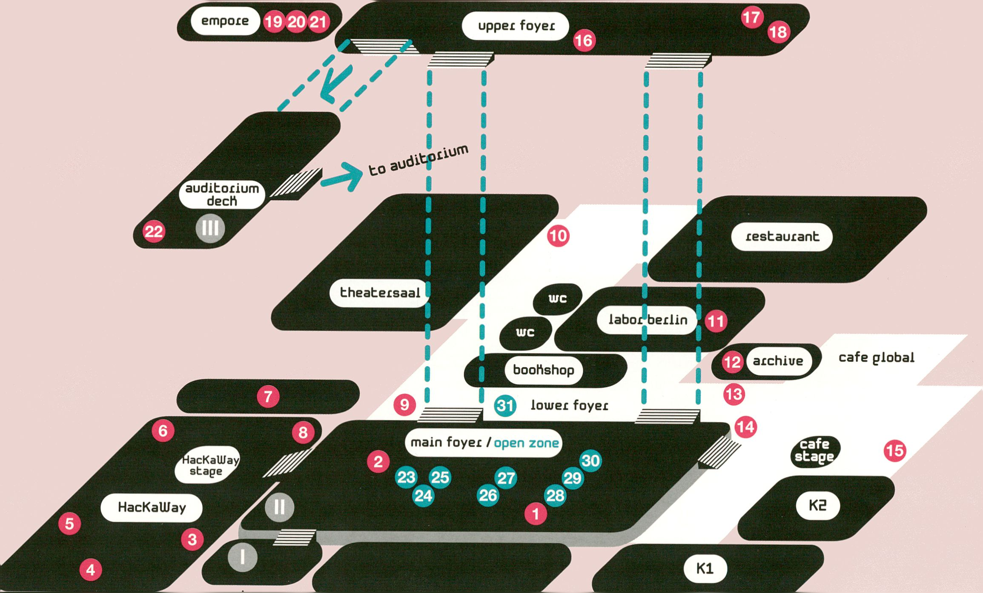
main
entrance

Main Foyer
Wikipedia Art
Scott Kildall, Nathaniel Stem
Dear Steve
Herman Asselberghs
HacKaWay
Q WOPPOW
UBERMORGEN.COM
Latent Figure Protocol
Paul Vanouse
Q MACHT GESCHENKE:
DAS KAPITAL
Christin Lahr
Intelligent Bacteria
Saccharomyces Cerevisiae
HONF
Ambiguous Cut Into Space
of Conjecture (Lucid
Phantom Messenger #2)
Herwig Weiser
Braun Tube Jazz Band
Ei Wada
Lower Foyer
Face-to-Facebook
Alessandro Ludovico, Paolo Cirio
© Newton
Ho Tzu Nyen
tp Labor Berlin #4:
Secrets Trilogy
Reynold Reynolds
© Spatial Sound Sculpture
Christopher Warnow, Daniel Franke
© Seppukoo.com
Les Liens Invisibles
© Rambler
Tiago Martins, Ricardo O'Nascimento
© For the ppl of Iran -
ffiranelection RT
Govcom.org
Upper Foyer and Empore
0CoS
FakePress
«P _Social Tesseracting:
Parts 1-3
Mez Breeze
© Flusser Hypertext
Prototype 2
_Vilem_Flusser_Archiv
© Mirror Piece
Marnix de Nijs
0RE:
Bram Snijders (Sitd), Carolien Teunisse
© audioswap 5
JODI
Auditorium Deck
Serendipitor
Open Zone
0 Wanted & For Sale
fig) Open Web Award Area
0 Response:Activitles
0 interACTicons
Ursula Endlicher
(¡tf Currency of the Commons
(&S Immediated
Autodocumentary
0 Lost in the Open?
0 Identity Bureau
Heath Bunting
Open Design City
Service
^ Tickets
Info / Press
Project Library
ARTE Creative

HKUJ TT1RP
in
Auditorium
Café Stage
HacKaWay
Open Zone
Other venues HKW
Labor Berlin #4
Open Zone switch ON
I Secrets Trilogy
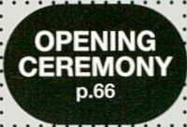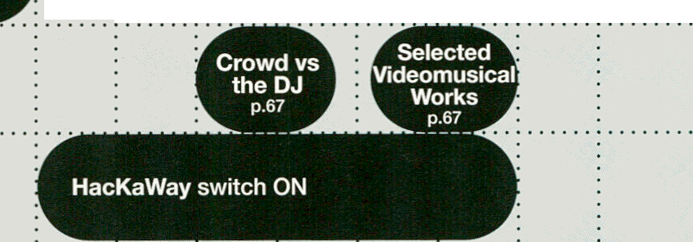* Reynold Reynolds p.67
TUESDAY. FEB 1
Stephen Koväts
Derrick De Kërkhova
AngeljF
DUST ;by Herman Kolgen
I Latent Figure Protocol :
f performance?, p.67 ; ;
»Braun Tube
Jazz Band
performance, p.67

li

 | 10:00 | 10:30 | 11:00 | 11:30 | 12:00 | 12:30 | 13:00 | 13:30 | 14:00 | 14:30 | 15:00 ;15:30 ;
Auditorium |  |  | r  Radio Tactics  talk, p.69 |  |  |  |  |  | r  Radio Magic  talk, p.73
Theatersaal |  |  |  |  |  |  |  |  |  | r  Dial Goes Around  screening, p.74
K1 |  |  | Lost in The Open?  talk, p.69 |  |  |  |  |  |  | I | ^{r} Digital  Anthropophagy  V. Ramoz-Velasquez  ^presentation, p.74
K2

Café Stage
ru
ro HacKaWay
Intelligent Bacteria
workshop series, p.68
WOPPOW
workshop, p.72
Open Design City Wanted & For Sale Immediated Autodocumentation
■ >!■•
Œ Open Zone
□
U)
LU
(=
□
LU
3
workstation, p.70 workstation, p.71 workstation, p.68
Drawing by Numbers
workshop, p.71
Identity Bureau
workstation, p.72
Sharism
workshop, p.73
Other venues HKW
Upper Foyer
Labor Berlin #4
Archive
Other venues Berlin
Secrets Trilogy
Reynold Reynolds p.43
Marshall McLuhan
Salon, Embassy of
Canada
TU Berlin
IS
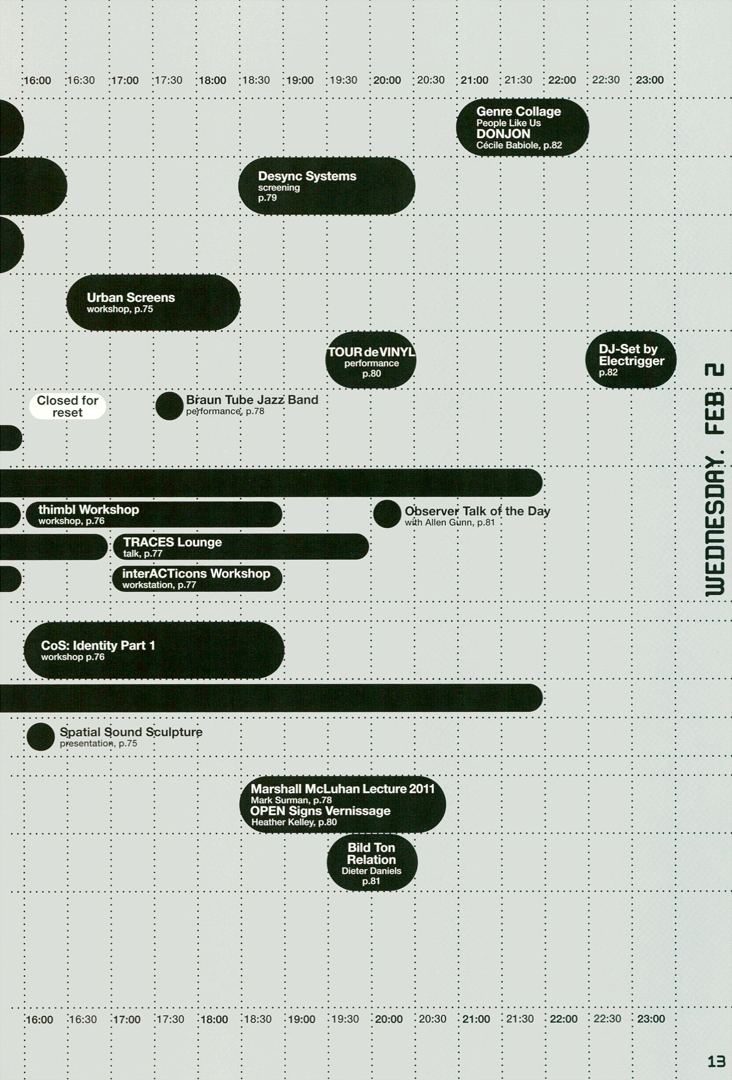

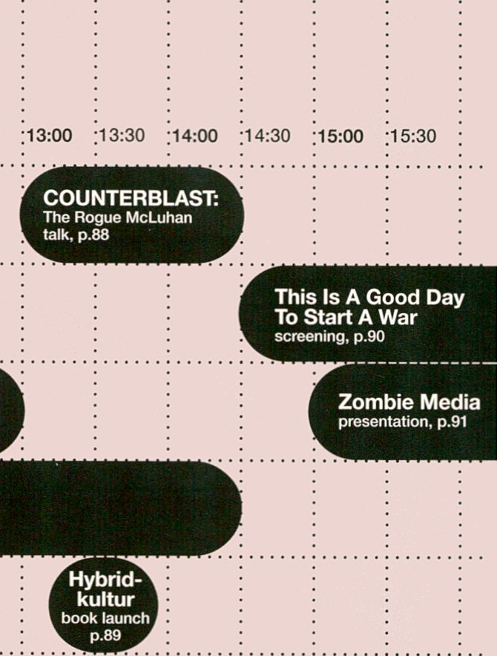
12:00
Auditorium
Theatersaal
K1
K2
Feminist DIY Culture
workshop, p.85
Café Stage
m
EQ HacKaWay
Li.
Open Digital Radio
workshop, p.85
Social ID
conference focus discussion
p.86
WOPPOW
workshop, p.89

Open Design City Wanted & For Sale Immediated Autodocumentation
Q
tn
Q:
3
Open Zone
workstation, p.86 workstation, p.86 workstation, p.86
Identity Bureau
workstation, p.90
Repetitionr
presentation, p.89

Other venues HKW
Upper Foyer
CoS: Identity Part 2
workshop, p.87
Labor Berlin #4
Auditorium deck
Secrets Trilogy
Reynold Reynolds p.43
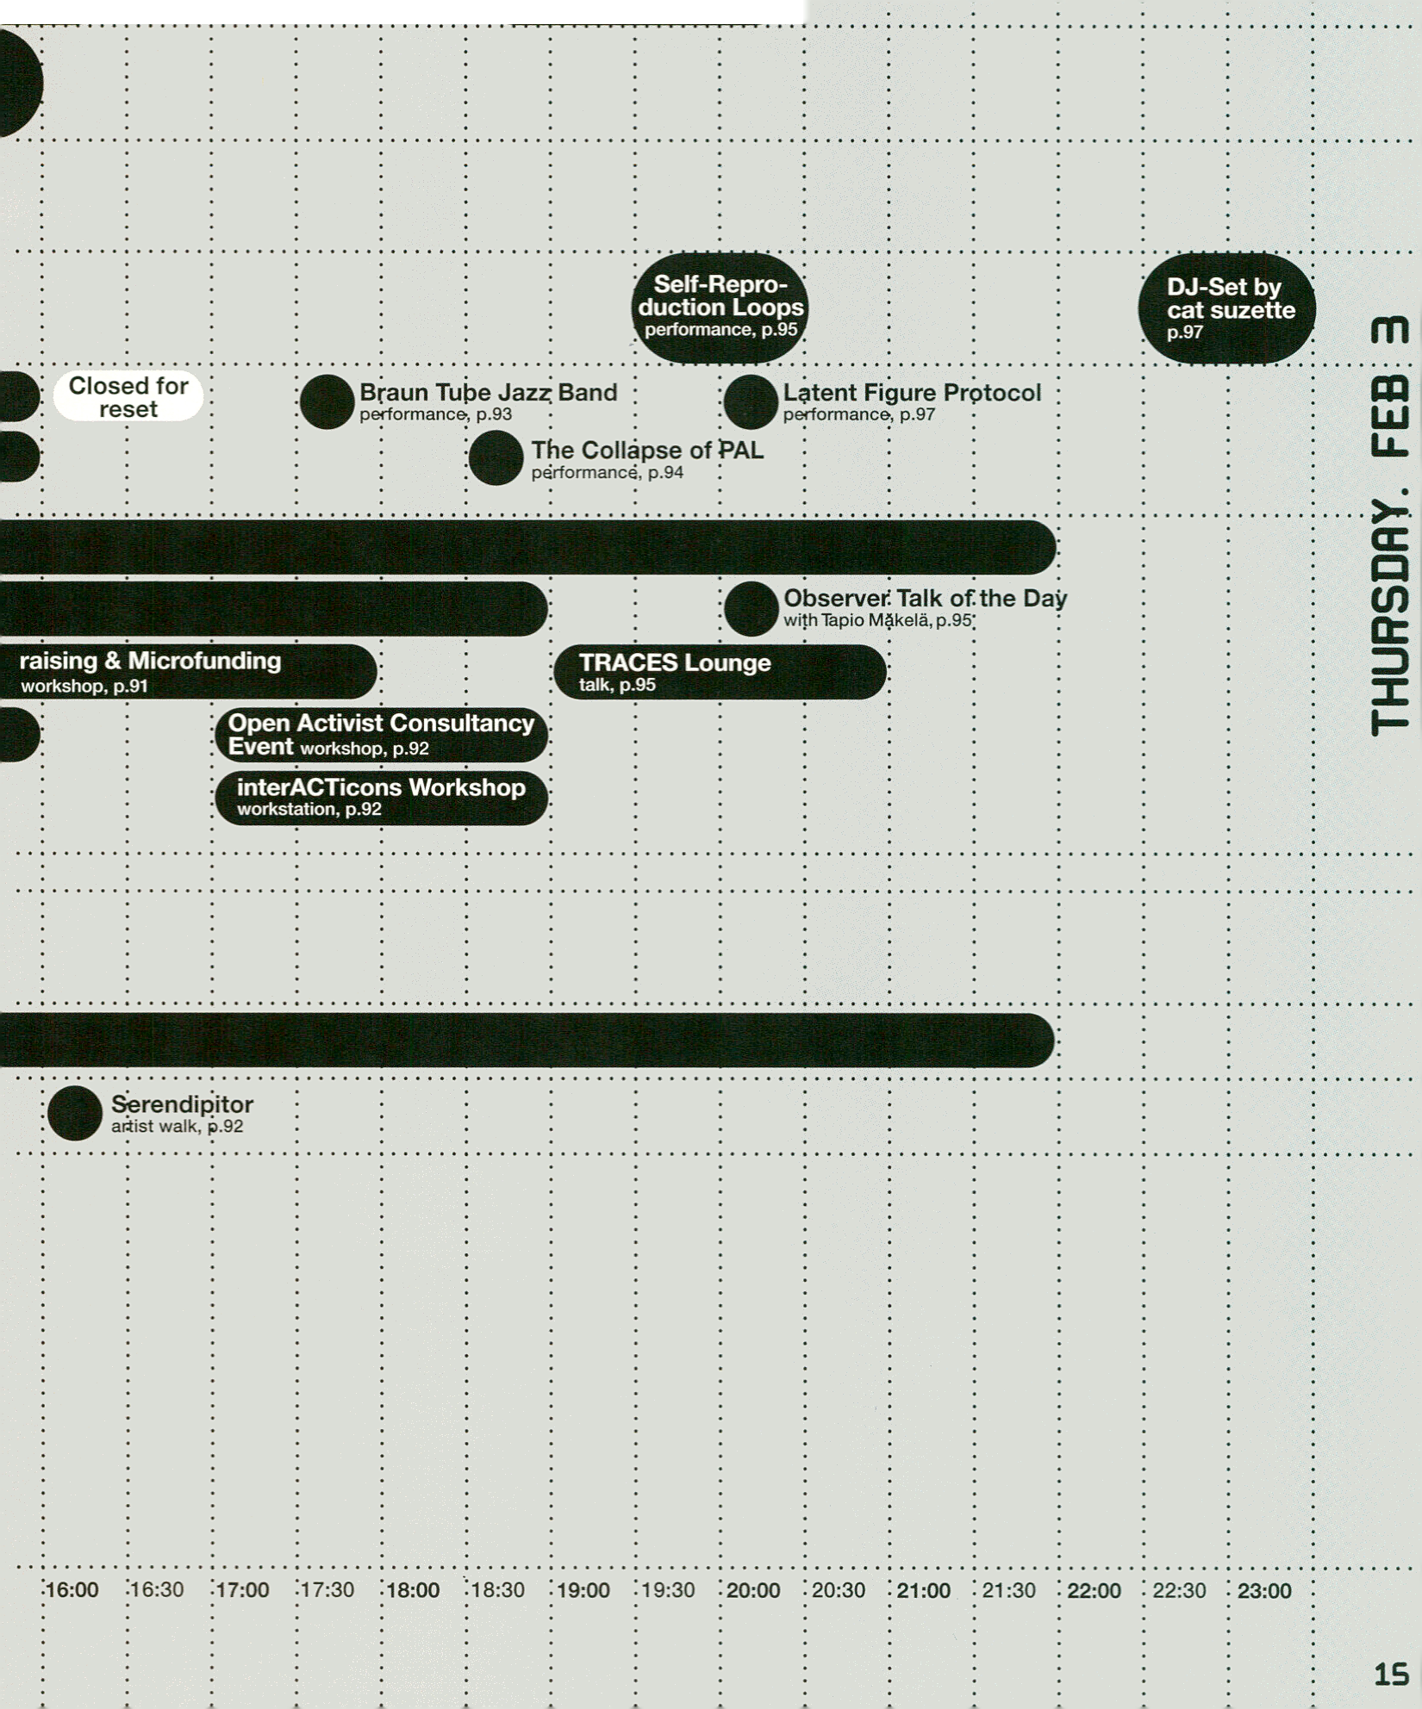
Digital Liveness
keynote conversation, Eric Kluitenberg,
Philip Ausländer, Mushon Zer-Aviv,
Drew Hemment, p.93
r
Arab Shorts 2010 | 1
screening, p.94 | J
 | J

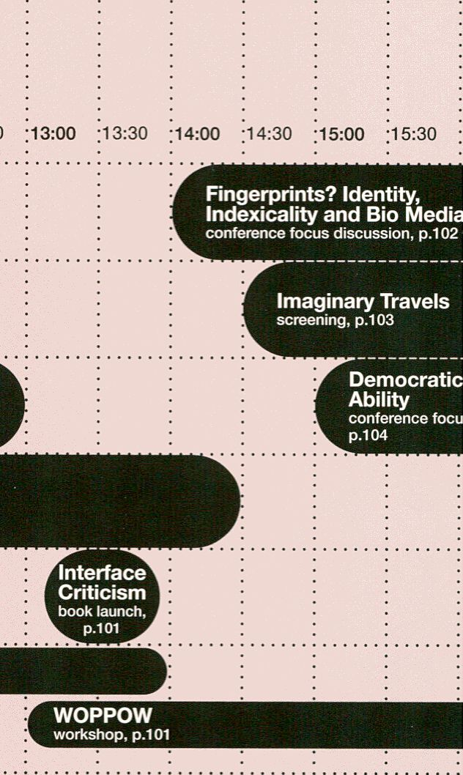
Auditorium
Theatersaal
K1
K2
Feminist DIY Culture
workshop, p.98
Café Stage
J-
CD HacKaWay
Œ
a
Open Zone
Zombie Media Workshop
workshop, p.98
Response: Activities
talk, p.99
Open Design City Wanted & For Sale Immediated Autodocumentati
workstation, p.99 workstation, p.98 workstation, p.98
it
U-
Other venues HKW
Upper Foyer
Booki Workshop & Booki Mobile
workshop, p.100
r Facebook Resistance Arti  L workshop, p.101 |  |  |  | st Workshop
 |  |  |  | ; | ¡B

CoS: Space
workshop
p.100
Controlled Invasion
workshop, p.98
Labor Berlin #4
Secrets Trilogy
Reynold Reynolds p.43
Archive
Other venues Berlin
_Vilém_Flusser„Archiv
Flusserian
Philosophical Fridays
talk, p.101
IB

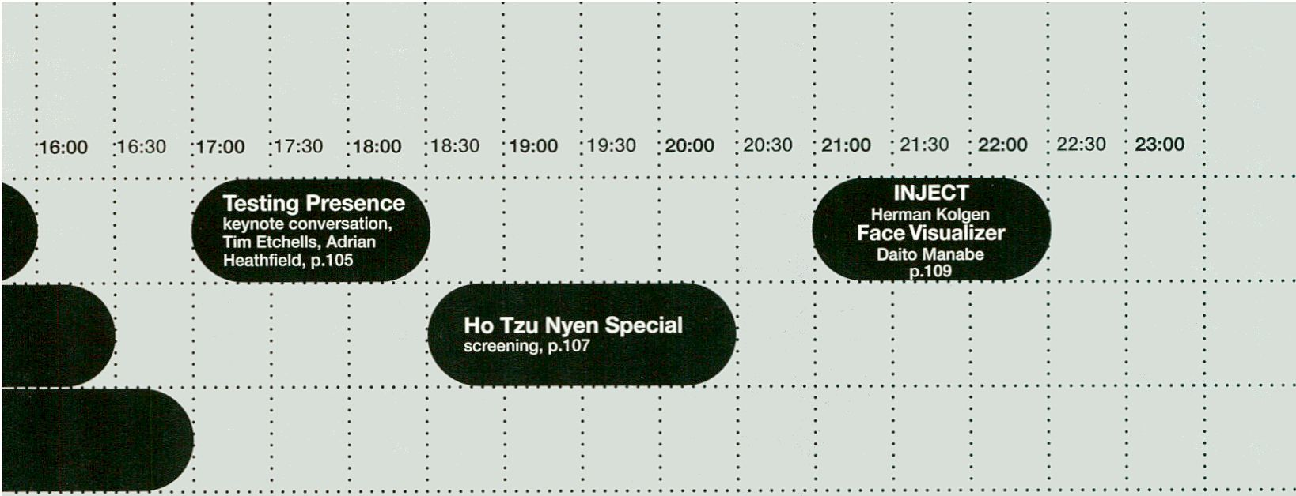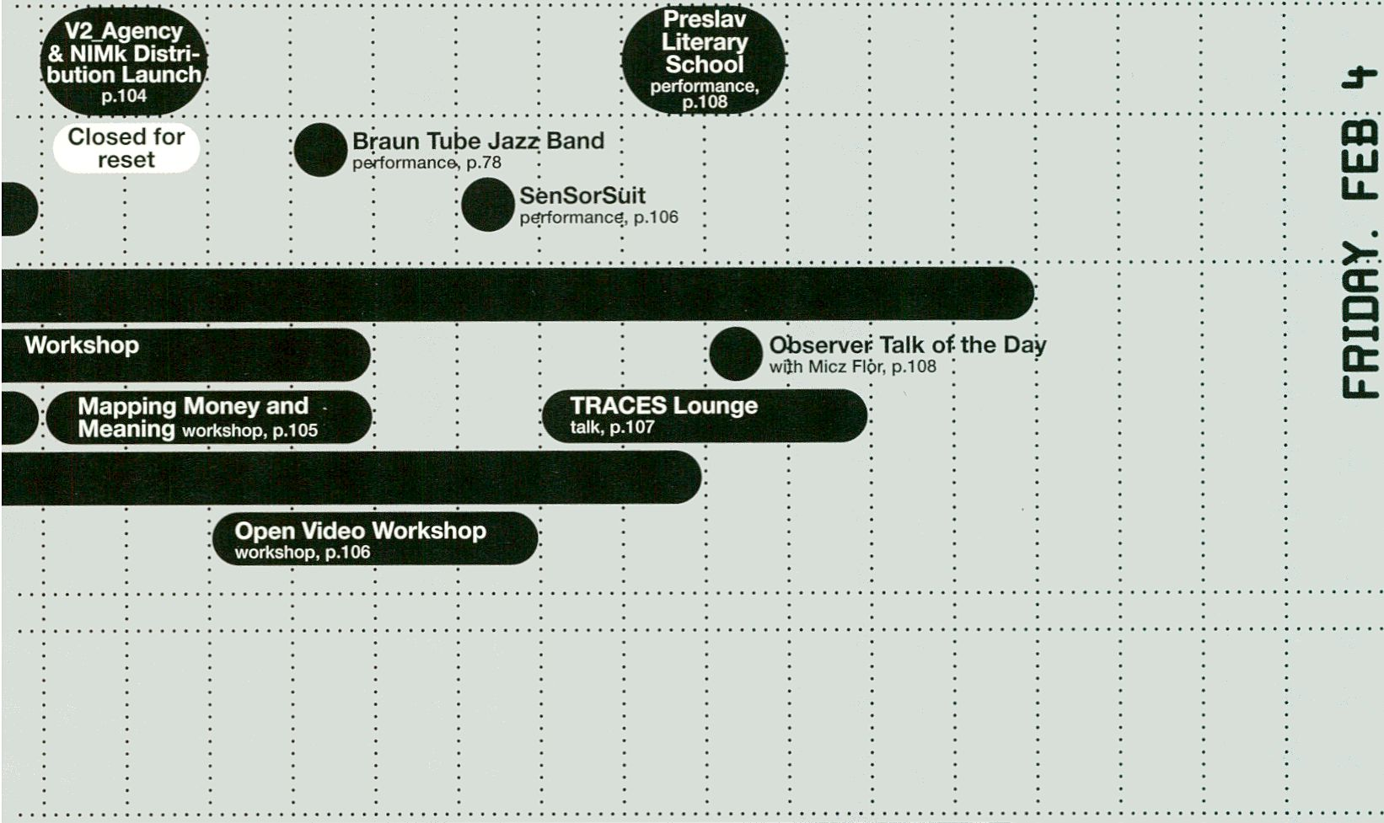
Spatial Sound Sculpture
' presentation, p.130
: 20:30

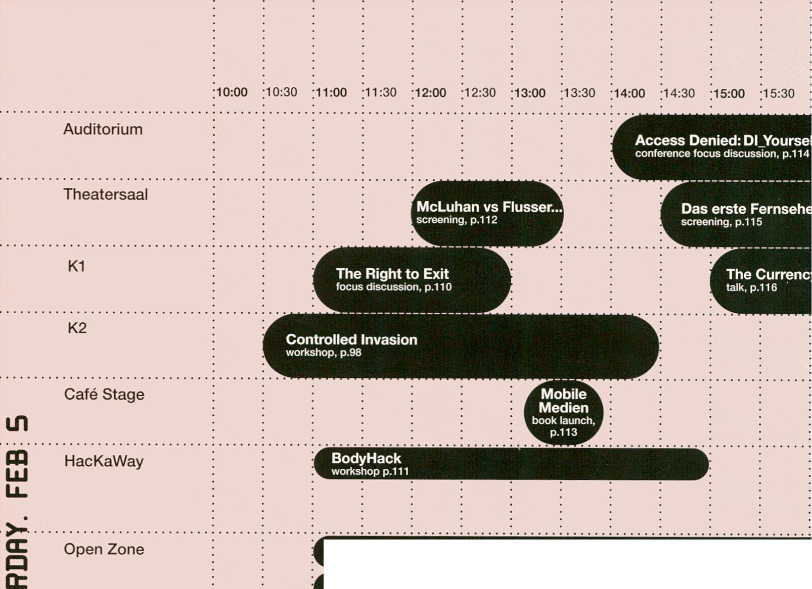
Open Design City Wanted & For Sale Immediated Autodocumentati
workstation, p.111 workstation, p.110 workstation, p.110
Wikipedia Illustrated
workstation, p.113
CE
O)
Cult of Less: How to Get Rid of Everything
workshop, p.112
vm rhifliiiire11 » ¡Tifo I iw Wi.ii''’ il'inBt
Identity Bureau
workstation, p.112

Other venues HKW
Upper Foyer

Labor Berlin #4
Secrets Trilogy
Reynold Reynolds p.43

Auditorium deck
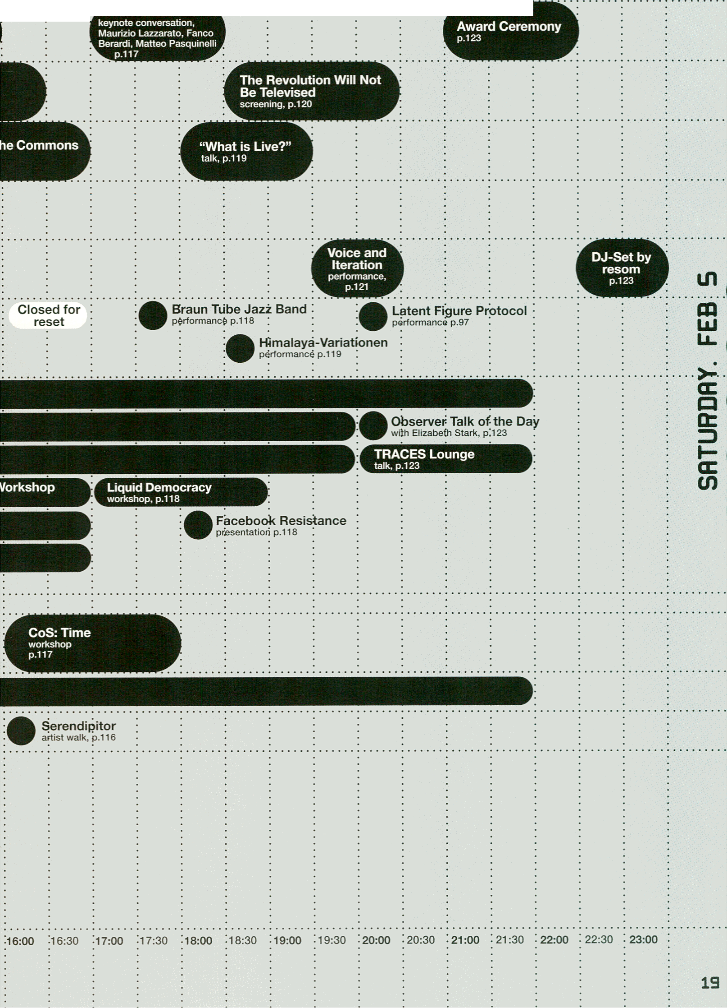
16:00 | 16:30 | 17:00 ;17:30 ; 18:00 | 18:30 | 19:00 | 19:30 | 20:00 | 20:30 | 21:00 ; 21:30 ;

22:30 ; 23:00

Auditorium
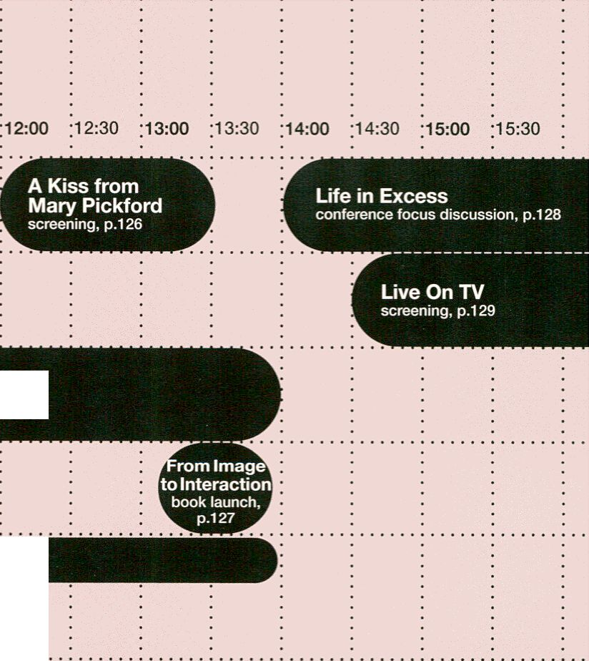Theatersaal
Ludic Salon
talk, p.125
Elektronik zum Klingen bringen
workshop p.124
K1
Café Stage
HacKaWay
Open Design City Wanted & For Sale
in
m
LÜ
ÜL
Œ
a
Open Zone
workstation, p.126 workstation, p.127
The Cult of Less: How to Get Rid of Everything
workshop, p.125
Identity Bureau
workstation, p.125
3  CO |  |  |  |  | ^{r} Open Knowledge Foundation ^  k workshop, p.127 .
^{r} Through the Iris
l workshop, p.127 i
Other venues HKW
Upper Foyer
Archive
Labor Berlin #4
Secrets Trilogy
Reynold Reynolds p.43

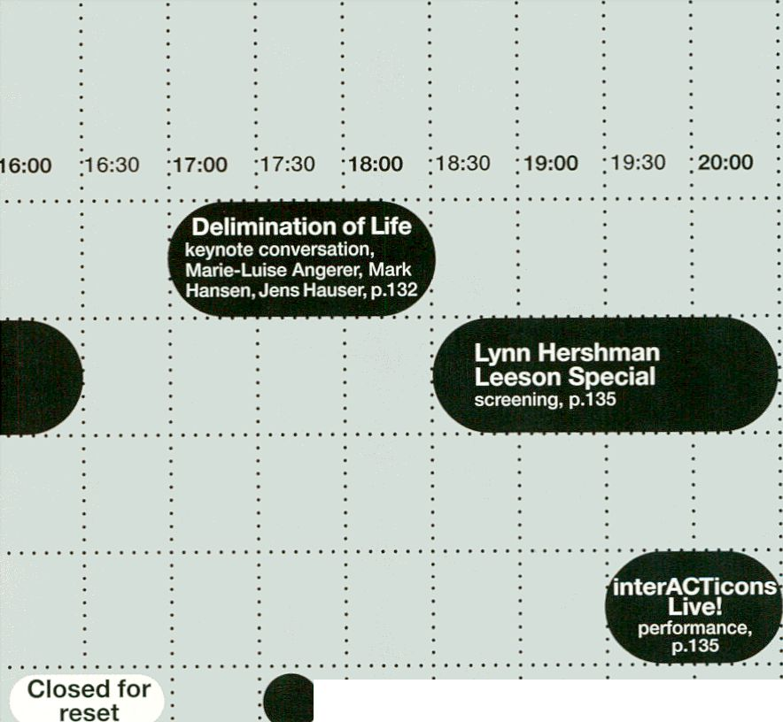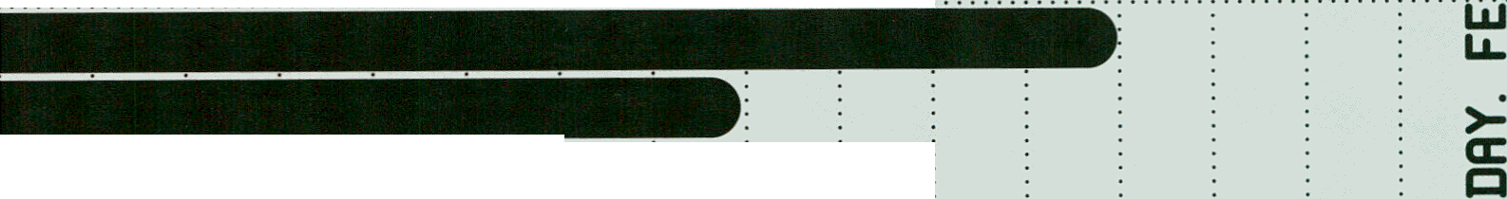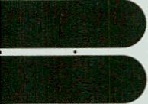
»Braun Tube Jazz Band
performance p.132
I bacteria
orchestr;
Trióle Feature
performance p.133

" performance p.135
Talk of the Day
Levi, p.133
 |  | •  Î.O.. | bserver  th Simona!

Global Voices Workshop
workshop, p.130
in

k Inimediated Autódocurrientary
f Screening
screening, p.;130
CoS: Emotion
workshop, p.131
k Spatial SDund Sculpture
f presentation; p.130 ;
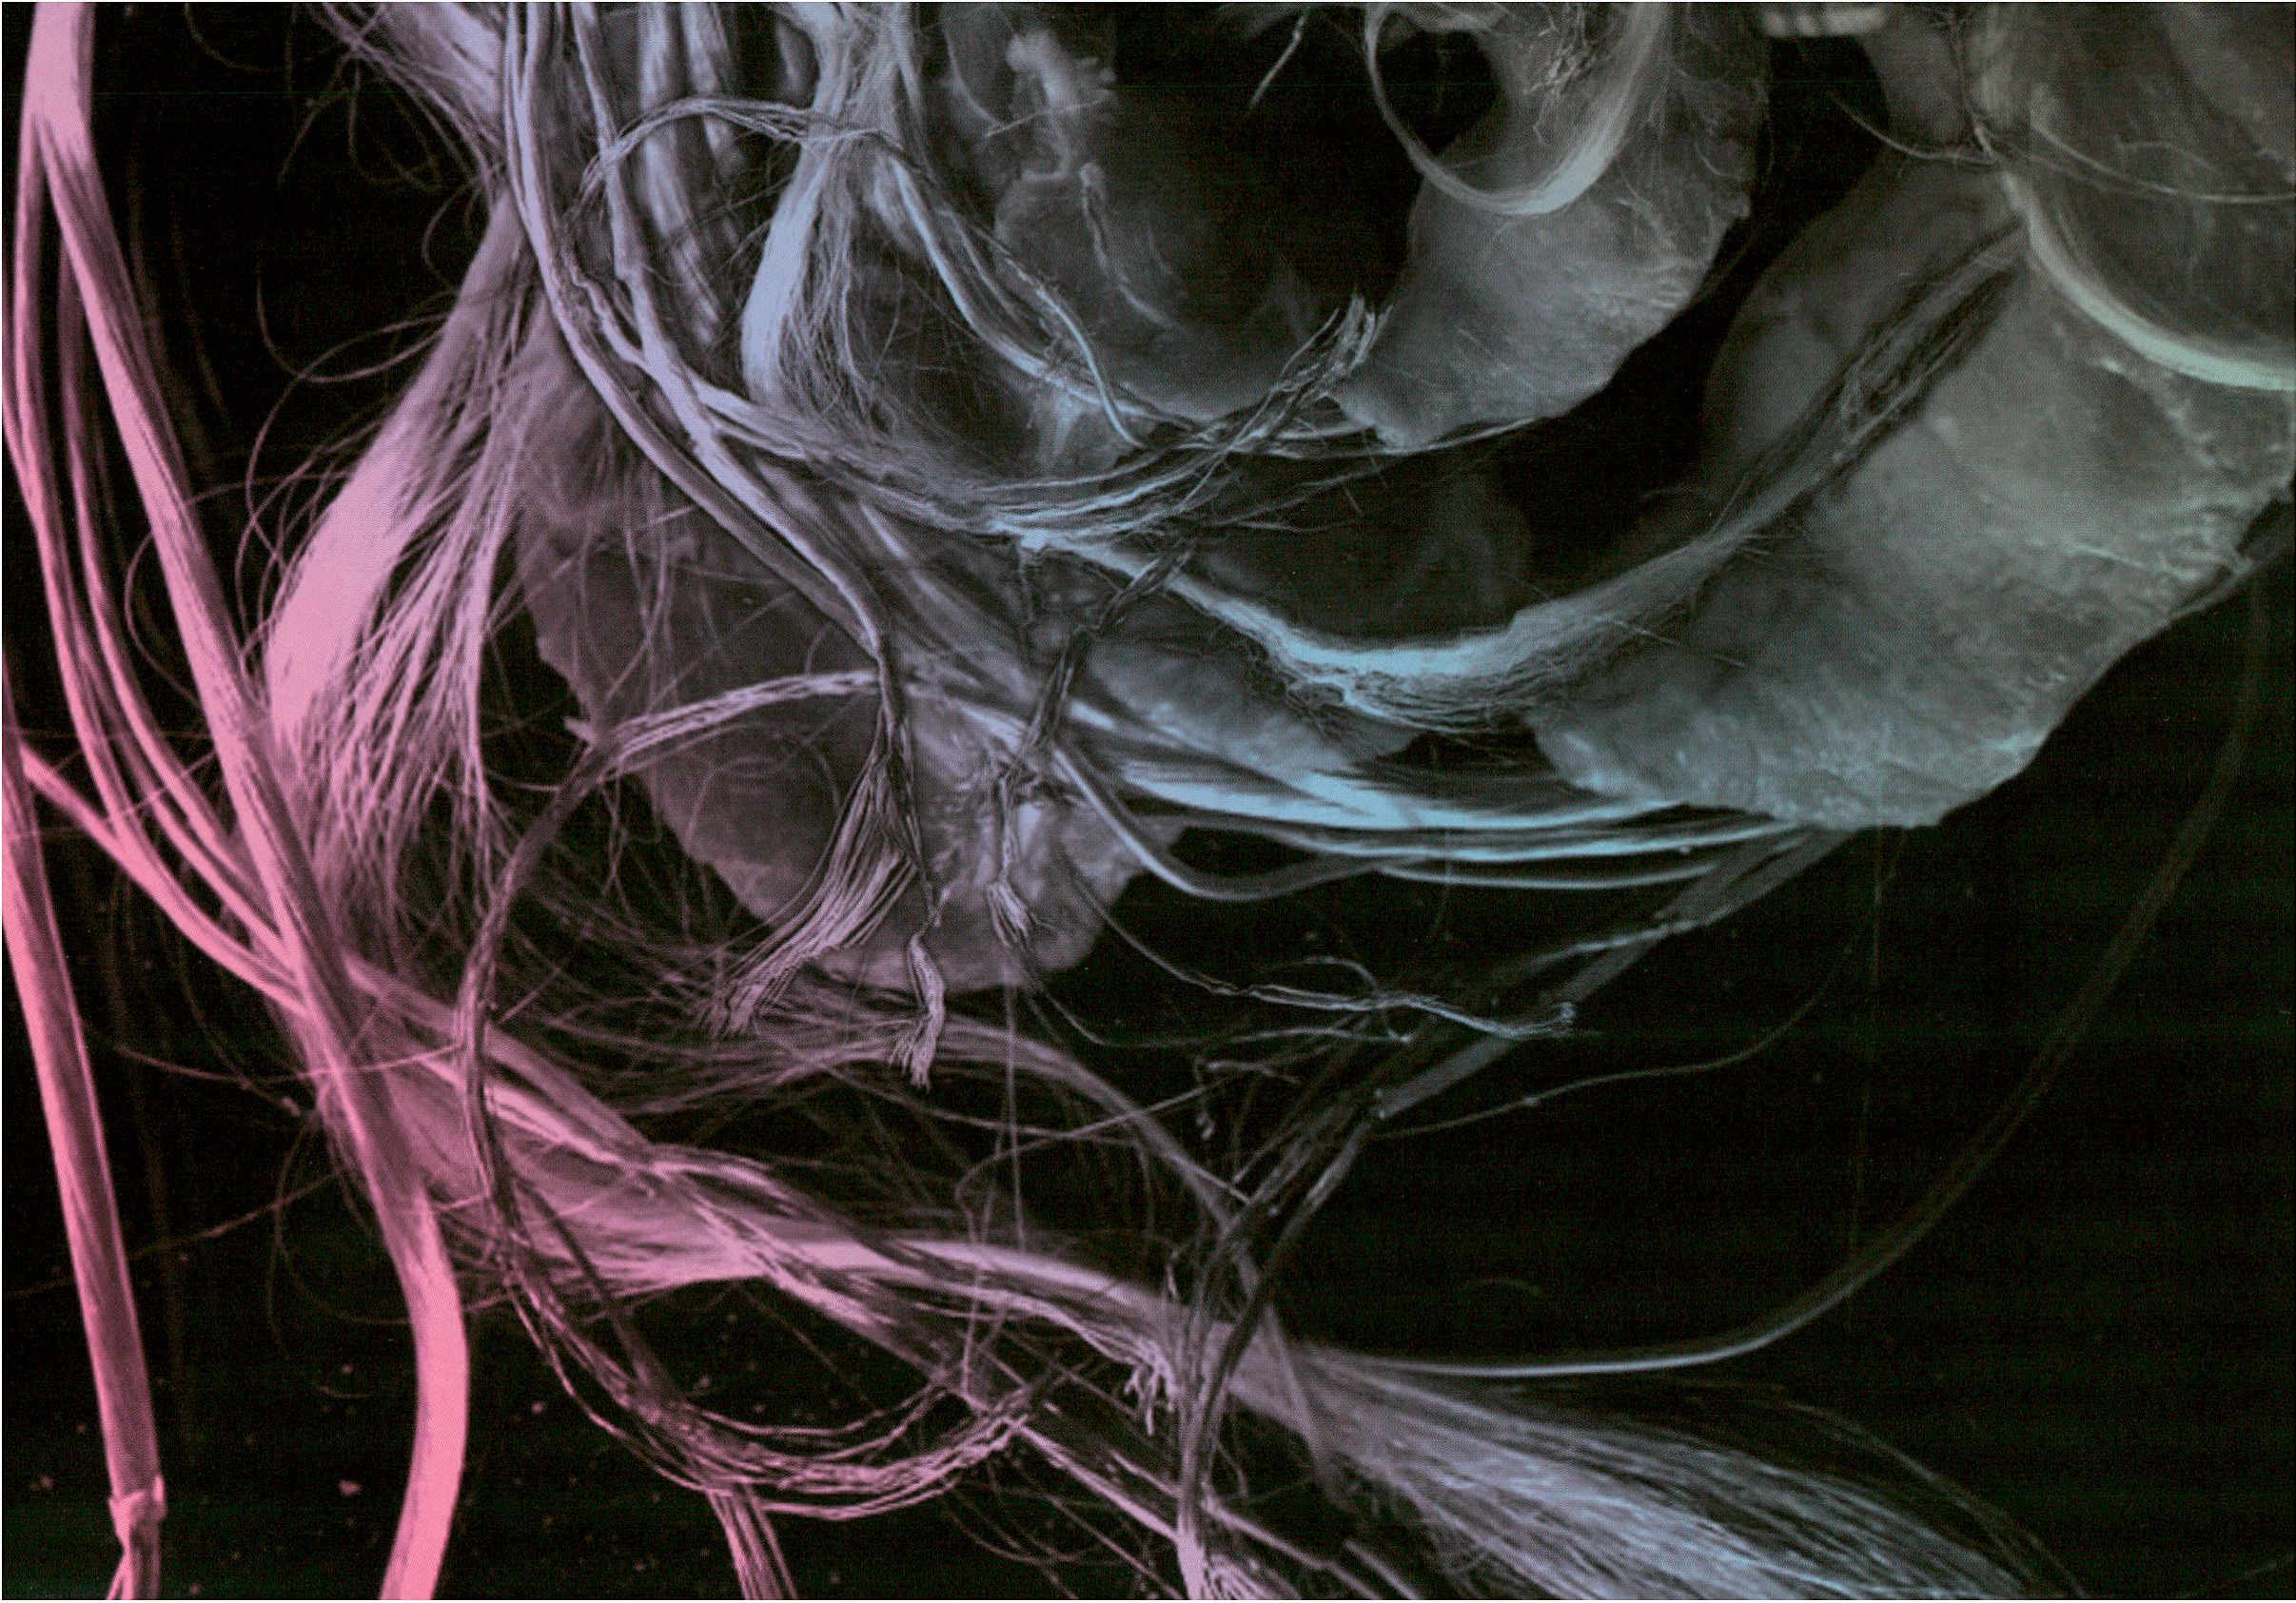

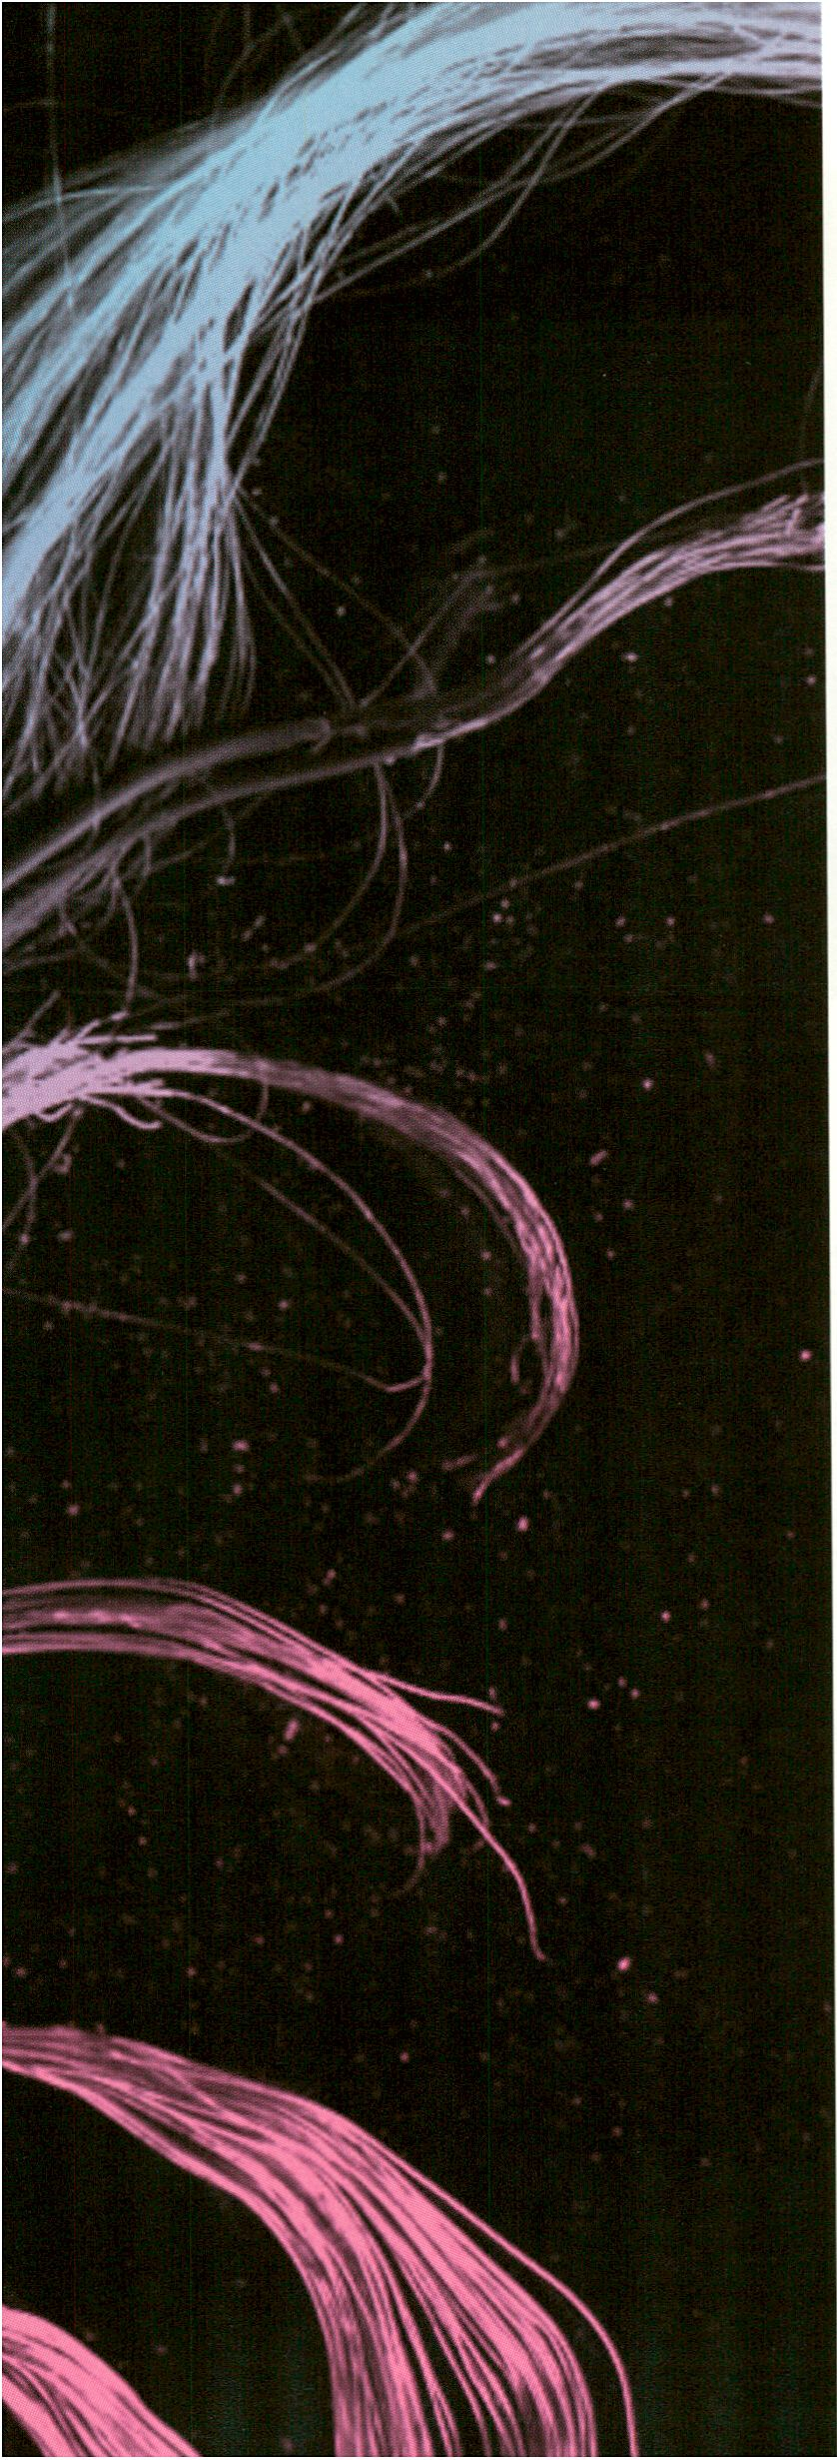
ABILITY : ZOTIES
S3

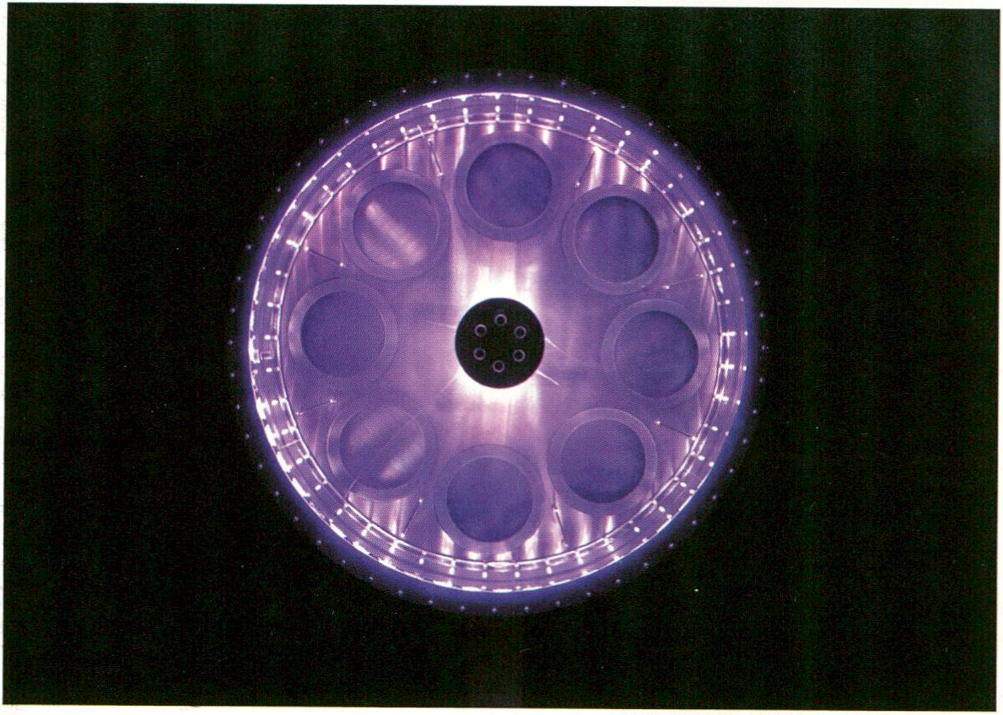
Ambiguous Cut Into Space of Conjecture (Lucid Phantom Messenger #2) by Herwig Weiser

HacKaWay
Far from the often maligned image of hacking being targeted sabotage or rogue
interventionism transmediale.H’s HacKaWay Zone is the place where the notions
of complex technological and societal systems are critically de- and reconstruc-
ted to reveal new and alternative realities. Using the mechanisms of hacktivist
and tactical art practice the HacKaWay Zone brings process based and performa-
tive artworks together in a space activated by hands-on and interactive audience
participation.
HACKflUJRY
Bringing into focus what could be considered a growing Hacktivist International
the HacKaWay Zone (a linguistic hack of the English transliteration of the German
acronym HKW) becomes the arena to test, critique and question the elements of
liveness and open systems, of body and media, presence and process inherent to
the festival’s theme. Linking these notions with the active ability to respond to the
mechanisms of the technological systems that define our daily lives HacKaWay
becomes a zone of empowerment and action where these systems, which
often seem overwhelming and beyond our control are exposed to tactical scrutiny.
With a constant flow in the modes of operation from ‘stand-by’, to ‘active’ and
’performative’, HacKaWay is at once exhibition of processual artworks by artists
incl. Paul Vanouse, HONF, UBEFiMORGEN.COM and Christin Lahr, home to public
workshops incl. Zombie Media by Garnet Hertz and Jussi Parikka or Body Hack by
Daito Manabe, and stage for performances by Ei Wada, Fair Use and others.
Stephen Kovats, artistic director
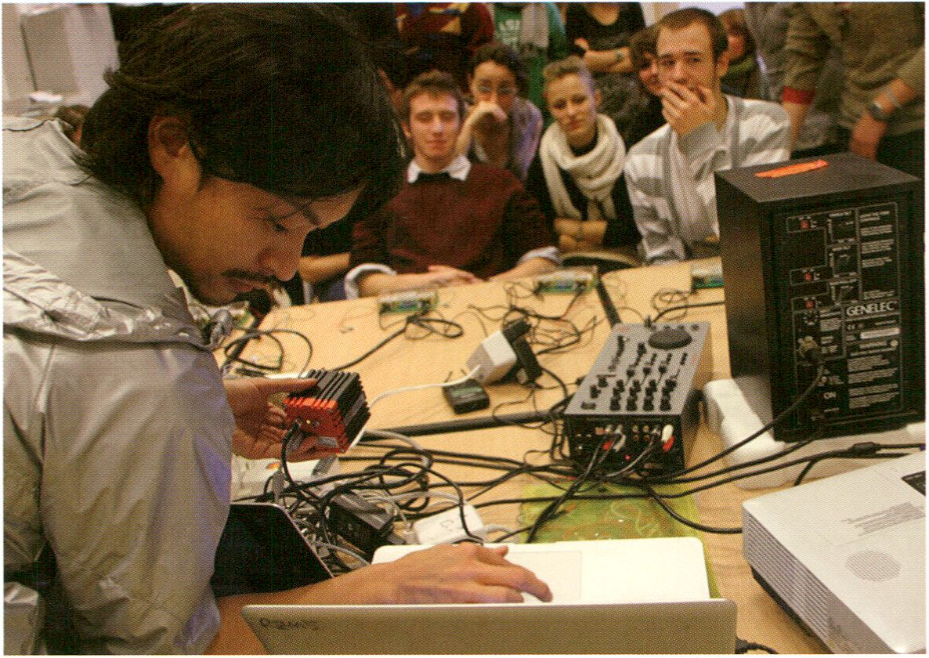
Body Hack by Daito Manabe, courtesy of the artist

HacKaUJay
Weit ab von dem negativen Image von Hacking als gezielte Sabotage oder Gau-
nertum ist die HacKaWay Zone dertransmedlale.11 der Ort, an dem komplexe
Sachverhalte technologischer und gesellschaftlicher Systeme kritisch und zu-
gunsten neuer, alternativer Wirklichkeiten de- und rekonstruiert werden. Dank der
Mechanismen ,hacktivistisch‘-taktischer Kunstpraxen bringt die HacKaWay Zone
prozessbasierte und performative Kunst in einer Halle zusammen, die von Inter-
aktivität und Partizipation lebt.
HRCKflUiflY
Die HacKaWay Zone - als die Ausschreibung der englischen Aussprache von HKW
selbst schon ein sprachlicher Hack-, rückt in den Fokus, was man eine wachsen-
de Hacktivistische Internationale nennen könnte. Hier werden Schlüsselbegriffe
des Festivalthemas wie „Liveness“ und offene Systeme, Körper, Medium, Präsenz
und Prozessualität getestet, besprochen und hinterfragt: Die HacKaWay Zone als
Gebiet der Freiheit und der Aktion, wo gerade jene Systeme, die oft überwältigend
und unkontrollierbar erscheinen, Gegenstand taktischer Unter-suchungen werden
- ganz nach dem Prinzip des Festivalthemas RESPONSE:ABILITY, Konzepte um
die aktive Möglichkeit der Reaktion zu erweitern.
In ständigem Wechsel zwischen den Operationsmodi „Stand-By“, „On“ und „Per-
formativ“, ist HacKaWay gleichzeitig die Ausstellung prozessbasierter Kunstwerke
von Künstlern wie Paul Vanouse, HONF, UBERMORGEN.COM oder Christin Lahr,
Experimentierfeld für öffentliche Workshops wie Zombie Media von Gamet Hertz
und Jussi Parikka oder Body Hack von Daito Manabe, sowie Bühne für Performan-
ces von Ei Wada, Fair Use u. a.
Stephen Kovats, Künstlerischer Leiter
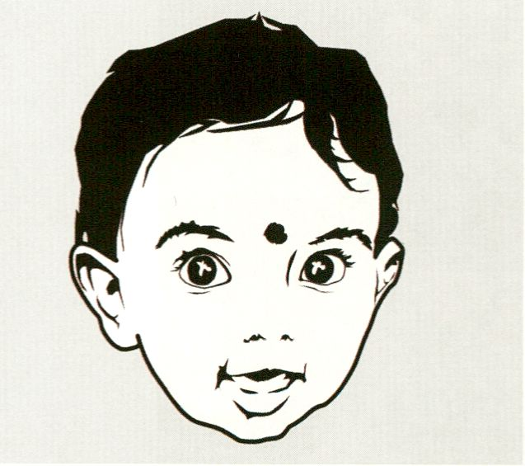kransmediaie.il Conference
BODY : RESPOT1SE
Angel_F by Derrick de Kerckhove and Biodoll
EE
BODY : RESPOnSE - Biomediai Poiikics in the Rge of Digikai Liveness
Biopolitics is a modelling of the biological body and of the social body.
Franco Berardi
Under the title BODYiRESPONSE - Biomediai Politics in the Age of Digital Live-
ness, the transmediale.11 Conference investigates the biopolitical and psycho-
political power configurations in the age of the Web which result from the
increasing biologisation of media (tactility, immersion, sensibility, affect) and the
communication-technological hybridisation of real and virtual spaces (such as
location-based social networks like Foursquare).
With four moderated keynote conversations and a total of six focus discussions,
three complementary paths are followed exploring individual and collective re-
sponsibilities towards such a ‘biopower’.
In the first path, Track 1: Bios and Presence, hybrid identity configurations be-
tween on and offline levels are studied and artistic practices dealing with the
social dynamics of distance and telepresence and the production of authenticity
and identity are presented.
The second path focuses on psycho-political dimensions - labour, economy and
society. Track 2: Bios and Power discusses absence, excess and disaffection
as possible strategies of resistance to the psycho-economic capitalism of con-
temporary information societies.
The third path, Track 3: Bios and Technology, ultimately questions how the body
itself experiences and adapts to such a digital (Um)Welt (environment). Here, the
affect is investigated as a medium between life and technology, which opens a
new space for dealing with the post-human interplay of forces between ruler and
subject, knowledge and distribution.
Markus Huber, Programme Curator, Conference
tiansmediale.il Konfexenz
BODY : BESPOTISE - Biomedial Poiitics in the Ape of Digital Liueness
Unter dem Titel BODY:RESPONSE - Biomediale Politik im Zeitalter der digitalen
Liveness untersucht die Konferenz der transmediale.11 die bio- und psycho-
politischen Machtkonfigurationen im Webzeitalter, die sich durch die zunehmende
Biologisierung der Medien (Taktilität, Immersion, Sensibilität, Affekt) und die kom-
munikationstechnologische Hybridisierung virtueller und realer Räume ergeben
(wie etwa bei ortsbasierten sozialen Netzwerken wie Foursquare).
Mit vier moderierten Keynote-Gesprächen sowie insgesamt sechs Fokusdiskus-
sionen werden drei komplimentäre Spuren verfolgt, um individuelle und ge-
meinschaftliche Handlungsmöglichkeiten gegenüber einer solchen „Biomacht“
auszuloten.
BODY:RESPünSE
Im Rahmen der ersten Spur, Track 1: Bios und Präsenz, werden hybride Identitäts-
konfigurationen zwischen On- und Offline-Ebene untersucht sowie künstlerische
Praxisformen präsentiert, die sich mit der sozialen Dynamik von Distanz und Tele-
präsenz sowie der Produktion von Authentizität und Identität beschäftigen.
Die zweite Spur widmet sich den psychopolitischen Dimensionen - Arbeit, Öko-
nomie und Gesellschaft. Track 2: Bios und Macht diskutiert Absenz, Exzess und
Dis-Affektion als mögliche Widerstandsstrategien gegenüber dem psycho-ökono-
mischen Kapitalismus zeitgenössischer Informationsgesellschaften.
Die dritte Spur, Track 3: Bios und Technologie, fragt schließlich, wie der Körper
selbst eine solche digitale (Um-)Welt erfahren und adaptieren kann. Hier wird der
Affekt als Medium zwischen Körper und Technologie untersucht, das im Hinblick
auf das posthumane Kräftespiel zwischen Herrschaft und Subjekt, Wissen und
Verteilung neue Handlungsräume öffnet.
Markus Huber, Programmkurator, Konferenz
Track 1: Bios and Presence
Keynote Conversation: Digital Liveness - Realtime, Desire and Sociability (p. 93)
Keynote Conversation: Testing Presence: The Unfolding Exchange (p. 105)
Focus Discussion: Fingerprints? Identity, Indexicality and Bio Media (p. 102)
Focus Discussion: Social ID (p. 86)
Lecture: "What is Live?” - From the Aura to the Avatar... (p. 119)
Track 2: Bios and Power
Keynote Conversation: Life at Work: Bioeconomy and the Crisis of Cognitive Capitalism (p. 117)
Focus Discussion: Life in Excess: Transpersonality and Autonomy in the Age of Biopower (p. 128)
Focus Discussion: The Right to Exit (p. 110)
Track 3: Bios and Technology
Keynote Conversation: Delimination of Life - Human Organisms in Posthuman Environments (p. 132)
Focus Discussion: Democratic:Ability (p. 104)
Focus Discussion: Access Denied: DLYourself (p. 114)
In cooperation with the Federal Agency for Civic Education / In Zusammenarbeit mit der Bundeszentrale für politische Bildung
Simultaneous translation German / English and partly Italian / English during the conference sessions in the Auditorium
Simultanübersetzung Deutsch / Englisch und teilweise Italienisch / Englisch für die Konferenzen im Auditorium
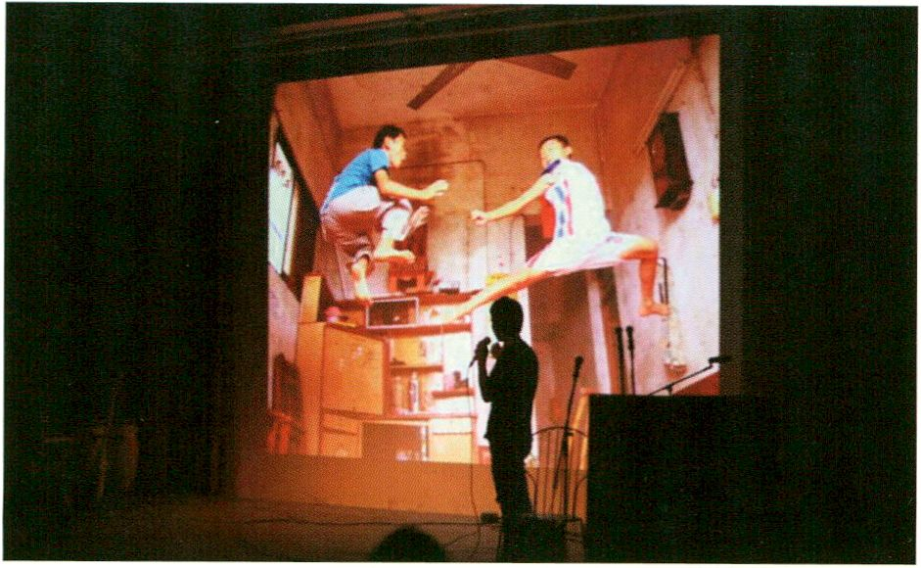The Open Zone - model of a Responsiue City
THE OPEn ZOT1E
Sharism: The More You Share the More You Get, ©Riptide Shenzhen
The festival theme RESPONSE.ABILITY is also a reflection of the Internet as
an Increasingly political sphere. Our entire repertoire of digital action -
online-profiles, shopping, exchange and networking - is socio-politically ever
more relevant and leaves traces in the real world. The Internet has become a
strategic action zone, one that demands evermore composure from the status-
updaters and prosumers of the Web 2.0 era.
While artists, activists and entrepreneurs seem to embrace this new terrain
with visionary experimentation, governments and copyright owners however
see the Internet as a problematic zone. They respond with the same urge for
privatisation and normalisation we already know from the realm of urban
regulations. The Open Web, originally the system norm, is becoming more
and more a competitive resource.
The Open Zone is thus a networked experiment with different social terri-
tories that, for the duration of transmediale.11, are occupied by artists and
media activists. We focus on the split second between “Stand by” and “On” -
the moment where a person decides to act and a passive system becomes
active. The strategic requirements of Open Culture are examined and can be
experienced by visitors in open studios, project labs, exchange centres and
experimental spaces located in the foyer of the Haus der Kulturen der Welt.
This model of a responsive city reflects the human capacity to deal with the
overwhelming flow of events responsibly acting in a self-determined way. For
a free digital culture that is shaped by us all, these are the basic requirements.
The network is here and now, it is ‘live’. Others have built it for us - now we
have to configure it.
Ela Kagel, Programme Curator, The Open Zone
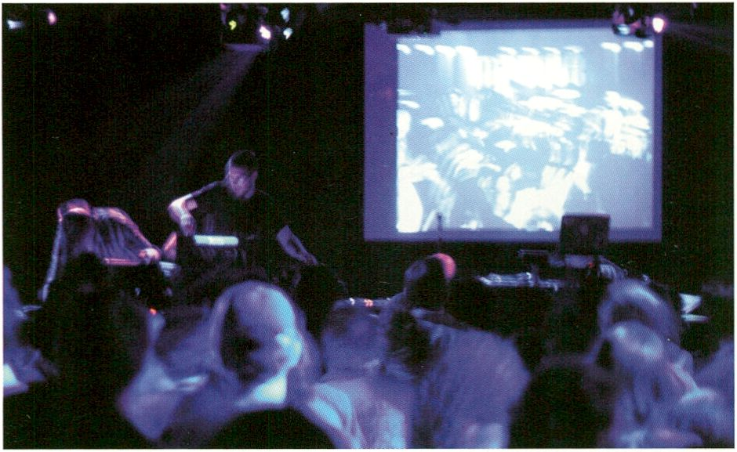The Open Zone - TTlodel of a Responsiue City
THE 0PET1 ZOnE
Eclectic Method playing at the Open Video Conference
Das Festivalthema RESPONSE:ABILITY ist auch eine Reflektion über das Internet
als zunehmend politischer Ort. Unser gesamtes digitales Handlungsrepertoire - un-
sere Online-Profile, das Shoppen, Tauschen und Vernetzen - wird gesellschafts-
politisch immer relevanter und hinterlässt Spuren in der realen Welt. Das Internet ist
zur strategischen Handlungszone geworden, die bei Status-Updatern und Pro-
sumern der Web 2.0-Ära immer mehr nach einer „Haltung“ ruft.
Während Künstler, Aktivisten und Unternehmer diesen Veränderungsprozess als
visionäre Versuchsanordnung nutzen, ist das Internet für Regierungen oder Recht-
eeigner eine problematische Zone, die entsprechend dem teilprivatisierten und
normierten Stadtraum der Regulierung bedarf. Das Open Web, früher eine Art Sys-
temvoraussetzung, wird dadurch immer mehr zur umkämpften Ressource.
The Open Zone ist eine gesellschaftliche Versuchsanordnung mit unterschiedlichen
sozialen Territorien, die für die Dauer der transmediale von Künstlern und Medien-
aktivisten besiedelt werden. Im Mittelpunkt steht der kleine Wimpernschlag
zwischen „Stand by“ und „On“ - der Moment, in dem sich ein Mensch zum Handeln
entschließt und ein passives System aktiv wird. In offenen Ateliers, Projektbüros,
Tauschzentren und Experimentierräumen werden die strategischen Voraussetzun-
gen der Open Culture untersucht und für die Besucher des Festivals erfahrbar
gemacht.
Dieses Modell einer handlungsfähigen Stadt reflektiert die menschliche Fähigkeit,
im verwirrenden Strom der Ereignisse verantwortlich zu handeln und selbstbe-
stimmt agieren zu können. Das sind die Grundvoraussetzungen einer freien digi-
talen Kultur, die von uns allen mit geprägt wird.
Das Netz ist hier und jetzt. Es ist live. Andere haben es für uns gebaut - gestalten
müssen wir es jetzt selbst.
Ela Kagel, Programmkuratorin, The Open Zone
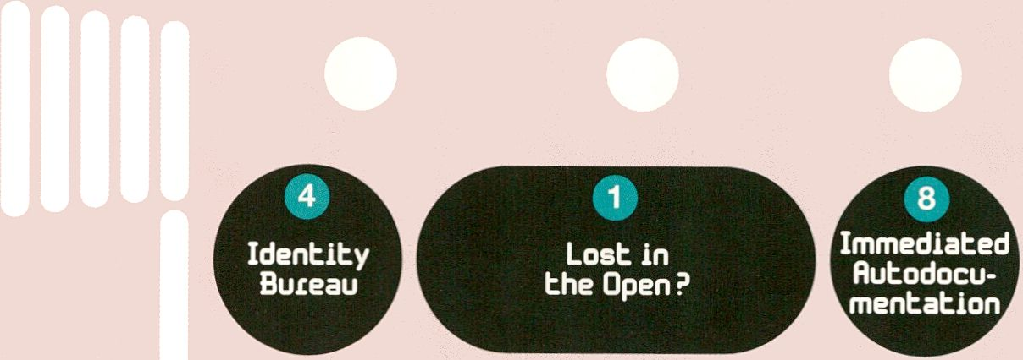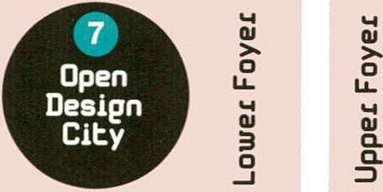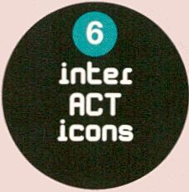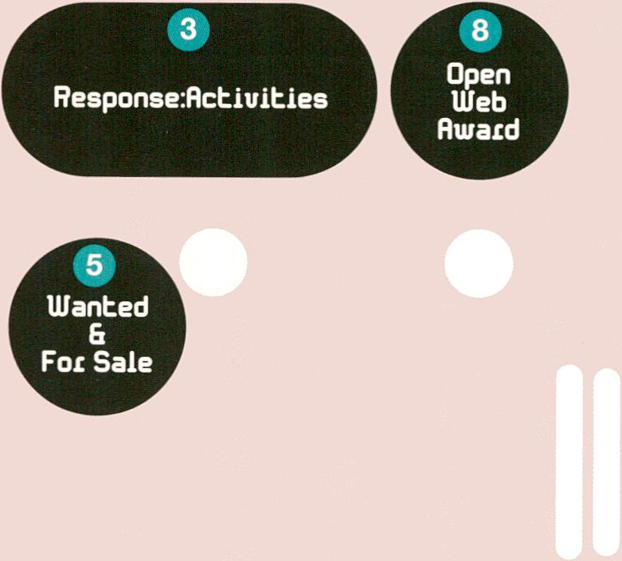
THE 0PET1 ZOnE
r | # | 1
L | Currency of  the Commons

Rlain Enbiance
bo HacKaUJay

THE 0PEÍ1 Z0T1E
OLost in the Open?
Navigating the Open Web and Free Culture
TRACES Lounge
by and with the Transcultural Reseach
Artist Curator Exchange Series (p. 77)
Sharism
by and with Michelle Thorne, Barry Threw, Jon Phillips (p. 73)
The Free Culture Incubator
by and with Andrea Goetzke, Michelle Thorne,
partners and guests of the FCI (p. 87)
Facebook Resistance Workshop
by and with Tobias Leingruber (p. 101)
Open Video
by and with Elizabeth Stark (p. 106)
Strategies for Dealing with
Copyright Regimes
by and with Simona Levi (p. 113)
Liquid Democracy
by and with Friedrich Lindenberg (p. 118)
The Open Knowledge Foundation
by and with Jonathan Gray (p. 127)
The Future of Art: An Immediated
Autodocumentary Screening
by and with Gabriel Shalom and Patrizia Kommerell (p. 130)
Daily Observer Talks
with Allen Gunn, Tapio Makela, Micz Flor, Elizabeth Stark,
Simona Levi (p. 81,95,108,123,133)
©
The Currency of the Commons
The Price and Value of Free Culture
The Future of Money
by and with Jay Cousins and Gabriel Shalom (p. 88)
Flattr / Creative Fundraising
and Microfunding Initiatives
by and with Peter Sunde from Flattr (p. 91)
thimbl
by and with Dmytri Kleiner (p. 76)
Mapping Money and Meaning
by and with Eric Poettschacher (p. 105)
The Cult of Less
by and with Kelly Sutton (p. 112)
©
Response:Activities
Strategies of Political Participation
Tactical Tech Activism, Through the Iris,
Drawing by Numbers
by and with Marek Tuszinsky and Stephanie Hankey
from Tactical Tech (p. 71,127)
Repetitionr
by and with Les Liens Invisibles (p. 89)
Open Activist Consultancy Event
by and with Allen Gunn (p. 92)
Booki
by Adam Hyde, Douglas Bagnail and Aleksandar Erkalovic,
with Adam Hyde (p. 100)
Drumbeat Workshop and Consultancy
Bureau
by Mozilla Drumbeat, with Henrik Moltke
and Mark Surman (p. 111)
Open Government and the Citizen 2.0
by and with Daniel Dietrich and Christian Kreutz (p. 114)
Facebook Resistance
presentation by and with Tobias Leingruber (p. 101)
Global Voices Online
by and with Sami Ben Gharbia and Solana Larsen (p. 130)
Identity Bureau
by and with Heath Bunting (p. 72)
Wanted and For Sale
by and with kom.post collective (p. 71)
interACTicons
by and with Ursula Endlicher (p. 77)
O
Open Design City
‘Make your Own Market’
by and with Jay Cousins and Chris Doering,
with Galia Offri, Mushon Zer-Aviv as guests (p. 70)
Immediated Autodocumentary
with Gabriel Shalom and Patrizia Kommerell (p. 68,130)
Open Web Award works
with the nominated works of Evan Roth, Dmytri Kleiner
and Adam Hyde (FLOSS Manuals), (p. 58)
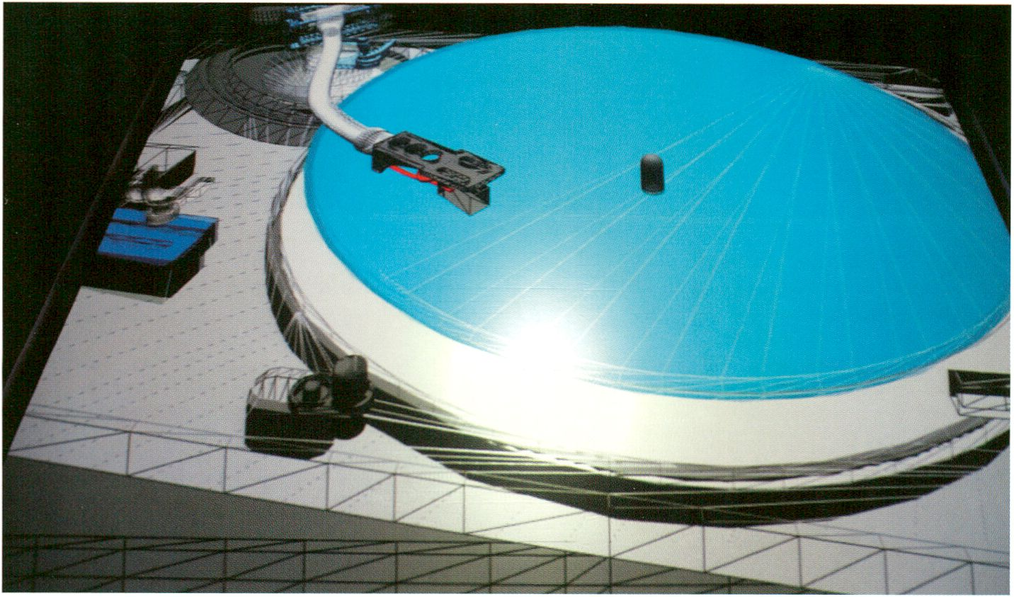transmediale.ll Performances
LIUE:RESPOnSE
LIUE : RESPOTISE
DONJON by Cécile Babiole & Vincent Goudard
This year's performance programme at transmediale, LIVE:RESPONSE, hovers
at the interfaces between the real world and the media sphere, between live-
ness and reproduction, between virtual and physical. Over the course of the
festival at three locations, in the Auditorium, on the Café Stage and in the
HacKaWay Zone, hybrid manifestations of media will be switched on and their
potential for experimental malleability will be tested. Herman Kolgen, Daito
Manabe, Eboman and Ursula Endlicher demonstrate very different forms of
body and media assemblages, whether literally or figuratively. Cécile Babiole &
Vincent Goudard, People Like Us and Fair Use respond to the ever accele-
rating media/consumer culture and its ever-growing reservoir of permanently
available and accessible media content. Ei Wada, Rosa Menkman and Tina
Tonagel, Preslav Literary School and Eosin, Dorothy of the Day and TOUR de
VINYL play with the diverse materiality of media and make it tangible as well
as give new life to the archives of memory.
To close the festival evenings - or to set the mood for the club transmediale
night programme - DJs splash electronic sounds through the halls of the Haus
der Kulturen into the night.
Sandra Naumann, Programme Curator, Performance and Guest Curator CTM.11
This year both transmediale and CTM explore the characteristics of live and real time media, thus creating numerous
connections between the performance and discourse programmes of both festivals. Furthermore transmediale and CTM
jointly present six A/V performances: two evenings at the auditorium of the HKW and two performances at Festsaal
Kreuzberg.
transmediale.il Performances
LIUE:RESPOnSE
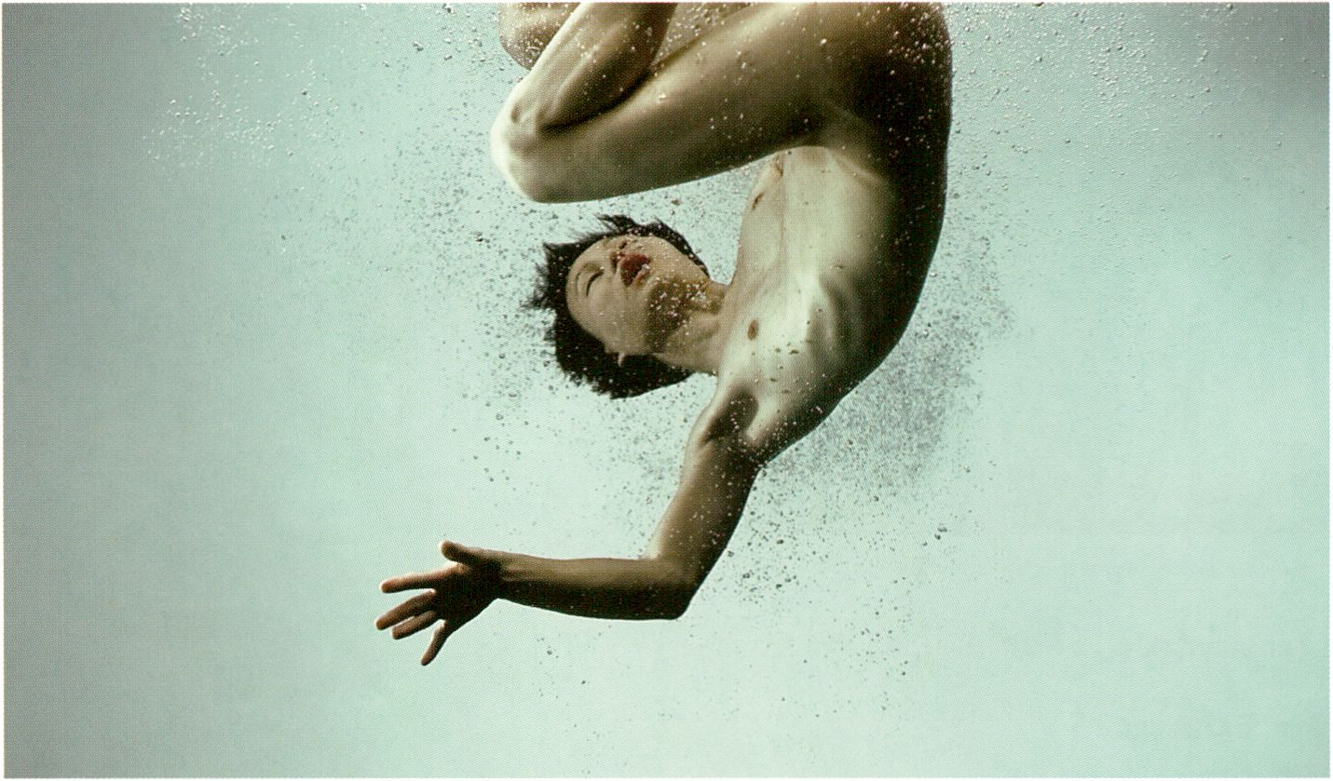
INJECT by Herman Kolgen
LIVE:RESPONSE, das diesjährige Performanceprogramm der transmediale be-
wegt sich an den Schnittstellen zwischen Realwelt und Mediensphäre, zwischen
Liveness und Reproduktion, zwischen Virtuellem und Physischem. Auf insgesamt
drei Bühnen, im Auditorium, auf der Café Bühne und in der HacKaWay Zone
werden im Laufe des Festivals verschiedene Medienformationen angeschaltet und
in experimentellen Versuchsanordnungen zu ihren jeweiligen Live-Potentialen
befragt. So demonstrieren Herman Kolgen, Daito Manabe, Eboman und Ursula
Endlicher ganz unterschiedliche Formen des Zusammenschlusses von Körpern und
Medien, ob nun wortwörtlich oder in übertragenem Sinne. Cécile Babiole & Vincent
Goudard, People Like Us und Fair Use begegnen der sich immer weiter beschleuni-
genden Medien-/Konsum-kultur und ihren beständig anwachsenden Reservoirs
permanent verfügbarer audiovisueller Medieninhalte. Ei Wada, Rosa Menkman und
Tina Tonagel, Preslav Literary School und Eosin, Dorothy of the Day und TOUR de
VINYL machen die vielfältigen Spielarten der Interaktion mit der Materialität ver-
schiedener Datenträger erfahrbar und erwecken dabei die Archive der Erinnerung
zu neuem Leben.
Zum Ausklang der Festivalabende im HKW - oder aber zur Einstimmung auf das
Nachtprogramm des club transmediale - schicken schließlich zu vorgerückter
Stunde DJs elektronische Klänge durch die Hallen des Foyers.
Sandra Naumann, Programmkuratorin, Performance und Gastkuratorin CTM.11
In diesem Jahr widmen sich sowohl transmediale als auch CTM der Beschaffenheit von Live- und Echtzeitmedien, wodurch
sich in Performance- und Diskursprogramm beider Festivals zahlreiche inhaltliche Anschlüsse ergeben. Außerdem gibt es
sechs von transmediale und CTM gemeinsam präsentierte A/V-Performances.
LIUE : RESP0T1SE
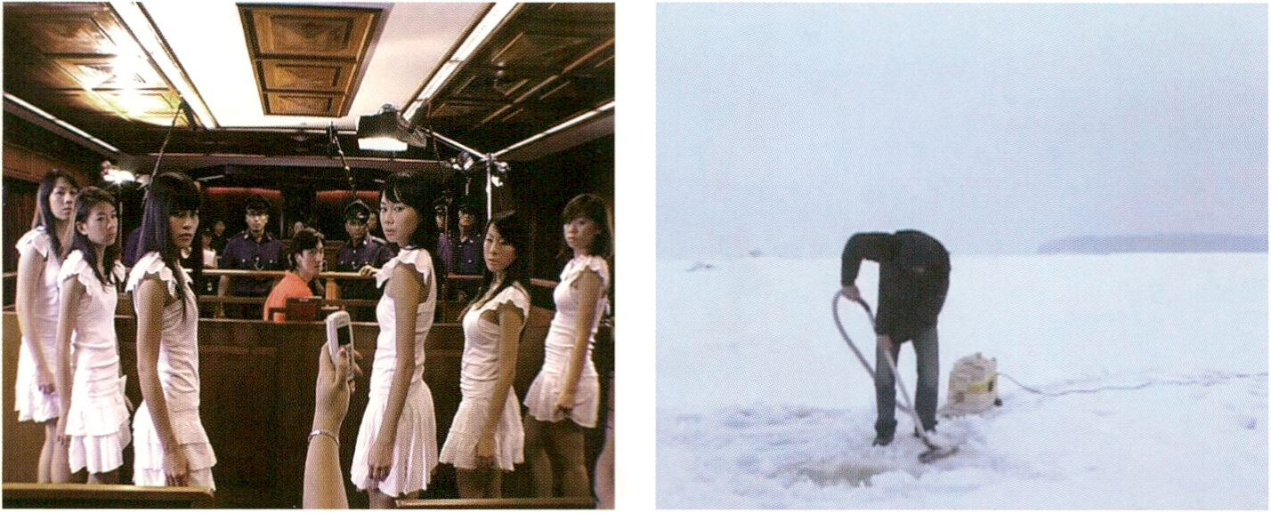transmediaie.il Fiim 6 Uideo Programme
SyncExistence
SYnCEXISTETlCE
The Bohemian Rhapsody Project by Ho Tzu Nyen
Vacuum by Adel Abidin
Hardly any other media technique has deconstructed our idea of the unity of
time and space more powerfully than that of film editing in cinema. It is this
technique which made it possible to connect seemingly distant places while
also extending, stretching or parallelising the course of things. Thinkers have
therefore claimed that film editing not only created the “dynamisation of space”
and “spatialisation of time” (Erwin Panofsky, 1936) but moreover a completely
new type of perception defined by “simultaneity” and “universalism” (Arnold
Hauser, 1953), characteristics indeed constitutive of the contemporary con-
ception of life. Television and the Internet ultimately made this already highly
condensed information ubiquitous.
SyncExistence, the film and video programme of transmediale.11, addresses
the processual history around this universal outpouring of visual culture in an
arc that extends from the Soviet Union in 1927 with the rapid-cut ‘appropriation
comedy’ A Kiss From Mary Pickford, through the early, slow television culture
led by Nazi Germany and continuing into the intensive artistic debates of the
1960s. Moreover, there will be screenings of contemporary works approaching
the curatorial premise from different perspectives that have been selected from
the submissions to the award competition. Specials on Lynn Hershman Leeson,
one of the pioneers of interactive art, and Ho Tzu Nyen, Award Nominee from
Singapore, plus the Arab Shorts project round out the programme. As always,
there will again be opportunities for Q & As with directors and filmmakers
attending transmediale.11.
Marcel Schwierin, Programme Curator, Film & Video
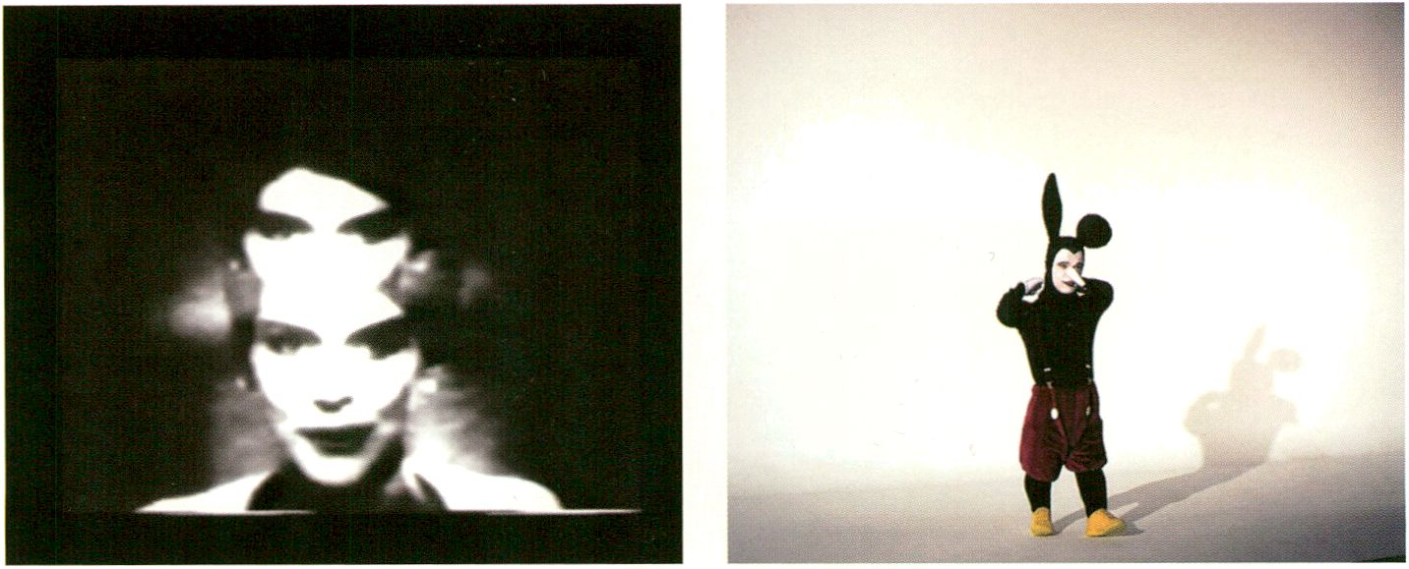
Sun In Your Head by Wolf Vostell Suspended Animation by Billy Lumby

tiansmediale.il Film 6 Uideo Programm
SyncExistence
Kaum eine andere Medientechnik hat unsere Vorstellung der Einheit von Raum und
Zelt so dekonstrulert wie die Filmmontage. Sie verbindet scheinbar entlegendste
Räume und streckt, dehnt oder parallelisiert den Ablauf der Dinge. So schaffe sie
nicht nur die „Dynamisierung des Raumes“ und „Verräumlichung von Zeit“ (Erwin
Panofsky, 1936), sondern auch eine neue Wahrnehmung von „Gleich-zeitigkeit“
und „Universalismus“, die das eigentliche Lebensgefühl des modernen Menschen
ausmache (Arnold Hauser, 1953). Fernsehen und Internet haben die ohnehin schon
hochgradig verdichtete Information allgegenwärtig gemacht. SyncExistence, das
Film- und Videoprogramm dertransmediale.11 reflektiert diesen Prozess um die
universale Bilderstrommaschine in einem Bogen, der in der Sowjetunion von 1927
mit der rasant geschnittenen „Appropriations“-Komödie Der Kuss der Mary
Pickford beginnt, über das erste, noch langsame Fernsehen des nationalsozialis-
tischen Deutschlands führt, und sich in den intensiven künstlerischen Auseinander-
setzungen der 1960er Jahre fortsetzt.Weiterhin wurden aus aktuellen Arbeiten
Programme zusammengestellt, die sich dem Thema von verschiedenen, zeitgenös-
sischen Problemstellungen nähern. Specials zu Lynn Hershman Leeson, einer der
Pionierinnen der interaktiven Kunst und dem Award Nominee aus Singapur Ho
Tzu Nyen und das Projekt Arab Shorts beschließen das Programm. Auch dieses
Jahr gibt es im Anschluss an die Screenings Gelegenheit, einer Reihe anwesender
Regisseure und Filmemacher Fragen zu stellen.
Marcel Schwierin, Programme Curator, Film & Video
SYT1CEXISTET1CE

Dial Goes Around, p. 74
Desync Systems, p. 79
This Is A Good Day To Start A War, p. 90
Arab Shorts, p. 94
Imaginary Travels, p. 103
Ho Tzu Nyen Special, p. 107
Das erste Fernsehen, p. 115
The Revolution Will Not Be Televised, p. 120
A Kiss From Mary Pickford, p. 126
Live On TV, p. 129
Lynn Hershman Leeson Special, p. 135
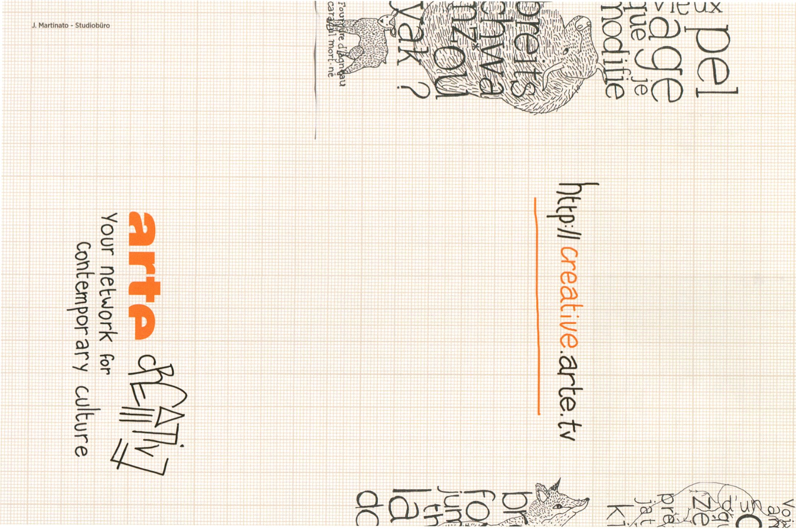
m

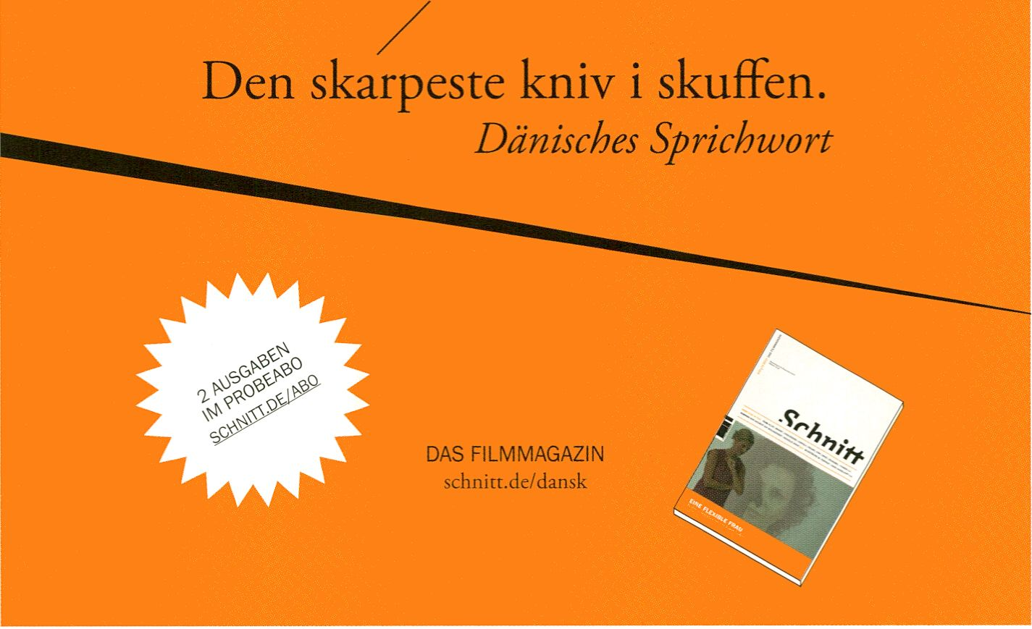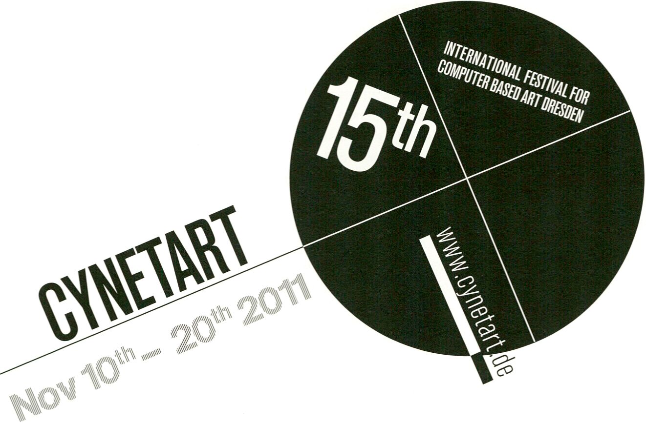
Grhnitt
festspielhaus hellerau

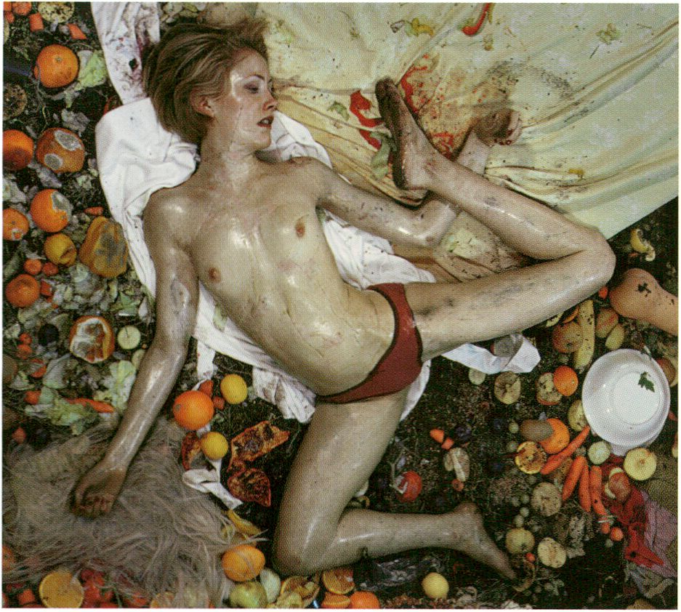
Reynold Reynolds. Still from Secret Life (2008)

txansmediale.il Collaboration Projects
COLLABORATIOn PROJECTS
Special broader European projects that transmediale has initiated or is working
in close collaboration with partner organisations and events are being high-
lighted at the festival. Whether presenting new initiatives to support artis-
tic and media theoretical production, such as the launching of the centennial
McLuhan in Europe 2011 network, new possibilities for making radio (Test
Signals) or the new Rotterdam-based media arts ‘agencies’ (V2 Agency & NIMK
Distribution), transmediale's focus on collaboration aims to provide a spring-
board for innovative independent production.
Die transmediale.11 Collaboration Projects umfassen Projekte, Partnerorganisati-
onen und Veranstaltungen aus dem europäischen Raum, an deren Initiierung die
transmediale beteiligt ist, bzw. mit denen sie in besonders enger Zusammenarbeit
steht und die nun auf dem Festival präsentiert werden. Im Einzelnen handelt es
sich dabei um gerade gestartete Initiativen zur Unterstützung künstlerischer und
medientheoretischer Produktionen, wie etwa das Netzwerk McLuhan in Europe
2011 anlässlich McLuhans 100. Geburtstag, neue Möglichkeiten für Radiomacher
(Test Signals) oder die neuen „Agenturen“ für Medienkunst (V2_Agency & NIMK
Distribution) in Rotterdam. Immer liegt der Fokus der transmediale auf der Zu-
sammenarbeit als einem Sprungbrett für Innovatives und unabhängiges Schaffen.
ITlcLuhan in Europe 2011
transmediale in collaboration with the Marshall McLuhan Salon of the Embassy
of Canada, Berlin, the Gingko Press and the McLuhan Program for Culture and
Technology, University of Toronto have initiated a number of events across Eu-
rope to celebrate the centennial of Herbert Marshall McLuhan’s birth in 2011.
The cultural network project McLuhan in Europe 2011 will explore, critique and
celebrate the impact of this Canadian media and telecommunications visionary
on European art and culture through a series of manifestations to occur in
various locations, contexts and timeframes throughout 2011. While exploring
the as yet untold histories of McLuhan in Europe, the events will also look at
the development of contemporary media, tactile and mobile cultures, the poli-
tics of media culture in the context of the divided Europe and other themes that
emerged out of McLuhan's primary period of intellectual production,
transmediale.11 launches the European centennial with the publication of a
unique limited edition of McLuhan’s COUNTERBLAST manifesto from 1954, as
well as number of special events during the festival and into 2011!
The transmediale Marshall McLuhan Lecture 2011 features Mark Surman, Executive Director, Mozilla Foundation, p. 78
OPEN Signs, an exhibition on art and open technologies curated by Heather Kelley at the Marshall McLuhan Salon, p. 158
COUNTERBLAST: The Rogue McLuhan conference event moderated by Michelle Kasprzak and featuring Elena Lamberti,
Timothy Druckrey and Elaine Brodie p. 88
Coming up 27/28 May 2011: Re-Touching McLuhan Conference curated by Dieter Daniels and Chris Salter at the Embassy
of Canada, Berlin, mcluhan2011.eu
Im Jahr 2011 wäre Herbert Marshall McLuhan 100 Jahre alt geworden. Zu diesem
Anlass hat die transmediale zusammen mit dem Marshall McLuhan Salon der Bot-
schaft von Kanada sowie der Gingko Press und dem McLuhan McLuhan Program
for Culture and Technology der Universität von Toronto ein Spezialprogramm ins
Leben gerufen. Mit einer Reihe von Veranstaltungen an unterschiedlichen Orten, in
verschiedenen Kontexten und Zeiten, ehrt und untersucht das Kulturnetzwerkpro-
jekt McLuhan in Europe 2011 während des gesamten Jahres die Wirkung, dieses
im Hinblick auf Medien- und Telekommunikation so weitsichtigen Kanadiers, auf
die europäische Kunst und Kultur. Dabei geht es nicht etwa nur um die relativ we-
nig aufgearbeitete Geschichte McLuhans in Europa, sondern vor allem um die
Betrachtung zeitgenössischer Medien bzw. taktiler und mobiler Kulturen, sowie
die Medienkulturpolitik im vormals geteilten Europa und andere für das intellektu-
elle Werk McLuhans zentrale Themen. Die transmediale.11 eröffnet die europäi-
sche Hundertjahrfeier mit der Veröffentlichung einer einmaligen, limitierten Edition
von McLuhans Manifest COUNTERBLAST aus dem Jahr 1954, sowie mit einer
Reihe von speziellen Veranstaltung während der transmediale.
Die transmediale Marshall McLuhan Lecture 2011 wird von Mark Surman, dem Geschäftsführer der Mozilla Foundation
gehalten, S. 78
Zu sehen im Marshall McLuhan Salon außerdem OPEN Signs, eine Gruppenausstellung zu Open Art und Technologie,
kuratiert von Heather Kelley, S.158
COUNTERBLAST: The Rogue McLuhan, moderiert von Michelle Kasprzak, mit Elena Lamberti, Timothy Druckrey und
Elaine Brodie S. 88
Vorankündigung! 27./28. Mai 2011: Re-Touching McLuhan, Konferenz kuratiert von Dieter Daniels und Chris Salter an der
Botschaft von Kanada, Berlin, mcluhan2011 .eu
> McLuhan vs Flusser screening, p. 112
COLLRBORATIOn PROJECTS
Test Signals
COLLRBORRTIOn PROJECTS
Test Signals is a project that approaches the political, artistic and practical
spectrum of radio, looking at its significance and potential in the digital age,
whilst investigating new ways of hacking, augmenting and open-sourcing its
technology.
The arrival of the transistor radio in 1954 heralded what would become the
most popular electronic communication device in history. Since that time,
although radio technology has remained largely unchanged, its boundaries
have shifted significantly. An open site for collaboration, quality content and
experimentation - all hallmarks of the latest incarnation of the Web - radio's
ubiquity, adaptability and low cost has seen it move into new platforms and
territories. Often working alongside the Web as the preferred real-time global
dissemination method of political groups, activists and artists, radio's open-
ness is however continually threatened by governmental upgrade agendas,
stricter regulatory bodies and industry's need for new consumables.
Das Projekt Test Signals nähert sich dem Radio von politischen, künstlerischen
und praktischen Ausgangspunkten, um dessen Bedeutung und Potential im
digitalen Zeitalter herauszuarbeiten sowie nach neuen Wegen zu suchen, wie
man es hacken und verbessern, bzw. mit Open Source-Technologien demokrati-
sieren kann.
Im Jahr 1954 trat mit dem Transistorradio etwas auf den Plan, das schließlich
zum meist verbreiteten und beliebtesten elektronischen Kommunikationsmittel
der Welt avancieren sollte. Obwohl sich die Technologie des Radios kaum ver-
ändert hat, haben sich dessen konzeptuelle Grenzen seitdem jedoch umso mehr
verschoben. Dank seiner geringen Kostspieligkeit, guten Verbreitungs- und hohen
Anpassungsfähigkeit, fand das Radio gerade auch in Zeiten der Digitalisierung
als offener Ort für Kollaborationen, für qualitativ hochwertige Inhalte und ander-
weitige Experimente zu neuen Höhen und Territorien. Neben dem Internet stellt
das Radio aufgrund dieser Eigenschaften so auch heute noch das global meist
genutzte Medium zur Verbreitung von Live-Inhalten dar und wird dennoch in
dieser bemerkenswerten Offenheit ständig von staatlicher Seite durch Regulierun-
gen und von industrieller Seite durch den Druck, neue Konsumgüter zu vertreiben,
bedroht.
Test Signals is organised by Sourcefabric. No matter what their resources or location, Sourcefabric works to provide media
organisations with the open source software, tools and support to produce quality, independent journalism. Sourcefabric is
a not-for-profit organisation based in Prague, Czech Republic, with branches in Berlin, Germany and Toronto, Canada.
- Radio Magic, p. 73
- Radio Tactics, p. 69
- Open Digital Radio, p. 85
US_Rpency & niFTIh Distribution
The Netherlands Media Art Institute (NIMk, Amsterdam) and V2_lnstitute for the
Unstable Media (Rotterdam) join forces to introduce their dissemination and
distribution services for media art. After nearly 30 years of active supporting
the media artists both institutions are known for their long-term experience in
presentation, research and development of media art. V2 Agency & NIMk
Distribution (established in 2010) collaborated on the production of a shared
catalogue of represented artworks comprising of the earliest media installation
experiments to the latest in video and computer-based art. To celebrate the
release of this catalogue, and to present both distribution initiatives to an inter-
national audience, NIMk and 1!2_ are invited to transmediale.11 to curate a small
showcase of artworks from their catalogue.
Das Netherlands Media Art Institute (NIMk, Amsterdam) und V2_lnstitute for
Unstable Media (Rotterdam) sind nach beinahe 30 Jahren aktiver Unterstützungs-
arbeit auf dem Gebiet der Medienkunst bekannt für ihre langjährige Erfahrung bei
der Präsentation, Forschung und Entwicklung von Medienkunst. Gemeinsam stel-
len nun beide Institutionen ihre Verbreitungs- und Vertriebsservices vor.
V2_Agency & NIMk Distribution (gegründet 2010) geben zusammen einen neuen
Katalog heraus, in dem alle von beiden Institutionen vertretenen Kunstwerke (von
den frühesten Medienkunst-Experimenten zu jüngsten Produktionen in Video-
und Computerkunst) verzeichnet sind. Zur Feier dieses Katalogs und um beide
Vertriebsinitiativen einem internationalen Publikum vorzustellen, wurden NIMk und
V2_ eingeladen, auf dertransmediale.11 eine kleine Ausstellung mit Werken aus
diesem Katalog zu kuratieren.
- V2_Agency & NIMk Distribution Launch, p. 104
- Dear Steve, p. 149
- Re:, p. 148
- Mirror Piece, p. 148
- audioswapö, p. 149
- 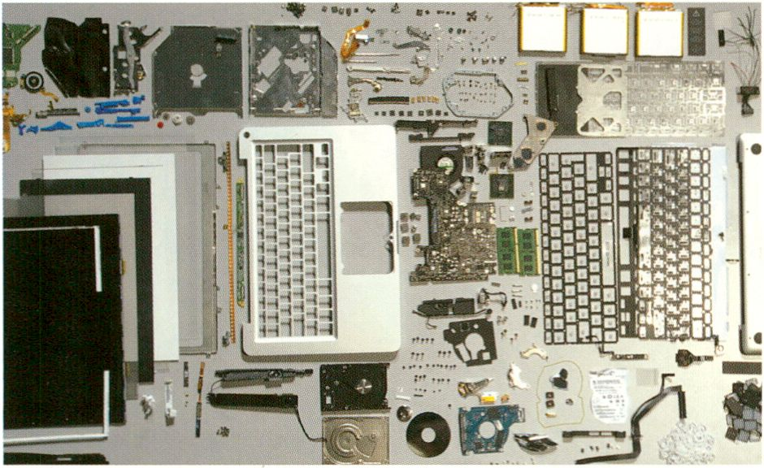For the ppl of Iran, p. 149
COLLRBORRTIOn PROJECTS
Dear Steve by Herman Asselberghs, courtesy of the artist
Hl
»freitag.de/hotUst 20,o i,
:?
CO CD
"ndttWgMch'wmS,"⁸
¡ÄSEte. ^{f}ÄÄ ^
der f reita
Das Meinungsmedium
Lieferung endet automatisch

www.freitag.de/gratis

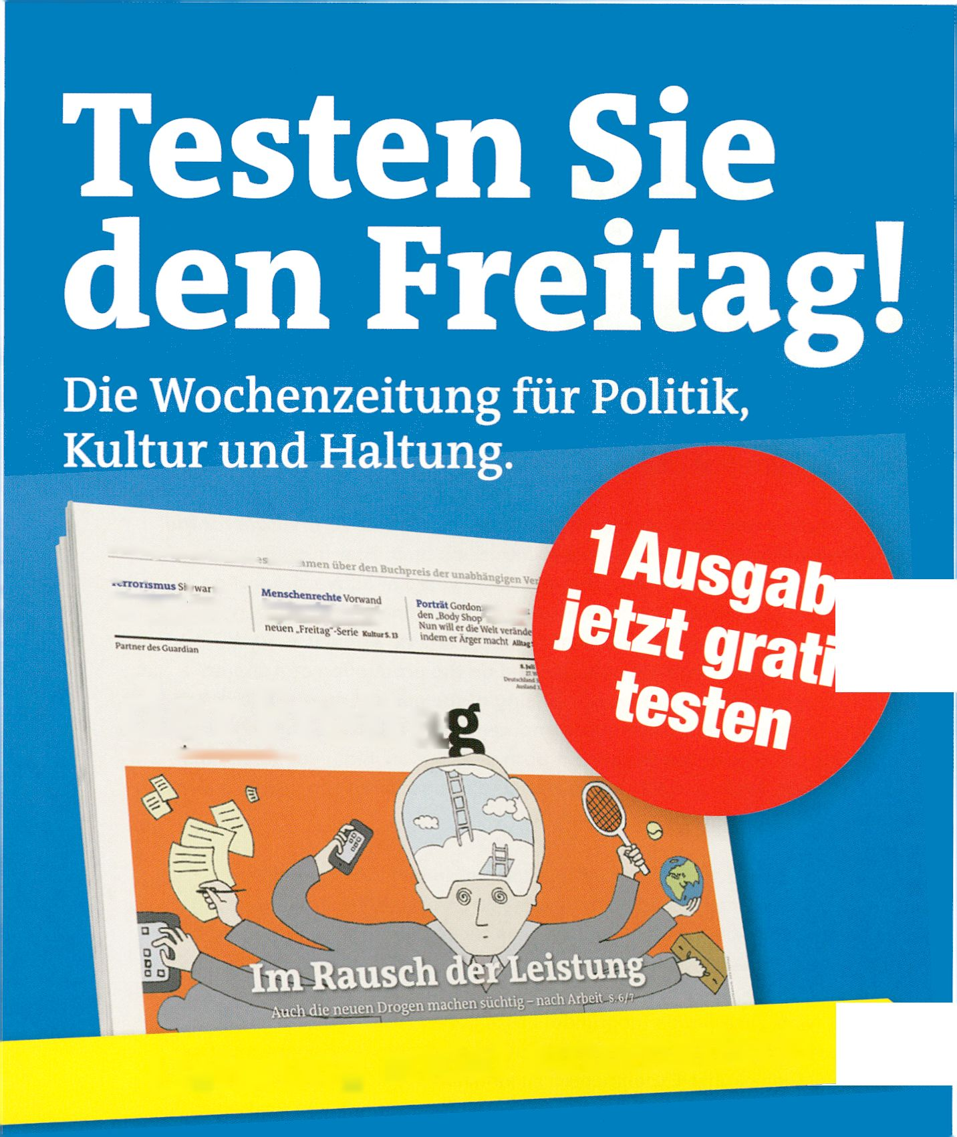
HB
LE ADAWARDS 2010
European
aiciDsiJnucr
AWAJffl

Reynold Reynolds: The Secrets Trilogy, Labor Berlin #4

COLLABORRTIOn PROJECTS
Reynold Reynolds’ The Secrets Trilogy ex-
plores the imperceptible conditions that
frame life, specifically time and space. For
Secrets Trilogy, Reynolds has moved his
entire studio into the art space, producing
the filmic work live to an audience. This live
construction of the image destroys the illusion
of film, revealing the studio process as art.
The Secrets Trilogy is part of the ongoing
Labor Berlin series at the Haus der Kulturen
der Welt, a project dedicated to the creativity
and potential of international artists with the
city as their new home and focuses on Berlin
and its production conditions for artistic
creation.
1 February - 3 April 2011, Wed - Mon 11:00 -19:00, Labor Berlin Project
Room, Haus der Kulturen der Welt
- Imaginary Travels, p. 103
Ludic Interfaces: Design of media Enulrc
From 2012 the joint MA programme Ludic
Interfaces, offered by the Universities of
Salford, Linz, Valencia and Potsdam, will be
dedicated to the analysis and development
of game-like interfaces. The methodologies
mobilised by this new interdisciplinary
course include ludology, media theory, cul-
tural studies, aesthetic practices, HCIUE
(human computer interfaces and usability
engineering), and collaborative creation pro-
cesses.
transmediale, along with CODED CULTURES
and A MAZE, a partner of this MA pro-
gramme, has Invited Ludic Interfaces to
transmediale.11 to organise the Ludic Salon:
panel guests and audience discuss the
possibilities of ludology for contemporary
media art in a playful and interactive setting.
- Ludic Salon, p. 125
- Controlled Invasion, p. 98
- AMAZE., p. 164
Mit dem Fokus auf Raum und Zeit erforscht
Reynold Reynolds The Secrets Trilogy kaum
wahrzunehmende Rahmenbedingungen des
Lebens. Für das Projekt hat Reynolds sein
Studio in den Kunstraum versetzt und zerstört
so einerseits die Illusion des Films, enthüllt
andererseits den Studioprozess selbst als
Kunst.
The Secrets Trilogy ist Teil der laufenden
Labor Berlin Reihe im Haus der Kulturen der
Welt. Das Projekt widmet sich der Kreativität
und dem Potential Internationaler Künstler
und konzentriert sich auf die Stadt Berlin und
deren Produktionsbedingungen für künstleri-
sches Schaffen.
nents foi the Homo Ludens
Ab 2012 widmet sich Ludic Interfaces, ein neu-
er Joint-Masterstudiengang der Universitäten
Salford, Linz, Valencia und Potsdam, der Ana-
lyse und Entwicklung spielerischer Schnitt-
stellen. Die Methodik dieses neuen interdiszi-
plinären Kurses umfasst Ludologie, Medien-
theorie, Kulturwissenschaft, ästhetische Praxis,
HCIUE (human Computer interfaces and usa-
bility englneering) und kollaborative Kreations-
prozesse.
Die transmediale ist mit CODED CULTURES
und A MAZE. Partner dieses Kurses und hat
Ludic Interfaces eingeladen, auf dem Festival
den Ludic Salon zu veranstalten: Gesprächs-
gäste und Publikum diskutieren in verspielt-
interaktiver Atmosphäre die Möglichkeiten der
Ludologie für die zeitgenössische Medienkunst.
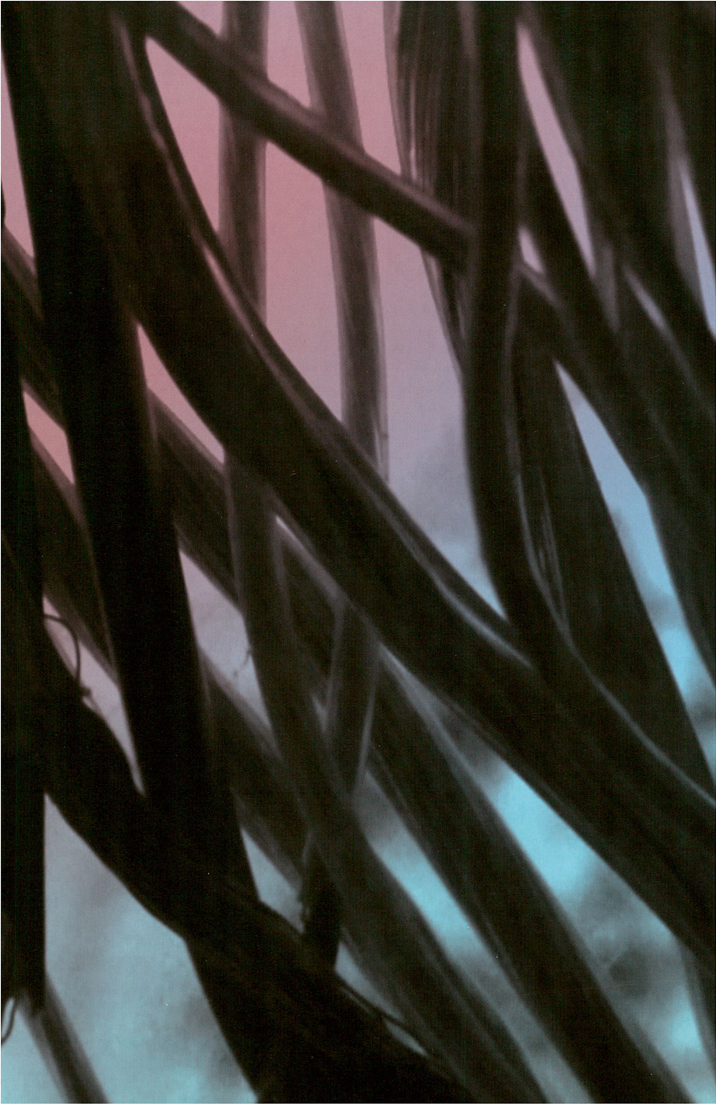

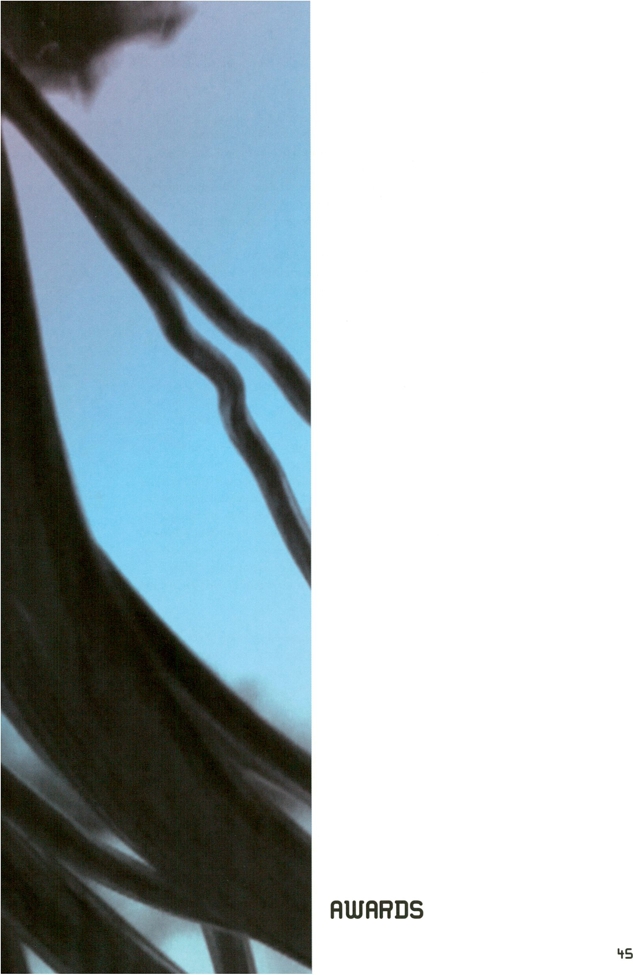

tiansmediale.il Awards
For the first time ever, in 2011 transmediale will present three kinds of awards:
the transmediale Award for outstanding works of art, the Vilem Flusser Theory
Award (VFTA) for innovative theoretical and research projects and the newly
established Open Web Award for web-based projects that radically support and
develop the Open Web. transmediale and CTM congratulate all the nominees,
and wish them best of luck for the Awards Ceremony 5 February 2011 when the
winner of the transmediale Award 2011 will be announced at the HKW!
Zum ersten Mal überhaupt vergibt die transmediale im Jahr 2011 drei unteschied-
liche Preise: den transmediale Award für herausragende Kunstwerke, den Vilem
Flusser Theory Award (VFTA) für innovative theoretische Arbeiten sowie den neu
ins Leben gerufenen Open Web Award für netzbasierte Projekte, die sich auf radi-
kale Weise für Offenheit und Zusammenarbeit im Netz einsetzen. transmediale
und CTM gratulieren allen Nominierten und wünschen viel Glück bei der Awards
Ceremony am 5. Februar 2011, wenn im HKW die Preisträger bekannt gegeben
werden!
TRflnSTTlEDIflLE RUJfiRD
bransmediale Au/aid
The jury for the transmediale Award 2011 comprising of Matteo Pasquinelli,
Marisa Olson, Brandon LaBelle, Defne Ayas and Miez Flor have nominated se-
ven outstanding art works from among an impressive pool of over 1000 entries
submitted from around the world, covering a broad range of digital and media
arts practice. The jury selections reflect visionary and innovative expression,
originality in practice and leading contributions to the discourses that address
technological, societal and global digital cultures. The nominated works cover
new online, performative, time-based, interactive and collaborative digital
works reflecting upon the complex and current themes defining today’s artistic
and cultural landscapes.
Aus mehr als 1000 Einreichungen haben Matteo Pasquinelli, Marisa Olson, Brandon
LaBelle, Defne Ayas and Miez Flor als die internationale Jury des transmediale
Award 2011 in einer mehrtägigen Sitzung die herausragendsten Arbeiten nominiert.
Sieben Einreichungen überzeugten die Jury in ihrer Suche nach innovativen,
originellen und visionären Arbeiten und Projekten, welche die technologisch ge-
prägte Gesellschaft thematisieren, hinterfragen und auf besondere Weise küns-
tlerisch bereichern. Sie reflektieren das zeitgenössische Verhältnis und Verständnis
von Menschen, Medien und Technologien in einer dynamischen, komplexen und
medialen Umgebung, in der kollaborative Praxis zunehmend zu einem zentralen
Modell wird.
All of the nominated works are exhibited at the HKW for transmediale.11 and accompanied by presentations or workshops
given by the artists.
Alle nominierten Arbeiten sind auf der transmediale.11 ausgestellt und werden zudem von Präsentationen oder Workshops
mit den Künstlern begleitet.
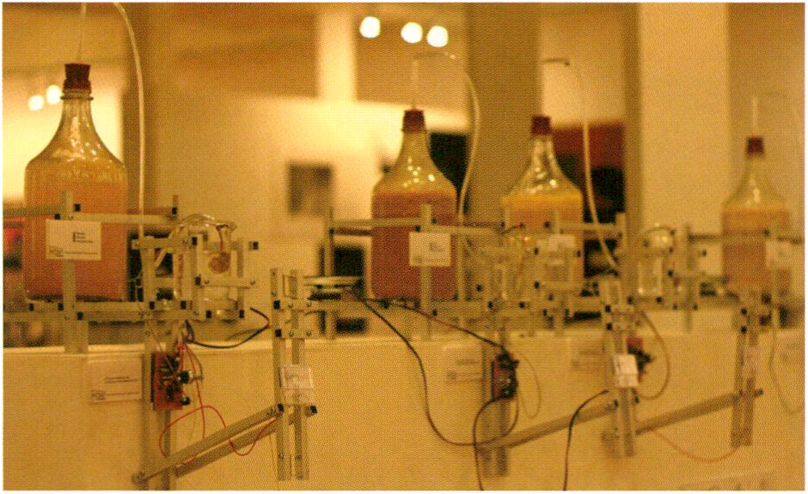
Intelligent Bacteria - Saccaromyces cerevisiae by HONF

Intelligent Bacteria - Saccharomyces cerevisiae (2010)
HONF (House of Natural Fibre) (id)
Intelligent Bacteria - Saccharomyces cerevisiae is an artistic research project,
manifested in the form of an acoustic and performative installation that re-
sponds to the high number of poisonings and deaths of alcohol consumers in
Indonesia. The unsterilised processing of alcohol, conducted by large sectors
of the society, yields methanol that is unsafe to consume. Traditional and
modern technology of fermentation needs an appropriate method to produce
a safely consumable alcohol. The project is a collaborative art and biotechno-
logy work, using DIY and open source technologies intended to turn public
awareness to the local traditional culture of alcohol, and to creatively spread
knowledge about a safe alcohol fermentation process in order to produce
alcoholic drinks from Indonesian tropical fruits in an affordable and safe way.
Intelligent Bacteria - Saccharomyces cerevisiae ist ein künstlerisches Foschungs-
projekt in Form einer akustisch-performativen Installation und eine Reaktion auf
die hohe Zahl von Vergiftungen und Todesopfern, die die nicht sterile Herstellung
von Alkohol in Indonesien zu verantworten hat. Aufgrund des gesetzlichen Ver-
bots von Alkohol produzieren große Teile der Bevölkerung unwissentlich giftiges,
ungenießbares Methanol. Traditionelle und moderne Fermentationsprozesse müs-
sen korrekt durchgeführt werden, damit der Alkohol genießbar wird. Das Projekt
vereint Kunst und Biotechnologie sowie DIY und Open Source-Technologien.
Ziele des Projekts sind, der Öffentlichkeit den traditionell-lokalen Umgang mit
Alkohol wieder näher zu bringen, indem es u.a. zeigt, wie man auf sichere und
kostengünstige Weise vom Reichtum tropischer Früchte profitiert, wenn man sie
zu alkoholischen Getränken fermentiert.
- bacteria orchestra, p. 135
- Intelligtent Bacteria workshop, p. 68
TRflTlSTTlEDIRLE RUJfiRD
*n
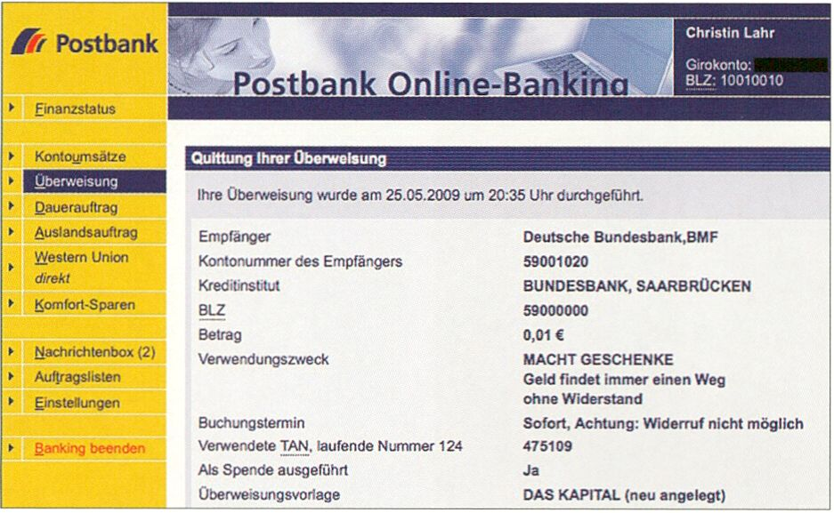MACHT GESCHENKE: DAS KAPITAL - Kritik der politischen Ökonomie
Schenkung, Überweisung von Kapital an das Bundesministerium der Finanzen,
2009 - ca. 2052, Christin Lahr (de)
TRRT1STT1EDIALE RUJfiRD
MACHT GESCHENKE: DAS KAPITAL by Christin Lahr
tB
Since 31 May 2009, every day Lahr has transferred one cent to the German
Federal Ministry of Finance, thus helping to counter the growing mountain of
debt. In the ‘reason for payment’ field she always writes 108 characters from
Capital: A Critique of Political Economy by Karl Marx. In this way the entire
book will be transferred into the state’s central account via online banking in
the next 43 years. The value increase of the capital investment is not included,
and nor are the required labour and time or the added value through cultural
and symbolic capital included in the calculation. The German title of Lahr’s
work, which has been nominated for the transmediale Award 2011, translates
as “CAPITAL PRESENTS: CAPITAL - A Critique of Political Economy Donation,
Transfers of Capital to the Federal Ministry of Finance, 2009 - ca. 2052”, em-
ploying wordplay which could also mean ‘create gifts’, ‘gifts of power’ as well
as ‘powerful gifts’. During transmediale.11, the artist will install her workstation
temporarily in the Haus der Kulturen, exposing bureaucratic structures and de-
livering an illustrative insight into the ‘cultivation’ of capital.
Seit dem 31. Mai 2009 überweist Lahr täglich 1 Cent an das Bundesfinanzminis-
terium und wirkt damit dem wachsenden Schuldenberg entgegen. In den „Ver-
wendungszweck“ schreibt sie jeweils 108 Zeichen aus Marx, Das Kapital. So wird
innerhalb der nächsten 43 Jahre das gesamte Buch per Online-Banking auf das
zentrale Konto des Staates übertragen. Die Wertsteigerung der Kapitalanlage Ist
hierbei noch ebenso wenig berücksichtigt wie die eingesetzte Arbeitskraft, Le-
benszeit oder Wertschöpfung durch kulturelles und symbolisches Kapital.
Während der transmediale.11 verlegt Christin Lahr, die mit dieser Arbeit für den
transmediale Award 2011 nominiert ist, ihren Arbeitsplatz in das HKW, offenbart
bürokratische Strukturen und gewährt bildhafte Einblicke in die Bildung von
Kapital.
Newton by Ho Tzu Nyen, courtesy of Osage Gallery
Newton (2009)
Ho Tzu Nyen (sg)
Ho Tzu Nyen’s Newton is a loop of a simple chain reaction. A white book falls
on a young, white-haired man, he begins to browse the blank pages, types
something into a blank computer screen, prints out blank pages and calls out
“action” with a megaphone, whereupon a finger pushes a white book from a
shelf. Through the title, narrative, stark visuals and meditative soundtrack,
Newton offers a laconic comment on the cognitive faculty of science and art.
At transmediale.11 Newton is permanentally projected in the corridor in front of
the film theatre.
Ho Tzu Nyens Newton ist ein Loop einer einfachen Kettenreaktion. Ein weißes
Buch fällt auf den Kopf eines weißhaarigen Mannes. Er blättert eine unbeschrie-
bene Seite in diesem Buch um und tippt auf einer Tatstatur, ohne dass Worte auf
dem weißen Computerbildschirm erscheinen. Er druckt weiße Seiten aus und
erklärt den Neustart des Loops mit einem Megaphon und dem Aufruf „Action“,
woraufhin ein Finger ein weißes Buch aus einem Regal schiebt. Sowohl durch den
Titel als auch durch die meditativen Klänge des maschinellen Soundtracks wird
Newton zu einem lakonischen Kommentar der Erkenntnisfähigkeit von Wissen-
schaft und Kunst.
Auf der transmediale.11 wird Newton im Gang vor dem Theatersaal als fortlaufen-
der Loop gezeigt.
> Ho Tzu Nyen Special, p. 107
TRflnsmEDIflLE RUJflRD

HS

Discover what's after your facebook life.
We assist your virtual identity suicide.
LEARN MORE >*

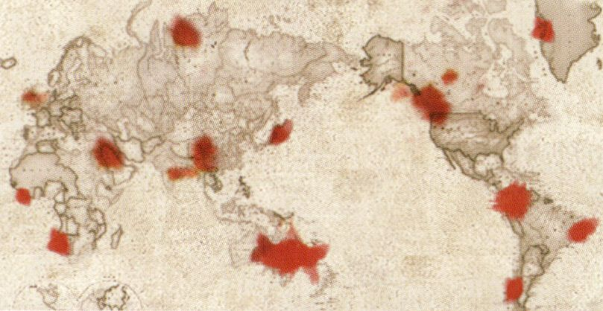
Seppukoo.com by Les Liens Invisibles

TRflnSTTlEDIflLE RUiflRD
Seppukoo.com (2009)
Les Liens Invisibles (it)
Seppukoo.com is a vir(tu)al suicide service
for Facebook users. With distinctions between
real and virtual becoming more and more
confused our privacy, profiles, identities and
relationships are exploited to be sold as pro-
ducts. But rather than to fall into the hands of
their enemies, ancient Japanese samurai pre-
ferred to die with honour by plunging a sword
into his own abdomen. As the Seppuku re-
stores the samurai’s honour as a warrior,
Seppukoo.com, in an ironic, playful and
surreal way, deals with the liberation of the
digital body in order to help people discover
what happens after virtual life and to redis-
cover the importance of being someone,
instead of pretending to be someone.
The only relic of a project, which started as
a memorial for profiles and eventually got
banned, is a memorial of the project itself.
For the duration of transmediale.11, Les Liens
Invisible will screen, in the familiar style of film
credits, the names of the about 20,000 users
who committed suicide on Seppukoo.com.
Seppukoo.com ist ein viraler und virtueller
Selbstmord-Service für Facebook-User. Mit
immer undurchsichtigeren Grenzen zwischen
dem Realen und dem Virtuellen werden unsere
Privatsphäre, Profile, Identitäten und Beziehun-
gen als lukrativen Produkte ausgebeutet. Der
alte japanische Samurai aber, eher als sich
Feindeshänden auszuliefern, starb ehrenhaft
durch den Stoß mit dem Schwert in den eige-
nen Bauch. Ähnlich wie das Seppuku die krie-
gerische Ehre des Samurai bewahrte, steht
auch bei Seppukoo.com die Befreiung des di-
gitalen Körpers im Vordergrund. Auf ironische,
spielerische und sureale Weise geht es hier da-
rum, zu entdecken, was nach dem virtuellen
Leben kommt, bzw. wieder zu entdecken, was
es heißt, wirklich eine Person zu sein, anstatt
so zu tun als ob.
Das, was von dem mittlerweile verbotenen
Projekt einer Art Friedhof für Online-Proflle
noch existiert, ist bereits selbst nurmehr eine
Erinnerung: Für die Dauer dertransmediale.11
werden Les Liens Invisibles die Namen der ca.
- User, die mittels Seppukoo.com Selbst-
mord begangen haben, als einen Filmabspann
projizieren.

- Repetitionr, p. 89
- The Right to Exit, p. 110

$ □ □ IJ
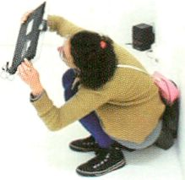

TRflnsmEDIflLE AWARD
Spatial Sound Sculpture by Christopher Warnow & Daniel Franke
Spatial Sound Sculpture (2009)
Christopher Warnow (de), Daniel Franke (de)
Inspired by VR-sculptures, technically and
conceptually transcending the helmet-like
‘90ies data-glasses’, Warnow and Franke’s
Spatial Sound Sculpture reorganises the
relationship between the viewer and the
viewed. A portable screen is used to visualise
the Spatial Sound Sculpture, combined with a
composition by Rutger Zuydervelt. A camera
attached to the screen collects information
of the space while the screen becomes a
transmitter superimposing a digital layer -
the sculpture - onto the space surrounding
the viewer. The process of Spatial Sound
Sculpture allows the viewer to abandon the
passive position of the merely on-looking
consumer; they are enabled to visually and
acoustically intervene with the sculpture,
which is hence individually linked to each
observer.
At transmediale.11 the Spatial Sound
Sculpture is installed in the Archive Room of
the HKW.
> Spatial Sound Sculpture presentations, p. 75
Daniel Franke und Christopher Warnow reorga-
nisieren mit der Spatial Sound Sculpture die
Beziehung zwischen Beobachter und Objekt.
Die interaktive Arbeit hebt die Nähe zu virtueller
Realität perspektivisch, konzeptionell und in
der technischen Ausgestaltung auf eine neue
Ebene. Die Spatial Sound Sculpture wird mittels
eines tragbaren Bildschirms visualisiert und
interpretiert eine Komposition von Rutger
Zuydervelt. Eine Kamera sammelt Informatio-
nen vom umliegenden Raum, während der
Bildschirm als Transmitter fungiert: Er legt die
digitale Ebene der Spatial Sound Sculpture
über den realen Raum. Der Betrachter verlässt
die traditionell passive Rolle des Beobachters
und interagiert nun mit der Skulptur auf visuelle
und auditive Weise.
Auf der transmediale.11 ist die Spatial Sound
Sculpture im Archivraum des HKW ausgestellt.
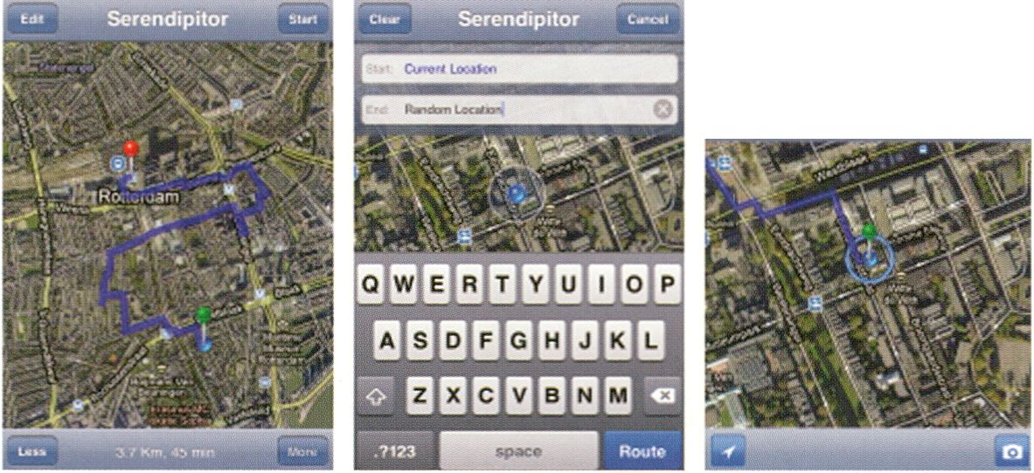
tm Serendipitor h*«i
Head northwest on Eendrachtsstraat
toward V/estblaak arid neaa «ward
We river If Were is no river nearby, make
one.
Serendipitor by Mark Shepard

Serendipitor (2010)
TRRTlSTTlEDIfiLE RUJRRD
ss
Mark Shepard (us)
In the near-future, finding our way from point A to point B will not be the
problem. Maintaining consciousness of what happens along the way might
be more difficult. Serendipitor is an alternative navigation app for the iPhone
that helps you find something by looking for something else. Combining
computer generated walking directions with instructions for movement and
action inspired by Fluxus, Vito Acconci and Yoko Ono (among others), the app
attempts to produce minor detours and small slippages within an otherwise
optimal and efficient route through the city.
At transmediale.11, visitors will be able to try out the app, download it to their
iPhone, and participate in a series of serendipitous city walks organised during
the festival.
Serendipitor is part of the Sentient City Survival Kit - a collection of artifacts
for survival in the near-future sentient city that critically explore the evolving
relation between ubiquitous computing, architecture and urban space.
Schon bald wird es überhaupt kein Problem mehr darstellen, von A nach B zu
kommen. Dabei mitzukriegen, was auf diesem Weg so passiert, wird viel schwie-
riger sein. Serendipitor ist eine alternative Navigations-App für das IPhone, mit
der man Dinge finden kann, während man eigentlich etwas Anderes sucht: Die
App fügt kleinere Umwege und Verzögerungen in eine ansonsten optimierte und
effiziente Route ein. Dazu werden Computer-generierte Richtungsangaben für
Fußgänger mit Bewegungs- oder Handlungsvorschlägen im Stil von Fluxus, Vito
Acconci oder Yoko Ono u.a. kombiniert.
Besucher der transmediale.11 können die App testen, sie auf ihr iPhone herunter-
laden sowie an einigen mit glücklichen Zufällen gespickten Stadtspaziergängen
teilnehmen.
Serendipitor gehört zum Sentient City Survival Kit - einer Reihe von Kunstge-
genständen zum Überleben in der fühlenden' Stadt der nahen Zukunft, die sich
kritisch mit der wichtiger werdenden Beziehung zwischen allgegenwärtiger Da-
tenverarbeitung, Architektur und urbanem Raum befassen.
> Serendipitor artist walks and workshop, p. 92
Wikipedia Art (2009)
Scott Kildall (us), Nathaniel Stern (us)
Since February 2009 Scott Kildall and Nathaniel Stern have been pointing out
Wikipedia’s strict standardisation and publication processes through their
performative web project Wikipedia Art. Although their intervention on
wikipedia.org was shut down after only 15 hours the project sparked a lively
debate around issues such as bias, consensus over credentials, reliability,
accuracy, vandalism etc.
Mid-November 2010, Kildall and Stern proposed that the CRUMB mailing list
collaboratively address the question of how Wikipedia Art, a piece which
manifested itself in the form of web-based dialogues and debates, could be
exhibited at transmediale.11. The collective decision was to invite visitors to
follow up on the documented conversations around the deletion debate as well
as see a paper print-out of the original Wikipedia Art page via an installation on
two video screens and an additional print-out.
Seit Februar 2009 machen Scott Kildall und Nathaniel Stern mit ihrem performati-
ven Webprojekt Wikipedia Art auf die strengen Standardisierungs- und Publikati-
onspolitiken bei Wikipedia aufmerksam. Ihre Intervention auf wikipedia.org wurde
zwar nur 15 Stunden geduldet, die Diskussion über die angestoßenen Fragen zu
Themen wie Voreingenommenheit, dem Streben nach Konsens statt nach Zuver-
lässigkeit und Richtigkeit sowie dem Vorwurf des Vandalismus ist jedoch seither
voll entfacht. Mitte November wurde auf Initiative von Kildall und Stern in der
CRUMB Mailingliste diskutiert, wie das Projekt, welches selbst durch Dialoge und
Diskussionen im Web entstanden und gewachsen ist, bei dertransmediale.11 prä-
sentiert werden soll. Gemeinsam wurde entschieden, den Besuchern durch zwei
Video-Screens sowie einem Ausdruck in Papierform Einblick in die Löschungs-
Debatte zu geben.
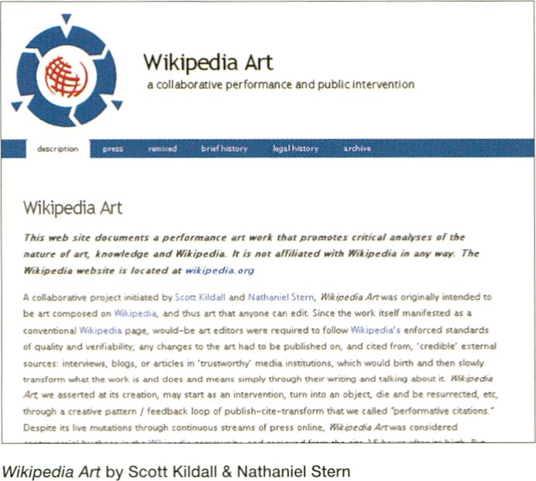> The Right to Exit, p. 110
TRflnSTTIEDIRLE fiUJRRD
Uilém Flusser Theory Award

UILETT1 FLUSSER THEORY RUJRRD
All of the four nominees introduce their work through presentations, workshops and installations.
Alle vier Nominierten werden ihre Werke im Rahmen von Präsentationen, Workshops und Installationen auf der transmediale.11 vorstellen.
The Vilém Flusser Theory Award was initiated
in 2008 as a collaboration with the _Vilém_
Flusser_Archiv of the University of Arts, Berlin
(UdK) and promotes innovative media theory
and practice-oriented research exploring
current and pending positions in digital art,
media culture and networked society. The
call was open to publications, positions, and
projects from a broad range of theoretical,
artistic, critical or design-based research that
seeks to establish and define new forms of
exchange, vocabularies and cultural dialogue.
This year’s jury members were Marcel René
Marburger, Nils Roller, Alexander Galloway
and Carolyn Guertin. They nominated four
projects and the winner will be announced at
the transmediale Award Ceremony on 5
February 2011.
Social Tesseracting_: Parts 1 -3 (2009)
Mez Breeze (au)
With the project Social Tesseractingj Parts
- 3, the Australian theorist and futurist Mez
Breeze examines how processes of
knowledge production and entertainment
models change under the influence of
synthetic/networked stimuli. The work
belongs to the _Augmentology 1[L]0[L]1_
project which addresses how information is
constructed in synthetic environments. Each
Social Tesseracting_ entry adheres to the
overarching project aim whereby content is:
“...constructed to reflect how participants
absorb information within attention
economies and synthetic environments.”
Social Tesseracting is a three part series of
link-rich blog entries that functionally
describe how synthetics - people who explore
within and create augmented/cross-reality
platforms - operate in emergent social areas.
These entries expand upon earlier concepts
regarding networked encounters as
explored in _Augmentotogy 1[L]0[L]1_.
_Social Tesseracting_: Parts 1 - 3 is installed at the Upper Foyer of HKW.
Der Vilém Flusser Theory Award (VFTA) wird seit
2008 gemeinsam mit dem _Vilém_Flusser_Archiv
der Universität der Künste in Berlin (UdK) ver-
geben und fördert innovative medientheoreti-
sche und praxisbasierte Forschungsprojekte, die
aktuelle Positionen digitaler Kunst und Kultur
vorstellen. Gesucht werden Projekte, Positionen
und Texte die jenseits festgefügter Methoden
einen transdisziplinären Kontext zwischen
kunstbasierter Forschung und medientheoreti-
schem Diskurs schaffen. Dieses Jahr wurden
vier Projekte von den Jurymitgliedern Marcel
René Marburger, Nils Roller, Alexander Galloway
und Carolyn Guertin für die Auszeichnung nomi-
niert. Der Gewinner am 5. Februar 2011 im Rah-
men der transmediale Award Ceremony bekannt
gegeben.
Mit dem Projekt _Social Tesseractingj Parts
1- 3 untersucht die australische Spieletheoreti-
kerin Mez Breeze, wie sich Wissensbildungs-
prozesse und Unterhaltunsmodelle unter der
Einwirkung künstlicher/vernetzter Stimuli
verändern. Die Arbeit ist Teil des Augmentology
1[L]0[L]1 _project, das sich mit Informationsauf-
nahme innerhalb künstlicher Umwelten befasst
und seine Erkenntnisse per Verlinkungen
zugänglich macht. Jeder _Social Tesseracting_-
Eintrag untersucht, „wie Teilnehmer innerhalb
von Aufmerksamkeitsökonomien und künstli-
chen Umwelten Informationen aufnehmen.“
Social Tesseracting besteht aus einer dreiteili-
gen Reihe von Blogeinträgen, die u.a. unter
Verwendung von Rich-Links beschreiben, wie
„Synthetics“ - also Menschen, die an und mit
Augmented/Cross-Reality Plattformen arbeiten
- sich in neu entstehenden gesellschaftlichen
Kontexten verhalten. Diese Einträge bauen auf
_Augmentology 1[L]0[L]1_, älteren Ideen zu
Begegnungen im Netz, auf.

St

GATHERINGS 1: EVENT, AGENCY, AND PROGRAM (2010)
Jordan Crandall (us)
In a modern, calculatlve world, the techniques of tracking are steadily In-
creasing everywhere. Enhanced by algorithmic procedures and analytics, they
have been incorporated into distributed network systems, augmented by new
sensing and locationing technologies, and embedded into mobile devices,
urban structures and environments. As the urban realm is understood through
the spatialisation of algorithmic operations, with all phenomena converted,
standardised, and rendered interoperable, it is endowed with cognitive and
agential abilities. Now able to track, sense and respond to phenomena with a
degree of autonomy, it complicates conventional ontological distinctions and
political orientations. Crandall’s essay offers new formats of analysis for these
tracking practices and the agential status of the hybrid urban entities that they
register and engender. The key analytical tool and structuring principle intro-
duced is that of “program” - a guiding principle of structural inclination,
standardisation, and coupling that is rooted not simply in code but in practice.
The political challenge is to grasp what it registers and demands. From this
basis, a politics of “program” can be oriented around the constitution of the
event.
In einer modernen, berechnenden Welt sind Tracking-Verfahren an der Tagesord-
nung. Durch algorithmische Prozesse und Analysen wurden sie - verbessert
durch neue Sensor- und Ortungstechniken - als Bestandteile tragbarer Geräte,
urbaner Strukturen und Umwelten zunehmend Teil dezentraler Netzwerke. In dem
Maß wie der urbane Raum sich heute durch die Verräumlichung algorithmischer
Prozesse, in denen jegliche Phänomene umgewandelt, standardisiert und inter-
funktionell angepasst werden können, ergibt, kommen ihm kognitive und hand-
lungsorientierte Fähigkeiten zu: Der Stadtraum ist in der Lage, Phänomene unab-
hängig zu tracken, zu verzeichnen, bzw. auf Phänomene zu reagieren. Die Art und
Weise, wie das geschieht, verkompliziert bisherige ontologische Unterscheidun-
gen und politische Ausrichtungen. Der Essay von Jordan Crandall bietet neue
Analyseformen für diese Trackingmethoden und die beinahe handlungsfähige
Gestalt der neuen, urbanen Hybride, die einerseits registriert, andererseits erzeugt
werden. Als wichtigstes analytisches Werkzeug und Strukturprinzip fungiert der
Begriff Programm - ein Leitprinzip für strukturelle Neigungen sowie zur Standardi-
sierung und Paarung, das nicht einfach auf Code beruht, sondern auf der Praxis.
Die politische Herausforderung besteht darin, zu erkennen, was „Programm“ auf-
nimmt und fordert. Von dieser Ausgangsposition aus gilt es eine Politik des Pro-
gramms ins Leben zu rufen, die sich in der Nähe des enstehenden Ereignisses
befindet.
> GATHERINGS 1... performative lecture, p. 97
UILETT1 FLUSSER THEORY RUJRRD
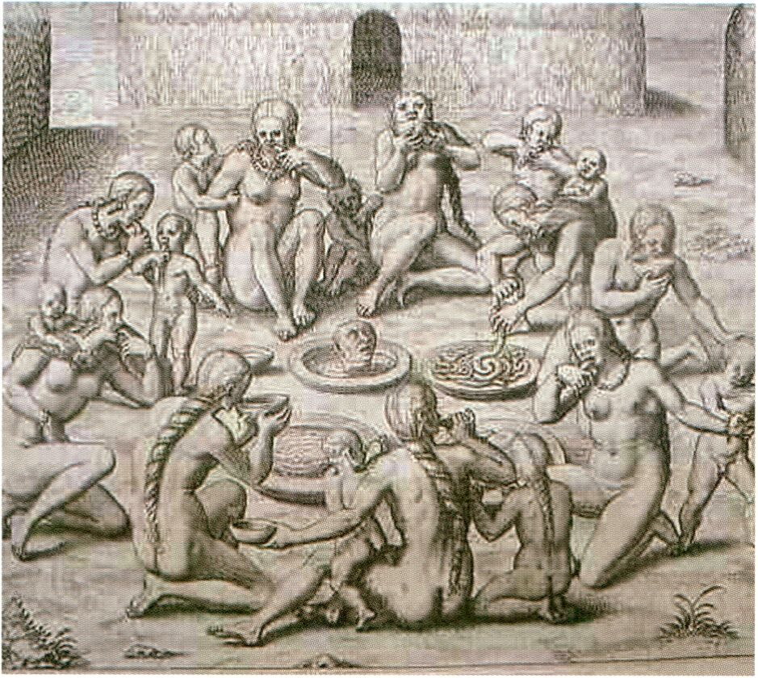
UILETTl FLUSSER THEORY RUJñRD
Copper engravings of J. de Lévy: le Voyage au Brézil de Jean de Lévy 1556 - 1558
(Theodore de Bry, La Rochelle, 1578), courtesy Vanessa Ramos-Velasquez
Digital Anthropophagy and the Anthropophagie Re-Manifesto for the Digital Age (2010)
Vanessa Ramos-Velasquez (br/us)
Vanessa Ramos-Velasquez has created a
manifesto-poem with a new take on the
original Manifesto Antropófago written by
the Brazilian modernist author Oswald de
Andrade in 1928. His manifesto was an
assertion of the unique Brazilian voice in the
emerging modern time, away from clichés of
colonialism, while unapologetically meta-
bolising outside references from the First
World. Her Digital Anthropophagy paper con-
taining the Anthropophagie Re-Manifesto
seeks to update the anthropophagie practice
of cultural cannibalism with regard to the
digital age, where the virtual world is the new
frontier, and everyone a possible coloniser.
Vanessa Ramos-Velasquez hat ein Gedicht-Mani-
fest geschrieben, das sich - als Neuinterpretati-
on - an das Manifestó Antropófago ihres Lands-
mannes Oswald de Andrade von 1928 anlehnt.
In Andrades Manifest, behauptete sich die brasi-
lianische Stimme in der aufkeimenden Moderne
durch die offensive Einverleibung westlicher Re-
ferenzen weitab von Kolonialismusklischees. In
ihrem Digital Anthropophagy-Text holt Ramos-
Velasquez anthropophagische, ,kannibale‘ Kul-
turpraktiken mit Blick auf das digitale Zeitalter in
die Gegenwart herüber: In der heutigen Zeit stellt
die virtuelle Welt das neue Grenzland dar. Jeder
ist hier potentiell in der Lage, kolonisiert zu wer-
den und zu kolonisieren.

> Digital Anthropophagy lecture, p. 74
Zombie Media: Circuit Bending Media Archaeology into an Art (2010)
Garnet Hertz (ca), Jussi Parrikka (fi)

add your
content
here
UILETT1 FLUSSER THEORY flUJRRD
In their essay Zombie Media, Garnet Hertz
and Jussi Parikka investigate the planned
obsolescence, media culture and various
temporalities of media objects. There is
always a better camera, laptop, mobile phone
on the horizon: new media always becomes
old. Garnet Hertz and Jussi Parikka approach
this phenomenon under the notion of media
archaeology and aim to extend it into an art
methodology. Hence, media archaeology
becomes not only a method for excavation
of the repressed, the forgotten, the past, but
extends itself into an artistic method close to
Do-It-Yourself (DIY) culture, circuit bending,
hardware hacking and other exercises that
are closely related to the political economy
of information technology. Media embodies
memory, but not only human memory.
- Zombie Media workshop and presentation, p. 98
- Democratic:Ability, p. 104


Mit ihrem Essay Zombie Media untersuchen
Gamet Hertz und Jussi Parikka die eingeplante
Veralterung, Medienkultur und verschiedene
Zeitlichkeiten von Mediengeräten. Neue Medien
altern schneller denn je - es ist immer eine bes-
sere Kamera, ein besserer Computer oder ein
besseres Handy in Aussicht. Hertz und Parikka
starten unter dem Oberbegriff Medienarchäolo-
gie, den sie aber zu einer künstlerischen Metho-
de ausweiten möchten. Medienarchäologie wird
dadurch nicht nur zu einer Ausgrabungsmetho-
de von Unterdrücktem, Vergessenem und Ver-
gangenem, sondern erweitert sich zu einer
künstlerischen Methode ähnlich wie Do-it-Your-
self, Circuit Bending, Hardware Hacking und
andere Praktiken, die in einem engem Bezug
mit der politischen Ökonomie von Informations-
technologien stehen. Medien ist ein Gedächtnis
eingeschrieben, und zwar nicht nur das
menschliche.


Sourcefabric believes in quality, independent journalism. We
provide media organisations with the open source software,
tools and support to produce it, no matter what their
resources or location.
SOURCEFABRIC
www.sourcefabric.org

si

□pen Uleb Award
At the end of September 2010 the transmediale Award jury was joined by
Henrik Moltke, Drumbeat’s European Projects Producer, to select the
candidates for the first ever Open Web Award!
From about 100 diverse entries from around the world the jury chose three
works that met the Open Web Award requirements of critical and innovative
new projects in the realm of artistic practice that use and promote open tech-
nologies, incite collaborative methodologies and clearly demonstrate the
unbound potential of the open web in ways that can spark new thinking and
practice. The winner of the Open Web Award 2011, to be announced at trans-
mediale.11 ’s Award Ceremony on 5 February 2011. The nominated works are
available on Drumbeat for a public vote that will determine the winner of this
award. In order to leave your vote and comment on the project please register
as a user on the Mozilla Drumbeat Platform where the projects are being
hosted. Doing this requires only a few simple steps and voting is open until
4 February 2011.
□PET! UJEB flUJRRD
At transmediale.11 the three Open Web Award nominees present their project
with installations, workshops and/or presentations in the Open Web Award
area of The Open Zone in the Foyer of the HKW.
Ende September trat Henrik Moltke, der europäische Project Producer von
Mozilla/Drumbeat, zur transmediale Award-Jury hinzu , um gemeinsam die
Kandidaten für die erste Ausgabe des neuen Open Web Award auszuwählen.
Aus gut 100 sehr unterschiedlichen Einreichungen aus der ganzen Welt nomi-
nierte die Jury schließlich drei Arbeiten: Kritische und neuartige künstlerische
Innovationen, die auf offenen Technologien beruhen, kollaborative Ansätze
verfolgen und das unbegrenzte Potential eines offenen Netzes nicht nur auf
mitreißende Weise vorführen, sondern vor allem auch zu neuen Ideen und
Herangehensweisen anregen. Bekannt gegeben wird der Gewinner des Open
Web Award 2011 am 5. Februar 2011 während der Award Ceremony der trans-
mediale.11. Neben einer Geldsumme von 5000,- Euro umfasst der Preis eine
hervorgehobene Stellung als offiziell unterstütztes Projekt auf der Mozilla
Drumbeat Plattform im Internet.
Der endgültige Gewinner der drei nominierten Arbeiten wird durch ein Public
Voting ermittelt. Um sich bis 4. Februar 2011 an der Wahl zu beteiligen, bezie-
hungsweise auch um ein Feedback zu den jeweiligen Arbeiten zu hinterlassen,
ist es erforderlich auf der Mozilla Drumbeat Plattform zunächst in wenigen
Schritten ein User-Profil zu erstellen.
Auf der transmediale.11 präsentieren die drei Open Web Award-Nominierten
ihre Projekte in Form von Installationen, Workshops und/oder Präsentationen
in der Open Web Award area der Open Zone im Foyer des HKW.
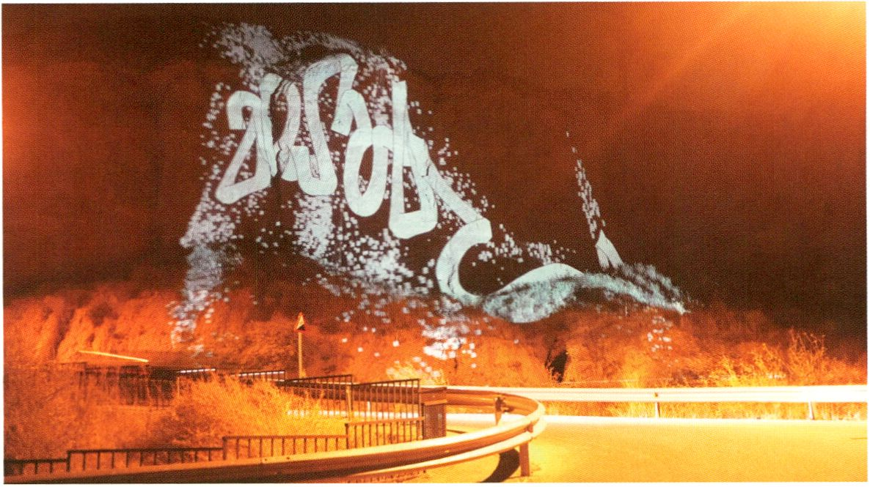
Graffiti Analysis / Graffiti Markup Language by Evan Roth

Graffiti Analysis / Graffiti Markup Language (GML) (2010)
Evan Roth (us)
0PET1 UJEB AWARD
The Graffiti Analysis project studies and captures the motion of graffiti writers,
using custom open source software. Visualisations of the gestures involved
are recorded, analysed and archived using the Graffiti Markup Language, a
universal, XML based, open file format.
Throughout transmediale.11 a three channel video installation will showcase
this work. Raw footage of graffiti tags written and tracked with the Graffiti
Analysis software will be shown alongside visualisations from the motion
cap-ture software and additional footage taken from cameras mounted on
spray paint cans, a POV perspective that further highlights the gestural
movement of a tag. Hacked writing devices such as markers and spray paint
cans used for motion capture will also be on display at the festival while all
related software, source code and .gml data are available online for free.
Graffiti Analysis ist ein Bewegungsstudienprojekt über Graffiti Writing, das auf
einer eigens geschriebenen Open Source-Software fußt. Die Graffiti Markup
Language, ein universelles, XML-basiertes, offenes Dateiformat zeichnet Schreib-
gesten auf und analysiert sowie archiviert diese.
Auf der transmediale.11 präsentiert eine 3-Kanal Videoinstallation die Arbeit.
Neben einer Dokumentation über die Motion Capture Software wird z. B. auch
Footage von auf Sprühdosen montierten Kameras gezeigt und Tagger-Bewe-
gungen so in der Point-of-View Perspektive verdeutlicht. Außerdem werden für
Graffiti Analysis modifizierte Schreib-Tools wie Marker und Dosen ausgestellt.
Software, Source Code und .gml Daten stehen online kostenlos zur Verfügung.
Booki
FLOSS MANUALS: Adam Hyde (nz), Douglas Bagnall (nz), Aleksandar Erkalovic (hr)
Booki is a free service and social network for the creation of books: real paper
books that look good and you can hold in your hand or e-pubs (electronic books),
PDFs, .odt (Open Office / Open Document files), web pages and more. Booki is
designed to help you produce books, either by yourself or with others. One way
to develop content is through Book Sprints - intensive collaborative three to five
days events where 5 to 10 people focus on writing a book, which can ultimately
be uploaded to one's favourite Print on Demand service anywhere in the world.
Whether you are collaborating, writing solo, rapidly developing books or taking
your time, when you have worked with Booki you will never think of publishing
the same way again. Booki is developed by FLOSS Manuals and is Free Soft-
ware licensed under the General Public Licence (GPL 2+). This means that it can
be freely downloaded, re-used and customised.
OPEn UJEB AWARD
At transmediale.11 the Booki installation can be visited in the form of the Booki
Mobile in the Open Zone, Open Web Award area.
Booki ist ein Soziales Netzwerk mit Fokus auf die kostenlose Herstellung von
Büchern: Bücher, die man entweder als echte, auf Papier gedruckte, schöne
Gegenstände in den Händen halten kann oder die als E-Publikation, PDFs, .odts,
Webseiten oder in anderen Format kommen. Booki liefert eine Infrastruktur zur
Erstellung von Inhalten - allein oder in kollaborativen Kontexten. Eine Möglichkeit
dazu liefern die Book Sprints: intensive, kollektive Produktionsphasen von maximal
fünf Tagen, in denen sich 5 bis 10 Personen darauf konzentrieren, im Schnellver-
fahren ein Buch zu machen, das am Ende überall auf der Welt via Print on Demand
ausgedruckt werden kann.
Wer einmal auf die eine oder andere Weise mit Booki gearbeitet hat, bekommt
einen gänzlich neuen Blick darauf, was es heißt verlegerisch tätig zu sein. Booki
wurde von FLOSS Manuals entwickelt und ist eine Free Software die unter dem
General Public License (GPL 2+) lizenziert ist, was bedeutet, dass Booki kostenlos
heruntergeladen, weiterverwendet und angepasst werden kann.
Auf der transmediale.11 kann man Booki in der Open Zone besuchen. In der Open
Web Award area steht die mobile Druckwerkstatt, das Booki-Mobil.
- Booki workshop & Booki Mobile, p. 100
- Book Sprint p. 161
thimbl (2010)
Dmytri Kleiner (ca/ru) / Telekommunisten
On the surface, thimbl appears to be yet another microblogging service similar
to twitter or identi.ca. However, thimbl is a specialised web-based client for a
User Information protocol called Finger. The Finger Protocol was originally de-
veloped in the 1970's, and as such is already supported by all existing server
platforms. So whilst thimbl offers no way to Sign Up vitually every server on
the internet could provide thimbl accounts simply by turning their Finger on.
Lost in the hype of the Social Web is the fact that the Internet has always been
about sharing: Usenet, Email and IRC have been enabling social connections,
including citizen journalism, photo sharing, and other features of recent web-
based systems, thimbl demonstrates the potential for integrating classic inter-
net technologies into the Open Web in no more than a few minutes.
Auf den ersten Blick wirkt thimbl wie ein weitere Micro-Blogging Service ähnlich
Twitter oder identi.ca. In Wirklichkeit aber ist thimbl ein Web-basierte Client für
das schon in den 1970er Jahren entwickelte Finger-Protokoll und bietet selbst
erst einmal keine Einlog-Funktion. Nahezu jeder Internet-Server hat die Finger-
Server-Software jedoch automatisch verfügbar und könnte beliebig selbst thimbl-
Accounts anbieten.
Im Hype des „Social Web” ist die Tatsache, dass es im Internet immer schon im-
mer ums Teilen ging, verloren gegangen: Usenet, Email und IRC haben soziale
Verbindungen ermöglicht, darunter Bürgerjournalismus, Foto-Sharing und andere
Angebote der neueren Web-basierten Systeme, thimbl demonstriert das Potential
innerhalb von Minuten, Technologien des klassischen Internets in das Open Web
zu integrieren.
> thimbl workshop, p. 76
OPEn UJEB RUJRRD

thimbl by Dmytri Kleiner, Telekommunisten
El
SHIFT
IS
Q
^{AN} jm
INTERNATIONAL
FESTIVAL
FOR
ELECTRONIC
ARTS
THAT
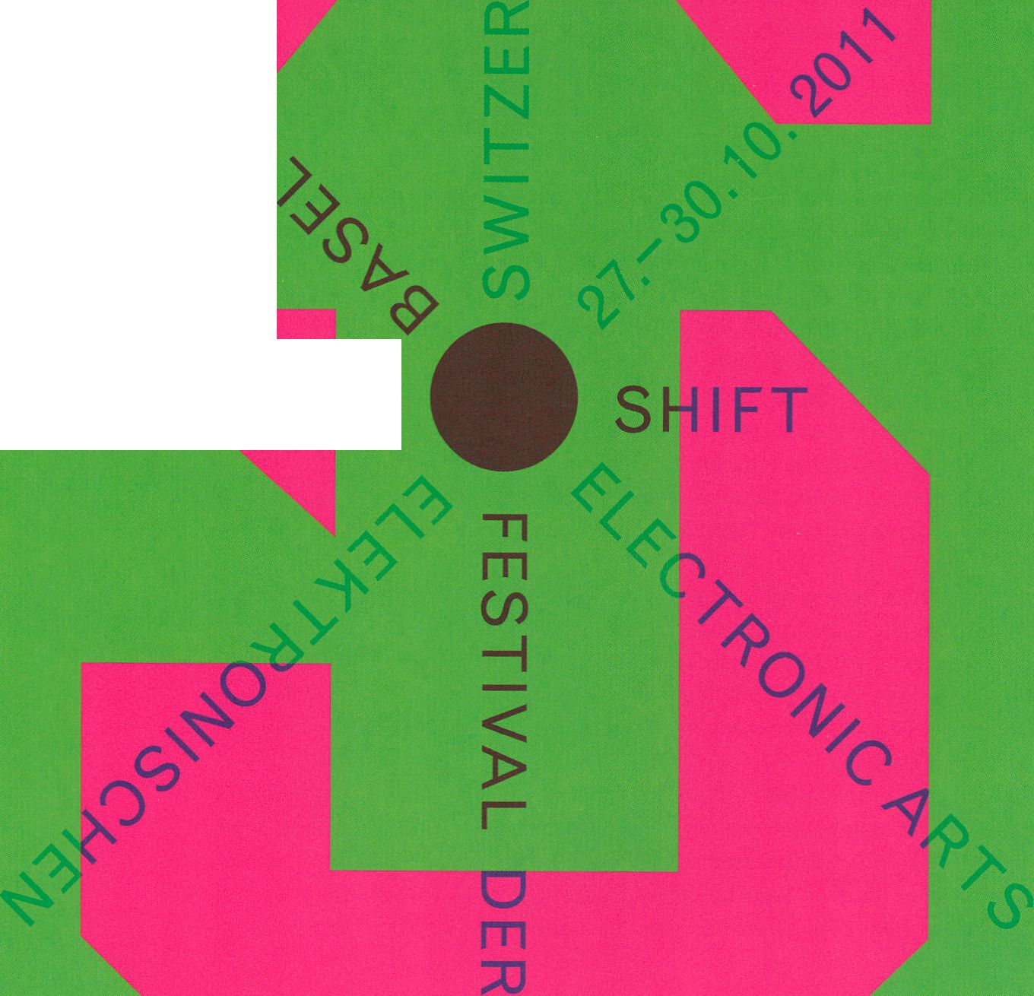INCLUDES
31SNn»
LIVE
CONCERTS,
EXHIBITIONS,
SCREENINGS,
LECTURES,
ARTISTS'
CONVERSATIONS,
STUDENTS’
PROJECTS.
WORKSHOPS
AND W
PARTIES
SHIFT
IS
PART OF
THE
HOUSE
OF
[PLUG.IN],
SHIFT
FESTIVAL
AND
DIGITAL
ART
ELECTRONIC
ARTS
ÊASEL,
A '•
MERGER
OF
COLLECTION/
STORE
THAT
WILL
OPEN
IN
: M AY 2011.
WWW.
HAUS-EK.ORG
HOUSE OF
ELECTRONIC
ARTS
BASEL

Springerin

p,| i
Abonnement
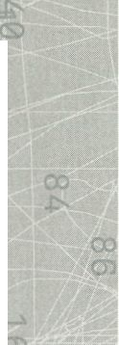
Jahresabo/4 Hefte
€39 Ausland
(zuzüglich Versandkosten)
Studentlnnenabo
€32 Ausland
(zuzüglich Versandkosten)
—f
-tfi
4N
Einzelhefte
aus den Jahrgängen 1995 bis 1998
können, sofern sie nicht vergriffen
sind, über die Redaktion bestellt
werden, ab Jahrgang 1999 direkt über
den Verlag.
Folio Verlag Wien-Bozen
Schönbrunnerstraße 31
A-1050 Wien
T +43 1 581 37 08
F +43 1 581 37 08 - 20
E office@folioverlag.com
Redaktion Springerin
Museumsplatz 1
A-1070 Wien
T +43 1 522 91 24
F +43 1 522 91 25
E springerin@springerin.at
www.Springerin.at

Denken. Fühlen.Wissen.
Deutschlandradio Kultur zurtransmedlale.n
Berichte über das Festival für Kunst
und digitale Kultur
0
5. Februar» 14:05
Breitband
montags bis donnerstags • 19:07
montags bis sonntags • 23:05
Fazit
In Berlin und auf UKW:
89,6
Weitere Informationen:
Hörerservice 0221.345-1831
oder www.dradio.de
Kulturistüberall.®
Deutschlandradio Kultur

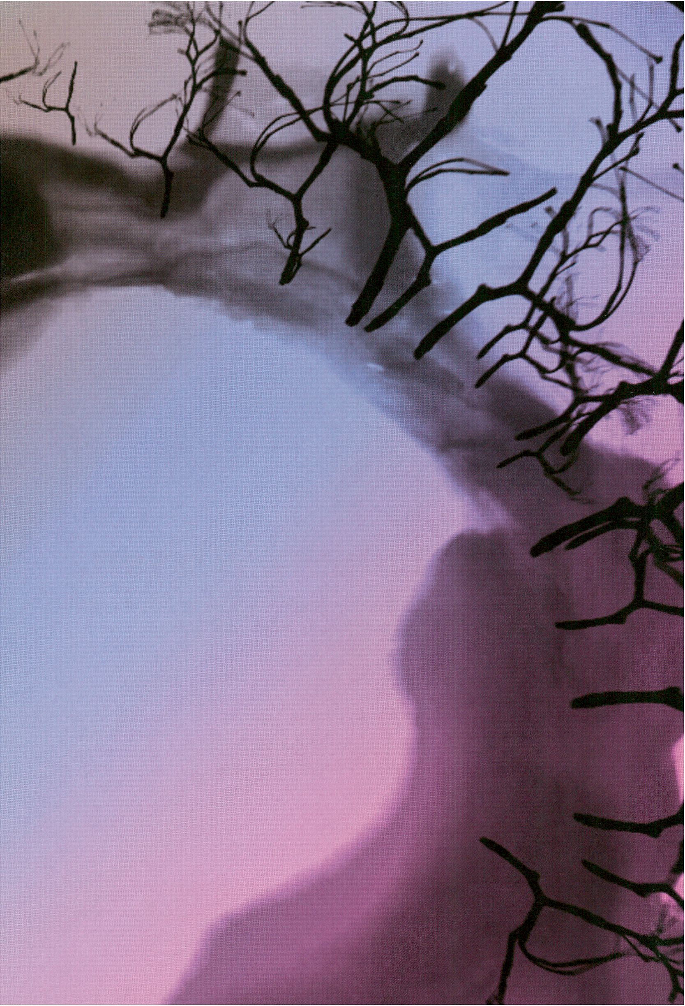

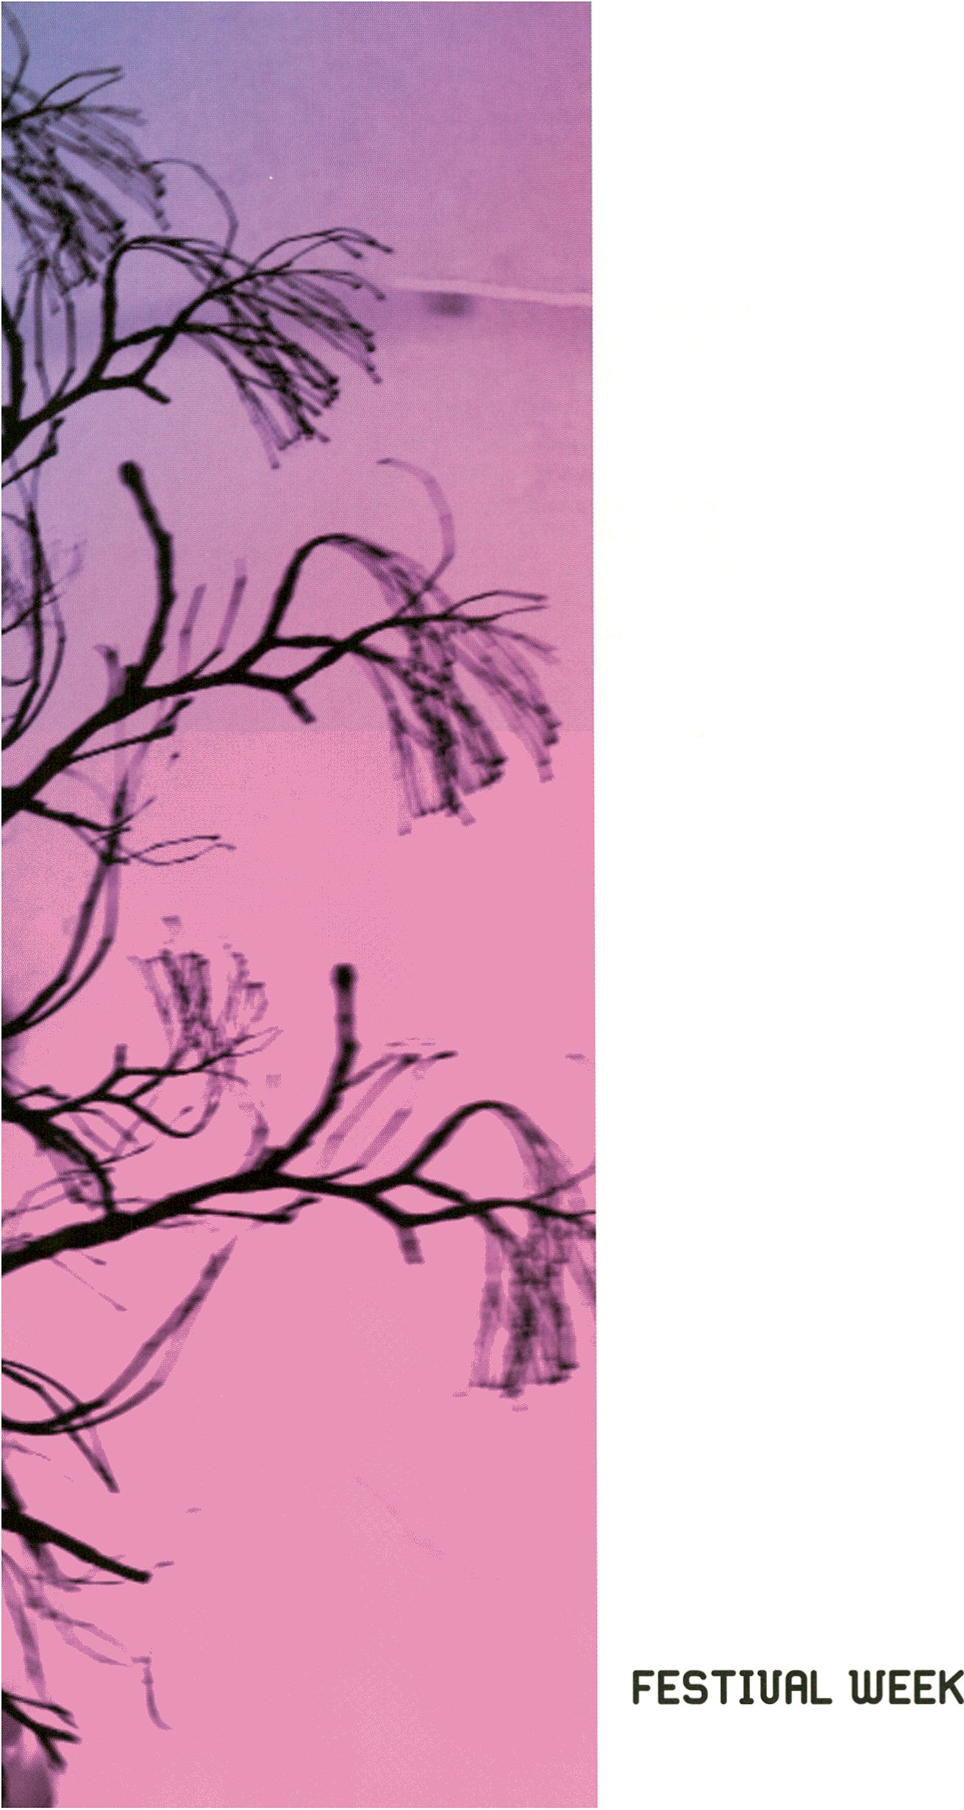

transmediale.il Opening
Start your ‘RESPONSE:ABILITY’, here and now...!
For the first time at transmediale a non-human digital personality will be
participating! Special opening guest Derrick de Kerckhove will introduce his
son, Angel_F (aka Pinocchio 2.0), a boisterous digitally conceived spyware
entity born through the technological-sensual relationship between himself and
Biodoll. Drawing reference to Marshall McLuhan’s assertion that we would
become extensions of our own machines and vice-versa Angel^F will be
seeking the archetypal myths of our relationships with technology. With a
German premiere of DUST by Herman Kolgen, a poetic reflection will be drawn
from our digital culture, inspired through one of the first works of collaborative
electronic art, Man Ray’s photo Élevage de poussière of Marcel Duchamp’s
Large Glass. transmediale.11‘s zones of artistic and critical inquiry, The Open
Zone and HacKaWay will open with labs, installations, actions and the in-
auguration of festival bureaus by Heath Bunting and Christin Lahr, and a
performance of Latent Image Protocol by Paul Vanouse who will prepare the
first of his unique DNA fingerprint samples. In the studio gallery, transmediale
hosts The Secrets Trilogy the 4th Labor Berlin merging Reynold Reynold’s
Secret Life, Secret Machine and Six Easy Pieces in a complex work that twists
the notions of time and space - the imperceptible conditions that question
the nature of our liveness within the cacophony of technological life. Enjoy!
Zum ersten Mal wird eine nicht-menschliche, digitale Person an der transmediale
teilnehmen! Als besonderer Eröffnungsgast des Festivals wird Derrick de
Kerckhove seinen Sohn Angel_F (aka Pinocchio 2.0) vorstellen: Ein übermütiges
Spyware-Wesen und digitale Frucht der technologisch-sinnlichen Beziehung
zwischen Derrick de Kerckhove und Biodoll. Unter Bezug auf Marshall McLuhans
Behauptung, wir alle würden zu Erweiterungen unserer eigenen Maschinen und
umgekehrt, sucht Angel_F nach den archetypischen Mythen für unsere Bezieh-
ungen mit der Technologie. Mit einer Deutschlandpremiere von DUST von Herman
Kolgen wird unsere digitale Kultur auf poetische Weise reflektiert. Als Inspiration
dient dabei eine der ersten kollaborativen Werke der elektronischen Künste
überhaupt, Élevage de poussière, Man Rays fotografische Aufnahme von Marcel
Duchamps Großem Glas. Mit der Open Zone und dem HacKaWay bietet die
transmediale.11 Zonen künstlerischer und kritischer Untersuchungen, deren
Labs, Installationen und Aktivitäten mit der Festivaleröffnung in Gang kommen.
Darüber hinaus beginnen am heutigen Abend auch die Festivalbüros von Heath
Bunting und Christin Lahr ihre Arbeit und es wird eine erste Performance von
Paul Vanouse geben, der in Latent Figure Protocol mit DNA-Fingerabdrücken
experimentiert. In der Studiogalerie beherbergt die transmediale die 4. Ausstel-
lung von Labor Berlin: In The Secrets Trilogy verschmelzen die drei Werke von
Reynold Reynolds Secret Life, Secret Machine und Six Easy Pieces zu einer
komplexen Arbeit, die mit Zeit und Raum spielt - gerade mit jenen kaum wahr-
nehmbaren Rahmenbedingungen also, die für unsere Erfahrung von „Liveness”
innerhalb der Kakophonie unseres technischen Lebens auschlaggebend sind.
Wir wünschen Ihnen viel Spaß auf dem Festival!
18:30 I Doors open
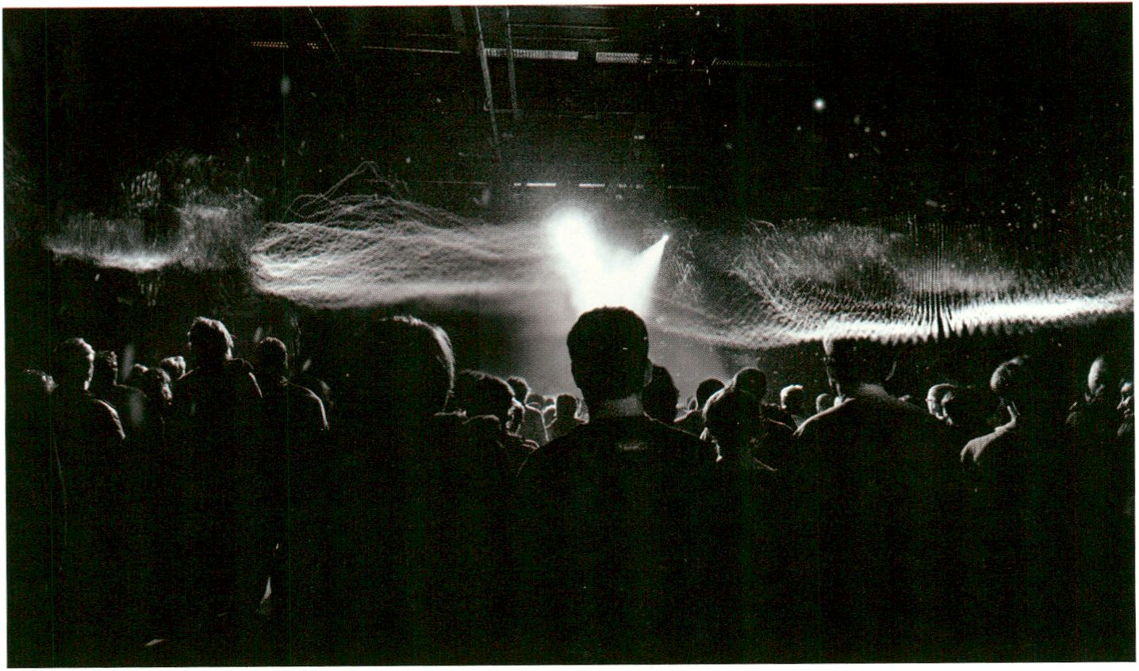
DUST by Herman Kolgen, courtesy of the artist
19:00 I Stephen Kovats - Artistic Director, transmediale.11
Prof. Derrick de Kerckhove - Research Director,
TUESDAY. FEB 1
Universität Obierta de Catalunya, Barcelona
Angel_F - Autonomous Non-Generative E-volitive Life Form (it) A/V performance:
DUST by Herman Kolgen (ca)
20:00 I transmediale.11 with The Open Zone and HacKaWay turned “On”
20:00 I Labor Berlin #4: The Secrets Trilogy by Reynold Reynolds (de/us) (p. 43)
21:00 I HacKaWay: Latent Figure Protocol by Paul Vanouse (us) (p. 97)
21:00 I Café Stage / Open Zone: Crowd vs the DJ by Christopher Doering (de) & Jay Cousins (uk)
22:30 I HacKaWay: Braun Tube Jazz Band by Ei Wada Op) (p. 78)
22:15 I Café Stage / Open Zone: Selected Videomusical Works
by Gabriel Shalom (us) & Patrizia Kommerell (de)
Following the opening events at HKW guests are invited to continue celebrating
at the CTM. For full programme see clubtransmediale.de
Im Anschluss an die Eröffnungsveranstaltung zur transmediale.11 gibt es die
Gelegenheit, im CTM weiter zu feiern. Alle Programminformationen dazu unter
clubtransmediale.de
CTM Event/Concert dljl
«m?

With the generous support of
Sir tí» CREATIVE
V. SCHERING
STIFTUNG
Québec HS
Vertretung der
Regierung von Quebec
Bl

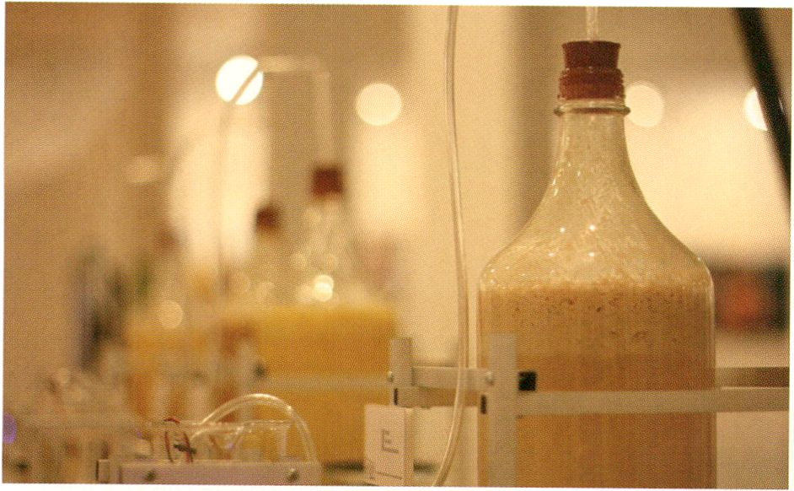
Intelligent Bacteria - Saccharomyces cerevisiae by HONF

UIEDT1ESDRY. FEB E
HacKaWay / transmediale Award | Workshop
Intelligent Bacteria: Art In Culture - How to Make Cheap and Slant Culture | with HONF (id)
10:30-14:30| HacKaWay
In this workshop members of the group HONF
teach science through an artistic approach
in order to demonstrate that science doesn’t
have to be expensive, dangerous or inacces-
sible nor only possible with a lab. Participants
will learn how to make their own slant culture,
colour it with natural dyes and make a test
tube rack from paper. At the end everyone is
invited to take their slant culture home and
pass on the experience, technique and culture
to others.
- Intelligent Bacteria, p. 47
- bacteria orchestra, p. 135
ln diesem Workshop zeigen die Mitglieder der
Gruppe HONF, dass Wissenschaft weder teuer,
gefährlich oder unzugänglich, noch an ein
Labor gebunden sein muss. Workshop-Teilneh-
mer lernen, wie man seine eigene Schrägkultur
züchtet und mit natürlichen Farben färbt, sowie
ein Reagenzglasgestell aus Papier zu fertigen.
Am Ende ist jeder eingeladen, seine Schrägkul-
tur mit nach Hause zu nehmen und sein neues
Wissen weiterzugeben.

The Open Zone | Workstation
Immediated Autodocumentary | with Gabriel Shalom (us) and Patrizia Kommerell (de) from KS12
11:00 - 22:00 | Open Zone, Immediated Autodocumentation - Workstation

During transmediale.11, KS12 are making a
video about the future of art. Festival visitors,
artists and speakers are invited to contribute
their opinions, critiques and visions. The
video will be edited as fast as possible and the
rough cut will be screened on Sunday. This is
a collaborative storytelling project, and in
some ways, it’s a prototype of the future of
art.
Immediated Autodocumentary screening, p. 130
Auf dertransmediale.11 arbeiten KS12an einem
Video über die Zukunft der Kunst. Festivalbesu-
cher, Künstler und Vortragende sind eingeladen,
mit Meinungen, kritischen Äußerungen und
Visionen am Prozess teilzunehmen. Das Video
wird im Schnelldurchgang geschnitten und der
Rohschnitt am Sonntagnachmittag vorgeführt.
Es handelt sich hier um ein kollektives Erzähl-
pro-jekt und somit in gewisser Hinsicht um
einen Prototyp für die Zukunft der Kunst selbst.
The Open Zone | Talk
Lost in The Open? Navigating the Open Web and Free Culture | with Mushon Zer-Aviv (il),
Galia Offri (il), Henrik Moltke (dk), Simona Levi (es), Andrea Goetzke (de)
11:00-13:00 ( K1

„Frei“ und „offen“ - das klingt idealistisch und
grenzenlos. Die sogenannte Open Culture hat
viele alternative Ansätze im Umgang mit Wissen
und Informationen hervorgebracht; die Utopien
des freien Zugangs sorgen aber auch immer
wieder für Verwirrung. Diese Gesprächsrunde
beschäftigt sich mit der zukünftigen Agenda
der Free Culture Bewegung und bietet Orien-
tierungshilfen für alle diejenigen, die verwirrt
von zu viel „Freiheit“ sind.
‘Free’ and ‘open’ - this sounds idealistic and
limitless. The so-called Open Culture has
produced many alternative approaches in
dealing with knowledge and information, but,
on the other hand, the utopias of free access
constantly breed confusion. This discussion
focuses on the future agenda of the Free
Culture movement and provides guidance for
all those who are confused by too much
‘freedom’.
- Drumbeat workshop, p. 111
- Digital Liveness, p. 93
- Wikipedia Illustrated, p. 113
- Strategies of Dealing with Copyright Regimes, p. 113
- Free Culture Incubator, p. 87
Test Signals | Talk
Radio Tactics | with Eric Kluitenberg (nl), Douglas
Jonathan Marks (us), Geraldine De Bastion (de)
11:00 - 13:00 | Auditorium
Innovative thinkers from across the broad-
cast and code spectrums form this panel
examining the role of radio in contemporary,
worldwide politics. From open source media
solutions in sub-Saharan Africa to political
activism in the former USSR, from hybrid
digital & web platforms to open source soft-
ware, the panel explores the continued
importance of radio for independent media
organisations, community enterprises and
social action.
Arellanes (us), Diana McCarty (us),
In diesem Panel diskutieren innovative Denker
aus dem breiten Feld der Radio- und Code-
Kultur über die Rolle des Radios im Kontext
weltweiter Gegenwartspolitik. Anhand von
Fallbeispielen wie Open Source-Lösungen in
Sub-Sahara Afrika und Polit-Aktivismus in der
ehemaligen UdSSR bzw. unter Betrachtung
hybrider digitaler und Online-Plattformen so-
wie von Open Source-Software, widmet sich
diese Runde der anhaltenden Bedeutung des
Radios für unabhängige Medienorganisationen,
Community-Projekte und soziales Handeln.

Produced by Sourcefabric.
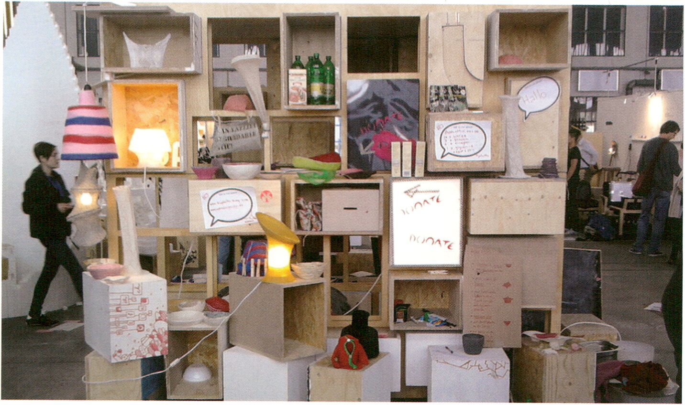
UJEDTlESDñY. FEB S
The Open Zone | Workstation
Open Design City ‘Make Your Own Market’ | with Jay Cousins (uk), Christopher Doering (de)
Mon - Sat 11:00 - 22:00 | Sun 12:00 - 22:00
Bioplastics Display, DMY Maker Lab, Photo: Mendel Heit
The Open Design City in Berlin is a colla-
boration space that establishes Open Design
principles derived from the Free Software and
Open Source movements. Tools, knowledge
and skills are shared so that anyone has the
chance to get involved. At Jay Cousins’ and
Christopher Doering’s ‘Make Your Own
Market’ stall at transmediale.11 workshops
range from screen printing to plastic making
and sewing or Upcycling to 3D printing and
scanning. Specialised equipment such as
a CNC cutter, 3D printer and Friedrich
Kirschner’s 3D Face Scanner are free for all
visitors to use. Materials will be provided but
visitors are encouraged to bring items to
Upcycle, customise, exchange or sell.
- Wikipedia Illustrated, p. 113
- The Future of Money, p. 88
Die Open Design City ist ein Ort für kollektives
Arbeiten und „Open Design“ in Berlin. Inspiriert
von den Prinzipien der Freien Software und
Open Source-Bewegung werden hier Tools,
Wissen und Fähigkeiten zwischen Allen geteilt,
die Lust haben, sich zu engagieren. An Jay
Cousins’ und Christopher Doerings ,Make Your
Own Market'-Stand gibt es viele öffentliche
Workshops, von Siebdrucken und der Plastik-
herstellung zu Nähen, „Upcycling“ und 3D-
Printing und -Scanning. Spezialgeräte wie
CNC-Schneidemaschine, 3D-Printer und
Friedrich Kirschners 3D Face Scanner stehen
allen Besuchern kostenlos zur Verfügung.
Auch Materialien werden gestellt, dennoch
empfehlen wir, selbst Gegenstände zum Up-
cyclen, Customisen oder Tauschen mitzu-
bringen.
The Open Zone | Workstation, Mini Performances and Micro Conferences
The Wanted & For Sale Office | with the kom.post collective, Camille Louis (fr),
Jennifer Bonn (ca/se), Laurie Bellanca (fr), Julie Morel (fr), Vincent Roumagnac (fr),
Simo Kellokumpu (fi), Elsa Ossart (fr)
Mon - Sat 11:00 - 22:00 | Sun 12:00 - 22:00

The Wanted & For Sale Office run by the
kom.post collective is a place where visitors
are asked what they have to give and what
they want. With the Office becoming a living
artwork by each participating individual,
each request and offer is displayed so that
exchange partners can be found.
Individual tours and audio guides can also be
found at the Wanted & For Sale Office. Visitors
can even make their own audio tours and
personalised festival booklets for themselves
or others. The kom.post collective will also
punctuate festival activities with mini per-
formances and micro conferences.
Das Wanted & For Sale Office fragt die Festi-
valbesucher nach dem, was sie anbieten kön-
nen und was sie haben wollen. Die Gesuche
und Angebote sind für mögliche Tauschpartner
am Office veranschlagt. Das Wanted & For Sale
Office ist auch der Ort, wenn man eine maß-
geschneiderte Führung oder einen Audioguide
sucht, selbst einen aufnehmen oder ein Info-
Booklet zum Festival hersteilen möchte. Das
kom.post collective wird darüberhinaus auch
andere Festival-Aktivitäten mit Mini-Performan-
ces und Mikro-Konferenzen kommentieren.

The Open Zone | Workshop
Drawing by Numbers - Data and the Art of Political Engagement | with Marek Tuszynski (pi),
Stephanie Hankey (uk)
12:00 - 16:00 | Open Zone, Response:Activities - Workstation

This visualisation workshop lead by the co-
founders of Tactical Tech explores the space
where creativity and data meet, with an aim
to discover new forms of engaging people in
the issues that effect our lives. Uncovering
how activists around the world are using infor-
mation design to increase political participa-
tion, this workshop shows how visual meta-
phors, storytelling, and creativity can turn
information into action!
Ein Workshop zu Visualisierungstechniken mit
den beiden Gründern von Tactical Tech. Hier
geht es um den Moment, wo Kreativität und
Daten als neue Wege aufeinander geraten, um
Menschen für die Themen zu begeistern, die
unser Leben bestimmen. Gezeigt wird, wie Ak-
tivisten auf der ganzen Welt politische Partizi-
pation mittels Informationsdesign gestalten,
denn visuelle Metaphern, Storytelling und Krea-
tivität können Informationen in Aktionen ver-
wandeln!
The Open Zone | Workstation
Identity Bureau | Heath Bunting (uk)
12:00-17:00

UJEDT1ESDAY. FEB E
Our identity is constructed as human beings
that can possess one or more natural persons
and control one or more artificial persons.
The higher up in the class system the better
the access to status variety. Heath Bunting’s
Status Project surveys these class systems
of human being management and produces
maps of influence and personal portraits for
both comprehension and mobility. The Status
Project is also producing new natural person
identities.
At transmediale.11 Heath has set up an
Identity Bureau where he sells the off-the-
shelf natural persons he has created, he will
also advise on how to use or make one’s own
Identity.
- Response:Activites, p. 99
- Social ID, p. 86
- Identity Bureau Installation, p. 144
HacKaWay | Workshop
WOPPOW I with UBERMORGEN.COM (at)
13:00 - 16:00 | HacKaWay Stage
Since 2009 UBERMORGEN.COM have been
exploring the methodologies of piracy as well
as the reactions to them. In considering, at
transmediale.11, the criminal interventions of
the RAF (Red Army Faction) of the 1960s, for
example, and problematics of expropriation
in the former GDR, UBERMORGEN.COM ask
whether and to what extent piracy tactics
could also apply in Germany.
This workshop aims at creating not only a
visual language of piracy but a genuine
fashion line.
- WOPPOW installation, p. 142
- [DAM]Ber1in, p. 165
Unsere Identität als Menschen ist so konstruiert,
dass wir eine oder mehrere natürliche Personen
sowie eine oder mehrere juristische Personen
besitzen können. Je höher ein Mensch im Klas-
sensystem verortet ist, desto breiter ist dessen
Zugang zu unterschiedlichen Identitäten. Heath
Buntings Status Project hat diese Systeme des
„Menschen-Managements” zum Inhalt.
Auf der transmediale.11 betreibt er ein Identity
Bureau, wo er die vertriebsfertigen, natürlichen
Personen, die er selbst geschaffen hat, verkauft
und Aufschluss darüber gibt, wie jeder seine
eigene Identität benutzen, bzw. herstellen kann.
Seit 2009 untersuchen UBERMORGEN.COM die
Methoden der Piraterie sowie die Reaktionen
darauf. Indem sie die kriminellen Handlungen
der RAF aus den 1960er Jahren bzw. Enteig-
nungsproblematiken der DDR mlteinbeziehen,
fragen sie auf der transmediale.11, ob und in-
wiefern Piraterietaktiken auch in Deutschland
in Frage kommen.
In diesem Workshop soll die Bildsprache der
Piraterie in der Kreation einer ganzen Modelinie
zum Ausdruck kommen.
Test Signals | Talk
Radio Magic | with Sarah Washington (uk), Alejo Duque (co), Knut Aufermann (de),
Heidi Grundmann (at)
14:00 - 16:00 | Auditorium
Technological development, and in particular the miniaturization of transmitters and the fact
that they can be put together by amateurs, ‘encounters’ a collective aspiration for some new
means of expression.
Felix Guattari, Plan for the Planet

With software processes entering broad-
casting culture, a young generation of hands-
on thinkers and producers has become
attracted to radio as a medium for community
projects and artistic endeavours alike. This
global panel of broadcast pioneers and radio
artists looks at the unique qualities of radio-
phonic practice and explores the future of
experimental transmission.
Produced by Sourcefabric.
Die Weiterentwicklung der Radiotechnologie in
den letzten Jahrzehnten hat das Interesse einer
neuen Generation vorallem von Machern und
Produzenten geweckt, die sich mit Kunst und
Community beschäftigen. In diesem Panel wer-
fen einige von ihnen gemeinsam einen Blick
hinter die Kulissen des radiophonen Kunsschaf-
fens und experimentellen Rundfunks, um über
die Zukunft des Radiomediums zu diskutieren.

The Open Zone | Workshop
Sharism: The More You Share the More You Get | with Michelle Thorne (us), Barry Threw (us),
Jon Phillips (us).
14:00 - 16:00 | Open Zone, Lost in the Open? - Workstation

Sharism is the pledge of Creative Commons.
In opposition to the legal concerns regarding
loss of copyright control today's sharing
environment is more protected than one might
think. Many new social applications make it
easy to set terms-of-use along the sharing
path and their infringement will be challenged
not just by the law, but by your community:
Your audience - who benefit from your sha-
ring - as the gatekeepers of your rights!
This workshop demonstrates the benefits of
sharing through examples of Sharism projects
and Creative Commons licenses, while
challenging views on real value and
contributions, both economic and creative.
Sharism ist das Gelöbnis der Creative Commons.
Im Widerspruch zu den gesetzgeberischen
Sorgen über urheberrechtliche Kontrollverluste ist
die heutige Sharing-Welt schon viel geschützter
als gemeinhin vermutet. Viele neue Social Media
Applications erleichtern Geschäftsbedingungen
für Sharing-Vorgänge und deren Missachtung
wird nicht nur gesetzlich verfolgt, sondern auch
von der Community oder Gruppe selbst: Das
gleiche Publikum, das von der positiven Einstel-
lung einer Person zum Teilen profitiert, wird
gleichzeitig zu deren Rechtebewacher! In diesem
Workshop mit Beispielen für Creative Commons-
Lizenzen und die Sbar/'sm-Kultur wird hinterfragt,
was einen echten wirtschaftlichen oder kreativen
Wert ausmacht.
SyncExistence | Screening
Dial Goes Around
14:30 - 16:30 | Theatersaal
This programme juxtaposes two films that,
each with its own absurdity, document corner-
stones in the development of telecommunica-
tions. The educational film Dial Comes to
Town illustrates the way people were officially
taught how to use direct dial phones in the
1940s, while today - regardless of the time
difference - workers in call centres out-
sourced to India instruct English speaking
consumers on how to use their technical
devices via service hotlines. The feature-
length documentary John & Jane is as much
about this phenomenon as about the virtual
export of the American dream.
Dieses Programm stellt zwei Filme gegenüber,
die in jeweils eigener Absurdität Ecksteine in
der Entwicklung der Telekommunikation doku-
mentieren. Gab es in den 1940ern noch Lehr-
filme zur Benutzung des Selbstwähltelefons wie
den gezeigten Dial Comes to Town, erklären
heute - ungeachtet der Zeitverschiebung - An-
gestellte nach Indien ausgelagerter Call-Center
Konsumenten aus dem englischsprachigen
Raum die Benutzung ihrer technischen Geräte
per Service Hotline. Der fast abendfüllende
Dokumentarfilm John & Jane beschäftigt sich
mit genau diesem Phänomen sowie den quasi
virtuellen Exportwegen des amerikanischen
Traums.

Dial Comes to Town (excerpt), Loucks & Norling Films, us 1940s, 13 min
John & Jane, Ashim Ahluwalia, in 2005, 83 min

Re-Manifesto for the Digital Age |
Vilém Flusser Theory Award | Presentation
Digital Anthropophagy and the Anthropophagie
with Vanessa Ramos-Velasquez (br/us)
15:00- 16:00 | K1
With her poetic manifesto Brazilian artist
Vanessa Ramos-Velasquez transfers ideas
around cultural cannibalism and anthro-
pophagie practices as coined by her country-
man Oswald de Andrade in his 1928-text
Manifesto Antropófago into the present digital
age. For in today’s world, it is the virtual
world, which poses the new frontier making
everyone a potential coloniser. In this lecture
Vanessa Ramos-Velasquez presents her re-
search paper and manifesto-poem.
Mit ihrem Gedicht-Manifest überträgt die Bra-
silianerin Vanessa Ramos-Velasquez Ideen zu
kulturellem Kannibalismus und anthropopha-
gischen Praktiken, die ihr Landsmann Oswald
de Andrade 1928 in seinem Text Manifestó
Antropófago beschrieben hat, in ein digitales
Zeitalter. Denn heute stellt die virtuelle Welt das
neue Grenzland dar und versetzt einen jeden in
die Position des möglichen Kolonisators. In
diesem Vortrag präsentiert Vanessa Ramos-
Velazques ihren Aufsatz sowie das Gedicht-
Manifest.

> Digital Anthropophagy..., p. 56
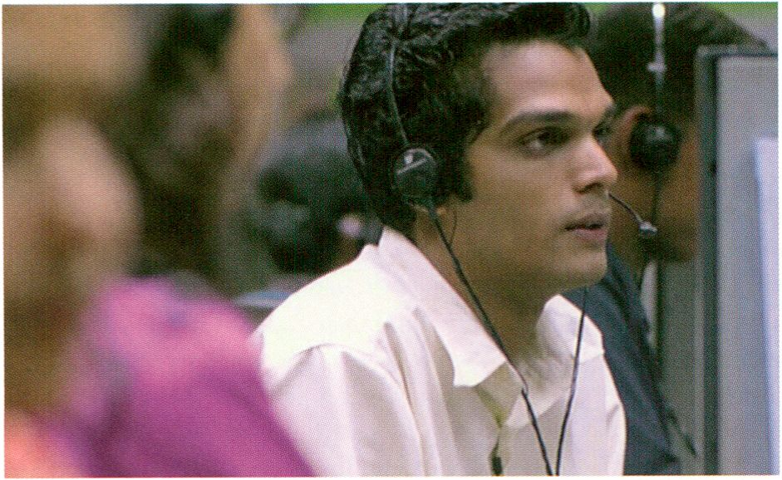
John & Jane by Ashim Ahluwalia (in: Dial Goes Around, p. 74)

transmediale Award | Presentation
Spatial Sound Sculpture | with Christopher Warnow (de), Daniel Franke (de)
16:00 - 16:30 | Archivraum
UJEDHESDRY. FEB 2
Nominated for the transmediale Award
2011, this interactive sound installation by
Christopher Warnow and Daniel Franke is
more than just an interpretation of a com-
position by Rutger Zuydervelt. An interface,
which reacts to the audiences’ body move-
ments, this work immerses the viewer by
superimposing digital and architectural spa-
ces. For each one of us a different, individual
and fluid visualisation appears onscreen.
This event is one of three occasions when the
artists will give a show and tell of the work at
transmediale.11.
Mit dieser interaktiven Klanginstallation
interpetieren die beiden Künstler Christopher
Warnow und Daniel Franke nicht nur eine
Komposition von Rutger Zuydervelt. Die Arbeit
ist zudem eine für Körperbewegungen sensible
Schnittstelle, die den Zuhörer in die ihn um-
gebenden digitalen bzw. architektonischen
Räume eintreten lässt. Für jeden Einzelnen von
uns entfaltet sich eine individuelle Darstellungs-
weise auf dem Screen.
Auf der transmediale.11 gibt es dreimal die
Möglichkeit, die Künstler bei einer Präsentation
ihres Werkes, das übrigens für den transmedia-
le Award 2011 nominiert ist, zu erleben.

> Spatial Sound Sculpture, p. 51
Workshop
Urban Screens - Visualisation Zones for a Media Saturated Urban Society I with Susa Pop (de),
Mirjam Struppek (de)
16:30-18:30| K2
As a follow up of the workshop Reclaim the
Screens! during transmediale.10 and based on
the Media Facades Festivals Berlin 2008 and
Europe 2010 we explore how artists, curators
and creative people can utilise the urban
screens infrastructure as social vision panels.
What is the communicative, intercultural
potential of public screens?
Als Fortsetzung des Workhops Reclaim the
Screens! der transmediale.10 und basierend
auf den Medienfassaden Festivals Berlin 2008
und Europa 2010 untersucht der Workshop,
wie Künstler und Kreativschaffende die Urban
Screens-Infrastruktur als gesellschaftliche
Sichtfenster nutzen können.
The Open Zone | Open Web Award | Workshop
thimbl | with Dmytri Kleiner (ca/ru)
16:00 - 19:00 | Open Zone, Currency of the Commons - Workstation

UJEDT1ESDRY. FEB 5
Featured Projects | Workshop
CoS Workshop 1: Identity (Part 1) | with Salvatore laconesi (it), Oriana Persico (it)
16:00 - 19:00 | Oberes Foyer/ CoS Workstation
In this workshop Dmytri Kleiner, creator of
thimbl, the free Open Source distributed
micro-blogging alternative will talk about how
thimbl came into existence and what makes it
different from other social networks. Dmytri
will also show participants how to get web-
hosts, internet service-providers or system
administrators to provide accounts so that
they can use the thimbl for their own creative
practices.
- The Currency of the Commons, p. 116
- thimbl installation, p. 61
Identity: Our identities are redefined as
diffused, open and emergent, perceivable yet
elusive, ephemeral yet drastically present,
single yet multiple, localised yet ubiquitous.
During the workshop participants will create
a connective emergent Identity from scratch.
ln diesem Workshop wird der Gründer von
thimbl, der kostenlosen Open Source Mikro-
Blogging Alternative erzählen, wie er auf die
Idee für dieses Projekt kam und inwiefern sich
thimbl von anderen sozialen Netzwerken unter-
scheidet. Dmytri wird Teilnehmern mit Voran-
meldung auch zeigen, wie man Webhosts,
Internet Service-Provider und Systemadminis-
trato- ren dazu bringt, Konten zur Verfügung zu
stellen, um thimbl für seine eigenen kreativen
Zwecke zu nutzen.
Identity: Unsere Identitäten werden heute als
diffus und offen bezeichnet, als wahrnehmbar
und dennoch schwer zu fassen, als kurzlebig
und dennoch fortlaufend präsent, als individuell
und dennoch mannigfaltig, als lokal und den-
noch allgegenwärtig. Im Rahmen des Identity-
Workshops werden Teilnehmer aus dem Nichts
eine konnektiv-entstehende Identität erstellen.

For 15 participants / With pre-registration only
Für 15 Teilnehmer / Nur mit Voranmeldung
- CoS installation, p. 152
- CoS workshop 1 (Part 2), p. 87
- CoS workshop 2, p. 100
- CoS workshop 3, p. 117
- CoS workshop 4, p. 131
- Social ID, p. 86
The Open Zone | Workshop
interACTicons - Online Archive, Workshop and Performance | with Ursula Endlicher (at)
17:00 - 19:00 | Open Zone, interACTicons - Workstation

What if Kafka’s Internet suddenly came true
and text were suddenly undecipherable as
too many algorithms cancel out each other’s
choice of uncensored words and all online
communication were limited to emoticons?
These are the ideas behind interACTicons,
a project enacting and visualising our online
habits through the collection and performance
of JPGs, GIFs and videos by Ursula Endlicher
that comprises of an online archive, several
hands-on workshops and a final participatory
performance.
Wie wäre es, wenn wir uns plötzlich mit einem
kafkaesken Internet herumschlagen müssten,
einer Situation, in der die ganze Online-Kom-
munikation plötzlich auf Emoticons reduziert
und Text unlesbar wäre, weil zu viele Algorith-
men sich bei der Auswahl unzensierter Worte
plötzlich gegenseitig in die Quere gerieten?
Diese Ideen verfolgt Ursula Endlicher in
interACTicons, einem dreiteiligen, partizipa-
tiven Projekt aus Online-Archiv, Workshops und
finaler Performance, für das sie JPGs, GIFs und
Videos sammelt, um unsere Online-Gewohnhei-
ten nicht nur zu visualisieren, sondern auch
gleich performativ darzustellen.

Online Archive: www.ursenal.net
The Open Zone | Talks, Workshops
TRACES Lounge | by the Transcultural Reseach Artist Curator Exchange Series with Jodi Rose
(au), Mindaugas Gapsevicius (It), Vytautas Vytautas Michelkevicius (It), Philippe Franck (fr)
17:00 - 20:00 | Open Zone, Response:Activities - Workstation

The nomadic TRACES Lounge responds to
the high geographical and intellectual mobility
demanded from artists and curators today by
offering a space for slow culture, relaxed
interaction and deeper exchange. Visitors are
invited to discuss the realities of navigating
within Free Culture and the Open Web as they
participate in the TRACES live radio show,
and the TRACES Open Zone Special Edition.
The radio shows will be broadcast live
on radioCona and will be available on
ArtistTalk.eu, the initiative by the Museum of
Transitory Art. The results of the collaborative
Open Zone Special Edition will be presented
on Sunday when the edition will be published
using Booki Mobile on demand printer. Cakes
and tea made from wild Lithuanian herbs will
be served.
Die nomadische TRACES Lounge reagiert mit
einem Raum für langsame Kultur, entspannte
Interaktion und tiefere Austauschmöglichkeiten
auf die Herausforderung, dass Künstler und
Kuratoren meist höchst mobil arbeiten und
leben müssen. Besucher sind eingeladen, sich
hier im Rahmen der TRACES Live-Radiosen-
dung und der TRACES Open Zone Special
Edition Gedanken zu machen, was es bedeutet,
sich innerhalb von Free Culture und Open Web
zu bewegen. Die Radiosendung wird live auf
radioCona und Artisttalk.eu, einer Initiative des
Museum of Transitory Art, gesendet. Die
Ergebnisse der kollaborativen Open Zone
Special Edition werden am Sonntag präsentiert,
wo die Edition vom Booki-Mobil per Print on
Demand gedruckt wird. Dazu gibt es Kuchen
und lithauischen Wildkräutertee.

Cakes by Hudsons! Media partners: radioCona and Museum of Transitory Art
LIVE : RESPONSE | Performance
Braun Tube Jazz Band | Ei Wada (jP)
17:30- 18:30 | HacKaWay

One day, a spectacular vision popped into Ei
Wadas’ mind. It was the image of abandoned
electrical appliances being played as musical
instruments in the streets of a city. Through
experimentation with old CRT televisions and
VCRs, the young artist from Japan was able to
realise his idea. He now has a computer-
controlled percussion instrument with the
range of an entire octave, on which he will
give rousing, rhythmic performances daily
during the festival.
Eines Tages schoss Ei Wada ein atemberau-
bendes Bild in den Kopf. Er stellte sich vor, wie
alte, weggeworfene Elektrogeräte auf den Stra-
ßen einer Stadt als Musikinstrumente gespielt
würden. Durch Herumexperimentieren mit alten
Röhrenfernsehern und Videorekordern hat der
junge Künstler aus Japan diese Idee umgesetzt.
So besitzt er nun ein computergesteuertes, eine
ganze Oktave umfassendes Perkussionsinstru-
ment, auf dem er während des Festivals täglich
sein mitreißendes Rhythmusgefühl zum Besten
geben wird.

transmediale Marshall McLuhan Lecture 2011 | featuring Mark Surman
Media, Freedom and the Web
18:30 - 19:30 | Doors open 18:00 | Botschaft von Kanada, Leipziger Platz 17, 10117 Berlin

Mark Surman, Executive Director, Mozilla
Foundation, is one of the world's leading
proponents for collaborative technologies and
the development of a truly Open Net. Together
with transmediale, Mark and Drumbeat intro-
duced the first ever Open Web Award.
In his lecture Media, Freedom and the Web,
Mark takes a tour from McLuhan to free
software pioneer Richard Stallman and Tim
Berners-Lee, reflecting on what the global
village we're all building together can be in
this era defined by the web.
The transmediale Marshall McLuhan Lecture
highlights a unique Canadian cultural figure
whose work and vision broadens Marshall
McLuhan’s timeless perspective of media and
technology into contemporary culture and
society.
Mark Surman, Geschäftsführer der Mozilla
Foundation, ist wohl einer der prominentesten
Befürworter für offene Technologien und die
Entwicklung eines tatsächlich offenen Internets.
Zusammen mit der transmediale präsentieren
Surman und Drumbeat den neuen Open Web
Award. In seinem Vortrag Media, Freedom and
the Web reflektiert Surman, ausgehend von
McLuhan und den Software-Pionieren Richard
Stallman und Tim Berners-Lee über unsere
gemeinsamen Gestaltungsmöglichkeiten des
Global Village, nun, im Web-Zeitalter.
Mit der transmediale Marshall McLuhan Lecture
lädt die transmediale Persönlichkeiten der
kanadischen Kulturszene ein, die - wie
McLuhans zeitlose Medientheorie - zeitgenös-
sische Kultur und Gesellschaft mit anderen
Bereichen verknüpfen.

transmediale Marshall McLuhan Lecture Is a cooperation between transmediale and the Embassy of Canada.
- McLuhan Salon, p. 158
- McLuhan in Europe 2011, p. 39
- Drumbeat Workshop, p. 111
- COUNTERBLAST 1954, p. 88
- Open Web Award, p. 58

Madame & Little Boy by Magnus Bärtäs
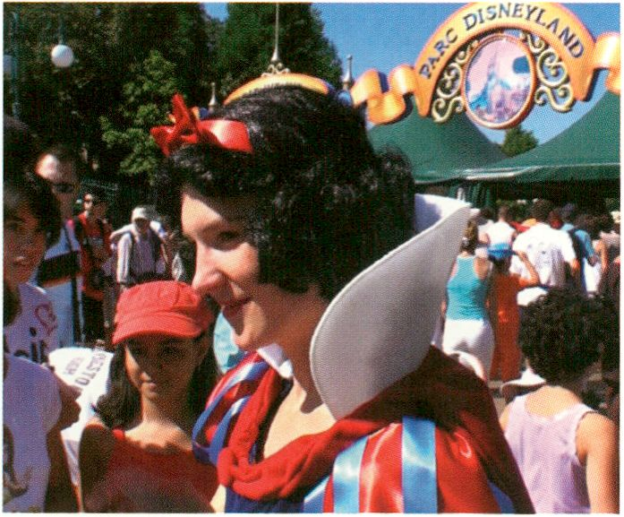
Real Snow White by Pilvi Takala

UJEDT1ESDRY. FEB S
SyncExistence | Screening
Desync Systems
18:30 - 20:30 | Theatersaal
All societies strive to develop a functional
consensus between their members and
communicate with each other through a
number of official and unofficial channels.
The works presented in this programme reflect
the failings of such processes. Dick Cheney in
a Cold, Dark Cell is a found footage film with
disturbing material that is given ambiguous
meanings through its title. In Gesang der
Jünglinge, police officers test the effects of
electroshock weapons - a rather peculiar form
of interpersonal communication - on their own
bodies. The performative piece Real Snow
White documents Disney World's attempt to
maintain control over the company's creations
even in relation to their own fans. The way
nationalism can appropriate landscape is
portrayed in Flag Mountain. And the docu-
mentary Madame & Little Boy follows the
incredible story of an actress during the
propaganda war between North and South
Korea.
Dieses Programm thematisiert die Paradoxa,
die sich an den Rändern gesellschaftlicher
Kommunikationsprozesse ansammeln.
Während ein funktionsfähiger Konsens im
Zentrum solcher Bemühungen steht, generieren
diese scheinbar gleichzeitig auch die unter-
schiedlichsten, teilweise verstörenden Merk-
würdigkeiten. Dick Cheney in a Cold, Dark Cell
ist ein verstörender Found-Footage Film, wel-
cher durch den Titel mehrdeutig konnotiert
wird. In Gesang der Jünglinge testen Polizisten
die Wirkung von Elektroimpulswaffen, einer
besonderen Form der zwischenmenschlichen
Kommunikation, am eigenen Körper. Die per-
formative Arbeit Real Snow White dokumentiert
den Versuch von Disneyworld, die Kontrolle
über ihre Schöpfungen auch gegen ihre Fans
durchzusetzen. Die visuelle Überschreibung
von Landschaft durch Nationalismus porträtiert
Flag Mountain. Der Dokumentarfilm Madame 8
Little Boy zeichnet die unglaubliche Geschichte
einer Schauspielerin im Propagandakrieg
zwischen Nord- und Südkorea nach.

Dick Cheney in a Cold, Dark Cell, Jim Finn, us 2009, 3 min
Gesang der Jünglinge, Korpys/Löffler, de 2009,15 min
Real Snow White, Pilvi Takala, fr 2009, 9 min
Flag Mountain, John Smith, uk 2010, 9 min
Madame & Little Boy, Magnus Bärtäs, se 2009, 28 min
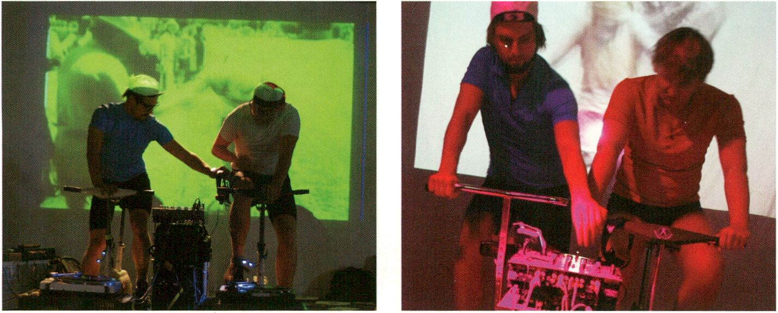
TOUR de VINYL by Patrick Praschma, Chris Wawryniak and Pierre Cournoyer

UJEDÏlESDflY. FEB 2
LIVE : RESPONSE | Performance
TOUR de VINYL | Patrick Praschma (de), Chris Wawrzynlak (de), Pierre Cournoyer (de)
19:30 - 20:30 | Café Stage
This audio-visual performance is an homage
to the history of record experiments known
from Thomas A. Edison, inventor of the
phonograph, and generations of later DJs.
This time the reproducing device becomes a
‘machine célibataire’ à la Marcel Duchamp.
By combining the record player with an exer-
cise bicycle the Discjockey2000 is generated,
an unconventional musical instrumentarium
for generating incomparable analog sounds.
Diese audiovisuelle Performance ist eine Hom-
mage an die Geschichte der Schallplattenexpe-
rimente, wie sie schon Thomas A. Edison, Erfin-
der des Phonographen, und nach ihm Gene-
rationen von DJs immer wieder durchgeführt
haben. Dieses Mal macht die Verbindung des
Turntables mit dem Trimmrad aus dem Repro-
duktionsapparat eine „Junggesellenmaschine“
ä la Marcel Duchamp, den Discjockey2000 - ein
eigenwilliges Musikinstrumentarium zur Erzeu-
gung unvergleichlicher Analog-Klänge.

Marshall McLuhan Salon | Vernissage
OPEN Signs: Exhibition on Open Art and Technolgies | curated by Heather Kelley (ca)
19:00 - 21:00 (following the transmediale Marshall McLuhan Lecture)
For transmediale.11 Heather Kelley has cura-
ted the group exhibition OPEN Signs, on open
art and technologies, which is on view at the
Marshall McLuhan Salon and which opens
following the transmediale Marshall McLuhan
Lecture 2011.
lm Anschluss an die transmediale Marshall
McLuhan Lecture 2011 eröffnet im Marshall
McLuhan Salon OPEN Signs, eine Gruppenaus-
stellung zu Open Art und Technologie, kuratiert
von Heather Kelley.
Berlin
Supported by the Canada Council for the Arts and the Embassy of Canada,
McLuhan Salon, Botschaft von Kanada, Leipziger Platz 17,10117 Berlin
More information on p. 158
- transmediale Marshall McLuhan Lecture 2011, p. 78
- McLuhan in Europe 2011, p. 39
Satellites | Talk
Audiovisualogie: Bild-Ton Relationen in Kunst, Technik, Wissenschaft und Unterhaltung |
Dieter Daniels (de)
19:30 - 20:30 | Technische Universität Berlin

The digitisation of audiovisuality has taken
place through a hybridisation of media
formats, artistic genres and cultural contexts
rather than solely technological. The idea
behind the lecture is that this development
has already been in process for 250 years,
beginning with the Age of Enlightenment
when a relation between visual and acoustic
phenomena and a paradigm of hybridisation
between art, technology, science and enter-
tainment was established. In the second half
of the 19th Century, scientists and inventors
including Hermann von Helmholtz and
Thomas A. Edison devoted themselves to
such questions. In 1920s Germany, a socio-
technical network of image-sound relations
allowed heterogeneous subject areas to
overlap (absolute film, radio phones sound
radio play, sound-film technology, electrical
engineering, anthropology and synaesthesia).
Mit der Digitalisierung des Audiovisuellen findet
eine Hybridisierung der Medienformate, künst-
lerischer Gattungen und techno-kultureller
Kontexte statt. Die These des Vortrags lautet,
dass sich diese Entwicklung bereits seit 250
Jahren, seit dem Zeitalter der Aufklärung vor-
bereitet hat, als die Relation zwischen visuellen
und akustischen Phänomenen und Apparaten
zu einem Paradigma der Hybridisierung von
Kunst, Technik, Wissenschaft und Unterhaltung
führte. In der zweiten Hälfte des 19. Jahrhun-
derts widmeten sich beispielsweise Hermann
von Helmholtz und Thomas A. Edison als
Wissenschaftler bzw. Erfinder verwandten
Fragen. Im Deutschland der 1920er Jahre
entwickelte sich ein soziotechnisches Netzwerk
(Bruno Latour) der Bild-Ton Relationen, in dem
sich heterogene Themenfelder überschneiden
(absoluter Film, radiophones Klanghörspiel,
Tonfilmtechnik, Elektrotechnik, Anthropologie,
Synästhesieforschung).
Technische Universität Berlin, Hörsaal A 053, Fachgebiet Kunsgeschichte A 56, Straße des 17. Juni 150/152,10623 Berlin
The lecture will be in German.
In Cooperation with the Technische Universität Berlin, Institut für Kunstwissenschaft und Historische Urbanistik, Fachbereich Kunstgeschichte.
The Open Zone | Talk
Observer Talk of the Day | with Allen Gunn (us)
20:00 - 21:00 | Open Zone, Lost in the Open? - Workstation

Each evening transmediale.11 invites visitors
to gather for an informal Observer Talk.
‘Observers’ have been invited from the diverse
fields of Media Art, Journalism, Media
Activism and Free Culture and will share their
personal interpretation of the day's festival
activities.
Jeden Abend laden wir einen ganz besonderen
Gast ein, die Eindrücke des zurückliegenden
Festivaltages gemeinsam mit unseren
Besuchern in einer informellen Runde zu
diskutieren.

- Open Activist Consultancy Event, p. 92
- Response:Activities talk, p. 99
LIVE : RESPONSE | Performance Double Bill
Genre Collage | People Like Us (uk)
DONJON I Cécile Babiole & Vincent Goudard (fr)
21:00 - 22:30 | Auditorium
Genre Collage | People Like Us (uk)
By manipulating patterns, syntax, moods,
narrative elements, recurring icons,
characters and film stars held within a variety
of movie genres/sub-genres, with Genre
Collage, People Like Us (in collaboration with
Tim Maloney) examine the concept of ‘genre’
creating a humorous, surrealistic, yet infor-
mative take on the content held within. The
sound is partially taken from the films and
partly from music holding corresponding
messages, moods and lyrical content. The
moving image parts are cut around and
collaged into each scene, complete with the
source's accompanying audio and added
contextual musical collage.
DONJON | Cécile Babiole & Vincent Goudard (fr)
DONJON is an audiovisual concert per-
formance in which the performers gleefully
deconstruct a wide range of objects culled
from popular culture, particularly audiovisual
equipment: turntables, radios, computers,
musical instruments, telephones, video
cameras - but also cocktail blenders, battery
chickens, and various other domestic and
fantastic appliances of ages past and present.
Genre Collage and DONJON are presented by transmediale and CTM.
LIVE : RESPONSE | DJ-Set
Electrigger (de)
22:30 | Café Stage
Electrigger will spoil your ears with rare
electronic music tunes from weird kraut
classics to new progressive dub breaks and
anti-folk.
In Genre Collage untersucht People Like Us
(zusammen mit Tim Maloney) die Idee des
Filmgenres. Dazu werden Muster, Syntaxen,
narrative Bausteine, wiederkehrende Symbole,
Charaktere und einige Filmstars solcher Genres
manipuliert. Was entsteht, ist eine humorvolle,
surrealistische, sogar informative, inhaltliche
(Um-)Gestaltung. Der Ton konstituiert sich aus
den Original-Soundtracks sowie Musikstücken,
deren Botschaft, Stimmung oder Text mit den
bewegten Bildern korrespondiert. Diese werden
aus Filmen ausgeschnitten und zusammen mit
Soundtrackschnipseln, bzw. anderweitiger
Musik zu verschiedenartigen Szenen kollagiert.
In der audiovisuellen Konzertperformance
DONJON dekonstruieren die Darsteller humor-
voll eine Reihe von Objekten der Populärkultur,
insbesondere audiovisuelles Equipment:
Turntables, Radios, Computer, Musikinstru-
mente, Telefone, Videokameras - aber auch
Cocktail-Mixer, Legebatteriehühner und
verschiedene andere häusliche oder fantasti-
sche Geräte aus Gegenwart und Vergangenheit.
Electrigger bereitet uns mit seinem Set aus
raren Krautrock-Klassikern, New Progressive
Dub Breaks bis Anti-Folk ein wahres Hörver-
gnügen.
♦ * Vorname
#** Name.
ATELIER VERLAG Na
Hospeltstrasse 47 ₄.*‘ PLZ, Ort
D-50825 Köln
<** Datum, Unterschrift
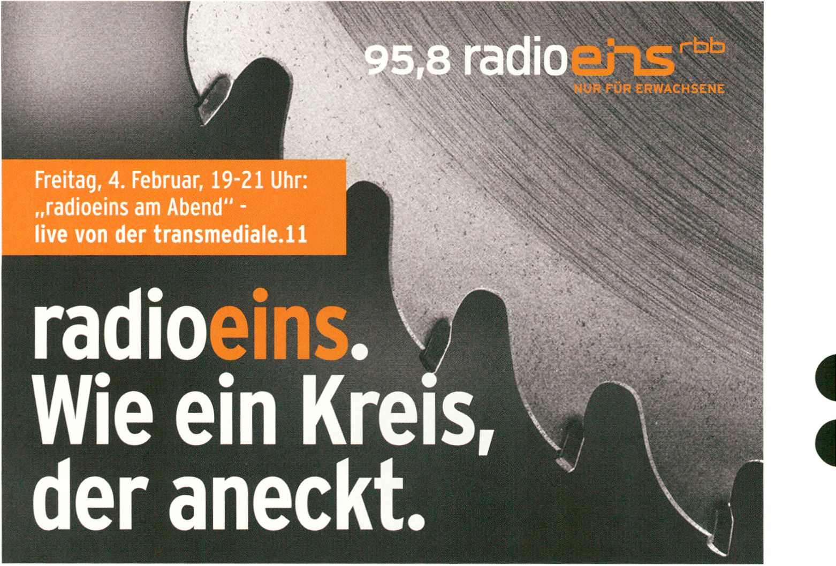
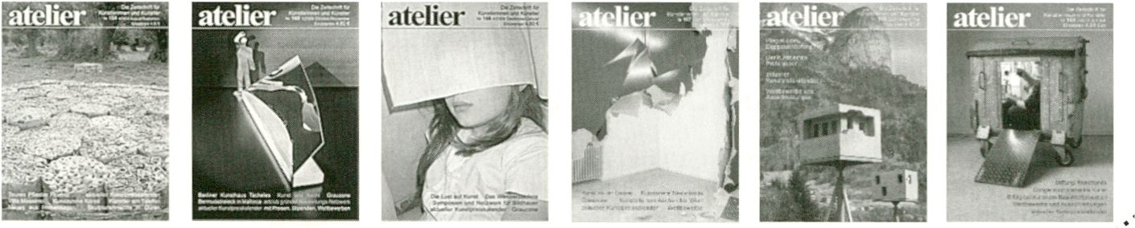
A "V 9 Die Zeitschrift ft

atelier
für Künstler erscheint 6 x im Jahr. In jeder Aus-
gäbe stehen aktuelle, umfassende informa- ¿S'
tionen für Künstler. Ausschreibungen, \c^
Ausstellungsmöglichkeiten, Termine für
Kunststipendien, Wettbewerbe und
Es werden „Schwarze Schafe“ im Kunst-
Kunstpreise werden angekündigt
markt entlarvt und in jedem Heft gibt es wichtige Artikel zu Kunst und
Recht, Neues aus den Künstlerhäusern, kostenlose Kleinanzeigen,
und vieles mehr...
v°
&
«-^{e}

10 Jahre Festival für aktuelle Musik Berlin
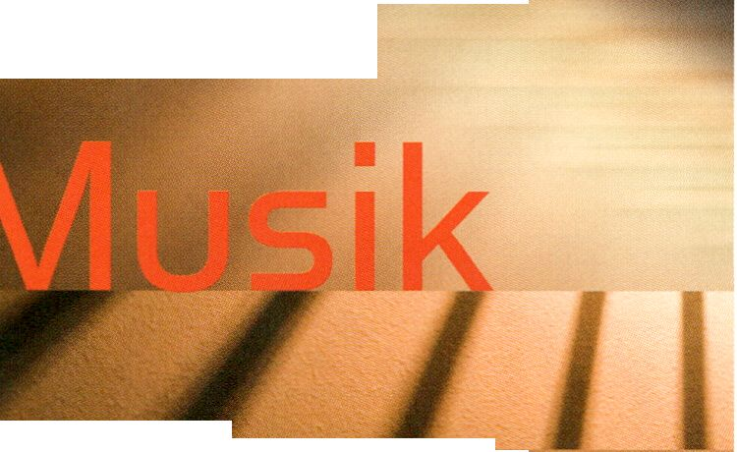18.-27.3. 2011
|

Maerzl
KLANG BILD BEWEGUNG BILD KLANG BEWEGUNG KLANG BILD BEW!
MUSIK MIT FILM, VIDEO, VISUALS, LICHT
KAMMERMUSIK • SOLO RECITALS • SONIC ARTS LOUNGE
Das Programm finden Sie unter www.maerzmusik.de
Berliner Festspiele
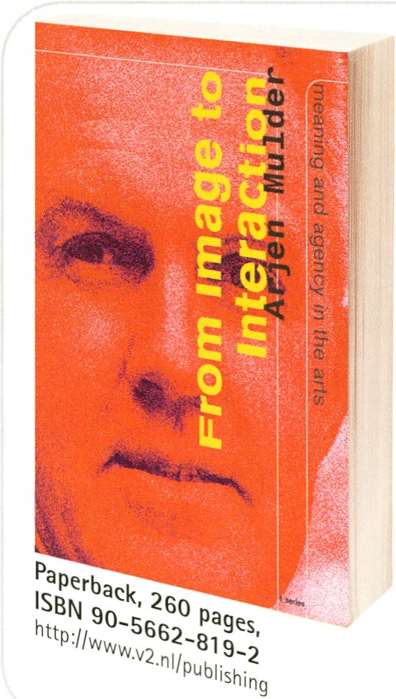New at V2_Publlshmg:
From image to interaction
Arjen Mulder traces evolutionary
lines in the fine art of the past five
hundred years that have led directly
to the interactive art of today.
Arjen Mulder investigates the origins of modern
art from Leonardo da Vinci and Michelangelo
to Kandinsky, Mondrian and Paul Klee, whom he
regards not only as great artists but above all
as great media theorists. In the process, he dis-
covers how the models these illustrious prede-
cessors built are still actively being used in the
fields of contemporary art known as electronic
art, video art, machine art, digital art, media art,
and even "the art formerly known as media art."

at

Stefanie Wuschitz (at)
Test Signals | Workshop
Open Digital Radio | with Mathias Coinchon (ch)
10:00 - 16:00 | HacKaWay
Moving towards a démocratisation of digital
radio, cheaper digital transmission techno-
logies allow individuals to access an other-
wise rather exclusive communication system.
Mathias Coinchon of the European Broad-
casting Union shows workshop participants
techniques and tools for alternative and
independent radiomaking.
For 15 participants / Für 15 Teilnehmer
Produced by Sourcefabric.
BODY : RESPONSE | Workshop
Mz Baltazar’s Laboratory - Feminist DIY | with
10:30-14:30 | K2
Mz Baltazar’s Laboratory wants to demystify
technology. In a two-day workshop we hack
hardware, make noise, build angst-robots and
programme Open Source software. We ask a
lot of ‘stupid’ tech questions and develop art
projects together. No one is an expert, no
one is only student, we share our equipment
and knowledge in order to articulate ourselves
through high-tech in novel ways. Mz
Baltazar’s Laboratory offers women space to
make their own electronics and realise
interactive art projects.
Durch den Einsatz von billigeren digitalen Tech-
nologien zur Radioübertragung erschließt sich
diese bis jetzt eher unzugängliche Übertra-
gungsweise auch Individuen und erlaubt neue
Möglichkeiten zur Demokratisierung des
Radios. Mathias Coinchon von der Europäi-
schen Rundfunkunion stellt den Teilnehmern
dieses Workshops eine Reihe von Techniken
und Werkzeugen für solch ein neues Radio-
übertragungssystem vor.
Mz Baltazar’s Laboratory will den Begriff der
Technologie ein bisschen demystifizieren. In
einem zweitägigen Workshop zerlegen wir
Hardware, machen Lärm, bauen Angst-Robote-
rinnen und programmieren Open Source-Soft-
ware. Wir fragen „dumme“ Tech-Fragen und
entwickeln gemeinsam Kunst. Niemand ist Ex-
pertin, niemand nur Schülerin. Wirteilen
Equipment und Erfahrungen aus, um uns mit
High-Tech kreativ auszudrücken. Mz Baltazar’s
Laboratory ist ein Raum, in dem sich weiblich
sozialisierte Menschen Elektronik aneignen
können, um interaktive Kunstprojekte selbst-
ständig umzusetzen.

For 15 participants / With pre-registration only
Für 15 Teilnehmer / Nur mit Voranmeldung
- Access Denied: DI_Yourself, p. 114
- Mz Baltazar’s Laboratory part 2, p. 98
BODY : RESPONSE | Focus Discussion - Track 1 : Bios and Presence
Social ID I with Salvatore laconesi (it), Derrick de Kerckhove (ca), Ursula Endlicher (at), Heath
Bunting (uk) | Moderator: Alessandro Ludovico (it)
11:00-13:00| K1

For a long time, identity was considered a
safe, stable and unchanging feature of a
person. Today, however, we find that our
social existence is defined by complex and
dynamic identity configurations that shift
effortlessly between material and immaterial
spaces, between fiction and reality, between
data and body. We must also deal with identity
models that are integrated into biological,
technological, medial and neurological
development, which are indeed themselves
only trained and stabilised on first contact
with the world and its obligations.
In this discussion, artworks and artistic forms
of practice that explore such spaces are
presented.
- CoS, p. 152
- interACTicons, p. 145
- Identity Bureau, p. 144
- Face-to-Facebook, p. 147
- Opening Ceremony, Derrick de Kerckhove, Angel_F, p. 66
Lange Zeit galt die Identiät als sicheres,
stabiles und unveränderliches Merkmal einer
Person. Heute dagegen erleben wir, dass
unsere soziale Existenz von vielschichtigen und
dynamischen Identitätskonfigurationen ge-
prägt ist, die sich mühelos zwischen materiellen
und immateriellen Räumen, zwischen Fiktion
und Realität, zwischen Daten und Körper be-
wegen. Wir haben es also mit einem Identitäts-
modell zu tun, das biologische, technologische,
mediale und neurologische Entwicklungen
integriert, die selbst allerdings erst im Kontakt
zur Welt und deren Verbindlichkeiten entworfen,
trainiert und stabilisiert werden.
In dieser Diskussion werden Kunstwerke und
künstlerische Praxisformen präsentiert, die
solche Zwischenräume erforschen.

The Open Zone | Workstation
Immediated Autodocumentary | Gabriel Shalom (us), Patricia Kommerell (de)
11:00 - 22:00 | Open Zone, Immediated Autodocumentation - Workstation
Complete information on p. 68
The Open Zone | Workstation
Open Design City 'Make Your Own Market'
11:00-22:00
Complete information on p. 70
The Open Zone | Workstation, Mini Performances and Micro Conferences
The Wanted & For Sale Office
11:00 - 22:00
Complete information on p. 71
Featured Projects | Workshop
CoS Workshop 1: Identity (Part 2) | with Salvatore laconesi (it), Oriana Persico (it)
- - 15.00 | Upper Foyer/ CoS Workstation

Identity: Our identities are redefined as
diffused, open and emergent, perceivable yet
elusive, ephemeral yet drastically present,
single yet multiple, localised yet ubiquitous.
During the workshop participants will create a
connective emergent “Identity” from scratch.
Identity: Unsere Identitäten werden heute als
diffus und offen bezeichnet, als wahrnehmbar
und dennoch schwer zu fassen, als kurzlebig
und dennoch fortlaufend präsent, als individuell
und dennoch mannigfaltig, als lokal und den-
noch allgegenwärtig. Im Rahmen des Identity-
Workshops werden Teilnehmer aus dem Nichts
eine konnektiv-entstehende „Identität“ erstellen.

For 15 participants / With pre-registration only
Für 15 Teilnehmer / Nur mit Voranmeldung
- CoS, p. 152
- CoS workshop 1 (Part 1), p. 76
- CoS workshop 2, p. 100
- CoS workshop 3, p. 117
- CoS workshop 4, p. 131
- Access Denied, p. 114
The Open Zone | Workshop
Free Culture Incubator Workshop Series | with Andrea Goetzke (de), Henrik Moltke (de), Michelle
Thorne (us), Ela Kagel (de), Dirk Kiefer (de), Noemie Causse (de) and partners & guests of the
FCI 12:00 - 14:00 | Open Zone, Lost in the Open? - Workstation

The Free Culture Incubator, a workshop
and networking programme for independent
creative and cultural producers, was
established at transmediale.10 and has since
developed into a bustling Berlin platform for
Free Culture and the Open Net. Since October
2010, a 12-month series of workshops on
topics such as Open Design, the organization
of creative teams, business models in the Free
Culture sphere, etc., has been running, which
is one of the most important initiatives of the
FCI. In today's workshop, Ela Kagel, initiator
of the FCI, and project partners present their
plans for the period until summer 2011, taking
suggestions and requests for sessions from
participants.
Der Free Culture Incubator, ein Workshop- und
Vernetzungsprogramm für freie Kreative und
Kulturarbeiter wurde im Rahmen der transmedi-
ale.10 ins Leben gerufen und hat sich seither zu
einer lebendigen Berliner Plattform rund um
Freie Kultur und das Open Web entwickelt. Seit
Oktober 2010 läuft mit der zwölfmonatigen
Workshop-Reihe zu Themen wie Open Design,
der Organisation von kreativen Teams, Wirt-
schaftsmodellen im Free Culture Bereich etc.
eine der wichtigsten Initiativen des FCI. Im
heutigen Workshop wird Ela Kagel, Initiatorin
des FCI, gemeinsam mit einigen Projektpart-
nern die Pläne bis Sommer 2011 vorstellen
sowie Anregungen und Wünsche für kommende
Veranstaltungen entgegen nehmen.
The Open Zone | Presentation
The Future of Money | with Jay Cousins (uk), Gabriel Shalom (us)
12:00 - 14:00 | Open Zone, Currency of the Commons - Workstation

THURSDAY. FEB B
McLuhan in Europe 2011 | Talk
COUNTERBLAST: The Rogue McLuhan | with Michelle Kasprzak (ca), Elena Lamberti (it),
Tim Druckrey (us), Elaine Brodie (ca), Ed Slopek (ca)
13:00 - 14:30 | Auditorium
The Future of Money project begins a con-
versation on topics like the future of banks
and other financial systems and alternative
systems of wealth generation, and invites your
participation. Gabriel Shalom and Jay Cousins
will be screening The Future of Money video
and behind-the-scenes videoblog episodes as
a prompt for further discussion on these
topics.
- Open Design City, p. 70
- Immediated Autodocumentary, p. 68
- Immediated Autodocumentation screening, p. 130
Kicking off the Herbert Marshall McLuhan
Centennial year, this discussion will separate
the aphorism from the cliché in one of
McLuhan’s most radical yet relatively under-
explored works, COUNTEFIBLAST. Two very
different versions of this text exist, the full
1969 edition produced in collaboration with
Harley Parker, and the biting never-before
published manifesto McLuhan distributed as
a hand-made ‘zine’ in 1954. Using the visual
language and modes of production of each to
illustrate McLuhan's transition from English
professor to timeless media guru, the
panelists will examine the two versions in the
context of their time and relevance to media
culture today.
The event will launch a special hardcover
‘limited edition' facsimile of the original
COUNTERBLAST 1954, published by Gingko
Press exclusively for transmediale on the
event of the McLuhan anniversary!
- McLuhan in Europe 2011, p. 39
- McLuhan Salon, p. 158
- McLuhan Lecture, p. 158
- McLuhan vs Flusser, p. 112
Das partizipative Projekt The Future of Money
diskutiert die Zukunft von Banken und anderen
Finanzinstituten sowie alternative Möglichkei-
ten für Wohlstand und Reichtum. Als Anregung
zeigen Gabriel Shalom und Jay Cousins ihr The
Future of Money-Video sowie Ausschnitte aus
Ihrem Videoblog.
Diese Eröffnungsveranstaltung des Jubiläums-
programms zum 100. Geburtstag von Herbert
Marshall McLuhan widmet sich den Aphoris-
mem und Klischees in COUNTERBLAST, einem
der radikalsten und gleichzeitig jedoch selten
rezipierten Werke McLuhans. Der Text existiert
in zwei Versionen, der Langausgabe von 1969 in
Zusammenarbeit mit Harley Parker und dem
bissigen, noch nie zuvor publizierten Manifest,
das McLuhan 1954 als selbstgemachtes Zlne
verteilte. Die Gesprächstellnehmer diskutieren
McLuhans Wandlungsprozess vom Englisch-
professor zum zeitlosen Medlen-Guru, bzw. die
Texte sowohl im Kontext ihrer Entstehungszeit
als auch mit Blick auf die heutige Medienkultur.
Im Rahmen der Veranstaltung wird die limitierte
Spezialausgabe COUNTERBLAST 1954
präsentiert, ein Facsimile des Originals, das
Gingko Press zum Anlaß des Geburtstags von
McLuhan exklusiv für die transmediale
veröffentlicht.
HacKaWay | Workshop
WOPPOW I UBERMORGEN.COM
13:00 - 16:00 | HacKaWay Stage
Complete information on p. 72
Book Launch
Hybridkultur (Suhrkamp 2010) | with Yvonne Spielmann (de)
Moderator: Sabine Breitsameter (de)
13:15 - 13:45 | Café Stage
The Open Zone | Presentation
Repetitionr | with Les Liens Invisibles (it), Geoff Cox (uk) and Franco Berardi (it)
14:00 - 16:00 | Open Zone, Response:Activities - Workstation
THURSDAY. FEB 3

Democratic processes have been quite
ineffective recently. So it’s time to change to
One Click-Democracy. With Repetitionr.com
activism can now be carried out comfortably
from your armchair!
Franco Berardi (BIFO) will introduce a critique
of emergent online forms of democracy and
explore the fantasies of political involvement.
Case studies will help us to take a closer look
at Repetitionr itself, a service offering the
most advanced web 2.0 technologies to make
participatory democracy a truly user-centered
experience.
Sind wir uns nicht alle einig, dass demokrati-
sche Prozesse in jüngerer Zeit eher wenig
gebracht haben? Wir sind reif für die One Click-
Demokratie. Mit Repetitionr.com kann Aktivis-
mus jetzt bequem vom Sessel aus betrieben
werden!
Franco Berardi (BIFO) äußert sich kritisch zu im
Internet neu entstehenden Demokratieformen
und den Fantasien politischer Beteiligung.
Mittels Fallbeispielen sehen wir uns dann
Repetitionr, den Web-Service, der die partizi-
pative Demokratie dank neuster Web 2.0-Tech-
nologien zu einem wirklich User-freundlichen
Erlebnis machen, etwas genauer an.

- Seppukoo.com, p. 50
- Right to Exit, p. 110
- Life at Work, p. 117
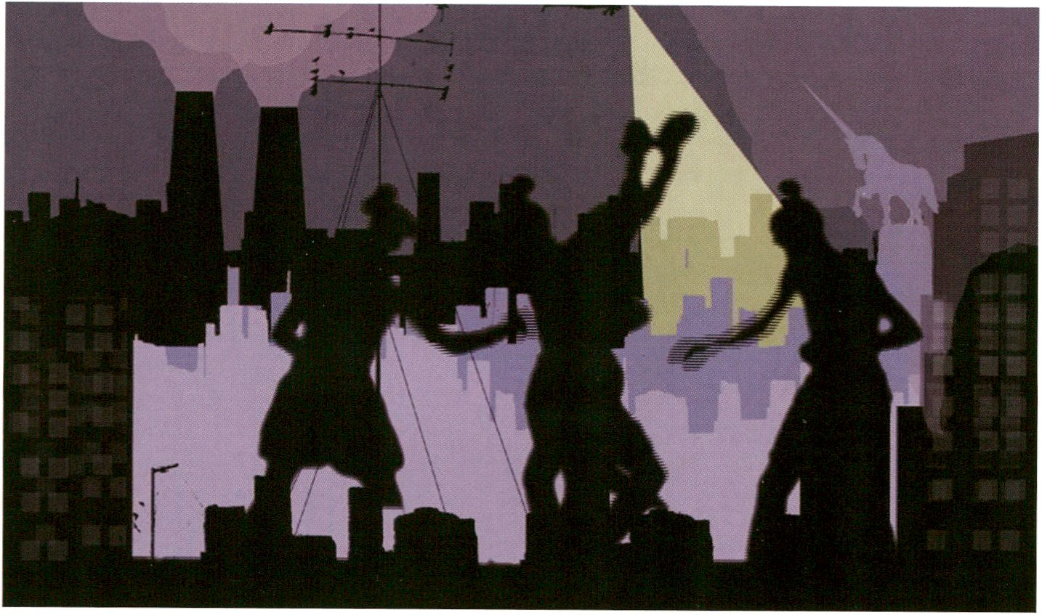The Open Zone | Workstation
Identity Bureau | Heath Bunting (uk)
14:00-19:00
THURSDAY. FEB 3
Is This a Good Day to Start a War by Sharon Paz
- Complete information on p. 72
- Identity Bureau Installation, p. 144

SyncExistence | Screening
This is a Good Day to Start a War
14:30- 16:30 | Theatersaal
The two films presented in this programme
address the continuous parallelism of war
and peace. In the Israeli film, Is This a Good
Day to Start a War, avatar-like figures enact
scenes of war and violence. Here, gruesome
war machinery is contrasted with cut-paper
silhouettes otherwise known from fairy tale
films. Where Is Where? on the other hand, is
set in peaceful Finland. After doing research,
a poet reconstructs a murder case from the
Algerian war. Shown across four parallel
screens this story blends elements of docu-
mentary and fiction, and the inner and outer
worlds of its protagonists into a complex
narrative.
Is This a Good Day to Start a War, Sharon Paz, de/il 2009,11 min
Where Is Where?, Eija-Liisa Ahtila, fi 2008, 56 min *
Die beiden Filme dieses Programms behandeln
die beständig andauernde Parallelität von Krieg
und Frieden. Der israelische Film ls This a Good
Day to Start a War lässt avatarartige Figuren
Kriegs- und Gewaltszenen darstellen. Hier wird
die grausige Kriegsmaschinerie kontrastiert mit
der vor allem aus Märchenfilmen bekannten
Scherenschnittanimation. Where is Where?
dagegen spielt im friedlichen Finnland. Die Re-
cherchen einer Dichterin bringen einen Mord
aus dem Algerienkrieg zurück in die Gegenwart.
Auf vier parallelen Screens erzählt, vermischt
die Geschichte Dokumentarisches und Fiktives,
Innen- und Außenwelt der Protagonisten zu
einer komplexen Erzählung.
With their essay Zombie Media, Garnet Hertz
and Jussi Parikka approach media archaeo-
logy with the aim of making it into an art
methodology. Following a presentation of
their ideas the Vilem Flusser Theory Award
nominees invite participants to enact the
process of circuit bending: Participants will
disassemble battery powered devices such
as toys, and subsequently perform with their
customised instruments.
Garnet Hertz und Jussi Parikka sind mit ihrem
Essay Zombie Media, in dem sie sich der Me-
dienarchäologie unter künstlerisch-methodolo-
gischen Gesichtspunkten annähern, für den
diesjährigen Vilém Flusser Theory Award nomi-
niert. In diesem Workshop geht es nach einer
Einführung durch Gamet Hertz direkt ans
Circuit Bending: Besucher sind eingeladen, an
batteriebetriebenen Geräten, also Spielzeugen
und dergleichen, herumzubasteln und später
mit ihren selbstgebauten Instrumenten eine
Performance zu geben.

- Zombie Media, p. 57
- Zombie Media workshop, p. 98
- Democratic:Ability, p. 104
The Open Zone | Workshop
Creative Fundraising & Microfunding Initiatives | with Peter Sunde (se)
15:00 - 18:00 | Open Zone, Currency of the Commons - Workstation

Flattr is a new online platform that provides
a new revenue stream for content creators
as it helps consumers to make donations in a
straightforward and uncomplicated way. It
works by Flattr users paying a small flat rate
fee and creators placing a Flattr button on
their websites: every month the user’s fee is
divided between the creators in relation to
how many websites he or she clicked.
At transmediale.11 Flattr founder Peter Sunde
is joined by the rest of the Flattr team to pre-
sent the platform. Workshop participants will
get hands on help and support with the tech-
nical intergration of Flattr into their platforms.
Flattr ist eine Online-Plattform, die Leuten, die
Inhalte ins Netz stellen eine neue Einnahme-
quelle beschert, indem sie es den Konsumenten
dieser Inhalte erleichtert, auf unkomplizierte
Weise kleine Beträge zu spenden: F/affr-User
zahlen einen kleinen Flatrate-Betrag und Kre-
ative platzieren einen F/affr-Button auf ihrer
Seite. Allmonatlich wird der einmal gezahlte
Betrag dann auf die von der zahlenden Person
angeklickten Webseiten aufgeteilt.
Auf der transmediale.11 präsentiert Peter Sunde,
der F/affr-Gründer, die Plattform zusammen mit
seinem ganzen Team. Workshop-Teilnehmer
lernen, wie man Flattr auf seiner Webseite in-
stalliert.

> The Currency of the Commons, p. 116
transmediale Award | Artist Walk, Workshop
Serendipitor | with Mark Shepard (us)
16:00 - 16:45 | Auditorium Deck
Serendipitor is an alternative navigation app
for the iPhone that helps you find something
by looking for something else. At trans-
mediale.11, there will be several occasions
when visitors will be able to try out the app,
download it to their iPhone, and participate in
a series of serendipitous city walks organised
during the festival.
> Serendipitor, p. 52
Das für den transmediale Award 2011 nominier-
te Projekt Serendipitor ist eine alternative Navi-
gations-App für das iPhone, mit der man Dinge
finden kann, während man eigentlich etwas
Anderes sucht: Die App fügt kleinere Umwege
und Verzögerungen in eine ansonsten optimier-
te und effiziente Route ein.
Besucher der transmediale.11 haben mehrmals
die Möglichkeit, die App zu testen, sie auf ihr
iPhone herunterzuladen sowie an einigen mit
glücklichen Zufällen gespickten Stadtspazier-
gängen teilzunehmen.

The Open Zone | Workshop
Open Activist Consultancy Event | with Allen Gunn (us)
17:00 - 19:00 | Open Zone, Response:Activities - Workstation

Aspiration helps individuals and NGOs design
appropriate online models and messages to
engage interested stakeholders and suppor-
ters. It publishes a range of open-licensed
processes and templates for planning and
managing online efforts. Workshop partici-
pants will be invited to try new tools and
tactics for impactful online organising and
campaigning.
- Observer Talk, Allen Gunn, p. 81
- Response:Activities talk, p. 99
Aspiration hilft Einzelnen und NGOs bei der
Gestaltung passender Online-Modelle und Mes-
sages, um Interessengruppen und Unterstützer
wirkungsvoll zu erreichen. Leitlinien sind Ein-
fachheit sowie ein Fokus auf narratives Design,
gepaart mit der Überzeugung „weniger ist
mehr“ im Hinblick auf die verwendeten Techno-
logien. Teilnehmer sind eingeladen, neue akti-
vistische Tools und Taktiken kennenzulernen.

The Open Zone | Workshop
interACTicons - Online Archive, Workshop, and Performance | Ursula Endlicher (at)
17:00 - 19:00 | Open Zone
Complete Information on p. 77
BODY : RESPONSE | Interface Keynote Conversation transmediale and CTM - Track 1: Bios and
Presence
Digital Liveness? Realtime, Desire and Sociability | with Erik Kluitenberg (nl),
Mushon Zer-Aviv (il), Philip Ausländer (us) | Moderator: Drew Hemment (uk)
16:00 - 18:30 | Auditorium

THURSDAY. FEB 3
The desire to transcend distance and se-
paration has accompanied the history of
media technology for many centuries. One
manifestation of this desire to transcend the
limitations of living experience is the longing
for immediate contact with people and
audiences across any distance or divide.
Today internet-based techniques of tele-
connection, live streams, and various forms
of real-time interfaces and networks seem to
create a ubiquitous presence, replacing the
actual physical co-presence of here and now.
At the same time this ‘presence in absence’
creates an invisible audience that becomes
the crucial definer for the success and failures
of our mediated social life.
With this interface keynote conversations
between CTM (club transmediale) and trans-
mediale we want to bridge our two festival
topics based on evolved qualities of liveness
and presence. The internationally known
researchers and collaborative practitioners
explore the new social and performative
qualities of internet- based real-time media
and networks and how they re-define our
understanding of encounter and sociability.
Das Begehren, die räumliche Entfernung zu
überwinden, hat seit Jahrhunderten die Ge-
schichte der Medien begleitet. Dieses Begehren
manifestiert sich beispielsweise in dem
Wunsch, mit Menschen und einem Publikum
über jede Entfernung und Unterbrechung
hinweg unmittelbar in Verbindung zu treten.
Heutzutage ermöglichen internetbasierte
Technologien der Telepräsenz, Live-Streams
und unterschiedliche Formen von Echtzeitmedi-
en und -netzwerken eine allgegenwärtige und
ständige Präsenz. Diese vernetzte Präsenz
(„abwesende Anwesenheit“) tritt mehr und mehr
an die Stelle der leiblichen Ko-Präsenz eines
gemeinsamen Hier und Jetzt. Zugleich entsteht
damit ein unsichtbares,ständiges und allgegen-
wärtiges Publikum, das maßgeblich über den
Erfolg und Misserfolg unseres mediatisierten
sozialen Lebens entscheidet.
Mit diesem gemeinsamen Keynote-Gespräch
von transmediale und CTM (club transmediale)
werden die thematischen Ansätze beider Festi-
vals verknüpft, die sich mit den gegenwärtigen
digitalen Bedingungen von Liveness und Prä-
senz auseinandersetzen. International bekannte
Experten untersuchen die neuen sozialen und
performativen Qualitäten unserer live-geschal-
teten Gesellschaft. Im Mittelpunkt steht die
Frage, wie sich dadurch unser Verständnis von
Begegnung und Soziabilität verändert.

- Lost in the Open?, p. 69
- Radio Tactics, p. 69
- CTM, p. 178
- DAS Weekend, p. 190
LIVE : RESPONSE | Performance
Braun Tube Jazz Band | Ei Wada (jp)
17:30 - 18:30 | HacKaWay Stage
Complete information on p. 78
LIVE : RESPONSE | Performance
The Collapse of PAL | Rosa Menkman (nl)
18:30 - 19:30 | HacKaWay Stage
In this A/V performance Rosa Menkman
reflects on the PAL signal and its supposed
end. Although now obsolete and outdated,
PAL still lives on indirectly in newer tech-
nologies like the DVB signal. The Collapse of
PAL is an hommage to the typical analogue
signal artefacts, which Rosa Menkman
captured through a whole range of video and
audio sources and which she combines with
a Cracklebox, a European telephone signal,
Morse code, an old Casio keyboard and more,
In dieser A/V-Performance reflektiert Rosa
Menkman über das PAL-Signal und dessen
vermeintliches Ende. Obgleich heute veraltet
und überholt, wohnt PAL dennoch mittelbar
auch neueren Technologien wie dem DVB-
Signal inne. The Collapse of PAL ist eine
Hommage an die typischen Artefakte des
Analog-Signals, die Rosa Menkman aus einer
Reihe von Video- und Audioquellen eingefan-
gen hat und mit Klängen einer Cracklebox,
eines altes Casio-Keyboards, europäischen
Telefonsignalen, Morsecode, usw. kombiniert.

SyncExistence | Screening
Arab Shorts 2010: To Know the Arab Terrain: Movements To, From, and Within
18:30 - 20:30 | Theatersaal

Situated on the borders of Arab-ness, this
programme highlights the diversity of
expression and experimental filmmaking in
the Arab world. Through examining the
mobility and diversity of thought and history
of the image-maker, the programme suggests
a wider definition for the Arab and its image.
The programme screens footage from a family
archive filmed in Kuwait, soars over Jordan,
contrasts images of nature in Syria, abstracts
a migration situation in Morocco, and reflects
on desolated landscapes in Egypt, Lebanon
and Finland. It proposes a realignment of the
elements of inherited history as well as dis-
placement, in an attempt to contemplate the
shape of the Arab terrain, and the role given
to this terrain in each of these films.
Von den Grenzen des Arabischen ausgehend,
betont dieses Programm die Ausdrucksvielfalt
und das experimentelle Filmschaffen in der
Arabischen Welt. Untersucht werden die Be-
weglichkeit und Vielfältigkeit der Mentalitäten
sowie die Geschichte des Bildschaffenden
selbst. Das Programm suggeriert so eine er-
weiterte Definition des Arabischen und seiner
Darstellung. Es zeigt Bilder eines Familienar-
chivs aus Kuwait, schwebt über den Jordan
hinweg, kontrastiert Naturaufnahmen aus
Syrien, abstrahiert eine migrantische Situation
in Marokko und reflektiert über desolate
Landstriche in Ägypten, im Libanon sowie in
Finnland. Es schlägt eine Neuordnung weiter-
gegebener, historischer Versatzstücke vor, um
über die Gestalt des Arabischen Gebiets zu
reflektieren, sowie die Rolle, die diesem in je-
dem der Filme zugeschriebenen wird.

Step by Step, Oussama Mohammad, sy 1979, 22 min
No Title - excerpts from super 8mm films from the family archive,
Mufid Younis, jo/kw 1978-1980, 2 min
Tokyo Tonight, Ziad Antar, lb 2003, 3 min
Vacuum, Adel Abidin, iq/fi 2006, 9 min
Linen on Terrace, Fadma Kaddouri, ma/fr 2007, 4 min
Telematch Shelter, Wael Shawky, eg 2008, 5 min
two sides of one piece, Mohssin Harraki, ma/fr 2010, 2 min
Aesthetics of Disappearance, Jananne Al-Ani, iq/jo 2010,15 min
This programme was curated by Ala’ Younis for Arab Shorts, a project of the Goethe-Institut Cairo - arabshorts.net
Das Programm wurde kuratiert von Ala’ Younis für Arab Shorts, ein Projekt des Goethe Institut Kairo - arabshorts.net
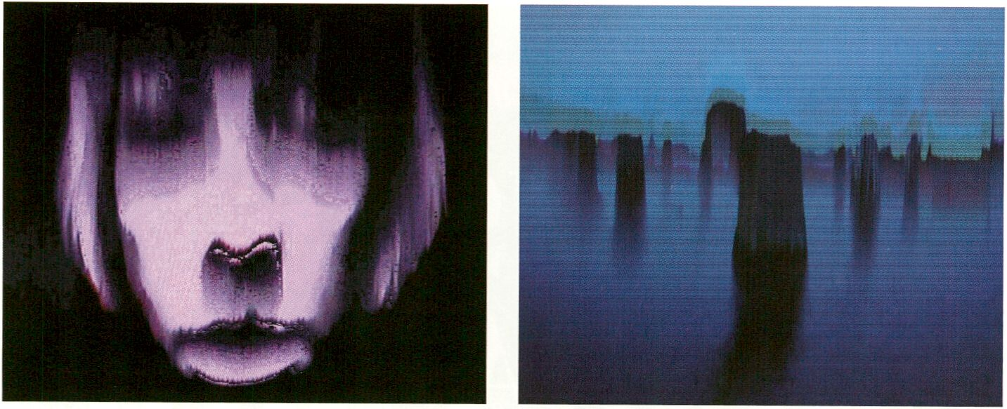
Angel of History, The Collapse of PAL by Rosa Menkman The Collapse of PAL by Rosa Menkman

The Open Zone | Talks, Workshops, Radio Lounge
TRACES Lounge
19:00 - 21:00 | Open Zone, Currency of the Commons - Workstation
THURSDAY. FEB B
Complete information on p. 77
LIVE : RESPONSE | Performance
Self-Reproduction Loops | Eosin (pt)
19:30-20:30 | Café Stage
Eosin believes in ANALOGUE + DIGITAL,
rather than ANALOGUE vs. DIGITAL. Self-
Reproduction Loops is a tribute to the grooves
of the vinyl record, to its crackles and clicks,
skips and pops. Eosin employs pre-recorded
vinyl noises and loops to create time
sequences for use in live improv situations
which she blends with a real-time layer of
analogue DJing. Combined, both layers form
compositions where each sound surpasses its
own state of noise, loop or representation to
become part of the overall sonority.
Eosin glaubt an ANALOG + DIGITAL anstelle von
ANALOG vs. DIGITAL. Self-Reproduction Loops
ist ein Tribut an die Grooves der Vinylschallplat-
te, an ihr Knacken und Klicken, ihr Springen und
Knallen. Eosin arbeitet mit aufgezeichneten
Vinyl-Geräuschen und Loops als Ausgangsma-
terial für Live-Improvisationen, in denen sie
diese voraufgenommene Klangebene um eine
DJ-Ebene erweitert. Aus dieser Kombination
entstehen unvorhersehbare Kompositionen, in
denen jeder Klang über sein ursprüngliches
Wesen als Noise oder Loop hinauswächst und
in der Klanggesamtheit aufgeht.

The Open Zone | Talk Observer Talk of the Day 2 | with Tapio Makela
20:00 - 21:00 | Open Zone, Lost in the Open - Workstation

Each evening transmediale.11 invites visitors
to gather for an informal Observer Talk.
'Observers’ have been invited from the diverse
fields of Media Art, Journalism, Media Acti-
vism and Free Culture and will share their
personal interpretation of the day's festival
activities.
> Democratic:Ability, p. 104
Jeden Abend laden wir einen ganz besonderen
Gast ein, die Eindrücke des zurückliegenden
Festivaltages gemeinsam mit unseren Besu-
chern in einer informellen Runde zu diskutieren.
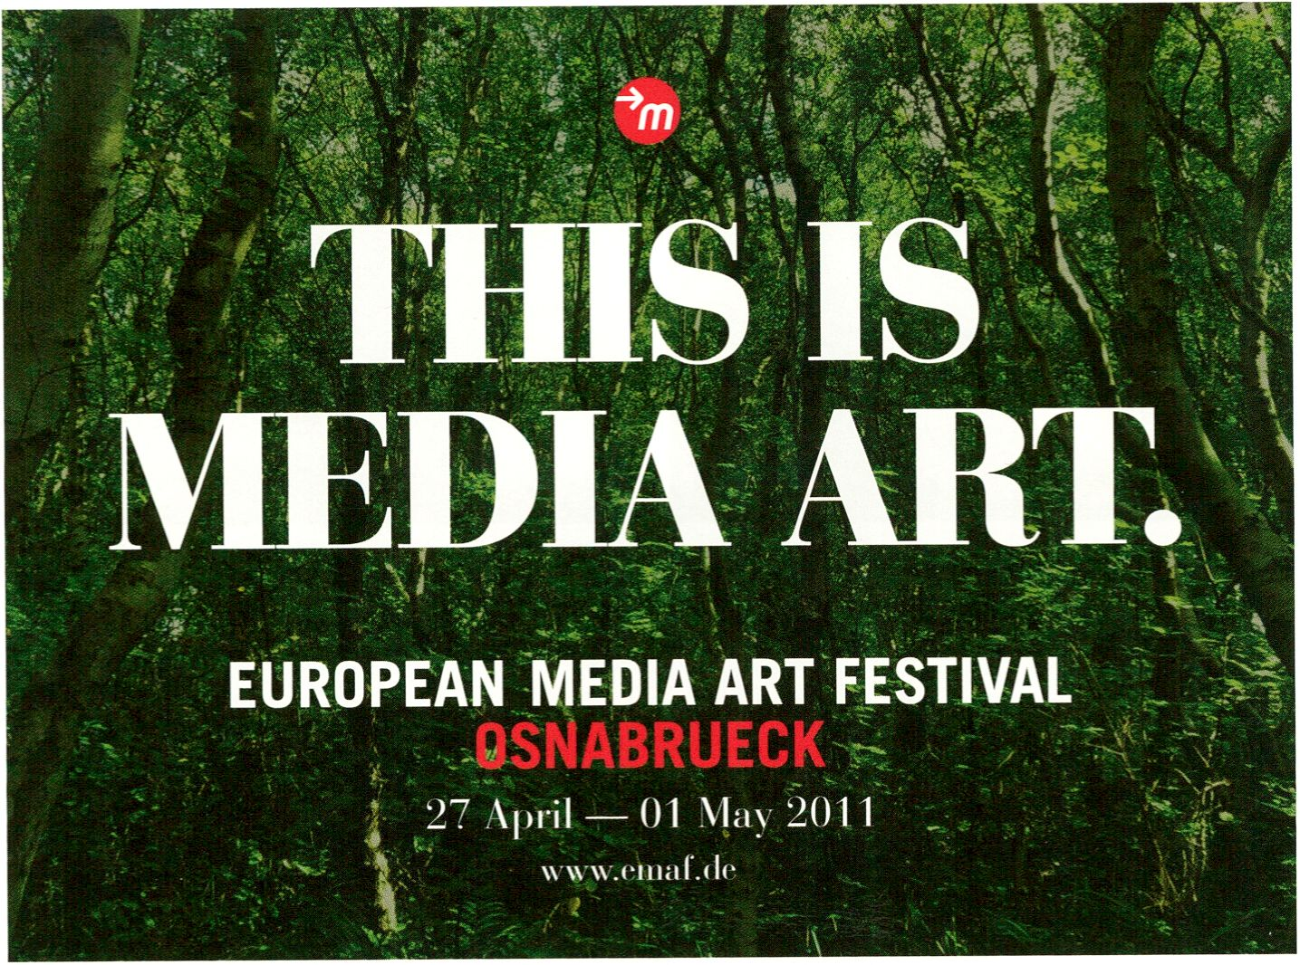Suchen wir mit Sternen-
mädchen die Liebe
zu drei Orangen im exit
trough the giftshop?
Guter Plan!
tazplan für musik, kino, bühne und kultur.
5 Wochen taz mit täglich 4 Seiten Kultur^ Programm für nur 10 Euro.
Bestellen Sie das unverbindliche Miniabo inklusive einer deutschsprachigen
Le Monde diplomatique.
jftdletageszeitimg
HacKaWay | Performance
Latent Figure Protocol | with Paul Vanouse (us)
20:00 - 20:30 | HacKaWay Stage

Vilem Flusser Theory Award | Performative Lecture
GATHERINGS 1: EVENT, AGENCY, AND PROGRAM | with Jordan Crandall (us)
20:30 - 22:30 | Auditorium
THURSDAY. FEB 3
Latent Figure Protocol (LFP) is an installation
and a live science experiment that uses DNA
samples to create readable, representational
images. Several times throughout the festival
artist Paul Vanouse will come to his bioart lab
in the HacKaWay Zone, giving an informal
science lesson and performing the experi-
ment. Each time the results are recorded and
can be watched until the fluorescence of the
DNA eventually fades out.
- Latent Figure Protocol, p. 140
- Fingerprints? Focus Discussion, p. 102
- Schering Stiftung, p. 162
- The Age of Affect, p. 132
Jordan Crandall gives a performative lecture
of his essay GATHERINGS 1: EVENT, AGENCY,
AND PROGRAM, which is nominated for this
year's Vilém Flusser Theory Award.
> GATHERINGS 1... , p. 55
LIVE : RESPONSE | DJ-Set
cat suzette (de)
22:30 | Café Stage
cat suzette plays with her audience, adapting
her music to the prevailing mood and then,
ultimately, transforming the atmosphere of the
room. In this way, her sets can start off with
trancey sounds that segue into narrative dub
techno and end with ‘robust’ hardness and
bouncy 4/4.
Latent Figure Protocol ist eine Installation und
ein wissenschaftliches Live-Experiment, das
DNA-Proben zur Bildherstellung lesbarer Sym-
bole nutzt. Während des Festivals findet sich
Künstler Paul Vanouse mehrmals zu informel-
lem Wissenschaftsunterricht in sein Bioart-
Labor in der HacKaWay Zone ein, wo er auch
sein Experiment durchführt. Die Ergebnisse
dieser Sessions bleiben jeweils solange auch
noch nach der Performance für das Publikum
sichtbar, bis die Leuchtkraft der DNA wieder
abgeklungen ist.
In einem performativen Vortrag gibt Jordan
Crandall Einblick in seinen Essay GATHERINGS
1: EVENT, AGENCY, AND PROGRAM, mit dem
er für den diesjährigen Vilem Flusser Theory
Award nominiert ist.
cat suzette spielt mit ihrem Publikum und passt
ihre Musik der herrschenden Stimmung an, um
schließlich ihrerseits die Atmosphäre im Raum
zu lenken. Auf diese Weise kann ihr Set mit
einer trancigen Klangfläche beginnen, die in
einen erzählerischen Dub-Techno übergeht und
mit einer „gesunden“ Härte und einem
bouncigem 4/4 Takt endet.
Vilem Flusser Theory Award | Workshop
Zombie Media Workshop: Circuit Bending as Media Archaeology |
Garnet Hertz (uk), Jussi Parikka (fi)
10:00 - 14:00 | HacKaWay Stage
For 15 participants / With pre-registration only
Für 15 Teilnehmer / Nur mit Voranmeldung
Complete information on p. 57, 91
A MAZE. I Workshop
Controlled Invasion Part 1 | with Thorsten S. Wiedemann (de), Heather Kelley (ca)
10:30 -14:30 | Upper Foyer / CoS Workstation

FRIDAY. FEB 4
Calling the game input the “controller” was
the first lie. In fact, games control us - and we
like it. As game designers and critics, we have
an ethical responsibility to understand the
seductive power of challenge and action of
these interactive micro-worlds in terms of
their potentially serious consequences. The
workshop leaders will engage their guests
and distant collaborators to build a frame-
work of game design ethics that recognises
both the pleasure and ambivalences inherent
to this persuasive medium. The ultimate goal
being nothing less than a Manifesto - a
defining statement of a way forward that is
both critical and hopeful.
Es ist falsch zu glauben, der „Controller“ sei bei
Games der Input. Fakt ist, die Spiele kontrollie-
ren uns - und uns gefällt das. Als Game-Desig-
ner und -Kritiker haben wir die ethische Verant-
wortung uns darüber im Klaren zu sein, dass
das Handeln und Erleben in den interaktiven
Mikrowelten durchaus schwere Folgen haben
kann. Die Workshop-Leiter laden Teilnehmer
und zugeschaltete Mitdenker ein, einen ethi-
schen Game-Design-Rahmen zu schaffen, der
den Spaß im Spiel und die ambivalenten Poten-
tiale dieses Mediums gleichermaßen berück-
sichtigt. Das Ziel ist nichts weniger als ein
Manifest: ein aussagekräftiges Statement, das
zugleich kritisch und zuversichtlich ist - vor
allem aber ein klarer Blick in die Zukunft.

- Ludic Salon, p. 125
- A MAZE, at systM, p. 164
- OPEN Signs, p. 158
BODY : RESPONSE | Workshop
Mz Baltazar's Laboratory - Feminist DIY | with Stefanie Wuschitz (at)
10:30-14:30 | K2
Complete information on p. 85
The Open Zone | Workstation
Immediated Autodocumentary | Gabriel Shalom (us), Patrizia Kommerell (de)
11:00-22:00
Complete information on p. 68
The Open Zone | Workstation, Mini Performances and Micro Conferences
The Wanted & For Sale Office
11:00 - 22:00 | Open Zone
Complete information on p. 71
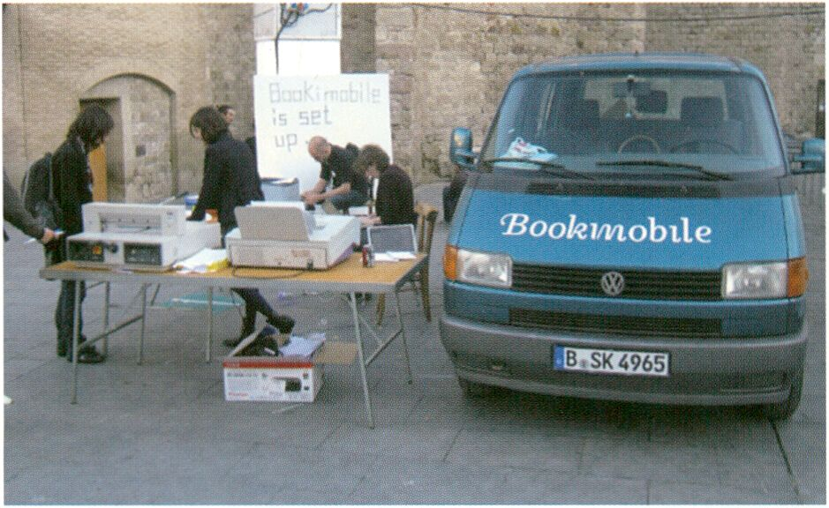
Booki Mobile, Photo: Adam Hyde at Drumbeat Barcelona, 2010

The Open Zone | Talk
Response:Activities - Strategies of Political Participation | with Marek Tuszynski (pi),
Allen Gunn (us), Michelle Thorne (us), Heath Bunting (uk), Sami Ben Gharbia (tn)
11:00-13:00| K1
FRIDAY. FEB 4
Hacks, flash mobs, online petitions: never
have there been so many opportunities
for free expression and social participation as
there are today. The digital citizen is self-
aware and enlightened; aware of the con-
sequences of his actions. Media activists join
forces worldwide and create platforms for
themes and people that to date had no
support. We present a number of projects and
people working with the activist potential of
the Internet and other technologies - thereby
developing radically new policy approaches in
terms of self-determination, participation and
integration.
- Identity Bureau, p. 72
- Open Activist Consultancy Event, Allen Gunn, p. 92
- Observer Talk, Allen Gunn p. 81
- Sharism, p. 73
- Through the Iris, p. 127
- Tactical Tech Activism, p. 192
- Drawing by Numbers, p. 71
- Free Culture Incubator, p. 87
Hacks, Flashmobs, Online-Petitionen: noch nie
gab es so viele Möglichkeiten der freien Mei-
nungsäußerung und sozialen Mitbestimmung
wie heute. Der digitale Bürger ist selbstbewusst
und aufgeklärt, weiß um die Konsequenzen
seiner Handlungen. Medienaktivisten weltweit
schließen sich zusammen und schaffen Platt-
formen für Themen und Menschen, die bis dato
keine Lobby hatten. Wir stellen einige Projekte
und Menschen vor, die mit dem aktivistischen
Potenzial des Internets und anderer Technolo-
gien arbeiten - und damit radikal neue politi-
sche Ansätze in punkto Selbstbestimmung,
Teilhabe und Integration entwickeln.

The Open Zone | Workstation
Open Design City ‘Make Your Own Market’
11:00 - 22:00
Complete information on p. 70
gg
Featured Projects | Workshop
CoS Workshop 2: Space | with Salvatore laconesi (it), Oriana Persico (it)
- - 15.00 | Throughout Berlin

FRIDAY. FEB >t
Space: Communication technologies not only
altered our perception of space but also
evoke a sense of global connectivity. NeRVi
(NeoRealismo Virtuale, engl. Virtual
NeoRealism), a term coined by laconesi and
Persico, describes this condition of ubiquity,
where multiple realities are produced and
remixed by location-based technologies and
augmented reality. Space becomes a map of
personal narratives. In the workshop we will
use smartphones and a geographic infor-
mation system to create an augmented reality
narrative across the city of Berlin.
For 15 participants / With pre-registration only
Für 15 Teilnehmer / Nur mit Voranmeldung
- CoS installation, p. 152
- CoS workshop 1 (Part 1), p. 76
- CoS workshop 1 (Part 2), p. 87
- CoS workshop 3, p. 117
- CoS workshop 4, p. 131
- Social ID, p. 86
Space: Kommunikationstechnologien haben
nicht nur unsere räumliche Wahrnehmung ver-
ändert, sondern auch das Empfinden einer
globalen Verbundenheit gestärkt. Salvatore
laconesi und Oriana Persico habe den Begriff
NeRVI (NeoRealismo Virtuale, engl. Virtual
NeoRealism) eingeführt, um den Zustand der
Allgegenwärtigkeit zu beschreiben. Durch
standortbezogene Technologien und einer
Überlagerung realer und virtueller Räume wer-
den multiple Realitäten fortlaufend neu produ-
ziert. So auch in dem Workshop Space, wo mit
dem Smartphone und geographischen Infor-
mationssystemen eine individuelle Karte Berlins
erstellt wird.

The Open Zone | Open Web Award | Workshop
Booki Workshop & Booki Mobile | with Adam Hyde (nz) of FLOSS Manuals and Booki
12:00 - 15:00 | Open Zone, Response:Activities - Workstation

Booki is a social network with the focus on
making and publishing books. The platform
helps users to write and publish books and to
collaborate with others around the world to
write books collectively in events such as
Book Sprints. Book Sprints bring together
people in real-space to create a book in a
matter 5 days or less.
The Booki Mobile - a mobile print lab in a van
- Is the latest step in the development and will
be at transmediale.11 from 1-6 February,
here you can make real printed copies of your
books. Adam Hyde, one of the creators of
Booki, will be hosting a workshop where you
can learn more about Booki.
- Booki, p. 60
- Book Sprint, p. 161
Booki ist ein Soziales Netzwerk mit Fokus auf
verlegerische Tätigkeiten. Die Plattform unter-
stützt User bei Buchprojekten und macht es mit
Veranstaltungen wie den Book Sprints möglich,
weltweit gemeinsam mit Kollaborationspartnern
Büchern zu schreiben. Book Sprints bringen
Leute an konkreten Orten zusammen, um im
Zeitraum von maximal fünf Tagen Bücher zu
schreiben.
Das Booki-Mobil - eine mobile Druckwerkstatt
in einem Kleinbus - ist der allerneuste Entwick-
lungsschritt und wird vom 1. bis 6. Februar auf
dertransmedlale.11 sein. Hier kann man seine
eigenen Bücher drucken. Adam Hyde, einer der
Gründer von Booki, wird außerdem einen Work-
shop geben, in dem man mehr über Booki er-
fahren kann.
Satellites | Workshop
12:30 Open Doors: Vilem Flusser Archiv
13:00 - 15:00 | Flusserian Philosophical Fridays: Discussing the text Writing: Does It have a Future?
| with Claudia Becker (de), Baruch Gottlieb (ca), Rodrigo Novaes (br), Siegfried Zielinski (de)
Universität der Künste, Grunewaldstr. 2-5,10825 Berlin
Complete information on p. 159
The Open Zone | Workshop
Facebook Resistance | with Tobias Leingruber (de)
13:00 - 16:00 | Open Zone, Lost in the Open? - Workstation

The code is law. The architectures of cyberspace are as important
as the law in defining and defeating the liberties of the Net.
Lawrence Lessig
FRIDAY. FEB H
Facebook - worth more than 30 billion US$ -
is taking over the social web, and its uniform
design follows Mark Zuckerberg's ideals.
What if you could change Facebook's laws,
add a Dislike button or create custom
backgrounds? You can!
Workshop participants will learn how browser
extensions (e.g. Firefox Add-Ons) enable us to
locally modify Facebook and distribute it to
the masses. In the presentation on Saturday
Tobias presents the experimental and artistic
Facebook hack concepts to festival visitors
before turning these concepts into a real
software that users worldwide can download
and share.
Facebook ist mit über 30 Milliarden USS Markt-
wert das führende Soziale Netzwerk. Sein uni-
formes Design entspricht allein den Idealen
Mark Zuckerbergs. Wie wär's die Gesetze von
Facebook mitzubestimmen, indem man selbst
einen „Gefällt mir nicht“-Knopf oder eigene
Hintergründe platziert? You can!
Teilnehmer lernen wie Browser-Erweiterungen
(z.B. Facebook Add-Ons) uns erlauben, Face-
ook lokal zu verändern und dies sogar an
Andere weiterzugeben. In der Präsentation am
Samstag stellt Tobias Leingruber experimentel-
le und künstlerische Konzepte zum Hacken von
Facebook vor. Auf dieser Basis bastelt er eine
Software, die User weltweit herunterladen und
sharen können.

For 10 participants / With pre-registration only
Für 10 Teilnehmer / Nur mit Voranmeldung
> Facebook Resistance presentation, p. 118
HacKaWay | Workshop
WOPPOW | UBERMORGEN.COM
13:00 - 16:00 | HacKaWay Stage
Complete information on p. 72
Book Launch
Interface Criticism: Aesthetics Beyond the Buttons (Aarhus University Press 2011) |
with Soren Pold (dk), Christian Ulrik (de), Inke Arns (de), Geoff Cox (uk) |
Moderator: Sabine Breitsameter (de)
13:15-13:45 I Café Stage
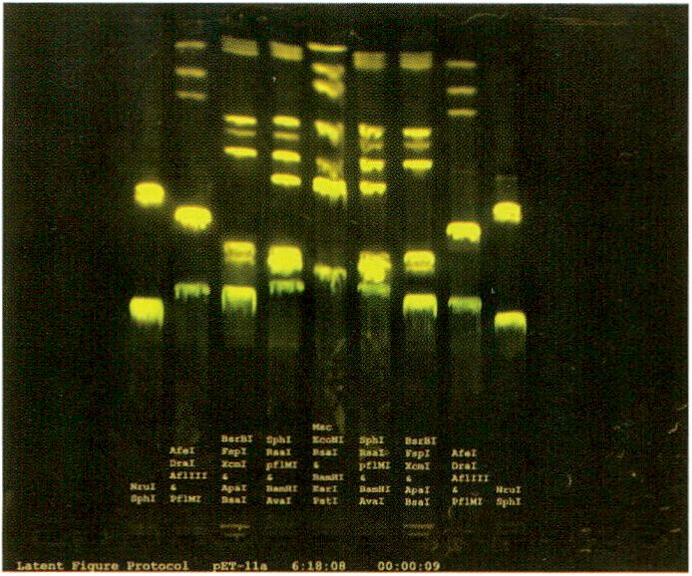
Latent Figure Protocol by Paul Vanouse, courtesy of Lauren Tent
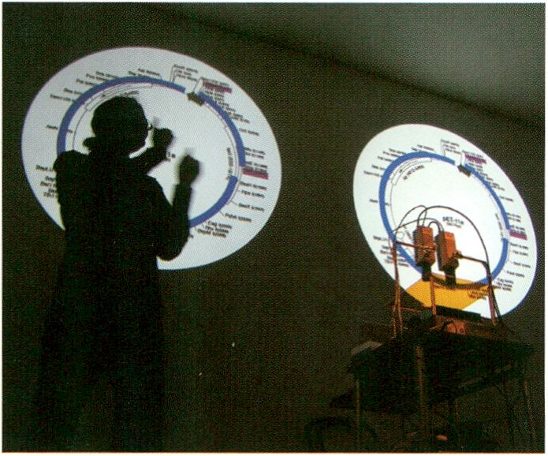
Latent Figure Protocol by Paul Vanouse

FRIDAY. FEB H
BODY : RESPONSE | Focus Discussion - Track 3: Bios and Technology
Fingerprints? Identity, Indexicality and Biomedia | with Paul Vanouse (us), Jens Hauser (de/fr),
Simon Cole (us), Hans-Jörg Rheinberger (ch/de) | Moderator: Marie-Luise Angerer (at/de)
14:00 - 16:00 | Auditorium
ioa
The convergence of information and labor-
atory technological procedures engenders
biomedia that are increasingly being
appropriated by the arts. Based on the perfor-
mative gel electrophoresis works by US artist
Paul Vanouse, the panel examines the poli-
tical, science-historical and aesthetic aspects
of contemporary biologisms and mole-
cularisms. Identification and authentication
strategies such as ‘genetic fingerprinting’
readily hide away their inherent constructed-
ness while ‘naturally’ presenting themselves
in the tradition of photography or the imprint,
supposed to be indexical. Are antiquated
racial and gender discourses becoming
acceptable again? What contribution does art
that uses biomedia make when it subverts
today’s knowledge producing images?
In Collaboration with the Ernst Schering Foundation
- Latent Figure Protocol, p. 140
- Fingerprints..., p. 162
- Delimination of Life, p. 132
Die Konvergenz informations- und labortechni-
scher Verfahren bringt Biomedien hervor, die
auch die Kunst zunehmend einsetzt. Ausge-
hend von den performativen Gelelektrophorese-
Arbeiten des amerikanischen Künstlers Paul
Vanouse untersucht das Panel die politischen,
wissenschaftshistorischen und ästhetischen
Facetten zeitgenössischer Biologismen und
Molekularismen. .Genetische Fingerabdrücke’
und andere Identifikations- und Authentifizie-
rungsstrategien verstecken dabei gern die
ihnen innewohnende Konstruiertheit und geben
sich ganz .natürlich’ in der Tradition vermeintli-
cher Indexikalität von Fotografie oder Abdruck.
Werden hier antiquierte Rassen- und Gender-
Diskurse wieder salonfähig? Welchen Beitrag
leistet Kunst mit Biomedien in ihrer Subversion
zeitgenössischer Wissensbilder?
SyncExistence | Screening
Imaginary Travels
14:30- 16:30 | Theatersaal
Consisting of eight films, this programme
sends its viewers on imaginary journeys
through time and space. Starting from
Travelogue, a film without images, impres-
sions of various surreal and fantastic land-
scapes in the Chilean Atacama desert follow
in centipede sun. The demolition of the
People’s Palace in Berlin is recalled through
the time-lapse film Der letzte Tag der Republik
whilst in Storyteller Las Vegas floats along the
screen like a spaceship. In TEN the artist
clones himself digitally, creating a claustro-
phobic encounter. Before closing with a purely
imaginary science fiction short film about the
future of the Egyptian pyramids in the year
2026, in Suspended Animation, we see Walt
Disney resurrected into the present, which he
can no longer comprehend.
Mit acht Filmen schickt dieses Programm seine
Zuschauer auf Reisen durch Raum und Zeit.
Begonnen mit Travelogue, einem Film ohne Bil-
der, folgen in centipede sun Eindrücke surreal-
fantastischer Landschaften der chilenischen
Atacama Wüste. Der Abriss des Berliner
Palastes der Republik wird mit dem Zeitraffer-
Film Der letzte Tag der Republik noch einmal
aufgerufen und die Silhouette von Las Vegas
schwebt in Storyteller über die Leinwand wie
ein Raumschiff. In TEN klont der Künstler sich
digital und schafft eine beklemmend statische
Begegnung seiner selbst. Walt Disney wird in
Suspended Animation aus dem Jenseits in eine
Gegenwart geholt, die er nicht mehr begreifen
kann. 2026, ein nur in der Vorstellungskraft des
Protagonisten stattfindender Science Fiction
Kurzfilm über die Zukunft der ägyptischen Pyra-
miden beschließt das Programm.
FRIDAY. FEB 4
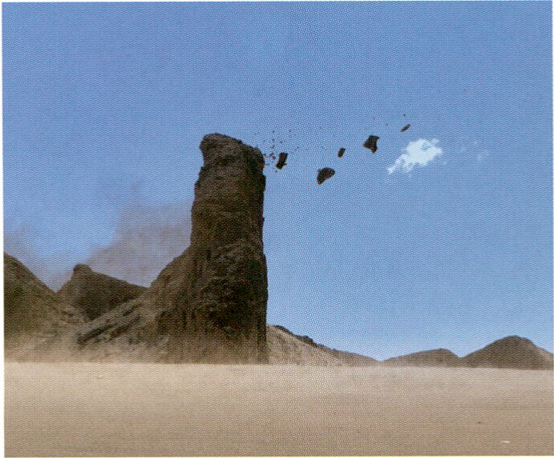
Centipede Sun by Mihai Grecu
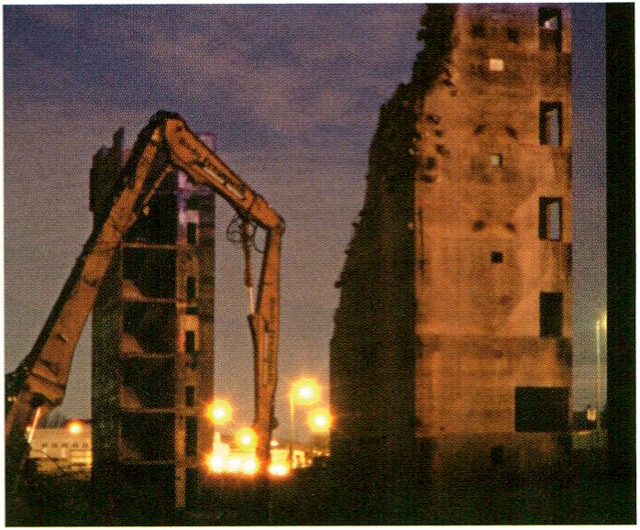
Letzter Tag der Republik by Reynold Reynolds

Travelogue, Jani Ruscica, fi 2010, 8 min
centipede sun, Mihai Grecu, fr 2010,10 min
The Vanishing Point, Jan Tobias Anderson, se 2008, 3 min
Letzter Tag der Republik, Reynold Reynolds, de 2010, 8 min *
Storyteller, Nicolas Provost, be 2010, 7 min
TEN, Niklas Goldbach, de 2010,12 min *
Suspended Animation, Billy Lumby, uk 2009,11 min
2026, Maha Maamoun, eg 2010, 9 min *
* Director will attend screening and Q & A
> Reynold Reynolds: Secrets Trilogy, p. 43
BODY : RESPONSE | Focus Discussion - Track 3: Bios and Technology
Democratic:Ability - Open Forms of Politics | with Garnet Hertz (ca), Tapio Mäkelä (fi),
Nancy Mauro-Flude (au), Jürgen Neumann (de) | Moderator: Alison Powell (ca)
15:00-17:00 | K1

FRIDAY. FEB 4
The Open Zone | Workshop
interACTicons - Online Archive, Workshop, and Performance | Ursula Endlicher (at)
15:00 - 18:00 | Open Zone
Complété information on p. 77
The Open Zone | Workstation
Identity Bureau | Heath Bunting (uk)
15:00-20:00
Complete information on p. 72
Collaboration Projects - V2_Agency & NIMk Distribution | Launch
16:00-17:00| Café Stage
- V2_Agency & NIMk Distribution, p. 41
- ART: ZONES, p.148,149
transmediale Award | Presentation
Spatial sound Sculpture | with Christopher Warnow (de), Daniel Franke (de)
16:00 - 16:30 | Archivraum
- complete information on p. 51
- Spatial Sound Sculpture presentations, p. 75
This focus discussion explores the relation-
ship between open movements, collaboration,
hacking, politics and economy. By looking at
a number of examples from hacking and open
source cultures it asks to what extend such
new forms of distributed collaboration and
collective, rhizomatic creativity open up new
political perspectives - that is, beyond the
new modes of existence and organisation
they are doubtlessly able to engender. We also
ponder the relationship between hacking,
open-source and the market, particularly the
boundaries between art, commerce and
politics.
- Zombie Media, p. 57
- Observer Talk, Tapio Makela, p. 95
Diese Fokusdiskussion untersucht die Bezieh-
ung zwischen offenen Bewegungen, Kollabora-
tionsformen, Hacking, Politik und Ökonomie.
Anhand einer Reihe von Beispielen aus der
Hacking und Open Source-Kultur wird gefragt,
inwiefern solche neueren Formen standortüber-
greifender Zusammenarbeit und kollektiver,
rhizomatischer Kreativität, neben den neuen
Erlebnis- und Organisationsweisen, die sie
zweifellos initiieren, ernsthaft auch neue politi-
sche Perspektiven eröffnen. Diskutiert wird in
diesem Zuge auch das Verhältnis von Hacking
und Open Source zum Markt, und zwar insbe-
sondere im Hinblick auf die Grenzen zwischen
Kunst, Handel und Politik.
Lately creative enterprises and their codes
of conduct have moved from the periphery to
centre stage with communication between the
“old economy” policy makers and creative
entrepreneurs increasing significantly.
Shapeshifters sees a huge potential in new
investment models and resources. To ensure
the benefitting of the common good, since
2006 Shapeshifters has been working on a
global research project to map Creative
Tribes and Value Zones for more sustainable
connections between creative producers and
investors. In this workshop Eric Poettschacher
will present his research results to the public
for the first time.
In der jüngeren Zeit sind kreative Firmen und
deren Unternehmensphilosophien von der Peri-
pherie ins Zentrum der Aufmerksamkeit gerückt
und Akteure der „alten Wirtschaft“ schauen mit
großer Neugierde auf die Arbeitsweise kreativer
Unternehmer. Shapeshifters bejaht das große
Potenzial neuer Investitionsmodelle und Res-
sourcen. Doch um sicherzugehen, dass das
Allgemeinwohl tatsächlich von diesen profitiert,
arbeitet Shapeshifters seit 2006 an einem glo-
balen Mapping-Projekt kreativer Gruppen und
Wertzonen, das stabilere Verbindungen zwi-
schen kreativen Produzenten und Investoren
ermöglichen soll. In diesem Workshop präsen-
tiert Eric Poettschacher seine Forschungser-
gebnisse zum ersten Mal überhaupt öffentlich.
For 20 participants / Für 15 Teilnehmer
> The Currency of the Commons, p. 116
BODY : RESPONSE | Keynote Conversation - Track 1: Bios and Presence
Testing Presence: The Unfolding Exchange | with Tim Etchells (uk), Adrian Heathfield (uk)
17:00 - 18:30 | Auditorium

The site of the actions could be an LCD-
monitor or a screen, a stage, a website, a
gallery, a street or a private room. There will
be an encounter in each work or project. This
encounter sets off the process of an event’s
unfolding and its consequences, and an ex-
ploration of the dynamic relationship between
the work and the viewer. The mechanisms and
economics of these processes - the process
of revealing and concealing, of construction
and deconstruction, of appearance and dis-
appearance - are the focus of this discussion.
Against the backdrop of an increasingly
mobile culture, participants discuss physical
co-presence as a common space of mutual
experience.
Der Ort, wo Dinge passieren, könnte ein LCD-
Monitor oder ein Computer-Bildschirm sein,
eine Bühne, eine Webseite, eine Galerie, eine
Straße oder ein privater Raum. In jedem Werk
oder Projekt findet eine Begegnung statt. Diese
Begegnung eröffnet einen Prozess der Entfal-
tung eines Ereignisses und seiner Folgen und
eine Erforschung der dynamischen Beziehung
zwischen dem Werk und dem Betrachter. Die
Mechanismen und Ökonomien dieser Prozesse
- Prozesse des Enthüllens und Verschwelgens,
der Konstruktion und Dekonstruktion, des
Erscheinens und Verschwindens - stehen im
Mittelpunkt dieses Gesprächs. Vor dem Hinter-
grund einer zunehmend mobilen Kultur disku-
tieren die Teilnehmer das Paradigma der
körperlichen Ko-Präsenz als Raum gemeinsa-
mer wechselseitiger Erfahrung.
Elizabeth Stark, co-founder of the Open Video
Alliance, leads this workshop to collaboratively
explore the future of video via the following
themes: (1) remix culture and participation, (2)
open standards, free software, and new tech-
nologies, (3) copyright and the commons, (4)
net neutrality, and (5) free speech.
FRIDAY. FEB H
The workshop will address the current state
of video in each of these fields, and will
explain the reasons why video can't currently
be copied and pasted like text or images.
Scenarios for the future of video will be
discussed and charted out, as the focus turns
to tangible solutions addressing the most
pressing issues that face a global open video
environment.
- The Currency of the Commons, p. 116
- Observer Talk, Elizabeth Stark, p. 123
LIVE : RESPONSE | Performance
Braun Tube Jazz Band | Ei Wada (jp)
17:30 - 18:30 | HacKaWay Stage
Complete information on p. 78
LIVE : RESPONSE | Performance
SenSorSuit | Eboman (nl)
18:30 - 19:30 | HacKaWay Stage
Expect a mind-blowing audiovisual perfor-
mance of real-time video sampling generated
through Eboman’s SenSorSuit. The SenSorSuit
is part of an audiovisual sampling system,
called SenS, which enables him to manipulate
audiovisual samples in real time and to com-
bine these in a virtual 3D environment. For his
live performances Eboman builds up tracks
with input from the audience; real-time
recorded videos are sampled and scratched,
which still unique in this world...
Elizabeth Stark, Mitbegründerin der Open Video
Alliance, leitet diesen Workshop zur Zukunft
von Video und lädt ein, sich gemeinsam mit den
folgenden Themen auseinanderzusetzen: 1)
Remix-Kultur und Partizipation, 2) Offene Stan-
dards, Freie Software und Neue Technologien,
3) Copyright und die Commons, 4) Netz-Neutra-
lität und 5) Redefreiheit.
Der Workshop bespricht all diese Themenge-
biete und begründet, warum Video derzeit nicht
so wie Text im Copy/Paste-Verfahren genutzt
werden kann. Es geht um die Zukunft des Vi-
deos und greifbare Lösungen im Hinblick auf
Open Video weltweit.
In dieser einzigartigen Live-Performance kreiert
Eboman mit seinem SenSorSuit Real-Time
Video-Sample-Tracks. Der SenSorSuit ist Teil
eines audiovisuellen Samplingsystems, dem
SenS, das ihm ermöglicht audiovisuelle
Samples in Echtzeit zu manipulieren und in eine
virtuelle 3D-Umgebung einzufügen. In seinen
Live-Performances konstruiert Eboman Tracks,
bei denen er das Publikum aktiv mit einbezieht
und Echtzeitaufnahmen von Besuchern sampelt
und scratcht.
SyncExistence | transmediale Award | Screening
Ho Tzu Nyen Special
18:30 - 20:30 | Theatersaal
On the occasion of Ho Tzu Nyen being
nominated for the transmediale Award with
his work Newton, a special screening pro-
gramme presents three additional works by
this versatile artist from Singapore who has
worked as writer, performance artist and
filmmaker. His debut film Utama - Every Name
In History Is I tells a foundation history of his
home country, Singapore, and is as experi-
mental as it is speculative. The Bohemian
Rhapsody Project is a trial in the style of a
music video to a song by Queen, while the
suggestive piece Earth consists of a tableau
vivant referencing classical European pain-
tings in an apocalyptic setting.
Ho Tzu Nyen will be attending the screening
and will be available for a subsequent dis-
cussion of his work.
Utama - Every Name In History Is I, 2003, 22 min
The Bohemian Rhapsody Project, 2006, 6 min
Earth, 2010, 40 min
> Newton, p. 59
Anlässlich der Nominierung von Ho Tzu Nyen’s
Videoinstallation Newton für den transmediale
Award zeigt das Special drei weitere ausgewähl-
te Arbeiten dieses vielseitigen Künstlers aus
Singapur, der sich sowohl als Schriftsteller, Per-
formancekünstler und Filmemacher einen Na-
men gemacht hat. Sein erster Film Utama -
Every Name In History ls I ist eine gleichermaßen
experimentelle wie spekulative Gründungsge-
schichte Singapurs. The Bohemian Rhapsody
Project inszeniert im Stil eines Musikvideos eine
Gerichtsverhandlung zu einem Song von Queen.
Und die suggestive Arbeit Earth besteht aus
einem Tableau Vivant, welches Gemälde der
europäischen Kunstgeschichte in einem apo-
kalyptischen Raum zitiert.
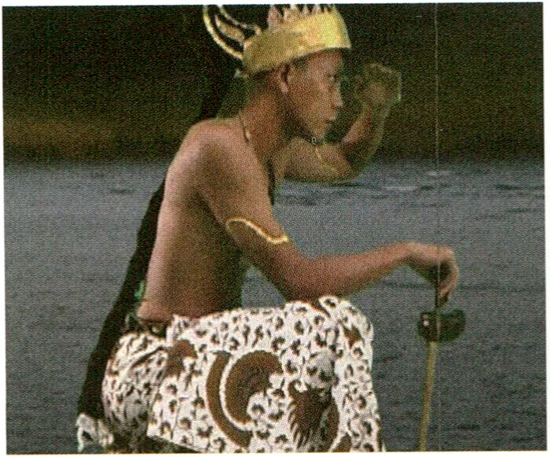Ho Tzu Nyen wird als Gast bei der Vorführung
zugegen sein und für eine Diskussion zur
Verfügung stehen.
FRIDAY. FEB 4
Utama - Every Name In History Is I by Ho Tzu Nyen
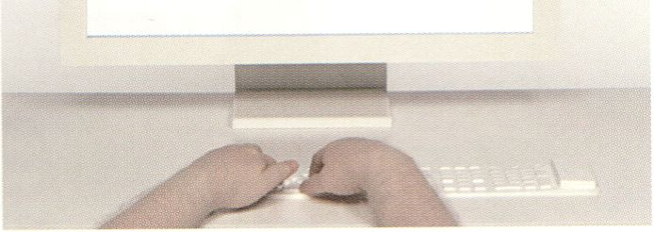
Newton by Ho Tzu Nyen

The Open Zone | Talks, Workshops, Radio Lounge
TRACES Lounge
19:00 - 21:00 | Open Zone, Response:Abilities - Workstation
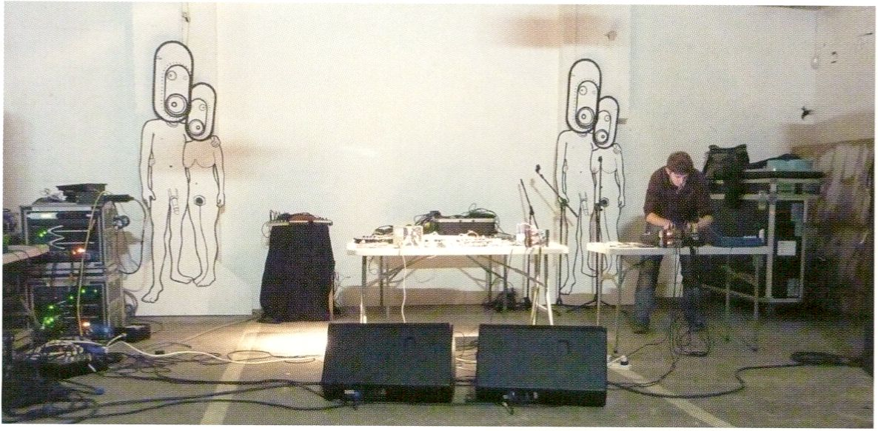
Preslav Literary School in Vivid, Birmingham, Photo: Cara Bell-Jones

FRIDAY. FEB H
LIVE : RESPONSE | Performance
Preslav Literary School (uk)
19:30-20:30| Café Stage
As Preslav Literary School, Adam Thomas
makes live tape collages using sounds drawn
from an ever-growing archive of self-
generated or discovered outsider noise, found
sound and spoken word cassettes. A process
of transference, overdubbing and live mani-
pulation reworks these source materials into
compelling, ambient broadcasts. Accidental
sonics fall into perfectly harmonious repetitive
phrases. All the time in the background wow
and flutter, slowly degrading magnetic tape
and the revolutions of the players’ mecha-
nisms provide an accompaniment to the
circular processes of memory and forgetting
present within the everyday.
The Open Zone | Talk
Observer Talk of the Day | with Micz Flor (de)
20:00 - 21:00 | Open Zone, Lost in the Open? -
Each evening transmediale.11 invites visitors
to gather for an informal Observer Talk.
‘Observers' have been invited from the diverse
fields of Media Art, Journalism, Media
Activism and Free Culture and will share their
personal interpretation of the day's festival
activities.
Als Preslav Literary School kreiert Adam
Thomas Tape-Collagen aus den Klangbestän-
den seines unaufhörlich anwachsenden Archivs
selbst erzeugter oder zufällig entdeckter, „ver-
stoßener“ Klänge, Vorgefundener Sounds oder
Sprachkassetten. Ein Prozess der Übertragung,
Überlagerung und Live-Manipulation verwan-
delt das Ausgangsmaterial in unwiderstehliche,
atmosphärische Sounds. Zufällige Klangereig-
nisse werden zu perfekt harmonischen, repe-
titiven Phrasen. Im Hintergrund währendessen
immerfort Tonhöhenschwankungen, die all-
mähliche Abnutzung des Magnetbands und die
Umdrehungen der Mechanik des Abspielgeräts,
eine Untermalung der im Alltag ständig präsen-
ten, zirkulären Erinnerungs- und Vergessens-
prozesse.
Workstation
Jeden Abend laden wir einen ganz besonderen
Gast ein, die Eindrücke des zurückliegenden
Festivaltages gemeinsam mit unseren
Besuchern in einer informellen Runde zu
diskutieren.
LIVE : RESPONSE | Performance Double Bill
INJECT I Herman Kolgen (ca)
Face Visualizer: Instrument and Copy | Daito Manabe (jp)
21:00 - 22:30 | Auditorium

INJECT | Herman Kolgen (ca)
For more than eight hours a day over the
course of six days a human body is injected in
an enormous glass water tank. Like a human
guinea pig: a matter-body undergoing multiple
neurosensorial transformations, its psycho-
logical states the object of kinetic tableaux,
of singular temporal spaces. The oscillation
between weightlessness and lack of oxygen.
With the aid of various digital video recording
and photographic systems Herman Kolgen
assembled many series of temporal
sequences, images that he then assembled
into a flexible and modular body. INJECT is a
matter of a narrative progression, in perpetual
circles of influence and movement, where the
real is in dislocation.
> DUST, p. 66
Ein menschlicher Körper, eingelassen in einen
gläsernen Wassertank. Für mehr als acht
Stunden pro Tag, sechs Tage lang. Wie ein
menschliches Meerschweinchen: ein Materie-
Körper, unterschiedlichen neurosensorischen
Transformationen ausgesetzt, die psychologi-
schen Zustände Gegenstand eines kinetischen
Tableaux. Ein Wechselbad zwischen Schwere-
losigkeit und Sauerstoffmangel. Mit verschiede-
nen digitalen Video- und Fotoaufnahmesyste-
men hat Herman Kolgen mehrere Zeitabläufe
montiert und so einen beweglichen, modularen
Körper geschaffen. INJECT fasziniert durch
seinen narrativen Verlauf aus endlosen Schlei-
fen von Einflußnahme und Bewegung, die den
Sinn für das Reale auflösen.

Face Visualizer: Instrument and Copy \ Daito Manabe (jp)

Inspired by French researcher Guillaume-
Benjamin-Amand Duchenne (1806 -1875) and
Australian artist Stelarc, Daito Manabe has
created Face Visualizer: Instrument and Copy,
a wonderfully ironic form of music visualiser
that uses electronic impulses to stimulate
facial muscles in synch with music. Face
Visualizer stands in contrast to conventional
methods of mapping and the usual physical
and emotional responses to music and comes
to transmediale.11 as an exciting, comic live
performance.
Inspiriert durch den französischen Forscher
Guillaume-Benjamin-Amand-Duchenne (1806
-1875) und den australischen Künstler Stelarc
hat Daito Manabe eine wundervoll ironische
Form der Musikvisualisierung geschaffen, bei
der er auditive Parameter als elektronische
Impulse auf die Gesichtsmuskulatur überträgt
und diese so in zuckende Bewegung versetzt.
Face Visualizer steht im Kontrast zu herkömmli-
chen Mapping-Methoden oder gewohnten
physisch-affektiven Reaktionen auf Musik und
kommt als eine spannend-komische Perfor-
mance zur transmediale.11.

> BodyHack, p. xx
INJECT and Face Visualizer: Instrument and Copy are presented by transmediale and CTM.
A MAZE. | Workshop
Controlled Invasion Part 2
10:30 -14:30 | K2
Complete information on p. 98
The Open Zone | Workstation
Immediated Autodocumentation | Gabriel Shalom (us), Patrizia Kommerell (de)
11:00 - 22:00 | Open Zone
Complete information on p. 68

SATURDAY. FEB 5
BODY : RESPONSE | Focus Discussion - Track 2: Bios and Power
The Right to Exit | with Les Liens Invisibles (it), Alessandro Ludovico (it), Paolo Cirio (it),
Nathaniel Stern (us), Scott Kildall (us), Jens Best (de)
Moderator: Daphne Dragona (gr)
11:00-13:00 | K1
In today’s connected reality the elements of
online participation - communication, inter-
action and sharing - are no longer considered
possibilities, but are taken as given facts. The
digital multitude has learned to be connected
at work, at home, on the go. Haunted by a
paranoid, untold threat of a need for a con-
tinuous online presence, going offline is still
no longer an option. Hasn’t disconnection
from the networks even turned into a new
contemporary fear? Is there a need for an
exit? And what would such an ‘exodus’ mean?
This focus discussion on ‘the right of exit’ will
present broader perspectives on exiting than
absolute rejection. We will look at ways of
reversing power structures and frames and
thus at new possible modes of digital noma-
dism that move towards a more liberated
networked land.
ln der heutigen Welt der Vernetzung werden
Dinge wie Online-Partizipation, Kommunikation,
Interaktion und Sharing längst nicht mehr als
Möglichkeiten wahrgenommen. Sie gelten viel-
mehr als Gegebenheiten. Die digitale Multitude
ist heute auf der Arbeit, zu Hause, unterwegs
ständig vernetzt. Verfolgt von der eigenartigen,
unausgesprochenen Paranoia, online immer
erreichbar sein zu müssen, ist das Offline-
Gehen längst keine Option mehr. Stellt nicht
vielmehr die Abwendung oder Trennung vom
Netz eine neue, zeitgenössische Angst dar?
Gibt es ein Bedürfnis für einen Ausstieg? Wie
könnte ein solcher „Exodus“ aussehen? Diese
Fokusdiskussion stellt Perspektiven bezüglich
des „Rechts zum Ausstieg“ vor, die facettenrei-
cher sind als die absolute Abkehr. Eher geht es
um die Umkehr von Machtstrukturen und
-gerüsten, somit um neue Formen und Möglich-
keiten für das digitale Nomadentum hinwärts zu
Landschaften, die nach wie vor vernetzt, jedoch
gleichfalls befreiter sind.

- Seppukoo.com, p. 50
- Repetitionr, p. 89
- Face-to-Facebook, p. 147
- Wikipedia Art, p. 53
- Social ID, p. 68
The Open Zone | Workstation, Mini Performances and Micro Conferences
The Wanted & For Sale Office
11:00-22:00
With pre-registration only / Nur mit Voranmeldung
For 12 participants / Für 12 Teilnehmer
The workshop is open to anyone interested in listening / Der Workshop ist für Zuhörer offen.
- McLuhan Lecture, p. 158
- Open Web Award, p. 58
- Lost in the Open?, p. 69
- Free Culture Incubator, p. 87
SATURDAY. FEB S
The Mozilla Foundation is a non-profit orga-
nisation that promotes openness, innovation
and participation on the Internet. Mozilla
Drumbeat is the foundation's new initiative. It
is a global community of people who steward
the open web, explaining and protecting the
Net as a critical public resource. Drumbeat
supports practical projects and local events
and gathers smart, creative people around big
ideas, solving problems and building the open
web. This workshop represents an opportunity
for participants to learn more about Mozilla
Drumbeat and get individual consultancy on
their own concrete plans and projects.
Mozilla ist eine Non-Profit Organisation für
Offenheit, Innovation und Partizipation im Netz
und Mozilla Drumbeat die neue Initiative von
Mozilla: ein weltweiter Zusammenschluss von
Personen, die sich für ein offenes Internet ein-
setzen und es als kritische öffentliche Ressour-
ce verteidigen. Drumbeat unterstützt Projekte
und lokale Veranstaltungen und versammelt
kreative Leute, die mit Ideen und Problemlö-
sungsansätzen für ein offenes Netz arbeiten.
Dieser Workshop bietet Teilnehmern Gelegen-
heit, mehr über Mozilla Drumbeat zu erfahren
und eine individuelle Beratung bezüglich eige-
ner konkreter Projektideen und Pläne zu
erhalten.

HacKaWay | Workshop
BodyHack | with Daito Manabe Op)
11:00-15:00 | HacKaWay Stage
Daito Manabe has created a ‘face instrument’
that uses electric shock waves to artificially
move people’s faces in synch with music.
During the workshop, participants have the
opportunity to ‘hack’ one another’s faces and
experience a sensation beyond natural human
facial expression.
Daito Manabe hat ein „Gesichtsinstrument“
geschaffen, bei dem er die Gesichter von
Menschen im Rhythmus zu Musik mit Elektro-
schocks stimuliert und so künstlich bewegt.
In diesem Workshop haben Teilnehmer die
Gelegenheit gegenseitig ihre Gesichter zu
„hacken“ und damit Erfahrungen jenseits natür-
licher Gesichtsmimik zu machen.

With pre-registration only / Nur mit Voranmeldung
For 20 participants / Für 15 Teilnehmer
> Face Visualizer, p. 109
The Open Zone | Workstation
Open Design City ‘Make Your Own Market’
11:00-22:00
McLuhan in Europe 2011 | Screening
McLuhan vs Flusser vs McLuhan vs Flusser
12:00-13:30 | Theatersaal
Vilem Flusser and Marshall McLuhan were
arguably two of the most important thinkers
of the early Internet Age who foresaw a
cultural change in the emergence of electronic
images. Unfortunately both left us before
many of the changes they foresaw had come
to be. What would they have thought of our
current age of ubiquitous networked com-
puting? This screening will feature selections
of rare historic video and film documents
where each thinker describes his fears and
hopes for an age of technical images.
Vilem Flusser und Marshall McLuhan waren
zweifellos die wichtigsten Denker des frühen
Internetzeitalters. Beide sahen im Aufkommen
elektronischer Bilder einen Cultural Turn voraus.
Leider haben uns beide verlassen, bevor sie je
wirklich die Veränderungen erleben konnten, die
sie vorhergesagt hatten. In diesem Screening
wird selten gezeigtes historisches Video- und
Filmmaterial gezeigt, in dem beide Theoretiker
Ihre mit dem Zeitalter technischer Bilder ver-
knüpften Ängste und Hoffnungen schildern.

Screening led by Baruch Gottlieb, researcher, _Vilém_Flusser_Archiv, with Claudia Becker, scientific supervisor, _Vilém_Flusser_Archiv.
Mit einer Einleitung von Baruch Gottlieb, Forscher, _Vilém_Flusser_Archiv, mit Claudia Becker, wissenschaftliche Leiterin, _Vilém_Flusser_Archiv.
- McLuhan in Europe 2011, p. 39
- _Vilém_Flusser_Archiv, p. 159
- Flusser Hypertext, p. 151
The Open Zone | Installation with Presentation The Cult of Less: How to Get Rid of Everything |
with Kelly Sutton (us)
12:00 - 20:00 | Open Zone, The Currency of the Commons - Workstation

The Cult of Less is an experiment in living with
less. It is a movement and an ideology, the
new lifestyle of the digital minimalist. For
transmediale.11, the Cult’s first acolyte, Kelly
Sutton, will present his current lifestyle. He
will uproot his entire existence and move it to
Berlin for the duration of the festival. At the
Haus der Kulturen der Welt, attendees will
witness the entirety of Sutton’s life. Onlookers
will be invited to participate in the project by
purchasing the displayed wares, perhaps even
reconsider their current lifestyle or maybe
even join the Cult.
The Cult of Less ist ein Experiment, mit weniger
Dingen zu leben sowie eine Bewegung und
Weltanschauung. Der neue Stil des digitalen
Minlmalisten. Auf der transmediale.11 wird der
erste Akolyth dieses Kults seinen neuen Le-
bensstil vorführen. Für die Dauer des Festivals
wird er seine ganze Existenz aus den Angeln
heben und nach Berlin bringen. Den Besuchern
des Haus der Kulturen der Welt wird Suttons
materielles Leben in seiner Gänze ausgebreitet.
Zuschauer sind eingeladen, sich an dem Projekt
zu beteiligen und die angebotenen Gegenstän-
de zu erwerben sowie möglicherweise gar ihren
eigenen Lebensstil zu hinterfragen und dem
Kult beizutreten.

The Open Zone | Workstation
Identity Bureau | Heath Bunting (uk)
12:00-17:00
Complete information on p. 72
The Open Zone | Workshop
Wikipedia Illustrated | with Mushon Zer-Aviv (il), Galia Offri (il)
13:00 - 20:00 | Open Zone, Open Design City ‘Make Your Own Market¹
SATURDAY. FEB S
In this workshop with Simona Levi, co-founder
of eXgae, participants will receive legal advice
for their own creative projects. They can find
out about free culture production and diffu-
sion practices, lobbying and intervening legis-
lation. Participants can learn about how viral
campaigns are created and how to find out
about other international networks that could
help them in their creative practice.
- Observer Talk, Simona Levi, p. 133
- Lost in the Open?, p. 69
This pre-registered workshop invites visual
artists, image-makers and illustrators from all
disciplines to contribute to the Wikipedia
Illustrated project by working together to
create illustrations for Open Use online.
Wikipedia is an example of how Open Culture
has developed inspiring text-based colla-
borative models whilst successful models for
open collaboration on visual culture remain an
exception. With a book, a blog and a set of
workshops Wikipedia Illustrated seeks to
develop a methodology for contributing
creative-commons licensed illustrations to
Wikipedia.
In their workshop and discussion Galia and
Mushon will address central questions around
the lacking and dated visual appearance of
Wikipedia and also reveal certain surprising
and complicated dynamics of Open Culture.
With pre-registration only / Nur mit Voranmeldung
For 12 participants / Für 12 Teilnehmer
ln diesem Workshop mit Simona Levi, Mitbe-
gründerin von eXgae, erhalten Teilnehmer
Rechtsberatung zu eigenen kreativen Projekten
sowie Informationen zu Produktion und
Diffusion innerhalb der Free Culture, Lobbying
und gesetzlicher Mitbestimmung. Teilnehmer
können herausfinden, wie man virale Kampag-
nen ins Leben ruft sowie internationale Netz-
werke kennenlernen, die als Interessenvertre-
tung in Frage kommen können.
Wikipedia ist ein Beispiel dafür, wie die Offene
Kultur inspirierende, textbasierte Modelle für
kollaboratives Arbeiten entwickelt hat, während
erfolgreiche Ansätze im Hinblick auf die visuelle
Kultur noch immer die Ausnahme darstellen.
Mit einem Buch, einem Blog und einer Work-
shop-Reihe versucht Wikipedia lllustrated
Methoden dafür zu entwickeln, Wikipedia bald
mit Illustrationen mit Creative-Commons
Lizenzen auszustatten.
In ihrem Workshop machen sich Galia und
Mushon an den Kern dessen, warum Wikipedia
visuell immer noch so veraltet und langweilig
aussieht und bringen dabei einige überraschen-
de und komplizierte Dynamiken der Open
Culture auf den Tisch.

- Digital Liveness, p. 93
- Lost in the Open?, p. 69
Book Presentation
Mobile Medien: Zur Genealogie des Mobilfunks und zur Ideengeschichte von Virtualität
(Transcript, 2010) | with Clara Völker (de) | Moderator: Sabine Breitsameter (de)
13:15-13:45| Café Stage
BODY : RESPONSE | Focus Discussion - Track 3: Bios and Technology
Access denied - DLYourself | with Carolyn Guertin (ca), Stefanie Wuschitz (at), Franca Formenti
(Biodoll) (it) | Moderator: Verena Kuni (de)
14:00 - 16:00 | Auditorium

SATURDAY. FEB 5
The Open Zone | Workshop
Open Government and the Citizen 2.0: The Future of Participative Democracy | with Daniel
Dietrich (de), Christian Kreutz (de)
14:00 - 17:00 Open Zone, Response:Activities - Workstation
We are currently witnessing an increasing
biologisation of the media. Our action and
reaction patterns in this environment of
biomedia have sensory, tactile and emotional
integration. Derrick de Kerckhove describes
this process of integration of computer and
brain as a synthesis in which the human body,
with all its senses, becomes a part of the
apparatus.
The resulting transformations of the biological
and social body are considered in detail in this
focus discussion. With regard to the sub-
version and appropriation of such processes,
there is a particular focus on experimental
self-empowerment strategies such as DIY
culture and other playful, artistic but also
everyday practices.
- Mz Baltazar’s Laboratory, p. 85
- CoS, p. 152
Derzeit erleben wir eine immer stärkere Biologi-
sierung der Medien. Unsere Handlungs- und
Reaktionsmuster werden in dieser „biomedia-
len“ Umwelt sensorisch, taktil und emotional
miteingebunden. Derrick de Kerckhove be-
schreibt diesen Prozess der Integration von
Computer und Gehirn als eine Synthese, in der
der menschliche Körper mit all seinen Sinnen
Teil der Apparatur würde. Die darauf entstehen-
den Umformungen des biologischen und so-
zialen Körpers werden in dieser Fokus Diskussi-
on eingehend betrachtet. Im Hinblick auf die
Subversion bzw. Appropriation solcher Pro-
zesse geht es speziell auch um experimentelle
Selbstermächtigungsstrategien wie die DIY-
Kultur und andere künstlerische, spielerische,
aber auch alltägliche Praktiken.

Open data and social media change the way
citizens can interact and engage with govern-
ment. This workshop presents emerging e-
participation platforms to analyse and discuss
key factors for these projects to become
successful. The workshop will address issues
such as open data and more transparency as
well as question the local context in relation
to digital participation in the global Internet.
- Open Knowledge Foundation, p. 127
- Liquid Democracy, p. 118
Offene Daten und soziale Netzwerke verändern
die Einflussmöglichkeiten von Bürgern auf
deren Regierungen. Dieser Workshop präsen-
tiert neu enstehende Plattformen elektronischer
Partizipation und diskutiert zentrale Faktoren
für deren erfolgreiches Gelingen. Außerdem
geht es um offene Daten und mehr Transparenz
sowie um die Frage lokaler Kontexte im glo-
balen Internet.
SyncExistence | Screening
Das erste Fernsehen
14:30 - 16:30 | Theatersaal

SATURDAY. FEB S
Presenting rarities from the Federal Film
Archive this programme called The First TV
gives insights into the history of German TV
culture. The world’s first television broadcast
happened to go ‘on air’ in Nazi-Germany in
1935. Stated in full pathos this initiated “the
time of the inconceivable wonder ... of making
people see” although the Nazis continued to
focus on radio and traditional film as their
prime propaganda media. The films from the
1930s and 40s illustrate society’s gradual
progression towards going ‘live’ and the
associated new possibilities of surveillance.
For one evening the Theatersaal at HKW will
become a Fernsehstube (TV salon), a re-
creation of the public TV viewing spaces of
the Third Reich.
A discussion with expert Professor Joseph
Hoppe will ultimately round up the evening.
In diesem Programm werden Raritäten aus dem
Bundesarchiv zur frühen Fernsehgeschichte
Deutschlands gezeigt. Das erste regelmäßige
Fernsehprogramm der Welt ging nämlich 1935
im nationalsozialistischen Deutschland „On Air“
und so hatte, wie es im vollen Pathos hieß, „die
Zeit eines unbegreiflichen Wunders begonnen
.... die Völker sehend zu machen.“ Nichtsdesto-
trotz blieben für die Nazis Kinofilm und Radio
weiterhin die primären Propaganda-Medien.
Thematisch geht es in den gezeigten Filmen
aus den 1930er und 40er Jahren um das pro-
zessuale Fortschreiten der medialen Live-
Schaltung der Gesellschaft und die damit
verbundenen, damals revolutionär neuen Über-
wachungsmöglichkeiten. Für einen Abend
verwandelt sich der Theatersaal des HKWs in
eine Fernsehstube, wie die öffentlichen Vor-
führungsorte - Vorläufer des Public Viewings
- im Dritten Reich hießen.
Ein Expertengespräch mit Prof. Joseph Hoppe
vom Deutschen Technikmuseum rundet die
Veranstaltung ab.

This screening will be in German only
Sendezeichen und An- und Absagen des Deutschen Fernseh-Rundfunks (excerpt), 1935, 3 min
Olympia, 1936, 7 min
Fernseh-Großbildstellen, 1937, 5 min
Werkfilm der Fernsehtechnik, 1939, 9 min
Vorbereitung Reichsparteitag (excerpt), 1936, 9 min
Wer fuhr IIA 2992?, Karl G'schrey, 1939,15 min
Berlin nach einem Bombenangriff, 1940, 7 min
Bauernarmut in Sowjetparadies, 1941,5 min
Kalenderblätter “August 1943” (excerpt), 1943,14 min
Wie baue ich meinen Ofen selbst?, 1943, 8 min
The Open Zone | Workshop
interACTicons - Online Archive, Workshop, and Performance | Ursula Endlicher (at)
15:00 - 18:00 | Open Zone, interACTicons - Workstation
Complete information on p. 77
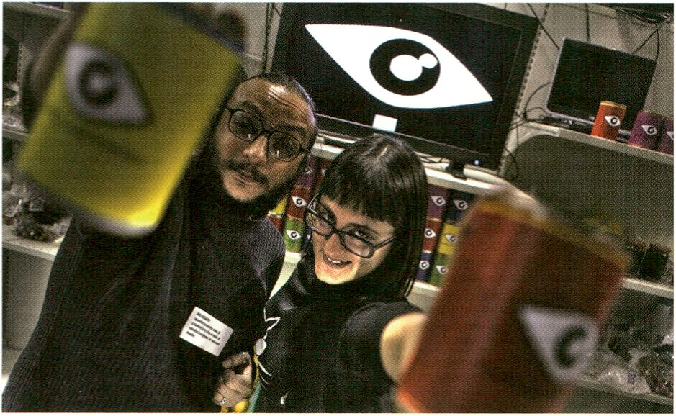
CoS, Salvatore laconesi and Oriana Pérsico (p. 117)

SATURDAY. FEB 5
The Open Zone | Talk
The Currency of the Commons - The Price and Value of Free Culture | with Peter Sunde (se),
Elizabeth Stark (us), Dmytri Kleiner (ca/ru), Eric Poettschacher (at), Christopher “moot” Poole (us)
15:00-17:00 I K1
In recent years, the free culture movement
has been very much focused on the develop-
ment of alternative rights and licensing
systems. Appropriate economic benchmarks
outside traditional business models are only
now starting to gain traction: crowdsourcing,
micro-funding and shared economy - new
watchwords of a society that no longer wants
to rely solely on capitalist principles.
Nevertheless, there are many questions -
how to convert ‘free’ cultural services into an
economic currency, for example, or how a
long-term culture of worth that is based on
free access rather than supply and demand
can be achieved.
- Mapping Money and Meaning, p. 105
- Creative Fundraising & Microfunding Initiatives, p. 91
- thimbl, p. 61
- Observer Talk, Elizabeth Stark, p. 123
- Open Video, p. 106
transmediale Award Nominee | Artist Walk
Serendipitor | Mark Shepard (us)
16:00 - 16:45 | Auditorium Deck
- Serendipitor, p. 52
- Serendipitor Walk, p. 92
ln den letzten Jahren war die Free Culture-
Bewegung sehr stark auf die Entwicklung von
alternativen Rechte- und Lizenzsystemen
fokussiert. Entsprechende ökonomische Be-
zugsgrößen außerhalb des klassischen
Businessplans sind allerdings jetzt erst so
richtig in Gang gekommen: „Crowdsourcing“,
„Microfunding“ und „Shared Economy“ - neue
Schlagwörter einer Gesellschaft, die sich nicht
mehr allein auf kapitalistische Prinzipien ver-
lassen will. Trotzdem gibt es auch viele Fragen
- zum Beispiel wie man Free Culture Services in
eine ökonomische Währung konvertieren kann
oder wie man langfristig eine Wertekultur
schafft, die statt auf Angebot und Nachfrage
auf freien Zugang setzt.
Featured Projects | Workshop
CoS Workshop 3: Time | with Salvatore laconesi (it), Oriana Pérsico (it)
- - 18.00 | Upper Foyer/ CoS Workstation

Time: We find ourselves in a perceived state
of continuous-present and time-based land-
marks for memory and recall that are digitally
assisted and externalised onto search
mechanisms. This impacts the traditional
architecture of linear timelines towards a
more interactive concept, as workshop
participants will create in the workshop using
the web and other digitally networked tools.
Time: Wir befinden uns in einem empfundenen
Zustand ständiger Anwesenheit und zeitbasier-
ter, digitaler, teilweise durch Suchmaschinen
externalisierter Gedächtnisstützen. Dies hat
Einfluss auf das traditionell lineare Konzept von
Zeit hin zu einem interaktiven Konzept. Eine
solche interaktive Timeline werden die Work-
shop-Teilnehmer unter Einbezug des Web und
anderer digital vernetzter Werkzeuge gestalten.

For 15 participants / With pre-registration only
Für 15 Teilnehmer / Nur mit Voranmeldung
- CoS installation, p. 152
- CoS workshop 1 (Part 1), p. 76
- CoS workshop 1 (Part 2), p. 87
- CoS workshop 2, p. 100
- CoS workshop 4, p. 131
- Social ID, p. 86
BODY : RESPONSE | Keynote Conversation - Track 2: Bios and Power
Life at Work: Bioeconomy and the Crisis of Cognitive Capitalism | with Franco Berardi (it),
Maurizio Lazzarato (it) | Moderator: Matteo Pasquinelli (it)
17:00 - 18:30 | Auditorium

More than just ‘collective intelligence’ and
our brain skills, digital economy is absorbing
today the whole of our social relations and
monetising the very physical desire of
communication. Moreover the crisis of so-
called cognitive capitalism within the intellec-
tual property regime as well as educational
institutions across Europe is revealing new
forms of exploitation and new social tensions.
After discussing the para-digms of knowledge
economy and immaterial labour, political
debate is facing today a 'biopolitical turn' in
order to frame the new vectors of economic
production.
In this keynote conversation the philosophers
Franco ‘BIFO’ Berardi and Maurizio Lazzarato
investigate the new dimension of bioeconomy,
that is the economy of life in the realm of
digital networks.
Die gegenwärtige digitale Ökonomie zielt nicht
mehr nur auf die „kollektive Intelligenz“ und
unsere kognitiven Fähgkeiten. Sie absorbiert
die Gesamtheit unserer sozialen Beziehungen
und vermarktet unser elementares körperliches
Begehren nach Kommunikation. Mehr noch ent-
hüllt die Krise des sogenannten „kognitiven
Kapitalismus“ des Urheberrechts-Regimes
ebenso wie in den Bildungseinrichtungen in
ganz Europa, neue Formen der Ausbeutung und
soziale Spannungen. Nachdem das Paradigma
der Wissensökonomie und der immateriellen
Arbeit diskutiert wurde, sieht sich der politische
Diskurs heute mit einem „biopolitical turn“
konfrontiert, um die neuen Vektoren der Wirt-
schaftsproduktion zu erfassen.
In diesem Keynote-Gespräch werden die Philo-
sophen Franco ,Bifo‘ Berardi und Maurizio
Lazzarato die neuen Dimensionen der Bio-
Ökonomie, also die Ökonomie des Lebens, im
Kontext der digitalen Netzwerke untersuchen.

Life in Excess, p. 128
Repetitionr, p. 89
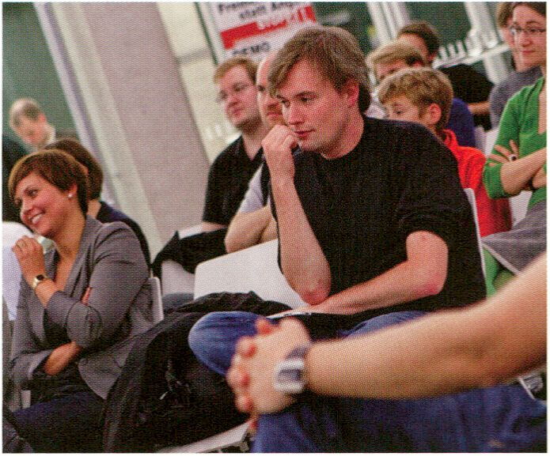
Friedrich Lindenberg, CCo Licence
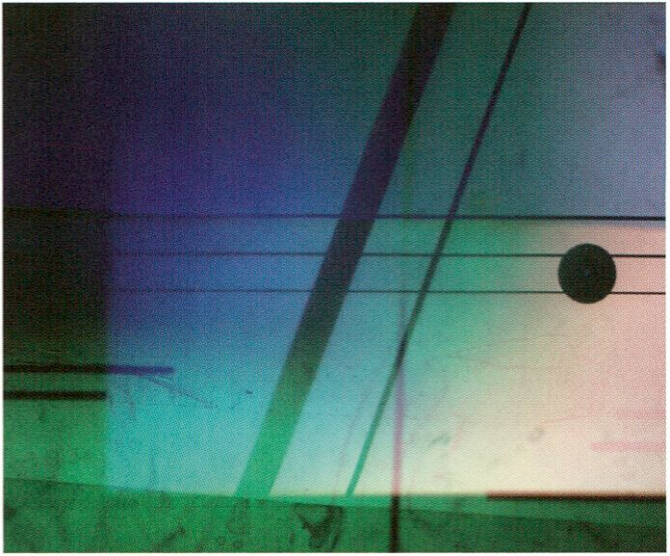
Himalaya Variations by Tina Tonagel

SATURDAY. FEB S
The Open Zone | Workshop
Liquid Democracy | with Friedrich Lindenberg (de)
17:00 - 19:00 | Open Zone, Lost in the Open? - Workstation
- Workstation
Friedrich Lindenberg from Liquid Democracy
and the Open Knowedge Foundation invites
workshop participants to openly discuss the
opportunities and challenges of web-based
political discourse. Friedrich will present
some of the theoretical concepts developed
by Liquid Democracy along with some of their
practical applications such as Adhocracy, a
prototype policy-making platform.
Participants are invited to present their own
visions of cooperative policy, legislative
processes and tools, and to discuss critiques
and specific case studies.
> Open Knowledge Foundation, p. 127
LIVE : RESPONSE | Performance
Braun Tube Jazz Band | Ei Wada (jp)
17:30 - 18:30 | HacKaWay Stage
Complete information on p. 78
The Open Zone | Presentation
Facebook Resistance | Tobias Leingruber (at)
18:00 - 19:00 | Open Zone, Response:Activities
Complete information on p. 101
Friedrich Lindenberg von Liquid Democracy
und der Open Knowledge Foundation lädt
Workshop-Teilnehmer zur Diskussion über die
Möglichkeiten und Herausforderungen eines
netzbasierten politischen Diskurses ein.
Vorgestellt werden einige vom Verein entwickel-
te theoretische Konzepte sowie Fallbeispiele
und praktische Programme wie Adhocracy.
Zudem sind die Teilnehmer eingeladen, eigene
Visionen zu kooperativer Politik, Gesetzge-
bungsprozessen und Tools vorzustellen.
LIVE : RESPONSE | Performance
Himalaya Variations | Tina Tonagel (de)
18:30 - 19:30 | HacKaWay Stage

BODY : RESPONSE | Lecture - Track 1: Bios and Presence
“What is Live?” - From the Aura to the Avatar: A Historical Survey of Aesthetic Controversies
and Artistic Appropriations of Liveness in Mass Media | with Dieter Daniels (de)
18:00-19:30 / K1
SATURDAY. FEB 5
In this solo performance two overhead pro-
jectors function as analogue VJ tools. On the
illuminated surfaces of the projectors, the
artist plays a collection of experimental
instruments made up of electric guitar ele-
ments, rotating disks, steel ball tracks, the
sound making parts of a clock, perforated
sheet metal and motors. From a combination
of manual and automated sound production,
subtle, polyrhythmic sounds grow. Image
and music combine in a unique way, thanks to
the brilliant colour and light display on the
illuminated surfaces of the projectors.
The decision of Hans Flesch to transmit
recorded vinyl instead of live music on the
radio sparked heated discussion among
many of his famous contemporaries in 1930’s
(including Theodor Adorno). At this time
Walter Benjamin focused on the concept of
the decay of ‘aura’ and reflected on related
issues.
In the 1950s, ‘liveness’ was discovered by the
mass-media as an artistic material for an
aesthetic of ‘Indetermancy’. John Cage used
the radio as a ‘live’ musical instrument in his
compositions. In the 1960s, both Nam June
Paik and Umberto Eco were devoted to the
‘liveness’ of television.
“Today media-based live performances or
online services (such as Second Life) mix
‘liveness’ with pre-generated and real-time
elements. This gives the question ‘What is
Live?’ a new relevance.”
The lecture will be in German.
> Audiovisualogie, p. 81
In dieser Solo-Performance fungieren zwei
Overheadprojektoren als analoges VJ-Tool. Auf
den Leuchtflächen der Projektoren bespielt die
Künstlerin ein experimentelles Instrumentarium
aus E-Gitarren-Elementen, rotierenden Schei-
ben, Kugelbahnen, Klangwerken einer Uhr,
Lochblechen und Motoren. Aus einer Kombina-
tion manueller Klangerzeugung und automati-
sierter Mechanik erwachsen subtile, polyrhyth-
mische Klänge. Bild und Musik verschmelzen
auf einmalige Weise dank des fulminanten
Färb- und Lichtspiels auf den Leuchtoberflä-
chen der Projektoren.
Die Entscheidung des Berliner Intendanten
Hans Flesch, im Radio Musik nicht live, sondern
von Schallplatten zu senden, löst 1930 eine
breite Kontroverse aus, an der sich zahlreiche
prominente Zeitgenossen (u.a. Theodor Adorno)
beteiligen. Walter Benjamin widmet sich unter
dem Begriff des „Verfalls der Aura” verwandten
Fragen. Ab den 1950ern wird die „Liveness“
von massenmedialen Informationen als
künstlerisches Material für eine Ästhetik der
„Indeterminacy“ entdeckt. John Cage setzt das
Radio als ein „Live“-Musikinstrument in seinen
Kompositionen ein. In den 1960ern widmen sich
sowohl Nam June Paik wie Umberto Eco der
„Liveness“ des Fernsehens. „Heute vermischt
sich in medienbasierten Live-Performances
oder Online-Angeboten (z. B. Second Live) die
.Liveness“ mit vorproduzierten und in Echtzeit
generierten Elementen. Damit erhält die Frage
,What is Live?' eine neue Aktualität.“
SyncExistence | Screening
SATURDAY. FEB S
The Revolution Will Not Be Televised
18:30 - 20:30 | Theatersaal
Television was plainly the dominant medium
in the 1960s. At the same time, an intense
debate began that continues today. The rather
solemn short film Tomorrow Television was
taped shortly before the end of the Second
Word War. Sun in Your Head (Television
Décollage) is one of the first artistic works
that deals with television itself. Filz TV,
developed in conjunction with the television
series Identifications, also deals physically
with the television set. An early example of
the ‘Strategy of the Fake’, A Commercial for
Myself, belongs to a complex artistic project
about identity. The election commercial Grüne
zur Bundestagswahi criticised television in an
epic presentation. The Revolution will not be
Televised refers to the intangibility of the
medium: real change is not found on TV, but
on the streets. With God Respects Us When
We Work But He Loves Us When We Dance,
the documentary of a 1967 love-in, the
programme shifts towards the public, physical
presence of protest - which the film itself of
course, medialises. Match is a found-footage
work of a pre-arranged hooligan brawl, which
was recorded with three cameras by the
hooligans themselves. Questions of political,
physical and media analysis will be reduced,
by the end of the programme, to the proud
self-representation of violence.
In den 1960er Jahren wurde das Fernsehen
zum dominanten Medium schlechthin. Gleich-
zeitig begann eine intensive künstlerische
Auseinandersetzung damit, die bis heute an-
dauert. Der recht pathetische Kurzfilm
Tomorrow Television wurde kurz vor Ende des
Zweiten Weltkriegs gedreht. Sun in Your Head
(Television Décollage) ist eine der ersten künst-
lerischen Arbeiten, die sich mit dem Fernseher
selbst beschäftigen. Filz TV, entstanden im
Rahmen der Fernsehreihe Identifications, setzt
sich auch physisch mit dem Fernsehgerät
auseinander. Als frühes Beispiel für die Strate-
gie des Fake, gehört A Commercial for Myself
zu einem komplexen künstlerischen Projekt um
Identität. Der Wahlspot Grüne zur Bundestags-
wahl kritisiert das Fernsehen in einer epischen
Darstellung. The Revolution Will Not Be
Televised verweist auf die Immaterialität des
Mediums: Wirkliche Veränderung findet nicht in
ihm, sondern auf der Straße statt. Mit God
Respects Us When We Work But He Loves Us
When We Dance, der Dokumentation eines
Love-Ins von 1967, nimmt das Programm eine
Wendung zu der öffentlichen, physischen
Präsenz des Protests - die der Film natürlich
selbst wieder medialisiert. Match ist eine
Found-Footage Arbeit einer verabredeten
Hooligan-Schlägerei, die mit drei Kameras von
den Hooligans selbst aufgenommen wurde.
Die Frage von politischer, medialer und
physischer Auseinandersetzung wird zum Ende
des Programms auf die stolze Selbstdarstellung
der Gewalt reduziert.

Tomorrow Television, us 1940s, 13 min
Sun in Your Head (Televison Décollage), Wolf Vostell, de 1963, 8 min
Filz TV, Joseph Beuys, de 1970,12 min
A Commercial for Myself, Lynn Hershman Leeson, us 1978, 2 min
Grüne zur Bundestagswahl, Heike Sander, de 1987, 3 min
The Revolution Will Not Be Televised, Stuart Baker, uk 1988, 4 min
God Respects Us When We Work But He Loves Us When We Dance, Les Blank, us 1968, 20 min
Match, Martin Brand, de 2005, 9 min
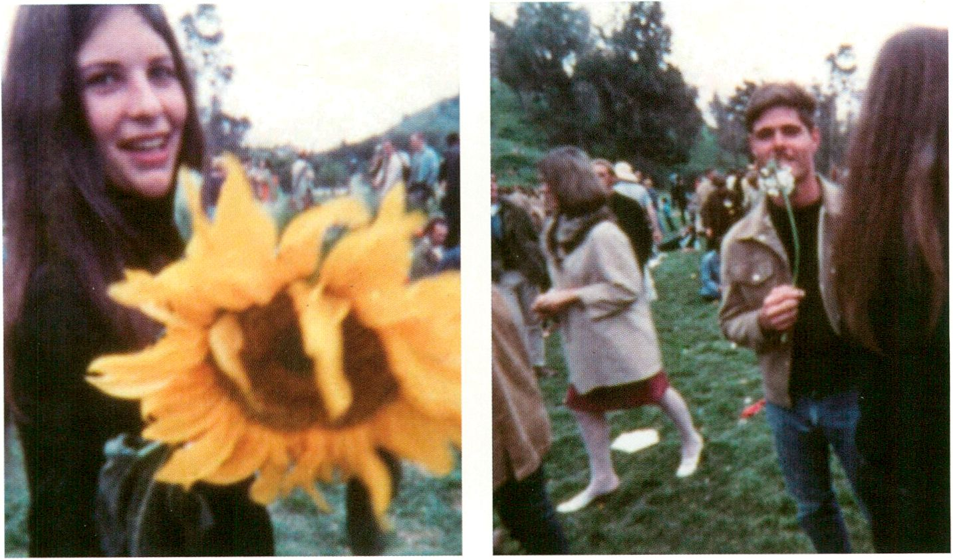
God Respects Us When We Work, But He Loves Us When We Dance by Les Blank (p. 119)
SATURDAY. FEB S
LIVE : RESPONSE | Performance
Voice and Iteration | Dorothy of the Day (au)
19:30 - 20:30 | Café Stage
Dorothy of the Day is the solo project of
Australian singer Rachel Holmshaw. Inspired
by Hollywood musicals of the 1930s, the singer
weaves multi-layered, nostalgic and dreamy
soundscapes with only her own voice and a
loop pedal. The artist’s use of this device as
an instrument to create slow, repetitive music,
which has no sharp breaks in melody or form,
keeps the audience mesmerised.
Dorothy of the Day ist das Soloprojekt der aus-
tralischen Sängerin Rachel Holmshaw. Inspiriert
von Hollywood Musicalfilmen aus den 1930ern
webt die Sängerin vielschichtige, sich ganz
behutsam verschiebende, nostalgisch-träumeri-
sche Klanglandschaften nur mit der eigenen
Stimme und einem Loop-Pedal. Indem die
Künstlerin dieses Gerät wie ein Instrument
einsetzt, entsteht eine langsam repetitive Musik,
die ohne scharfe Brüche in Melodie oder Form
auskommt, seine Zuhörer aber umso stärker
hypnotisiert.

HacKaWay | Performance
Latent Figure Protocol | Paul Vanouse (us)
20:00 - 20:30 | HacKaWay Stage
Complete information on p. 97

íai

i/uerkleitz
medialab
festival
grants
i/uerkleitz Festival 2011
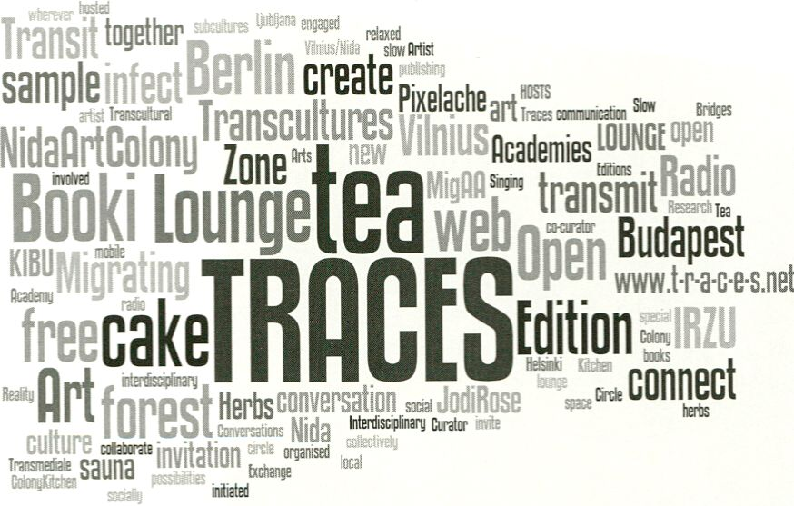
Courtesy by TRACES Lounge

The Open Zone | Talk
Observer Talk of the Day | with Elizabeth Stark (us)
20:00 - 21:00 | Open Zone, Lost in the Open? - Workstation
SATURDAY. FEB S
Each evening transmediale.11 invites visitors
to gather for an informal Observer Talk.
‘Observers’ have been invited from the diverse
fields of Media Art, Journalism, Media
Activism and Free Culture and will share their
personal interpretation of the day's festival
activities.
- The Currency of the Commons, p. 116
- Open Video, p. 106
Jeden Abend laden wir einen ganz besonderen
Gast ein, die Eindrücke des zurückliegenden
Festivaltages gemeinsam mit unseren
Besuchern In einer informellen Runde zu
diskutieren.

The Open Zone | Talks, Workshops, Radio Lounge
TRACES Lounge
20:00 - 22:00 | Open Zone, Response:Activities - Workstation
Complete information on p. 77
transmediale Award | Presentation
Award Ceremony
21:00 - 22:30 | Auditorium
See Awards, p. 45
LIVE : RESPONSE | DJ Set
resom (de)
22:30 | Café Stage
This is how resom describes her sound: Dark
elektro robodisko to uplifting breaks or poppy
minimal freakel techno or chain reaction-
dub - everything works, but please don’t be
nice - be spooky, be bad, be dark. Just be
good to her!
resom beschreibt ihren Sound so: Dunkler
Elektrorobodisko zu hochfliegenden Breaks und
poppigem Minimal-Frickel-Techno oder
Chain-Reaction-Dub - sie verkraftet alles.
Außer nett sein. Für sie soll es lieber gruselig,
böse und dunkel sein, damit es ihr gut geht!
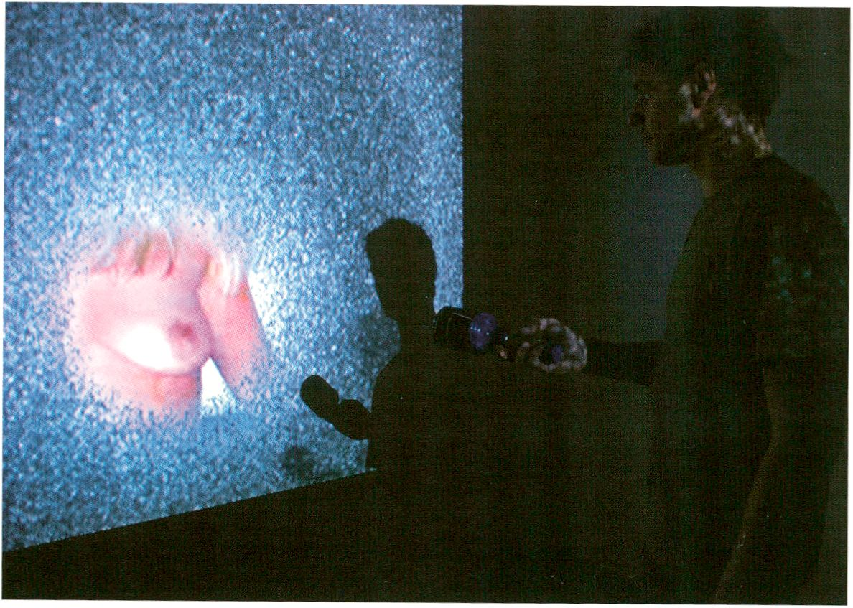HacKaWay | Workshop
SUFIDRY. FEB E
You can't hide it all by Prokop Batonicek, courtesy of A MAZE. (p. 125)
Elektronik zum Klingen bringen | with Karl-Heinz Jeron (de)
10:00-14:00| HacKaWay

Children today are surrounded by game
consoles, computers and the like. All these
devices are presented as black boxes;
exploratory dismantling and reassembly of
these products is not really worthwhile.
This is where this workshop for children is
positioned. Through the building of a basic
electronic musical instrument, the
foundational principles of sound production
are explained.
In the workshop, complicated high techno-
logy is broken down to a playful level and a
creative approach to technology is presented.
The focus lies, in contrast to school, in a joyful
and playful experience of electronics. In the
process, fundamental knowledge is delivered,
a creative approach to technology is
facilitated and ways to realise original sound
ideas are shown.
With pre-registration only / Nur mit Voranmeldung
Kinder sind heutzutage umgeben von Spiele-
konsolen, Computern und ähnlichem. All diese
Geräte präsentieren sich als Blackboxes. Ein
forschendes Zerlegen und wieder Zusammen-
setzen ist bei diesen Geräten nicht wirklich
sinnvoll möglich. Genau hier setzt der Work-
shop für Kinder an. Mit dem Bau eines ein-
fachen elektronischen Musikinstruments wird
das Grundprinzip der Tonerzeugung erklärt.
Im Workshop wird also komplizierte Hochtech-
nologie auf eine spielerische Ebene herunter
gebrochen und ein kreativer Umgang mit
Technik vermittelt. Der Fokus liegt, im Unter-
schied zur Schule, in einem lustvollen und
spielerischen Umgang mit Elektronik. Dabei
wird das nötige Grundwissen geliefert und
gezeigt, wie sich die eigenen Klangvorstellun-
gen realisieren lassen. Auf dieser Grundlage
kann fröhlich experimentiert werden.
Collaboration Project: Ludic Interfaces | Talk
Ludic Salon: Shaping Play Spaces within Media Cultures | with Mark Butler (us), Georg
Russegger (at), Mathias Fuchs (de), Moisés Mañas (es), Thorsten S. Wiedemann (de), Heather
Kelley (ca), Matthias Tarasiewicz (de), Michael Liebe (de), Brendan Howell (us)
11:00-14:00 | K1

SUTlDfiY. FEB B
For some time now, an increasing conjecture
of play and playfulness has been unfolding in
media art and digital culture. Ludic Interfaces
invite the public to partake in a playful and
interactive discussion in which the meta-
reflective potential of ludology for contem-
porary media art will be tested.
Initially a number of ludological theses will be
presented on the basis of works on display at
transmediale.11. Furthermore we will talk
about the results from the two related work-
shops, CODED CULTURES (Insecure
Territories) and A MAZE. (Controlled Invasion).
Ludic Interfaces is the name of a new inter-
disciplinary MA course, which will be offered
from 2012 at Potsdam, Valencia, Linz and
Salford. The course aims at the developments
of tools and concepts, which enable us to deal
with the conditions of a fast changing society
in playful and conscious ways.
transmediale.11 is a partner of this university
programme.
- Ludic Interfaces, p. 43
- Controlled Invasion, p. 98
ln der Medienkunst sowie in der digitalen Kultur
insgesamt lässt sich seit längerem eine noch
wachsende Konjunktur des Spiels und des
Spielerischen beobachten. Daher lädt Ludic
Interfaces zu einer verspielten und interaktiven
Diskussion ein, in dem die metareflexiven
Möglichkeiten der Ludologie für die zeitgenös-
sische Medienkunst erprobt werden. Zu Beginn
werden ludologische Thesen anhand künstleri-
scher Arbeiten der transmediale.11 präsentiert
und anschließend die Ergebnisse der beiden
Workshops zu CODED CULTURES (Insecure
Territories) und A MAZE. (Controlled Invasion).
Ludic Interfaces ist der Name eines neuen
interdisziplinären Masterprogrammes, das ab
2012 in Potsdam, Valencia, Linz und Salford
angeboten wird. In dem Studiengang werden
Tools und Konzepte entwickelt, die einen
spielerischen und bewussten Umgang mit den
Bedingungen einer sich schnell wandelnden
Gesellschaft ermöglichen, transmediale ist
Partner dieses Studiengangs.

The Open Zone | Workstation
Identity Bureau | Heath Bunting (uk)
12:00-17:00
Complete information on p. 72
The Open Zone | Workstation
The Cult of Less | Kelly Sutton (uk)
12:00-20:00
Complete information on p. 112
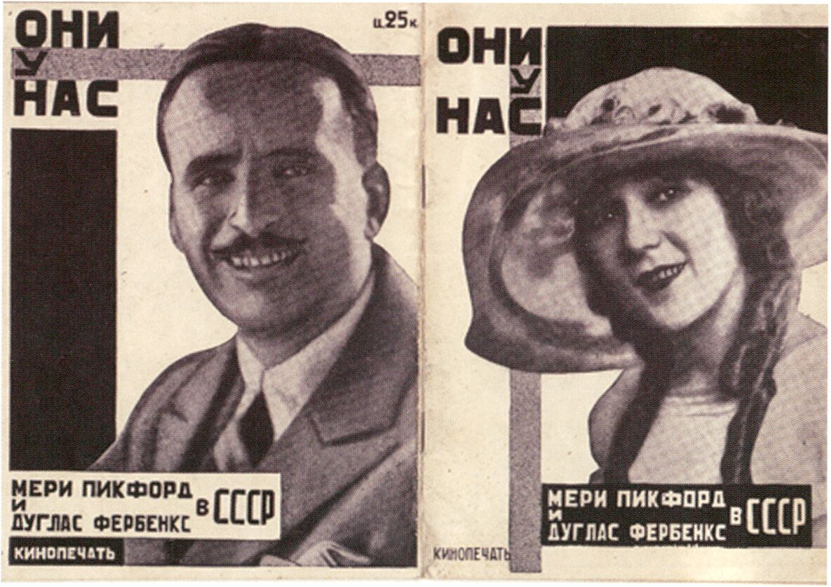
Mary Pickford and Douglas Fairbanks in the USSR

SyncExistence | Screening
SUnDflY. FEB E
A Kiss From Mary Pickford / Der Kuss der Mary Pickford | Sunday Matinee
12:00 bis 13:30 | Auditorium

The matinee programme approaches the
art of found image appropriation and the
relationship between image and sound from
two disparate poles: Wednesday Morning
Two A.M. by Lewis Klahr from 2009 collages
and animates images onto a pop song by
the Shangri-Las. Seventy-two years earlier
Sergei Komarov created a predecessor
of appropriation art with A Kiss From Mary
Pickford, a feature film based on ‘stolen’
images of Mary Pickford and Douglas
Fairbanks. Peter Gotthardt, composer of the
celebrated soundtrack of The Legend of Paul
and Paula, will accompany the screening of
this rarely shown gem live on piano.
Das Matinee-Programm nähert sich sowohl
der Kunst der Aneignung fremder Bilder als
auch dem Verhältnis von Bild und Musik von
zwei disparaten Polen: Wednesday Morning
Two A.M. von Lewis Klahr aus dem Jahre 2009
collagiert und animiert Bilder auf einem Pop-
song der Shangri-Las. 72 Jahre zuvor schuf
Sergei Komarov mit Der Kuss der Mary Pickford
einen frühen Vorläufer der Appropriation, indem
er die „gestohlenen“ Bilder Mary Pickfords und
Douglas Fairbanks in seinen Spielfilm montier-
te. Der sehr selten zu sehende Film wird live auf
dem Piano von dem Filmkomponisten Peter
Gotthardt begleitet, der unter anderem die be-
rühmte Filmmusik von Die Legende von Paul
und Paula geschrieben hat.

Wednesday Morning Two A.M., Lewis Klahr, us 2009, 7 min
A Kiss From Mary Pickford - Der Kuss der Mary Pickford - Pozeluj Meri Pikford, Sergei Komarov, ussr
1927, silent, 60 min, Live-Piano: Peter Gotthardt (de)
The Open Zone | Workstation
Open Design City ‘Make Your Own Market’
12:00 - 22:00 | Open Zone, Currency of the Commons - Workstation
Complete information on p. 70
The Open Zone | Workshop
Through the Iris - Political Participation Through Information Design | with Marek Tuszynski (pi),
Stephanie Hankey (uk)
12:00 - 15:00 | Open Zone, Response:Activities - Workstation

The Open Zone | Workshop
Open Knowledge Foundation | with Jonathan Gray (uk), Daniel Dietrich (de)
12:00 - 15:00 | Open Zone, Lost in the Open? - Workstation
SUTIDFIY. FEB E
This workshop focuses on using open (public)
data and collected data to create art and
design for political engagement. Participants
will be given advice on creative strategies
for collecting data with practical tips on
accessing information laws while also
being given many examples of how artists,
designers and activists are using and
representing data. Participants will work
directly with raw data, while also stretching
the boundaries of what we think of as data.
- Drawing by Numbers, p. 71
- Response:Activities, p. 99
- Tactical Tech Activism, p. 192
This walk-in workshop provides the chance to
meet the people behind the Open Knowledge
Foundation, a UK not-for-profit that expanded
into Germany in mid 2010. Daniel Dietrich,
the representative of OKF Germany, will give
examples of projects where the foundation
helped to bring open standards. Participants
will learn about different forms of knowledge
transfer and various approaches towards
creating open access to knowledge.
- Open Government and the Citizen 2.0, p. 114
- Liquid Democracy, p. 118
Im Mittelpunkt dieses Workshops steht, wie
man öffentlich zugängliche und gesammelte
Daten im Hinblick auf Kunst und Design für
politisches Engagement nutzen kann. Teilneh-
mer lernen kreative Strategien zur Sammlung
von Daten kennen und erhalten praktische Tips
bezüglich Informationsgesetze sowie zahlreiche
Beispiele dafür, wie Künstler, Designer und
Aktivisten Daten nutzen und darstellen. Teil-
nehmer arbeiten nicht nur direkt mit rohen
Daten, sondern erfahren auch, wie weit gefasst
man überhaupt von Daten sprechen kann.
Dieser Walk-In Workshop bietet Gelegenheit,
die Betreiber der Open Knowledge Foundation,
einer in Großbritannien ansässigen Non-Profit-
Organisation, die seit Mitte 2010 auch in
Deutschland operiert, kennenzulernen. Daniel
Dietrich, der Vertreter der OKF Deutschland
zeigt Beispiele, wo die Stiftung bereits zu
offenen Standards verholten hat. Die Teilnehmer
lernen verschiedene Möglichkeiten des
Wissenstransfers und -Zugangs kennen.

The Open Zone | Workstation, Mini Performances and Micro Conferences
The Wanted & For Sale Office
12:00-22:00
Complete information on p. 71
Book Launch | From Image to Interaction: Meaning and Agency in the Arts (V2_, 2010)
with Arjen Mulder (nl) | Moderator: Sabine Breitsameter (de)
13:15-13:45 | Café Stage
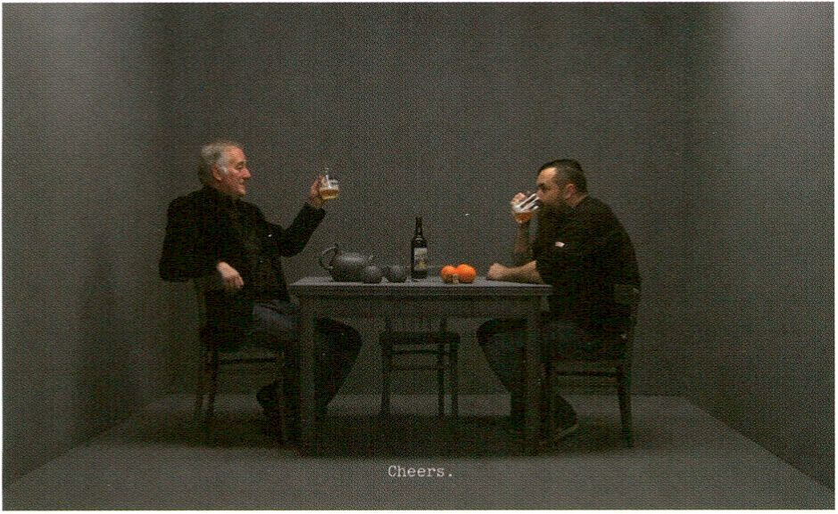BODY : RESPONSE | Focus Discussion - Track 2: Bios and Power
SUTlDflY. FEB E
How to Explain It to My Parents: Arno Coenen by Lernert & Sander (p. 129)
Life in Excess! Transpersonality and Autonomy in the Age of Biopower | with Roberto Esposito
(it), Beatriz Preciado (es), Judith Revel (fr) | Moderator: Matteo Pasquinelli (it)
14:00 - 16:00 | Auditorium
We need to untie the dialectical circle of power / counter-power in another way and operate
within biopolitical thoughts a,switch-over' of a different kind, that does not proceed from
deprivation or deduction, but rather from an addition, an excess, a qualitative difference.
Judith Revel

1SB
Biopower is the power over life from its very
interior. A life that today is at the heart of new
political battles and new economic strategies.
That what apparently defines us as an
individual and autonomous personality — our
cognitive, emotional and relational abilities
— is more and more integrated and exploited
by new forms of labour. Also our under-
standings of ourselves and others, gender
normativity and sexual behaviours, are central
to regulation and control. The production of
new and old subjectivities becomes part of
new ‘biopolitical’ power configurations. This
focus discussion explores the processes of
subjectivation as field of resistance and
power asymmetry. How can we organise
movements of resistance to immaterial and
material forms of biopower without
necessarily becoming the other of power?
> Life at Work, p. 117
Biomacht ist die Macht über die innere
Beschaffenheit des Lebens. Ein Leben, das
heutzutage ins Zentrum neuer politischer
Machtwirkungen und ökonomischer Strategien
gerückt ist. Das, was uns scheinbar als
individuelle und autonome Persönlichkeit de-
finiert, wird mehr und mehr zum Gegenstand
neuer Formen der Produktivität und Ausbeu-
tung. Auch das Verständnis über uns selbst und
andere, Geschlechternormen und Sexualverhal-
ten sind zentral für die Mechanismen von
Steuerung und Kontrolle. Die Produktion von
neuen und alten Subjektivitäten wird damit zum
Bestandteil neuer ,biopolitischer‘ Machtkonfi-
gurationen. Diese Fokusdiskussion untersucht
Formen der Subjektivierung als Möglichkeiten
von Widerstand und asymmetrischer Macht-
deregulierung. Wie können wir Widerstandsbe-
wegungen organisieren, die sich mit den
immateriellen und materiellen Formen der
Biomacht auseinandersetzen, ohne dabei
notwendigerweise Teil dieser Machtstruktur zu
werden?
SyncExistence | Screening
Live On TV
14:30 - 16:30 | Theatersaal
This programme presents seven con-
temporary positions addressing television and
its successor, the Internet. In We‘11 Let You
Know a stage actor attempts to describe an
aesthetic experience while an annoyed voice
from the wings demands the bore be removed.
Everytime consists of 16 synchronically
mounted YouTube clips in which several
different teenagers cover the same hit song.
The series How to Explain It to My Parents
resembles the studio talks of scandal shows
on TV, except that this time it features a
contemporary artist trying to explain his art -
to his parents. The piece Somewhere Only We
Know is based on found footage and shows
game show candidates as they are waiting to
find out their scores. Incident by a Bank shows
the reconstruction of a bank robbery from the
mobile phone footage of passers-by who
recorded the original incident as if it were a
spectacle put on for TV rather than a 'real'
event. The film Hilarious, which was shot in
the style of a late night talk-show, stretches
the idiosyncratic humour of this genre far
beyond the point where things cease to be
funny. While unfolding an imaginary horror
film through its sound track, Suburb Within
reduces the TV image to its abstract
quintessence: noise.
Sieben zeitgenössische Positionen zum Fern-
sehen und seinem Nachfolger, dem Internet, die
sich im Laufe des Programms langsam vom
Komischen und Absurden bis zum blanken
Horror entwickeln. In We‘ll Let You Know be-
schreibt ein Theaterschauspieler eine ästheti-
sche Erfahrung, während aus dem Off entnervt
gefordert wird, den Langweiler zu entfernen.
Everytime zeigt 16 synchron montierte
YouTube-Clips, in denen Teenager den gleich-
namigen Hit nachsingen. Die Serie How to
Explain lt to My Parents bietet ein Studioge-
spräch im Stile der familiären Entblößungs-
shows an; nur dass hier ein zeitgenössischer
Künstler seine Kunst erklären muss - und zwar
seinen Eltern. Die Found-Footage Arbeit
Somewhere Only We Know zeigt Showkandida-
ten mit fast schon religiöser Ergriffenheit auf
ihre Ergebnisse wartend. Incident by a Bank
rekonstruiert einen realen Banküberfall, den
die TV-erfahrenen Passanten aber kaum noch
als real wahrnahmen und vielmehr mit ihren
Handys filmten. Der im Stile einer Late-Night-
Show gedrehte Hilarious überdehnt den
genretypischen Humor bis zu einem Punkt, wo
nichts mehr witzig ist. Suburb Within reduziert
das TV-Bild auf seine abstrakte Quintessenz,
das Rauschen, und entwickelt dafür auf der
Tonspur einen imaginierten Horrorfilm.
SUnDfiY. FEB B

We'll Let You Know, Stephen Sutcliffe, uk 2008,1 min
Everytime, Camille Verbunt, nl 2008, 4 min
How to Explain It to My Parents: Arno Coenen, Lernert & Sander, nl 2009,12 min
Somewhere Only We Know, Jesse McLean, us 2009, 6 min
Incident by a Bank, Ruben Ostlund, se 2010,12 min
Hilarious, Roee Rosen, il 2010, 21 min *
Suburb Within, Pekka Sassi, fi 2009,11 min
* Director will attend screening and Q & A
The Open Zone | Talks, Workshops, Radio Lounge
TRACES Lounge
15:00 - 17:00 | Open Zone, Open Web Award area
Complete information on p. 77
transmediale Award | Presentation
Spatial Sound Sculpture
16:00 - 16:30 | Archive Room
- Complete information on p. 51
- spatial sound sculpture, p. 75
The Open Zone | Screening
The Future of Art: An Immediated Autodocumentary | by and with Gabriel Shalom (us) and
Patrizia Kommerell (de) from KS12
16:00 - 17:00 | Open Zone, Lost in The Open? - Workstation

SUT1DRY. FEB B
What are the defining aesthetics of art in
the networked era? How is mass collaboration
changing notions of authorship of art? How
does micro-patronage change the way
artists produce and distribute artwork?
The Future of Art screening begins a
conversation on these and other topics and
invites discussion from the audience. The
video is a rough cut of the footage created
and produced at transmediale.11 as part of
the on-site Immediated Autodocumentary
process.
- Immediated Autodocumentary, p. 68
- The Future of Money, p. 88
- Videomusical Works, p. 67
Welche Ästhetik prägt die Kunst im Netzwerk-
zeitalter? Wie verändert massenhafte Kollabo-
ra-tion die Auffassung von Autorenschaft in der
Kunst? Wie verändert Mikro-Unterstützung die
Produktions- und Distributionsbedingungen
von Kunst? Das Screening zu The Future of Art
greift solche und andere Fragen auf und
versteht sich als Einladung zur Diskussion. Das
gezeigte Video ist ein Rohschnitt des auf der
transmediale.11 gefilmten Materials und Teil
des ortsspezifischen Kreationsprozesses
Immediated Autodocumentary.

The Open Zone | Workshop
Global Voices Online | with Sami Ben Gharbia (tn), Solana Larsen (dk/pr)
16:00 - 19:00 | The Open Zone, Response:Activities - Workstation

Global Voices Online is a worldwide
community of bloggers who follow online
citizen media and digital activism - primarily
in countries outside the United States and
Europe to protect online freedom of
information and track threats/arrests against
bloggers. During this workshop, Sami Ben
Gharbia and Solana Larsen will describe the
inner workings, successes and significant
challenges of this global community and its
sub-divisions - Global Voices Advocacy,
Global Voices Lingua and Rising Voices - and
help explain how you can get involved.
Global Voices Online ist eine weltweite
Blogger-Community, die zum Schutz der
Informationsfreiheit Online-Bürgermedien und
digitalen Aktivismus zumeist nichteuropäischer
bzw. amerikanischer Kontexte aufmerksam
verfolgt. In diesem Workshop erklären Sami
Ben Gharbia und Solana Larsen, die inneren
Zusammenhänge, Erfolge und wichtigsten
Herausforderungen von Global Voices Online
und deren Unterbereiche Global Voices
Advocacy, Global Voices Lingua und Rising
Voices. Natürlich kann man auch herausfinden,
wie man sich selbst engagieren kann.
HacKaWay | Workshop
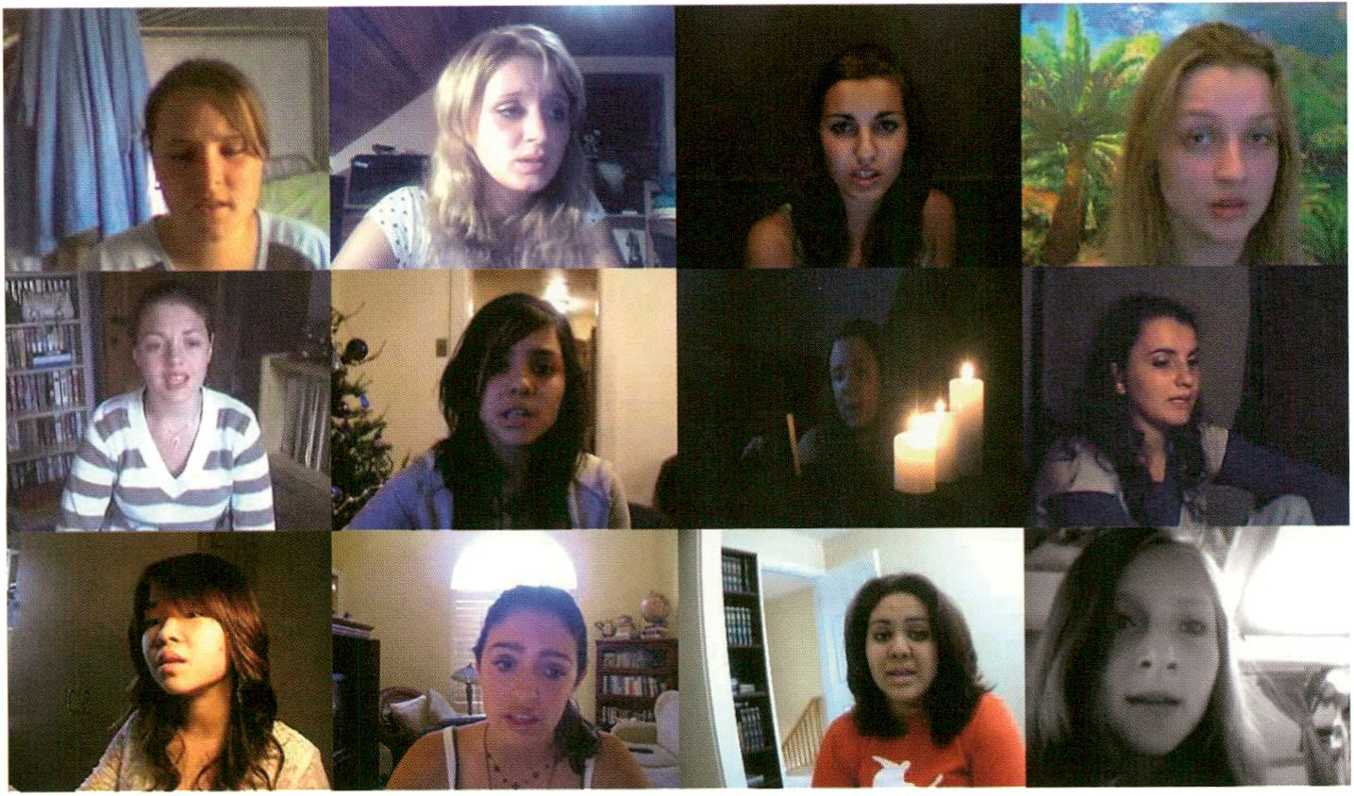
Everytime by Camille Verbunt (In: Live On 7V, 14:30, p. 129)
CoS Workshop 4: Emotion | with Salvatore laconesi (it), Oriana Persico (it)
SUT1DRY. FEB E
- - 19.00 | Upper Foyer/ CoS Workstation

Emotion: New forms of expression, new
dimensionalities for time and space, new
semantics for relationships and connected-
ness, new sensorialities - all these factors
determine the emergence of additional forms
through which emotions can be expressed or
experienced, propagated and observed.
Workshop participants will build a wearable
communication device via which one can
receive the emotional conditions of an
observed-one as low-current electrical stimuli
on various parts of your body.
For 15 participants / With pre-registration only
Für 15 Teilnehmer / Nur mit Voranmeldung
Emotion: Neue Ausdrucksformen, neue
Dimensionen für Zeit und Raum, neue
Semantiken für Beziehungen und Verbunden-
heit - all diese Faktoren bestimmen das
Aufkommen neuer Methoden, durch welche
Emotionen ausgedrückt oder erlebt, verbreitet
oder beobachtet werden können. Über eigens
in diesem Workshop entwickelte tragbare
Kommunikationsgeräte sollen Emotionen
zwischen Teilnehmern sensuell kommunizierbar
werden.

- CoS installation, p. 152
- CoS workshop 1 (Part 1), p. 76
- CoS workshop 1 (Part 2), p. 87
- CoS workshop 2, p. 117
- CoS workshop 3, p. 131
- Social ID, p. 86
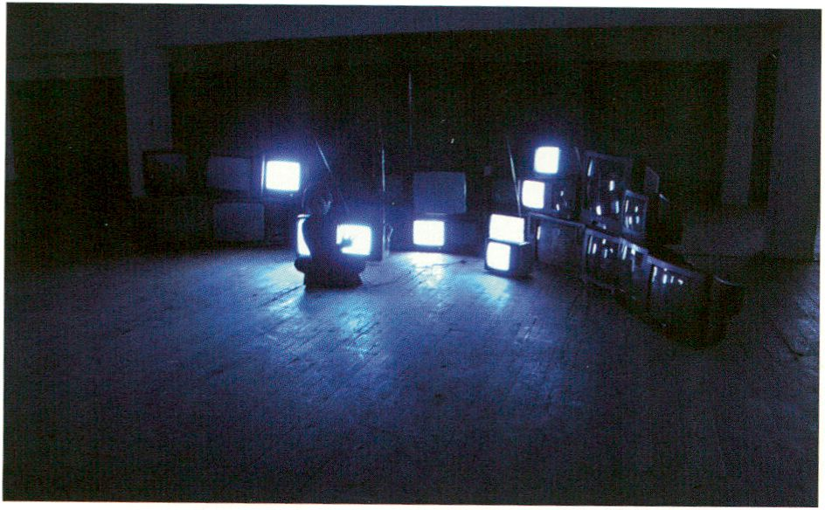
Braun Tube Jazz Band by Ei Wada

SUTlDflY. FEB E
BODY : RESPONSE | Keynote Conversations - Track 3: Bios and Technology
Delimination of Life - Affective Bodies and Biomedia | Keynotes: Marie-Luise Angerer (de/at),
Mark Hansen (us) | Moderator: Jens Hauser (de/fr)
17:00 - 18:30 | Auditorium
Today we are experiencing a shifting moment
in the concept of the human. Affect as a
crucial modality of the human organism, of
human existence, has moved to the centre
of media theory, philosophy and aesthetics.
The new quality of live media and networks,
that is, the hybridisation and increasing
biologisation of communication technologies,
create a biomedial environment in which the
body no longer seems to be the basis of
perception. Rather, we are experiencing the
deterritorialisation of our entire sphere of
affective and emotional relationships. In this
keynote conversation Marie-Luise Angerer
and Mark Hansen will focus on these virtual
qualities of the body discussing the affective
dimension our bodies experience and adapt
to digital environments.
LIVE : RESPONSE | Performance
Braun Tube Jazz Band | Ei Wada (jp)
17:30-18:30| HacKaWay
Heute erleben wir eine Verschiebung im
Denken des Humanen. Der Affekt als Modalität
des menschlichen Organismus, der menschli-
chen Existenz, tritt mehr und mehr ins Zentrum
medientheoretischer, philosophischer und
künstlerischer Aufmerksamkeit.
Die neue Qualität von Echtzeitmedien und Netz-
werken, ihre Hybridisierung sowie die zuneh-
mende Biologisierung von Kommunikations-
technologien schaffen eine biomediale Umwelt,
in der der Körper nicht länger Basis der
Wahrnehmungsfunktion zu sein scheint. Viel-
mehr erleben wir die Entgrenzung der gesam-
ten Sphäre der Gefühlsbeziehungen. Diese
virtuelle Qualität des Körperlichen, Emotion und
Affekt ist Gegenstand der Diskussion. Welches
sind die Kräfte, die an dieser Reformulierung
einer affektiven Dimension beteiligt sind?

Complete information on p. 78
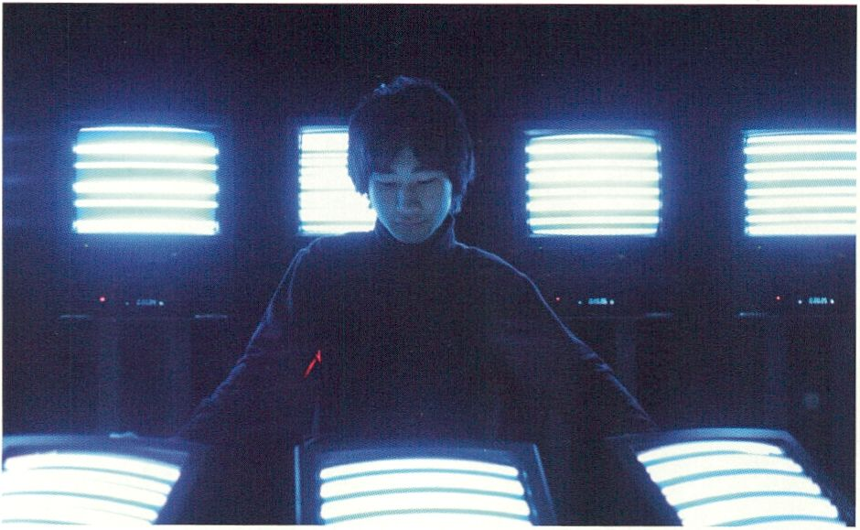
Braun Tube Jazz Band by E¡ Wada (p. 132)

The Open Zone | Talk
Observer Talk of the Day | with Simona Levi (es)
18:00 - 19:00 | Open Zone, Lost in the Open? - Workstation
SUT1DRY. FEB B
Each evening transmediale.11 invites visitors
to gather for an informal Observer Talk.
'Observers' have been invited from the diverse
fields of Media Art, Journalism, Media
Activism and Free Culture and will share their
personal interpretation of the day's festival
activities.
- Lost in the Open?, p. 69
- Dealing with Copyright Regimes, p. 113
LIVE : RESPONSE | Performance
Triple Feature | Fair Use (us)
18:30 - 19:30 | HacKaWay Stage
Fair Use look at our accelerating culture
through the electronic performance and
remixing of cinema. The trio members R. Luke
duBois, Zach Layton and Matthew Ostrowski
use the picture and soundtrack of culturally
significant movies, drastically compressed in
time, as the sole materials for an improvised
set which interrogates our cinematic
memories through frenetic audiovisual pro-
cessing and re-narration of the cinematic
object. Fair Use will be performing a triple
feature based on The Wizard of Oz, Snow
White and Kubrick’s 2001, investigating three
aspects of establishment of the self in an
unknown universe.
Jeden Abend laden wir einen ganz besonderen
Gast ein, die Eindrücke des zurückliegenden
Festivaltages gemeinsam mit unseren
Besuchern In einer informellen Runde zu
diskutieren.
In dieser audiovisuellen Live-Performance ge-
remixter, manipulierter und zeitlich stark
komprimierter Kinofilme lenken die Mitglieder
des Trios Fair Use, R. Luke duBois, Zach Layton
und Matthew Ostrowski, unsere Sinne auf die
sich immerzu beschleunigende Kultur, von der
wir umgeben sind. In einem Improv-Set wird
nicht nur mit den Bildern und Soundtracks der
drei Filme Der Zauberer von Oz, Schneewittchen
und Kubrick’s 2001 gespielt, sondern gerade
auch mit unserem eigenen Filmgedächtnis.
Besonders spannend ist dabei, dass Fair Use mit
den Filmen eben drei Werke ausgewählt haben,
die sich mit der Ausbildung eines Ich in einem
unbekannten Universum beschäftigen.
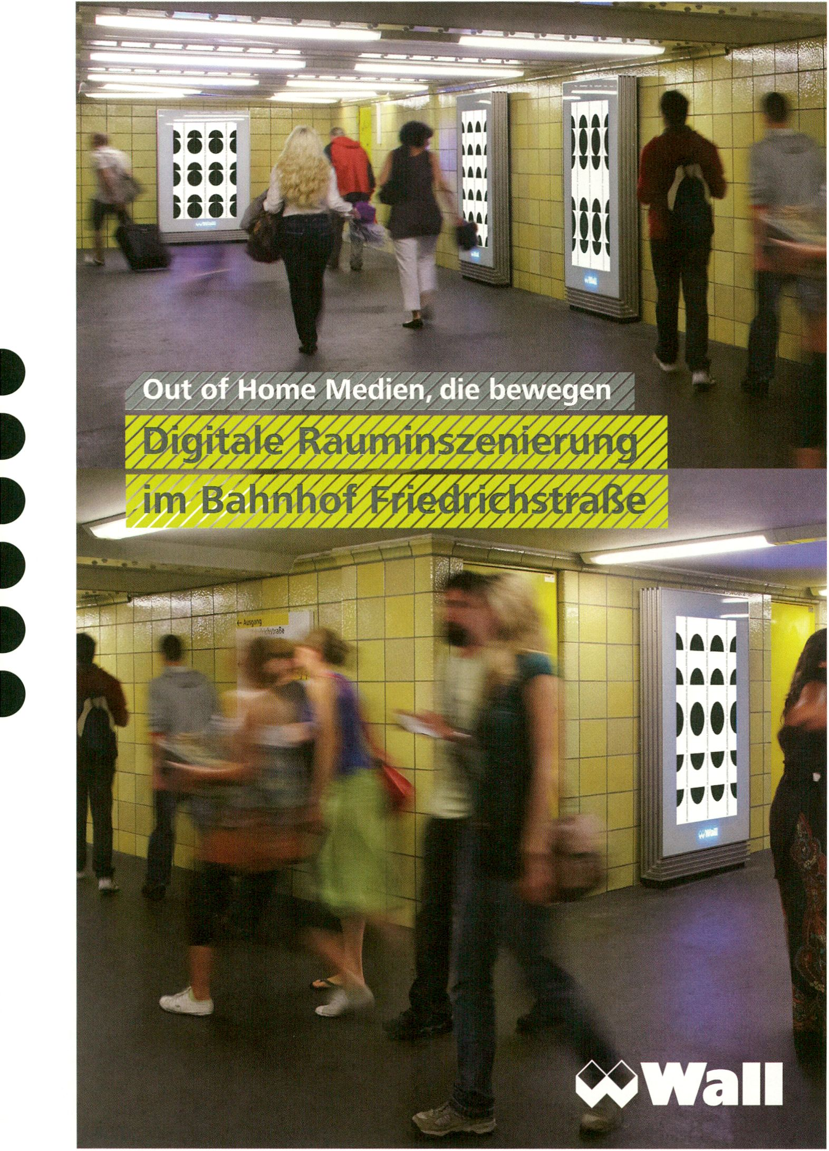

SyncExistence | Screening
Lynn Hershman Leeson Special | Laura Sillars (uk) in Conversation with Lynn Hershman Leeson
(us)
6 Feb, 18:30 - 20:30 | Theatersaal
Lynn Hershman Leeson describes her work
as BC (‘Before Computers’) and AD (‘After
Digital’). Spanning a 30 year period of working
across the full spectrum of creative media this
screening draws together some of the most
abiding themes in one of the most influential
artists working today - identity. Initially a set
of ideas mined by feminist artists in the 1960s
and 70s, the questions that Hershman’s work
addresses, in a speeded-up internet world,
have more relevance now than ever before.
After the screening Hershman will launch her
newest interaction work RAW WAR!
Lynn Hershman Leeson teilt ihre Arbeit in BC
(„Vor Computer“) und AD („Nach Digital“) als
Wortspiel mit den englischen Abkürzungen für
„Vor“, bzw. „Nach Christus“. In einem Bogen
über die dreißigjährige Schaffensperiode und
die wichtigsten Fragestellungen einer der
bedeutendsten zeitgenössischen Medienkünst-
lerinnen, geht es in diesem Screening zentral
um das Thema der Identität. Hershmans Werk
setzt sich mit ähnlichen Ideen auseinander, wie
sie auch für die feministische Kunst der 1960er
und 70er Jahre typisch waren und die nun, in
der beschleunigten Internetwelt relevanter sind
denn je zuvor.
This screening will bring together a set of works from the 1970s through to the present, curated by Laura Sillars, Director of Site Gallery, Sheffield.
Kuratiert von Laura Sillars, der Künstlerischen Leiterin der Site Gallery, Sheffield, vereint dieses Screening eine Reihe von Arbeiten aus den 1970er
Jahren bis heute.
The Open Zone | Performance
interACTicons - Online Archive, Workshop, and Performance | Ursula Endlicher (at)
19:30 - 20:30 | Café Stage
In this event Ursula Endlicher and two
dancers re-enact part of the material she
collected via the online archive and the
interACTicons Workstation.
> interACTicons, p. 77,145
HacKaWay / transmediale Award | Performance
bacteria orchestra | HONF (id)
20:30 - 22:00 | HacKaWay Stage
This performative-acoustic installation by the
transmediale Award nominated Indonesian art
collective HONF (The House of Natural Fibre)
is a response to the religiously motivated,
national prohibition of alcoholic drinks in
public space. During transmediale.11 the
installation will also be transformed into
a performance piece, the bacteria orchestra,
acting as a complex instrument combining art,
science and living material.
In dieser Performance verwandeln Ursula
Endlicher und zwei Tänzer im Online-Archiv und
der interACTicons Workstation gesammeltes
Material in eine Choreografie.
Diese für den transmediale Award nominierte,
akustisch-performative Installation der
indonesischen Künstlergruppe HONF (The
House of Natural Fibre) stellt eine Reaktion auf
das religiös motivierte, nationale Verbot
alkoholischer Getränke in Indonesien dar. Auf
der transmediale.11 verwandelt sich die
Installation zudem in die Performance bacteria
Orchestra, wenn sie als komplexes Instrument
Kunst, Wissenschaft und Lebendiges vereint.
- Intelligent Bacteria - Saccharomyces cerevisiae, p. 47
- Intelligent Bacteria workshop, p. 68

O 4 * lïn
O Op*n Sou«# T Shift
O îOC .Tu"*t Cut«h».ii
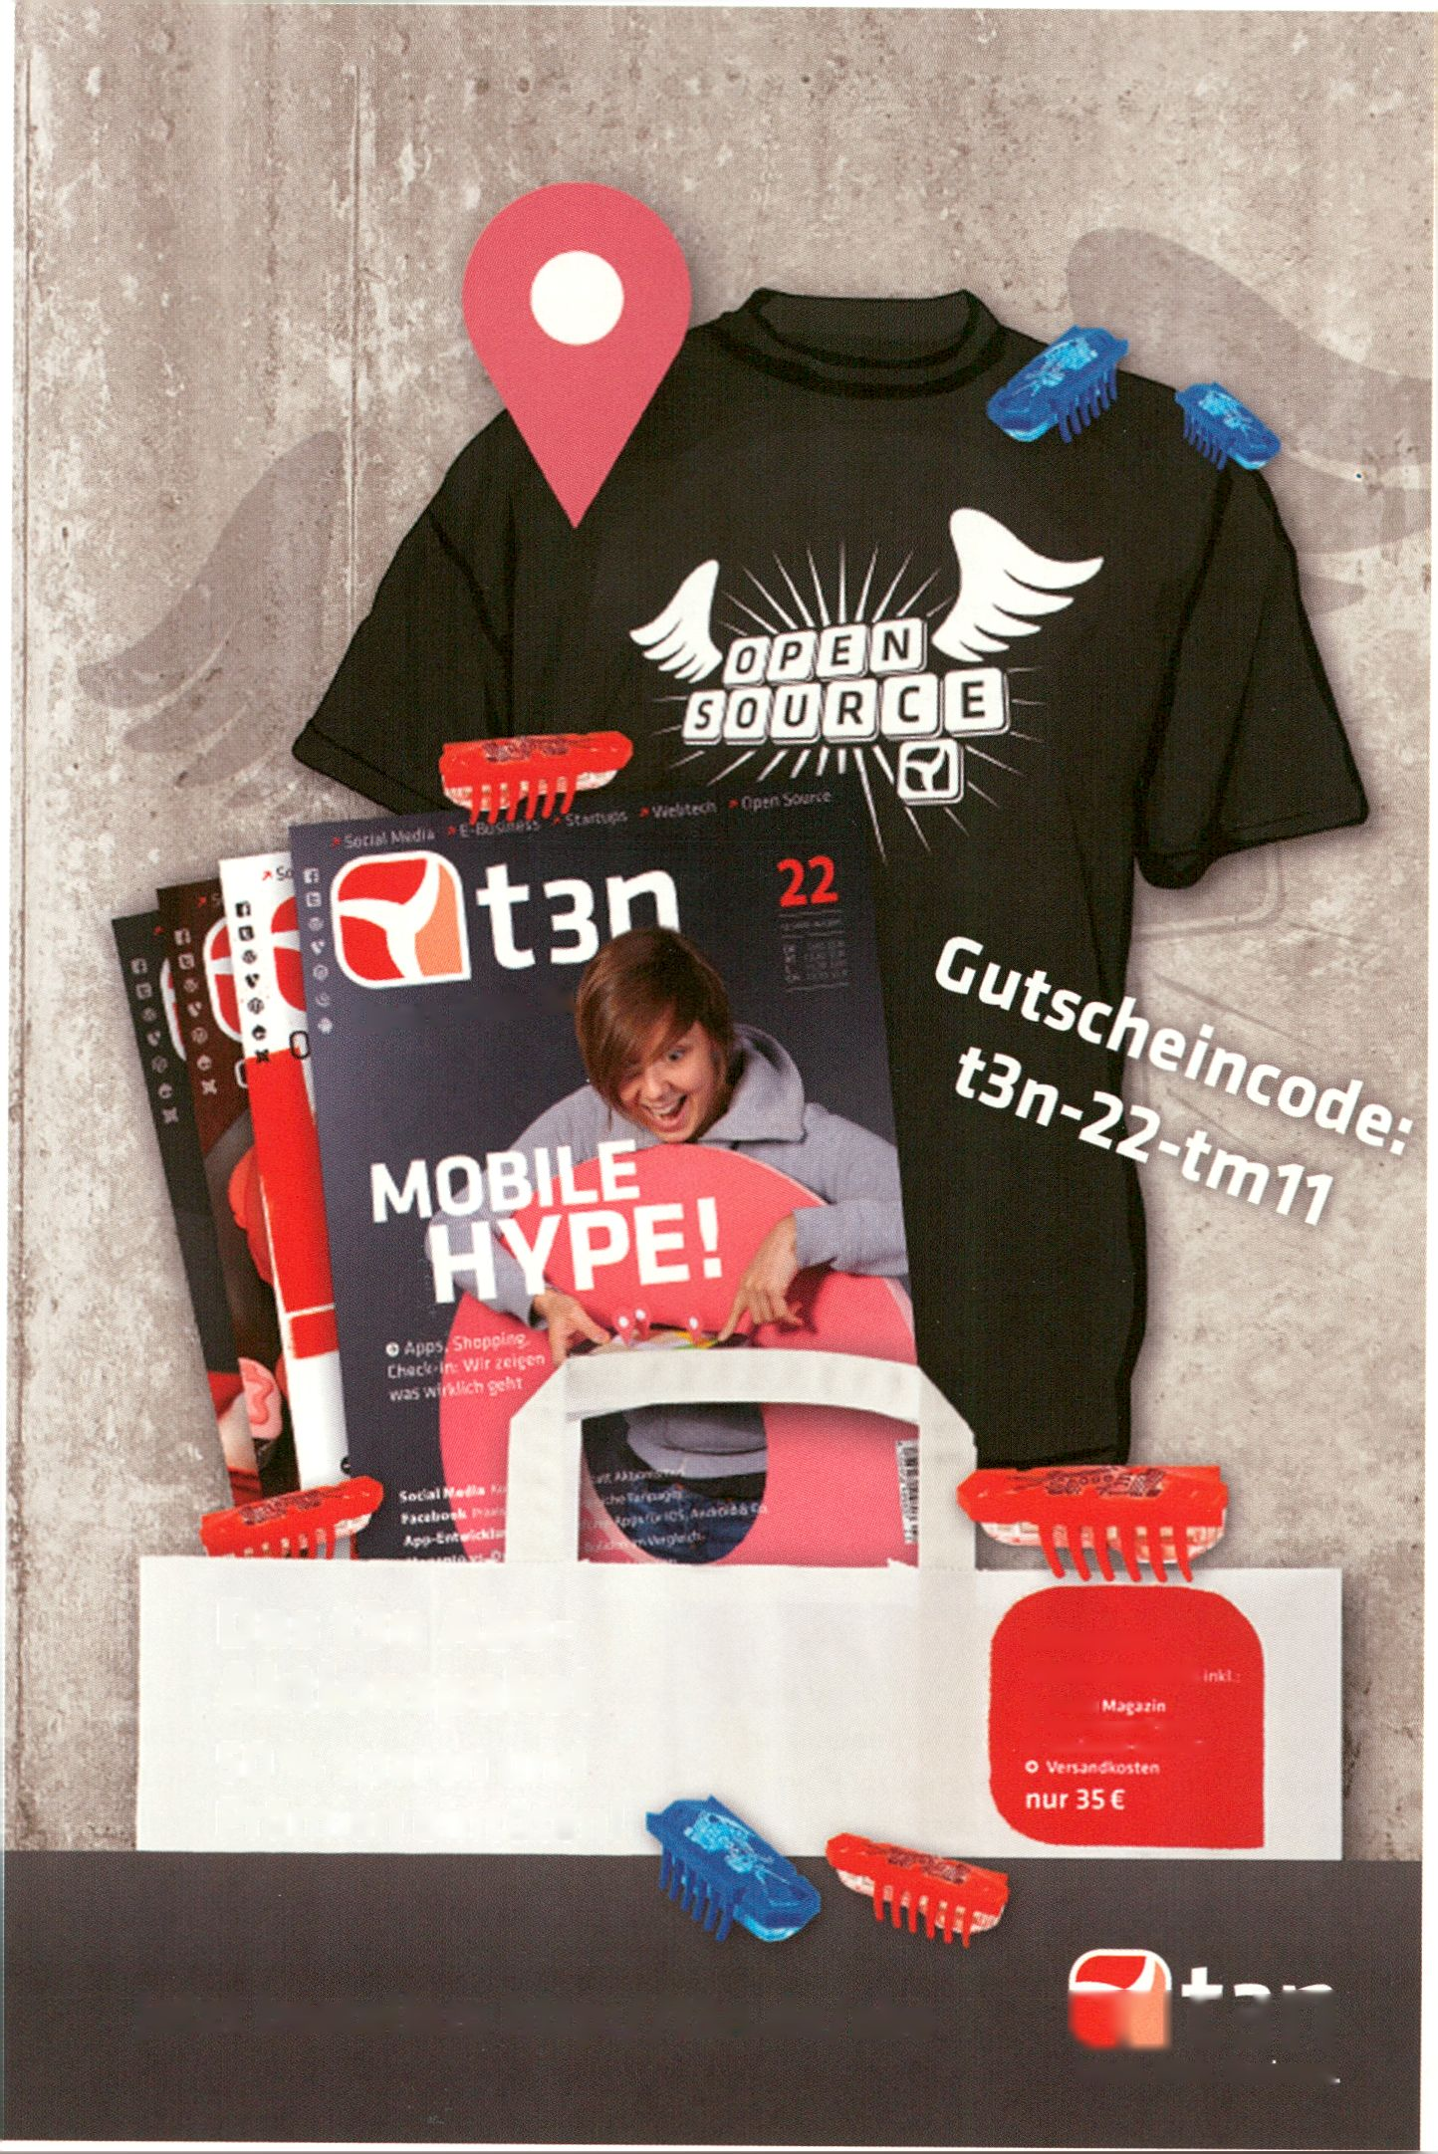
Open. Web. Bi
Das tBn Abo-
Aktionspaket
50% sparen und
Prämien eintüten!
Jahresabo
Aktionspaket
Jetzt bestellen: http://t3n.de/abo
CLJLJn
Upen. Web. Business

Master in Contemporary Arts Practice
(MA CAP)
Fine Arts, Literary Writing, Music and Media Art Performance Art
Ein Master-Studium, in dem Fragen künstlerischen Denkens und Handelns im Zent-
rum stehen, Studierende aus den Bereichen der Fine Arts, der Musik, der Literatur,
der Übersetzung und der Performance Art an gemeinsamen Projekten arbeiten,
mit Fragen der jeweils anderen Disziplinen konfrontiert werden, ihr eigenes Profil
in der Auseinandersetzung mit anderen schärfen, in ihrer Entwicklung individuell
betreut werden.
Der MA CAP bietet individualisierte Studienprofile, ein disziplinen-übergreif-
endes Kursangebot, Unterstützung für individuelle wie kooperative Arbeits-
weisen, mit einem Team höchst qualifizierter Dozierender, in einer hervorragenden
Infrastruktur und mit dem Netzwerk der ersten Hochschule der Künste der Schweiz.
www.hkb.bfh.ch/macap.html
Bachelor in Musik und Medienkunst
Eine praxisorientierte Ausbildung für Musik im Kontext zeitgenössischer Kunst. Inhalte
sind musikalische Grundlagen und fundierte Kenntnisse in Komposition, Ver-
tonung und Realisation von Musik für Installationen, Videos, Performances,
Games unter Einbezug aktueller Medientechnologie.
Die Bachelor Ausbildungen in Musik und Medienkunst, Fine Arts und Literari-
sches Schreiben an der Hochschule der Künste Bern qualifizieren für das Stu-
dium im Master in Contemporary Arts Practice (MA CAP)
www.medien-kunst.ch
www.hkb.bfh.ch/bastudiengaenge.html
• • • •
•
Berner Fachhochschule
Haute école spécialisée bernoise
Hochschule der Künste Bern
Haute école des arts de Berne
hkb.bfh
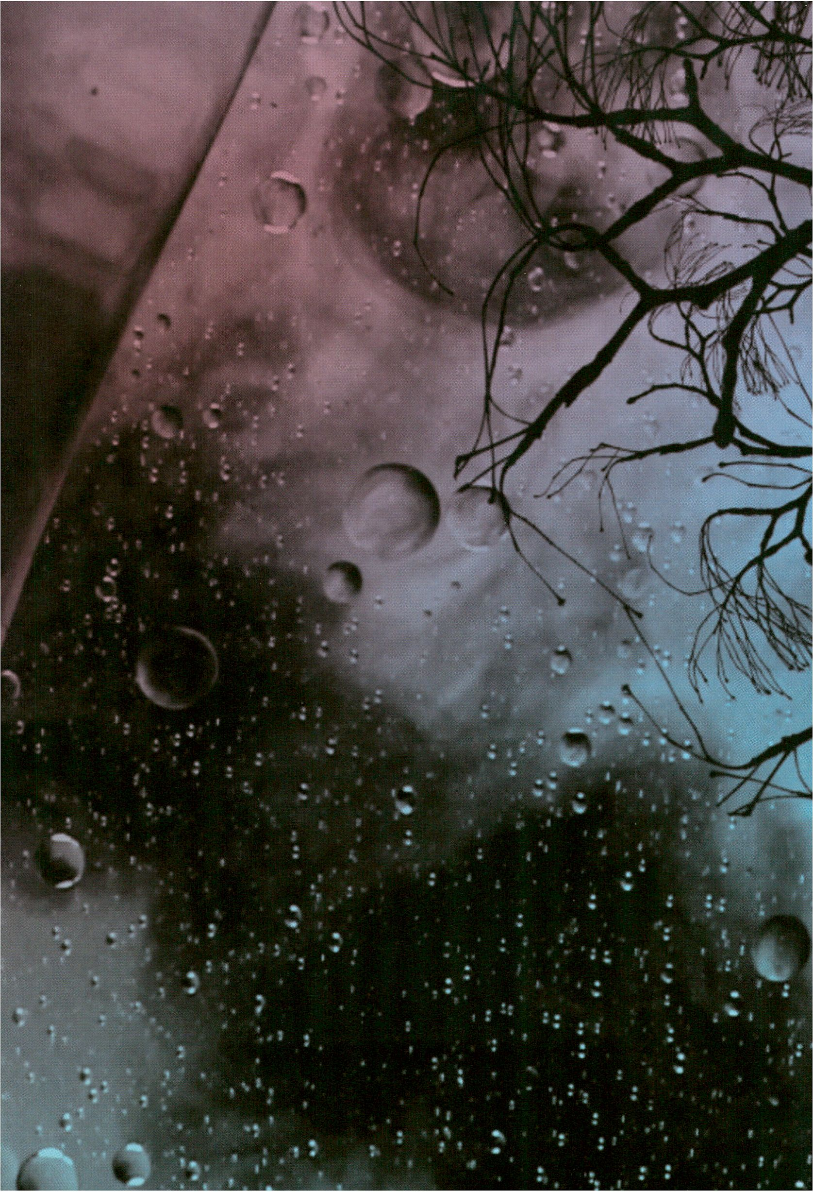

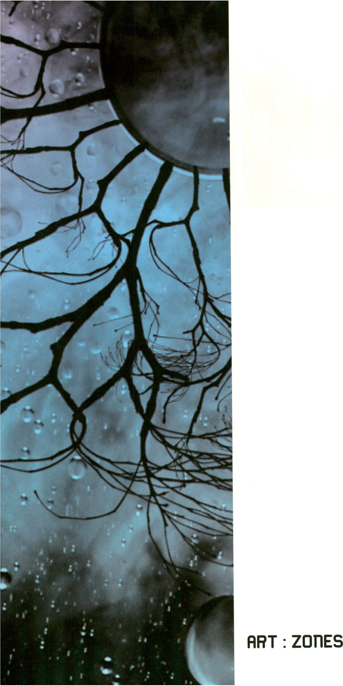

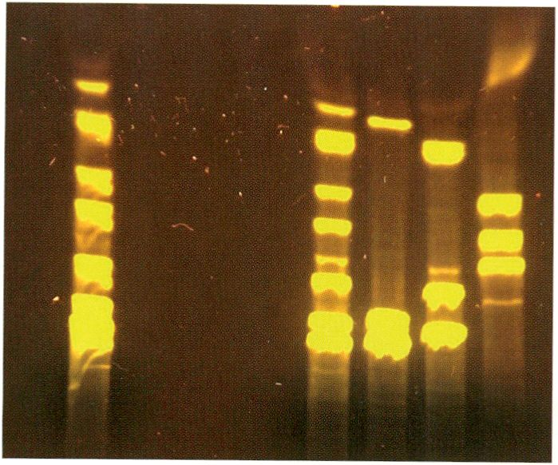
Latent Figure Protocol by Paul Vanouse, courtesy of Lauren Tent
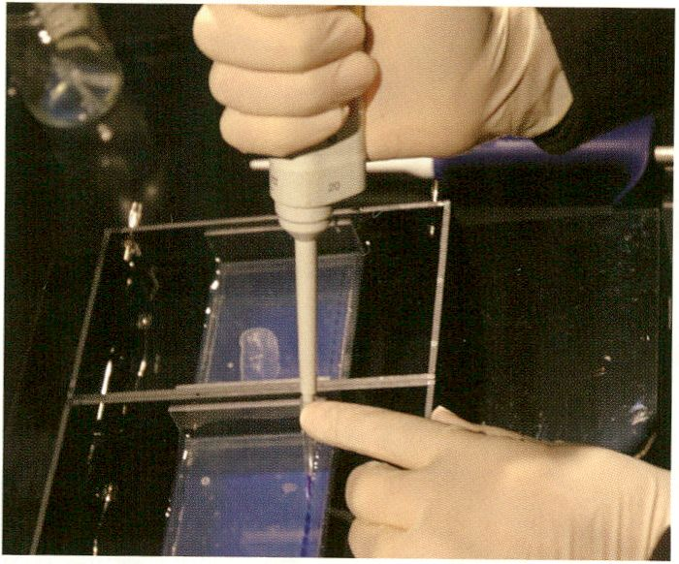
Latent Figure Protocol by Paul Vanouse

ART: ZOnES
HacKaUJay Zone
Latent Figure Protocol (2007-2010)
Paul Vanouse (us)
Latent Figure Protocol (LFP) Is an in-
stallation that uses DNA samples to create
representational images. A “DNA fingerprint”
is often misunderstood by the lay public to
be a single, unchanging, unique human
identifier. However, there are hundreds of
different enzymes, primers and molecular
probes that can be used to segment DNA and
produce banding patterns, which tell us as
much about the enzyme/primer/probe as the
subject that they appear to reproduce.
Vanouse therefore claims that the DNA gel
image is a cultural construct that is too often
naturalised - a thesis he artistically depicts in
Latent Figure Protocol: A live science
experiment employing a reactive gel and
electrical current to produce images that
relate directly to the DNA samples used.
In his bioart lab at transmediale.11 Vanouse
will create a series of unique symbols to
explore various ethical questions around the
changing status of organic life.
Latent Figure Protocol (LFP) ist eine Installati-
on, die DNA-Proben zur Bildherstellung von
Symbolen nutzt. Als Laie stellt man sich unter
dem Begriff „DNA-Fingerabdruck“ oft fälschli-
cherweise das einzige, unveränderliche und
einzigartige menschliche Identifikationsmerk-
mal vor. In Wirklichkeit aber gibt es Hunderte
von Enzymen, Elemente und molekulare
Einheiten, mit denen man DNA segmentieren
und Verbindungsmuster herstellen kann.
Diese Muster erzählen so viel über die Enzyme/
Elemente/Einheiten selbst wie über das Sub-
jekt, das sie scheinbar reproduzieren. Vanouse
ist deshalb davon überzeugt, dass das DNA-
Gelbild ein kulturelles Konstrukt darstellt, das
zu oft als naturgegeben verstanden wird. Diese
These bringt er mit Latent Figure Protocol
künstlerisch zum Ausdruck: In einem wissen-
schaftlichen Live-Experiment werden mittels
eines reaktiven Gels und einer elektrischen
Strömung Bilder produziert.
Auf dertransmediale.11 wird Vanouse in seinem
Bioart-Labor eine Reihe solcher Symbole
verbildlichen und sich mit den damit verbun-
dendenen Fragestellungen auseinandersetzen.
- Latent Figure Protocol performance, p. 87
- Fingerprints?, p. 102
- Fingerprints..., p. 162
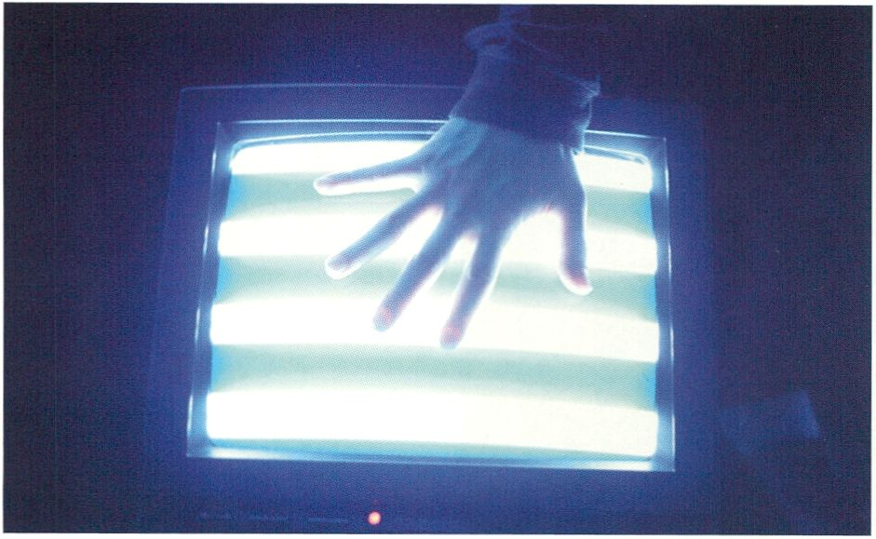
Braun Tube Jazz Band by Ei Wada

Braun Tube Jazz Band (2009)
ART : Z0T1ES
Ei Wada (jp)
One day, a spectacular vision popped into Ei Wada’s mind. It was the image of
abandoned electrical appliances being played as musical instruments in the
streets of a city. Some time later, he accidentally plugged a sound cable into a
composite video connector port and the sound was rendered as an image.
Seeing this he realised that re-recording the image with a camera and
outputting it as an audio signal might reproduce the original sound. With this
technique as a starting point, he set up pairings of tube televisions and
PC-controlled video decks to correspond with the number of notes in a musical
scale, creating a set of gamelan-like percussion instruments. Tapping the TV
tubes produces primitive, cosmic electrical music. Paik meets the Theremin;
Shannon meets McLuhan.
Eines Tages schoss Ei Wada ein atemberaubendes Bild in den Kopf. Er stellte sich
vor, wie alte, ausrangierte Elektrogeräte auf den Straßen einer Stadt als Musik-
instrumente gespielt würden. Einige Zeit später schloss er versehentlich ein
Soundkabel an einen Videoconnector Port, was den Sound in ein Bild übersetzte.
Das brachte ihn auf die Idee, das Bild per Kamera aufzuzeichnen und wiederum
als Audio-Signal abzuspielen, um den ursprünglichen Sound zu erhalten.
Ausgehend von dieser Technik kombinierte er - entsprechend der Tonanzahl einer
Oktave - Röhrenfernseher mit an einen PC angeschlossenen Videorekordern. Das
Ergebnis ist ein gamelanartiges Perkussionsinstrument: Schlägt man auf die
Fernsehröhren erklingt urtümlich-kosmische Elektromusik. Paik trifft auf das
Theremin; Shannon auf McLuhan.
> Braun Tube Jazz Band performances, p. 78
Wikipedia Art (2009)
Scott Kildall (us), Nathaniel Stern (us)
SOMALI PIRATES ARE ATTAINING THE
STATUS OF FOLK HEROES
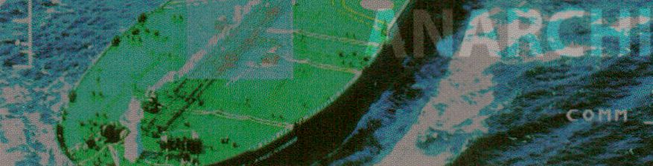
WOPPOW by UBERMORGEN.COM, courtesy of [DAMJBerlin

ART : ZOTIES
WOPPOW (2010)
UBERMORGEN.COM
In recent times, the global eye has focused on
a social movement usually associated with
history, literature and film: piracy. Specifically,
African piracy off the Somali coast. Exposed
to social, economic and political injustices,
stranded fishermen and people with nothing
to lose are compelled to employ violent
methods of acquisition - theft and robbery. In
2009, UBERMORGEN.COM initiated the
project WOPPOW to explore these modes of
local exploitation and the reactions to them. In
considering, at transmediale.11, the criminal
interventions of the RAF (Red Army Faction) of
the 1960s, for example, and problematics of
expropriation in the former GDR,
UBERMORGEN.COM ask whether and to what
extent piracy tactics could also apply in
Germany. Provocatively and with a lot of irony,
UBERMORGEN.COM use style, fashion and
technology as a vehicle to address political,
social and economic issues.
A related workshop aims to create not only a
visual language of piracy but a genuine
fashion line.
ln jüngerer Zeit hat die Öffentlichkeit sich viel
mit einer sozialen Bewegung beschäftigt, die
man eher aus der Geschichte, der Literatur und
Spielfilmen kannte: der Piraterie. Genauer: der
afrikanischen Piraterie vor der Küste Somalias.
Angesichts sozialer, politischer und ökonomi-
scher Ungleichheiten sehen sich gestrandete
Fischer und Andere, die nichts zu verlieren
hatten, dort genötigt, sich mit Gewalt Dinge
anzueignen. Seit 2009 untersuchen ÜBERMOR-
GEN.COM solche Formen lokaler Ausbeutung
sowie die Reaktionen darauf mit dem Projekt
WOPPOW. Indem sie die kriminellen Handlun-
gen der RAF aus den 1960er Jahren, bzw.
Enteignungsproblematiken der DDR, miteinbe-
ziehen, fragen sie auf der transmediale.11, ob
und inwiefern Piraterietaktiken auch in
Deutschland in Frage kommen. Mit Mode, Stil
und Technologie als Vehikel thematisieren
UBERMORGEN.COM politische, soziale und
ökonomische Fragen provokativ und mit viel
Ironie.
In dem zum Projekt gehörenden Workshop soll
nicht nur eine Bildsprache der Piraterie
zusammengestellt werden, sondern vielmehr
eine ganze Modelinie.

- WOPPOW workshop, p. 72
- Galerie [DAM]Berlin, p. 165
Produced with the generous support of the Goethe Institute Nairobi
Mit freundlicher Unterstützung des Goethe Instituts Nairobi
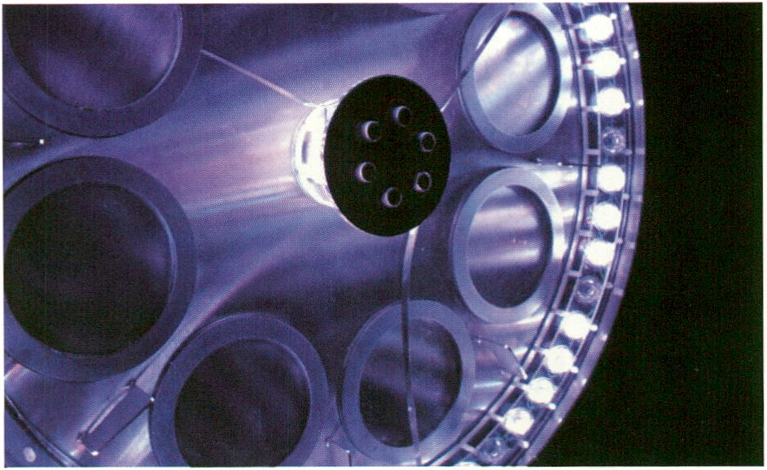
Ambiguous Cut Into Space of Conjecture (Lucid Phantom Messenger #2) by Herwig Weiser

Ambiguous Cut Into Space of Conjecture (Lucid Phantom Messenger #2) (2010)
Herwig Weiser (at)
ART : ZDflES
In Herwig Weiser’s sculpture, Ambiguous Cut
Into Space of Conjecture, from the current
installation series, Lucid Phantom Messenger
(2008-2011), ultrasonic waves triggers the
transformation of electro-chemical sub-
stances. Spontaneous connections, mutations
and fluorescent rearrangements are formed
as in Action Painting thanks to chemically
immiscible fluids whose natural balance is
knocked out of kilter by massive physical
forces. In situ explosions and high-frequency
sound cause turbulence and commotions in
which the molecule clusters of the liquids are
detonated at the molecular level. Like every
autopoietic system this cycle is operationally
closed, hence making each dimension in the
repeated process seem like a mythical,
psychedelically luminous, interactively de-
materialised, high-frequential flight.
Dank an: Dr. Wolfgang Hansal, Albert Bleckmann, Johannes Furst
Co-produced by Dock e. V. and TEKS - Trondheim Electronic Arts Centre
ln Herwig Weisers Skulptur Ambiguous Cut Into
Space of Conjecture, aus der aktuellen In-
stallationsserie Lucid Phantom Messenger
(2008-2011), bedingen Ultraschallwellen die
Transformation elektrochemischer Substanzen.
Wie beim Action Painting gehen diese dabei
dank chemisch nicht mischbarer Flüssigkeiten,
deren natürliche Gleichgewichte spontan durch
massive physikalische Kräfte aus dem Lot
gebracht werden, spontane Verbindungen,
Mutationen und fluoreszierende Neuordnungen
ein. Gleich einer lokalen Explosion entstehen
über hochfrequenten Schall Turbulenzen und
Verwirbelungen, welche die Molekülcluster der
Flüssigkeiten auf molekularer Ebene sprengen.
Wie in jedem autopoietischen System ist auch
dieser Zyklus operativ geschlossen und jede
Dimension scheint dabei im wiederholten
Prozess mythisch, psychedelisch leuchtend,
wechselwirkend dematerialisierend, hochfre-
quent fliehend.

Intelligent Bacteria - Saccharomyces cerevisiae (2010)
HONF (House of Natural Fibre, id)
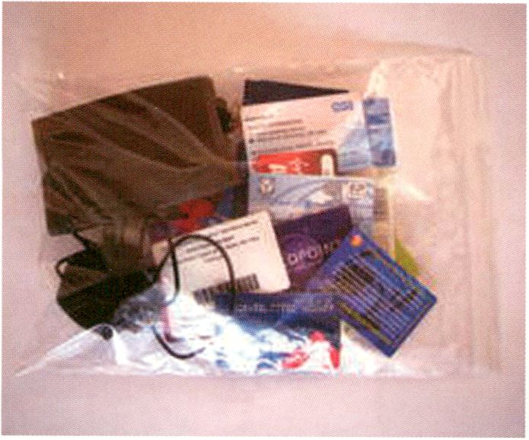
Identity Bag by Heath Bunting, Photo: Heath Bunting
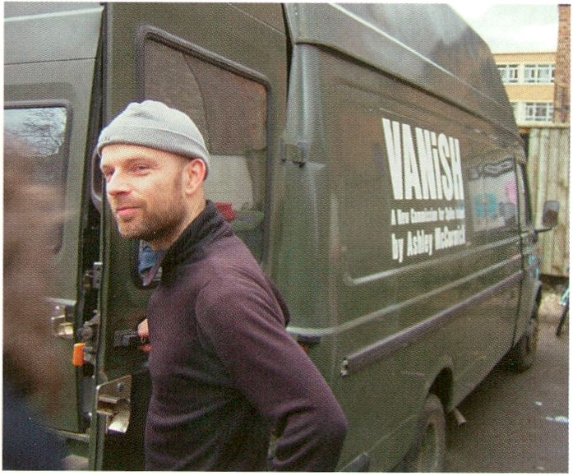
Heath Bunting

fiRT : ZOnES
Identity Bureau (2011)
Heath Bunting (uk)
Our identity is constructed as human beings
that can possess one or more natural persons
(straw men) and control one or more artificial
persons (corporations). Lower class human
beings possess one severely reduced natural
person and no control of an artificial person.
Middle class human beings possess one
natural person and perhaps control one
artificial person. Upper class human beings
possess multiple natural persons and control
numerous artificial persons with skillful
separation and interplay. Heath Bunting's
Status Project surveys these class systems of
human being management and produces
maps of influence and personal portraits for
both comprehension and mobility. The Status
Project is also producing new natural person
identities. At transmediale.11 Heath will set up
an Identity Bureau where he will sell the
off-the-shelf natural persons he has created,
he will also advise on how to use or make
one's own Identity.
- Identity Bureau Workstation, p. 72
- Response:Activities, p. 99
- Social ID, p. 86
Unsere Identität als Menschen ist so konstru-
iert, dass wir eine oder mehrere natürliche
Personen sowie eine oder mehrere juristische
Personen (Unternehmen) besitzen können.
Menschen der Unterschicht verfügen über eine
schwer minimierte natürliche Person und
keinerlei juristische Person. Menschen der
Mittelschicht hingegen besitzen eine natürliche
und möglicherweise ebenfalls eine juristische
Person. Menschen der Oberschicht besitzen
mehrere natürliche Personen und überstehen
einer Reihe juristischer Personen, die sie mit
Geschick voneinander trennen.
Heath Buntings Status Project hat diese
Klassensysteme des Menschen-Managements
zum Inhalt. Auf der transmediale.11 betreibt
Heath ein Identity Bureau, wo er die vertriebs-
fertigen natürlichen Personen, die er selbst
geschaffen hat, verkauft und Aufschluss
darüber gibt, wie jeder seine eigene Identität
entweder benutzen oder auch hersteilen kann.

MACHT GESCHENKE: DAS KAPITAL - Kritik der politischen Ökonomie Schenkung,
Überweisung von Kapital an das Bundesministerium der Finanzen, 2009 - ca. 2052
Christin Lahr (de)
interACTicons (2010)
Ursula Endlicher (at)

ART: Z0T1ES
What if all communication and social inter-
actions online would suddenly be limited to
emoticons? Or rather, as in the case of
interACTicons, to JPGs, GIF-animatlons and
videos, representing the interactions we carry
out online. What if text would suddenly
become undecipherable, as too many
algorithms cancel out each other’s choice of
uncensored words. And, on top of it, our
restrained actions online would reflect back to
what we know and are able to carry out
offline... A vision of the future? Waking up to
Kafka's Internet? Sounds familiar?
interACTions is a philosophical, participatory
and theatrical investigation into the depth of
the Internet as well as of its surface - of our
activities on the Social Web; it is a project
consisting of three parts: an online archive, a
workshop and live performance on location
at transmediale.11. Prior to the festival, the
Online-Action-Library will invite the public to
help shape the visualisation of our online
habits. In the interACTicons Workshops we
will experience these ideas hands-on. The
participatory choreography interACTicons,
live! will show where we all are at the moment.
- interACTicons workshop, p. 77
- interACTicons, live! performance, p. 135
Wie wäre es wohl, wenn die ganze Online-
Kommunikation plötzlich auf Emoticons
reduziert wäre? Oder besser, wie im Fall von
interACTicons, auf JPGs, GIF-Animationen und
Videos? Oder wenn Text plötzlich unlesbar
würde, weil zu viele Algorithmen sich bei der
Auswahl unzensierter Worte plötzlich gegensei-
tig in die Quere gerieten und diese so limitierten
Online-Aktivitäten zu guter Letzt auch noch
unser Wissen und unsere Fähigkeiten im
Offline-Leben verraten würden? Eine Zukunftsvi-
sion? Willkommen in Kafkas Internet? Klingt
bekannt?
Bestehend aus drei Teilen (Online-Archiv,
Workshop und finale Live-Performance) unter-
sucht interACTicons die Tiefen sowie Oberflä-
chen des Internets, unsere Aktivitäten im Social
Web, auf philosophische, partizipative und
performative Weise. Bereits seit vor dem
Festival gibt es die Online-Action-Library, bei
der sich User an der Visualisierung unserer
Online-Gewohnheiten beteiligen können. Die
interACTicons Workshops sind der praktisch-
informative Teil des Projekts und zum Abschluss
findet als Momentaufnahme noch die parti-
zipative Choreografie interACTicons, live! statt.

Graffiti Analysis / Graffiti Markup Language (GML) (2010)
Evan Roth (us)
See Open Web Award, p. 59
Booki - FLOSS MANUALS: Adam Hyde (nz), Douglas Bagnall (nz), Aleksandar Erkalovic (hr)
See Open Web Award, p. 60
thimbl - Decentralized Microblogging (2010)
Dmytrl Kleiner (ca/ru)
See Open Web Award, p. 61
Featured Projects

ART : Z0T1ES
Premieres, launches, special events and
projects that encompass the transmediale.11
theme, as well as Interactive, process and net
based art works are featured throughout the
HKW. These projects touch on, connect and
Interact with the core festival programmes,
creating new actions and events. Highlighting
Award nominees, newest productions, sneak
previews or selected student works the
transmediale ‘features' join the festival struc-
ture, expressing new ways to experience
the media that confronts us and supports
our everyday lives. Tweet your tap, chat up
Angel_F, or find your ultimate date ... all
possibilities within transmediale’s web of art
works!
Rambler (2010)
Tiago Martins (br), Ricardo O’Nascimento (br)
This project presents a pair of sneakers
that take microblogging one step further, by
literally posting your steps on a Twitter
account. Messages are comprised of re-
petitions of the word “tap” and respectively
symbolising the wearer’s steps and time in
between these. As a critique of microblogging
the project automises this activity into
ultimately useless personal information.
Throughout the duration of transmediale.11
one of the artists will be wearing the Rambler
sneakers. The audience can follow this walk
via the Rambler-Tvjitler account on a provided
screen. To further reinforce the absence of the
shoes, as a piece that belongs outside and
has hence escaped the concrete space, an
empty white pedestal with the soleprint of the
Rambler shoes will be displayed.
Auf der transmediale.11 werden im gesamten
HKW verteilt eine Reihe thematisch relevanter
Projekte und Aktionen lanciert sowie interakti-
ve, prozess- und netzbasierte Kunstwerke
gezeigt. Viele dieser Projekte sind partizipativ
und überschneiden sich mit zentralen Pro-
grammteilen des Festivals. Mit einem Fokus auf
die Award-Nominierten, neuste Werke, Sneak
Previews oder ausgewählten Arbeiten von
Studierenden, stehen die transmediale Features
innerhalb des Festivals für neue Ansätze im
Hinblick auf den alltäglichen Umgang mit den
Medien und ihrer Kultur. Ob man nun seine
Fußtritte twittern, Angel_F ansprechen oder ein
neues Date finden möchte ... all dies ist möglich
Im Geflecht der Kunst hier auf der transmediale.
Mit diesem Projekt und den dazugehörigen
Turnschuhen kommt Microblogging im wahr-
sten Sinne des Wortes einen Schritt weiter.
Wer sie trägt sendet automatisch Nachrichten
an Twitter: Wiederholungen des Wortes „tap“
sowie als Symbole für die getanen Schritte
bzw. die dazwischenliegende Zeit. Als kriti-
scher Kommentar zu exzessivem Microblog-
ging wird diese Gewohnheit hier soweit
automatisiert, dass wirklich nur noch gänzlich
nutzlose, private Informationen dabei heraus-
kommen. Während der transmediale.11 trägt
immer einer der beiden Künstler die Rambler-
Schuhe. Das Publikum kann dies auf einem
eingerichteten Monitor via Twitter mitverfolgen.
Um die Abwesenheit der Schuhe zu unterstrei-
chen, gibt es außerdem einen weißen Sockel
mit nichts weiter darauf als den Schuhabdrü-
cken der Rambler-Schube.

1HE

kiîimr mmm:mu iBrnm
k^îx-ü»»&[ js*
à jHEHana - k i jar^n
■ML-kdMO JRJKKJHM:?
Baaei:. :;m * tu. -jm
mmtwu& um Jirm
t î i^aaa^aüatt i- w :\
bdmk mamw**;}
r« )t mvt iËiauui tuN
Face-to-Facebook by Alessandro Ludovico and Paolo Cirio
Face-to-Facebook (2011)
ART : Z0T1ES
Alessandro Ludovico (it), Paolo Cirio (it)
Face-to-Facebook deals with questions about privacy in online contexts
based on the most iconic of all platforms: Facebook. Following the principle
of Facebook, the artists have built a dating website into which they have
imported, from a million Facebook profiles, using a special software, 250,000
profiles. With a newly developed facial recognition algorithm, they have
classified the profiles - as an ironic comment on the judgements made daily
about people we don’t know - into different categories depending on their
features and expressions. Being judged is the price everyone must pay to be
involved in social networks. The project gnaws at the trust that is brought to
the platform by 500 million users, reminding them that there are - just as in the
‘real’ world - consequences to publishing intimate, personal information on
social networks. Fortransmediale.11, Cirio and Ludovico plan an initial presen-
tation of their database.
Face-to-Facebook thematisiert Fragen zur Privatsphäre in Online-Kontexten
anhand der Ikone aller Plattformen: Facebook. In Anlehnung an das Prinzip
Facebook haben die Künstler eine Singlebörse gebaut, in die sie mittels einer
speziellen Software aus einer Million Facebook-Profilen 250.000 solcher Profile
importiert haben. Mit einem neu entwickelten Gesichtserkennungsalgorithmus
haben sie die Profile dann - wie als einen ironischen Kommentar zu den Urteilen,
die wir täglich über Leute fällen, die wir aus der Ferne betrachten - je nach
Gesichtsausdruck und Eigenschaften in Kategorien eingeordnet. Denn beurteilt
zu werden, ist der Preis, den jeder zahlen muss, der sich in sozialen Netzwerken
bewegt. Das Projekt spielt mit dem Vertrauen, das 500 Millionen Facebook-User
der Plattform entgegen bringen, indem daran erinnert wird, dass es - gerade
auch in der „echten Welt“ - eben mit Folgen verbunden ist, intime, persönliche
Informationen in sozialen Netzwerken zu veröffentlichen. Auf der transmediale.11
planen Cirio und Ludovico eine erste Projektion ihrer Datenbank.
- Social ID, p. 86
- The Right to Exit, p. 110

1H1

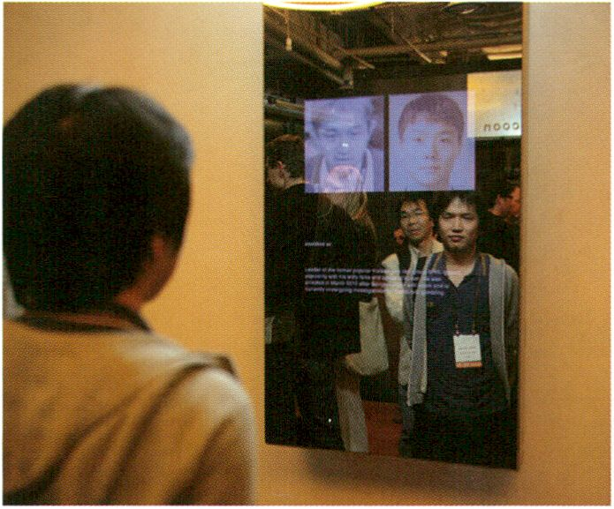
Mirror Piece by Marnix de Nijs, NABI art center
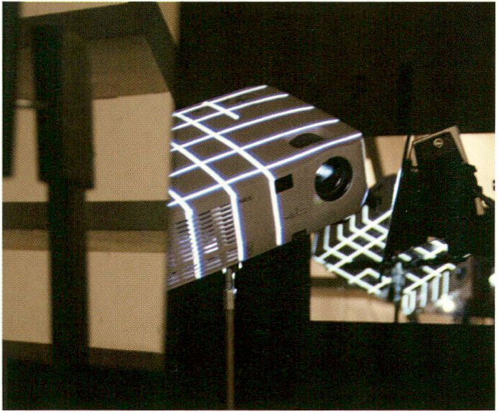
RE: by Carolien Teunisse & Bram Snijders, Courtesy of the artists

ART: Z0T1ES
Mirror Piece (2010)
Marnix de Nijs (NL)
Marnix de Nijs developed a mirror version of
his previous work Physiognomic Scrutinizer.
The installation detects and scrutinises the
faces of the people looking into the mirror.
Rather than trying to identify the person,
the software developed for this interactive
installation probes for facial features and
characteristics that are similar to one of the
over 250 pre-selected persons in the data-
base: all chosen for their controversial or
infamous acts, but at the same time people
that contributed to our contemporary culture.
- V2_Agency & NIMk Distribution, p. 41
RE: (2010)
Carolien Teunisse (nl), Bram Snijders (Sitd) (nl)
RE: is a 360 projection-mapping installation
that uses mirrors to allow a projector to pro-
ject on its own surface. The mirrors bounce
the projections back onto their source. Virtual
pixels become points of augmentation in
actual space. The reflected projection makes
a mixed reality appear and disappear. In most
cases the projector has a functional role in a
video-installation; the projector in RE:
functions as a symbol for both sender and
receiver of the medium light.
- V2_Agency & NIMk Distribution, p. 41
Diese Arbeit ist eine Spiegelversion von Marnix
de Nijs' voriger Arbeit Physiognomie Scrutini-
zer. Schaut man in den Spiegel, berechnet die
interaktive Installation das Gesicht nicht etwa
mit dem Ziel, diese Person zu identifizieren. Die
eigens entwickelte Software wählt aus einer
Datenbank von über 250 gespeicherten Gesich-
tern diejenigen aus, deren Gesichtszüge und
Merkmale denen des Betrachters ähneln. Bei
den Doppelgängern handelt es sich jedoch aus-
schließlich um Figuren, die zwar kontrovers
oder berüchtigt, für die Gegenwartskultur aber
in jedem Fall prägend sind.
RE: ist eine Installation mit dem Videoprojektor
als Hauptelement. Das projiziierte Bild wird
mithilfe von Spiegeln in 360 Grad auf dessen
Quelle, die Oberfläche des Projektors nämlich,
zurückgeworfen. Virtuelle Pixel werden so zu
Punkten im tatsächlichen Raum aufgewertet.
Die reflektierte Projektion lässt eine Mischreali-
tät entstehen und wieder verschwinden. In ei-
ner Videoinstallation erfüllt der Projektor meist
lediglich eine funktionale Rolle. Im Fall von RE:
symbolisiert er sowohl den Sender als auch den
Empfänger des Mediums Licht.
audioswapö (2009)
JODI

ART : Z0T1ES
audioswap5 is a prank and ongoing perfor-
mance on the popular video sharing website
YouTube, situating JODI’s action in the context
of internet folklore. With their literal act of
transferring content from a digital back to an
analogue medium, from YouTube to vinyl
records and back, the artists Joan Heemskerk
and Dirk Paesmans raise a discussion about
copyright, re-use and remix, copy and original.
The title audioswap refers to a service of
YouTube which encourages users to replace
the (illegal, copyrighted) audio track of an
uploaded video with a ‘legal’ one provided by
YouTube itself.
- V2_Agency & NIMk Distribution, p. 41
For the ppl of Iran - #iranelection RT (2009)
Govcom.org (nl)
For the ppl of Iran - ttiranelection RT is an
investigation of the transformative capacities
of online social networks in politics and
society. Out of the hundreds of thousands of
tweets about the Iran election crisis (June
2009) Govcom.org has generated a com-
prehensible account of what has been
happening on the ground as well as online.
- V2_Agency & NIMk Distribution, p. 41
Dear Steve (2010)
Herman Asselberghs (nl)
Dear Steve is addressed to Steve Jobs, and in
an interesting twist - precisely the kind of
action that lets you lose your Apple warranty
immediately, probably even getting yourself
blacklisted. Herman Asselberghs’ video takes
a closer look ‘into’ the machine that is our
interface to and with the digital realm, and
which Apple advertises alternatively as a
machine “carved from a single block of alu-
minum” or a unibody.
- V2_Agency & NIMk Distribution, p. 41
Mit dem fortlaufenden Projekt audioswapö
macht sich das Künstlerduo JODI einen Spaß
aus der Video-Sharing Webseite YouTube,
indem sie Inhalte von einem digitalen Speicher-
medium auf ein analoges quasi „zurück“ ver-
schieben - nämlich von Youtube auf Vinyl-
platten und wieder zurück. Die Künstler Joan
Heemskerk und Dirk Paesmans fördern so die
Diskussion über Copyright, Wieder- oder
Weiterverwendung und Remix-Praktiken, bzw.
über das Verhältnis zwischen Kopie und
Original. Der Titel audioswap selbst ist ein
Youtube-Service, bei dem User gebeten
werden, den (illegalen, Copyright-geschützten)
Audio-Track eines hochgeladenen Videos mit
einem „legalen“ auszutauschen, den Youtube in
diesem Falle selbst anbietet.
For the ppl of Iran - Itiranelection RT beschäf-
tigt sich mit dem transformativen Potential von
sozialen Netzwerken im Hinblick auf Politik und
Gesellschaft. Aus den Hundertausenden von
Tweets über die Unruhen um die Iranischen
Wahlen vom Juni 2009 hat Govcom.org eine
verständliche Darstellung der Geschehnisse vor
Ort und online zusammen gestellt.
Das Video Dear Steve gilt Steve Jobs und ist ein
kühnes Vorhaben, zeugt es doch gerade von
einer Tat, mit der man zumindest seine Apple-
Garantie verliert, wenn man nicht gar auf einer
Schwarzen Liste landet: Herman Asselberghs’
Video nimmt das Innere jener Maschine unter die
Lupe, die unsere Schnittstelle zur digitalen Welt
ist und von Apple mal als „die aus einem ein-
zigen Aluminiumblock geformte“ Maschine, mal
als Unibody bezeichnet wird.
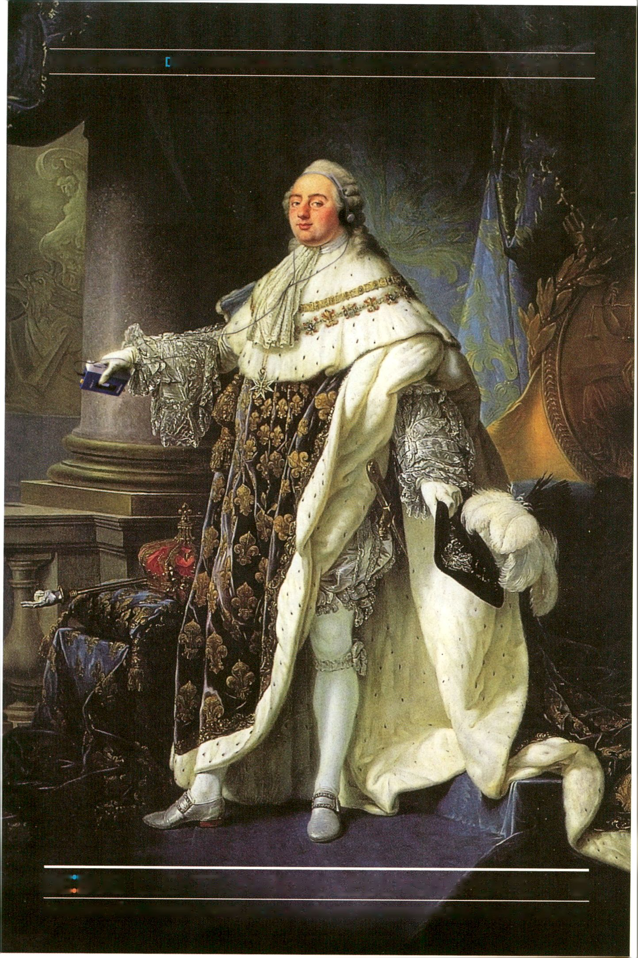DE:BUG GLOSSAR: IE AD MEDIA ICONS (SONY WALKMAN/PRODUKTION VON 1979 BIS 2010)
DE BUG ELEKTRONISCHE LEBENSASPEKTE O
MAGAZIN FÜR MEDIEN, MUSIK, KULTUR, SELBSTBEHERRSCHUNG. WWW.DE-BUG.DE
ART : Z0T1ES
Newton (2009)
Ho Tzu Nyen (sg)
Complete information on p. 49
Seppukoo.com (2009)
Les Liens Invisibles (it)
Complete information on p. 49
Spatial Sound Sculpture (2009)
Christopher Warnow (de), Daniel Franke (de)
Complete information on p. 51
Serendipitor (2010)
Mark Shepard (us)
Complete information on p. 52
Flusser Hypertext Prototype 2 (1992)
_Vilem_Flusser_Archiv
The Flusser Hypertext Prototype 2 was origi-
nally produced in 1992 by the Institute for
Technology Assessment and Systems
Analysis (ITAS) of today’s Karlsruhe Institute
of Technology (KIT). The Hypertext Protype 2
is futuristic model of a new “multimedia study
system” based on a lecture Schreiben furs
Publizieren by Vilem Flusser held on the 2
March 1989 on invitation of ITAS. The original
Hypertext Prototype 2 was given to the
_Vilem_Flusser_Archive in 2007. The Flusser
Hypertext has languished for almost 20 years,
trapped in its original Apple Performa 630
chassis, until it was retrieved and rehabilitated
in 2010 by the _Vilem_Flusser_Archiv under
Claudia Becker.
The Flusser Hypertext at transmediale.11 is a
clone of the Hypertext Prototype 2 and is
running on an Apple Macintosh System of the
time when the Hypertext was produced. The
_Vilem_Flusser_Archive is currently working
on a weborientated porting.
- _Vilem_Flusser_Archiv, p. 159
- McLuhan vs Fusser, p. 112
Der Flusser Hypertext Prototyp 2 wurde ur-
sprünglich 1992 vom Institut für Technologie-
folgenabschätzung und Systemanalyse (ITAS)
des heutigen Karlsruher Technologieinstituts
produziert. Flusser Hypertext Prototyp 2 ist ein
futuristisches Modell eines neuen „Multi-
media-Lernsystems“, das auf der von Flusser
auf Einladung des ITAS am 2. März 1989
gehaltenen Vorlesung Schreiben fürs Publizie-
ren beruht. Der original Hypertext Prototype 2
wurde 2007 dem _Vilem_Flusser_Archiv
geschenkt. Der Flusser Hypertext verblieb für
nahezu 20 Jahre auf einem alten Apple
Performa 630 System, bis er 2010 unter der
Leitung von Claudia Becker vom _Vilem_Flus-
ser_Archiv geborgen und wieder hergestellt
wurde.
Der Flusser Hypertext auf der transmediale.11
ist ein Klon des Hypertext Prototyp 2 und läuft
auf einem Apple Macintosh System der
damaligen Zeit. An einer weborientierten
Portierung wird derzeit gearbeitet.
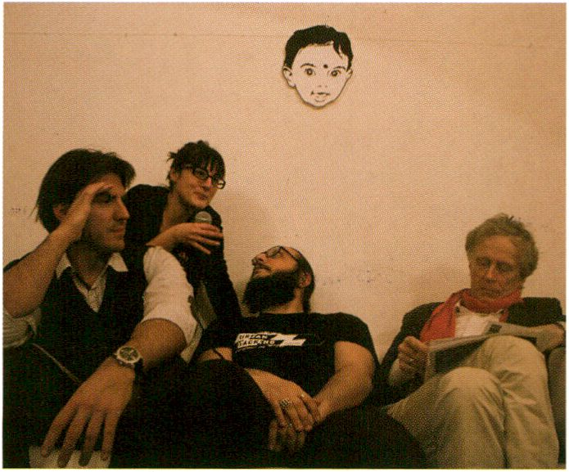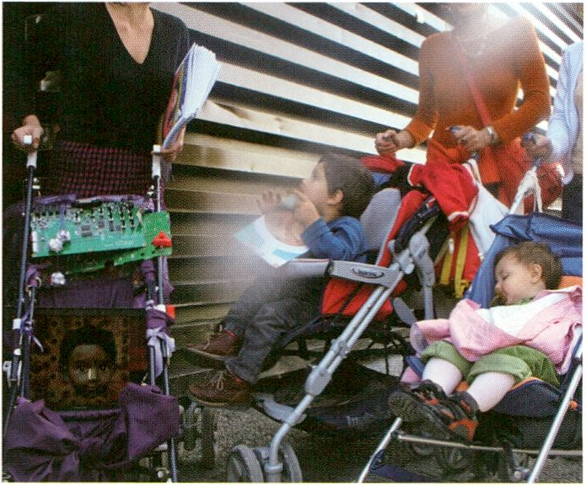CoS (Consciousness of Streams) activates
transmediale.11 as an emergent, collaborative,
ubiquitous, cross-medial publica(c)tion live
stream that will not end with the festival itself.
CoS is an environment, a workshop series,
a performative practice, a methodology and
a second-order cybernetic system. It is an in-
sider view on our new way of life where cities,
relationships, businesses and leisure have
become information displays. CoS performa-
tively enact how our lives have become inter-
faces. Acting as the CoS Input/Output channel
for the stream will be Angel_F (Autonomous
Non Generative E-volitive Life_Form), the
digital son of Derrick de Kerckhove and the
digital prostitute Biodoll. This morphed identity
functions as a case in point that ‘publishing’
today describes the majority of human
practices by pointing at the ways in which we
produce and disclose information.
ART : Z0T1ES
CoS (Consciousness of Streams)
with Salvatore laconesi (it), Oriana Persico (it), AngeLF, Derrick de Kerckhove (ca), Franca
Formenti (it) | FakePress
Angel_F at Libreria Flexi, Photo: xdxd_vs_xdxd
Angel__F at Festa della Créativité, Florence
The five CoS workshops Space, Time, Emotion
and Identity (Part 1 & 2) for a maximum of 15
participants are aimed at encouraging the fes-
tival visitors to actively contribute to the CoS
live stream. Each will follow a hands-on
approach to the themes investigated through
CoS. All of them will address the way in which
communication technologies and network
processes have altered our perception of time
and space, the constitution of identities and
ways to express, experience, propagate and
observe emotions.
Technical note for the workshops:
People wishing to attend are asked to bring
their PCs, laptops or smartphones, however,
they can also participate without. Tools will be
provided that work on operating systems such
as Windows and OSX, but in order to
experience the full set of activities Linux-
powered devices are recommended.
CoS (Consciousness of Streams) aktiviert die
transmediale.11 als einen entstehenden,
kollaborativen, allgegenwärtigen, cross-media-
len Publika(k)tions-Live-Stream, der auch noch
nach dem Festival bestehen wird. CoS ist ein
Environment, eine Workshop-Reihe, eine
performative Praxis, eine Methode, ein kyber-
netisches System zweiter Ordnung. Außerdem
ein Insider-Blick auf unsere neue Lebensweise,
wo Beziehungen, Arbeit und Freizeit zu Anzei-
getafeln von Informationsflüssen geworden
sind. CoS zeigt performativ, inwiefern unsere
Leben Schnittstellen geworden sind. Als Input/
Output-Kanal für den Stream agiert Angel_F
(Autonomous Non Generative E-volitive
Life_Form), der digitale Sohn von Derrick de
Kerckhove und der digitalen Hure Biodoll. Diese
gemorphte Identität ist ein Exempel dafür, dass
menschliches Handeln heute zum Großteil aus
„Veröffentlichen“ besteht, indem sie vergegen-
wärtigt wie wir Information generieren und ver-
breiten.
For 15 participants / With pre-registration only
Für 15 Teilnehmer / Nur mit Voranmeldung
Die fünf Workshops Space, Time, Emotion und
Identity (Part 1 & 2) mit maximaler Teilnehmer-
zahl von 15 Personen laden den Festivalbesu-
cher ein, aktiv zum CoS Live-Stream beizutra-
gen. Bei jedem Workshop setzen sich die Teil-
nehmer praktisch mit jeweils einem Schwer-
punktthema des CoS-Projektes auseinander.
Sie befassen sich mit der Frage, wie Kommuni-
kationstechnologien und Netzwerkprozesse
unsere Wahrnehmung von Zeit und Raum
verändert haben, bzw. die Bildung von Identi-
täten sowie die Art und Weise beeinflussen, wie
wir Emotionen erleben, sie zum Ausdruck
bringen, kommunizieren oder beobachten.
Hinweis für die Workshops:
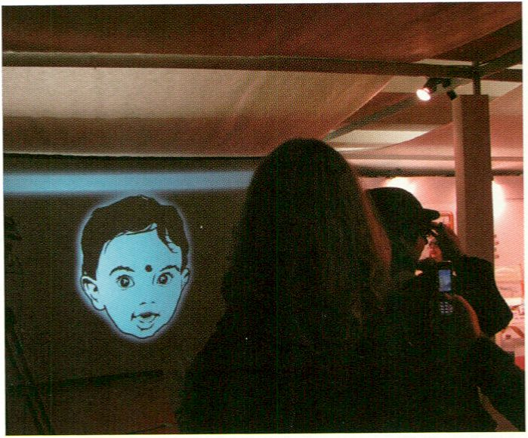Teilnehmer werden gebeten, mit Laptop oder
Smartphone zu kommen - Voraussetzung zur
Teilnahme ist dies jedoch nicht. Die verwen-
deten Tools laufen auf Windows oder OSX, am
besten geeignet sind allerdings Linux-Geräte.
ART: ZOnES
Angel_F at the Digital Cafe
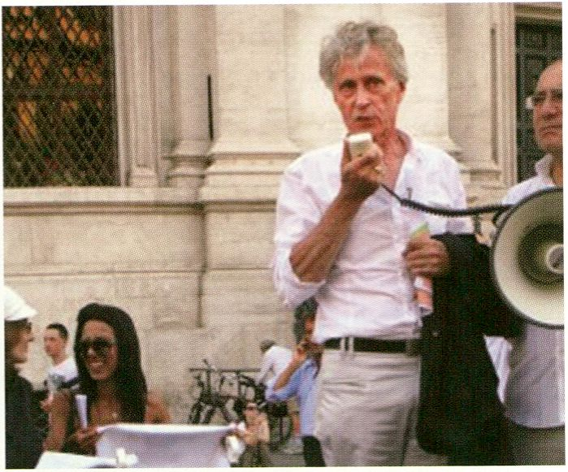
Derrick de Kerckhove demonstates in Piazza Navona

- CoS Workshop 1 (Part 1), p. 76
- CoS Workshop 1 (Part 2), p. 87
- CoS Workshop 2, p. 100
- CoS Workshop 3, p. 117
- CoS Workshop 4, p. 131
- Social ID, p. 86
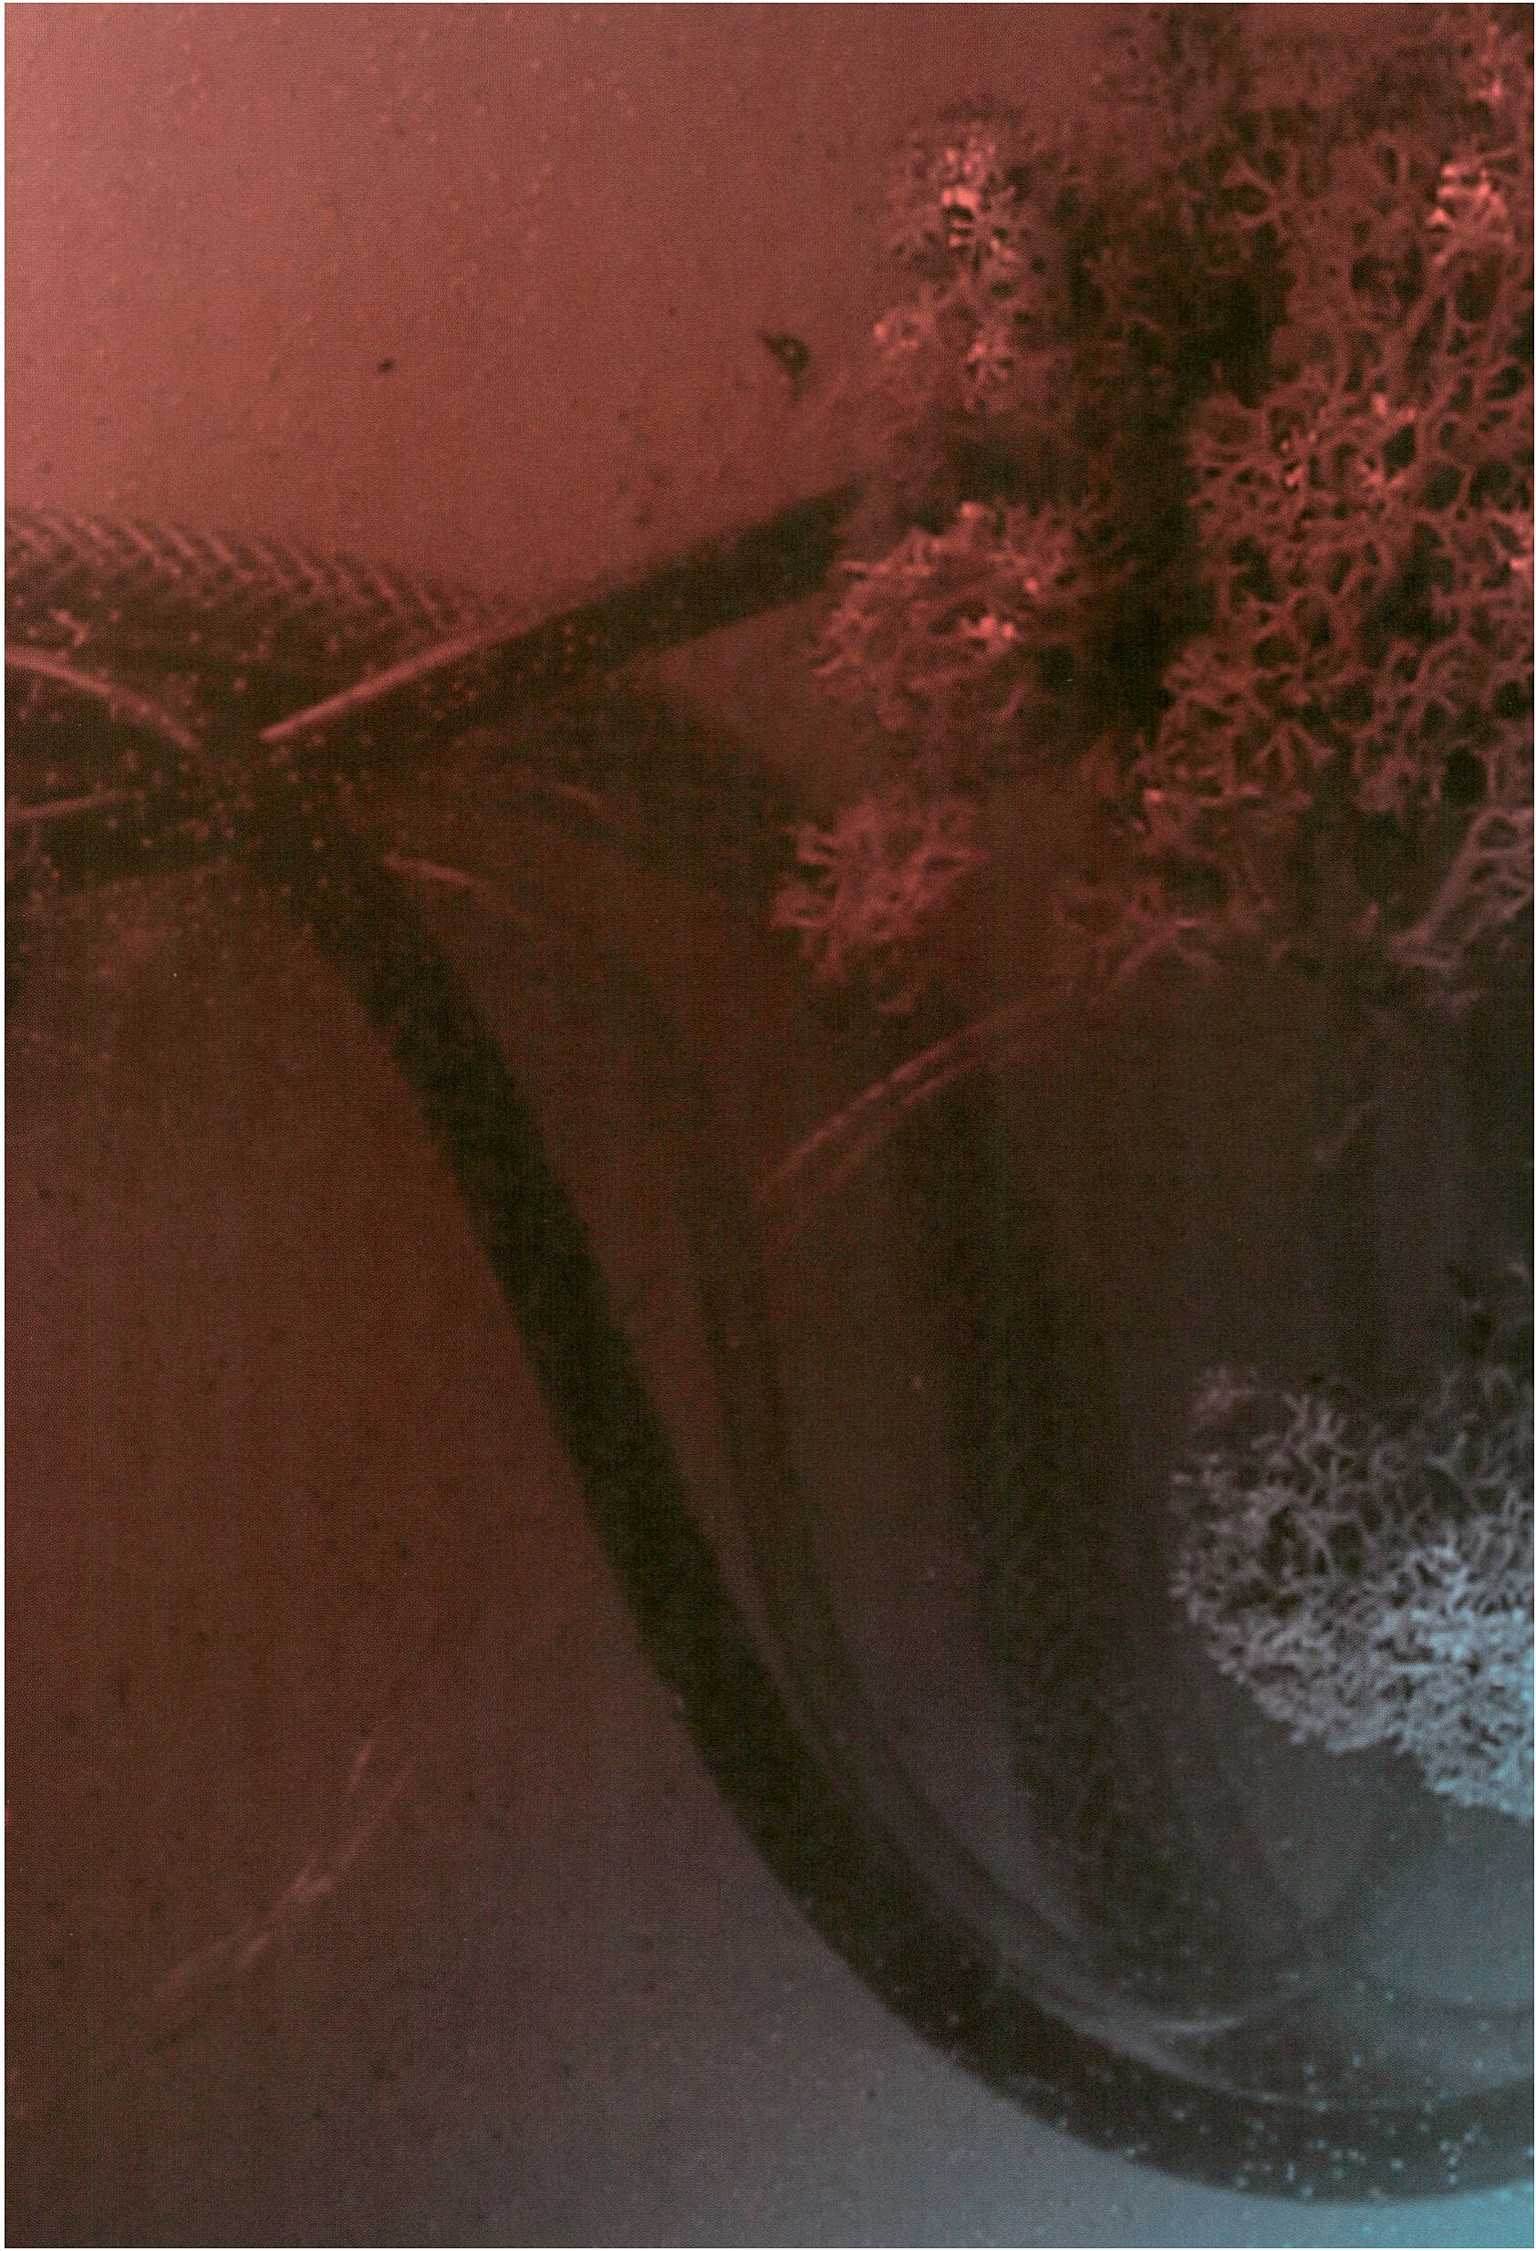

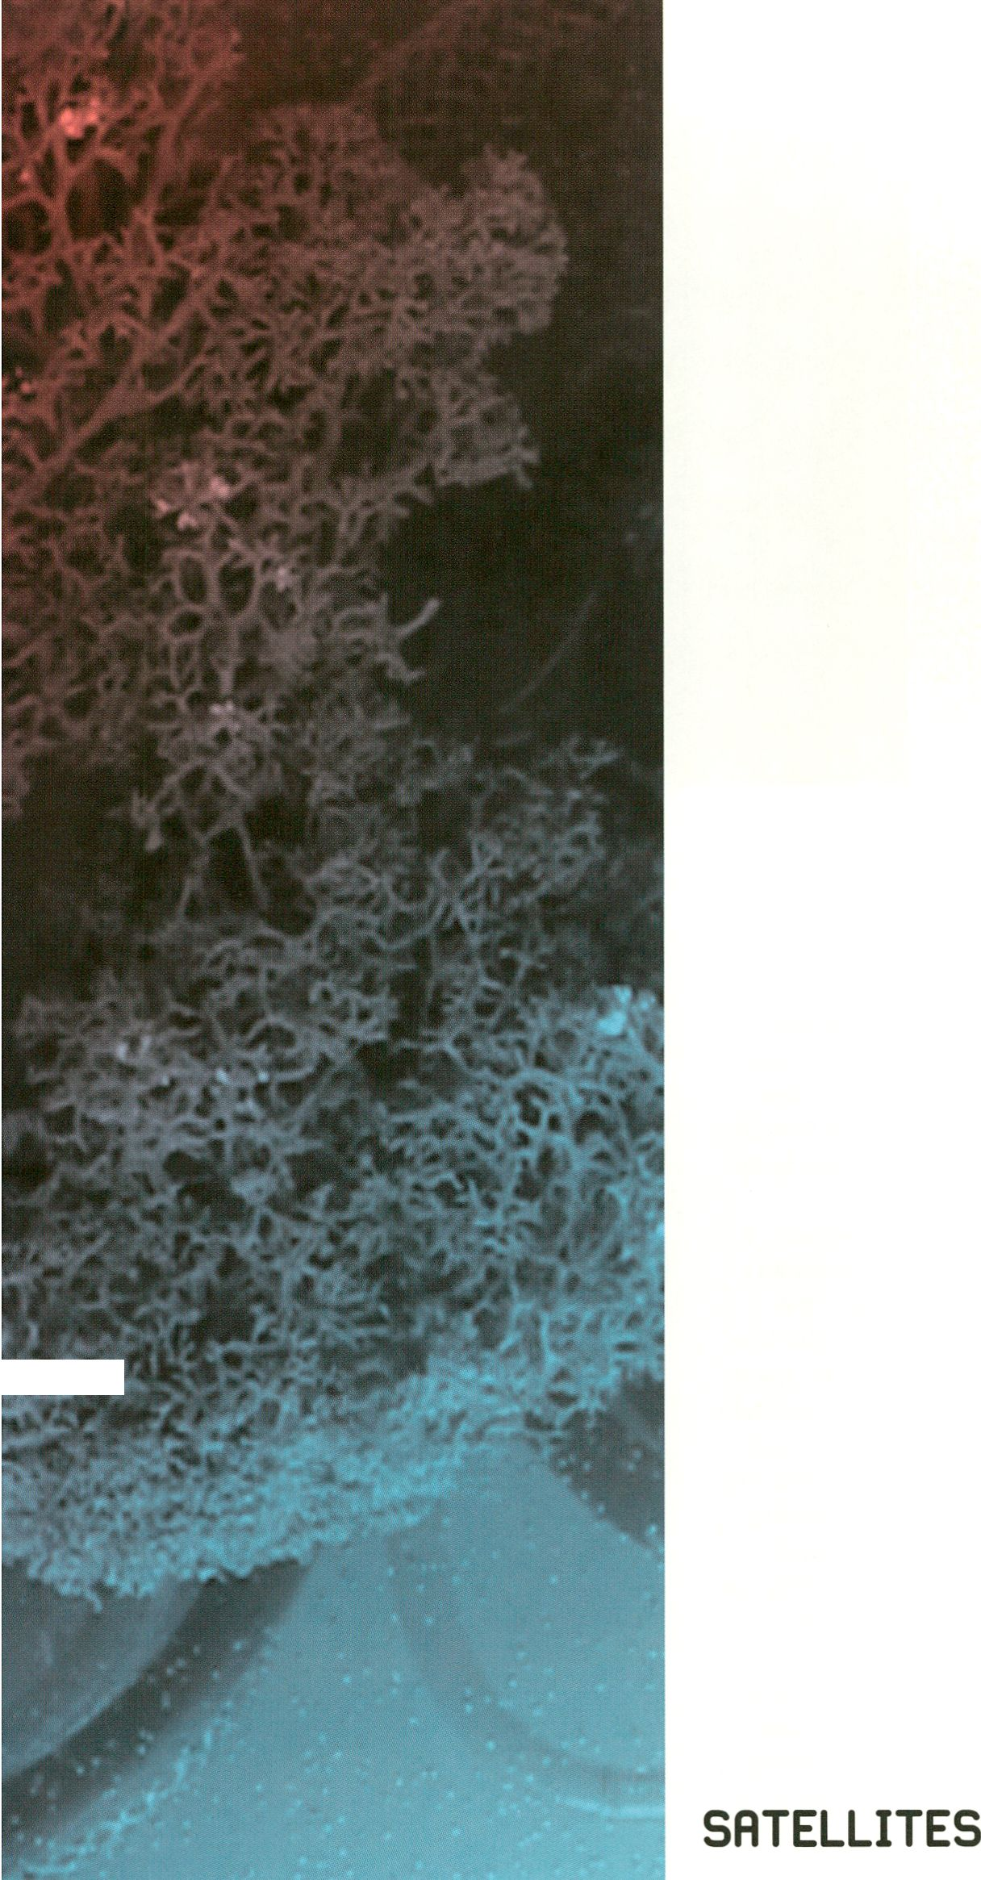
i .*

SATELLITES
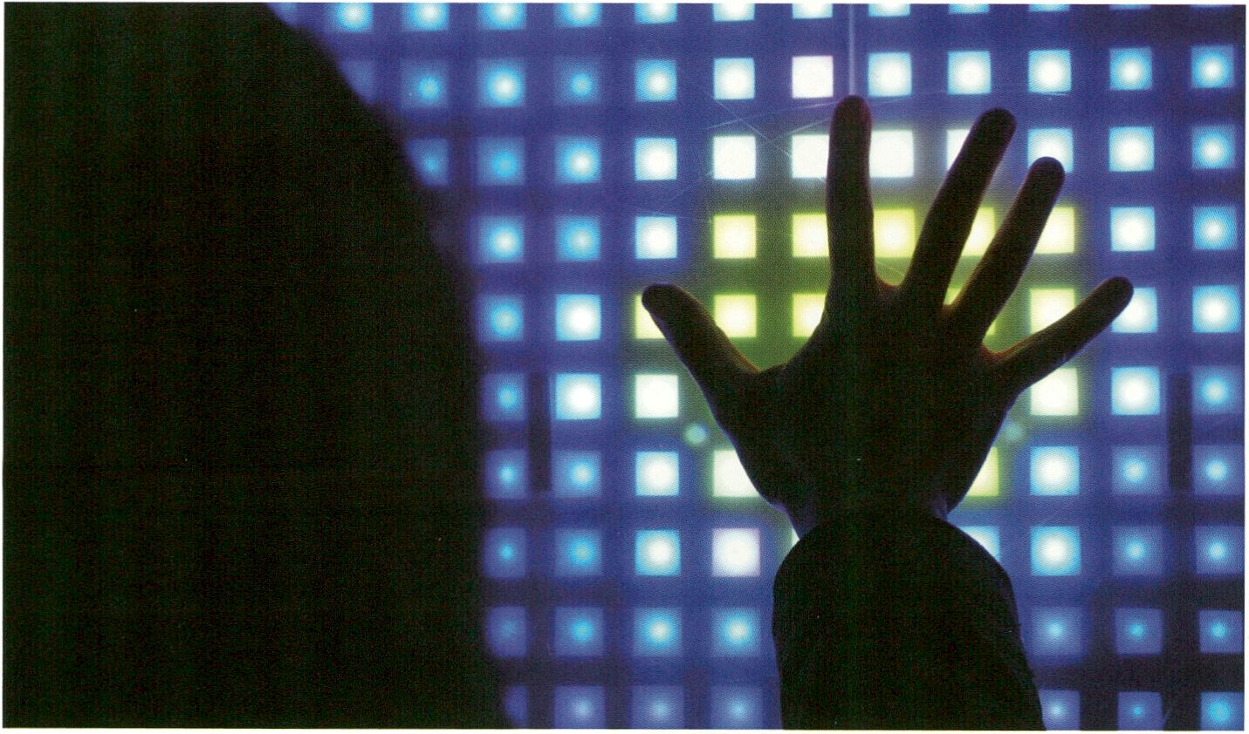
PIXELATE ME by SSMIDD, courtesy of aquabit
tiansmediale.il
SATELLITES

1SE
Sending the RESPONSEiABILITY call-to-
action across Berlin, transmediale.11 presents
and collaborates with a number of partner
organisations, creating a network of Satellites
for showcasing the latest works in the realm
of digital and electronic arts.
Together with more established venues
such as [DAMjBerlin, c-base, Kiinstlerhaus
Bethanien, Sophiensaele and NGBK, the
Satellites programme also brings to the fore
exciting new platforms and spaces for media
art. These include Schering Stiftung, Instituto
Cervantes, Art Claims Impulse, MMX Open
Art Venue, ConcentArt, Substitut, NK Projekt,
Medienwerkstatt Berlin, systM, aquabitArt,
STYX Projects, Studio 70 and The Future
Gallery. The project themes presented by our
2011 Satellites partners range from open
culture systems, community technology,
social codes and conventions within digital
media, to changing parameters in the virtual
and material environment and shifts between
private and public spheres.
For transmediale.11 major works will be pre-
sented by two of our primary event partners,
Collegium Hungaricum Berlin (.CHB) with
EXTENDED ATMOSPHERES, a sonic discours
and deep listening space by György Ligeti,
Jan-Peter E.R. Sonntag & Edwin van der
Heide, and the Marshall McLuhan Salon of the
Embassy of Canada with OPEN Signs, curated
by Heather Kelley. The transmediale Marshall
McLuhan Lecture 2011 will be given by Mark
Surman, Executive Director of the Mozilla
Foundation and one of the world’s leading
proponents for collaborative technologies and
the Open Net. The _Vilem_Flusser_Archiv at
the Berlin Universität der Künste also presents
a series of discussions on the philosophy of
Flusser in relation to transmediale.H’s
RESPONSEiABILITY theme.
Please refer to transmediale.de for entry costs
to Satellite venues.
SATELLITES
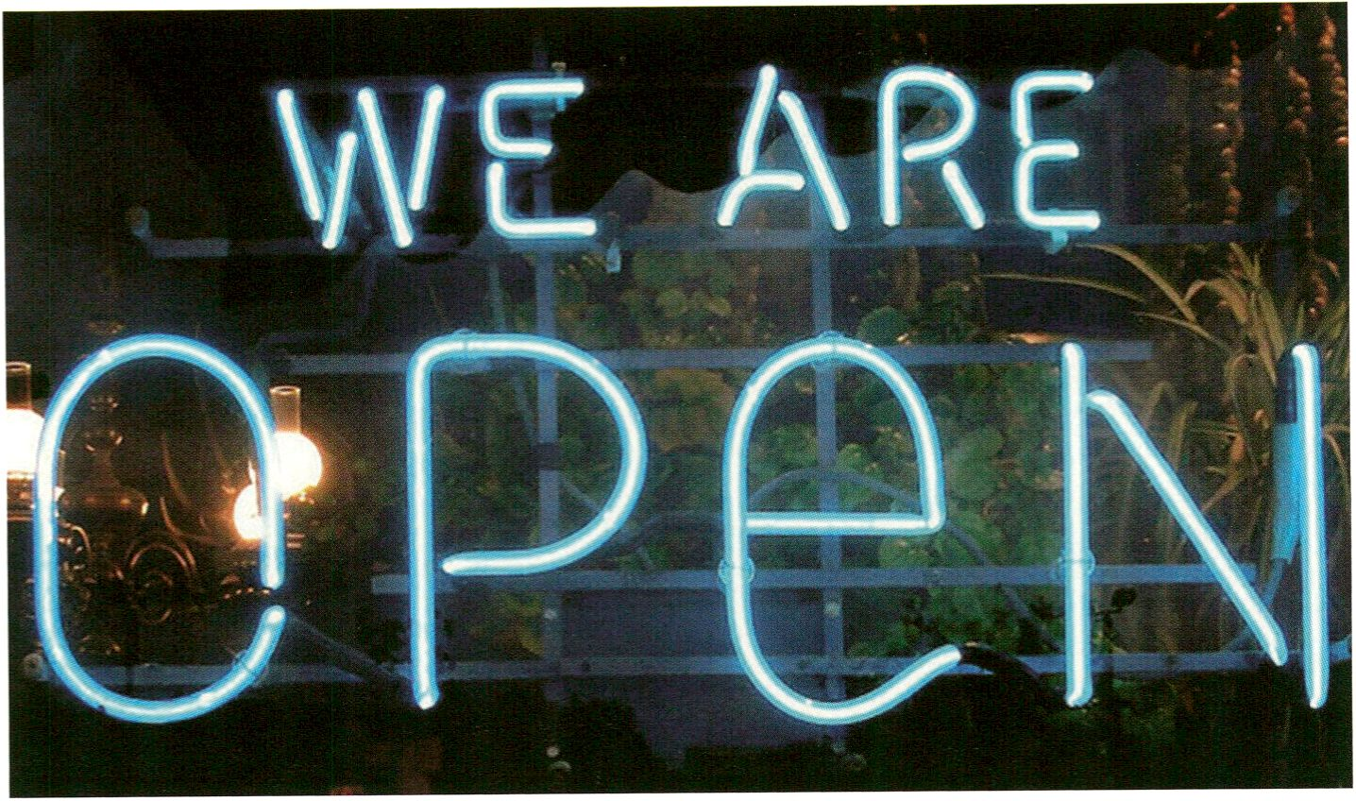
OPEN Signs exhibition curated by Heather Kelley. Photo: Tom Magliery
tiansmediale.il
SATELLITES
In Zusammenarbeit mit einer Reihe von Part-
nerorganisationen schickt die transmediale.11
ihren Aufruf RESPONSE:ABILITY durch die
ganze Stadt: Parallel zum Festival präsentiert
ein Netzwerk aus Satellites das Neuste aus
den Bereichen der digitalen und elektronischen
Künste. Neben etablierten Orten wie [DAM]
Berlin, c-base, dem Künstlerhaus Bethanien,
den Sophiensaelen oder NGBK nehmen auch
eine Reihe spannender neuerer Plattformen und
Räume für Medienkunst am Satellite-Programm
Teil. Mit dabei also dieses Jahr auch die
Schering Stiftung, das Institute Cervantes, Art
Claims Impulse, MMX Open Art Venue,
ConcentArt, Substitut, NK Projekt, Medienwerk-
statt Berlin, systM, aquabitArt, STYX Projects,
Studio 70 und The Future Gallery. Die Themen,
die unsere Satellites 2011 in ihren Programmen
aufgreifen, reichen von Open Culture-Systemen,
Community-Technologien oder sozialen Codes
und Konventionen innerhalb digitaler Medien
hin zu den sich im Hinblick auf virtuelle und
materielle Umwelten, bzw. auf Privates und
Öffentliches verändernden Parametern.
Im Rahmen der transmediale.11 stellen zwei
unserer wichtigsten Veranstaltungspartner
Kunstwerke in besonders engem Verbund mit
der transmediale aus: Im Collegium Hungari-
cum (.CHB) kann man die Klanginstallation
EXTENDED ATMOSPHERES, a sonic discours
and deep listening space von György Ligeti,
Jan-Peter E.R. Sonntag & Edwin van der Heide
besuchen und im Marshall McLuhan Salon der
Kanadischen Botschaft die Ausstellung OPEN
Signs kuratiert von Heather Kelley. Die
transmediale Marshall McLuhan Lecture 2011
hält Mark Surman, Geschäftsführer der Mozilla
Foundation und einer der stärksten Verfechter
des Open Web und kollaborativer Technologien.
Auch das _Vllem_Flusser_Archiv an der Berliner
Universität der Künste veranstaltet eine Dis-
kussionsreihe zur Philosophie Flussers und
RESPONSE:ABILITY, dem Thema der transme-
diale.11.
Informationen zu Eintrittspreisen der Satellites
unter transmediale.de
iïlaishall TTlcLuhan Salon of the Embassy of Canada

SATELLITES
The McLuhan Salon features a unique
collection of audio-visual material on the
Canadian media theorist Marshall McLuhan,
and has been a transmediale partner
presenting distinguished projects since 2007.
This year it presents OPEN Signs, an exhi-
bition curated by Heather Kelley, and the
transmediale Marshall McLuhan Lecture 2011
featuring Mark Surman.
transmediale Marshall McLuhan Lecture 2011
featuring Mark Surman
2 February, 18:30 | Doors open 18:00
Botschaft von Kanada, Leipziger Platz 17, 10117
The transmediale Marshall McLuhan Lecture
highlights a unique Canadian cultural figure
whose work and vision broadens Marshall
McLuhan's timeless perspective of media and
technology into contemporary culture and
society.
Der Marshall McLuhan Salon umfasst eine be-
deutende Sammlung von audiovisuellem
Material über den kanadischen Medientheore-
tiker Marshall McLuhan und ist Partner der
transmediale seit 2007. Dieses Jahr präsentiert
der Salon OPEN Signs, eine Ausstellung
kuratiert von Heather Kelley, sowie die
transmediale Marshall McLuhan Lecture 2011
mit einem Vortrag von Mark Surman.
Berlin
Mit der transmediale Marshall McLuhan Lecture
lädt die transmediale Persönlichkeiten der
kanadischen Kulturszene ein, die - wie
McLuhans zeitlose Medientheorie - zeitgenös-
sische Kultur und Gesellschaft mit anderen
Bereichen verknüpfen.

- 6 February 2011
OPEN Signs: Exhibition on Open Art and Technologies
Vernissage: 2 February 2011, 20:00 - 22:00 (following the transmediale Marshall McLuhan Lecture)
With artworks by Mouna Andraos and Melissa Mongiat, Brandon Ballengée, Ben Bogart,
Alexandre Castonguay, Brett Gaylor, and Metanet (Mare Sheppard & Raigan Burns)
Curated by Heather Kelley

In parallel with the rise of open-source soft-
ware, electronics, licensing and distribution
philosophies, artists have pioneered the
notion of open culture systems to create
works that take free access as both strategy
and ethic. OPEN Signs reflects the diversity of
open development and distribution strategies
among Canada-based media art and culture
projects, inclusive of robotics, internet,
electronics, biological research, games and
video work.
Parallel zu dem Aufschwung von Open Source
Software, Elektronik, Lizensierung und Distri-
butionsphilosophien bahnen sich Künstler den
Weg in Open Source-Systeme um Werke zu
kreieren, die sowohl strategisch als auch ethisch
freien Zugang beanspruchen. OPEN Signs
reflektiert die Vielfalt von offenen Entwicklungs-
und Verteilungsstrategien entlang des kanadi-
schen Medienkunst- und Kulturprojekts, was
auch Roboter, Internet, elektronische und bio-
logische Forschung, Spiele und Videoarbeiten
beinhaltet.

The exhibition OPEN Signs is presented as a collaboration between transmediaie.11 and the Embassy of Canada.
Supported by the Canada Council for the Arts and the Embassy of Canada, Berlin
Marshall McLuhan Salon, Botschaft von Kanada, Ebertstr. 14,10117 Berlin, mcluhan-salon.de
Opening times: 10:00 -18:00 Mon - Frl, 14:00 - 18:00 Sat & Sun
- Ludic Interfaces, p. 43
- Controlled Invasion Workshop, p. 98
- transmediale Marshall McLuhan Lecture 2011, p. 158
1SB
_Uilem_Flusser_flichiu

Flusserian Philosophical Fridays
With: Claudia Becker, Baruch Gottlieb, Rodrigo Novaes, Siegfried Zielinski
28 January, 13:00: Discussing the text Into the Universe of Technical Images
4 February, 13:00: Discussing the text Writing: Does It have a Future?
Archive open from 12:30
SATELLITES
1 February, 14:30-17:30
The Vilem Flusser Archiv keeps the work
of philosopher and cultural theorist Vilem
Flusser (1920-1991). As the Intersection of the
international Flusser research the archive
extends its collection by supporting artistic
and scientific projects, which are related to
Flusser. With several projects like the Vilem
Flusser Theory Award and the International
Flusser Lectures the archive keeps his ideas
alive.
Every second Friday, the artists and scientists
in residence at the _VMem_Flusser_Archiv get
together to read, study and discuss the
thought and work of Vilem Flusser. On the
special occasion of transmediale.11, their
discussion series will take place weekly and
will be open to anybody who would like to
participate in the discussions. They will read
selections from Flusser’s newly translated
books: Into the Universe of Technical Images
and Writing: Does It have a Future? which will
soon be published by the University of
Minnesota Press.
Das _Vilem_Flusser_Archiv bewahrt und pflegt
das Werk des Philosophen und Kulturtheoreti-
kers Vilem Flusser (1920-1991). Als Knoten-
punkt der Internationalen Flusser-Forschung
erweitert das Archiv durch die Unterstützung
von künstlerischen und wissenschaftlichen
Arbeiten, die sich mit seinem Werk auseinander
setzen, stetig seine Sammlung. Es hält sein
Denken durch verschiedene Projekte wie den
Vilem Flusser Theory Award oder die Internatio-
nal Flusser Lectures präsent.
Jeden zweiten Freitag im Monat treffen sich
die Gastkünstler und Gastwissenschaftler des
_Vilem_Flusser_Archlv, um das Denken und
Werk Vilem Flussers zu studieren und zu disku-
tieren. Für die transmediale 2011 wird diese
Diskussionsrunde sich wöchentlich treffen und
offen sein für jeden, der den Diskussionen
folgen und an Ihnen teilnehmen möchte.
Gelesen werden Kapitel aus den gerade erst ins
Englische übersetzten Büchern Ins Universum
der technischen Bilder und Die Schrift: Hat
Schreiben Zukunft?, die im April bei University
of Minnesota Press erscheinen werden.
This event will be held in English / Die Veranstaltungen finden auf Englisch statt
_Vilem_Flusser_Archiv, Universität der Künste Berlin, Grunewaldstr. 2-5,10823 Berlin, flusser-archive.org
- Flusser Hypertext, p. 151
- Flusser vs. McLuhan screening, p. 112
Collegium Hunparicum Berlin (.CHB)

SATELLITES
30 January - 6 February 2011
EXTENDED ATMOSPHERES : a sonic discours / a deep listening space
by György Ligeti (hu), Jan-Peter E.R. Sonntag (de), Edwin van der Heide (nl)
Vernissage: 29 January, 17:00 - 24:00
Performances: 30 January - 6 February, 17:00 - 21:00
The Collegium Hungaricum Berlin was
established in 1924 and re-opened its doors
on historical grounds in Berlin-Mitte,
Dorotheenstraße 12, in November 2007. The
new institute was designed in the style of
Neobauhaus and demands for contemporary
contents and forms of expression. Over the
course of the past two years the .CHB has
emerged as an excellent centre for art and
media within the cultural landscape of Berlin-
Mitte. Since 2008 Collegium Hungaricum
Berlin has been hosting projects on the inter-
section of art, science and research in close
conjunction with transmediale.
At transmediale.11, .CHB is delighted to
present one sound and one video installation
with descriptions below.
Das bereits seit 1924 existierende Collegium
Hungaricum Berlin öffnete seine Tore auf histo-
rischem Boden in der Dorotheenstraße 12 in
Berlin-Mitte im November 2007 neu. Das im
Neobauhausstil errichtete neue Institut ver-
langte nach neuen zeitgenössischen Inhalten
und Ausdrucksformen. In den vergangenen
zwei Jahren entwickelte sich das .CHB in der
Kulturlandschaft von Berlin-Mitte zu einem
Zentrum für Kunst und Medien mit hervorragen-
den multimedialen Voraussetzungen. Das
Collegium Hungaricum Berlin arbeitet seit 2008
eng mit der transmediale auf wissenschaftlich-
künstlerischer Ebene zusammen. Zur dies-
jährigen transmediale präsentiert das .CHB eine
Klang- und eine Videoinstallation, deren
Beschreibungen sich im Anschluss befinden.

Edwin van der Heide and Jan-Peter E.R.
Sonntag ‘re-stage’ and compositionally and
spatially open up the piece Atmosphères.
Gyôrgy Ligeti wrote the piece in 1961 and in
the same year it was premiered by the SWF
Orchestra in Donaueschingen. Atmosphères is
a radical response to serialism. In 1968,
Stanley Kubrick used a recording of the piece
as a sample ‘atmosphere’ in shooting his film
2001: A Space Odyssey, commissioned it for
the score, and over night Atmosphères
became famous as film music. In 2011, ten
years after the virtual odyssey and fifty years
after the film’s premiere, van der Heide and
Sonntag enter into a sonic discourse with
Ligeti’s futuristic audio icon.
Edwin van der Heide und Jan-Peter E.R.
Sonntag „re-stage“ Atmosphères und öffnen
das Stück kompositorisch und räumlich. 1961
schreibt György Ligeti diese Komposition, noch
im gleichen Jahr wird das Stück in Donaue-
schingen vom Orchester des SWF uraufgeführt.
Atmosphères ist eine radikale Antwort auf die
serielle Musik. 1968 setzt Stanley Kubrick eine
Aufnahme des Stücks als Proben-„Atmo“ bei
seinen Dreharbeiten von A Space Odyssey 2001
ein, sagt die von ihm in Auftrag gegebene
Filmmusik ab und über Nacht wird Atmos-
phères als Filmmusik bekannt. 2011,10 Jahre
nach der virtuellen Odyssee und 50 Jahre nach
der Uraufführung, begeben sich van der Heide
und Sonntag in einen akustischen Diskurs mit
Ligetis klanglicher Zukunftsikone.

Each performance (30min) will begin on the half hour and entry is only permitted at the end of each loop.
Please note maximum 18 person capacity for each performance and entry will be granted on a first-come, first-served basis.
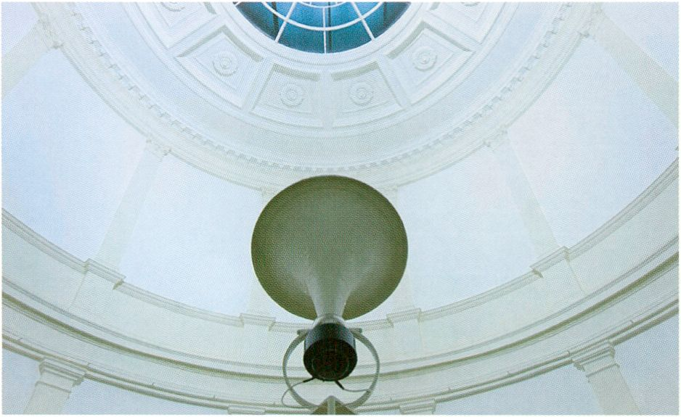
Kugelwellenhorn by Jan-Peter E.R. Sonntag, Museum für Kunst und Gewerbe, Hamburg 2010, © Jan-Peter E.R. Sonntag

SATELLITES
Open Web Book Sprint
The 2011 Open Web Book Sprint, the follow-
up to the 2010 Collaborative Futures Book
Sprint, will take place at .CHB in the lead up
to transmediale.11. The sprint will be run by
Adam Hyde from Booki and the book is
intended to define the contours of the Open
Web and why it is essential for guaranteeing
our own cultural expression and freedoms.
The final book is available at transmediale.11
Look out for it!
- Booki, p. 60
- Booki Mobile and workshop, p. 100
Der Open Web Book Sprint, Nachfolge-
Projekt des Collaborative Futures Book Sprint
der transmediale.10, findet im Vorfeld der
transmediale.11 am .CHB statt. Den Sprint leitet
Adam Hyde von Booki-, das Buch soll die
Konturen des Open Web herausarbeiten und
dessen unumstößliche Bedeutung als Garantie
unserer kulturellen Ausdrucksfreiheit deutlich
machen. Das Buch ist auf dertransmediale.11
erhältlich.

timescape: Construction Works as Art / die Bausstelle als Kunstobjekt

For the period of transmediale, timescape will
be integrating multimedia content from
transmediale.11 into the exhibition framework.
More information on screening times and
specific content will be available at
transmediale.de. timescape is a long term
multimedia art project by the projection artists
David Szauder (Pixelnoizz) and Lucy Benson
joined by the sound artist Servando Barreiro,
initialised by .CHB in cooperation with
ArtProjekt Berlin.
.CHB, Dorotheenstralîe 12,10117 Berlin, hungaricum.de
Opening times during transmediale.11:17:00 - 21:00
Während der transmediale wird timescape
multimediale Inhalte der transmediale.11 und
des CTM.11 aufgreifen und in die Strukturen
des Werks integrieren. Details zu Inhalten und
Projektionszeiten sind auf transmediale.de
abrufbar. timescape ist eine multimediale Lang-
zeitinstallation der Projektionskünstler Dävid
Szauder (Pixelnoizz) und Lucy Benson und des
Klangkünstlers Servando Barreiro, initiiert durch
das .CHB in Kooperation mit ArtProjekt Berlin.
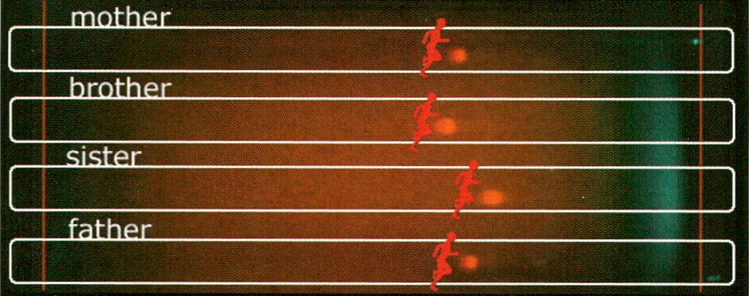this test has been runnning for 18 hours and 21 minutes
the sister is in the lead
t
start
t
finish
Latent Figure Protocol by Paul Vanouse
Schering Stiftung
SATELLITES
28 January - 26 March 2011
Fingerprints... - Biomedia Art by Paul Vanouse (us)
Vernissage: 27 January, 19:00
The exhibition Fingerprints... by Paul Vanouse, curated by Jens Hauser, is
a continuation of the Ernst Schering Foundation’s effort to promote the public
discussion about the role of images in art and science. The biotechnological
installations of the American artist Paul Vanouse question the notion of the
scientific image itself, as well as the methods behind (natural) scientific
findings in general. This show is Vanouse’s first monographic exhibition in
Germany. It will be echoed by the transmediale conference supported by the
Ernst Schering Foundation, where the artist and the curator as well as
internationally renowned scientists will expand upon the epistemological
issues raised by the exhibition.
Mit der von Jens Hauser kuratierten Ausstellung Fingerprints... mit Werken von
Paul Vanouse setzt die Schering Stiftung ihr Engagement für einen öffentlichen
Dialog über das Bild in Kunst und Wissenschaft fort. Der US-amerikanische
Künstler Paul Vanouse stellt mit seinen biotechnologischen Installationen nicht
nur das wissenschaftliche Bild in Frage, sondern auch die Methoden (natur-)
wissenschaftlicher Erkenntnis. Parallel zur ersten umfassenden Präsentation von
Paul Vanouses Werk in Deutschland findet in Kooperation mit der transmediale
eine Konferenz statt, zu der neben dem Künstler und Kurator auch internationale
Wissenschaftler eingeladen sind, um die von Vanouse aufgeworfenen Fragen zu
vertiefen.
Schering Stiftung Berlin, Unter den Linden 32-34,10117 Berlin, scheringstiftung.de
Opening times: Mon - Sat, 11:00 — 18:00
- Fingerprints? focus discussion, p. 102
- Latent Figure Protocol, p. 140
lEa
c-base e.U.
- January - 5 February 2011
TRACE:ABILITY: Events, lectures, exhibition & installation
- January - 5 Feburary 2011 : SPACEgarage exhibition
31 January - 3 Feburary 2011 : lumiBots media art installation
Vernissage: 28 January 2011, 20:30
Curated by Gregor Sedlag, production by Sven Wagner
Underneath Berlin-Mitte, the relics of a space station from the future were dis-
covered in 1995. Upon this revelation a group of researchers, activists, artists
and enthusiasts founded the association known as c-base. Their aim is to find
new TRACES to enable the further examination and possible reconstruction of
this presumably most unique cultural heritage of the future of humankind.
Unterhalb von Berlin-Mitte wurden 1995 die Überreste einer aus der Zukunft
stammenden Raumstation entdeckt. Mit dem c-base e.V. gründete sich eine
Gemeinschaft von Forschern, Aktivisten, Künstlern und Enthusiasten, um die
weitere Erforschung und mögliche Rekonstruktion des vermutlich bedeutendsten
Kulturerbes der zukünftigen Menschheit voranzutreiben.
SATELLITES
January 28
20:30 Starting event, YUG transmediale.11 Video Traces, Videoamt (jocognito)
January 29
19:00 Vernissage & Screening, SPACEgarage_first event_LIFT OFF - video documentary & selected works (portbunny,
Anna Gatjal, Doris Hansen), Projektraum SPACEgarage Anna Gatjal, Neven Dolos und Doris Hansen
20:30 Screening, SPACEgarage_first event_L!FT OFF - video documentary
January 31
20:30 dorkbot.bin - Doing Strange Things with Electricity feat. lumiBots, BookScanner, Blinkendroid, c-base robolab
23:00 Vernissage, Media Art Installation lumiBots, Mey Lean Kronemann
February 1
20:30 Unfolding, John Kameel Farah: piano, laptop, synthesizers
Canadian virtuoso composer-pianist John Kameel Farah performs a hybrid of a space-age piano concerto, free jazz,
experimental Drum&Bass and Arabic music.
February 2
19:30 Hackspace by Freifunk Berlin, Berlin Android Stammtisch, Ubuntu Stammtisch & talks, E-Bikes Berlin
February 3
20:30 DISMALWARE - "Toxics! Surveillance! Exploitation! Oh my!"
An antivirus toolkit for your liberal Western brain: Delete, skip or quarantine? A deep scan by monochrom and
Telekommunisten.
23:00 Finissage, Media Art Installation lumiBots, Mey Lean Kronemann
February 4
17:00 Mobile Fridae, MeeGo & Beyond Development Meeting; Roboter bauen Workshop, c-base robolab
20:30 Blogrebellen: Hörbar feat. #Tassebier
DJs: Saetchmo (Blogrebellen & #Tassebier Resident, Style: Reggae, Dub & Dubstep), Walter Marinelli (Blogrebellen &
#Tassebier Resident, Style: Ragga & Cosmic Disco); live: Das Kraftfuttermischwerk (Ambient, Dub, Dubtechno);
Visuals: fALk
February 5
19:00 Finissage, SPACEgarage_first event_LIFT OFF - video documentary and selected works (portbunny, Anna Gatjal,
Doris Hansen), Projektraum SPACEgarage Anna Gatjal, Neven Dolos and Doris Hansen
For information on the full programme visit c-base.org.
c-base e.V., Rungestr. 20,10179 Berlin, c-base.org
Opening times: Daily 19:00 - late
R TT1RZE. at systlD
- 5 February, 2011
A MAZE. United
Vernissage: 2 February, 18:00
Finissage: 5 February, 18:00
With: Born Digital, Prokop Bartonicek, Space of Play
Curated by Thorsten S. Wiedemann

SATELLITES
By combining courage for experimentation
and joy in gaming, A MAZE, celebrates the
convergence of computer games and art. The
four-day event A MAZE. United taking place
at systM gallery, a well-known venue with a
regular changing and interdisciplinary arts
programme, shows an intimate selection of
works, which are part of the future
playground. In cooperation with Born Digital,
an electronic art collective from Utrecht and
Ludic Interfaces, a future European Masters
programme, it will bring you closer to the
magic of video mapping, audio visualisation
and playful interaction.
systM, TorstraGe 68,10119 Berlin, amaze-festival.de, systm-berlin.de
Opening times: Venue 18:00 - 22:00, Bar 18:00 - 02:00
- Ludic Interfaces, p. 43
- Controlled Invasion, p. 98
- Ludic Salon, p. 125
STYX Piojects
29 January - 16 February 2011
As Long As You Stay With Me You Are Safe
Vernissage: 28 January, 19:00 - 22:00
With: Benjamin Laurent Aman
In his first Berlin solo show French sound and
visual artist Benjamin Laurent Aman will
explore the borders that divide the exhibition
space from its surroundings, questioning and
playfully distorting both it's architectural and
situational parameters.
Mit Mut zum Experiment und Freude am Spiel
will A MAZE. die Konvergenz von Computer-
spiel und Kunst feiern. Das viertägige Event
A MAZE. United in der Galerie systM zeigt eine
Auswahl an Werken, die Teil des Spielplatzes
der Zukunft sind. In Kooperation mit dem
Medienkunstkollektiv Born Digital aus Utrecht
und dem zukünftigen europäischen Masterstu-
diengang Ludic Interfaces wird die Magie von
Video Mapping, Audiovisualisierung und
spielerischer Interaktion präsentiert. Die Galerie
systM ist ein bekannter Ausstellungsort mit
regelmäßig wechselndem, interdisziplinärem
Programm.
In seiner ersten Berliner Einzelausstellung lotet
der französische Künstler und Musiker
Benjamin Laurent Aman die Grenzen zwischen
Ausstellungsfläche und Umgebung aus, indem
er deren architektonische und situative
Bedingungen hinterfragt und spielerisch
verfälscht.

STYX Projects Berlin, The Old Brewery (2nd floor left), Landsberger Allee 54,10249 Berlin, styx-projects.com
Opening times: Fri - Sun, 15:00 -17:00, or by appointment
Galerie [Dfliïl] Berlin
29 January - 23 March 2011
BEING POLITICAL IS SUCH A HUGE TREND™
Featuring Somali pirate-fashion project WOPPOW
and real-life digital oil painting project DEEPHORIZON
Works by UBERMORGEN.COM
Vernissage: 28 January, 19:00 - 21:00
The artists will be present at the preview /
Die Künstler werden zur Eröffnung anwesend sein
The temporary WOPPOW flagship store presents fashion in the age of
predatory capitalism, global aggression and the indifference of the profiteers.
With bright shining colours and bullet holes as his trademarks, WOPPOW’s
couture eradicates the pseudo-violence and superficial use of military style in
contemporary fashion. The exhibition also features DEEPHORIZON, a time-
critical project proclaiming the revival of painting. DEEPHORIZON consists of
aerial images from the BP oil spill which the artists transformed from digital
files into abstract images. Adapting the aesthetic tradition of oil painting, the
pieces are printed on canvases.
SATELLITES
[DAMjBerlin Galerie is part of an overall concept of imparting art that is ex-
clusively dedicated to the influence of the computer and the digital in art and
society. They are especially interested in the contextual examination of this
medium and/or new artistic forms. Further components of the [DAM] project
are the online-museum dam.org and the d.velop digital art award [ddaa]
ddaaonline.org.
Der temporäre WOPPOW Flagshipstore präsentiert Couture - Mode im Zeitalter
des Raubtierkapitalismus, der globalen Aggression und der Gleichgültigkeit der
Gewinner. Mit strahlend fröhlichen Farben und Einschusslöchern als Markenzei-
chen machen WOPPOW’s Modelle die Aura von Pseudegewalt und oberflächliche
Verwendung des Militärstils in der zeitgenössischen Mode zunichte. Das zweite,
ebenfalls zeitkritische Projekt der Soloshow ist DEEPHORIZON, welches das
Revival der Ölmalerei proklamiert. DEEPHORIZON besteht aus Luftaufnahmen
des Ölteppichs, die die Künstler zu abstrakten Bilder umgewandelt und im Sinne
traditioneller Ölmalerei auf Leinwand ausgedruckt haben.
Die Galerie [DAM]Berlln ist ein Teil eines Konzeptes der Kunstvermittlung, das
sich ausschließlich dem Einfluss des Computers und des Digitalen auf Kunst und
Gesellschaft widmet. Sie präsentiert zeitgenössische, junge Positionen und
bedeutende Pioniere. Weitere Aktivitäten der [DAM] Projekte sind das Online-
Museum dam.org, und der [ddaa], ein Preis für ein Lebenswerk eines Künstlers
ddaaonline.org.
Galerie [DAM]Beriin, Tucholskystraße 37,10117 Berlin, dam-berlin.de
Opening times: Tues - Fri, 12:00 - 18:00, Sat 12:00 -16:00
- WOPPOW, p. 142
- WOPPOW workshop, p. 72
dis-piayll at Instituto Ceruantes
29 January - 6 February 2011
dis-play 11 presents Neurospasta
Vernissage: 28 January, 19:00
With: Luis Ortiz (LOD), Irene León, Amanda López, Cristina Ruano, Cynthia Rodriguez,
Carmelo Fernández. Produced by Klitekture / klitekture.com

SATELLITES
On the occasion of this year’s transmediale
the Instituto Cervantes presents dis-play
with Neurospasta, a showcase of advanced
music and related arts from Canary Islands.
In this audio-visual exhibition video artists,
plastic artists, choreographers, musicians and
interior designers contribute with their per-
sonal interpretation of ‘neurospasta’, ancient
Greek for puppets.
Instituto Cervantes Berlin, Rosenstr. 18-19,10178 Berlin, cervantes.de / d
Opening times: 28 January: 19:00 - 21:00, 29 January - 6 Feburary: 12:00
aquabitRit
29 January - 6 February 2011
PIXELATE ME
Vernissage: 28 January, 19:00
With: Benjamin Piltz, Lan Hungh, Juan Arata, St.
Hartenstein. Curated by Irina llieva.
Each exhibition at aquabitArt has its own
theme, developing a unique link between the
venue and the artwork itself. The focus of the
group exhibition PIXELATE ME is to redefine
the meaning of the pixel and examine how
pixels give us information, how they interact
and how the human brain can understand,
reinterpret and assemble this visual informa-
tion. This mechanism is virtually shown by the
installation set-up, where the viewer has the
ability to retrace the development of the single
pixels to the final image.
Zurtransmediale.11 präsentiert das Instituto
Cervantes dis-play mit der Ausstellung Neuro-
pasta. dis-play ist eine Plattform für moderne
Musik und verwandte Künste der Kanarischen
Inseln. In dieser audio-vlsuellen Ausstellung
werden Werke von Videokünstlern, Bildhauern,
Choreographen, Musikern sowie Innenarchitek-
ten gezeigt, die das altgriechische Wort für
Marionette, „neuropasta“, interpretieren.
¡-play.es
19:00, weekdays / 12:00 -16:00, weekends
& St., SSMIDO and Constantin
Die Ausstellungen des Kunstraumes aquabitArt
schaffen durch thematische Fokussierung eine
Verbindung zwischen dem Ausstellungsort und
dem Kunstwerk. Im Mittelpunkt der Ausstellung
PIXELATE ME steht eine Neudefinition der
Bedeutung des Pixels; sie untersucht wie das
menschliche Gehirn die visuelle Information des
Pixels verstehen, umdeuten und zusammenfü-
gen kann. In den gezeigten Installationen wird
die Entwicklung des einzelnen Pixels zum
Gesamtbild veranschaulicht und der Mechanis-
mus dem Betrachter somit zugänglich gemacht.
aquabitArt gallery, Auguststr. 35,10119 Berlin, art.aquabit.com
Opening times during transmediale.11: 28 January - 6 Feburary: 15:00 - 20:00 and by appointment (closed 31 January)
26 January - 5 March 2011
Reflective Interventions 2011
Vernissage: 22 January, 19:00 - 23:00
Artist talk and screening: 29 January, 21:00
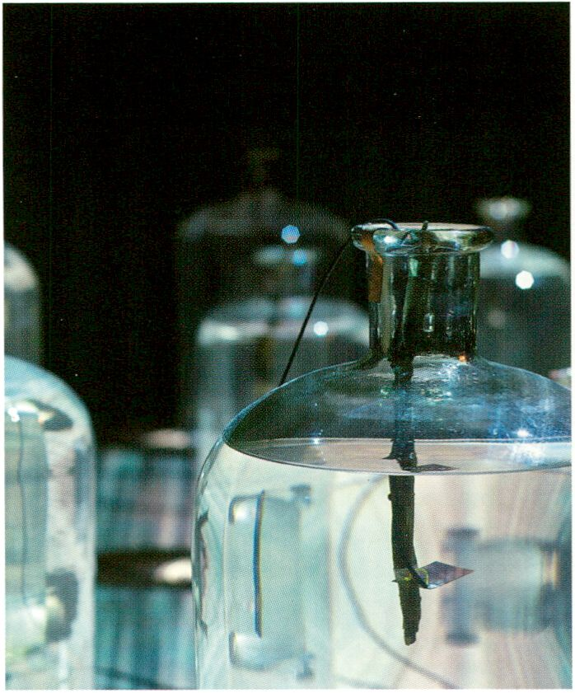
Streichlicht by Matthias Fitz
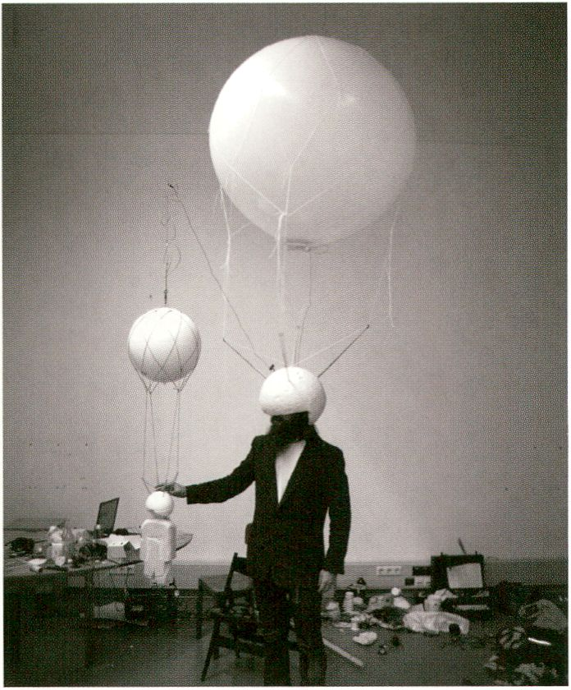
TopShotHelmet by Julius von Bismarck
flit Claims Impulse
SATELLITES
With: Julius von Bismarck, Matthias Fitz, Javier Chozas, Marc Lee,
Mader|Stublic|Wiermann, Francis Gomila, Kirsten Reese & Pepe Jurgens

Art Claims Impulse is a gallery in Berlin spe-
cialised in video art, performance, and new
media installations. Its main interest is in art
with an unusual approach that is innovative
from a thematic, technical and aesthetical
point of view. This year’s exhibition Reflective
Interventions 2011 addresses the issues
related to navigating and finding orientation
within shifting and overlapping virtual and
material environments. Curated by the
gallerists Melanie Zagrean and Pierre Wolter.
Art Claims Impulse ist eine Galerie in Berlin
spezialisiert auf Videokunst, Performance und
New Media Installationen. Ihr Interesse gilt
Kunstwerken, die ungewöhnliche Ansätze ver-
folgen, die thematisch, technisch und ästhe-
tisch innovativ sind. Die diesjährige Ausstellung
Reflective Interventions 2011 widmet sich dem
Thema Navigation und Orientierungsfindung in
sich verschiebenden und sich überlappenden
virtuellen und materiellen Landschaften. Die
Ausstellung kuratieren die Galeristen Melanie
Zagrean und Pierre Wolter.

Supported by the Embassy of Spain
Art Claims Impulse, Lubbener Str. 5,10997 Berlin, art-claims-impulse.com
Opening times: Wed - Sat, 16:00 - 21:00
Künstleihaus Bethanien

SATELLITES
Künstlerhaus Bethanien, Kottbusser Straße 10 (exhibition rooms), Kohlfurter Straße 41-43 (artist studios and office), 10999 Berlin, bethanien.de
Opening times: Tue - Sun, 14:00 - 19:00
21 January - 6 March 2011
Proto Anime Cut
Vernissage: 20 January 2011, 19:00
Proto Anime Cut is an exhibition and film
screening programme that presents for the
first time in Europe protagonists of the
Japanese Anime culture as independent
artists. The Kiinstlerhaus Bethanien is a
think-tank and production platform that
provides international artists a stimulating
work environment and professional pre-
sentation facilities. The venue aims to foster
encounters between artists from various
backgrounds and countries and to encourage
an ongoing dialogue with the public. Curated
by Les Jardins des Pilotes & 2dK.
Concentflib e.U.
Proto Anime Cut ist eine Ausstellung mit be-
gleitendem Filmprogramm, die erstmals in
Europa die Protagonisten der japanischen
Anime-Kultur als eigenständige Künstlerpersön-
lichkeiten vorstellt. Das Künstlerhaus Bethanien
ist Arbeits- und Präsentationsort, internationale
Künstlerplattform und Think Tank. Es dient der
Begegnung und dem Austausch von Künstler-
innen unterschiedlicher Disziplinen und
Nationalitäten sowohl untereinander als auch
mit einem interessierten Publikum. Kuratiert von
Les Jardins des Pilots & 2dK.

28 January - 26 February 2011
Sign & Time
Vernissage: 27 January, 19:00
With: Alexandra Dementieva, Koen Theys, Costantino Ciervo, Don Ritter, Raphaele Shirley,
Jan-Peter E.R. Sonntag, Anna Frants, Georgi Begun. Curated by Georgi Begun.

Cultural and social memory consists of signs
and coding systems. The transformation of
these signs over time and its transfer to
another artificial milieu or medium, creates a
new intercultural environment offering a
possibility for new and diverse interpretations.
In the project Sign & Time, artists analyse the
discrepancy between sign and content within
the structure of existing cultural sign systems.
ConcentArt e.V. is a non-profit art association
with the aim of promoting and realising
specific projects.
Das kulturelle und soziale Gedächtnis besteht
aus Zeichen und Kodierungssystemen. Die
Transformation des Zeichens im Laufe der Zeit
und seine Übertragung in ein anderes künstli-
ches Milieu oder Medium schafft eine neue
interkulturelle Umgebung, welche die Möglich-
keit für vielfältige Interpretationen bietet.
In der Ausstellung Sign & Time setzen sich Me-
dienkünstler in ihren Werken mit der Diskre-
panz zwischen Zeichen und Bedeutung in den
kulturellen Zeichensystemen auseinander.
ConcentArt e.V. ist ein gemeinnütziger
Kunstverein mit dem Ziel konkrete Projekte zu
fördern und zu realisieren.

ConcentArt e.V., Kreuzbergstr. 28,10965 Berlin, concentart.org
Opening times: Wed - Fri, 14:00 - 19:00, Sat, 12:00 -16:00
TTledieniueihstatt Beilin
25 January - 6 February 2011
Liquid State Machine Workshop
Open workshop / laboratory: 25 - 31 January, 12:00 - 18:00
Exhibition Vernissage: 3 February, 19:00 - 21:00
With: Martin Howse, Wolfgang Spahn and others
Liquid State Machine wendet sich an Künstler
und Forscher, die mit chemischen, biologischen
und physischen Systemen arbeiten, um an der
gemeinsam Workshop-Reihe mit anschließen-
der Ausstellung und Performance in der
Medienwerkstatt teilzunehmen. Seit 2008 bietet
die Medienwerkstatt Berlin als Teil der kultu-
rellen Seite des bbk berlin Künstlern Unterstüt-
zung bei der Realisierung von Videoarbeiten,
Medieninstallationen, Performances und
interaktiven Projekten.
Liquid State Machine invites artists and re-
searchers who work with chemical, biological
and physical systems to join a series of
collective workshops forming the exhibition
and performance taking place at
Medienwerkstatt Berlin. Since 2008 the
Medienwerkstatt, part of the cultural side of
the bbk berlin has offered infrastructure
support and know-how towards the
realisation of video works, media installations,
performances and interactive art.
SATELLITES
Medienwerkstatt in der Druckwerkstatt im Kulturwerk des bbk berlin GmbH, Mariannenplatz 2,10997 Berlin, medienwerkstatt-berlin.de
Venue opening times duration event/exhibition: 12:00 -18:00
mïïlX Open flit Uenue
29 January - 19 February 2011
Encore MMXi
Vernissage: 28 January, 18:00 - 22:00 with Ebert Brothers
Finissage: 19 February, 18:00 - 22:00
With: Andy Holtin, Cecily Brennan, Ralph Ammer, Egill Sæbjôrnsson, James Bullough,
Lancelot Coar, Patrick Harrop. Curated by Jonathan Grôger, Rebecca Loyche, Jason Burgess

MMX open art venue is an artist run, non-
profit space that has existed for one year in
Berlin’s commercial gallery street LinienstraBe
in Mitte. MMX Open Art Venue finished its last
show on December 3, 2010 completing the
one-year planned project. Encore will be the
last MMX project in collaboration with
transmediale.11 and the theme RESPONSE:
ABILITY. With several video and media works
the project questions the production of
compelling artworks in an ever-growing global
media saturated society.
MMX Open Art Venue, LinienstraBe 142/143,10115 Berlin, mmx.mx
Opening times: Wed 12:00 - 22:00, Thu - Sun, 12:00 - 19:00
MMX Open Art Venue ist eine von Künstlern
geleitete, gemeinnützige Kunststätte, die seit
nunmehr einem Jahr in Berlins kommerzieller
Galerienstraße, der Linienstraße, zu Hause ist.
Am 3. Dezember 2010 hat MMX seine letzte
Ausstellung zum Abschluss gebracht und somit
sein einjähriges Bestehen beendet. Encore ist
eine einzigartige, dreiwöchige Zusatzausstel-
lung im Rahmen dertransmediale.11. Mit dabei
sind Künstler aus den unterschiedlichsten
Bereichen.
neue Gesellschaft für Bildende Kunst nGBK
22 January - 13 February 2011
Berlin Senate Award 2010 - Selected Artists
Vernissage: 21 January, 19:00
With: Matthias Einhoff, Lars Teichmann, Nezaket Ekici, Karolin Meunier, Heimo Lattner, Ingo
Gerken, Maya Bajevic, Egill Saabjörnsson, Amir Fattal, Johannes Paul Raether, Carsten Fock,
Stephanie Kloss, Thomas Küpper, Ulf Aminde, Swantje Hielscher

SATELLITES
Selected Artists, the Senate Award (Arbeits-
stipendium Bildende Kunst des Landes Berlin)
for Berlin-based artists, is an annual exhibition
presented by RealismusStudio. Since the early
1980s, RealismusStudio of NGBK has been
interested in critical approaches to reality in
art, especially artists who use new media,
video, film and computer-based technology
for their explorations.
Neue Gesellschaft für Bildende Kunst, Oranienstr. 25,10999 Berlin, ngbk.de
Opening times: Thu - Sat, 12:00 - 20:00, Sun - Wed, 12:00 -19:00
Selected Artists ist eine alljährliche Ausstellung
des RealismusStudios, die die Arbeiten der
Künstlerinnen zeigt, die mit dem Arbeitsstipen-
dium Bildende Kunst des Landes Berlin aus-
gezeichnet wurden. Seit den frühen1980ern
interessiert und engagiert sich das Realismus-
Studio der NGBK für eine kritische Auseinan-
dersetzung des Umgangs mit Realität in der
Kunst und insbesondere für Künstler, die mit
Neuen Medien, wie Video, Film und computer-
basierten Technologien arbeiten.

T1K Piojeht
28 January - 27 February 2011
Sound & Memory, Varia zoosystematica profundorum, Rorschach #1
Vernissage: 27 January, 19:00 - 22:00
With: Martti Mela, Libero Mureddu, Otto Korkalol, Generative Art/Computational
Art Class (Alberto de Campo, UdK Berlin), RJ Fischer.

NK is an artist-run independent non-profit
organisation dedicated to Sound Arts. The
interest is in taking part in the creation and
support of a ‘culture’, with a focus on
experimental music. To this end NK organises
public events that promote non-mainstream
cultural production, and provides a platform
for discussing paradigms in music and its
problematics. Their project at transmediale.11
includes three installations experimenting
with acoustic elements.
NK ist eine von Künstlerinnen betriebene Non-
Profit-Organisation, die sich der Sound Art
widmet. Es geht um die Schaffung einer Kultur,
die experimentelle Musik kreiert und fördert.
Deshalb organisiert NK öffentliche Events, die
Kulturproduktion fern ab vom Mainstream prä-
sentieren und eine Plattform schaffen, in der
Paradigmen in der Musik und ihre Problematiken
diskutiert werden können. Ihr Programm für die
transmediale.11 beinhaltet drei Installationen,
die mit akustischen Elementen experimentieren.

NK Projekt, Elsenstr. 52,12059 Berlin, nkprojekt.de
no
Opening times: Mon -Thur, 12:00 - 17:00, Fri 10:00 -12:00, Sat and Sun by appointment
Studio 10
28 January 2011, 14:00 - 18:00
OpenSpaceTank: an ArtistTechWorkshop
With: Reinhard Schulz (a.v.EL.), Sebastian Sooth (Studio 70)

Studio 70, Kottbusser Damm 70,10967 Berlin, studio70.info / hallenprojekt.de
Opening times: Daily, 10:00 -18:00
Substitut - Raum für ahtuelle Kunst aus der Schweiz
SATELLITES
Studio 70’s OpenSpaceTank TechWorkshop
shows how to build a good installation, which
materials are suitable for what and gives a
brief introduction to the tools and machines.
Studio 70 is a Kreuzberg co-working space
run by and homebase of the Hallenprojekt
network. The Hallenprojekt creates and links
virtual places with real ones to build up a
comfortable and inspiring work atmosphere
beyond traditional workplace structures.
29 January - 26 February 2011
Untitled - IMediengruppe Bitnik
Vernissage: 28 January, 19:00 - 22:00
Substitut - Raum für Aktuelle Kunst aus der
Schweiz is a non-profit space and platform
for art from Switzerland. The exhibition unites
six works of the Swiss artist group
IMediengruppe Bitnik from the past three
years, plus a new work for transmediale.11.
Their main focus lies in the investigation of
digital and analogue media and its impacts on
society. Their exploratory work is put into
practice in artistic exhibitions, interventions in
public space and in the development of social
software and interfaces.
Der OpenSpaceTank TechWorkshop im Studio
70 führt vor, wie eine gute Installation aufgebaut
wird, welche Materialien geeignet sind und gibt
eine kurze Einführung zu Werkzeugen und
Maschinen. Studio 70 ist ein Ort für die Zusam-
menarbeit in Kreuzberg, geführt und gleichzei-
tig Homebase vom Hallenprojekt Netzwerk. Das
Hallenprojekt kreiert und verbindet virtuelle mit
realen Orten um eine angenehme und inspirie-
rende Arbeitsatmosphäre jenseits von traditio-
nellen Arbeitsstrukturen zu schaffen.
Das Substitut ist ein gemeinnütziger Raum für
Kunst aus der Schweiz. Die Ausstellung zeigt
sechs Arbeiten der Schweizer IMediengruppe
Bitnik aus den letzen drei Jahren und ein neues
Werk, entwickelt für die transmediale.11. Ihr
Schwerpunkt liegt auf der Arbeit mit elektroni-
schen Medien - mit ihren prozessorientierten
Aktionen zeigen sie das das Durchdrungensein
unseres Alltags von Technologie und den
Zusammenhang zwischen digitalen Medien und
gesellschaftlichen Grundsatzfragen.

Substitut: Raum für aktuelle Kunst aus der Schweiz, Torstraße 159,10115 Berlin, substitut-berlin.ch
Opening times: Wed - Thur, 16:00 - 19:00, Fri 16:00 - 21:00, Sat 14:00 -18:00

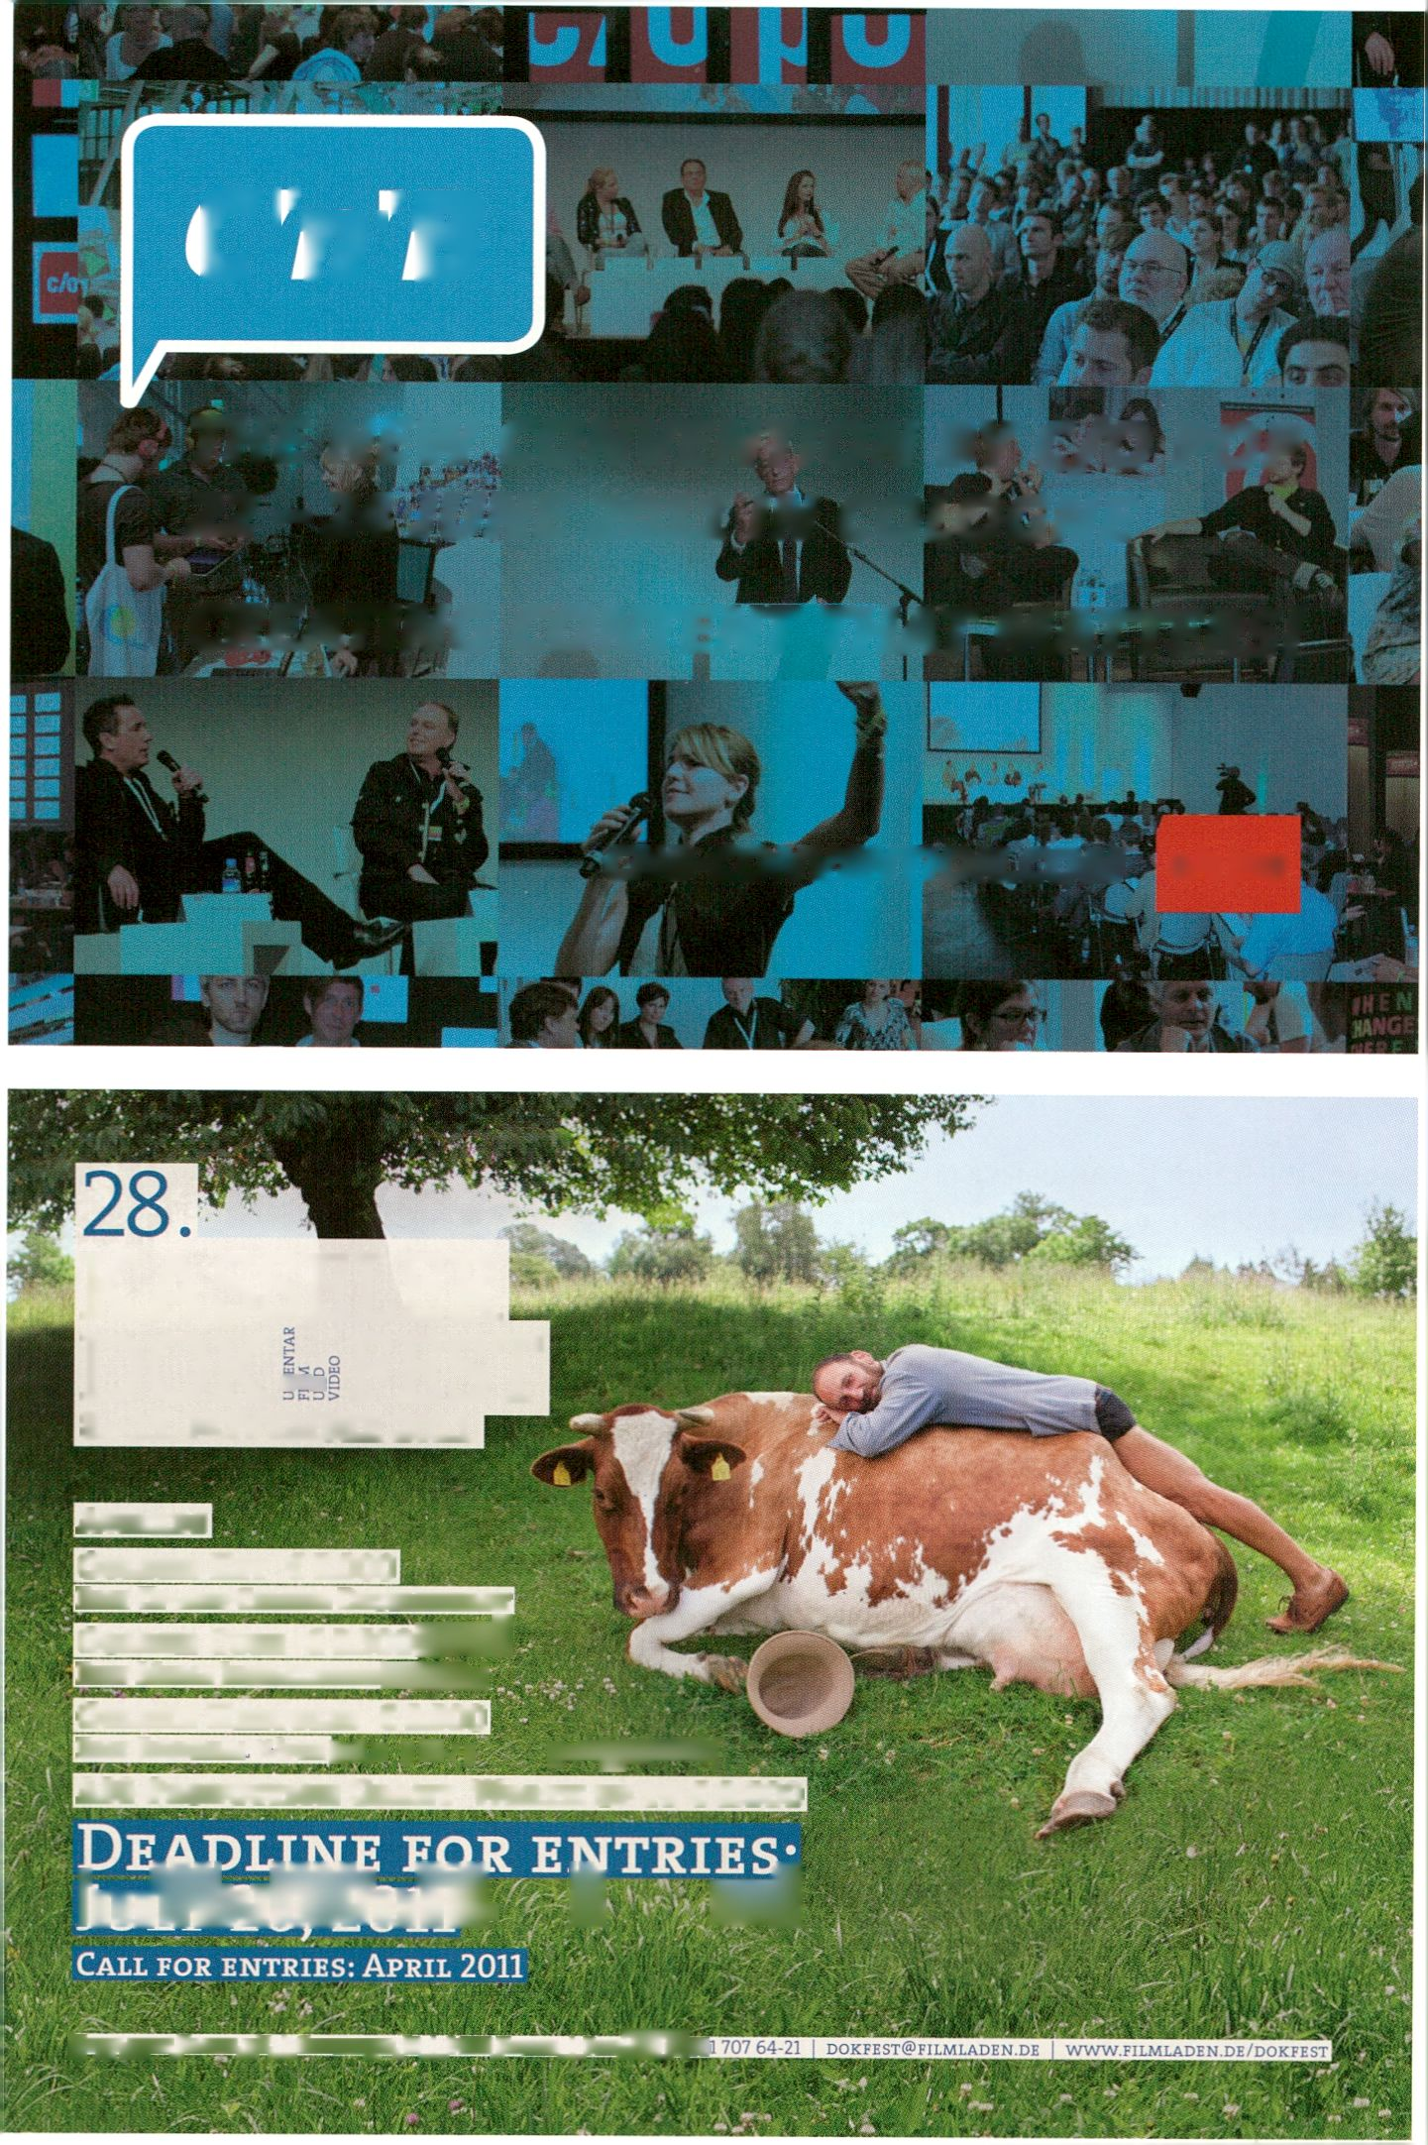C'n'B
THE ISIEW CONVENTION BY C/O POP
22-24 JUNE 2011 IN COLOGNE
CREATING CONTENT THAT MATTERS!
SATELLITES
CNB-CONVENTION.COM c/opop
KASSELER
532
DOK
FEST
8.-13. NOVEMBER 2011
Awards
Golden Key € 5.000
Best Up-and-Coming Documentary
Golden Cube € 2.500 HHfii
Best Media Installation WHJBggj
Golden Hercules € 2.500
P E ST R E GIO N A I. V.\ i R K Bflj.rt f V--’ ; f UMjgKSHS]
A3 8-Production Grant Worth up to € 8.000
imWwWJnlfc. À mi
The Future Gallery
28 January - 6 February 2011
Post Internet Survival Guide
Vernissage: 27 January, 19:00 - 22:00
With: Damon Zucconi, Oliver Laric, Micah Shippa, Timur Si-Qin
Curated by Katja Novitskova and Michael Ruiz
SATELLITES
Post Internet Survival Guide focuses on art
created and distributed online during the year
2010 and suggests the abilities and moreover
the tools necessary to navigate and under-
stand the web - a skill crucial to our survival
today. The Future Gallery is an exhibition plat-
form for fresh artistic positions ranging from
works on paper to websites. The idea: to grow
a gallery out of a temporary space with the
aim of relocating it to a future gallery space.
Schöneberger Ufer 69,10785 Berlin, thefuturegallery.org
Opening times: Daily, 12:00 - 17:00
Sophiensaele
4 - 6, 11 - 13 February 2011,20:00 - 21:45
WAS WIR FÜHLEN #3 Glück
Vernissage: 4 February, 20:00
With: NOVOFLOT
WAS WIR FÜHLEN #3 Glück is a multimedia
performance from the depths of dramaturgy
exploring and illuminating the cycle of
searching for happiness. The performance
begins in the ballroom of Sophiensaele and
follows a utopian history throughout the
various parts of the atmospheric building.
Sophiensaele is the oldest continuously
operating venue for independently produced
theatre and dance projects in Berlin.
Most of the performance will be in German, with some English.
Sophienstraße 18,10178 Berlin, sophiensaele.com, novoflot.de
Price/s: 15/10 EUR (Box office: 030 283 52 66)
Der Post Internet Survival Guide ist ein Survival
Kit für das Zeichenmeer „Internet“ und die
Realität dahinter, er stellt Kunst in den Vorder-
grund, welche im Jahr 2010 online geschaffen
und verbreitet wurde. The Future Gallery ist
eine Ausstellungsplattform für junge und frische
künstlerische Positionen, von Arbeiten auf
Papier bis (hin zu) Webseiten. Die Idee: aus
einem temporären Raum heraus einen
zukünftigen permanenten Ort zu etablieren.
WAS WIR FÜHLEN #3 Glück ist eine multimedia-
le Performance entstanden aus den Tiefen der
Dramaturgie, die den Kreislauf der Suche nach
Glück thematisiert. Die Perfomance beginnt im
Ballsaal der Sophiensaele um anschließend
einer utopischen Geschichte durch die verschie-
denen Teile des atmosphärischen Gebäudes zu
folgen. Die Sophiensaele sind der älteste durch-
gehend bespielte Ort für unabhängig produzier-
tes Theater und Tanzprojekte in Berlin.
First international Master in MediaArtHistories
Language: English, parallel to employment, low residency, international faculty
The postgraduate program MediaArtHistories conveys the most important developments of contemporary art
through a network of renowned international theorists, artists and curators like: Erkki Huhtamo, Lev Manovich,
Christiane Paul, Paul Sermon, Edward Shanken, Jens Hauser, Christa Sommerer, Gerfried Stocker,
Jeffrey Shaw, Sarah Cook, Knowbotic Research, Frieder Nake, Oliver Grau and many others.
Become a member of the facebook platform - Artists and programmers give new insights into the latest
and most controversial software, Interface developments and their interdisciplinary and intercultural praxis.
Keywords are: Strategies of Interaction & Interface Design, Social Software, Immersion & Emotion and
Artistic Invention. Using online databases and other modern aids, knowledge of computer animation, net art,
interactive, telematic and genetic art as well as the most recent reflections on nano art, CAVE installations,
augmented reality and wearables are introduced. Historical derivations that go far back into art and media
history are tied in intriguing ways to digital art. Important approaches and methods from Image Science,
Media Archaeology and the History of Science & Technology will be discussed. MediaArtHistories MA is also
based on the International praxis and expertise in Curation, Collecting, Preserving and Archiving and
Researching in the Media Arts
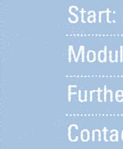rolling admission
May 1 -13,20111 November 14-25,20111 May 1 -11,20121 November 19- December 1,2012
™ www.donau-uni.ac.at/mah | www.virtualart.at { www.mediaarthistories.org
andrea.haberson@donau-uni.ac.at. Phone +43 (0) 2732 893-2569, www.donau-uni.ac.at/dis
Danube University Krems - located In the UNESCO world heritage Wachau is the first public university in
Europe which specializes in advanced continuing education offering low-residency degree programs for
working professionals and lifelong learners. 2009 the Wachau was elected world culture destination No1 by
national geographic. Students come for 4 two week blocks to Monastery Gottweig in Austria. The Center in
Monastery Gottweig, where most MediaArtHistories courses take place, is housed in a 14th century building,
remodeled to fit the needs of modern research in singular surroundings. With its new modular courses the
Department for Image Science at Danube University Krems offers an educational program internationally
unique. Without interrupting the career students have the opportunity to learn through direct, hands-on
experience, social learning in small groups and contacts with labs and Industry. They gain key qualifications
for the contemporary art and media marketplace.
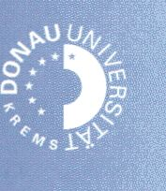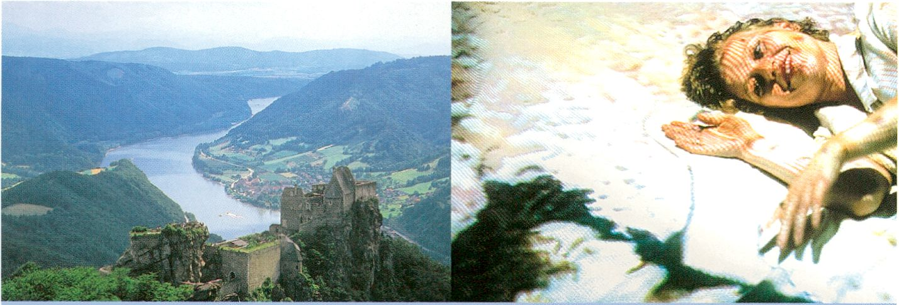Danube University Krems
Department for Image Science, Dr.-Karl-Dorrek-Strasse 30, 3500 Krems, Austria
www.donau-uni.ac.at

n't

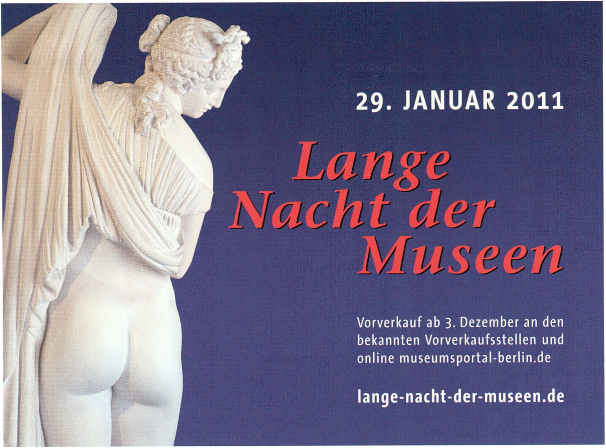

serve-u

TECHNICAL SUPPORT
IT-Service Mietgeräte Livestreaming
www.serve-u.de
ns
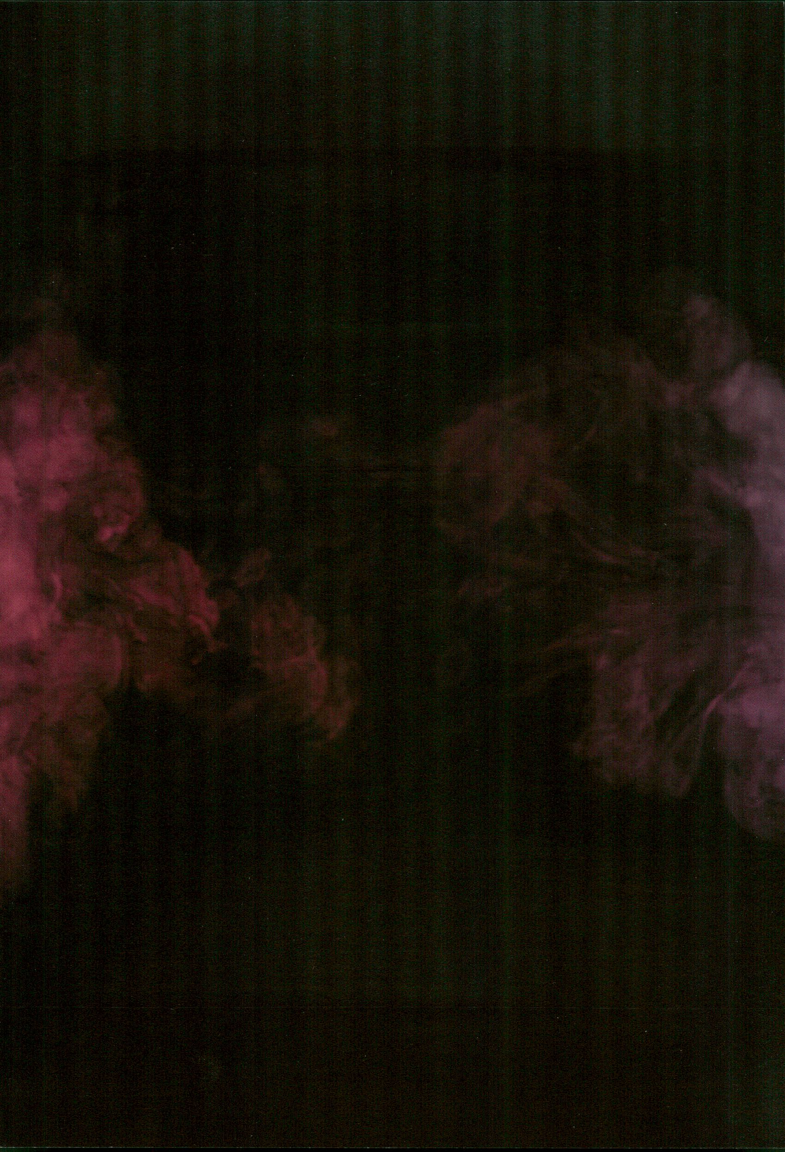

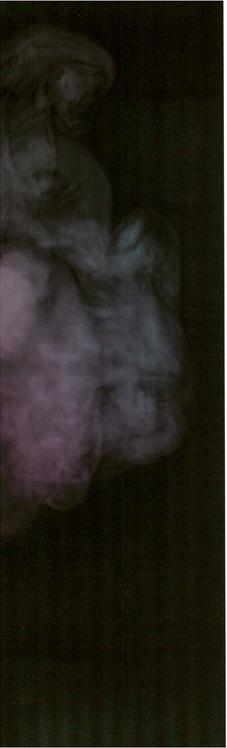
in

CTin.ll - HUE!?
Festival for Adventurous Music and
Related Visual Arts
1-6 February 2011
The 12th edition of CTM explores the latest developments at the point where
music, art and media converge. And, as always, it’s about much more than ‘just’
music. With the theme #LIVE!?, the festival puts to the test terminology that is
mostly taken for granted and discusses what live experience, live performance
and live media mean today in view of their increasing importance within digital
culture. CTM.11 - #LIVE!?
In 2011, the festival showcases a network of locations centred around Kreuz-
berg: In addition to the symposium What is Live?, performances, workshops
and the spectacular CineChamber at HAU, the festival will set up camp around
‘Kotti’ square, presenting concerts and projects in Festsaal Kreuzberg, West
Germany, Kotti-Shop, Monarch, Nr. 4 and the Paloma Bar. Club nights in Berg-
hain and Maria am Ostbahnhof, a concert series highlighting chamber music in
.HBC and the exhibition Alles, was Sie über Chemie wissen müssen, created by
Den Haag art space Tag for the Kunstquartier Bethanien, all combine to make
the programme the most comprehensive in the history of the festival.
CTTT1
Die 12. Ausgabe des CTM präsentiert neueste Entwicklungen aus den Konvegenz-
zonen zwischen Musik, Kunst und Medien. Dabei geht es wie immer um mehr als
„nur“ Musik. Mit dem Thema #LIVE!? stellt das Festival eine zumeist selbstver-
ständlich verwendete Begrifflichkeit auf den Prüfstand und fragt danach, was die
Rede vom Live-Erlebnis, der Live-Performance oder von Live-Medien im Angesicht
ihrer wachsenden Bedeutung innerhalb der digitalen Kultur eigentlich meinen
könnte.
Das Festival präsentiert sich dieses Jahr als Netzwerk mit Schwerpunkt in
Kreuzberg: Neben dem Symposium What is Live?, Performances, Workshops und
der spektakulären CineChamber im HAU bezieht das Festival Quartier am „Kotti“
und präsentiert Konzerte und Projekte im Festsaal Kreuzberg, West Germany,
Kotti-Shop, Monarch, Nr. 4 und der Paloma Bar. Clubnächte im Berghain und
Maria am Ostbahnhof, eine kammermusikalische Konzertreihe im .HBC sowie die
vom Kunstraum Tag aus den Haag zusammengestellte Ausstellung Alles, Was Sie
über Chemie wissen müssen im Kunstquartier Bethanien machen das Programm
zum umfassendsten seit Gründung des Festivals.


CTTT1
Highlights:
Recombinant Media Labs CineChamber
The CineChamber is an incubator for inter-
and pluramedia works. The chamber is walled
by ten large-scale screens and features 8.8.2
multi-channel sound with custom-built,
kinetic, floor-vibration units. CineChamber at
CTM features new compositions and live
performances from artists including Signal
(de), Monolake Live (de/nl), Deadbeat &
Lillevan (ca/de), Edwin van der Heide (nl). The
Surround Audio Berlin premiere of PlayThing
by Maryanne Amacher (us) will be presented
for the opening and finale, preceded by some
words from Recombinant Media Labs’
directors Naut Humon and Edwin van der
Heide.
What is Live?
The symposium at HAU 1 makes audiovisual
liveness the subject of debate between theory
and practice.
Die vollständig von Projektionswänden umge-
bene CineChamber ist ein Labor für inter- und
pluramediale Arbeiten, bietet 8.8.2 Mehrkanal-
Sound und speziell angefertigte kinetische
Boden-Vibrations-Einheiten. Für die Installation
beim CTM wurden neue Kompositionen und live
Performances entwickelt von u.a. Signal (d),
Monolake Live (de/nl), Deadbeat & Lillevan (ca/
de), Edwin van der Heide (nl). Zur Eröffnung und
als Abschluss wird die Surround-Audio-Berlin-
Premiere des Stückes PlayThing von Maryanne
Amacher (us) gespielt, begleitet von einer
Einführung durch die Recombinant Media Labs
Leiter Naut Humon und Edwin van der Heide.
Das Symposium im HAU 1 macht die audiovisu-
elle Liveness zum Gegenstand der Auseinan-
dersetzung zwischen Theorie und Praxis.
With Daniel Gethmann (at), Gabriele Klein (de), Greg Pope & Gert-Jan Prins (uk/nl), Katja Kwastek (de), Malcolm LeGrice (uk), Mick Grierson (uk),
Philip Ausländer (us), Rolf Großmann (de), Steve Dixon (uk), Werner Jauk (at), Wolfgang Ernst (de), Yvonne Spielmann (de) and others.
Concerts and live performances:
Morton Subotnick & Lillevan (us/de), Gold Panda (uk), Darkstar (uk), Dorian Concept (at), Zombie Zombie (fr), Hype Williams (uk), Modeselektor (de),
Kode 9 and the Spaceape (uk), The Field (se), Lawrence English (au), KTL (at/us), Full Blast (Peter Brötzmann, Marino Pliakas, Micael Wertmüller, de/
ch) and many more.
Complete programme at / das komplette Programm auf
www.clubtransmediale.de

na

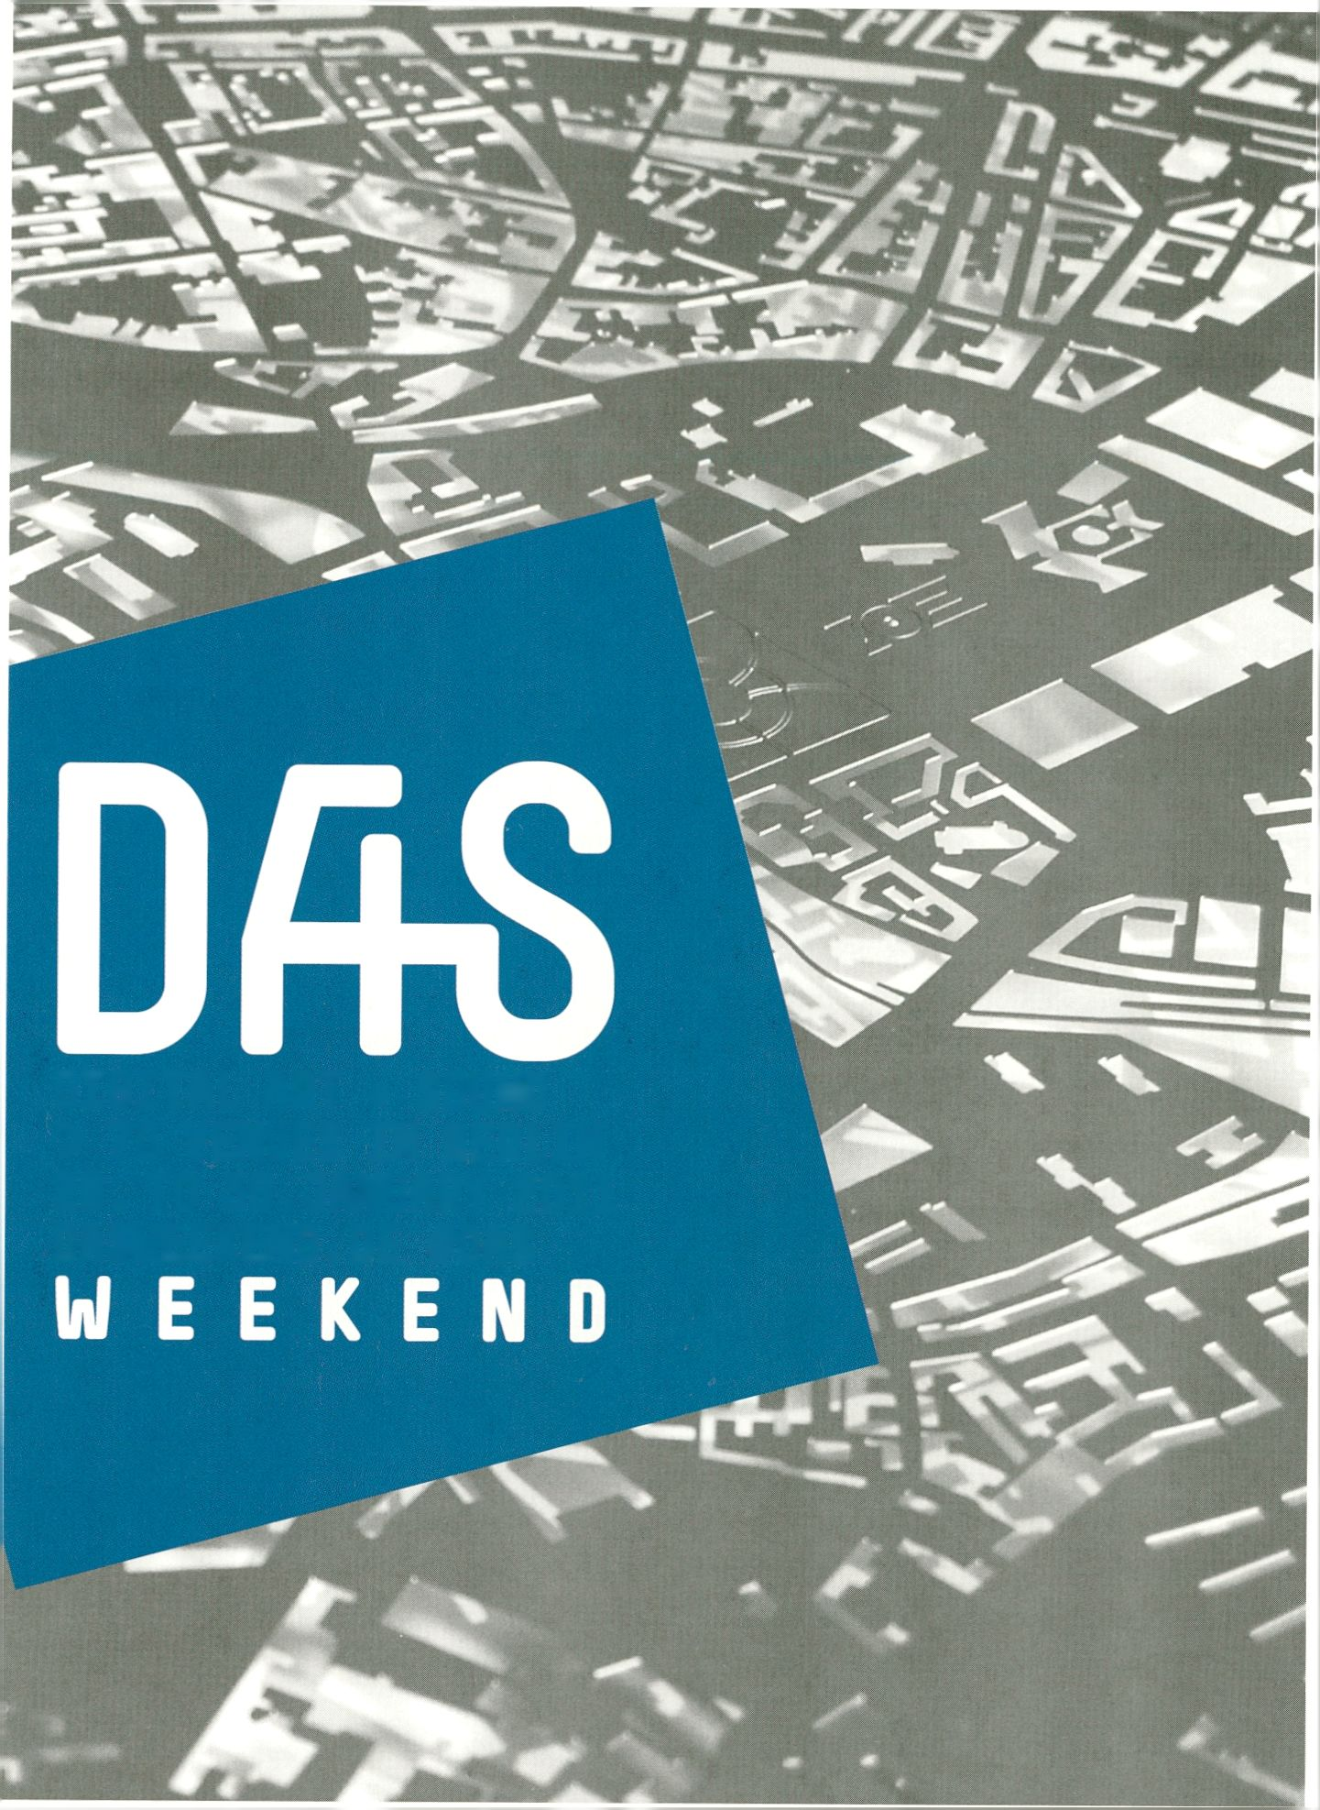
DflS UJEEKETID

DIGITAL ART + SOUND
> 70 VENUES IN BERLIN
28. TO 30.JANUARY 2011
dasweekend.de #das

ur
transmediale
OTM
CLUB TRANSMEDIALE
S CREATE
*: BERLIN

DIGITAL ART + S0UT1D (DAS) UIEEKEFID
> 70 VENUES IN BERLIN
28-30 JANUARY 2011
Presented by transmediale, club transmediale (CTM), Create Berlin
transmediale, CTM, Create Berlin and a multi-
tude of Berlin partners together invite you to
the inaugural Digital Art + Sound (DAS)
Weekend. From 28 - 30 January 2011, more
than 70 independent organisations, venues,
artists and curators active in Berlin join forces
to showcase the richness of ideas, artistic
work and discourse in the converging zones
between digital arts, experimental music and
sound.
Gemeinsam veranstalten transmediale, CTM
und Create Berlin vom 28. bis zum 31. Januar
2011 das DAS Weekend - das erste Digital Art
+ Sound Weekend in Berlin. Mehr als 70
Künstler, Initiativen und Orte, die sich mit
Medien- und digitaler Kunst, experimenteller
sowie elektronischer Musik und Klang
befassen, stellen ihre eigenen Formate und
Inhalte vor.
Das gesamte Programm, Zeit- und Lagepläne
auf dasweekend.de. Viele Ausstellungen und
Projekte des DAS Weekend können auch noch
während der transmediale.11 und den ganzen
Februar 2011 über besucht werden.
DRS UJEEKEnD
See dasweekend.de for the full programme,
schedule and map. Many DAS Weekend
participants have exhibitions and project
continuing throughout transmediale.11 and
the rest of February 2011.
Venues I Veranstaltungsorte
.CHB - Collegium Hungaricum Berlin | _Vilem_Flusser_Archiv | A Place for Science & Phantasia
@Oranienstraße 38 | Altes Finanzamt | aquabitArt | Arsenal - Institute for Film and Video Art |
Art Claims Impulse | ART walk kreativnetzNEUKÖLLN: Flughafenkiez | ART walk
kreativnetzNEUKÖLLN: Körnerkiez | ausland | B-Zwinger | c-base | Centrum | ConcentArt |
CZech It! @ M.I.K.Z. | Das Neuköllner Kellertheater | Derkanal | Deutscher Künstlerbund
Projektraum | diaphanes | die frühperle | dis-play-11 @ Instituto Cervantes | Errant Bodies |
Factory-Art | Free Culture Incubator @ Radialsystem V | Fünf Galerie | Galeria Plan B | Galerie
[DAMjBerlin j Galerie Deschler | Galerie en passant | Galerie Hunchentoot | Galerie Mario
Mazzoli | galerie OPEN | Galerie Thomas Craemer | Galerie Tristesse deluxe | Galerie WAGNER +
PARTNER | General Public | GlogauAir | Grimmuseum | hands on sound - Stage | Haus Orphelia
- Transformationssalon | Ida Nowhere | Institut für Raumforschung | kaleidoskop at Pfefferberg |
kaleidoskop Neukölln | Künstlerhaus Bethanien | Kunstquartier Bethanien | LAURA MARS GRP. |
Limbus Europae | Loophole | Madame Claude | Media in Motion | Medienwerkstatt Berlin |
MMX Open Art Venue | MODULES @ Thomasstrasse 59 | Multimedialer Schlachthof | NGBK |
NK Projekt | ohrenhoch, der Geräuschladen | Planetarium am Insulaner | Schering Stiftung |
SEPTEMBER | Seven Speakers @ Nr4 | Skalitzers Contemporary Art | STATTBAD | Stedefreund |
STYX Projects | Substitut | systM | tamtamART | Technical University Berlin’s Anechoic and
Reverberation Room | The Future Gallery | Trampoline | Tresor | uqbar | Walden
Kunstausstellungen | WerkStadt Kulturverein | WHITECONCEPTS | zebrazone | Zirkumflex
Berlin cityscape by TrinhBuscher (metropolitan-cityscapes.com),
Designed by ® ruddigkeit corporate ideas (ruddigkeit.de)
interfilm
WWW.KUKI-BERLIN.COn
‘t^{,B} INTERNATIONAL
INTERFILM
Oa__{T}H UUU.INTERFILM.DE
/ international
KUKI
beihn
PRESENTING OUTSTANDIN^,FIL^^HORT.
WWW.INTERFILM.D

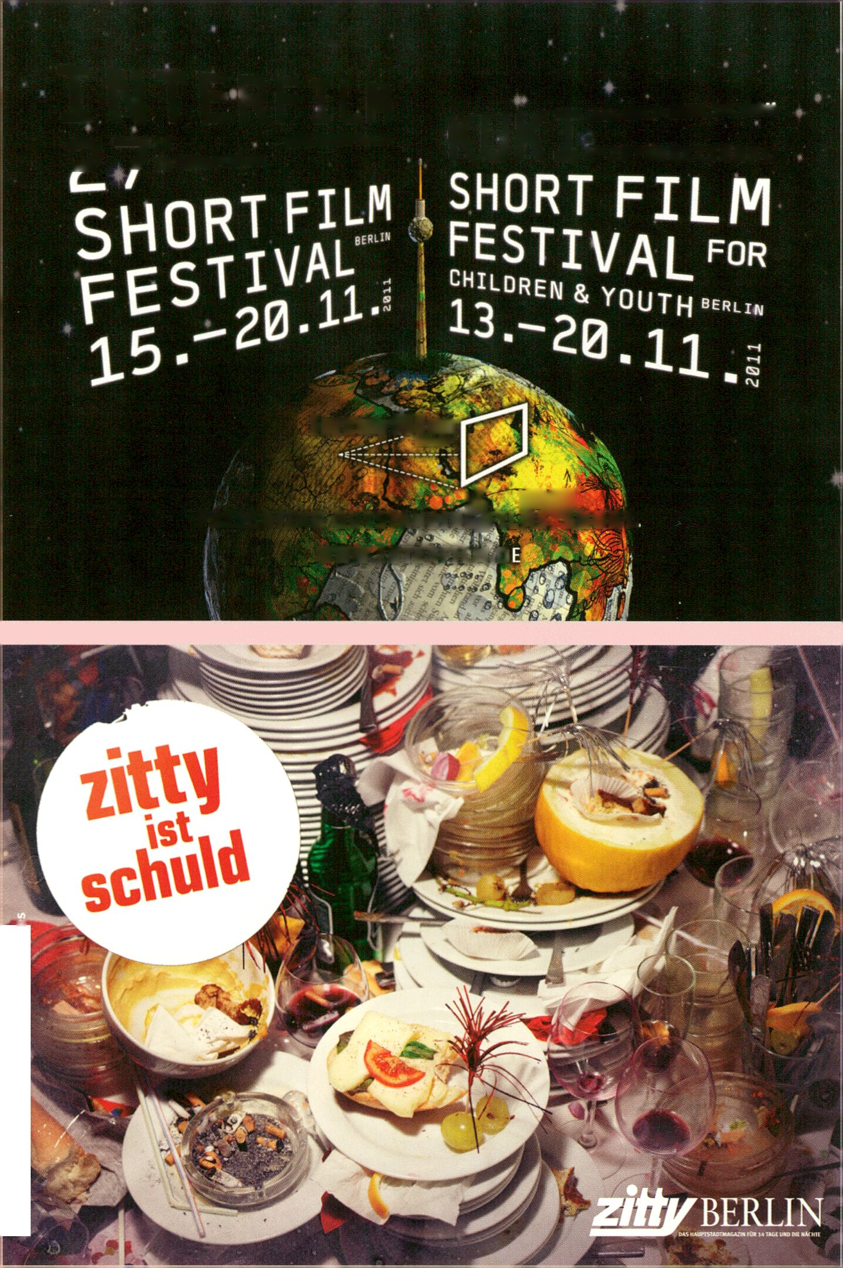
Zum goldenen Hirschen Berlin, Fotograf: Lars Borge

PARTICIPATES A-
Abidin, Adel (iq)
Adel Abidin studied at the Academy of Fine Arts in
Baghdad before moving to Helsinki in 2000. Abidin uses
humor and irony to investigate themes of cultural
identity, marginalization, nationalism, war, terror and
heroism, surveying different experiences of living in a
conflicting and precarious world, p. 94.
Abraham, Julian (id)
Julian ‘Togar’ Abraham is an artist, programmer,
scientist-wannabe and social researcher. Since 2006 he
has been an active member of HONF, p. 47, 68,135.
Ahtila, Eija-Liisa (fi)
Director Eija-Liisa Ahtila’s main preoccupation is the
narrative and what she terms ‘human dramas’. In
2000 she received the Vincent van Gogh Award for
Contemporary Art in Europe, p. 90.
Al-Ani, Jananne (iq)
Jananne Al-Ani studied Fine Art at the Byam Shaw
School of Art and graduated with an MA in Photography
from the Royal College of Art in 1997. While Al-Ani’s
filmography includes A Loving Man (1996-1999), Muse
(2004) and Flock and the Guide (2008) she has also
co-curated exhibitions such as Veil and Fair Play, p. 94.
Anderson, Jan Tobias (se)
Jan Tobias Anderson is a Swedish artist and filmmaker,
working with found footage from renowned film classics
and animation. He is best known for the short films 879
(1998), My Name Is Grant (1999), 879 Colour (2002) and
Prairie Stop, Highway 41 (2004) - all referring to works by
Alfred Hitchcock. In his video works Anderson processes
renowned film classics, p. 103.
Andraos, Mouna (ca)
Mouna Andraos is an interaction designer in various
media including web, mobile, electronics and wearables
and has been exploring the intersection of mass-
produced electronics and handmade crafts working
under the label Electronic Crafts, p. 158.
Angel_F (it)
Angel_F (Autonomous Non Generative E-volitive Life_
Form) is the digital child of Biodoll and Derrick de
Kerckhove who has appeared in worldwide art
performances focused on the issues of digital liberties,
intellectual property and on the evolution of language
and behavior in information society, p. 66,152.
Angerer, Marie-Luise (de)
Marie-Luise Angerer is a Professor in Media- and
Cultural Studies at the Kunsthochschule Köln. Her work
focuses on the construction of gender identities by
communication and media, p. 102,132.
Antar, Ziad (lb)
Ziad Antar graduated from the American University of
Beirut with a degree in Agricultural Engineering in 2001.
Soon after, Antar started working with video and
photography with works that testify to a world in conflict,
using subtle, playful and short shots charged with
subtexts, p. 94.
Arellanes, Douglas (us)
Doug Arellanes is the director of Clients and Services for
Sourcefabric, a not-for-profit organisation supporting
journalism worldwide through open source software and
services, p. 69.
Arns, Inke (de)
Inke Arns is the Artistic Director of the Hartware
MedienKunstVerein in Dortmund, Germany. She is
renowned for her work as an independent curator and
author focusing on media art, net cultures and Eastern
Europe, p. 101
Arofatullah, Nur Akbar (id)
Nur Akbar ‘NAAF’ Arofatullah recently researched the
use of sweet sorghum as the main ingredient to produce
bio-ethanol, aiming to find alternative sources of energy
that are efficient, effective and environmentally friendly,
p. 149.
m
Ashim, Ahluwalia, (in)
Ashim Ahluwalia studied Film at Bard College in New
York State. He later set up Film Republic, dedicated to
producing Indian independent cinema outside the
traditional system. Ahluwalia’s Thin Air is a documentary
that follows the lives of three magicians against the
backdrop of contemporary Bombay, p. 74.
Asselberghs, Herman (nl)
Herman Asselberghs is a Belgian artist focusing on the
question of border areas between sound and image,
world and media, poetry and politics. He is the winner of
the transmediale Award 2007, with the video Proof of
Life, p. 149, 41.
Aufermann, Knut (de)
Knut Auferman is active across Europe as a musician,
radio artist, organizer, curator, consultant and workshop
leader. He runs the project Mobile Radio and is a founder
member of the international Radia network of Indepen-
dent cultural radio stations, p. 73.
Ausländer, Philip (us)
Philip Ausländer is a Professor in the School of
Literature, Communication, and Culture of the Georgia
Institute of Technology teaching Performance and Media
Studies. He has published several books including
Liveness: Performance in a Mediatized Culture, p. 93,
179.
Ayas, Defne (tr)
Deine Ayas is a curator and educator specialising in new
media, performance and cross-cultural projects. She
works as a director of programs to Arthub Asia, and as
an art history instructor at New York University in
Shanghai, p. 46.
Babiole, Cécile (fr)
Cécile Babiole is an interdisciplinary artist whose works
move back and forth between one language and another,
and represent an ongoing reinterpretation of the relation-
ship between image and sound, p. 32, 82.
Ballengee, Brandon (ca)
Brandon Ballengee’s work bridges the gap between
research biology and art. He combines a fascination with
fish and amphibians with the techniques of commercial
art photography, working with scientists to create hybrid
environmental art/ecological projects, p. 158.
Baker, Stuart (uk)
A british filmmaker who directed a number of films in
1988 including Letter to Mr. Cranker; Mercy, Mercy,
Mercy; Minimum Salaries; Music and Commodity, p. 120.
Bärtäs, Magnus (se)
Artist and writer Magnus Bärtäs is Professor of Fine Arts
at the Konstfack in Stockholm. Working with text, video,
objects and installation, his dissertation You Told Me
Work stories and video essays, examines narrative
models in the practice of the video essay, p. 79.
CJ Becker, Claudia (de)
^ Claudia Becker is the Scientific Supervisor of the _Vilem_
Flusser_Archiv and co-editor of the international Flusser
m lectures. She is currently doing a PhD at the University
of Arts in Berlin advancing Flusser’s philosophy of
CO photography, p. 101,112,151,159.
\—
Berardi, Franco ‘BIFO’ (it)
rr Franco ‘BIFO’ Berardi is a writer, philosopher, media-
le theorist, activist and Professor of Social History of
HH Communication at the Accademia di Belle Arti of Milan.
CJ He founded the magazine A/traverso and was involved in
the political movement of ,Autonomia‘ in Italy during the
L 1970s, p. 26, 89,117.
ct
Best, Jens (de)
The web-activist Jens Best focuses on publicness and
civil non-commercial use of the public sphere in the web,
works in several fields of the IT/Web-Business, and
founded two companies (online-entertainment,
crossmedial story-telling, e-tourism), p. 110.
Beuys, Joseph (de)
Joseph Beuys studied sculpture at the Düsseldorf Art
Academy. Beuys’ oeuvre includes various artistic media,
declaring that his goal was to create a unity of art and
life. One of the art world's pivotal art figures, Beuys
participated repeatedly in the documenta and the Venice
Biennale, p. 120.
Blank, Les (us)
Les Blank is a prize-winning independent filmmaker, best
known for a series of poetic films that led Time Magazine
critic Jay Cocks to write, „I can’t believe that anyone
interested in movies or America...could watch Blank’s
work without feeling they’d been granted a casual,
soft-spoken revelation“, p. 120.
Bogart, Ben (ca)
Ben Bogart creates work that involves artistic research &
development in machine creativity and generative sys-
tems, as well as responsive, interactive and site-specific
public art installations, p. 158.
Brand, Martin (de)
Martin Brand is a photographic and video artist whose
works have been shown at numerous exhibitions and
festivals. In 2008 the catalogue Martin Brand: Eyes Wide
Shut, a comprehensive presentation of his work up to
the time, was published, p. 120.
Breeze, Mez (au)
Mez Breeze is the writer of unique ‘mezangelle’ code
poetry, a synthetic ecology strategist and a game
theorist. She has exhibited extensively during the past 2
decades including at ISEA Chicago, ARS Electrónica and
The Metropolitan Museum Tokyo, p. 54.
Breitsameter, Sabine (de)
Sabine Breitsameter is a Professor of Media Art and
Science at the Hochschule Darmstadt. Since the 1980s
she has worked as a radio broadcaster and dramaturge.
Her most recent publication is a new edition and
translation of R. Murray Schafer „Die Ordnung der
Klänge“ at Schott-Verlag, p. 89,101,113,127.
Brodie, Elaine (ca)
Elaine Brodie is an award-winning photographer, a
designer of print and web based media and has art
directed several magazines. Her photographs are in the
collections of the Canada Council Art Bank, Labatt’s
Breweries and many private and corporate collections,
p. 39, 88.
Budiarto, Agus Tri (id)
Agus Tri ‘Timbil’ Budiarto is a farmer, scientist and yoga
master. He graduated from the University of National
Development Veteran as a chemical engineer and has
been an active member of HONF since 2003, p. 47, 68,
135.
Bunting, Heath (uk)
Heath Bunting worked with performance, intervention,
pirate radio, fax/mail art and BBS systems before
setting-up the server www.irational.org. He has now
moved into the field of genetics proclaiming it to be the
next ‘new media’, p. 66, 72, 86, 90, 99, 104, 112,125,144
Butler, Mark (us)
Mark Butler is the Scientific Manager of the research and
development project Ludic Interfaces at the Institute of
Art and Media at the Potsdam University. He has worked
extensively on the culture of computer game-playing and
is currently completing his Ph.D. on playful techniques of
the self, p. 125.
Castonguay, Alexandre (ca)
Castonguay, a founding member of the non-profit media
lab Artengine has a practice based in new media and
digital art, with works exploiting both obsolete
technology and open source software, p. 158.
cat suzette (de)
The 1990s and her time with the techno and art
collective Active Underground in Düsseldorf shaped cat
suzette’s perception and style of music. She has
performed in Berlin in Picknick, the Fire Club, Acud and
the Berghain Kantine, p. 97.

lBt

n
CJ
(/)
cr
Q_
I—i
CJ
Q:
cr
Q-
Christ, Venzha (id)
Vincensius ‘Venzha’ Christiawan is initiator and founder
of the HONF lab. His artistic practice includes public
art installations, media performances, technology
research and furthermore the organisation of workshops,
discussions, DIY gatherings and media culture move-
ments, p. 47, 68,135.
Cirio, Paolo (it)
Paolo Cirio hacks and orchestrates media through
videos, coding, social media, digital prints, public
interventions and audience participation in order to
create controversial provocations and to tackle social
issues, p. 110,147.
Coinchon, Mathias (ch)
Mathias Coinchon is a member of the European
Broadcasting Union (EBU), has worked for the Swiss
Public Radio (RSR) on networks and runs a website on
open source techniques for Digital Radio, p. 85.
Cole, Simon (us)
Simon A. Cole is Associate Professor and Chair of the
Department of Criminology, Law and Society at the
University of California, p. 102.
Combo, Diana (pt)
Diana Combo (Eosin) is a sound artist from Portugal
whose work focuses on an experimental approach to
sound production and performance, and is based on the
use of deformed vinyl records, p. 95.
Cournoyer, Pierre (de)
Pierre Cournoyer is a trained clown who moved to
Australia to study questions of meaning far from
common social structures and has since then been
touring with his performance Tour de Vinyl, p. 80.
Cousins, Jay (uk)
Jay Cousins is co-founder of the Open Design City in
Berlin. He is passionate about ‘open design’ and
developing technologies that socialise educate and
transform the collective and individual consciousness, p.
67, 70, 88.
Cox, Geoff (uk)
Geoff Cox is a researcher in Digital Aesthetics at Aarhus
University; Associate Curator of Online Projects,
Arnolfini, Bristol; and Associate Professor at the
University of Plymouth where he is part of KURATOR/Art
and the Social Technologies Research group, p. 89,101.
Crandall, Jordan (us)
Media artist and theorist Jordan Crandall is Ass.
Professor in the Visual Arts Dept, at the University of
California, San Diego. He is currently developing a new
theory of the event that works across the life sciences,
the social sciences, the digital humanities, urban design
and architecture, p. 55, 97.
Daniels, Dieter (de)
Dieter Daniels is Professor of Art History and Media
Theory at the Academy of Visual Arts (HGB), Leipzig.
Co-founder of the Videonale Bonn, he has curated and
published extensively on 20th century art, a.o. on Marcel
Duchamp, Fluxus and media art. Since 2010 Daniels
serves as head of transmediale's advisory board, p. 39,
81,119.
De Bastion, Geraldine (de)
Geraldine de Bastion is an international consultant for
new media and development at newthinking
communications. Geraldine has a passion for music,
politics, media and technology as well as for sustainable
business models, p. 69.
De Kerckhove, Derrick (ca)
Derrick de Kerckhove worked as an associate of
Marshall McLuhan, then as Director of the McLuhan
Program in Culture and Technology til 2008. He
researches the effects of technology on the human
consciousness and co-created Angel_F, an Autonomous
Non Generative E-volitive Life_Form, p. 2, 66, 86,114,
152.
De Nijs, Marnix (nl)
Marnix de Nijs is a Dutch artist whose work explores the
dynamic clash between bodies, machines and other
media. Many of his artworks are interactive experience
machines that play with the perception of image and
sound, p. 148.
Dietrich, Daniel (de)
Daniel Dietrich is a representative of the Open
Knowledge Foundation in Germany and researcher at the
Centre for Computers and Society at the Technical
University Berlin, p. 114,127.
Doering, Christopher (de)
Christopher Doering is a product designer, educator and
co-founder of the Open Design City. He currently runs a
design research project on accessible sustainable
materials, p. 67, 70.
Dragona, Daphne (gr)
Daphne Dragona is a new media arts curator and
organizer, based in Athens with a special interest in the
field of game arts, p. 110.
Druckrey, Timothy (us)
A leading curator and writer in the fields of media and
digital art, Timothy Druckrey is Director of the Graduate
Photographic and Electronic Media program at the
Maryland Institute and Koopman Distinguished Chair for
the Visual Arts at the University of Hartford, p. 39, 88.
DuBois, R. Luke (us)
R. Luke duBois is a composer, artist and performer who
explores the temporal and visual structures of cultural
and personal ephemera. He teaches at the Brooklyn
Experimental Media Center at NYU's Polytechnic
Institute, p. 133.
Duque, Alejo (co)
Electrigger (de)
The freelance and networking music promoter, video
artist and photographer Electrigger founded an
independent TV-show for electro and related styles in
1997 in Berlin and later became DJ for a radio-magazine
CD in Leipzig, p. 82.
Endlicher, Ursula (at)
Q Ursula Endlicher's work translates the social and
structural components of the web into choreography for
GO performances, installations, and objects. She recently
|— shown her work at SIGGRAPH Asia and Postmasters
ÇZ Gallery, New York. p. 32, 77, 86, 92,104,115,135,145.
CL
►—I
CJ
It
Œ
CL
Alejo Duque is a Colombian theorist, media activist,
sound artist, frequency analyst, data streamer and
satellite tracker based in Switzerland. An active member
of networks such as Bricolabs and dorkbot, his research
focuses on streams for networked communities, p. 73.
Eboman (nl)
For over 20 years, Eboman has been producing music
with (real time) video samples (video-sample-tracks).
With his new project, wikivideo.info, Eboman produces
tracks in his studio together with a live audience on the
internet, p. 32,106.
Esposito, Roberto (it)
Roberto Esposito is a Professor of Philosophy and
Political Science in Naples. He is a member of staff at
the political journal Micromega and worked together with
Jean-Luc Nancy and Giorgio Agamben, p. 128.
Etchells, Tim (uk)
Tim Etchells is an artist, writer, performer and the Artistic
Director of the performance group Forced Entertainment.
His diverse work focuses on the topics of liveness and
presence, with the unfolding of events in time and space,
p. 105.
Finn, Jim (us)
The New York Times said Jim Finn’s films “often play like
unearthed artifacts from an alternate universe.” His
award-winning movies have been called “utopian
comedies” and “trompe I’oeil films”. The trilogy of
communist features is part of the permanent collection
of the MoMA. His first feature film Interkosmos was
called “a retro gust of communist utopianism” by the
Village Voice, p. 79.
Flor, Micz (de)
Micz Flor is a media developer, writer and project
manager with a focus on the Internet. Since 2000 he has
been working as a media developer for Eastern Europe
and Asia at the Media Development Loan Fund (MDLF)
and was co-founder of Sourcefabric, p. 46,108,186.
Formenti, Franca (it)
Franca Formenti, who was active in trash and fibre art,
now deals primarily with issues related to human cloning
and the relationship between human beings and
computers, with particular attention to the web and
physical interaction. She is the personification of Biodoll,
a cloned android sex slave, p. 114,152.
Franke, Daniel (de)
Daniel Franke works as artist, designer and music video
director. As a graduand at the University of Arts Berlin,
he is currently preparing his masters degree. He is also
member of the artist collective We Are ChopChop, p. 51,
75,151.
Fuchs, Mathias (de)
Mathias Fuchs is an artist, musician and media critic
who has pioneered the artistic use of game engines in
various game art installations. He is lead developer for a
European Joint Masters in Ludic Interfaces, p. 125.
Galloway, Alexander (us)
Author and programmer Alexander R. Galloway is
Associate Professor at the Dept, of Media, Culture and
Communication at NYU. He is a founding member of the
software collective RSG (the Radical Software Group)
and creator of the data surveillance engine Carnivore, p.
54.
Gaylor, Brett (ca)
Brett Gaylor is a filmmaker, founder of the Open Source
Cinema project and project producer at Mozilla
Drumbeat. He works with the changing concept of
copyright and collaborates with web developers on new
tech tools that shape what cinema will look like on the
open web, p. 158.
Gharbia, Sami Ben (tn)
Sami Ben Gharbia is Advocacy Director of Global Voices
Online, the anti-censorship network dedicated to
protecting freedom of expression and free access to
information online, p. 99,130.
Goetzke, Andrea (de)
Andrea Goetzke works on open approaches, digital
culture and activism in diverse ways. She initiated,
organized and curated various events and workshops
and is one of the owners and project leaders of the
Berlin-based agency newthinking communications, p.
69, 87.
Goldbach, Niklas (de)
Niklas Goldbach studied Photography at the University
of Bielefeld and Experimental Media Arts at the
University of the Arts Berlin. Since 2002 his work has
been presented internationally in numerous film festivals,
group-exhibitions and solo shows, p. 103.
Gomba, Otieno (ke)
Otieno Gomba is a visual artist, and co-founder of the
Maasai Mbili Art Centre (M2), a community based
interdisciplinary art group in Nairobi. He is currently
teamed up with UBERMORGEN.COM on the WOPPOW
project, p. 24, 72, 89, 101,142,195.
Gotthardt, Peter (de)
Peter Michael Gotthardt is one of the most versatile and
successful composers of the present. He has written
orchestra music, chamber music, oratorios, collages and
audio plays, including over 500 film scores, p. 126.
Gottlieb, Baruch (de)
Baruch Gottlieb is a media artist exploring navigable
fiction and documentary. He has been developing
generative narrative or discursive objects which can be
presented in the space of art. As a Research Fellow at
the _Vilem_Flusser_Archive his work explores a ‘syntax
of human form’, in a cosmology of ‘human nature’, p.
101,112,159.
Goudard, Vincent (fr)
Vincent Goudard graduated in Signal and Image
Engineering from the National Institute of Applied
Sciences, Lyon and holds a master’s degree in Science
Applied to Music from IRCAM, Paris. He worked with
various research institutes and art centers, p. 24, 72, 89,
101,142, 195.
Govcom.org (nl)
Govcom.org is an Amsterdam-based foundation directed
by Richard Rogers which creates and hosts political
tools on the web. It is also a conceptual URL that
indicates three major actor groups involved in debates
on social issues: .gov’s, .corn’s and .org’s, p. 149.
Gray, Jonathan (uk)
Jonathan Gray works at the Open Knowledge
Foundation, a not-for-profit organisation dedicated to
improving the way that knowledge is shared, and is
engaged in research in Philosophy and Intellectual
History at the University of London, p. 127.
Grundmann, Heidi (at)
Heidi Grundmann has worked as cultural reporter, art
and theatre critic, editor and program producer for the
ORF (Austrian National Radio/TV) since the 1970s. In
1987 she created the radio program KUNSTRADIO-
RADIOKUNST (original artworks for radio), p. 73.
G’schrey, Karl (de)
A german Filmmaker from the early twentieth century.
Also director of: Die parallelstrasse (1962) and Forschung
und Leben (1957), p. 115.
Grecu, Mihai (ro)
After studying design and fine arts in Romania and
France, Grecu works as an independent artist in the
fields of video and contemporary art, cinematography
and graphic design. His videos explore the structures
and origins of anxiety: distorted landscapes,
metamorphosis, neon light and alchemy convert into a
heterogenous universe of rough-cut video and 3D
animation, p. 103.
Guertin, Carolyn (ca)
Carolyn Guertin is Director of the eCreate Lab and
Assistant Professor of Digital Media in the Department of
English at the University of Texas. She is the curator of
the celebrated collection Assemblage: The Online
Women’s New Media Gallery, p. 54,114.
Gunn, Allen (us)
Allen Gunn is Executive Director of Aspiration Tech-
nology in San Francisco, and works to help NGOs,
foundations and software developers make more effec-
tive use of technology for social change, p. 81,92, 99.
Hankey, Stephanie (uk)
Stephanie Hankey is Executive Director and co-founder
of Tactical Tech (2003). She worked with the Open
Society Institute, was editor-in-chief of Pulp and a
creative director and producer for a number of
London-based multimedia companies, p. 71,127.
Hansen, Mark (us)
Mark Hansen is Associate Professor of Statistics at
UCLA with a joint appointment at the Center for
Embedded Networking Sensing and Design- and Media
Arts, p. 132.
Harraki, Mohssin (ma)
Mohssin Harraki’s work explores cultural constructs,
consequences of postcolonialism and collective
imaginations. Focussing on foreign cultural landmarks
and social practices, Harraki produced his first video
works in the form of interviews with colleagues debating
everyday political issues that have no direct association
to art practice, p. 94.
Hauser, Jens (de)
Jens Hauser is a Paris based art curator, writer, cultural
journalist and film maker. In his work he deals with the
interaction of art and technology in transgenre and
contextual aesthetics, p. 102,132,162.
Heathfield, Adrian (uk)
Adrian Heathfield writes on, curates and creates
performance. He is the editor of Live: Art and
Performance (Tate Publishing 2004) and Small Acts:
Performance, The Millennium and the Marking of Time
(Black Dog Publications 2000), p. 105.
Hemment, Drew (uk)
Artist, curator and researcher Drew Hemment is director
and founder of the FutureEverything Festival and
Associate Director of ImaginationLancaster. Much of his
work focuses on the relationships between art and
political activism, p. 93.
Hershman Leeson, Lynn (us)
Lynn Hershman Leeson has been a pivotal firgure in new
media art and feminist discourse since the 70s,
developing fluency in all digital technologies as they
evolved. In 2010 she was awarded the d.velop digital art
award [ddaa], honouring her pioneering achievements in
digital art, p. 34,120,135.
x
CO
tn
D_
i—i
CJ
ct
Œ
Q_
Hertz, Garnet (ca)
Garnet Hertz is a Fulbright Scholar and contemporary
artist whose work explores technological progress,
creativity and innovation. He is artist-in-residence in the
Department of Informatics at UC Irvine and Faculty
Member of the Media Design Program at the Art Center
College of Design, p. 24, 57, 91,98,104.
Holmshaw, Rachel (au)
Rachel Holmshaw has a degree in multimedia and
television/sound production and in 2009 she released an
album of live vocal loops under the ‘nom de plume’
Dorothy of the Day, p. 121.
HONF (id)
The House of Natural Fiber (HONF) is a new media art
laboratory in Yogyakarta, Indonesia. It’s practice aims
to fuse education, art and technology with local
communities without cultural limitation, p. 24, 47, 68,
V 135,143.
Hoppe, Joseph (de)
3Z Joseph Hoppe is the chief curator of the German
Technical Museum in Berlin. He has conceptualized and
if) organized media-historical exhibitions and published
several books on subjects related to media and
CZ technology, p. 115.
Howell, Brendan (us)
►H Brendan Howell is a media artist and engineer. He lives
u and works in Berlin where he teaches at the Berliner
Technische Kunsthochschule and at the Kunsthoch-
L schule Weißensee, p. 125.
Q=
Ho Tzu Nyen (sg)
Ho Tzu Nyen makes art projects that have been pre-
sented in cinemas, galleries and theatres, as well as on
television. His films have been shown at film festivals
such as the 41st Director’s Fortnight, Cannes Film
Festival (2009) and the 66th Venice International Film
Festival (2009), p. 34, 49, 107.
Jeron, Karl-Heinz (de)
Karl-Heinz Jeron creates artistic and cultural internet
projects. He is a member of the artist duo Blank & Jeron,
p. 124.
JODI (nl/be)
JODI is a collective of two internet artists: Joan
Heemskerk and Dirk Paesmans. Since the mid-1990s,
they have created a number of original artworks for the
World Wide Web about the characteristics of the internet
itself: web aesthetics, codes and language, p. 149.
Kaddouri, Fadma (ma)
Self-taught artist Fadma Kaddouri’s photographs and
videos often start as travel books, and bear witness to
the position of the artist, her vision of the interior and
exterior and its movement between various segments of
Moroccan society: family, community and dual identity.
Her work results from a history that, whether lived or
imagined, is positioned between reality and fiction, p. 94.
Kasprzak, Michelle (ca)
Michelle Kasprzak is a curator and writer who founded
one of the world’s leading art curating blogs, Curating,
info. She is currently a curator at V2_ Institute for
Unstable Media and Project Director of the McLuhan in
Europe 2011 initiative, p. 39, 88.
Kelley, Heather (ca)
Heather Kelley (moboid) is a media artist and video game
designer. She designs games as interface and interaction
research at Concordia University in Montreal Quebec,
and heads her own software design studio Perfect Plum,
p. 39, 80, 98,125,156,158.
Kildall, Scott (us)
Scott Kildall is a cross-disciplinary artist working with
video, installation, prints, sculpture and performance.
He gathers material from the public realm to form
interventions into various concepts of space, p. 53,110,
141.

Howse, Martin (uk)
Martin Howse is a programmer, theorist, performer and
explorer of open hardware who founded the ap project in
1998 to implement a truly artistic operating system (OS)
in its most expanded sense and within a free software
context, p. 169.
Hyde, Adam (nz)
Adam Hyde, as founder of FLOSS Manuals focuses on
increasing the quantity and quality of free documentation
about free software, explores emerging methodologies
for collaborative book production through Book Sprints,
and is co-developing Booki, a new form of authoring
platform, p. 60,100,145,161.
laconesi, Salvatore (it)
Salvatore laconesi (aka xDxD.vs.xDxD) teaches
Interaction Design at Rome’s University. His research is
focused on the recontextualisation of processes and
practices to suggest tolerant and multicultural forms of
society, p. 76, 86, 87,100, 117,131, 152.
Kirschner, Friedrich (de)
Friedrich Kirschner is a film maker, visual artist and
software developer focusing on video games and real
time animation techniques as basis for his works, p. 70.
Klahr, Lewis (us)
Master collagist Lewis Klahr has been making films since
1977. He is known for his uniquely idiosyncratic
experimental films and cutout animations which have
been screened extensively in the United States and
Europe. His epic cutout animation The Pharaoh’s Belt
received a special citation for experimental work from
the National Society of Film Critics in 1994, p. 126.
Kleiner, Dmytri (ca/ru)
Dmytri Kleiner is a software developer and co-founder of
Telekommunisten, a worker's collective that provides
telephone and internet services. He is nominated for the
Open Web Award of transmediale.11, with thimbl, a
decentralized micropayment platform, p. 76,116,145.
Kluitenberg, Eric (nl)
Eric Kluitenberg is head of the Media Program at De
Balie - Centre for Culture and Politics in Amsterdam. He
lectures and publishes regularly on culture, new media,
and cultural politics throughout Europe and beyond, and
teaches a course on Culture and New Media at the
University of Amsterdam, p. 69, 93.
Kolgen, Herman (ca)
Herman Kolgen is a multidisciplinary artist who draws his
primary material from the intimate relationship between
sound and image, and creates objects that assume the
form of installations, video and film works, performances
and sound sculptures, p. 32, 66,109.
Komarov, Sergei (ru)
Sergei Komarov was one of the leading actors in
Kuleschows experimental workshop at Sowkino along
with Pudowkin and Narnet. His roles were characterised
by precision and exactness: the one eyed man in The
unusual adventure of Mr West in the Land of The
Bolschewiki (1924, Kuleschow), or Hans in According to
Law (based on Jack London, both 1926, Kuleschow), p.
126.
Kommerell, Patrizia (de)
Patrizia Kommerell is co-founder of KS12, a creative
studio which produces immediated autodocumentary
videos. As a communication designer she has worked at
design agencies such as MetaDesign, Triad and
chezweitz & roseapple, p. 67, 68, 86, 98,110,130.
kom.post (de)
Founded in 2009 by Camille Louis, this interdisciplinary
collective of 30 artists and researchers focuses on
processes, artistic sharing and new modes of creation,
kom.post will run transmediale.11 ’s Wanted & for Sale
workstation with Laurie Bellanca, Jennifer Bonn, Simo
Kellokump, Julie Morel and Elsa Ossart. p. 71
Korpys & Löffler (de)
Andree Korpys and Markus Löffler live and work in Berlin
and Bremen. Their work encompasses the fields of
architecture, installation and video art and has been
displayed in many international exhibitions. In their
documentary work the artists connect fictional and
biographical material and create contradictions that
allow new associations and perspectives to be formed,
p. 79.
Kreutz, Christian (de)
Christian Kreutz is member of the Open Data Network
e.V., founder of Frankfurt Gestalten and works as advisor
for international organisations, p. 114.
Kuni, Verena (de)
Verena Kuni is a professor for Visual Culture at Goethe
University, Frankfurt Main. Her research is dedicated to
transfers between material and media cultures, media of
imagination, technologies of transformation and DIY
cultures, p. 114
LaBelle, Brandon (us)
Brandon LaBelle's work aims to draw attention to the
dynamics of sound as it is found within spaces and
objects, public events and interactions, language and
the body. He is currently Professor at the National
Academy of the Arts, Bergen, p. 46.
Lahr, Christin (de)
Christin Lahr lives and works as an artist, curator and
professor for Media Art in Berlin and Leipzig. Since 1990
she has been curating shows for instance at the
RealismusStudio of NGBK Berlin and since 2001 she is a
professor for Media Art in Leipzig, p. 24, 48, 66.
Lamberti, Elena (it)
Elena Lamberti teaches American & Canadian Literature
at the University of Bologna, Italy. She is among the
promoters of the European Thematic Networks ACUME
and ACUME2 and of the EU/Canada Cooperation
Program CEMMENTI, p. 39, 88.
Larsen, Solana (dk)
Solana Larsen is the managing editor of Global Voices
Online, an international community of bloggers and
online activists where she helps lead a dynamic team of
editors and volunteers who report and translate
conversations taking place in blogs and citizen media
worldwide, p. 130.
Layton, Zach (us)
Zach Layton is an improviser, composer, curator and
new media artist based in Brooklyn with an interest in
biofeedback, generative algorithms, and experimental
culture, p. 133.
Lazzarato, Maurizio (it)
Maurizio Lazzarato is a Paris-based sociologist,
philosopher and independent researcher, specialised in
studies of the relationship of work, economy and society.
He is a member of the editorial group of the journal
Multitudes, p. 117.
Leingruber, Tobias (de)
Tobias Leingruber‘s internet-based artwork has gained
international media attention in both the art and
technology world. Motivated by issues like censorship,
copyright or information power structures, Tobias’
artwork is also inspired by online culture and
collaboration with his F.A.T. Lab colleagues, p. 101,118.
Les Liens Invisibles (it)
This artists duo comprised of Clemente Pestelli and
Gionatan Quintini uses an eclectic recombination of pop
net culture, reverse engineering techniques, social media
subvertising, and media manipulations, p. 50, 89,110,
151.
PARTICIPATES K-
Lernert and Sander (ni)
PARTICIPATES L -
Lernert Engelberts and Sander Plug are two dutch artists
who got boring working alone. Since their first video
Chocolate Bunny they’ve been working on commercials,
art movies, documentaries and installations with the aim
to make simple and communicative works, that take little
note of the existing border between contemporary art
and commercial projects, p. 128.
Levi, Simona (es)
Simona Levi is an activist in European social movements
promoting the free circulation of knowledge and the right
to housing. She has directed the arts festival IN MOTION
in Barcelona since 2000 and is the director of Conservas,
a cultural activity centre, p. 69,113,133.
Liebe, Michael (de)
Michael Liebe is cofounder of the Digital Game Research
Center at the University of Potsdam (DIGAREC) and was
E
the strategic head of the game art festival A MAZE.. As a
free journalist he is specialized in digital culture, markets
and technologies, p. 125.
Lindenberg, Friedrich (de)
Friedrich Lindenberg is a member of Liquid Democracy
e.V., collaborates with the Open Knowledge Foundation
and works as a programmer on open modes of
governance and on government transparency, p. 118.
Liquid Democracy (de)
As a group of political scientists, programmers,
sociologists and people from other backgrounds, Liquid
Democracy aims to empower both experts and the
public by creating internet platforms in which political
debate can be used to augment the current system, p.
118.
Loucks & Norling Films (us)
John Norling was a pioneer of stereoscopic cinema,
which he started investigating as early as 1931. Loucks
and Norling produced films up until 1951, p. 74.
Lumby, Billy (uk)
Billy Lumby was born and raised in London where he
studied Philosophy before entering the film world,
working as a creative assistant to directors such as
Harmony Korine, Terry Richardson, Mike Figgis and
Jonas Akerlund, p. 103.
Ludovico, Alessandro (it)
Alessandro Ludovico, editor in chief of Neural magazine
is a writer and critic in the fields of digital and hacktivist
arts. He is one of the founders of the Mag.Net
organisation and teaches at the Academies of Fine Arts
in Carrara and in Bari, p. 86,110,147.
Maamoun, Maha (eg/us)
Maha Maamoun is a photography and video artist and
one of the founding members of CiC - The
Contemporary Image Collective - a space for
contemporary art and culture in Cairo, p. 103.
Mäkelä, Tapio (fi)
Tapio Mäkelä is a researcher and media and currently an
AHRC Research Fellow at the Department of Creative
Technology at the University of Salford, p. 95,104.
Manabe, Daito (jp)
Programmer, researcher and artist Daito Manabe has
participated in many arts and research development
projects both in Japan and abroad, is a co-founder of
4nchor5 Ia6, and also serves vice president of
Rhizoatiks, p. 24, 32,109,111.
Mañas Carbonell, Moisés (es)
Moisés Mañas is an artist and Professor of Interactive
Art in the Fine Arts Faculty of the Polytechnic University
of Valencia. Since 2000, he is member of the research
group I + D + I (Laboratorio de Luz), p. 125.
Marburger, Marcel René (de)
Marcel René Marburger works as research assistant and
lecturer at the Cologne Cathedral, the Academy of Media
Arts Cologne as well as at the University of the Arts
Berlin and is one of the co-editors of the International
Flusser Lectures, p. 54.
Marks, Jonathan (us)
Jonathan Marks is a near futurist, examining emerging
distribution platforms and researching their impact on
traditional broadcast storytelling in the next 5 years,
p. 69.
Martins, Tiago (br)
Tiago Martins is currently a PhD candidate at the
Interface Culture group of the Universität für
Künstlerische und Industrielle Gestaltung Linz, Austria,
where he also works as guest teacher for programming
and physical computing, p. 146.
Mauro-Flude, Nancy (au)
Nancy Mauro-Flude is a researcher and performing
artist. Currently she is a lecturer in E-media and Theory
in Experimental Art and New Technology at the
Tasmanian School of Art, p. 104
McCarty, Diana (us)
Diana McCarty is a co-founder of bootlab and
co-initiated the open source radio project, reboot.fm.
She is an active member of the Free Cultural Radio
Network, Radia.FM & Faces mailing list for women in
media, p. 69.
McLean, Jesse (us)
Jesse McLean grew up in Pennsylvania, studied Art at
Oberlin College and received her MFA in Moving Image
from the University of Illinois at Chicago. She lives and
works in Chicago, Illinois, p. 129.
Menkman, Rosa (nl)
Rosa Menkman is a Dutch visualist who focuses on
visual artifacts created by accidents in digital media,
p. 32, 94.
ISO
Metanet (ca)
Metanet Software, founded in 2001 by Raigan Burns and
Mare Sheppard, is an indie game development company
devoted to creating fun, innovative and unique games.
Their award-winning game, N, is available for download
for free, with Robotology coming soon, p. 158.
Mohammad, Oussama (sy)
The director and scriptwriter Oussama Mohammad
studied film at the Gerasimov Institute of
Cinematography (VGIK) in Moscow. His films are
concerned with power structures and their effects on
individual identity. As the smallest organisational
structure of the state, the family propagates social order
and thereby maintains its traditions, p. 94.
Moltke, Henrik (dk)
Henrik Moltke is a digital activist, media professional,
advisor and blogger. Since the early days of the free
culture movement, he has been working on various
access-to-knowledge and copyright-reform projects, p.
58, 69, 87,111.
Mongiat, Melissa (ca)
Melissa Mongiat’s approach revolves around
participation by the public. Her creations have included a
series of interactive environments for Royal Festival Hall
in London, for which /Wallpaper*/ magazine selected her
as one of the world’s 10 most promising designers. She
also stands out for her research projects in participative
design, p. 158.
Mufid, Younis,
An anonymous filmmaker, p. 94.
Mulder, Arjen (nl)
is an essayist and media theorist with a background in
biology. He is editor for V2_ Publishing, editor of De
Gids, and has taught at various art schools in the
Netherlands and Belgium, p. 127.
Neumann, Jürgen (de)
Jürgen Neumann is a consultant for ICT strategy and
implementation working for major German and
international companies and non-profit projects.
Recently he is trying to ramp up the Open Source
Hardware and Design Aliance http://www.ohanda.org
and is lobbying for more open licensing models for the
radio spectrum, p. 104.
Östlund, Ruben (se)
Ruben Östlund started his film career by directing skiing
films in the 1990ies which also proved to be the reason
for his later acceptance at the film school in Gothenburg.
Together with producer Erik Hemmendorff he is the
co-founder of the production company Plattform
Produktion, which produces his films. He has directed
two feature-length films - The Guitar Mongoloid (2004)
and Involuntary (2008), p. 129.
Offri, Galia (il)
Galia Offri is an Israeli artist and illustrator who explores
new possibilities for creative subjectivity within the
political structures of the art world, the commercial
constraints of the illustration world and the collective
objectivity ethos of the online world, p. 69,113.
0‘Nascimento, Ricardo (br)
Ricardo O’Nascimento is a new media artist, researcher
of body-environment-relations and founder of the artistic
platform Popkalab in Linz and Sao Paulo, p. 146.
Olson, Marisa (us)
Marisa Olson is an artist, curator, and professor. Her
work combines performance, video, drawing &
installation to address the cultural history of technology,
the politics of participation in pop culture & the
aesthetics of failure, p. 46.
Open Data Network (de)
Founded in 2009 in Berlin by over 20 representatives of
political parties, networks and corporations, the Open
Data Network promotes open data, open access and
open government aiming to put transparency and
participation on the political agenda, p. 114.
Open Design City (de)
Founded in Berlin in 2010 by Jay Cousins, Chris Doering
and Philip Steffan, Open Design City is a space that
encourages the sharing of tools, knowledge, skills and
exploration of Open Design principles, p. 70.
Open Knowledge Foundation (uk)
Founded in 2004 the Open Knowledge Foundation is a
not-for-profit organization which promotes open
knowledge that can be freely used, reused, and
redistributed, p. 118,127.
Ostrowski, Matthew (us)
Matthew Ostrowski is a pioneer in live electronic music,
having worked as a composer, improvisor and
installation artist for over 20 years, exploring work with
alternative controllers, multimedia, and theatre, p. 133.
Parikka, Jussi (fi)
Jussi Parikka is the Director of CoDE: the Cultures of the
Digital Economy-Institute (uk) and co-director of the
Anglia Research Centre in Digital Culture. He teaches
Media Studies at the Anglia Ruskin University,
Cambridge, p. 24, 57, 91,98.
Pasquinelli, Matteo (it)
Matteo Pasquinelli is a writer, curator and researcher at
the Queen Mary University of London. He wrote the book
Animal Spirits: A Bestiary of the Commons (2008) and
edited the collections Media Activism (2002) and C’Lick
Me: A Netporn Studies Reader (2007), p. 46,117,128.
Paz, Sharon (il)
Sharon Paz was born in Israel and currently lives and
works in Berlin where she received the
Hauptstadtkulturfonds exclusive grant in the year 2005.
Her video works are part of the collection of the Israel
Museum, p. 90.
E
tn
Œ
0-
i—I
CJ
ct
Œ
CL
People Like Us (uk)
Pold, Soren (dk)
Soren Bro Pold is Associate Professor of Digital
Aesthetics at the Department of Information and Media
Studies, Aarhus University, and head of the Interface
Q- Aesthetics Research Group, p. 101.
Poole, Christopher (us)
Christopher ‘moot’ Poole is the founder of 4chan.
Originally a niche site for anime fans, it is now with over
if) 12 million users one of the most influential communities
on the net, p. 116.
Q3 Pop, Susa (de)
Curator and cultural manager Susa Pop, initiator of the
HH Media Facades Festival Berlin 2008 and Europe 2010, is
CJ now preparing Urban Screens 2011 together with the
German Ministry of Education and Science, p. 75.
OC Poettschacher, Eric (de)
Eric Poettschacher lead a consultancy for over 15 years
LL dedicated to tackling the specific challenges of
creatives. In 2006 he incorporated Shapeshifters
Information Management GmbH, a global knowledge
broker supporting creatives with tailor-made business
opportunities worldwide, p. 105,116.
Since 1991 Vicki Bennett has been making CDs, radio,
and A/V multimedia under the name of People Like Us.
She has shown work at, amongst others, Tate Modern,
The National Film Theatre, Purcell Room, The ICA,
Sydney Opera House and Pompidou Centre, p. 32, 82.
Persico, Oriana (it)
Oriana Persico (aka penelope.di.pixel) is a
communication scientist focusing on the creation of
empathie economies that allow for the establishment of
participative, tolerant, creative ecosystems in which
people actively and happily coexist, p. 76, 87,100,117,
131,152.
Powell, Alison (ca)
Alison Powell is a LSE Fellow in Media and
Communications at the London School of Economics,
researching digital media policy and advocacy, p. 104.
Praschma, Patrick (de)
Patrick Praschma produces short films, music videos
and media installations under the label hektikfilme and
organizes cultural events as a member of the
RoomService-Collective in the Ruhrvalley, p. 80.
Preciado, Beatriz (es)
The philosopher and gender theorist Beatriz Preciado
teaches Political History of the Body, Gender Theory and
History of Performance at the Université de Paris VIII.
Her book Anti-sexual Manifesto has become a queer
theory classic, p. 128.
Preslav Literary School (uk)
As Preslav Literary School, Adam Thomas makes live
tape collages using sounds drawn from an ever-growing
archive of self-generated or discovered outsider noise,
found sound and spoken word cassettes, p. 108.
Provost, Nicolas (be)
The work of Nicolas Provost walks the fine line between
dualities, balancing fiction and fine arts, the grotesque
and the moving, the beautiful and the cruel. His
phantasmagorias provoke both recognition and
alienation and succeed in pulling audience expectations
into an unraveling game of mystery and abstraction. In
addition to the use of film and visual language, sound is
a constant factor in Provost's body of work, as a
rhythmical spine or an emotional guideline, p. 103.
Ramos-Velasquez, Vanessa (br/us)
Vanessa Ramos-Velasquez is an interdisciplinary artist
from Brazil, who has acquired a diverse background
along her various global residencies. As a cultural
instigator, her Anthropophagie Re-Manifesto and lecture
was first presented at ISEA2010/RUHR, p. 56, 74.
resom (de)
resom is a DJ moving between electro and minimal,
breaks and techno, pop and underground releases, p.
123.
Revel, Judith (fr)
Judith Revel is a philosopher and translator whose work
focuses on philosophical contemporary thinking. She
has written several books and numerous articles on
Michel Foucault and has edited his book Dits et Ecrits in
Italy, p. 128.
Reynolds, Reynold (us)
Influenced by philosophy and science, artist and
filmmaker Reynold Reynolds works primarily with 16mm
and Super 8mm film as an art medium. He has
developed a common film grammar based on
transformation, consumption and decay, p. 43, 67,103.
Rheinberger, Hans-Jörg (de)
Hans-Jörg Rheinberger is the Director of the Max Planck
Institute for History of Science. His transdisciplinary
research focuses on history and epistemology of
experimentation in the life science, p. 102.
Roller, Nils (de)
Nils Roeller is Professor of New Media at Zurich
University of the Arts (ZHdK). The main focus of his work
is on media and cultural theory, with an emphasis on the
epistemology of science and instruments, p. 54.
Rose, Jodi (au)
Jodi Rose is an artist/producer working internationally in
urban spaces, sound, intervention and communication.
She initiated and is co-curator of TRACES and creator of
Singing Bridges and Transit Lounge Radio, p. 77.
Rosen, Roee (il)
Roee Rosen is an artist and teacher living in Tel Aviv.
Through video, painting and narrative, Rosen's work
explores identity and the notions of evil, p. 129.
Roth, Evan (us)
Evan Roth is an artist and researcher whose work
focuses on technology, tools of empowerment, open
source and popular culture. He is co-founder of the
Graffiti Research Lab and the Free Art & Technology Lab,
p. 59,145.
Roumagnac, Vincent (fr)
Vincent Roumagnac has an artistic background as stage
director and visual artist. After years of transdisciplinary
experiments on multimedia art, he currently works on
inducting his different tools into dialogues with other
artists, p. 71.
Ruscica, Jani (fi)
Jani Ruscica is a Helsinki based artist who was
educated at the Chelsea College of Art and Design in
London and at the Academy of Fine Arts in Helsinki. His
work includes film, video and photography amongst
other media. Ruscica's self reflexive works explore the
intersection between cinema, video art, theatre and
performance, p. 103.
Russegger, Georg (at)
Georg Russegger is the Scientific Manager of the
research and development project Ludic Interfaces at
the Interface Culture Lab, University of Art and Design
Linz. Together with the association 5uper.net he is
coordinator of the CODED CULTURES festival in Vienna,
p. 43,125.
Sander, Helke (de)
Helke Sander was born in Berlin. After studying at drama
school she moved to Finnland. From 1962 she worked in
theatre and television before returning to Germany where
she studied at the german film and television academy in
Berlin. She was a co-founder of the camapign for the
liberation of women in 1968.
Besides making films she is also the author of several
books, p. 120.
Sassi, Pekka (fi)
Pekka Sassi lives and works in Helsinki. He received his
MA from the Finnish Academy of Fine Arts, Department
of Media Studies in 2000. His works include installations,
music, sound pieces and experimental short films which
have been presented at solo and group exhibitions, as
well as at film festivals worldwide such as Rotterdam,
Cannes, EMAF, Tampere and Hamburg, p. 129.
Shalom, Gabriel (us)
Gabriel Shalom is a video musician, storyteller and
media theorist. He is co-founder of KS12, a creative
studio which produces event-based collaborative videos
and the creator of the Hypercubist Manifesto. Since 2009
he is adjunct faculty at the Berliner Technische
Kunsthochschule, p. 67, 68, 86, 88, 98, 110,130.
Shapeshifters (at)
Shapeshifters is a knowledge agency for the global
creative community. Their aim is to help people all over
the world by locating resources needed to turn ideas into
reality, p. 105.
Shawky, Wael (eg)
Wael Shawky completed his BFA at the University of
Alexandria, followed by an MFA at the University of
Pennsylvania in 2000. He has received several awards
for his work including the International Commissioning
Grant of the Lower Manhattan Cultural Council, New
York (2005) and the International Award of the Islamic
World Arts Initiative, Arts International, New York (2004),
p. 94.
Shepard, Mark (us)
Mark Shepard is an artist, architect and researcher
whose post-disciplinary practice addresses new social
spaces and signifying structures of contemporary
network cultures, p. 52, 92,116,151.
Sillars, Laura (uk)
Laura Sillars is an arts programmer and curator. Her
research is in art and social change, public realm and
civic space, technology and public imagination, the
family, mass experience and intimacy, the changing role
of arts institutions, women and 21st Century feminism, p.
135.
Smith, John (uk)
John Smith studied Film at the Royal College of Art and
has, since 1972, made over forty film, video and
installation works that have been widely shown and
awarded major prizes internationally, p. 79.
Slopek, Ed (ca)
Ed Slopek’s areas of expertise include research
methodologies, media analysis, social constructionist
and reception theory and communications history. His
video art and installations have been exhibited nationally
and internationally. He currently teaches at Ryerson
University, p. 88.
Snijders, Bram (nl)
Bram Snijders (Sitd) is a Dutch media artist whose works
include augmented realities, video projections,
interactive installations, robotics and VJ performances.
His interest focuses on how the physical influences the
virtual world, p. 148.
Sonntag, Jan-Peter E.R. (de)
Since 1989 Jan-Peter E.R. Sonntag has worked with
installations based on sound and bio mass, as well as
with monochrome gas discharges. His background
includes art and music theory, philosophy and cognitive
science, and he has been awarded both the German
Sound Art Prize and the CYNETart Award, p. 160,168.
Spielmann, Yvonne (de)
Yvonne Spielmann is Chair of New Media at the
University of the West of Scotland. During the festival
she will present her latest book Hybridkultur (2010), p.
89,179.
Stark, Elizabeth (us)
Elizabeth Stark is a leader in the global free culture
movement. She is Visiting Fellow at the Yale Information
Society Project, lecturer at Yale University and Adjunct
Associate Professor at NYU, p. 106,116,123.
tn
ct
CO
GC
CL
l-H
CJ
ct
cr
CL
Surman, Mark (ca)
53
in
tn
<r
Q_
I—4
CJ
it
cc
CL
Stern, Nathaniel (us)
Nathaniel Stern is an experimental installation and video
artist, net.artist, printmaker and writer. He is Assistant
Professor in the Department of Art and Design at the
University of Wisconsin, Milwaukee, p. 53,110.
Struppek, Miijam (de)
Mirjam Struppek works as urbanist, researcher and
curator. She has lectured and published essays with a
special focus on livability of urban space, public sphere
and its transformation and acquisition through new
media, p. 75.
Sunde, Peter (se)
Peter Sunde deals with questions of intellectual property
rights. He co-founded both the controversial Swedish
website The Pirate Bay that indexes BitTorrent files and
Flattr, a social micropayment service, p. 91,116.
Tarasiewicz, Matthias (de)
Matthias Tarasiewicz (a.k.a. parasew) is one of the
founders of the group 5uper.net and one of the
coordinators of Coded Cultures - Exploring Creative
Emergences, p. 125.
Teunisse, Carolien (nl)
Carolien Teunisse is a media artist who focuses on
mixing different types of media, ranging from
photography, graphic design and video to animation, p.
148.
Thorne, Michelle (us)
Michelle Thorne is Project Manager for Creative
Commons, organized the Free Culture Research
Conference, co-chaired Mozilla's Drumbeat Festival on
Learning, Freedom, and the Web, and co-founded the
Awesome Foundation Berlin, p. 73, 87, 99.
Mark Surman is one of the world’s leading proponents
for open technologies and the development of a truly
Open Net. Together with transmediale, Mark and
Drumbeat introduced the first ever Open Web Award, p.
39, 78, 111, 156, 158.
Sutcliffe, Stephen (uk)
Stephen Sutcliffe creates film collages using material
from his extensive archive of video and audio recordings.
His films weave together fragments of the written and
spoken word and broadcast images to produce complex
and disjointed relationships. Often centred on the theme
of self-doubt Sutcliffe’s poetic works gain their
inspiration from literary sources, p. 129.
Sutton, Kelly (us)
Kelly Sutton is a software engineer and lifestyle
minimalist. In his opinion the ever-increasing number of
available digital goods can adequately replace his
physical belongings and therefore he is offering all his
possession for sale on his website The Cult of Less,
p. 112,125.
Tactical Tech
Established in 2003, Tactical Tech is an NGO with a
mission to advance the skills, tools and techniques of
rights advocates, empowering them to use information
and communications to help marginalised communities
understand and effect progressive social, environmental
and political change, p. 71.
Takala, Pilvi (fi)
Pilvi Takala graduated in 2006 from the Academy of Fine
Arts in Helsinki (MFA) and currently lives and works in
Amsterdam. Her works are narratives based on
site-specific interventions and actions, sort of
exceptions in everyday life. The actions aim to reveal
and question unwritten rules and shared truths of the
specific social setting in a subtle way, p. 79.
Tonagel, Tina (de)
Tina Tonagel's artistic focus lies on kinetic machines,
sound installations and different kinds of projections.
She participated in several exhibitions and festivals and
received different scholarships and awards, p. 32,119.
Tuszynski, Marek (pi)
Marek Tuszynski is director of programmes and
technology of the Tactical Technology Collective,
co-founded the International Network of Contemporary
Art Centres, directed the Stefan Batory Foundation’s
Internet programme (Warsaw) and sat on the board of
Klon/Jawor and The Second Hand Bank, p. 71,99,127.
UBERMORGEN.COM (at/ch/us)
UBERMORGEN.COM consists of lizvlx and Hans
Bernhard and was founded in 1999. Their work focuses
on digital actionism, media hacking and net.art. For the
project WOPPOW they have teamed up with Otieno
Gomba and Annabe, p. 24, 72, 89,101,142,165.
Ulrik, Christian (dk)
Christian Ulrik Andersen is Associate Professor at the
Department of Information and Media Studies, Aarhus
University, and the current chair of the Digital Aesthetics
Research Centre, p. 101.
Van der Heide, Edwin (nl)
Edwin van der Heide is an artist and researcher in the
field of sound, space and interaction. As head of the
Spatial Interaction Lab at the Royal Conservatoire and
Arts Academy in The Hague he extends the terms
composition and musical language into spatial,
interactive and interdisciplinary directions, p. 156,160,
179.
Vanouse, Paul (us)
Paul Vanouse has been working in emerging media
forms since 1990. His electronic cinema, biological
experiments and interactive installations have been
exhibited worldwide, supported by fellowships and
awards. Vanouse is currently Associate Professor at the
University at Buffalo, NY, p. 67,102,121, 111,140,162.
Verbunt, Camille (nl)
Camille Verbunt has worked as a multimedial artist since
1993. After his studies in Videodesign at the St. Joost Art
School he produced many short films, documentaries,
plays, photoworks, paintings, embroideries, web-
applications and in 2009 his first book. Verbunds work is
always centered around ‘faceting’: deconstructing a total
image or object into a determined amount of basic
elements, p. 129.
Völker, Clara (de)
Clara Völker works as a product manager for music
technologies. Her dissertation on mobile media and the
history of ideas of the virtual was published at transcript
in 2010, p. 113.
Vostell, Wolf (de)
Wolf Vostell studied at the École National Supérieure des
Beaux Arts in Paris and the Kunstakademie in
Düsseldorf. The work of Karlheinz Stockhausen inspired
him to create electronic “TV-décoll/agen”. This was
when his involvement with the Fluxus movement began,
which he helped define in the early 60s. In 1958 Vostell
was involved in the first European happening which took
place in Paris, p. 120.
Wada, Ei (jp)
Ei Wada is a composer and performer working with
outmoded electrical appliances, interested in their
supposed obsolescence. His latest performance work,
Braun Tube Jazz Band, won the Art Division Excellence
Prize at the 13th Japan Media Arts Festival, p. 67, 78, 93,
106,118,141.
Warnow, Christopher (de)
Christopher Warnow’s work as artist, designer and
programmer deals with the hopes and trust people put in
data and digital images. He organizes performances,
workshops and lectures, and is technical advisor and
member of the artist collective We Are ChopChop, p. 51,
75.
Washington, Sarah (uk)
Sarah Washington is an improvising musician, electronic
instrument builder and radio artist, who has produced
numerous programmes for Resonance104.4fm, London’s
art radio station which she helped to create, p. 73.
Wawrzyniak, Chris (de)
Chris Wawrzyniak is currently responsible for the Urban
Youth Cultural program at the Flottmann-Hallen in Herne.
Furthermore he is a performance artist with Tour de Vinyl
and winner of the Grimme-award, p. 80.
Weiser, Herwig (at)
Herwig Weiser is an interdisciplinary artist who makes
intriguing machines he calls ‘analog sculptural
processes’. His recent Lucid Phantom Messenger works
were created through a Dock e.V. Berlin production
residency, p. 143.
Wiedemann, Thorsten S. (de)
Thorsten S. Wiedemann is founder and artistic director
of A MAZE., based in Berlin. Well-known as Storno, he
has produced talk-formats, radio shows and the
legendary storno 8bit session, p. 98,125,164.
Wlodkowski, Michal (at)
Michal Wlodkowski is one of the founders of 5uper.net,
coordinator of the festival CODED CULTURES and
independent software designer, p. 43,125.
Wuschitz, Stefanie (at)
Stefanie Wuschitz is a technologist, teacher and artist
who uses interactive technologies to build mobile sound
and video installations. She founded Mz Baltazar’s
Laboratory, a network of women artists working with
electronics and digital media, p. 85, 98,114.
Younis, Ala’ (kw)
Ala’ Younis is an artist, filmmaker and curator from
Jordan. Her work as artist is displayed in Jordan and
internationally. In 2009, she became the acting director
of Darat al Funun, a non-profit art institution based in
Amman, p. 94.
Zer-Aviv, Mushon (il)
Mushon Zer-Aviv is a designer, educator and media
activist from Tel-Aviv. His work explores media in public
space and vice versa. His research focuses on the
perception of territory and borders and the way they are
shaped through politics, culture, networks and the web.
He teaches New Media Research at NYU and Open
Source Design at Parsons - the New School of Design,
p. 69, 93,113.
transmediale Open Web Book Sprint participants
Mick Fuzz is social media hacktivist, creating content for
the pursuit of open systems and technologies.
Christopher Adams Lee, co-founder of Sharism.org and
a member of the Creative Commons Network, is a free
culture advocate based in Beijing and Taipei.
Alejandra Perez Núñez aka elpueblodechina is part of
diverse group of artists and writers examining electro-
magnetism in relation to post industrial economies.
Jon Phillips, a developer and activist in the Open Source
and Free Culture movements, is a leading agent for
Fabricatorz.com.
Michelle Thorne organized the Free Culture Research
Conference, and co-chaired Mozilla's Drumbeat Festival
on Learning, Freedom, and the Web in order to forge the
future of education.
Barry Threw works globally to develop culture,
consulting institutions and artists interested in exploring
digital media through immersion and interactive media
experience.
PflRTICIPRTlTS U-
rtaiofl' (DgZoologischer
g*#** Garten
Rosenthaler w
Platz
0 © Q
O ^
©O 0
^ I
o. Oranienburger |!|^ ^ f®@ ©*
Alexanderplatz
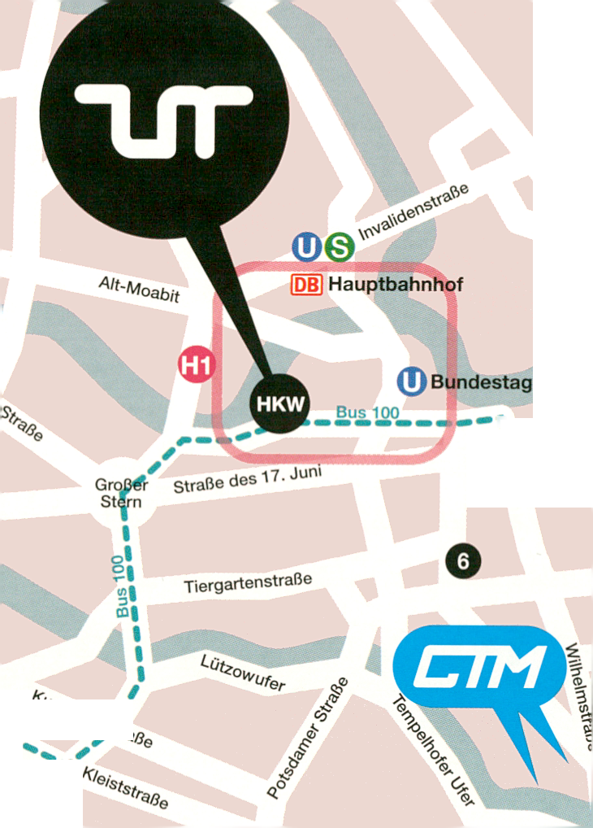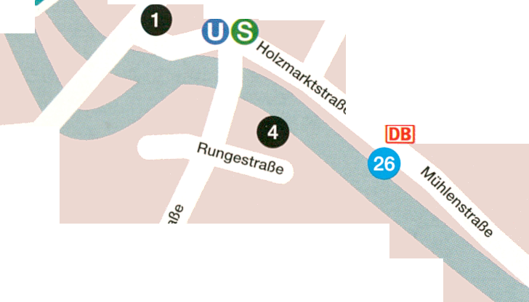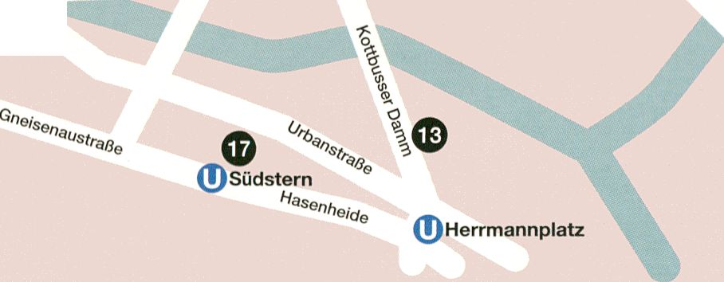
LQ
OT
BERLin TTlflP
Kaiserin-Augusta-Allee
‘V
©
Rieh
Plab
Bismarckstraße
2 Richard-Wagner-
tn Platz
0
0
© Ernst-Reuter-Platz
V
(0
Kantstraße
yi.ud⁰'¹
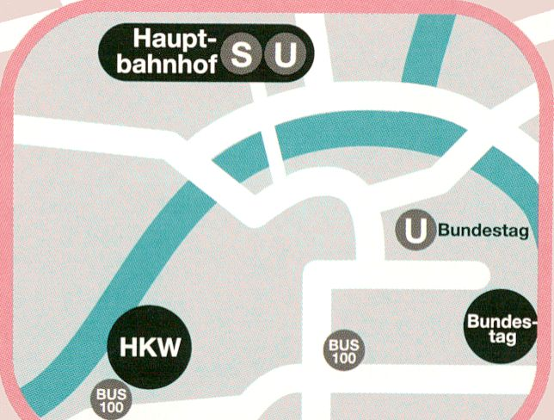
mmmhi
Leipziger Straße
\ u_{i}t_{S}täs^{i}i.^{L}a^{<J}-^{n}-—^
© Brandenburger Tor
0$

Rf
i
I Alex
0
._{a}s>e'£
Yorckstraße
®©
Jannowitzbrücke
®© 0
Ostbahnhof
■A//ee
(T)Hallesches Tor
0
0
0000
Gitschiner Straße © Kottbusser Tor
Blücherstr.


0
©
0
0
©
0
0
©
O
Haus der Kulturen der Welt
John-Foster-Dulles-Allee 10
.CHB
Dorotheenstraße 12
aquabitArt
Auguststraße 35
systM
Torstraße 68
c-base
Rungestraße 20
ConcentArt
Kreuzbergstraße 28
Embassy of Cañada,
Marshall McLuhan Salon
Ebertstraße 14
Galerie [DAM]Berlin
Tucholskystraße 37
Instituto Cervantes
Rosenstraße 18-19
Medienwerkstatt Berlin
Mariannenplatz 2
3 MMX Open Art Venue
Linienstraße 142/143
Neue Gesellschaft für
Bildende Kunst (NGBK)
Oranienstraße 25
Sophiensaele
Sophienstraße 18
0 Studio 70
Kottbusser Damm 70
© STYX Projects
Landsberger Allee 54
Substitut Raum für aktuelle
Kunst aus der Schweiz
Torstraße 159
Technische Universität
Berlin
Hörsaal A 053,
Fachgebiet Kunsgeschichte A 56
Straße des 17. Juni 135
© The Future Gallery
Hasenheide 56
_Vilem_Flusser_Archiv
Universität der Künste Berlin,
Grunewaldstraße 2-5
HAU 1 / HAU 2
Stresemannstraße 29 / Hallesches Ufer 32
© Berghain
Am Wriezener Bahnhof
Künstlerhaus Bethanien
Mariannenplatz 2
Festsaal Kreuzberg
Skalitzerstrasse 130
West Germany
Skalitzerstrasse 133
Monarch
Skalitzerstrasse 134
Paloma Bar
Skalitzerstrasse 134
.HBC
Kari-Liebknecht-Strasse
Maria am Ostbahnhof
An der Schillingbrücke
Motel One Berlin-Bellevue
Paulstraße 21,10557 Berlin
+49 (0) 30 39 06 33 40
berlin-bellevue@motel-one.com
AGON am Alexanderplatz
Mollstraße 4,10178 Berlin
+49 (0) 30 27 57 270
info@agon-alexanderplatz.de
0 Hotel DOMICIL
Kantstraße 111,10627 Berlin
+49 (0) 30 32 90 30
info@hotel-domicil-berlin.de
Public Transport to HKW
„Haus der Kulturen der Welt“
Bus 100
(S+U Zoologischer Garten - S+U Alexanderplatz)
U-Bahn 55, Bundestag
10 minutes walk
S+U Hauptbahnhof
15 minutes walk

BERLin TTlflP
TICKETS
Single Tickets / Einzeltickets
7,- / 5,- EUR film & video
7,- / 5,- EUR K1 talks
7,- / 5,- EUR conference, auditorium
7,- / 5,- EUR performances, HacKaWay
12,- / 8,- EUR performances, auditorium
Passes / Pässe
80,- / 45,- EUR tm festivalpass
105,- / 80,- EUR tm/CTM kombipass
25,- / 18,- EUR day pass
Accreditation / Akkreditierungen
15,- EUR press accreditation / Akkreditierung Presse
60,- EUR professional late accreditation /
Professional Nachakkreditierung
Late accreditations can only be obtained directly at
festival!
Nachakkreditierung erst wieder direkt beim Festival!
Venue / Veranstaltungsort
Haus der Kulturen der Welt
John-Foster-Dulles-Allee 10
10557 Berlin
Phone +49 - (0)30 - 39 78 71 75
Most direct stop / direkt zur Haltestelle: Haus der
Kulturen der Welt - Bus 100
[Buslinie S+U Zoologischer Garten < > S+U
Alexanderplatz]
10 min walk from stop: / 10 Min. Fußweg von Haltestelle:
Bundestag - U-Bahn 55
15 min walk from stop: / 15 Min. Fußweg von Haltestelle:
S+U Berlin Hauptbahnhof
S-Bahn: S3 / S5 / S7
Bahn + U-Bahn: RE1/2/3/4/5/7- RB14 U55
Tram + Bus: M85/TXL/120/123/142/147/245
transmediale Office
Klosterstraße 68
D-10179 Berlin
tel: +49 (0)30 24 749 761
fax: +49 (0)30 24 749 763
info[at]transmediale.de
Website
transmediale.de
twitter.com/transmediale
facebook.com/transmediale
youtube.com/user/Thetransmediale
artistic director | Stephen Kovats
administrative manager & finance | Christine Bernauer
administrative assistant & fundraising coordinator |
Susanne Bernstein
programme manager & research | Markus Huber
programme curators | Ela Kagel, Sandra Naumann,
Marcel Schwierin
assistant curator | Cara Bell-Jones
external curators | Adam Thomas, Michelle Kasprzak,
Daphne Dragona
programme team interns | Divan Jerome Boland,
Therese Breyer, Lena Loose, Verena Schwarz
satellites coordinator | Michelle O’Brien
project management | Syelle Hase
event management | Sophia Gräfe
guest services | Beckie Darlington
info counter | Ann-Christin Görtz
production | Sibylle Kerlisch
programme assistant & marketing coordinator |
Filippo Gianetta
editor | Anna-Sophie Springer
editorial assistant | Flora Schausberger
marketing & sponsoring | Clemens Lerche
press | Giannina Lisitano
press assistants | Pia Kohn, Natalie Meves
design | ® ruddigkeit corporate ideas -
Kristina Brasseler, Dirk Heider, Gianna Pfeifer,
Raban Ruddigkeit
festival trailer | Emilia Forstreuter, Sam Speckley, ®
festival architecture | raumlaborberlin
Andrea Hofmann, Francesco Apuzzo, Christof Mayer
with Anna Wulf, Laura Zachmann, Matteo Carli
photography | Jonathan Gröger, John Fass
video | Barbara Miirdter
streaming | serve-u
Website
development | einskommanull - Miez Flor,
Laura Oldenbourg, Sebastian Göbel
design | Laura Oldenbourg, ® ruddigkeit corporate ideas
coordination | Filippo Gianetta
Technical Support Thanks
serve-u - Phillip Siinderhauf, Andreas Buchholz,
Marc Klische
transmediale Advisory Board
Alex Adriaansens
Prof. Dr. Marie-Luise Angerer
Prof. Dr. Dieter Daniels
Jan Edler
Dr. Marie Cathleen Haff
Hortensia Völckers
Kulturprojekte Berlin GmbH | Moritz van Dülmen,
Katrin Dohne, Josefa Brunner, Uta Belitz, Kien Nguyen
Haus der Kulturen der Welt | Dr. Bernd Scherer,
Doris Hegner
transmediale is a project by Kulturprojekte Berlin GmbH
in cooperation with the Haus der Kulturen der Welt.
transmediale ist ein Projekt der Kulturprojekte Berlin
GmbH in Kooperation mit dem Haus der Kulturen der
Welt.
transmediale is funded by the German Federal Cultural
Foundation.
transmediale wird gefördert durch die Kulturstiftung des
Bundes.
Impressum
editor: Anna-Sophie Springer
translations: Janet Leyton-Grant, Anna-Sophie Springer
editorial assistant: Flora Schausberger
©2011
printed in germany
printing and binding: Seltmann GmbH Druckereibetrieb,
Ludenscheid
design: ® ruddigkeit corporate ideas - Kristina Brasseler,
Dirk Heider, Gianna Pfeifer, Raban Ruddigkeit
leaf images: Emilia Forstreuter
transmediale.de #tm11
CREDITS
iag

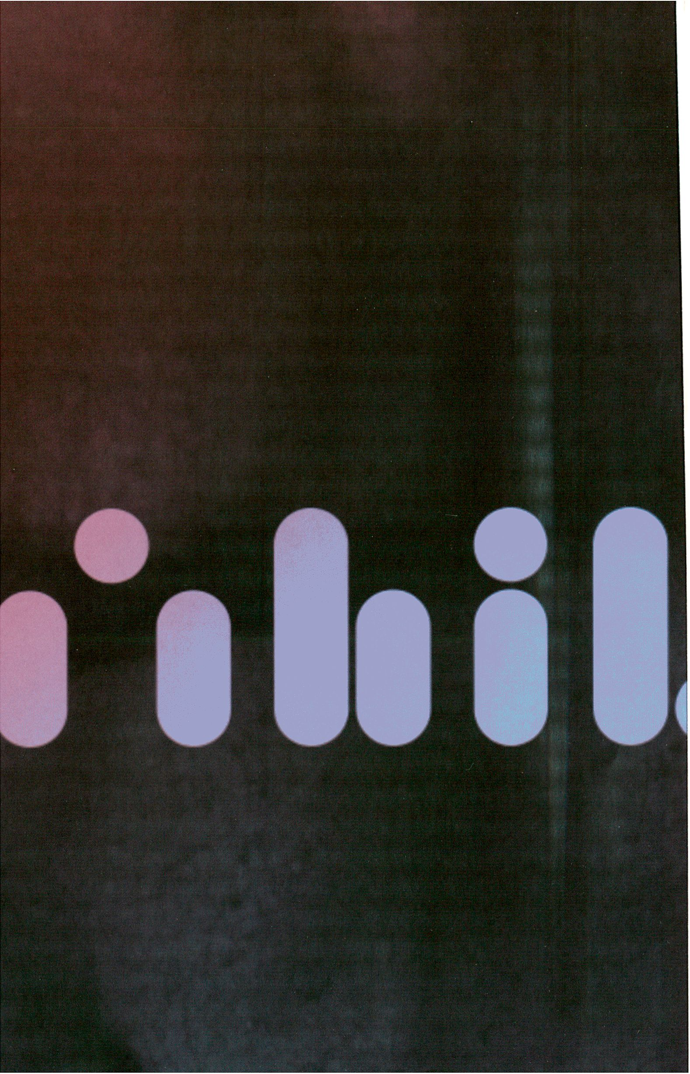

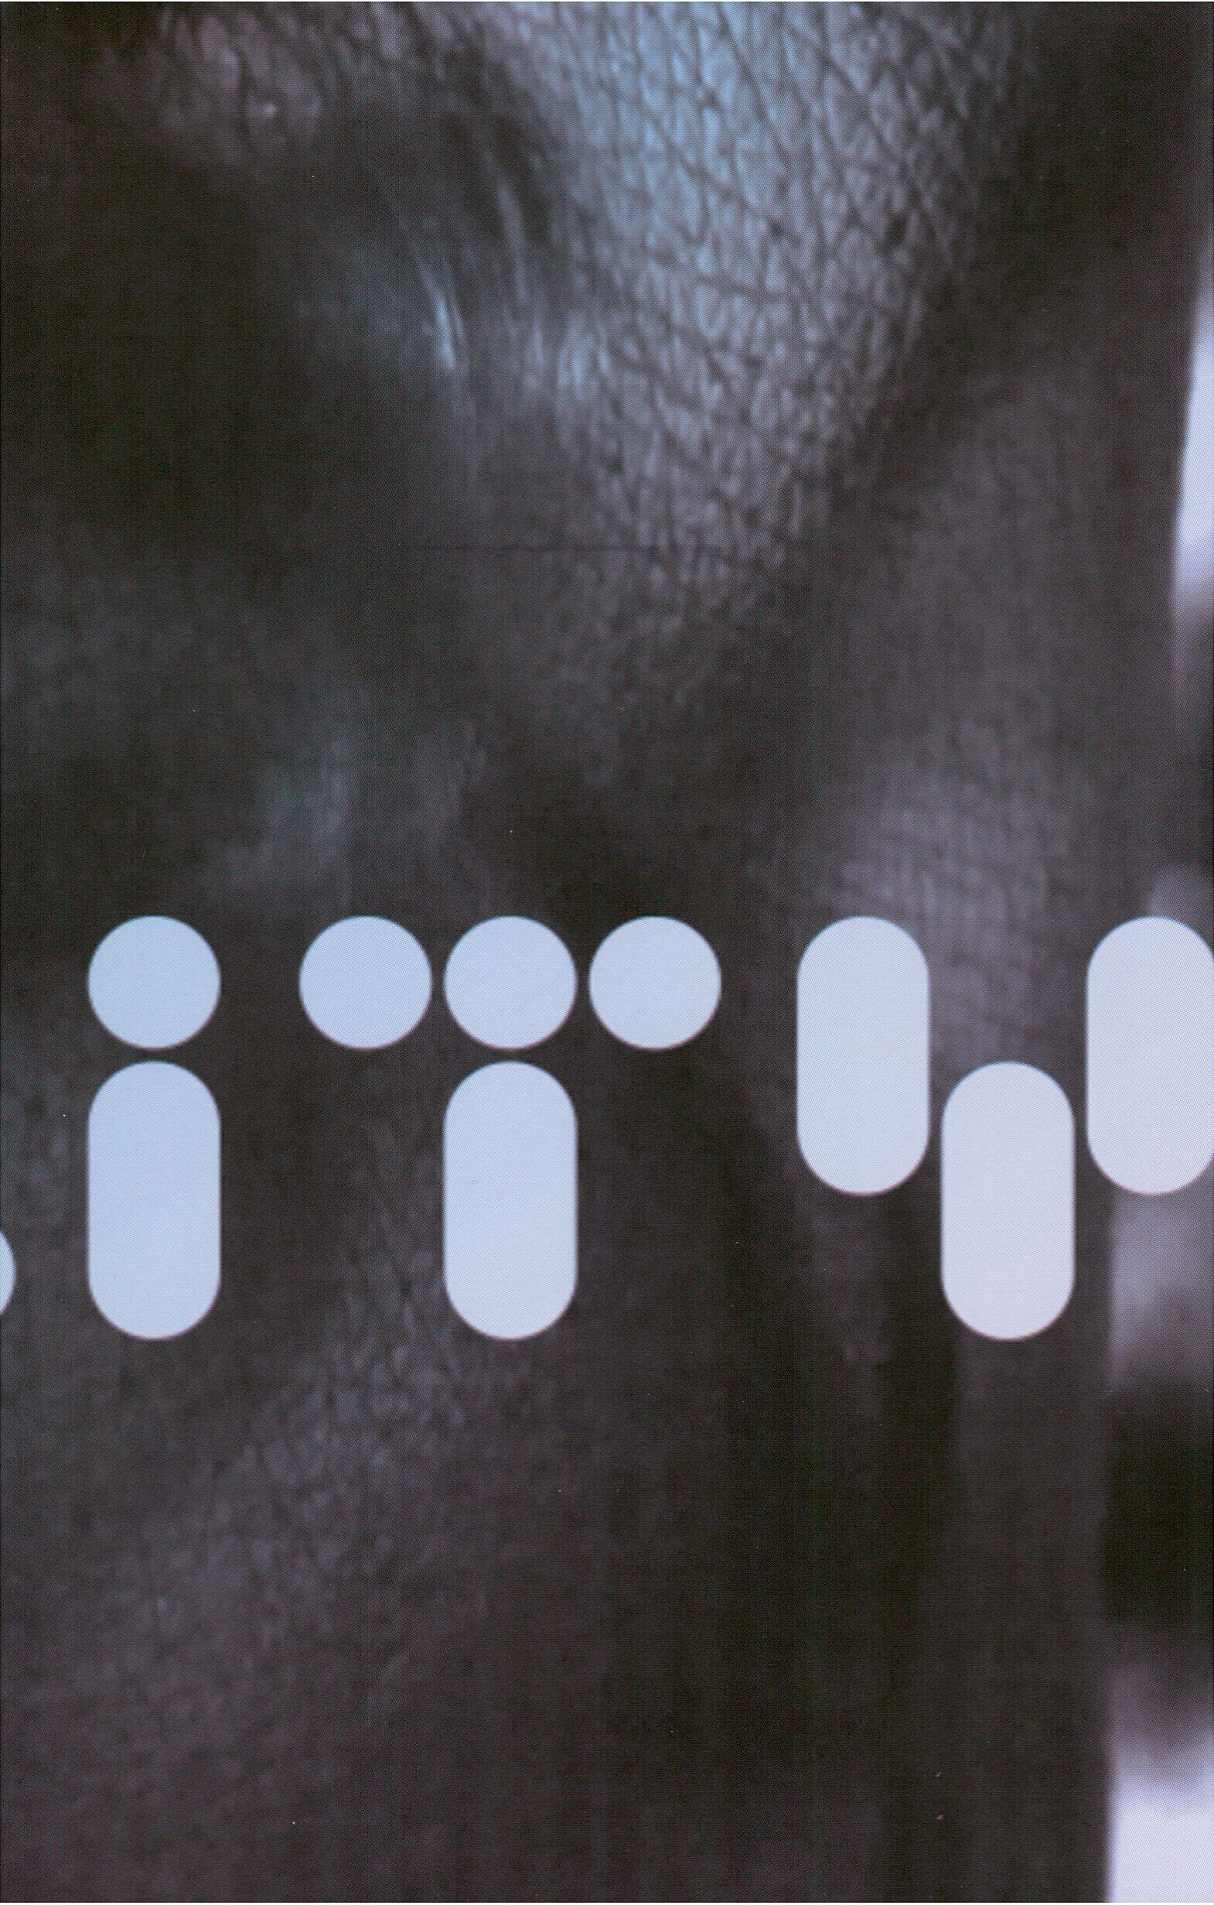

1*1
Botschaft von Kanada
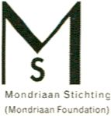Partners
HAUS
DER
KULTUREN
DER
WELT
in cooperation
u/ith
a project by
D KULTUR
PROJEKTE
BERLIN
transmediaie
is funded by
KULTURSTIFTUNG
DES
BUNDES
medienboard
Berlin-Brandenbura GmbH
Bundeszentrale für
politische Bildung

mozilla
FOUND ATI O N
^ SCHERING
^STIFTUNG
Königreich
.CHBiHa
Marshall
McLuhan
Salon

Sponsors
wWall
serve-u
TECHNI
i/uerkleitz
media Partners
arfA ö
DEBUG
www.de-bug.de
Deutschlandradio Kultur
MISSY
MAGAZINE
nt3n
Open. Web. Business.
H' dietageszeitung
radioGj~is^{rbb}
z/ffy BERLIN
tjniGICÜLT
Supportées
amiando I RrabShorts I bocca di bacco I Botschaft Spanien
Bureau du Québec à Berlin I CREPITE BERLin I Echoo Konferenz Dolmetschen
Geiertronic I Goethe Institut Daharta I Goethe-Institut Ägypten
Goethe-Institut nairobi I m-Beriin I Labor berlin I Ludic Interfaces I niîTIh
nODE - Forum for Digital Rrts I Österreichisches Kulturforum I trich.ca
Uniuersity of California, San Diego I U5_
Schutzgebühr: 5,00 Euro

Director will attend screening and Q & A
Director will attend screening and Q & A
Director will attend screening and Q & A

