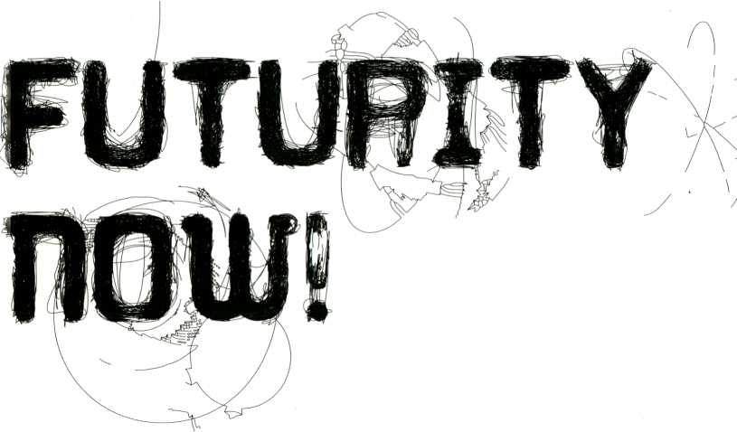
t£ansmediaie.lO ^
2-1 FEB 2010
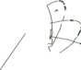

FUTURITY now
But my mind was too confused to attend to it, so with a kind of madness growing upon me, I flung myself into futurity.
H.G. Wells, 1895
2010 - a year synonymous with past images of the future. Much of 20th century society strove to depict 2010 as a shining example of a future framed by technological progress and social harmony.
But as 2010 arrives it is clear that global society is neither the utopia nor the dystopia traditionally presented in the fictions, architectures and theories of the future. Rather we have entered an era beyond futurist rhetoric, interwoven with the unstable and complex web of economic, political and cultural systems dependent on being perceived as ‘future worthy’ without having been there yet. With the ubiquity of digital systems, communications mobility and social media firmly entrenched as an intrinsic part of our cultural code, we see that what we used to think of as the future has caught up to us... and is experiencing an identity crisis.
Futurity examines what qualities we attribute to our understanding of the ‘future’ as a conditional and creative enterprise. FUTURITY NOW! invites you to create new templates for the future and ask not what the future has in store for us, but what is it that we have in store for the future?
Das Jahr 2010 steht für die Bilder, die sich die Vergangenheit von der Zukunft gemacht hat. Das ganze 20. Jahrhundert hindurch stellten Schriftsteller und Vordenker das Jahr 2010 als das leuchtende Beispiel einer Zukunft dar, die von technischem Fortschritt und sozialer Harmonie geprägt sein würde.
Aber nun ist 2010 Heute und es ist deutlich geworden, dass die Weltgesellschaft weder die Utopie noch die Anti-Utopie ist, die üblicherweise in diesen Zukunftsfiktionen, -architekturen und -theorien gezeichnet wurde. Stattdessen befinden wir uns in einer Zeit jenseits futurisierender Rhetoriken, jedoch geprägt von einem Netz aus wirtschaftlichen, politischen und kulturellen Systemen, die unbedingt .zukunftstauglich* wirken müssen, auch wenn dies unmöglich abzuschätzen ist.
Durch die Allgegenwärtigkeit digitaler Praxis und sozialer Medien, die als wesentlicher Teil unseres Lebens fest in unserem kulturellen Code verwurzelt sind, haben wir uns in unseren eigenen Zukunftsvorstellungen verfangen - und damit erlebt selbst die Zukunft nun eine Identitätskrise.
Futurity - Zukünftigkeit - ist ein Konzept, das untersucht, was .Zukunft* als bedingendes und kreatives Vorhaben sein kann. Das Motto FUTURITY NOW! ist eine Einladung neue Zukunftsmodelle zu bilden, bei denen es nicht darum geht, was die Zukunft für uns bereit hält, sondern was wir für die Zukunft bereit halten.
1

Introduction i
Schedules 4
Openings p. 4
Wednesday. 3 Feb p. 5
Thursday, 4 Feb p. 6
Friday, 5 Feb p. 7
Saturday, 6 Feb p. 8
Sunday, 7 Feb p. 9
HKW Map 10
Preface 12
Conference - Future Observatory 15
Futurity Long Conversation p. 16
Session i: Ideologies and Futures of the Internet p. 18
Session 2: Atemporality - A Cultural Speed Control p. 19
Session 3: Liquid Democracies p. 20
Salon 21
Salon Talks p. 22
Price and Value of Cultural Work p. 22
Phuturama p. 23
Creativity as an Economic Resource p. 24
Processual Media Art and Theory p. 24
Art 2.0 p. 25
Forms of Cultural Organisation p. 26
Which Organisation are you Shooting the Film for? p. 26
The Identity of Cultural Enterprises p. 27
Destination Moon p. 27
Invisible Cities p. 28
The Cultural Enterprise of the Future p. 28
Salon Projects p. 30
Feral Trade Café - Kate Rich p. 30
Manifest Utopia - Laboratoire Déberlinisation p. 30
VALU€S - l-Wei U p. 31
Artzilla - Tobias Leingruber p. 3¹
Media Facades Festival Europe 2010 - Susa Pop p. 32
FuckGoogle - F.A.T. Lab p. 32
Default To Public: Tweetscreen - Jens Wunderling p. 33
Longplayer - Jem Finer p. 33
Salon Workshops p. 34
The Basis of Free Culture p. 34
Free Software for Cultural Enterprises p. 34
Creative Business Models p. 35
Chaos and Structure p. 35
Topologies of a Future City p. 36
Wifi Camera Workshop p. 3⁶
Collaborative Futures Book Sprint p. 37
The Project Library p. 37
Film & Video 39
Media Personifications p- 40
Inner Wars p. 41
Agit-Prop, Punks and Poets p. 42
Short Fictions p. 43
Long Distance Transfers p. 44
Studies in Light and Space p. 45
Future Bodies p. 46
Man & Machine p. 47
Marineé: Der Schweigende Stern p. 48
The Succession of the Future p. 49
Hypno Media p. 50
Artist Index | 105
Map | 118
Credits | 120

Performance 53
Tintinnabulations - Charlemagne Palestine p. 54
Beyond the Rest - Benjamin Laurent Aman p. 55
VJ Set - aaajiao p. 55
Landschaft N0.2 - Matthias Fritsch, Shingo Inao, Marco Brosolo p. 56
cl_loop - Pe Lang p. 56
Pattern Recognition
Test Pattern - Ryoji Ikeda p. 57
Materia Obscura - Jürgen Reble & Thomas Kôner p. 57
Elektrolab - Rachida Ziani & Dewi De Vree p. 58
POWEr - artificel p. 58
It’s About When It Came Out - Lord Cry Cry p. 58
The Long Conversion - Sosolimited p. 59
Spectral Continuum Berlin 2010 - Charlemagne Palestine p. 59
Time Machine
self_resolution - Andrea Lange p. 61
La Chambre Des Machines - Martin Messier, Nicolas Bernier p. 61
raster.noton.unum p. 62
Myths of the Near Future p. 63
Exhibition - Future Obscura 65
data.tron (3 SXGA+Version) - Ryoji Ikeda p. 66
A Parallel Image - Gebhard Sengmüller p. 67
White Noise - Zilvinas Kempinas p. 68
The Space Beyond Me - Julius von Bismarck p. 69
From One To Many - Yvette Mattern p. 70
Panoramic Wifi Camera - Adam Somlai-Fischer, Bengt Sjôlén, Usman Haque p. 71
Optofonica Capsule - TeZ p. 72
The Inverted Cone - Julien Maire p. 73
Paparazzi Bots - Ken Rinaldo p. 74
Artvertiser - Julian Oliver, Clara Boj, Diego Diaz, Damian Stewart p. 75
The Invisible Stain - Alice Miceli p. 76
Award 79
transmediale.10 Award p. 79
Jury Statement p. 80
Coincidence Engines I 81II - [The User] p. 81
Chapter I: The Discovery - Félix Luque Sánchez p. 81
F.A.T. - Free Art And Technology Lab p. 82
Reconstitution - Sosolimited p. 82
Carnivorous Domestic Entertainment Robots - Auger-Loizeau & Zivanovic p. 83
Bicycle Built For Two Thousand - Aaron Koblin & Daniel Massey p. 84
Artificial Moon - Wang Yuyang p. 85
Buscando Al Sr. Goodbar - Michelle Teran p. 86
The Exception and the Rule - Brad Butler & Karen Mirza p. 87
Vilém Flusser Theory Award p. 88
Transactional Arts - Daniela Alina Plewe p. 88
There Must Be An Angel - David Link p. 88
Neuropower-Warren Neidich p. 89
Syjettes - Mina Lunzer p. 89
CTM 90
Satellites 93
Collegium Hungaricum Berlin (.CHB) p. 94
Instituto Cervantes p. 95
Marshall McLuhan Salon, S-Bahnhof Potsdamer Platz i p. 96
Hausradio and Resonance 104.4 FM / station melt p. 97
_Vilém_Flusser_Archiv p. 98
Deutsches Technikmuseum p. 98
c-base; betahaus p. 99
[DAM]Berlin; Substitut p. 100
Art Claims Impulse; The Future Gallery p. 101
Schering Stiftung, Sophiensaele p. 102
Landesvertretung NRW; Galerie Zero p. 103

TRANSMEDIALE SATELLITE EVENT OPENINGS
14 Jan
19:00 ScheringStiftung: Agnes Meyer-Brandis, Wolken-Kern-Scanner 16 Jan
19:00 Art daims Impulse: Reflective Interventions
- Jan
18:00 CTM Opening: Performance: Raphaël Isdant - A Battre
- Jan
19:00 S-Bahnhof Potsdamer Platz: Graham Smith INTERSECTION 19:00 substitut: Esquisses 19:00 The Future Gallery:
Better Brain: Projected Manifestations of Futurity
- Jan (Long Night of the Museums)
16:00 Instituto Cervantes: Félix Luque Sánchez - Chapter I: The Discovery 17:00 .CHB: [The User] - Coincidence Engines 1 & 2
16:00 [DAM]Berlin: GaMe!
19:00 Galerie ZERO: Hybrid Frequencies
- Feb
10:00 Marshall McLuhan Salon: Graham Smith - INTERSECTION II 17:00 c-base: PHUTURITYNOW!
19:00 Landesvertretung NRW: new talents - biennale koln
- Feb
9:00 Deutsches Technikmuseum - IT and Media Art
TRANSMEDIALE OPENING, TUESDAY, 2 FEB
17:45 Auditorium doors open
18:00 Opening HKW Auditorium
Dr. Bernd Scherer, Director of the House of World Cultures
Hortensia Volckers, Artistic Director of the German Federal Cultural Foundation
Stephen Kovats, Artistic Director, transmediale Prof. Dr. Herbert W. Franke, artist and writer
19:00 Performance, HKW Terrasse /Tiergarten Carillon
Charlemagne Palestine - Tintinnabulations For Tomorrow and Tomorrow, p. 54
Yvette Mattern - From One to Many - Laser installation ‘switch on’, p. 70
20:00 Exhibition opens
Future Obscura, p. 65
20:30 Performances, HKW Café Stage
aaajiao
Benjamin Laurent Aman, p. 55

Wednesday, 3 Feb
11:00 11:30 12:0012:3013:0013:3014:0014:3015:0015:3016:0016:3017:0017:3018:0018:3019:0019:30 20:0020:3021:00 21:30 22:0022:30
Pattern Recognition test pattern by R. Ikeda Materia Obscura by J. Reble & T. Këner, p. 57
wusmmmm
Media Personifications works by E. Pong, D. Campbell and others, p. 40
Inner Wars
works by B. Melhus, D. Gagnon and others, p. 41
KG553CM' PRICE and Value
of Cultural Work
J. Stapleton, K. Rich, l-Wei Li, B. Gottlieb, D. Kleiner, p. 22
mm.Essr
Phuturama
S. Gaycken, C. Heller, H. Logemann, N. Dolo§, M. Khaimzon, H.W. Franke, 0. Handlos, A. N. Shapiro, p. 23
The Bas»? qf free Culture
M. Thorne
(workshop for registered participants), p. 34
WjfLSAMERA
A. Somlai-Fischer, B. Sjolén (workshop for registered participants) p. 36
M. Fritsch, S. Inao, M. Brosolo p. 56
Future Obscura (open from 10:00) p.65
CL LOOP P. Lang p. 56
EcnEmgs Artvertiser Gallery Talk
Guided Tour F. L. Sánchez
p. 75 Instituto Cervantes
P- 95
Marshall McLuhan Lecture Graham Smith Canadian Embassy p. 96

■CEHE33HCBÍ
Lçbsbsst
MtrwTiï.nœ.
B0CB55Z5B8
■csaa—: nsm

■t.iiíu.i-mrar
Thursday, 4 Feb
ll:00 II3O 12:00 12:30 13:00 I33O 14:00 14:30 15:00 I53O l6:00 16:30 17:00 I73O I8æ0l8:30 19:00 I93O 20:0020:30 21:00 21:30 22U>022:30
POWER
performance by artificiel, p. 58
Creativity
as an Economic Resource A. Cameron, M. Pasquinelli, A. Somlai-Fischer, B. Lippe, M. Kühn, p. 24
Agit-Prop. Punks and Poets works from arabshorts.net, presented by R. Salti, p. 42
Short Fictions
works by I. Spengler, B. Melhus, M. Mattuschka and others P- 43
Processual Media Art Art 2.0
and Theory M. Fritsch, J. Wilkinson,
S. Jaschko, D. Plewe, M. M. Peternák, 0. Grau, p, |  | Lunzer,  24 |  | M. Teran, A. Koblin 81 D. 1 |. Wunderling, p.25 |  | Vlassey,
Free So | ftware For Cultural Enterpr |  |  | ISES
M. Beckendahl
(workshop for registered participants), p. 34
WiFi camera
A. Somlai-Fischer, B. Sjolen (workshop for registered participants) p. 36
Elektrolab D. de Vree and R. Ziani, p. 58
It’s About When It
Came Out
Lord Cry Cry p.58
Future Obscura (open from 10:00) p. 65
Artverthser Gallery Talk
Guided Tour [The User]

Friday, 5 Feb
11:00 11:30 12:0012:3013:00 13:30 14:0014:3015:00 15:30 16:0016:3017:00 17:30 18:0018:3019:0019:30 20:0020:3021:00 21:30 22:0022:30
Ml'ITTiU-WBM
Keynote The Futurity Lqnq Cqnversatipn
R. Barbrook D. Hemment, J. Finer, A. Cameron, K. Rinaldo, D. Kera, W. Neidich, G. Giannachi, S. Benford, J. Loizeau, T. Scholz, D. Link,
p. 16 M. Kuzmanovic, J. Oliver, T. Edler, R. Debatty, S. Neiman, J. Tang, A. N. Shapiro, jaromil, G. H. Iskandar, N. Triscott,
C. Christov-Bakargiev, p. 16
Long Distance Transfers works by K. Mirza & B. Butler, A. Rasdjarmrearnsook and others, p. 44
Studies in Light and Space works by A. Meyer-Brandis,
P. Medvedev, and others, p. 45

B. van Heur, M. Tazeoglu, T. Scholz, M. Liebe,
A. Kalandides, p. 26
mmmwm.
Which Qr<? AN..I5AT) on.. AREYOUSHfiflllNGTHE.
Film for?
D. Mende, NCS, S. Choi, p. 26
Creative business Models
S. Pop (workshop for to registered participants)
P- 35
EGEEZHÄ
wumnmoK

The Long Conversion
performance by Sosolimited, p. 59
Euium Qpscura (open from io;oq)
p. 65
Vilém Flusser Archiv p. 98
Futures Exchange
- Kagel, K. Rich, B. Gottlieb, l-Wei Li,
- A.T. Lab, p. 30
Spectral Continuum Berlin 2010 C. Palestine
Französischer Dorn, p.59

Saturday, 6 Feb
11:00 11:30 12:0012:30 13:00 13:30 14:0014:30 15:00 15:30 16:0016:3017:00 17:30 18:0018:3019:0019:30 20:0020:3021:00 21:30 22:0022:30

Ideologie? And
Futures qfThe Internet
C. Wolfram, G. Grameisberger, J. Rotich, F. Rötzer, M. Bunz, p. 18
ACULTURAL $PEED CONTRQL
B. Sterling, J. L de Vicente, A. Rose, M. Sandbothe,
S. Zielinski, p. 19
tm.iq Award
Ceremony
B. Kisseler, p. 79
Future Bodies
The Identity of cultural Enterprises M. Fritsch, C. Lerche,
T. Weiter, R. Haschka - Helmes, p. 27
works by R. Reynolds, E. Hwang and others, p. 46
Destination Moon
R. la Frenais, W. Yuyang, P. Medvedev, A. Meyer-Brandis, L. Zhenhua, p. 46
Man & Machines
works by D. Angerame,
U. Hörner 81 M. Antifinger, G. Rey and others, p. 47
Chaos And Structure
C. Kogler (workshop for registered participants) P- 35
Haim
IlmE-Maçhines
self_resolution by A. Lange, La Chambre des Machines by M. Messier and N. Bernier, p. 61
Exhibition
Future Obscura (open from 10:00)
p.65

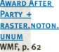

Sunday, 7 Feb
11:00 11:30 12:0012:3013:0013:3014:0014:3015:0015:3016:0016:3017:0017:3018:0018:3019:0019:30 20:0020:3021:00 21:30 22:0022:30
msnm
mcumirmsm
WMZEïïnJÊKL
Café Stage
Matinée
Per Schweigenoe Stern works by K. Maetzig, p. 48
Invisible Cities
V. Kunl, J.v.Bismarck, M. Howse, J. Oliver, A. Somlai-Fischer, p. 28
mm:
Future Obscura (open from 10:00)
p. 65
K—K
Liquid Democracies
T. Terranova, M. Pasquinelli, S. Lambert, S. Lobo, p. 20
Myths Of the Near Future performances by FM3_Zhang, Feng Mengbo, aaajiao, p. 63
The Succession ofthe Future works by K. Stoyanov, Lui Wei P- 49
The .Cultural Enterprise of
the Future
E. Kagel, M. Kasprzak, Li Zhenhua, p. 28
Hypno Media
works by A. Helmcke, eteam,
M. Kreifiler 81 M. Conrath, p. 50
eArts
$HQWÇA?E
p. 63

J

J

1
PI Ben Huang ~j| p.63

1

J

1

Restaurant
Theater
SAAL
Archive
Room
Studio
Gallery
Bookshop
Lower
*} .3 A
Foyer «
Ki/Salon
Main Entrance
m | • | ♦
m
Wardrobe |  | u_
 | « ® $ Project Library
* ♦ | »  » | # •
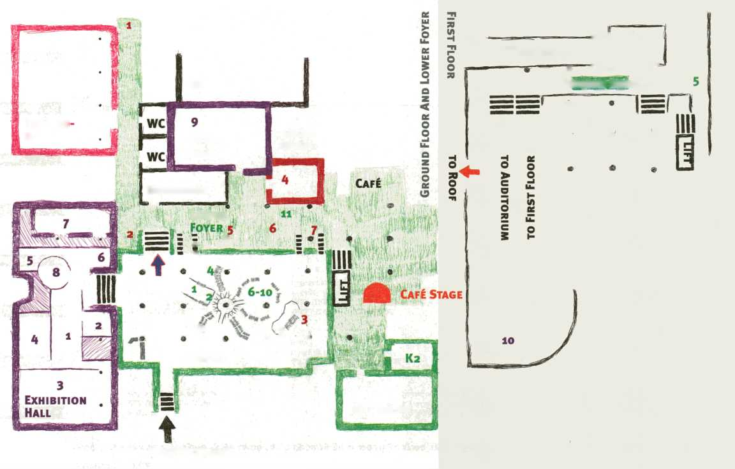
Exhibition Future Obscura
- Paparazzi Bots - Ken Rinaldo
- Artvertiser - Julian Oliver
- data.tron [3 SXGA version] - Ryoji Ikeda
- Parallel Image - Gebhard Sengmüller
- Optofonica Capsule-TeZ
- The Invisible Stain - Alice Miceli
- Inverted Cone - Julien Maire
- The Space Beyond Me - Julius von Bismarck
- White Noise - ¿¡Ivinas Kempinas
- Panoramic Wifi Camera - Adam Somlai-Fischer, Bengt Sjölen, Usman Haque
Salon - Futures Exchange
- Feral Trade Café - Kate Rich
- Free Culture Incubator Info
- FuckGoogle - F.A.T. Lab
- Default to Public: Tweetscreen - Jens Wunderling
- Longplayer - Jem Finer
- Wifi Camera Workshop - Adam Somlai-Fischer, Bengt Sjülén
- VALU€S - l-Wei Li
- Manifest Utopia - Laboratoire Deberlinisation
- Artzilla -Tobias Leingruber
- Media Facades Festival Europe 2010 - Susa Pop
- Intersection (excerpt) - Graham Smith
TRANSMEDIALE AWARD
- Bicycle Built for Two Thousand - Aaron Koblin, Daniel Massey
- Carnivorous Domestic Entertainment Robots - Auger-Loizeau & Zivanovic
- F.A.T. - Free Art and Technology Lab
- Buscando al Sr. Goodbar (Remix) - Michelle Teran
- Artificial Moon (Documentation) - Wang Yuyang
- Coincidence Engines I & II (Documentation) - [The User]
- Chapter I: The Discovery (Documentation) - Félix Luque Sánchez

FUTURITY NOW! began as a discussion around cacophonic systems and volatility
in the wake of the meltdown of global financial systems - the world’s first digital
storm. The mythical future-laden year of Arthur C. Clarke’s 2010 loomed seem-
ingly unattainable, as distant as the sci-fi fantasy it was penned to be. In the
accelerated hype of media multiplicators, collaboration statistics and networked
friends creating invisible communities it seemed that what we used to think of
being the future suddenly became passé! The paths of technological progress,
the ‘truth systems’ that mark our digital culture could no longer be set on auto-
pilot, and that the conditions for another form of future needed to be laid out.
FUTURITY NOW! is not about what will come, but how we have to re-consider our
past futures. The future has caught up with us, and now it is our task to define it...
transmediale acts as a connection machine for this debate, inviting artists, writers, researchers, critics and activists to Berlin’s House of World Cultures. Without the generous support of the German Federal Cultural Foundation, and agencies including the Medienboard Berlin-Brandenburg, the Federal Agency for Civic Education, as well as local partners including the Collegium Hungaricum Berlin, serve-u, the Marshall McLuhan Salon and the _ViU>m_Flusser_Archive this unique meeting joining the arts, sciences and industry wouldn’t be the leading global event it has become. As a challenge in the realisation of creative ideals transmediale is an intense team effort to which we welcome all our guests and participants!
Welcome - and launch yourself into Futurity ... Now!
f ■
Begin your festival with a special opening event featuring a rare laudatio by
celebrated computer arts pioneer, Herbert W. Franke, an extraordinary carillon
performance by Charlemagne Palestine, and the ‘switch-on’ of Yvette Mattern’s
spectacular laser installation From One To Many. The opening of the exhibition
Future Obscura curated by Honor Harger and AV sets by aaajiao and Benjamin
Laurent Aman kick off transmediale.10’s extensive performance programme in-
cluding Ryoji Ikeda, artificiel and Feng Mengbo among other great artists.
Keynotes by Bruce Sterling, Conrad Wolfram and Richard Barbrook along with
the unique Futurity Long Conversation highlight the Future Observatory,
transmediale.10’s conference. Phuturama, the Free Culture Incubator, award
screenings and projects, salons and workshops all consider new takes on what
^another concept of future could be!
Stephen Kovats
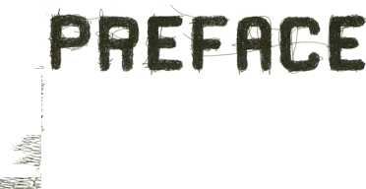
FUTURITY NOW! entstand aus einer Diskussion um Flüchtigkeit und kakofonische
Systeme als Folge der globalen Finanzkrise - dem weltweit ersten digitalen
Sturm. Arthur C. Clarkes mythisches, zukunftsgeladenes Jahr 2010 zeichnete
sich scheinbar unerreichbar ab, so weit entfernt eben wie eine schriftstellerische
Science-Fiction-Fantasie es ist. Angesichts des beschleunigten Hype medialer
Multiplikatoren und vernetzter Freunde, die unsichtbare Gemeinschaften grün-
den, schien, was wir bisher für die Zunkunft hielten ganz plötzlich passé! Die
Wege des technologischen Fortschritts, die Wahrheitssysteme, die unsere digi-
tale Kultur kennzeichnen, konnten nicht länger auf Autopilot weiterlaufen. Neue
Bedingungen für eine andere Art von Zukunft sind gefragt. Bei FUTURITY NOW!
geht es nicht um das Künftige, sondern darum, wie wir unsere vergangenen
Zukünfte neu denken müssen. Wir wurden von der Zukunft eingeholt und jetzt ist
es an uns, sie zu bestimmen ...
transmediale lädt Künstler, Autoren, Forscher, Kritiker und Aktivisten in das
Berliner Haus der Kulturen der Welt ein. Ohne die großzügige Unterstützung
durch die Kulturstiftung des Bundes, das Medienboard Berlin-Brandenburg,
die Bundeszentrale für Politische Bildung, sowie lokale Partner wie das
Collegium Hungaricum Berlin, serve-u, der Marshall McLuhan Salon und das
_ Vilém_Flusser_Archiv hätte dieses einzigartige Treffen von Kunst, Wissen-
schaft und Industrie nicht zu einer weltweit führenden Veranstaltung werden
können. Als eine Herausforderung an die Realisierung kreativer Ideale ist
die transmediale das Produkt intensiver Teamarbeit und wir laden alle Gäste
und Teilnehmer herzlich ein!
Willkommen in der Zukünftigkeit ... Jetzt!
Bei der Eröffnungszeremonie freuen wir uns ganz besonders auf den seltenen
Auftritt von Herbert W. Franke, Pionier der Computerkunst, sowie auf das Carillon
Konzert von Charlemagne Palestine und Yvette Matterns Installation From One To
Many am Berliner Nachthimmel. Die Eröffnung der von Honor Harger kuratierten
Ausstellung Future Obscura und audiovisuelle Performances von aaajiao und
Benjamin Laurent Aman leiten das transmediale.10 Performance Programm mit
Auftritten von Ryoji Ikeda, artificiel und Feng Mengbo u. a. ein. Keynotes von
Bruce Sterling, Conrad Wolfram und Richard Barbrook, sowie die Futurity Long
Conversation sind die Highlights von Future Observatory, der transmediale.10
Konferenz. Phuturama, der Free Culture Incubator, Award Screening und Projekte
Salons und Workshops beschäftigen sich mit anderen Zukunftsvorstellungen!


Stephen Kovats


n-iunol
> www.neural.it/subscribe.phtml
Neural is one of the most influential magazines about digital culture. Established in 1993 it publishes features, j interviews, essays and lots of reviews. Every month 190.000 unique users visit Neural.it and every four months ! 4000 copies of the new printed Neural issue are distributed worldwide in shops and public libraries. Neural subscribers ! get the magazine first and with exclusive gifts (dvds, catalogues, etc...), supporting a completely independent publisher, j
IS^{H}

Springerin

Abonnement
Jahresabo/4 Hefte (€ 39,00 Ausland zuzüglich Versandkosten)
Studentlnnenabo (€ 32,00 Ausland zuzüglich Versandkosten)
Folio Verlag Wien-Bozen Schönbrunnerstraße 31, A-1050 Wien T +43 1 581 37 08 F +43 1 581 37 08 - 20 E office@folioverlag.com

Einzelhefte
aus den Jahrgängen 1995 bis 1998 können,
sofern sie nicht vegriffen sind, über
die Redaktion bestellt werden, ab Jahrgang
1999 direkt über den Verlag.
Redaktion Springerin
Museumsplatz 1, A-1070 Wien
T +43 1 522 91 24
F +43 1 522 91 25
E springerin@springerin.at
www.springerin.at
14

CftflFEREnCE
FUTURE OBSERURTORY
Have we caught up with our notions of the future?
Future Observatory, the transmediale.io Conference, examines the limits, gaps and dysfunctions of the future as cultural object of projection and seeks to delineate possibilities and strategies to analyse our present (and its media). Media define how we judge our reality as it is. Via them we construct our views of time and space, in turn conditioning our approach to seeing and comprehending at a fundamental level. If our vision of the future is obsolete, what paths do society’s present state reveal? Which is the cultural code determining the future? The Conference will be kicked-off with the Futurity Long Conversation, a nine-hour long uninterrupted dialogue. In changing constellations 22 guests will discuss \ a multiplicity of utopias, projects and technologies crucial for our future today. j With the dialogue thus unfolding as an aesthetic, analytical and collaborative process it establishes an open space in which the audience can wander about freely between the disciplines of art, science and economy. Now that we have left the future behind, where do we go?
Haben wir unsere Vorstellung von der Zukunft eingeholt?
Unter dem Titel Future Observatory widmet sich die transmediale.10 Konferenz den Epistemologien, Grenzen und Dysfunktionen der Zukunft als kultureller Projektionsfläche. Future Observatory fragt nach Möglichkeiten und Strategien der (Medien-) Analyse unserer Gegenwart. Medien prägen unsere Sicht der Wirklichkeit. Durch sie konstruieren wir unsere Anschauungsformen von Raum und Zeit und bedingen auch grundlegend unsere Formen des Wahrnehmens urtd des Erkennens. So sind es gerade die Bilder, die wir uns von der Zukunft machen, die uns Auskunft über die Verfasstheit unserer Gesellschaft heute geben. Wie funktioniert der gesellschaftliche Code, der die Operation Zukunft ausführt? Eröffnet wird die Konferenz mit der Futurity Long Conversation. 22 Gäste werden in wechselnden Konstellationen über die Dauer von neun Stunden Projekte, Technologien und Utopien diskutieren, die jetzt schon unsere Zukunft bestimmen.
In der Futurity Long Conversation weitet sich der Dialog als ästhetischer, analytischer und kollaborativer Prozess zu einer Sonderzeitzone, in der das Publikum zwischen den Disziplinen der Kunst, Wissenschaft und Wirtschaft wandeln kann. Wir laden Sie ein, mit uns einen Blick auf die Struktur vergangener und gegenwärtiger Zukünfte zu werfen!

In cooperation with the Federal Agency for Civic Education.
In Zusammenarbeit mit der Bundeszentrale für politische Bildung.
Simultaneous translation German / English during the conference sessions 1-3 Simultanübersetzung Deutsch / Englisch der Konferenz Sessions 1-3

IMAGINARY FUTURES HETtmTOTM!»
Keynote: by Richard Barbrook(uk)
- fffT Futurity Long Conversation
The Futurity Long Conversation, a relay of one-to-one conversations, brings 22 leading artists, designers, theorists, journalists and media interventionists together to discuss, contextualise and explore the abstract and qualitative elements defining what we conceive of the future today. The format of the Futurity Long Conversation was developed in conjunction with the UK arts organisation Artangel and the Longplayer Trust, and inspired by the work of The Long Now Foundation, an international organisation crafting ways with which to perceive time and durational process in radically different and perhaps media technologically appropriate ways. In their approach, we are in a period which redefines the ‘now’ within a timespan of 10 000 years, altering our notions of future and the acceleration of progress and development. The event questions the predominant way in which ‘future’ finds its cultural roots at a point in history where the convergence of media technologies, communications mobility and means of simultaneity eclipse the 20th century rhetoric of the future.
Die Futurity Long Conversation - eine Aneinanderreihung von Zweiergesprächen - bringt 22 führende Künstler, Designer, Theoretiker, Journalisten und Medienaktivisten zusammen, um herauszuarbeiten, welche abstrakten und qualitativen Kriterien unseren heutigen Blick auf die Zukunft definieren.
Das Format der Futurity Long Conversation wurde in Zusammenarbeit mit The Longplayer Trust und der ebenfalls britischen Kunstorganisation Artangel konzipiert. Es basiert auf den Ideen der The Long Now Foundation, einer internationalen Organisation, die unser gegenwärtiges Bild von Zeitverlauf und dem Jetzt“ radikal neu - und vielleicht zu unseren heutigen Medientechnologien besser passend - denken will: Denn nach ihrer Ansicht befinden wir uns in einem 10 000 Jahre anhaltenden Jetzt¹, eine Vorstellung, die unseren traditionellen Zukunftsbegriff sowie unseren Sinn für Beschleunigung, Fortschritt oder Entwicklung vollkommen verändert. So stellt die Veranstaltung die Idee der Zukunft, wie sie bisher in der Kultur verankert war, just in einem Moment in Frage, in dem konvergierende Medientechnologien, mobile Kommunikation und zunehmende Gleichzeitigkeit die Zukunftsrhetorik des 20. Jahrhunderts zum Verblassen bringen.
Artangel commissions exceptional projects by outstanding contemporary artists. Often complex and difficult to produce, these artistic visions are unlikely to be undertaken by other arts bodies.
» Longplayer, p. 33 9 The Long Conversion, p. 59
9 Hausradio and Resonance 104.4 FM / station melt, p. 97
16

Jl Order of Appearance:
Drew Hemment & David Link
David Link & Jem Finer
Jem Finer & Alan N. Shapiro
Alan N. Shapiro & Ken Rinaldo
Ken Rinaldo & Tim Edler
Tim Edler & Maja Kuzmanovic
Maja Kuzmanovic & Joy Tang
Joy Tang &Jaromil
Jaromil & Gustaff Harriman Iskandar
Gustaff FIarriman Iskandar & Gabriella Giannachi
Gabriella Giannachi & Steve Benford
Steve Benford & Warren Neidich
Warren Neidich & Denisa Kera
Denisa Kera & Jimmy Loizeau
Jimmy Loizeau & Régine Debatty
Régine Debatty & Nicola Triscott
Nicola Triscott & Andy Cameron
Andy Cameron & Julian Oliver
Julian Oliver & Carolyn Christov-Bakargievg
Carolyn Christov-Bakargiev& Susan Neiman
Susan Neiman & Drew Hemment
The conversants constellation reflects the structure and confirmations as per l December 2009. Shifts and changes until the festival are likely! Please consult transmediale.de for the final line-up.
17

¿'fgf jgyfyyg Session i: Ideologies and Futures of the Internet
Ideologien und Zukünfte des Internets

gSEgSBEEft
Keynote: Conrad Wolfram (uk) - Wolfram Alpha: Information, Computation and the New Era of Knowledge
Participants: Juliana Rotich (ke), Gabriele Grameisberger (de), Florian Rotzer (de) Moderator: Mercedes Bunz (de)
The best way to predict the future, is to invent it!
Alan Key 1971.
One of the potentials of the new media technologies is to change the ways in which knowledge is produced and communicated. The indétermination of how media are being used upon their introduction is a “utopian and political factor” (Mercedes Bunz).
The current technological, cultural and social quality of what we refer to as the Internet, demands that we rethink the most fundamental elements of our cultural identity, namely human communication, interaction and interrelation. We live in a time in which diverse cultures can virtually at any time enter into mutual exchange, dialogue or cooperation, something not possible without the present digital technologies. Having arrived in the technological future we are facing the responsibility to redefine its social and cultural application.
Which ideologies and notions of the future will emerge from the introduction, application, rearrangement and expansion of the Internet as “twin phenomenon of technology and society” (Dirk Baecker)?
Das Potential neuer Medien(-technologien) besteht u.a. darin, die Art und Weise zu verändern, wie wir Wissen produzieren und kommunizieren. In dieser Unbestimmtheit zwischen der Einführung von neuen Medien und ihrer Anwendung liegt ein „utopisches und politisches Moment“ (Mercedes Bunz).
Die gegenwärtige technologische, kulturelle und soziale Qualität dessen, was wir als Internet bezeichnen, erfordert es, die Basiselemente unseres kulturellen Selbstverständnisses - menschliche Kommunikation, Interaktion und Interrelation - neu zu denken. Wir erleben allgegenwärtigen Austausch, Dialog und Zusammenarbeit zwischen verschiedenen Kulturen, was ohne die gegenwärtigen digitalen Technologien nicht möglich wäre: Wir sind in der Zukunft der Technologie angekommen, nun haben wir die Verantwortung, für ihre soziale und kulturelle Anwendung zu sorgen.
Welche sind die Ideologien und Zukunftsmomente, die sich mit der Einführung, Anwendung, Umstellung und Erweiterung des Internets als „Doppelphänomen von Technik und Gesellschaft ergeben“ (Dirk Baecker)?
18

QBMCSflBBEBCrSESSION 2: ATEMPORAUTY - A CULTURAL SPEED CONTROL
Atemporalität- Ein kultureller Tempomat
Keynote: Bruce Sterling (us) - Atemporality
Participants: Alexander Rose (uk), Siegfried Zielinski (de), Mike Sandbothe (de)
Moderator: José Luis de Vicente (es)
Henry DeTamble has a genetic disorder known as “chrono-lmpairment” that causes him to time travel unpredlctably. The different dimensions of past, present and future flow into each other, creating a state of atemporality.
The speed of our society is constantly increasing in terms of processes, logistics and media, causing the present to “shrink”. We are experiencing the dissolution of meaningful frameworks in a similar way as Henry DeTamble: in politics, the intervals of planning and acting are reduced to the duration of a legislative period and in post-industrial economics volatile unpredictability has come to replace regular traits of growth and stability. Progress as the paradigm of modernity has been replaced by the continuous modulation of events. If progress is to go beyond the banal indulgences that give rise to a never-ending array of car shell designs then we need to analyse our present time with regard to its aesthetics and its media. The structure of the future has changed, and with it our sense of time. Are we running out of a future as a resource for growth, progress and stability? Has our cultural cruise control become defective?
Henry DeTamble leidet an einem Gendefekt, bekannt als „Chrono-lmpairment“, der ihn unkontrollierbar durch die Zeit reisen lässt. Die unterschiedlichen Dimensionen von Vergangenheit, Gegenwart und Zukunft fließen ineinander und bilden einen Zustand der Zeittosigkeit.
Die mediale, logistische und operative Geschwindigkeit unserer Gesellschaft nimmt ständig zu und bewirkt einen Effekt der Gegenwartsschrumpfung. Ähnlich wie Henry DeTamble erleben wir die Auflösung sinnstiftender Rahmungen: Politische Planungs- und Handlungsintervalle schrumpfen auf die Dauer von Wahlperioden, die postindustrielle Wirtschaft ist nicht länger durch Wachstum und Stabilität geprägt, sondern durch volatilen, unvorhersehbaren Wandel. An die Stelle des Fortschritts als Paradigma der Moderne tritt die andauernde Modulation aller Ereignisse. Wenn Fortschritt mehr sein soll als das Re-Design bereits vorhandener Fahrzeugpaletten, benötigen wir eine ästhetische und mediale Analyse unserer Gegenwart. Die Struktur der Zukunft und mit ihr unser temporales Bewusstsein haben sich geändert. Geht uns Zukunft als Ressource für Wachstum, Fortschritt und Stabilität aus? Ist unser kultureller Tempomat defekt?
19

I]-¡‘TW*\¡gflBPEÜ SESSION 3: Liquid Democracies
Flüssige Demokratien
Participants: Matteo Pasquinelli (it), Steve Lambert (us), Sascha Lobo (de)
Moderator: Tiziana Terranova (it)
To raise a question about the future always also implies to ask for the actualisation of the political and, in particular, ethical concepts for the society that we live in today. We are about to lose our operational sense for ethics, politics and culture. Rather, we see ourselves confronted with a depersonalised politics and a ‘desubjectified’ communication as the result of two factors: the disappearance of the political body with institutions capable of acting on the one hand; and increasingly faster digital social media tools that reduce the space for reaction and reflexion on the other hand. This is a moment of crisis where we must think about the role of social media.
Due to the recent events in which social networking sites have replaced traditional news coverage it seems worthy to closely examine the ‘radical’ role of tools like Twitter and Facebook as ‘revolutionary’ media. Are we dealing with a new force, a new social mechanism for the exchange of information, a new truth? Or are we only listening to a new siren song?
Die Frage nach der Zukunft ist auch immer eine Frage nach der Aktualisierung politischer und vor allem ethischer Konzepte für die Gesellschaft, in der wir heute leben. Wir sind im Begriff, unser operatives Konzept für Ethik, Politik und Kultur zu verlieren. Stattdessen sehen wir uns mit einer körperlosen Politik und einer desubjektivierten Kommunikation konfrontiert, bedingt einerseits durch den Verlust des politischen Körpers und seiner handlungsfähigen Institutionen, andererseits durch die soziale Geschwindigkeit digitaler Medien und Tools, die den Reaktions- und Reflexionsraum verkürzt. Wir sind an einem Moment, an dem wir einige Überlegungen über die fluide Beschaffenheit sozialer Medien und die individuelle ethische und politische Verantwortung anstellen sollten.
Angesichts der Auswirkungen der jüngsten Ereignisse, in denen Social Networking die traditionelle Berichterstattung verdrängt hat, lohnt es sich, die .radikale“ Rolle von Werkzeugen wie Twitter und jüngst auch Facebook als .revolutionäres¹ Medium näher zu betrachten. Haben wir es mit einer neuen Kraft, einem neuen sozialen Mechanismus für den Informationsaustausch, mit einer neuen Wahrheit zu tun? Oder lauschen wir nur einem neuen Sirenengesang?
20

iff
IM
\ The transmediale.io Salon consists of three interdisciplinary strands - talks,
projects and workshops - exploring FUTURITY NOW!. Besides the traditional
, lectures in Ki at the HKW, participatory projects by international media artists
r and activists such as Kate Rich or F.A.T. Lab will be presented throughout the
. building’s foyer. Most of them will take place within an adventurous Futures
Exchange that was commissioned for transmediale.io and created by Berlin
Wifav architects Raumlabor. , •
. _{v} D.I.Y. and collective research of ideas are also at the core of the talks and artist-
^{L} ^ 'ied projects and workshops offered within the Free Culture Incubator, a set of
'if interlinked, public and participatory sessions led by Ela Kagel. This project will
bring together stakeholders from the arts, science and business sectors to work
on a business model for a cultural enterprise of the future.
Im transmediale.io Salon koexistieren diesmal drei interdisziplinäre Bereiche
fM nebeneinander. Ein gemischtes Programm aus Vorträgen, laufender Projekt-
ärbeit und Workshops beleuchtet das Festival-Thema FUTURITY NOW!. Neben
den traditionellen Diskussionrunden im Ki des HKW, präsentiert der für
transmediale.io in Auftrag gegebene und von dem Berliner Architektenbüro

Raumlabor realisierte Futures Exchange im Foyer verschiedene medienakti-
vistische, partizipatorische Projekte wie Kate Richs Feral Trade Café oder F.A.T.
Labs FuckGoogle.
Um D.I.Y. und kollektives Ausbrüten von Ideen geht es auch in den Talks und
spannenden, von Künstlern geleiteten Workshops und Projekten des Free
Culture Incubator, einem ganzen Komplex partizipativer Veranstaltungen unter
der Leitung von Ela Kagel: Sie hat Experten an den Schnittstellen von Kunst,
r Wissenschaft und Wirtschaft eingeladen, auf der transmediale.io gemeinsam
ein Modell für das Kulturunternehmen der Zukunft zu entwickeln.
&
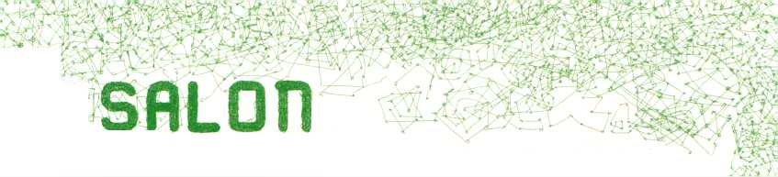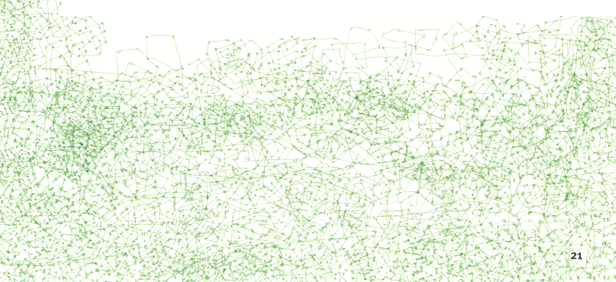
lH? Salon Talks
Positioning the future as a meme ready for redefinition, eleven transmediale.io Salon Talks will bring together artists, theoreticians and specialists in a forum for open dialogue in order to address the implications of FUTURITY NOW! across a multitude of artistic platforms, diverse cultures and societal backgrounds.
In insgesamt li transmediale.io Salon Talks wird die Zukunft als ein Mem - also ein aktiv gestaltbares, kulturelles Verhaltenselement - betrachtet. Künstler, Theoretiker und Experten werden angesichts einer Vielzahl künstlerischer, kultureller und gesellschaftlicher Plateaus über die Bedeutung von FUTURITY NOW! diskutieren.

Price and Value of Cultural Work m»
Moderation: Jaime Stapleton (uk)
Participants: Kate Rich (uk), l-Wei Li (tw/de), Baruch Gottlieb (ca/de), Dmytri Kleiner (de)
What is the currency for the cultural enterprise of the future? Cultural producers and artists produce a multiplicity of values, most of which are immaterial. It is difficult to translate cultural values into adequate market values: how do you determine the economic value of cultural work? Which currency systems are available here? And, vice versa: how much is culture actually worth for us today?
Welche Währung hat das Kulturunternehmen der Zukunft? Kulturarbeiter und Künstler produzieren eine Vielfalt von Werten von zum Großteil immaterieller Natur. Schwierig wird es, wenn kulturelle Werte in adäquate Marktpreise übertragen werden sollen: Wie ermittelt man den ökonomischen Wert von kultureller Arbeit? Welche Währungssysteme stehen uns hierbei zur Verfügung? Und, umgekehrt gefragt: Wieviel ist uns Kultur heute eigentlich wert?
# Part of the Free Culture Incubator.
9 Futures Exchange: Feral Trade Cafe, p. 30 9 Futures Exchange: VALU€S, p. 31 9 Futures Exchange: Manifest Utopia, p. 30
22

<ta®@B!8ER3EE phuturama
Sub-Konferenz zu spekulativem und fiktionalem Design

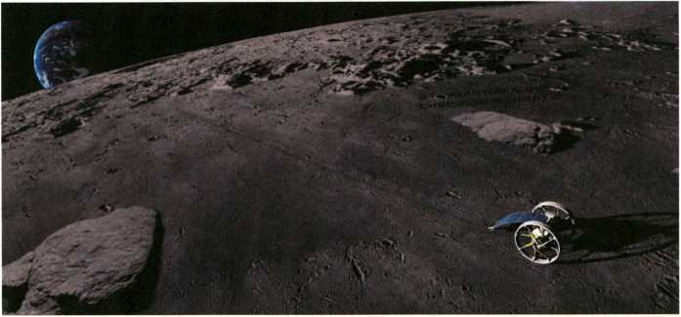
c-base Open Moon Google Lunar X-Prize Team: Rendering C-ROVE-i - Expedition Moon Rover, © Marten Suhr, Christian Bennat
Moderation: Sandro Gaycken (de)
Participants: Herbert W. Franke (at), Christian Heller (de), Holger Logemann (de),
Oliver Handlos (de), Neven Dolos (de), Alan N. Shapiro (us), Michael Khaimzom (ru / il)
PHUTURAMA invites ‘Visual Futurists’ - designers and artists from various branches of media and production - to discuss whether and how a growing picture power of speculative, futuristic or fictional design impacts the design of the ‘real’ world. Film production designers, game developers, SciFi authors, comic artists and visionary car designers encounter futurologists,and professionals meet SciFi activists and fans.
PHUTURAMA lädt .Visual Futurists’ - Designer und Künstler aus verschiedenen Medien- und Produktionsbereichen - ein, darüber zu diskutieren, welchen Einfluss die Bildmacht von spekulativem, futuristischem und fiktionalem Design auf das ,reale* Industriedesign ausübt: Film- Production-Designer treffen auf Spieleentwickler, SF-Autoren auf Comiczeichner, visionäre Automobildesigner auf Futurologen; Profis auf Aktivisten des einflussreichen SF-Fandom.
PHUTURAMA is curated by Gregor Sedlag (conceptioneer, c-base, Berlin). PHUTURAMA will be held in German.
» Futurity Long Conversation, p.i6
23

iTEf^ ffl! jStf Creativity as an Economic Resource l.'fll
Moderation: Andy Cameron (uk)
Participiants: Matteo Pasquinelli (it), Adam Somlai-Fischer (hu), Barbara Lippe (at),
Markus Kühn (de)
Due to the economic crisis, the creative industries have been highlighted by politicians as a growth market soon to outperform the car industry. We ask: in which way has this new framework changed the relation between art and capital? Can there be an exchange at eye level? What are the preconditions for a cooperation?
Spätestens seit Beginn der Wirtschaftskrise ist die Kreativindustrie endgültig zum Standortfaktor geworden. Politiker schwärmen von einem neuen Wachstumsmarkt, der bald die Automobilindustrie überflügeln soll. Wir fragen: Wie sehen die veränderten Rahmenbedingungen im Verhältnis zwischen Kunst und Kapital aus? Kann es hier eine Kommunikation auf Augenhöhe geben? Und was sind die Voraussetzungen für eine Kooperation?
Part of the Free Culture Incubator » Panoramic Wifi Camera, p. 71 » Futurity Long Conversation, p. 16

-f TI Processual Media Art and Theory 1T?i>
Moderator: Susanne Jaschko (de)
Participants: Miklös Peternäk(hu), Oliver Grau (de), Mina Lunzer (at), Daniela Alina Plewe (de)
Having arrived in the 21st century, processes have become one of the major paradigms and creative strategies of contemporary art and design. We are confronted with art that performs itself in a continuous flux. These works reject traditional ways of how art is perceived. Instead the works demand a persistent, perpetual and repeated observation.
This Salon Talk focuses on possible models and strategies with which processes that surround us in art, science and everyday life can be read, described or recorded.
Im 21. Jahrhundert angekommen, stellen Prozesse in Kunst und Design die paradigmatischen kreativen Strategien dar. Diese in ständigem Fluss befindliche Kunst stellt traditionelle Auffassungen von Kunst fundamental in Frage und verlangt vielmehr eine beharrliche, anhaltende und wiederholte Beobachtung.
ln diesem Salon Talk geht es um mögliche Modelle und Strategien, wie wir die Prozesse, die uns in Kunst, Wissenschaft und Alltag gleichermaßen umgeben, lesen, beschreiben oder aufzeichnen können.
» Vilem Flusser Theory Award 2010, p. 89 ~B Project Library, p. 37
24

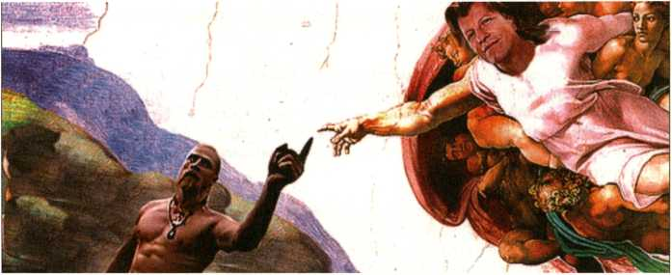
Technoviking reaction from the internet “Creation of Technoviking”, sampled by Matthias Fritsch
Moderator: Matthias Fritsch (de)
Participants: Michelle Teran (ca), Jens Wunderling(de), Jamie Wilkinson (us), Aaron Koblin & Daniel Massey (us)
Social networks in the so-called Web 2.0, traditional circles of friends, cultural and economic referential systems alike seem to always already generate a ‘creative material’ which artists use in different ways for their works. The panel Art 2.0 focuses on different strategies of artistic appropriation such as crowdsourcing, the direct invitation of a group of people to participate in an artwork, or the retroactive gathering and recycling of foreign contents and forms.
The invited artists will present selected works which articulate new approaches towards authorship and intellectual property as well as towards the interaction between individuals and communities.
Soziale Netzwerke im sogenannten Web 2.0, herkömmliche Freundeskreise, kulturelle und ökonomische Referenzsysteme scheinen immer schon aus sich heraus ein .kreatives Material* zu generieren, das Künstler auf verschiedene Art und Weise für ihre Arbeiten verwenden. Innerhalb des Panels Art 2.0 werden unterschiedliche Strategien der künstlerischen Aneignung wie .Crowdsourcing“, die direkte Aufforderung einer Gruppe von Menschen zur Mitarbeit an einer künstlerischen Arbeit, bis hin zum nachträglichen Sammeln und Recyclen fremder Inhalte und Formen diskutiert.
Die eingeladenen Künstler werden ausgewählte Arbeiten präsentieren, an denen sich ein neuer Umgang mit Autorenschaft, geistigem Eigentum und die Interaktion von Individuen mit Communities diskutieren lassen.
* Bicycle Built For Two Thousand, p. 84
- Buscando alSr. Goodbar, p. 86 » Landschaft No.2, p. 56
® Futures Exchange: F.A.T. Lab, p. 32 » Futures Exchange: Default to Public, p. 33
25

HüTtfl flForms of Cultural Organisation XSi
Moderation: Bas van Heur(nl)
Participiants: Mustafa Tazeoglu (de), Ares Kalandides (de/gr), Trebor Scholz (de/us),
Michael Liebe (de)
“Well, I have this project...” - this is how many stories around independent, creative labour begin. Cultural forms of organisation hardly ever develop on the basis of strategic considerations but rather cluster around the individual needs of a specific project. How is it possible to build sustainable structures in spite of such unreliable dynamics? Which models of organisation make sense in the field of art and the creative industries? And, most importantly: how will the cutural enterprise of the future look like?
„Ich hab‘ da ein Projekt...“ - so beginnen viele Geschichten rund um selbständige, kreative Arbeit. Kulturelle Organisationsformen entstehen selten auf der Basis einer strategischen Überlegung, sondern bilden sich meist um aktuelle Projektbedürfnisse herum. Wie schafft man es, in dieser Dynamik überhaupt eine nachhaltige Struktur aufzubauen? Welche Organisationsmodelle machen im Kunst- und Kulturbetrieb unter welchen Voraussetzungen Sinn? Und, die wichtigste Frage: Wie wird das Kulturunternehmen der Zukunft aufgestellt sein?
# Part of the Free Culture Incubator Futurity Long Conversation, p. 16 M A MAZE. Interact - Music Games Exibition, p. 90

Which organisation are you shooting the film for?
Moderator: Doreen Mende (de)
Participants: no.w.here, Brad Butler & Karen Mirza (uk), Nyein Chan Su (mm),
Sun-Ju Choi (de/kp)
Providing a forum in which to discuss concerns regarding artistic projects realised in Asia and shown in Europe, this Salon Talk takes its title from NCS’s recent film Near Mandalay.
After a panel-related screening, the relationship between ‘here’ and ‘elsewhere’ provides a point of departure to reflect on the (im)possibitities of shifting spaces as well as on the politics of image production. The panel will also investigate the specific political conditions and impact created through the presentation of these projects in a European art festival such as transmediale.
In diesem Salon Talk geht es um asiatische Kunstprojekte, die in Europa gezeigt werden. So ist auch der Titel treffend ein Zitat aus NCS’ jüngstem Film Near Mandalay.
Im Anschluss an ein Screening zum Thema, bildet das Verhältnis von ,Hier‘ und .Anderswo' den Ausgangspunkt für eine Reflexion über die (Un-)Möglichkeiten, zwischen Orten zu wechseln, sowie über die Politik der Bildproduktion. Vor dieser Fragestellung wird die Diskussionsrunde auch die politischen Auswirkungen untersuchen, wenn diese Projekte im Rahmen europäischer Kunstfestivals wie der transmediale gezeigt werden.
S Long Distance Transfers, p. 44 m The Exception and the Rule, p. 87
26

The Identity of Cultural Enterprises 3
Moderator: Inga Wellmann (de)
Participants: Matthias Fritsch (de), Regine Haschka-Helmer(de), Clemens Lerche (de),
Tonia Weiter (de)
Each great brand needs its own culture for identity formation. Do cultural projects analogously have to become a brand too in order to attract a larger audience?
Whilst traditional enterprises conjure up their corporate identity, the creative sector proudly points to its heterogeneity. Cultural producers however must find a language with which they can reach the public and be economically successful. How much corporate identity does a cultural enterprise need - and how does one communicate this identity?
Jede große Marke braucht ihre eigene Kultur um identitätsstiftend zu sein. Müssen dann umgekehrt Kulturprojekte auch zu einer Marke werden, um überhaupt ein breites Publikum zu finden? Während traditionelle Unternehmen ihre Corporate Identity heraufbeschwören verweist die Kreativbranche lustvoll auf ihre Heterogenität. Dennoch brauchen Kulturproduzenten eine Sprache, mit der sie die Öffentlichkeit erreichen und letzten Endes auch wirtschaftlichen Erfolg haben. Wieviel Corporate Identity braucht ein Kulturunternehmen - und wie kommuniziert man diese Identität nach Außen?
% Part of the Free Culture Incubator S Art 2.0, p. 25 'm Landschaft No.2, p. 56

tr-1 Destination Moon
E3ö
Moderator: Rob La Frenais (uk)
Participants: Pavel Medvedev (ru), Agnes Meyer-Brandis (de), Wang Yuyang (cn), Li Zhenhua (cn)
The title of the panel refers to the seminal 1958 novel Destination Moon by Robert Heinlein, which helped develop the popular mythology of the Moon. This Salon Talk features presentations by artists shown in transmediale.10 whose work engages with the past, present and future of the moon.
This Salon Talk is hosted by Rob La Frenais, curator of The Arts Catalyst. Their future exhibition project Republic of the Moon will investigate humanity’s relationship with the moon, both in terms of cultural meaning and the possible return by humans in spacecraft to the moon in a new global space race.
Der Titel der Runde verweist auf den Roman Endstation Mond von Robert Henlein (1958), der grundlegend zum populären Mythos Mond beigetragen hat. Dieser Salon Talk präsentiert Künstler, die sich in ihren auf der transmediale.io gezeigten Arbeiten mit der Vergangenheit, Gegenwart und Zukunft des Mondes beschäftigen.
Moderiert wird dieser Salon Talk von Rob La Frenais, Kurator beim britischen The Arts Catalyst, deren anstehende Ausstellung Republic of the Moon die vielschichtige menschliche Beziehung zum Mond beleuchten wird.
» Studies in Light and Space, p. 45 » Artificial Moon, p. 85
27

WRU Invisible Cities S3*
Moderator: Verena Kuni (de)
Participants: Julian Oliver (nz), Martin Howse (uk), Oswald Berthold (de), Danja Vasiliev (de/ru), Adam Somlai-Fischer (hu) & Bengt Sjolen (se), Julius von Bismarck (de)
Cities, like dreams, are made of desires and fears, even if the thread of their discourse is secret, their rules are absurd, their perspectives deceitful, and everything conceals something else.
Italo Calvino, Invisible Cities, 1972
Italo Calvino’s book Invisible Cities is the cornerstone of much modern speculation about urban living and architecture. This session draws together four transmediale projects that use wireless technologies, augmented realities and mapping tools to reveal the undisclosed topologies of Berlin.
Viele moderne Spekulationen über das Stadtleben und seine Architektur fussen auf Italo Calvinos Buch Die Unsichtbaren Städte. Diese Runde bringt vier Projekte zusammen, die auf der trans- mediale.io mit drahtlosen Technologien, erweiterten Realitäten und Mapping Tools versteckte Topologien Berlins aufdecken.
» The Space Beyond Me, p. 69 » Panoramic Wifi Camera, p. 71 m Artvertiser, p. 75 » Topology Of A Future City, p. 36 » Wifi Camera Workshop, p. 36

The Cultural Enterprise of the Future JE»
Resum£ of the Free Culture Incubator Programme
Chaired by Michelle Kasprzak (ca) and Li Zhenhua (cn). With Ela Kagel (de) and guests
Together with a selection of guests of the Free Culture Incubator, we would like to sum up the results and insights this project has generated during the past days: What have we found out about the cultural enterprise of the future and how can we continue to use and disseminate these insights. What can become of the Free Culture Incubator? Is it enough to have a toolkit for creative start-ups or istherea potential for a true infrastructure? And if so, underwhich preconditions could such an infrastructure work?
Gemeinsam mit einer Auswahl von Gästen des Free Culture Incubator wollen wir Bilanz ziehen und die Ergebnisse und Erkenntnisse aus diesem Projekt vorstellen. Dabei geht es vor allem um die Frage, was wir über das Kulturunternehmen der Zukunft gelernt haben und wie wir die Ergebnisse weiterverwerten und teilen können. Wie kann es mit dem Free Culture Incubator weitergehen? Reicht uns ein Toolkit für kreative Start-ups oder gibt es Potenzial für eine echte Infrastruktur? Und wenn ja, unter welchen Voraussetzungen kann diese funktionieren?
# Part of the Free Culture Incubator » Award, p. 79
28


First international Master in MediaArtHistories
LANGUAGE: ENGLISH, PARALLEL TO EMPLOYMENT, LOW RESIDENCY, INTERNATIONAL FACULTY
The postgraduate program MediaArtHistories conveys the most important developments of contemporary art through a network of renowned international theorists, artists and curators like: Steve DIETZ, Erkki HUHTAMO, Lev MANOVICH, Christiane PAUL. Paul SERMON, Edward SHANKEN, Jens HAUSER, Christa SOMMERER; Gerfried STOCKER, Knowbotic RESEARCH, Frieder NAKE, Oliver GRAU and many others.
Become a member of the facebook platform - Artists and programmers give new insights into the latest and most controversial software, interface developments and their interdisciplinary and intercul- tural praxis. Keywords are: Strategies of Interaction & Interface Design, Social Software, Immersion & Emotion and Artistic Invention,
Important approaches and methods from Image Science, MediaArtHistories MA is also based on the international praxis and expertise in Curation, Collecting, Preser-ving and Archiving and Researching in the Media Arts.
Start: rolling admission
Module dates: May 1 - May 11, 2010 | November 22 - December 5, 2010 | May 1 - May 13, 2011 November 21 - December 1, 2011
Further Information: www.donau-uni.ac.at/mah | www.virtualart.at | www.mediaarthistories.org
Contact: Andrea Haberson, Phone +43 (0) 2732 893-2569, andrea.haberson@donau-uni.ac.at, www.donau-uni.ac.at/dis
Danube University Krems - located in the UNESCO world heritage Wachau is the first public university in Europe which specializes in advanced continuing education offering low-residency degree programs for working professionals and lifelong learners. 2009 the Wachau was elected world culture destination No1 by national geographic. Students come for 4 two week blocks to Monastery Gottweig in Austria. The Center in Monastery Gottweig, where most MediaArtHistories courses take place, is housed in a 14th century building, remodeled to fit the needs of modern research in singular surroundings.
Danube University Krems
Department for Image Science, Dr.-Karl-Dorrek-Strasse 30, 3500 Krems, Austria | ^{Q} *. M*  „ ^mco
www.donau-uni.ac.at
29

Salon Projects
Part research-station, part media-laboratory, part docking-module, the structure of the Futures Exchange in the HKW foyer, designed by the Berlin architecture practice Raumlabor, will house interdisciplinary, process-based projects exploring the notion of futurity as a cultural construct.
Im HKW Foyer wird es den Futures Exchange geben: ein von dem Berliner Architekturbüro Raumlabor entworfenes Gebilde, das Medienlabor, Docking Modul und Recherchestation in einem ist und interdisziplinäre, prozessbasierte Projekte beherbergen wird, die sich mit Zukünftigkeit als kulturellem Konstrukt beschäftigen.
Times / Dates: See website or visit the Futures Exchange for exact times

WM Feral Trade Caf§
Kate Rich (uk)
Since 2003 Feral Trade (import-export) has been trading small-scale releases of migrant grocery products, sourced directly from their suppliers and circulated along social routes, primarily using other artists, curators, friends and relations as mules. An underground freight network at least as reliable as DHL.
For the Free Culture Incubator programme, Feral Trade will operate a stall with demonstrations of new Feral Trade products, courier sign-up, plus recently imported refreshments served.
Seit 2003 transportiert Feral Trade (import-export) kleine Mengen von Lebensmittelprodukten, die direkt bei ihren Herstellern abgeholt werden, entlang .sozialer“ Routen: sie reisen im Gepäck von meist Künstlern, Kuratoren oder Freunden mit - ein Untergrund-Frachtnetz, mindestens so verlässlich wie DHL.
Für den Free Culture Incubator wird Feral Trade einen Stand mit neuen Feral Trade Produkten betreiben, bei dem man sich auch als Kurier eintragen und von neu importierten Waren kosten kann.
# Part of the Free Culture Incubator » Price and Value of Cultural Work, p. 22

äHC Manifest Utopia
Laboratoire Deberlinisation (int) 9
Laboratoire Deberlinisation will present the AFRO - a currency for all of Africa, as well as their latest products, including the AFRO-Express card, which allows you to purchase, spend and exchange your AFROs quickly and easily. At their market stall you will be able to test out the AFRO yourself. How will the world be with an Africa that is prosperous, proud, sovereign, in control of its own resources, and in control of its own destiny?
Laboratoire Deberlinisation präsentieren den AFRO - eine Währung für ganz Afrika, sowie ihre jüngsten anderen Produkte: z. B. die AFRO-Express Karte, mit der man AFROs schnell und einfach kaufen, ausgeben und wechseln kann. An ihrem Marktstand kann man den AFRO auch selbst ausprobieren. Wie würde die Welt aussehen, wenn Afrika wohlhabend, stolz und souverän wäre und Kontrolle über seine Ressourcen sowie sein Schicksal hätte?
# Part of the Free Culture Incubator » Price and Value of Cultural Work, p. 22
30

VALUCS. I-Wei Li (tw/ca)
With VALU€S I-Wei Li attempts to resolve the stressful and difficult issue of which ingredients add value to an artwork or reputation of an artist by revealing to artists their exact market value In realtime.
Using a super-powerful machine, specifically designed for transmediale.io, the artist will record a participant’s neurological reactions to five questions relating to art or their own art practice. A mega-computer linked to a reliable database of cultural references calculates the potential value of each participant on the basis of the given answers. Each candidate obtains a ‘diploma’ whose size is proportional to the value achieved. Thus, people at transmediale.io can compare their VALUES and contemplate - what is the greatest value of all?
Mit VALUES versucht I-Wei Li die leidige und schwierige Frage hinsichtlich der Zutaten zu lösen, die einem Kunstwerk oder dem Ruf eines Künstlers Wert verleihen, indem sie Künstlern ihren Marktwert live nachvollziehbar macht.
Mit einer supermächtigen Maschine, die I-Wei Li nur für die transmediale.io entworfen hat, misst sie die neurologischen Reaktionen eines Teilnehmers auf fünf Fragen zu Kunst oder der eigenen Praxis. Anhand der Antworten wertet ein Mega-Computer unter Berufung auf eine verlässliche Datenbank kultureller Verweise den potentiellen Wert des Teilnehmers aus. Wer mitmacht, bekommt am Ende ein .Diplom“, dessen Größe proportional zu dem jeweiligen Wert ist. Die Besucher der transmediale.io können so ihre W€RTE vergleichen und anschliessend gemeinsam beraten, was am Wertvollsten ist.
# Part of the Free Culture Incubator » Price and Value of Cultural Work, p. 22

ArtzillaW Tobias Leingruber (de)
Artzilla is dedicated to the development of experimental browser software. The platform collects and exhibits creative works, shares code and tutorials, and publishes news from the scene.
For transmediale.io, Artzilla founding-member Tobias Leingruber will present his artworks and show the audience how to use and design Mozilla browser plug-ins during informal walk-in workshops.
Artzilla entwickelt experimentelle Browser-Software, sammelt und zeigt kreative Ansätze, teilt Codes, gibt Tutorials und verbreitet Neuigkeiten aus der Szene. Auf der transmediale.io präsentiert Gründungsmitglied Tobias Leingruber seine Kunstwerke und lehrt das Publikum in informellen Workshops, wie man Mozilla Browser Plug-Ins baut und nutzt.
- Part of the Free Culture Incubator
- Free Art and Technology Lab, p. 82
31

mi Media Facades Festival Europe 2010 Susa Pop (de) & MFF 2010 Partners W
Media Facades Festival Europe 2010 reflects on the increasing presence of massive-infrastructures with digital visual elements in public spaces worldwide while investigating their communicative function in the urban environment. Media Facades also represents a new exhibiton format operating at the interface of art, economy and technology.
At the Free Culture Incubator stall, the Media Facades Festival Europe 2010 will present a selection of interactive artworks and newest screen technologies: the audience can catapult digital phrases onto a wall in a project by VR/URBAN, explore newest touch screens or experiment with technological interfaces.
Das Europäische Medienfassaden Festival 2010 reflektiert einen weltweiten Trend zu Urban Screens und erforscht kritisch deren kommunikative Funktion als urbanes Element. Medienfassaden stehen auch für ein neues Austeilungsformat an der Schnittstelle von Kunst, Wirtschaft und Technologie. Im Free Culture Incubator Stand wird das Medienfassaden Festival Europa 2010 eine Auswahl interaktiver künstlerischer Arbeiten und neuste Screen-Technotogien präsentieren: Besucher können zum Beispiel mit einer digitalen Steinschleuder von VR/URBAN Sätze an die Wand katapultieren, neuste Touch Screens erforschen oder mit technologischen Schnittstellen experimentieren.
# Part of the Free Culture Incubator » Creative Business Models, p. 35

WK FuckGoogle
F.A.T. Lab (int) Sm
I Googled it. “?Ü5W. Je l'ai googlele. leg googlede det. 0 d 11" Eu Googled isso. Ich hab's gegoogled. # googled f. Yo googleo - Google, Ergo Sum.
Google is the most popular site on the World Wide Web and has grown to be much more than just the online search utility. Besides having over 150 domains, dozens of web, browser and desktop applications, a number of the most popular sites on the web (like YouTube), partnerships with multinational multimedia conglomerates, one spy satellite and a mysterious network of telecommunication infrastructure, Google has become a new word in the international lexicon.
For transmediale.10, F.A.T. Lab will develop FuckGoogle, a collection of browser add-ons, open source software, theoretical musings and direct actions aimed at creating an awareness of the role Google plays in our daily lives.
Google ist die beliebteste Seite im World Wide Web und ist mittlerweile viel mehr als lediglich eine Online-Suchmaschine. Neben mehr als 150 Domains, Dutzenden von Web-, Browser- und Desktop-Programmen, unzähligen Webseiten (wie YouTube), Partnerschaften mit multinationalen Multimedia-Konglomeraten, einem Spionage-Satelliten und einem undurchschaubaren Telekommunikationsnetz, ist Google heute auch ein Wort im internationalen Sprachschatz.
Für die transmediale.10 werden F.A.T. Lab FuckGoogle betreiben, Browser Add-Ons und Open Source Software erstellen und mit theoretischen Überlegungen und gezielten Aktionen ein Bewusstsein für die Rolle von Google in unserem Alltagsleben schaffen.
Follow the The F.A.T. Lab’s actions live under fffff.at
® Free Art and Technology Lab, p. 82
32

Default to Public / TweetscreenJ^Ü m Jens Wunderling (de)
Default to Public is an ongoing project dealing with the discrepancy between people’s feelings of privacy on the web and the physical world. Tweetscreen is a networked installation in public space, displayingTwitter tweets on a large projection screen, thus on a medium widely received as ‘public’. An automatic reply message including a webcam-photograph hence notifies the respective Twitter users of their publication, something which causes a repercussion of communication on the topic in the online world.
Das Projekt Default to Public veranschaulicht am Beispiel von Twitter die Unterschiede zwischen digitaler Selbstdarstellung und physischer Privatsphäre. Mit Tweetscreen werden Twitter-Posts für jeden sichtbar ins HKW projiziert, die virtuelle Interaktionsform also um eine physische Komponente bereichert, die gemeinhin als .öffentlicher' empfunden wird als die Online-Welt.
Per automatischer Rückmeldung mit Foto wird jeder .veröffentlichte“ Twitter-User von der Aktion informiert, was seinerseits einen Wiederhall im Netz erzeugt, um hier als Ausgangspunkt für Kommunikation zum Thema zu dienen.
» ART 2.0, p. 25

Longplayer HB m Jem Finer (uk)
Longplayer is a one thousand year long musical composition. It began playing at midnight on the 31st of December 1999, and will continue to play without repetition until the last moment of 2999, at which point it will complete its cycle and begin again. Conceived and composed by Jem Finer, it was originally produced as an Artangel commission, and is now in the care of the LongplayerTrust. Longplayer can be heard in the lighthouse at Trinity Buoy Wharf, London, where it has been playing since it began. It can also be heard at several other locations around the world, and globally via a live stream on the internet.
At transmediale.10, Longplayer will be able to be heard through a special listening-post, allowing visitors to experience FUTURITY NOW! through an amazing example of atemporality that brings the future and the past into the present.
Longplayer ist eine tausendjährige Komposition, deren Spiel am 31. Dezember 1999 einsetzte und die ohne Unterbrechung bis zu ihrem Ende im Jahr 2999 weiterspielen wird, woraufhin sie dann von vorn beginnt. Ersonnen und komponiert hat dies Jem Finer mit Unterstützung der Londoner Kunst-Organisation Artangel. Fleute wird das Stück von der Stiftung LongplayerTrust betreut und kann zu jedem Zeitpunkt im Leuchtturm der Londoner Trinity Buoy Werft sowie an anderen Orten weltweit und natürlich im Internet gehört werden.
Im Rahmen von transmediale.io kann man durch eine eigens eingerichtete Flörstation an Longplayer teilnehmen und FUTURITY NOW! und Atemporalität auf besondere Weise erleben.
With the support and collaboration of Longplayer Trust and Artangel
® Futurity Long Conversation, p. 16 » Hausradio and Resonance 104.4 FM / station melt, p. 97
33

Salon Workshops
The majority of the Salon Workshops take the form of expert-led Free Culture Incubator working groups seeking to define the problematic zone between art and open cultural practice in Germany. They attempt to establish an arts and culture incubator for Berlin that will continue to support and develop new forms of cultural practice beyond the festival’s lifespan.
Die Mehrheit der Salon-Workshops sind Arbeitsgruppen des Free Culture Incubator unter der Leitung von Experten, aus verschiedenen Bereichen der Freien Kultur. In den Workshops werden strukturelle und organisatorische Aspekte von unabhängigen Kulturunternehmern behandelt.
# All these Workshops are Part of the Free Culture Incubator, Flow to apply, p.36

i^fgf rr'jfirfVy?.the Basis of Free Culture:
Copyright, Open Licenses, and Sharing Creative Works ___ with Michelle Thorne (us/de) Js w
Free Culture and Creative Commons licenses are not an alternative to copyright. Rather, they work alongside it as a modification where needed: the default “all rights reserved” can change to “some rights reserved.” Michelle Thorne will demonstrate how to make use of copyrights and open licences in the cultural practice.
Freie Kultur und Creative Commons Lizenzen sind keine Alternative zum Copyright, sondern stellen eher eine Modifizierungsmöglichkeit dar: „alle Rechte Vorbehalten” kann zu „einige Rechte Vorbehalten” werden, wenn es besser passt. Michelle Thorne wird zeigen, wie man Urheberrechte und offene Lizenzen in der Kulturarbeit zu seinen Gunsten nutzen kann.

Free Software FOR Cultural Enterprises
with Markus Beckedahl (de) Ja .*’’
This workshop gives an insight into different types of free software such as open source freeware and shareware. The focus is on various free software solutions for eCommerce, creative work, emailing, calendars, network servers and customer relationship management.
Dieser Workshop verschafft einen Überblick über unterschiedliche Bereiche der Freien Software, wie zum Beispiel Open Source, Freeware oder Shareware. Im Mittelpunkt stehen verschiedene freie Softwarelösungen für eCommerce, kreatives Arbeiten, E-Mail und Kalenderlösungen, Netzwerkserver oder Customer Relationship Management.
34

Creative Business Models
with Susa Pop (de)
On the basis of several Best Practice Projects, Susa Pop will illustrate how an idea can grow into a sustainable cultural business model.The session will focus on developing formats, funding and sponsoring as well as the related necessary lobbying including searching for partners and cooperating with institutions and politicians.
Susa Pop wird anhand einiger Best Practice Projekte zeigen, wie aus einer Idee ein tragfähiges kulturelles Businessmodell werden kann. Hierbei stehen die Themen Formatentwicklung, Projektfinanzierung und Sponsoring im Mittelpunkt, aber auch die damit verbundene Lobbyarbeit - angefangen von der Suche nach Partnern bis hin zur Zusammenarbeit mit Institutionen und Kulturpolitikern.
» Media Facades Festival Europe 2010, p. 32

g-irjr.i.g Chaos and Structure:
Planning and Organising Creative Teams
with Claudia Kogler (at)
im
Claudia Kogler uses examples from her own professional practice to show how teams in the field of communication, project management and know-how-transfer collaborate not only productively but also with engagement.
In diesem Workshop geht es um die Frage, wieviel Struktur kreative Prozesse brauchen. Claudia Kogler zeigt anhand von Beispielen aus ihrer eigenen Berufspraxis, welche Möglichkeiten es im Bereich Kommunikation, Projektmanagement und Know-How-Transfer gibt, damit freie Kreativteams nicht nur produktiv sondern auch motiviert Zusammenarbeiten können.
35

Topology Of A Future City
dK!i--gg:N:T»Erf-renTT with Martin Howse (uk), Oswald Berthold (de), Verena Kuni (de), Danja Vasiliev(de/ru)
Borrowing techniques from geophysical archaeology (revealing and mapping), narrative displacements (filmic manipulations of temporality), and coded psychogeographics, the workshop will sketch a novel model and working practice for the future city flaneur.
Mit Techniken aus der geophysischen Archäologie (Offenlegen und Kartografieren), narrativen Deplacements (filmische Manipulationen von Zeitlichkeit) und kodierten Psychogeographien wird dieser Workshop dem Stadtflaneur der Zukunft neue Schablonen und Vorgehensweisen aufzeichnen.
Topology is situated within the context of a mobile research laboratory initiated by -micro-research in 2010.
» Invisible Cities, p. 28
Adam Somlai-Fischer and Bengt Sjölen have been building wifi cameras for many years and have found many ways to create really simple ones. In this workshop they share the know-how and process of making them, and the joy of revealing the hidden phenomena of wifi data files.
Nach jahrelangem Bauen von Wifi-Kameras kennen sich Adam Somlai-Fischer und Bengt Sjölen mittlerweite bestens damit aus, wie man diese ganz einfach herstellt. In diesem Workshop zeigen sie wie das geht und wie man den versteckten Wifi-Daten auf die Spur kommt.
M Creativity as an Economic Resource, p. 24 » Invisible Cities, p. 28 » Panoramic Wifi Camera, p. 71
HOW To APPLY (all six workshops)
Details on Deadlines and Applications online under www.transmediale.de with limited capacities on the basis of first come first serve.
Participation is free of charge to festival or day pass holders.
In English language.

5 Wifi Camera Workshop
with Adam Somlai-Fischer (hu) & Bengt Sjölen (se)

dazazam
36

4L Collaborative Futures Book Sprint WBSBBBBS&S&BBmBBBBBßBB with Adam Hyde (de/nz)
The Book Sprint, an intensive and innovative methodology for the rapid development of books, is being hosted by transmediale, together with FLOSS Manuals in the run-up to the festival: Six people will be locked in a room in Berlin for 5 days to produce a book with the sole guiding meme being the title - Collaborative Futures. They will create the concept, write the book, and output it to print in 5 days.
Zusammen mit FLOSS Manuals veranstaltet transmediale kurz vor dem Festival den Book Sprint, ein Experiment, Bücher im Schnellverfahren herzustellen: Sechs Teilnehmer verbarrikadieren sich für fünf Tage in einen Raum, um anhand eines einzigen Leitfadens - dem Titel Collaborative Futures -ein Buch fertig zu stellen. In weniger als einer Woche müssen sie also vom Konzept über das Schreiben bis hin zum Drucken alles schaffen.
Participants: Alan Toner, Marta Peirano, Mike Linksvayer, Michael Mandiberg, Mushon Zer-Aviv and Adam Hyde.
The process is also open to remote collaboration during the sprint week 17 Jan - 23 Jan
Supported by the IMA Design Village

Cthe Project Library / Die Projektbibliothek
The project library gives access to most of the ca. 1,500 artworks and theoretical positions that embrace and challenge media and digital culture submitted to the transmediale and Vilem Flusser Theory Awards 2010. Additionally, the project library includes a viewing station for the tm.10 Film & Video Programme with 54 works selected primarily from the entries, and stations for two further partner projects:
Transitland: Video Art from Central and Eastern Europe 1989 - 2009, an archive featuring 100 single-channel video works reflecting the transformation process in post-socialist Central and Eastern Europe.
The new DVD of Vilem Flusser interviews We shall survive in the memory of others conducted by Hungarian media theorist Miklos Peternäk, published by the _Vilem_Flusser_Archive, UdK Berlin and C3, Budapest.
In der Projektbibliothek kann fast die Gesamtheit der ca. 1.500 für den transmediale bzw. Vilem Flusser Theory Award 2010 eingereichten Kunstwerke und theoretischen Positionen zum Thema Medien- und digitale Kultur eingesehen werden. Darüber hinaus bietet die Projektbibliothek die Möglichkeit, alle 54 im transmediale.io Film & Video Programm gezeigten Werke (meist ebenfalls Einreichungen) an einer Viewing Station zu sehen. Zusätzlich werden zwei weitere Partner durch Viewing Stations vertreten sein:
Transitland: Video Art from Central and Eastern Europe 1989 - 2009 ist ein Archiv aus 100 Videoarbeiten (Einkanal), die sich mit dem postsozialistischen Umwätzungsprozess in Mittel- und Osteuropa beschäftigen.
We shall survive in the memory of others ist eine neue DVD mit Interviews, die der ungarische Theoretiker Miklos Peternäk mit Vilem Flusser führte und vom _Vilem_Ftusser_Archive, UdK Berlin gemeinsam mit C3, Budapest, publiziert wurde. •
• Processual Media Art and Theory, p. 24
37

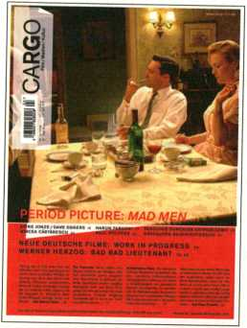
Täglich: Die Webseite Video- und Audio-Interviews, aktuelle
www.cargo-film.de Features, wöchentliche Filmratings, Blog
Nominiert für den Grimme Online Award 2009
CARGO Film / Medien / Kultur
Vierteljährlich: Das Heft
Period Picture: Die Serie Mad Men/
Work in Progress: Neue deutsche Filme -
Arbeitsberichte u.a. von Petzold, Graf, Karmakar/
Texte zu Spike Jonze, Pier Paolo Pasolini,
Lucrecia Martel, Paul Pfeiffer u.v.m.
Im Jahresabo 32 Euro frei Haus
Am Bahnhofskiosk oder
einfach bestellen auf > www.cargo-film.de
interfilm
berlin
fP

INTERFILM
www.interfilm.de
* INTERNATIONAL
26:

SHORT FILM

FESTIVAL^{BERLIN} NOVEMBER 2010
QQjnffiEöQQQgiEB
COMPETITIONS:
PRESENTING OUTSTANDING FILMS. SHORT.
INTERNATIONAL COMPETITION GERMAN COMPETITION KUKI -
SHORT FILMS FOR CHILDREN & YOUTH DOCUMENTARY COMPETITION CONFRONTATIONS - INTERNATIONAL FILMS AGAINST VIOLENCE AND INTOLERANCE EJECT - THE LONG NIGHT OF ODD FILMS - AUDIENCE AWARD
INTERFILM BERLIN 26TH FESTIVAL I TEMPELHOFER UFER IA I 10961 BERLIN
T/F +99(0)30 693 29 59 OR +99(0)30 25 29 13 22 I FESTIVALBINTERFILM.DE I UUU.INTERFILM.DE
3»

T
FILTH 6UIDE0
.M
The Film & Video programme of transmediale.io consists of eleven programmes
with a total of 54 films of all genres. Feature, documentary, animation, experi-
mental films and video art from 20 countries will be shown, with a special focii
on the selections from the 600 submissions from 30 countries. The films look
at FUTURITY NOW! in terms of failed utopias and illuminate various sub-topics
such as the role of the media, the future human body or the post-socialist era
^7 _ Guest curator Rasha Salti from Beirut is going to present the online platform
Arabshorts.net and discuss the relevance of digital media for the Arab world. T\
additionally curated programmes will approach the theme of transmediale.io
from a historical perspective: Man & Machine is about the conflicts between ma
and the technologies created by himself. Short Fictions presents science fiction
shorts made by artists. In 1957 Hugh Stubbins designed the utopian architecture,
of the HKW as a conscious counterpart to the Stalin Allee in East Berlin. In the
Matinée on Sunday the plot of the GDR’s first Science Fiction film will unfold in
this very building: Der Schweigende Stern (1959) by Kurt Maetzig pictures the
dark vision of a failed civilisation.
Das Film- & Videoprogramm der transmediale.10 zeigt elf Programme mit insge-
samt 54 Filmen aller Gattungen: Spiel-, Dokumentär-, Animations-, Experimen-
talfilme und Videokunst. Der Schwerpunkt liegt auf der Auswahl aus ca. 600
Einsendungen aus 30 Ländern. Sie reflektieren die Idee von FUTURITY NOW! vor
allem als Auseinandersetzung mit gescheiterten Utopien und beleuchten ver-
schiedene Subthemen, wie die Rolle der Medien, den Körper der Zukunft oder
das postsozialistische Zeitalter. Die Gastkuratorin Rasha Salti aus Beirut stellt
das Onlinefilmprojekt Arabshorts.net vor und diskutiert die Bedeutung digitaler
Medien für die Arabische Welt. Zwei weitere Sonderprogramme nähern sich dem
Thema der transmediale.io aus historischer Perspektive: Man & Machine
handelt vom Konflikt des Menschen mit der von ihm geschaffenen Technik und
Short Fictions präsentiert rare Science Fiction Kurzfilme von Künstlern. Die
utopische Architektur des Haus der Kulturen der Welt, das 1957 von dem Ame-
rikaner Hugh Stubbins als bewusster Gegensatz zur Stalin Allee in Ostberlin <
geschaffen wurde, wird in der Sonntags-Matinee zum Schauplatz des ersten
Science Fiction Films der DDR: Der Schweigende Stern (1959) von Kurt MaetzK ^
zeichnet in Totalvision das düstere Bild einer gescheiterten Zivilisation.

-n
Marcel Schwierin, Curator Film & Video
s
39

Media Personifications
Theater&al
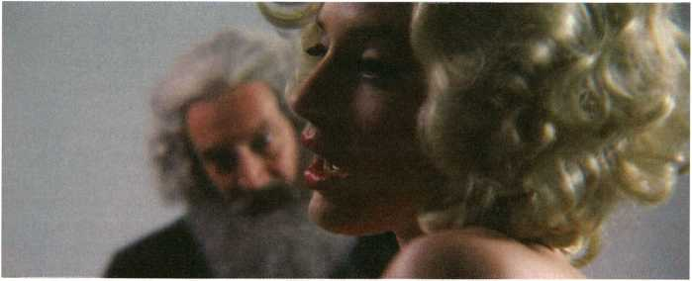
After the Empire by Elodie Pong
After the Empire, Elodie Pong, ch 2008,14min Speech Bubble, Adam Leech, be 2008, 5min Dear Adviser, Vincent Meessen, be 2009, 8min *
Bernadette, Duncan Campbell, uk 2008, 37min
The media typically showcase social developments by singling out certain people. Normally these are embodied by celebrities but sometimes also nobodies are dragged into the spotlight and then re-abandoned to the dark. By reducing them to an individual, complex and obscure processes are boiled down to human scale. In each of the films presented here an artist either imitates (Speech Bubble), satirises (After the Empire), confronts {Dear Adviser) or analyses {Bernadette) at least one such person. The programme draws a panorama of media key figures of the 20th century, representing its utopias as much as their failures.
Die Medien suchen sich gerne Personen, die exemplarisch für gesellschaftliche Entwicklungen stehen. Normalerweise sind das Celebrities, manchmal werden aber auch Nobodies ins Scheinwerferlicht gezerrt - und anschließend wieder ins Dunkel zurückgeschickt. Komplexe, schwer durchschaubare Prozesse werden so - scheinbar - auf ein menschliches Maß, nämlich ein Individuum, reduziert. In jedem Film dieses Programms stehen eine oder mehrere Personen für einen solchen Prozess, den die Künstler imitieren (Speech Bubble), persiflieren (After the Empire), konfrontieren (Dear Adviser) oder analysieren (Bernadette). So entsteht in diesem Programm ein Panorama medialer Schlüsselfiguren des 20. Jahrhunderts, die ebenso für dessen Utopien wie deren Scheitern stehen.
*Director will attend screening and Q & A
40

fE£ÄiGrag!SSI inner Wars liTmrriT
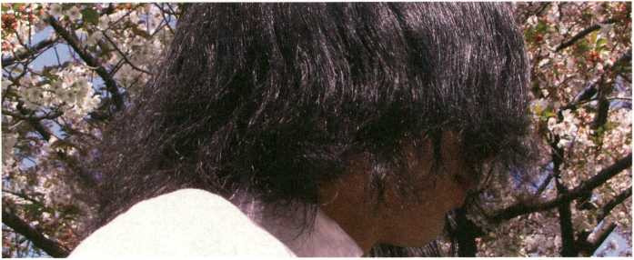
Sakura (Cherry Blossom) byTomoko Inagaki
Sakura (Cherry Blossom), Tomoko Inagaki, jp 2009, 3min Murphy, Bjorn Melhus, de 2008, 4min *
RIP in Pieces America, Dominic Gagnon, ca 2009, 62min *
Wars, which actually imply an interaction between people or nations, are not only destructive towards an exterior but also cause extreme repercussions towards the individual and collective psyche: “War is terrible insofar as it creates more evil people than it removes” (Immanuel Kant). In a simple setting Cherry Blossom thwarts a cynical methaphor of World War 2 about spring and premature death in Japan. With Murphy the viewer gains insight into a veteran phenomenon which seems merely trivialised by the term ‘Post Dramatic Stress Disorder’. RIP in Pieces America documents the inner battle of its protagonists who disseminate their dark premonitions and conspiracy theories in amateur internet videos.
Kriege, die ja eigentlich eine Interaktion zwischen Völkern darstellen, sind nicht nur zerstörerisch nach Außen, sondern haben auch eine extreme Rückwirkung auf die individuelle, wie kollektive Psyche. „Der Krieg ist darin schlimm, dass er mehr böse Leute macht, als er deren wegnimmt.” (Immanuel Kant). In einem einfachen Setting konterkariert Cherry Blossom eine zynische Metapher des Zweiten Weltkrieges über Frühling und frühen Tod in Japan. Murphy lässt in seiner visuellen Gewalt den Betrachter an einem Veteranen-Phänomen teilhaben, für das der Begriff ,Post Traumatic Stress Disorder* noch verharmlosend wirkt. RIP in Pieces America dokumentiert den inneren Kampfseiner Protagonisten, die in selbst gebastelten Internetvideos düstere Warnungen und Verschwörungstheorien verbreiten.
*Director will attend screening and Q & A
Ai

fjrlttWf HEf~Mt&FT Agit - Prop, Punks and Poets
Digital Media between wmmmmmsm.
Film, Video and Activism in the Arab World Hi iTI^ ®
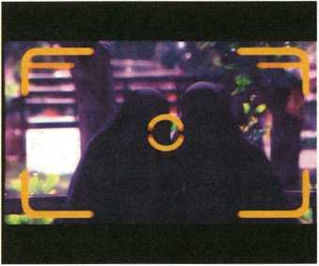
The Poster by Samer Barkawi
Transit by Taysir Batnji
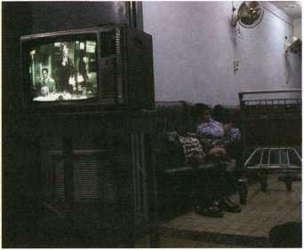
The Poster, Samer Barkawi, sy 2008, 4min
Red, Green and Black Indians, Sobhi al-Zobeidi, ps 2007, 5min
We Will Win, Mahmoud Hojeij, lb 2007, 8min
Faces Applauding Alone, Ahmad Ghossein, lb 2008, 7min
Straight Stories - Part 1, Bouchra Khalili, ma/fr/es, 2006, lomin
Transit, Taysir Batnji, ps/fr, 2004, 8min
Lebanon / War (Lebanon Slash War), Rania Stephan, lb 2006, 30min
Much has been said about the democratising impact of digital media, yet perhaps not a lot with regards to the Arab world. In this region videos are emerging in a landscape saturated with fabricated images, and in which the means of fabrication and dissemination seem to be the exclusive monopoly either of those in control of the public sphere or those in control of the market. With respect to the current historical and political situation of the Arab world, video and film practice is often perceived as one of the sharpest and most striking political acts. The selection of works in this programme attempts to illustrate the various ways in which digital media are used to subvert genres and challenge dominant media emissions in situations of political crises or violence. Streaming videos on the net is yet another story. The online platform Arabshorts.net is a pioneering experiment on many levels and will be presented and discussed as part of this programme.
Die demokratisierende Wirkung der digitalen Medien ist ein vieldiskutiertes Thema - womöglich jedoch nicht so sehr im Hinblick auf die Arabische Welt. Videos kommen hier aus einem Umfeld, das von fabrizierten Bildern gesättigt ist, und deren Produktions- und Distributionsmittel in den Händen derer liegen, die Öffentlichkeit und Markt kontrollieren. In dieser historischen und politischen Situation ist die Video- und Filmpraxis oft eine der schärfsten und wirkungsvollsten politischen Waffen. Die präsentierte Auswahl von Werken soll zeigen, wie unterschiedlich die Künstler der Region digitale Medien nutzen, um Genres zu unterwandern und die herrschenden Medien in Zeiten von Gewalt und politischen Krisen herauszufordern. Filmstreaming im Internet ist ein weiteres Thema: Die neue Online-Plattform Arabshorts.net ist auf mehreren Ebenen ein bahnbrechendes Experiment und wird im Rahmen dieses Programms präsentiert und diskutiert.
Text by curator Rasha Salti who will be present at the screening.
In cooperation with Arabshorts.net
42

fr’iJj jrfHgrBPTSff Short Fictions Jfci;l'J.'- j<.
Captain by Bjern Melhus
Permanent Residents by Isabell Spengler
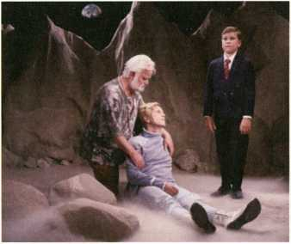
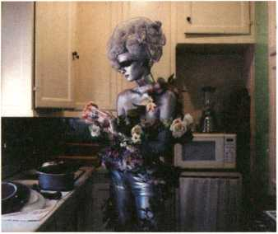
Space Patrol - Title Sequence & What Is In This Box, us 1951, 2mm Science Fiction, J.J. Murphy, us 1979, 5min Yantra, James Whitney, us 1957,10min
Der Schweigende Stern - Trailer, Kurt Maetzig, gdr 1959, 3min Permanent Residents, Isabell Spengler, de 2005,10min *
Gray, Eija-Lilsa Ahtlla, fl 1993, 2min
S.O.S. Extraterrestria, Mara Mattuschka, at 1993, umin
Captain, Bjorn Melhus, de 2005,14min *
Manual, Christoph Girardet & Matthias Müller, de 2002, lomln Space Patrol - Solution, us 1951, imin
Science Fiction films are normally epic feature films made with giant budgets, with the successful productions amongst them probably having defined our idea of the future like no other medium. Framed by trailers from the 1950s, the special programme Short Fictions however presents short and epigrammatic visions of the future. Whilst the early experimental classic Yantra, with its semiabstraction and psychedelia, could have pioneered how the cosmos was depicted in other more commercial Science Fiction works, the other films show artistic appropriations of the picture power and unintentionally comical cinematic visions of the future. They reduce this epic format to its least common denominator: the interaction between humans.
Science Fiction Filme sind normalerweise Spielfilme epischer länge mit entsprechenden Produktionskosten. Dafür prägten die erfolgreichen unter ihnen unser Bild der Zukunft wie wahrscheinlich kein anderes Medium. Eingerahmt von Werbetrailern aus den 1950er Jahren präsentiert das Sonderprogramm Short Fictions dagegen kurze und kürzeste Visionen der Zukunft. Während der frühe Experimentalfilm-Klassiker Yantra in seiner semi-abstrakten und psychedelischen Form die Darstellung des Kosmos im kommerziellen Science Fiction Film eher beeinflusst haben könnte, sind die weiteren Filme des Programms künstlerische Reaktionen auf die gleichermaßen bildgewaltigen wie unfreiwillig komischen Zukunftsvorstellungen des Kinos. Sie führen das epische Format auf seinen kleinsten gemeinsamen Nenner zurück: die menschliche Interaktion.
‘Director will attend screening and Q & A
43

Long Distance Transfers jMHfSBSSSI
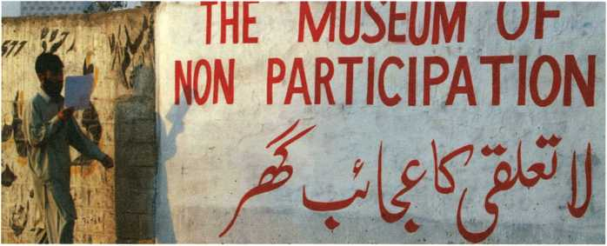
The Exception and the Rule by Karen Mirza & Brad Butler
Near Mandalay, NCS (Nyein Chan Su), mm 2009,14mm *
Dow Song Duang, Araya Rasdjarmrearnsook, th 2008,17min
The Exception and the Rule, Karen Mirza & Brad Butler, uk 2008, 37min *
This programme presents three films all shot in Asia which address, in different ways, the communication between remotely distant worlds. The screening of Near Mandalay is an international premiere documenting a Buddhist pilgrimage to sites around the historic royal capital Mandalay. In Dow Song Duang the inhabitants of peasant villages in Thailand discuss several classic European paintings. Contemplated outside of the museum, in such an atypical context, entirely different aspects are illuminated than in the traditional European canon. The film The Exception and the Rule Is nominated for the transmediale Award 2010 and part of the larger project The Museum of Non Participation. It explores under which conditions dialogues between Pakistan and Europe can be based on art (films).
Dieses Programm präsentiert drei Filme, die in Asien gedreht wurden und auf sehr unterschiedliche Weise die Kommunikation zwischen weit voneinander entfernten Welten thematisieren. Near Mandalay, der zum ersten Mal außerhalb Myanmars gezeigt wird, dokumentiert eine buddhistische Wallfahrt zu den Orten nahe der historischen Königsstadt Mandalay. Klassiker der europäischen Malerei werden in Dow Song Duang von Einwohnern thailändischer Bauerndörfer diskutiert. Außerhalb ihres gewöhnlichen musealen Kontextes kommen völlig andere Aspekte dieser hierzulande längst kanonisierten Werke ans Licht. Der für den transmediale Award 2010 nominierte Film The Exception and the Rule ist Teil des größeren Projekts The Museum of Non Participation und untersucht die Bedingungen zeitgenössischer (Film-)Kunst als dialogische Form zwischen Pakistan und Europa.
*Director will attend screening and Q & A
» Which organisation are you shooting the film for?, p. 26
44

L Studies in Light and Space JES3ISG3W
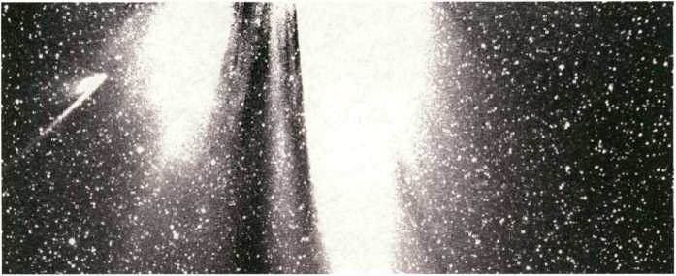
Black Hain by Semiconductor
Studies in Transfalumination, Peter Rose, us 2008, 5min Slack Rain, Semiconductor, uk 2009, 3min
The Moon Goose Experiment, Agnes Meyer-Brandis, de 200B, 5min *
Ascension (Woschosdenije), Pavel Medvedev, ru 2008, 50min *
Four entirely different ways of appropriating light and space are at the core of this programme. For Studies in Transfalumination the artist, besides using light performatively within his work, also manipulates the projector of the screening. Black Rain visualises the scientific images of solar winds gathered by satellites. The Moon Goose Experiment pursues the Syberian myth of the moon geese which - following reports from the 17th century - annually travel between the earth and the moon. Ascension compiles rare - partly unreleased - archive material of Soviet space travel programmes, including the cruelties against man and animal which seemed necessary for conquering outer space.
Vier völlig verschiedene Methoden zur Aneignung von Raum und Licht vereint dieses Programm. Studies in Transfalumination nutzt nicht nur das Licht in performativer Anwendung durch den Künstler, sondern manipuliert auch den Projektor der Aufführung. Die von Satelliten gewonnenen wissenschaftlichen Bilder des Sonnenwindes werden in Black Rain visualisiert. The Moon Goose Experiment ist dem Mythos der Mondgänse in Sibirien auf der Spur, die, nach Berichten aus dem 17. Jahrhundert, jedes Jahr zwischen Erde und Mond pendeln. Seltenes, teilweise nie gezeigtes Material der sowjetischen Raumfahrtprogramme kompiliert Ascension, einschließlich der Grausamkeiten gegenüber Menschen und Tieren, die für die Eroberung des Weltalls notwendigschienen.
^Director will attend screening and Q & A
B Destination Moon, p. 27
45

PS3BBEÜ Future Bodies Jfc?!H =WT=TT--f^HB
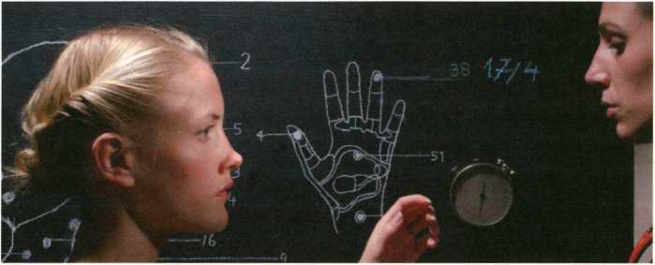
Secret Machine by Reynold Reynolds
Secret Machine, Reynold Reynolds, de 2009,14min *
Future Creatures, Eunjung Hwang, us/kr 2009, 8min *
Naked, Tove Kjellmark, se 2009, 9min
Burning Palace, Mara Mattuschka & Chris Haring, at 2009, 32min
Since modernity the notion of progress nearly always also implies technological progress. In principle the human body hardly changes, thus finding itself at a permanent conflict with the radically changing environment man constructs around himself. Secret Machines re-enacts the intense medical examinations that were conducted during Fordism in order to optimise the cooperation between man and machine. In Future Creatures the freedom of animation allows for the creation of a depressing world populated by strange creatures. A particularly simple robot - a toy panda - undergoes surgery in Naked; although what’s treated is obviously dead matter the viewer can hardly elude their empathic reaction. The dancers in Burning Palace on the other hand move as if by digital animation, the film thus pointing out both the painful process of homogenising man and technology as well as the extend to which our gaze has already been trained by the media.
Seit der Moderne wird Fortschritt fast immer essentiell auch als technischer Fortschritt gedeutet. Der sich im Prinzip kaum verändernde menschliche Körper steht dadurch in einem ständigen Spannungsverhältnis zu der sich durch den Menschen selbst radikal verändernden Umgebung. Secret Machine re-inszeniert die intensiven Körperuntersuchungen, wie sie im Fordismus durchgeführt wurden, um das Zusammenwirken zwischen Mensch und Maschine zu optimieren. Die Freiheit der Animation ermöglicht es Future Creatures, eine bedrückende Welt voller seltsamer Lebewesen zu entwickeln. Ein besonders primitiver Roboter - ein Spielzeugpanda - wird in Naked operiert: Obwohl es sich offensichtlich um totes Material handelt, kann sich der Betrachter der Empathie kaum entziehen. Die Tänzer in Burning Palace dagegen bewegen sich, als wären sie selbst schon digital animiert und verdeutlichen so sowohl die Konditionierung des medial geschulten Blickes als auch den schmerzhaften Angleichungsprozess von Mensch und Technik.
*Director will attend screening and Q & A
46

) - 20:30
L’homme nu, George Rey, fr 1969,3min
Vierbeinige Weltraumfahrer, Moskauer Studio für populärwissenschaftliche Filme, udssr 1959, 22min [German only]
A Wonderful New World of Fords, Ford Motor Company, us i960, 3min
Autos von Morgen - Straßen von Heute - Menschen von Gestern, Hansjürgen Pohland, de i960, 4min [German only]
Leave It To Roll-Oh, Flandy (Jam) Organization, us 1940, 9min Le nouveau OMIZA, Ute Hörner & Mathias Antifinger, de 2007, 6min *
Cosmetic Emergency, Martha Colburn, de 2005, 9min Anaconda Targets, Dominic Angerame, de 2004,11min
Whereas the contemporary works presented in the programme Future Bodies address the tension between man and machine from the perspective of the body, this curated programme focuses on historical films. L’homme nu suggests the possibility of man to disappear. The documentary Vierbeinige Weltraumfahrer indicates that, in opposition to us humans, animals are often the first - involuntary - users of new technologies. A Wonderful New World of Fords advertises the newest generation of spacy cars, whilst Autos von Morgen - Straßen von Heute - Menschen von Gestern brutally illustrates people’s inabilities to deal with the velocities of these new models. Leave It to Roll-Oh from 1940 praises the skills of robotic machines new and futuristic at that time, and Le nouveau OMIZA touchingly addresses the current state of robotics. With cosmetic surgeries like those seen in Cosmetic Emergency man begins to re-design himself according to ideals defined by the media. The harrowing found footage film Anaconda Targets depicts how coldly technology eliminates people in the context of war.
Während das Filmprogramm Future Bodies das Spannungsverhältnis von Mensch und Technik mit aktuellen Arbeiten aus der Perspektive des Körpers betrachtet, stehen in diesem Sonderprogramm historische Filme im Mittelpunkt. L’homme nu deutet das mögliche Verschwinden des Menschen an. Dass nicht Menschen, sondern Tiere oft die ersten - unfreiwilligen - Nutzer neuer Technologien sind, zeigt der Dokumentarfilm Vierbeinige Weltraumfahrer. Die neueste Generation .spaciger’ Autos werden in A Wonderful New World of Fords beworben, während Autos von Morgen - Straßen von Heute - Menschen von Gestern auf brutale Weise zeigt, wie Menschen mit der Geschwindigkeit eben dieser Modelle nicht mehr zurecht kommen. Leave It to Roll-Oh preist die Möglichkeiten damaliger und damals künftiger Automaten an, und Le nouveau OMIZA zeigt auf anrührende Weise den Stand der Robotik von heute. Mit den in Cosmetic Emergency thematisierten Schönheitsoperationen beginnt der Mensch, sich nach seinen medial geprägten Idealen neu zu gestalten. Der erschütternde Found-Footage Film Anaconda Targets hingegen zeigt die kalte Vernichtung des Menschen durch die Technik im Krieg.
‘Director will attend screening and Q & A
47

Der Schweigende Stern 'AWMWWffrflifr
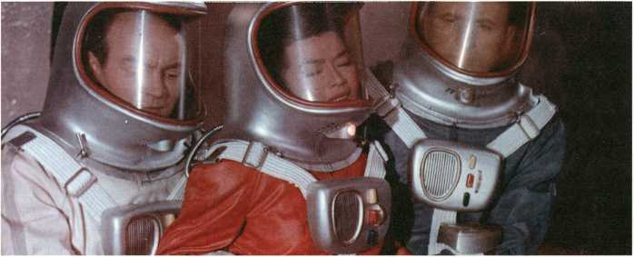
Der Schweigende Stern by Kurt Maetzig
Der Schweigende Stern, Kurt Maetzig, gdr 1959, 95min (German only)
Socialism is the most extensive social experiment in the history of humankind that is based on an initially utopian, then scientific, notion of the future: Communism. It is from this realm that one of the few Science Fiction works emerged which really deserves the attribute ‘science’: the Polish writer Stanislaw Lem spent his entire life developing a vision of the future that would incorporate technological, social and psychological criteria. Fittingly, the first Science Fiction film coming out of the GDR as a German-Polish co-production - Der Schweigende Stern - is based on one of his early works. The fascinating imagery in Total Vision (the East German wide screen equivalent of the American Cinemascope) reveals how a global visual canon of utopian ideas was begun to be created in the 1950s; and further developed throughout the following decades until eventually coming more or less to a standstill for lack of new utopias.
Der Sozialismus ist das umfangreichste Gesellschaftsexperiment der Menschheitsgeschichte, das auf einer zunächst utopischen, dann wissenschaftlichen Idee der Zukunft, dem Kommunismus, basiert, in diesem Umfeld entstand eines der wenigen Science Fiction Oeuvres, welches das Attribut .Science’ wirklich verdient: Der polnische Autor Stanislaw Lern arbeitete sich sein ganzes Leben daran ab, eine Vorstellung der Zukunft unter Berücksichtigung technischer, sozialer und psychologischer Faktoren zu entwickeln. Der erste Science Fiction Film der DDR - Der Schweigende Stern - war folgerichtig auch eines seiner Frühwerke deutsch-polnischer Koproduktion. Die faszinierenden Bilder in Totalvision (dem DDR-Breitwandformat analog zum amerikanischen Cinemascope) zeigen auch, wie in den 1950er Jahren weltweit ein Bilderkanon des Utopischen geschaffen wurde, der in den folgenden Jahrzehnten zwar weiter ausformuliert wurde, sich aber mangels neuer Utopien kaum weiterentwickelt hat.
48

tflriiWTIiftWEffHr The Succession of the Future AYW*
Heroes No Longer, Sun Xun, cn 2008, 9min
Artzone-Timezone, Kamen Stoyanov, cn 2009,4min
Mary Koszmary, Yael Bartana, pl/il 2007, limin
Unforgettable Memory, Liu Wei, cn 2009,13min
Kak Stat Stervoi - Bitch Academy, Alina Rudnitskaya, ru 2008, 30min
All films shown in this programme originate from post-socialist countries and reflect the encounter of Yesterday’s Society of Tomorrow - Socialism - with the reality of Today. The animation Heroes No Longer refers to the founding fathers of Socialism - Marx & Co. - who officially still represent the state-supporting ideology in China, but in reality have been replaced by a novel form of Capitalism. By using rap Artzone-Timezone explores the opposition between traditional and contemporary art in China. Mary Koszmary stages a past utopia: the welcome return of the Jews to socialist Poland. Unforgettable Memory on the other hand addresses memories of the Tiananmen Square Massacre. In Bitch Academy we witness the ideologically and pragmatically equally charged process of the heroine of labour being re-transformed into the traditional image of woman as accessory of man.
Alte Filme dieses Programms sind in (post-)sozialistischen Staaten gedreht, sie reflektieren die Begegnung der gestrigen Gesellschaft von Morgen - dem Sozialismus - mit der Realität von heute. Oie Animation Heroes No Longer bezieht sich auf Gründungsväter des Sozialismus, Marx 81 Co., die zwar offiziell noch eine staatstragende Ideologie in China repräsentieren, in Wirklichkeit aber längst durch eine neue Form des Kapitalismus abgelöst sind. Artzone-Timezone untersucht rappenderweise den Gegensatz zwischen traditioneller und zeitgenössischer Kunst in China. Eine Utopie der Vergangenheit, die willkommene Rückkehr der luden ins sozialistische Polen, inszeniert Mary Koszmary, wohingegen Unforgettable Memory das Massaker auf dem Platz des Himmlischen Friedens thematisiert. Bitch Academy dokumentiert die gleichermaßen ideologische wie lebenspraktische Rückverwandlung der Heldin der Arbeit zu einem traditionellen Frauenbitd als Anhängsel des Mannes.
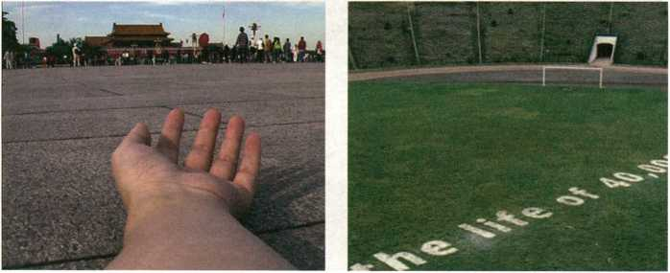
Unforgettable Memory by Liu Wei
Mary Koszmary by Yael Bartana
49

Theater:

ZUKUNFT
Immer wieder Zukunft by Marion Kreißler & Martin Conrath
Immer wieder Zukunft, Marion Kreißler & Martin Conrath, de 2009, 6min *
58 Pages, Aline Helmcke, uk 2008, 7min Hypno Project, Doug Fishbone, uk 2009,13min Scope, Volker Schreiner, de 2008, 5min Scary Maze, Camille Verbunt, nl 2008, 3min
Prim Limit, Franziska Lamprecht & Hajoe Moderegger (eteam), us/ de 2009, 32min *
Each of the works presented in this programme explores a different communication medium through artistic means. A caleidoscope of media indespensable for modernity unfolds before us: Immer wieder Zukunft strings together West German election slogans, revealing them as empty promises astonishingly void of content. 58 Pages shows an entire newspaper animated page by page by rotoscoping. In Hypno Project an artist presents his theses in front of an authentically hypnotised audience - as if symbolising the apathy with which we take in the media day by day. The found footage film Scope compiles images of radios in feature films, displaying this medium within another medium. Scary Maze synchronises internet streams of children playing computer games, transforming the individuals into a virtual collective. Prim Life addresses the, not long ago, much talked about augmented reality of Second Life by narrating a story about its forgotten avatars.
Jede Arbeit dieses Programms untersucht mit künstlerischen Mitteln ein anderes Kommunikationsmedium; so entsteht ein Kaleidoskop dieser für die Moderne so unentbehrlichen Technologien. Immer wieder Zukunft reiht westdeutsche Wahtkampfparolen als bare Versprechen erstaunlicher Inhaltslosigkeit aneinander. Die Rotoskopie 58 Pages extrahiert sämtliche Bilder einer Tageszeitung aufeinander. In Hypno Project wird ein real hypnotisiertes Publikum mit den Thesen des Künstlers konfrontiert - wie ein Sinnbild für die tägliche, passive Medienstarre. Der Found-Foot- age Film Scope kompiliert Bilder von Radios in Spielfilmen und reflektiert so die Reflektion des Mediums im Medium. Scary Maze synchronisiert Internetstreams von computerspielenden Kindern und verwandelt Individuen in ein virtuelles Kollektiv. Die einst vieldiskutierte künstliche Welt des Second Life thematisiert Prim Limit in einer Erzählung seiner vergessenen Avatare.
*Director will attend screening and Q & A
50

Anteil der 14- bis 29-Jährigen, die sich ein Leben ohne Handy nicht vorstellen können, in Prozent: 97
Anteil der 14- bis 29-Jährigen, die sich ein Leben ohne ihren aktuellen Partner nicht vorstellen können, in Prozent: 43
Weitaus mehr als nur Zahlen.
Das Wirtschaftsmagazin brand eins. Jetzt abonnieren: www.brandeins.de
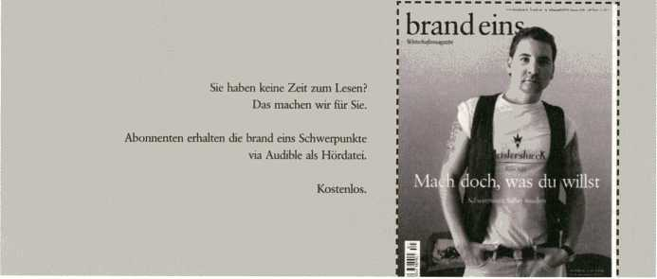
51
Meir6undMeir6

ANGST HAT GROSSE AUGEN
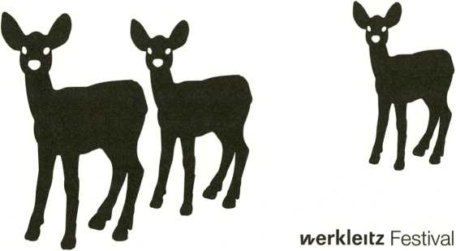
April - Oktober 2010
Gefördert durch die Kulturstiftung des Bundes und die Mitteldeutsche Medienförderung
Preise Awards
27.mmvm
KASSELER! DOK In FEST
9.-14. NOVEMBER 2010
Golden Key € 5.000t
Best Up and Coming Documentary
Golden Cube € 2.500
|Best Media Installation .
IGolden Hercules € 2.500|
■ Best Regional Work Wf •
A38-Production Grant Worth up to € 8.0001
Deadline for entries: 19. Juli 2010
kFilmladen Kassel eV | Goethestr. 31 | 34119 Kassel
dokfest@filmladen de | www filmladen de/dokfest
52
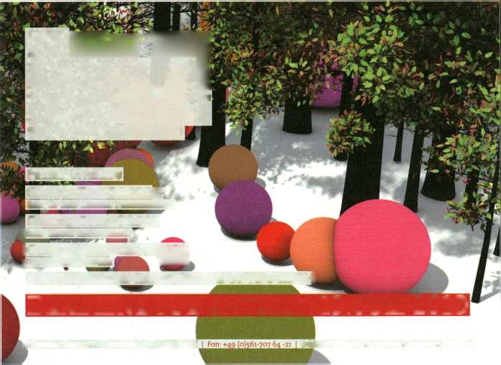

"
. te Utff¿ i---¿K-i''"^{- t¿- :} V”:',^''.-
PERF0RTT1RÎ1CES
We were making the future... and hardly any of us troubled to think what future we were making.'■ And here it is!
HG Wells, 1895 pSS
®r
The transmediale.io Performance programme presents a range of concerts and events acting as auditory and performative interrogations of FUTURITY NOW!. The t*gg highlight: six concert evenings in collaboration with CTM featuring some of theSil3|§||jj most important figures working within music and sound today. Each night new,

I
and often rare, performances by Ryoji Ikeda, artificiel, Jürgen Reble & Thomas pi
Köner, Atom TM and Feng Mengbo will represent the most experimental intersec-
tions of audiovisual culture and digital art. Charlemagne Palestine will open the
festival with a special performance in the Tiergarten Carillon, transmediale.io
Award nominees Sosolimited will unveil an entirely new work, a live coding per-
formance of the Futurity Long Conversation.
transmediale is also proud to present performances on the Café Stage at FIKW.
A world première of ¿a Chambre Des Machines by Nicholas Bernier & Martin
Messier, plus some of Berlin’s finest talents, such as Pe Lang und Benjamin
Laurent Aman, will enrich each evening with sonic interpretations of our condi- _{x}
tional future.

"’i
2®


Das transmediale.io Performance Programm präsentiert Konzerte und andere
audiovisuelle Veranstaltungen, die das Festival-Thema FUTURITY NOW! performativ,;
beleuchten. Als Highlight bieten sechs gemeinsam mit CTM organisierte Konzert-tjfpil
abende die rare Möglichkeit, zeitgenössische Größen aus Musik und Klangkunst;:
live zu erleben: Abend für Abend führen uns Künstler wie Ryoji Ikeda, artificiel,
* ■
Jürgen Reble & Thomas Köner, Atom TM und Feng Mengbo mit Ereignissen aus
fv! Klang und Licht an die Schnittstelle von audiovisueller Kultur und digitaler Kunstljll
V'
\
Eröffnet wird das Festival mit einem exklusiven Carillon-Konzert von Charlemagne i
Palestine. Die für den transmediale.io Award nominierte Gruppe Sosolimited wirdy*
am Freitag innerhalb von 8 Stunden eine vollkommen neue Arbeit erschaffen,
indem die Künstler das internationale Symposium Futurity Long Conversation
transformatorisch begleiten. I
Auf der Café Bühne im HKW präsentiert transmediale viele weitere Performances!
v . >
jj i) wie Nicholas Bernier 81 Martin Messier mit ihrer Weltpremiere von La Chambre Des^
Machines und eine Reihe in Berlin lebender Musiker wie Pe Lang und Lord Cry Cryi?®
mïïwmi

d ®
'\h hL:
53
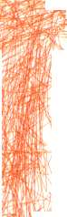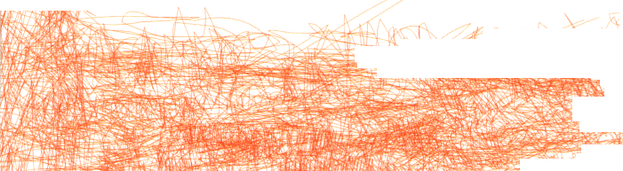

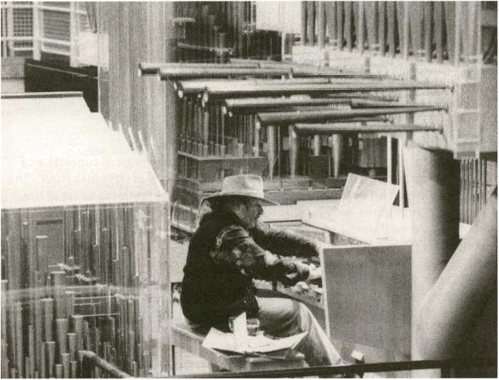
Charlemagne Palestine playing the Eindhoven University Organ

ÂE150BÈ3E0E Tintinnabulations For Tomorrow and Tomorrow
Charlemagne Palestine (us)
What better place to begin a festival examining futurity than a bell tower, that traditional demar- cator of time. Before the invention of the mechanic clock, it was bell towers that manifested a concept of shared, public time. Pioneering musician Charlemagne Palestine will therefore launch transmediale.io by ringing the bells of one of the world’s largest and most distinctive instruments - the Tiergarten Carillon, next to the HKW.
Was passt besser zu einem Festival, das durch und durch der Zukünftigkeit gewidmet ist, als der Glockenturm als traditioneller Zeitanzeiger?
Einläuten wird die transmediale.io deshalb der Musiker und Komponist Charlemagne Palestine mit seinem Konzert im Tiergarten Carillon unmittelbar neben dem HKW. Das Gebäude ist eines der weltweit grössten Carillons überhaupt und birgt ein einmaliges Hörerlebnis in Raum, Zeit und Geschichte.
Presented by transmediale and CTM
Produced in assocation with Jeffrey Bossin and CarillonConcertsBerlin
54

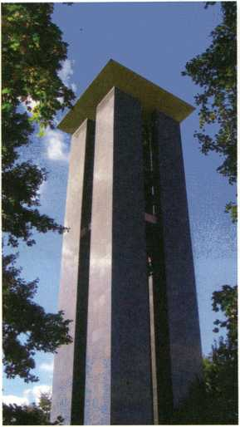
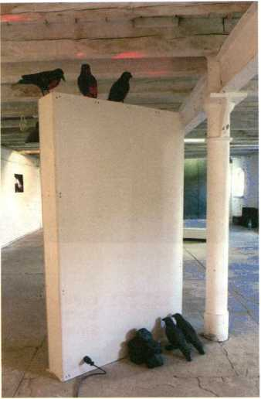
Tiergarten Carillon
Installation by Benjamin Laurent Aman
Gsrnmasssm aaauao («) i-«. ««
Shanghai based digital artist and computer hactivist aaajiao embeds his open source sound and programming work into a performance of scintillating bursts of live visual data.
Der digitale Künstler und .Computer-Haktivist“ aaajiao aus Shanghai zaubert aus Open Source Klängen und Programmen live ein Funkelfeuer aus visuellen Daten.
Myths of the Near Future, p. 63

Beyond the Rest
Beniamin Laurent Aman (fr)
With this first set at the Café Stage, which is all about the strangeness of futurity, we get a taste
of experimental sound art and music courtesy of Benjamin Laurent Aman. The Frenchman will con-
struct a Dj set featuring field recordings, fragmentary stories, drones, improvised music and sound
poetry from a diversity of artists. This is music that captures the senses by losing them.
Bei dieser ersten Veranstaltung auf der Café Bühne wird der Franzose Benjamin Laurent Aman ein
Gefühl für Unvorhersehbarkeit vermitteln und unser Gehör auf die Zukünftigkeitsprobe stellen.
Als DJ webt er aus Field Recordings, bruchstückhaften Erzählungen, Improv und Klangpoesie
vieler anderer Künstler einen Klangteppich, auf dem uns die Sinne davon fliegen.

55

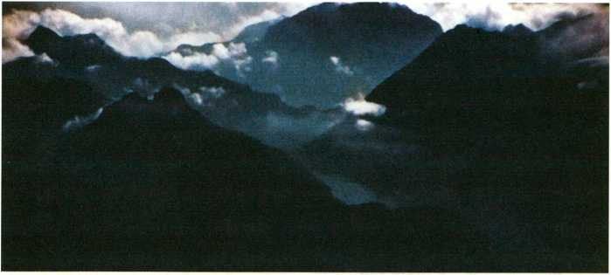
Landschaft No.2 by Matthias Fritsch

mtèüBLandschaft No.2

Matthias Fritsch (de)
interpreted by Shingo Inao (jp) & Marco Brosolo (it)
The world première of Landschaft No.2 - an interpretation of Matthias Fritsch’s work Landschaft - will feature instrumentation from Shingo Inao and Marco Brosolo. Originating from very different musical practices, both musicians use sensor-driven instruments in order to generate sound. After a solo performance by each musician, the two will mediate a musical dialogue against the backdrop of Fritsch’s video landscapes.
Die Weltpremiere von Landschaft No.2 entsteht aus dem Zusammenspiel von Shingo Inao und Marco Brosolo. Obgleich von sehr unterschiedlichen Richtungen kommend, nutzen beide Musiker sensorbetriebene Instrumente zur Geräuscherzeugung. Im Anschluss an Soloauftritte beider Künstler werden sie sich vor Fritschs Videolandschaften in einen musikalischen Dialog begeben.
Feb (22:00 - 22:00
L CL LOOP _____
Pe Lang (ch)
cljoop is an audio improvisation based on the manipulation of an electromagnetic field. For this performance Lang utilises three small battery-powered devices that contain two coils whose functions are contradictory; one acts as a sensor and the other as an electromagnet.The effects of inserting and removing magnets and other objects into and from the activated area in front of the artist unfold as a captivating sound experience.
Das Stück cljoop lebt von der Faszination für die Materialität und die kinetische Seite des Tons, sowie von unkonventionellen Tonquellen. Für cljoop nutzt Lang drei kleine batteriebetriebene Apparate: zwei gegensätzliche Transformatoren und einen Elektromagnet. Das elektromagnetische Feld manipuliert Lang mit kleineren Magneten und anderen Gegenständen. Die Geräuscheffekte erzeugen ein faszinierendes Hörerlebnis.
56

gfjfTMITRt'B-vg-ï'gs. Pattern Recognition ^JMíúLjIü»!
We have no future because our present is too volatile.... The spinning of the given moment’s scenarios. Pattern recognition.
William Gibson, Pattern Recognition, 2003
transmediale.10 and CTM.10 are delighted to present two stunning works by some of the most important audiovisual performance artists today, that both address the materiality of moving images.
Mit Pattern Recognition präsentieren transmediale.10 und CTM.10 zwei audiovisuelle Performances von weltberühmten Künstlern, die sich beide mit der Materialität bewegter Bilder beschäftigen.
Ryoji Ikeda - test pattern (2008), Concept, composition: Ryoji Ikeda, Visual Programming: Tomonaga Tokuyama

C Test Pattern
Ryoji Ikeda (jp) [live set]
Ryoji Ikeda, performing at transmediale for the first time, presents the latest audiovisual work in his datamatics series. Audio signals are converted into tightly synchronised flickering imagery resembling the black and white patterns of barcodes. The audience is enveloped in intense fusion of sound and visuals emerging in perfect unison.
Ryoji Ikeda tritt zum ersten Mal bei der transmediale auf und wird das jüngste Werk seiner Serie datamatics präsentieren. Per Software werden Audiosignale live in einen sich bewegenden Bildteppich umgerechnet, der an Barcode erinnert. Die Sinneswahrnehmung des Publikums schwebt in einem dichten Gewebe aus Bild und Ton.
Produced by Forma


C. Materia Obscura
Jürgen Reble (de) & Thomas Köner (de) 39
With Materia Obscura Jürgen Reble and Thomas Köner reveal the hidden structures of dark matter. Thousands of Reble’s ‘chemograph’ scans are edited live as they are magnified by a projector. Köner’s otherworldly soundscapes are the additional push for our desire to delve right into what is opened up before our senses.
Materia Obscura öffnet die Tore zu der dunklen Materie, die uns umgibt. Reble erzeugt fremd anmutende Bilder, indem er Tausende seiner ,Chemograph‘-Scans projiziert. Zusammen mit Köners außergalaktischen Geräuschlandschaften nehmen uns die Künstler mit auf eine ungewöhnliche Reise der Sinne.
Pattern Recognition is presented by transmediale and CTM
57

Elektrolab .
RACHIDA ZlANI (fr) & DEW! DE VREE (NL)35aB0na®
In the first of two performances which explore atemporal electrical inventions, transmediale invites you to marvel at the audiovisual spectacle of energy being generated live. In Elektrolab, a battery is created and dissected live on stage, recalling the invention of the first battery by Alessandro Volta in 1800. The artists bring this vital device into the future in a fascinating contemporary performance context.
Elektrolab ist die erste von zwei Performances zum Thema Atemporalität und Elektrizität. In dieser Performance erleben wir das audiovisuelle Schauspiel der Elektrizitätsgewinnung: In Elektrolab wird eine Batterie auf der Bühne gebaut und auseinander genommen - ähnlich wie es im Jahr 1800 einst ihr Erfinder Alessandro Volta tat - und die Künstlerinnen bringen so diesen wichtigen Gegenstand in einer faszinierenden zeitgenössischen Performance zur Geltung.
Supported by Mondriaan Stichting (Mondriaan Foundation)
POWER
ARTIFICIEL (CA) XB3IH3IE
POWEr by artificiel is a performance in which the only source for sounds and visuals is a Tesla coil,
invented by Nikola Tesla in 1891. The piece is an impressive example of how atemporality, physi-
cal energy and digital technology create complex new performative phenomena.
Bei der Performance POWEr dient ein Tesla-Transformer (erfunden von Nikola Tesla im Jahr 1891)
als einzige Bild- undTonquette. Das Stück stellt mit bestechender Eindringlichkeit dar, wie Zeitlo-
sigkeit, physische Energie und digitale Signale neue performative Phänomene bilden können.
■UESZCESBESIX
POWEr is a commission for the 10th edition of MUTEK. This project has been supported by the Canada Arts Council and the Conseil des arts et lettres du Québec, artificiel also thanks Steve Ward for his contribution to the development of the audio-modulated DRSSTC.
Presented by transmediale and CTM
Fëb C 21:30 - 23:00

It’s About When It Came Out Lord Cry Cry (uk)
ranima
Berlin-based musician and composer Lord Cry Cry presents a mixture of music regarded as futuristic when first released, alongside contemporary music which also anticipates the future - a special of mixes covering genres like avant-garde jazz, classical, electronic, reggae and dubstep.
In seinem DJ Mix kombiniert der in Berlin lebende Lord Cry Cry ältere Musik, die zum Zeitpunkt ihrer Veröffentlichung als futuristisch galt mit zeitgenössischer Musik, die ebenfalls in zukünftigen Gefilden schwelgt. Eine Session mit Avantgarde-Jazz, Klassischer und Elektronischer Musik, Reggae, Dubstep und Vieles mehr.
58

POWErby Artificiel

the Long Conversion
SOSOLIMITED (US)
The Long Conversion is a world première especially crafted for transmediale.io by transmediale
Award nominees Sosolimited. The piece exists alongside the extended experimental discussion
Futurity Long Conversation happening simultaneously in the HKW Auditorium.
The artists have developed a software that samples and analyses the video, audio, and textual con-
tent of the lecturers’ speech. Through a series ofvisual and sonic transformations, Futurity Long
Conversation will be disassembled and recombined to reveal linguistic patterns, expose thematic
content and structures, and fundamentally alter the way in which the lectures are experienced.
The Long Conversion ist ein exklusiv im Rahmen der transmediale.io entstehendes Hybrid aus
Installation und Performance. Mittels einer speziell entwickelten Software nimmt die für den
transmediale.io Award nominierte Gruppe das zeitgleich im HKW Auditorium stattfindende
experimentelle Symposium futurity Long Conversation auseinander und setzt es anschließend
so wieder zusammen, dass z. B. sprachliche oder inhaltliche Muster und Strukturen der Vorträge
deutlich werden. So tritt ein vollkommenen anderer Rezeptionsansatz in den Vordergrund, als bei
den Vorträgen nur wenige Meter höher im selben Haus.
» Futurity Long Conversation, p. 16

Spectral Continuum Berlin 2010
Charlemagne Palestine (us)
This organ concert in Französischer Dom is the second chance to witness Charlemagne Palestine play live in the context of transmediale.io and CTM.10. When playing the organ, Palestine famously uses a repetitive minimal technique, which elicits a glorious earsplitting resonance from the instrument. The audience is easily convinced they are witnessing a dozen organ players at once - an unforgettable experience.
Dieses Konzert im Französischen Dom ist die zweite Gelegenheit Charlemagne Palestine im Rahmen von transmediale.io und CTM.10 live zu erleben. Bei seinen außergewöhnlichen Orgel- Konzerten entlockt Palestine dem großartigen Instrument mit seiner berühmten minimalistischen Methodik eine so markerschütternde Klangfülle, dass er die Hörer glauben macht, sie wohnten dem Spiel eines Dutzend Organisten bei - ein unvergessliches Erlebnis.
Presented by transmediale and CTM
59

NUR.FUR FRWACH^FNF

95,8 radio
radio
Wie ein Blick ^ unter die Oberfläclie.
5. Februar, 19-21 Uhr:
"radioeins am Abend" mit Knut Elstermann live von der Transmediale
HBBWWiiiB ... I Hh H ^{v}
Das Programm erscheint im Januar 2Q10 | www.maprzmusik rlp

Festival für aktuelle Musik Berlin
19. - 28.3.2010
UTOPIE [VERLOREN]
ORCHESTERKONZERTE • KAMMERMUSIK ■ MUSIKTHEATER • PERFORMANCE INTERMEDIA • SONIC ARTS LOUNGE
Berliner Festspiele
6o
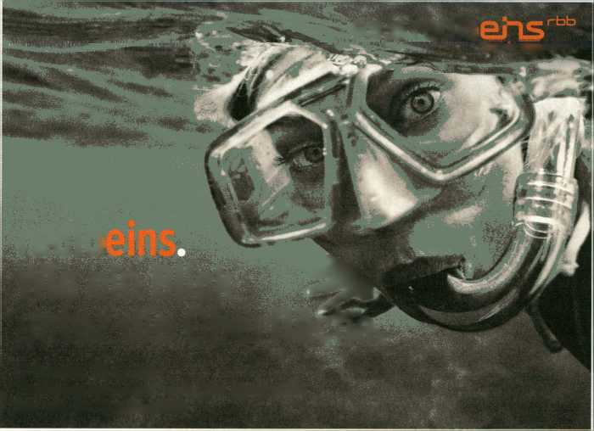

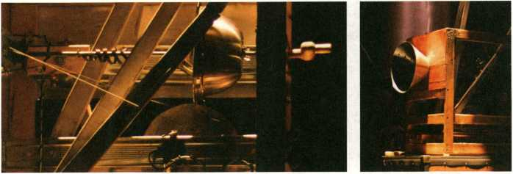
La Chambre Des Machines by Martin Messier & Nicolas Bernier

Time Machines
Taking 1895 classic The Time Machine by H.G. Wells as a departure point, transmediale.10 presents a double bill featuring self_resolution by Berlin-based Andrea Lange and a world première of La Chambre Des Machines by Montreal duo Martin Messier & Nicolas Bernier.
ln Anlehnung an H.G. Wells Klassiker Die Zeitmaschine präsentiert die transmediale.10 die beiden Performances self_resolution der Berlinerin Andrea Lange und die Weltpremiere La Chambre Des Machines von Martin Messier 81 Nicolas Bernier aus Montreal.
C^SELF_RESOLUTION
Andrea Lange (de)
An audio-visual performance involving four radio sets with digital clock displays. The pulsation of the sound output is directly connected to the pulsation of the clocks. Minimal sequences emerging through electricity and the mere passing of time are mirrored visually in the rhythms of the clocks’ LED displays.
Eine audiovisuelle Performance mit vier digitalen Radioapparaten: Durch Strom und das reine Verstreichen der Zeit entstehen minimale Tonsequenzen, die visuell unmittelbar von den Rhythmen der Uhranzeigen wiedergespiegelt werden.

3t' La Chambre Des Machines
Martin Messier (ca) & Nicolas Bernier (ca)
As futurism celebrates its 101st anniversary, this world premiere gives a new context to an instrument developed by Italian futurist Luigi Russolo, the Intonarumori. In this performance, which also includes a collection of antiquated alarm clocks, the instrument is opened up, allowing audiences to perceive its hidden mechanisms.
Durch feinsinnige und höchst originelle Spielweisen erweckt La Chambre Des Machines alte Wecker und das von dem Futuristen Luigi Russolo im frühen 20. Jahrhundert entwickelte Intonarumori pünktlich zum 101. Geburtstag des Futurismus zu neuem Leben. In dieser Performance ist das Intonarumori geöffnet und seine versteckten Mechanismen sind für das Publikum sichtbar.
Supported by the Canada Council for the Arts and le Conseil des Arts et Lettres du Québec Supported by Conseil des arts et lettres du Québec. Intonarumoris: Alexandre Landry
6l

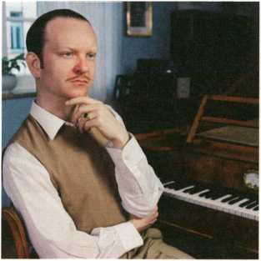
Atom TM
!®KQ31iW&feiat Raster.Noton.Unun
Atom TM (de), Grischa Lichtenberger (de) —~__
Senking (de), Aoki Takamasa (jp), Ulf Eriksson (se)
ln 2009 Atom TM aka Uwe Schmidt released two new albums, Liedgut on Raster-Noton and Muster on his own label, Rather Interesting. To celebrate, transmediale and CTM have invited this exceptional electronic musician with his umpteen stage names (Atom Heart, Senor Coconut, Lassique Bendthaus, DOS Tracks and many more) over from his adopted home country Chile to play a live gig as Atom TM in Berlin! The acclaimed label, Raster-Noton from Chemnitz will take this opportunity to present its new series unun, whose division in nine parts is conceptually based on the atomic numbers 111-119 of the periodic table of chemical elements. The concert features Grischa Lichtenberger, Senking und Aoki Takamasa. To round it all up we will see Ulf Eriksson, DJ and organiser of the Full-Pull Festival in Malmö, spin a set of Detroit-style dance music.
2009 erschienen gleich zwei neue Alben von Atom TM aka Uwe Schmidt, Liedgut auf Raster-Noton und Muster auf seinem eigenen Label Rather Interesting. Anlass genug für den in Chile lebenden Ausnahme-Elektroniker mit den Zig Pseudonymen (Atom Heart, Senor Coconut, Lassique Bendthaus, DOS Tracks usw.), um endlich wieder in Berlin live als Atom TM auf der Bühne zu stehen. Passend dazu präsentiert das Chemnitzer Konzeptlabel Raster-Noton seine neue Serie unun, die auf den Atomzahten der chemischen Elemente 111-119 des Periodensystems basiert und dementsprechen aus neun Teilen besteht. Mit dabei sein werden Grischa Lichtenberger, Senking und Aoki Takamasa. Zum Abschluss lädt Ulf Eriksson, D) und Organisator des Full-Pull Festivals in Malmö, mit einem Detroit-inspirierten Set zum Tanzen ein.
Presented by transmediale and CTM
62

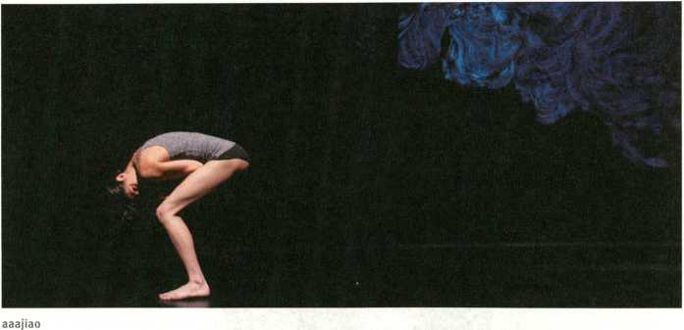

&'J JTjftfFfffffE'gtMTMyths Of The Near Future

FM3_Zhang (cn), aaajiao (cn)

Feng Mengbo (cn), Ben Huang (cn)
HKW
Nobody is interested in the future at all. I think the future has been annexed into the present. Occasionally a futuristic image is trotted out, ransacked like an image of the past and absorbed into the ongoing continuum that represents present-day life.
J.G. Ballard, Myths Of The Near Future, 1982
In collaboration with Shanghai eARTS Festival and CTM.10, transmediale.10 presents a night of performance and music examining China as one of the motifs of FUTURITY NOW!. Featuring four artists who represent a new wave of Chinese practitioners working beyond the constraints of social, political or geographical identity, Myths Of The Near Future will open up an axis between China and Berlin, exploring a future dialogue based on shared values of experimentation, digital practice and cultural exchange.
The evening begins in Café Global with the eARTS Showcase, a special reception to announce eARTS 2010, and is followed by Auditorium performances by Feng Mengbo, FM3_Zhang (Zhang Jian) and aaajiao (Xu Wenkai). Ben Huang, the man responsible for bringing Beijing’s club scene to Europe (and vice versa) completes the evening with a DJ set at the Café Stage.
In Zusammenarbeit mit dem Shanghai eARTS Festival und CTM.10 präsentiert transmediale.10 einen Performance-Abend, der China als ein für FUTURITY NOW! zentrales Motiv hervorhebt. China gilt als Inbegriff der Zukunft von Märkten und künstlerischen Praktiken gleichermaßen. Eingeladen sind vier chinesische Künstler, die für den vielschichtigen, nicht enden wollenden Selbstfindungsprozess stehen, in dem sich das Land befindet.
Im Anschluß an den eARTS Showcase, einen Empfang zu Ehren von eARTS 2010 im Café Global, geht es im Auditorium mit den Auftritten von Feng Mengbo, FM3_Zhang (Zhang Jian) und aaajiao (Xu Wenkai) weiter. Ben Huang, der Mann, der Pekings Clubszene nach Europa gebracht hat (und umgekehrt), wird den Abend mit einem DJ Set auf der Café Bühne abrunden.
Presented by transmediale and CTM in cooperation with eARTS Festival Shanghai it aaajiao [uvevj set], p. 55
63

JETZT AM KIOSK: DE:BUG 138

—
DE BUG ELEKTRONISCHE LEBENSASPEKTE
MAGAZIN FÜR MEDIEN, MUSIK, KULTUR, SELBSTBEHERRSCHUNG. WWW.DE- BUG.DE
64
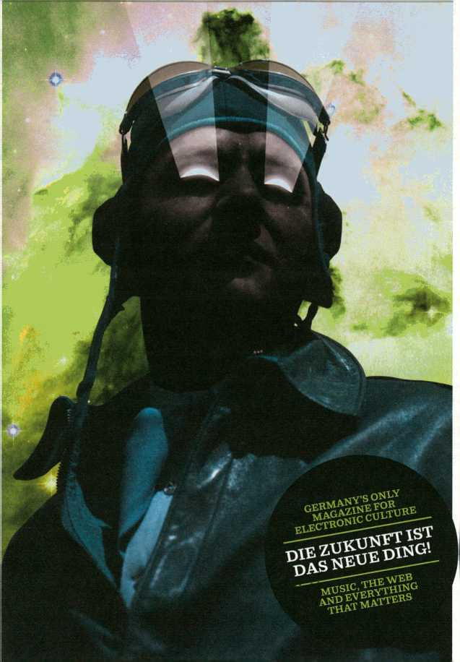
/;r)
i
m
EXHIBITIOn
FUTURE OBSCURA
We make our journeys out there in the low light of the future, and return to the bourgeois day and its mass delusion of safety, to report on what we’ve seen. What are any of these ‘utopian dreams’ of ours but defective forms of time-travel?
Thomas Pynchon, Against the Day, 2006
Die Kunstwerke in Future Obscura betrachten die Komplexität der Zukünftigkeit durch die Lupe der Bildherstellung. Klare Grenzen zwischen Vergangenheit, Gegenwart und Zukunft werden durchbrochen und unser Blick auf das „glimmende Licht der Zukunft” gelenkt.
Als gedanklicher Ausgangspunkt diente Kuratorin Honor Harger die Camera Obscura, jener altmodische Apparat und Behälter, in dessen Innerem das Abbild einer äußeren Szene projiziert werden kann.
Future Obscura untersucht, wie die Materialien, Mechanismen und Maschinen der Bilderzeugung unser Gefühl fürTemporalität bestimmen, indem sie die Realität einfangen und wiedergeben. Einige Künstler, z. B. Gebhard Sengmüller und Julien Maire, spielen damit, wie die optischen Apparate Camera Obscura und Filmprojektor unsere Wahrnehmung von Licht und Zeit beeinflussen können. Die Werke von Zilvinas Kempinas und Julius von Bismarck zeigen Tonband- und Filmmedien sowohl als temporale Gedächtnismechanismen (als Datenspeicher), als auch als formale künstlerische Materialien mit spezifischer Räumlichkeit. Gemeinsam hinterfragen die ausgestellten Werke, inwiefern Zukünftigkeit nicht eine verschleierte Erwartung unserer Idee von Zukunft ist.
Future Obscura brings together a group of diverse artworks which explore the complex condition of futurity through the lens of image-making. Clear boundaries of the time continuum are broken down by artists whose work allows us to peer into the “low light of the future”.
As her curatorial departure point, guest curator Honor Harger explores the camera obscura, the historical apparatus in whose interior the image of an exterior scene can be projected.
Future Obscura explores how the machines and materials of moving-image making capture, retain and reproduce our reality and so alter our sense of temporality. Some of the works, such as those by Gebhard SengmUller and Julien Maire, refer to the way that optical devices, such as the camera obscura and the film projector, manipulate light and temporality. Other works by the likes of Zilvinas Kempinas and Julius von Bismarck show how mediums such as tape and film can act as both mechanisms of memory in the form of data-storage, but also as L formal artistic materials. Together the works in the exhibition meditate on how I futurity is an obscured notion of what we used to think of as the future.
it
‘
-,
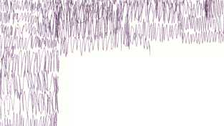

DATA.TRON [3 SXGA+ VERSION] (2OO7-O9) Ryoji Ikeda (jp) JD
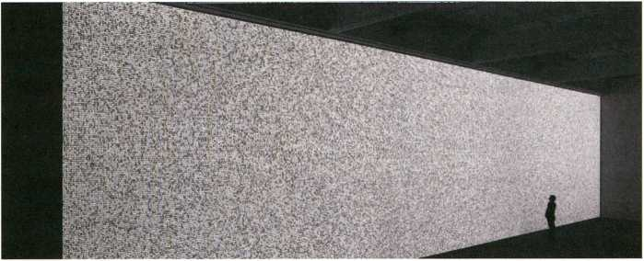
data.tron [3 SXGA+ version] (2007 - 09) by Ryoji Ikeda, Photo: Ryuichi Mamo
Ryoji Ikeda’s visual works are emblematic of a future defined and visualised through the lens of digital technologies. In this large-scale audiovisual installation - shown for the first time in Germany - Ikeda makes the imperceptible sea of data that permeates our world, dramatically visible through digital projection. A vast field of white light, which occasionally resembles the ‘white noise’ of a detuned television, confronts the visitor. Each single pixel of the visual Image Is strictly calculated by mathematical principle, data.tron [3 SXGA+ version] is part of the datamatics series of experiments that seek to materialise pure data. Scientists and mathematicians use the same banks of data to create predictive models which describe possible futures. Ikeda translates this data into an intense and striking immersive experience.
Die visuellen Werke Ryoji Ikedas funktionieren wie Sinnbilder einer Zukunft, die maßgeblich von digitalen Technologien beherrscht sein wird. In der ausgestellten audiovisuellen Installation data.tron [3 SXGA+ version] macht Ikeda mit einer digitalen Projektion das unsichtbare Meer an Daten, das uns ständig umgibt, auf eindringliche Weise sichtbar. Es ist das erste Mal, das diese Arbeit in Deutschland gezeigt wird: Die Besucher treffen auf eine große Fläche aus gleißendem Licht, nicht unähnlich dem weißen Rauschen eines falsch eingestellten Fernsehers. Doch jedes einzelne Pixel folgt einer streng mathematischen Formel, data.tron [3 SXGA+ version] gehört zur datamatrics Reihe, Arbeiten, bei denen Ikeda mit der visuellen Umsetzung roher Datenmengen experimentiert. Bei der Herstellung von Modellen, die die Zukunft Voraussagen sollen, stützen sich Wissenschaftler und Mathematiker auf dieselben Datenbänke wie Ikeda in data.tron [3 5XGA+ version], nur dass er diese Datenmengen für uns in ein unvorstellbar immersives Erlebnis zu übersetzen vermag.
Ryoji Ikeda - data.tron [3 SXGA+ version] (2007-09)
Courtesy of Gallery Koyanagi Concept, composition: Ryoji Ikeda
Computer graphics, programming: Shohei Matsukawa, Norimichi Hirakawa.TomonagaTokuyama
produced by § | supported by | ▲
it
» test pattern [live set], p. 57
66

A Parallel Image (2009) 'Gebhard Sengmüller (at)
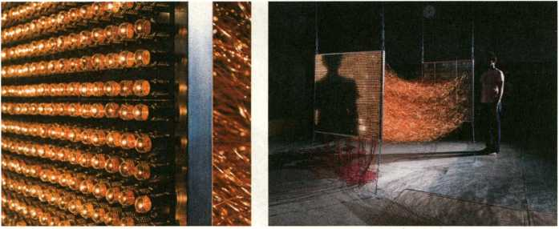
A Parallel Image by Gebhard Sengmüller
A Parallel Image is an electronic camera obscura. This media-archaeological, interactive sculpture is based on the Active assumption that the contemporary principle of electronically transmitting moving images, namely by breaking them down into single images and image lines, was never discovered. The result is an apparatus that attempts a highly elaborate parallel transmission of every single pixel from sender to receiver. This is only possible by connecting camera and monitor using approximately 2,500 individual cables.
The work is an excellent example of the notion of atemporality, in its supposition of a parallel timeline, in which the technologies of today, don’t exist. In this parallel timeline, a technique of the past is required to create an effect which is oddly futuristic in its sensorial impact. Unlike conventional electronic image transmission procedures, A Parallel Image is technologically transparent, conveying to the viewer a correspondence between real world and transmission that can be sensually experienced.
A Parallel Image ist eine elektronische Camera Obscura. Diese medienarchäologische, interaktive Skulptur basiert auf einem Gedankenspiel: Was wäre, wenn man niemals darauf gekommen wäre, bewegte Bilder in Einzelbilder und Bildtinien aufzubrechen, um sie elektronisch transportierbar zu machen? Herausgekommen ist ein höchst aufwendiger Apparat, der einzelne Pixel vom Sender zum Empfänger schickt - etwas, das überhaupt nur möglich ist, weit eine Kamera und ein Monitor mit 2.500 separaten Kabeln gekoppelt wurden.
Durch das Suggerieren eines parallelen Zeitverlaufs, in dem die heutigen Technologien nicht existieren, artikuliert Sengmüllers Arbeit einleuchtend, was Zeitlosigkeit sein kann: Denn in dieser Parallelzeit erzielt plötzlich eine eigentlich bereits veraltete Technikeinen ganz erstaunlich futuristischen Effekt. Anders als herkömmliche elektronische Bildsendungsprozesse sind die Vorgänge in A Parallel Image erstaunlich transparent. Der Betrachter kann die Verbindung zwischen der wirklichen Welt und der Transmission verfolgen und sinnlich wahrnehmen.
A Parallel Image was made in collaboration with Franz Buchinger, supported by Fels-Multiprint.
67

White Noise (2007)
ZILVINAS KEMPINAS (LT) H
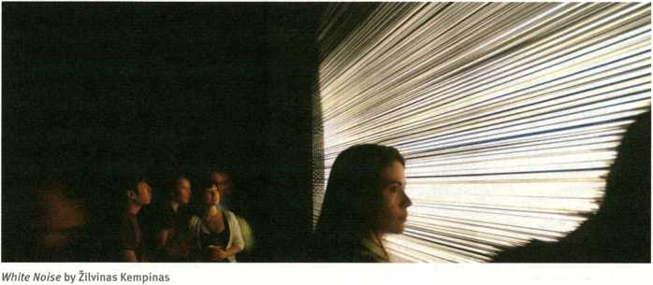
Zilvinas Kempinas uses unspooled videotape as a material to create unique works which encourage us to consider tape as both physical object and container of information.
Moving on from his gravity-defying works, such as Double 0, in which large shimmering loops of tape are levitated in space by industrial fans, White Noise more explicitly refers to videotape as moving image medium. Viewers enter a dark, almost cinematic space and are confronted by what appears to be a large projection screen of pixelated static. The screen vibrates with the fragmented black and white pixels we associate with an untuned video source. A low hum and fluttering sound reinforce the connotation. As viewers move forward, they become aware that the screen is actually hundreds of strands of videotape stretched in horizontal bands vibrated by air currents created by a multitude of fans.
The obsolescent medium of tape is employed to evoke the flickering visual sensation of noise, thus creating a formal resonance with Ryoji Ikeda’s installation of monochrome pixels and digits in the Exhibition Hall.
Kempinas shows us that videotape is more than merely a neutral carrier of virtual moving images. He uses tape to extend its virtuality, transforming it into a medium of futurity, which sculpts and redefines space.
Zilvinas Kempinas nutzt lose Videobänder als Ausgangsmaterial für Werke, die diese Bänder sowohl in ihrer physischen Qualität als auch als Informationsträger zur Geltung bringen. White Noise bezieht sich noch direkter auf das Videoband als Medium bewegter Bilder als z. B. seine Arbeit Double 0, in der weitläufige Bandschleifen der Schwerkraft zum Trotz von großen Industrieventilatoren in der Luft gehalten wurden. Die Besucher betreten einen dunklen, beinahe cine- matischen Raum und treffen auf das Weiße Rauschen auf einer Projektionsfläche, die regelrecht vibriert. Ein leises Brummen und Flattern unterstützt den Eindruck einer schlecht eingestellten Bildquelle. Doch unter näherer Betrachtung wird schnell klar, dass es sich bei der Leinwand tatsächlich um Hunderte horizontal aufgespannte Videobänder handelt, die von Ventilatoren bewegt werden.
Das überkommene Medium erzeugt hier einen visuellen Eindruck, der formal mit Ryoji Ikedas Installation einfarbiger Pixel in der Ausstellungshalle korrespondiert. Kempinas zeigt uns, dass Videoband mehr ist, als ein neutraler Träger von virtuellen, bewegten Bildern. Ja, er weitet diese Virtualität vielmehr soweit aus, dass wir uns vor einem Medium der Zukünftigkeit wiederfinden.
Zilvinas Kempinas is represented by Yvon Lambert
68

The Space Beyond Me (2009 - 2010) Julius von Bismarck (de)
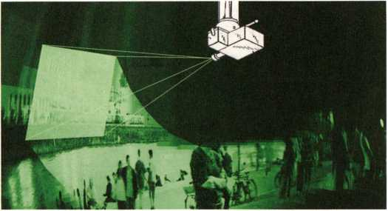
The Space Beyond Me, by Julius von Bismark
This major new work by Julius von Bismark, shown for the first time at transmediate.io, uses the materials and devices of filmmaking to create an uncanny experience of space and time.
The Space Beyond Me recreates a process in the human brain in which virtual three dimensional images are reconstructed from two dimensional information; a principle that enables us to vividly imagine a place where we have never been before, or a time that is already history.
In the gallery this takes the form of an immersive installation, where a 16mm camera, which has been converted into a projector, beams a film onto a circular screen that is painted with phosphorescent paint. The small phosphorescent crystals memorise the projected image chemically, analogous to the human mind. The past is projected into the present as an ephemeral image which fades from view like a fleeting memory.
In this landmark work, historical instruments and contemporary digital and robotic technology combine to create a transient experience of futurity.
Auf der transmediale.io wird dieses neue Werk von Julius von Bismarck zum ersten Mal gezeigt: ein unheimliches Erlebnis von Raum und Zeit aus den Materialien und Geräten des Films. The Space Beyond Me (Der vergangene Raum) ahmt mechanisch und chemisch etwas nach, das sich normalerweise im menschlichen Gehirn ereignet: Aus zweidimensionalen Information wird dort ein virtueller dreidimensionaler Raum errechnet - eine Fähigkeit, die uns gar Orte vorstellen lässt, an denen wir noch nie zuvor gewesen sind, bzw. Zeiten, die bereits Geschichte sind.
Dazu hat von Bismarck eine 16mm Kamera zu einem Projektor umgestattet, der jetzt auf eine zirkuläre, mit phosphoreszierender Farbe bestrichene Leinwand einen Film ausstrahlt. Die kleinen Phosphorkristalle prägen sich diese Bilder chemisch ähnlich ein wie ein menschliches Gehirn. Projiziert wird die Vergangenheit in die Gegenwart, und zwar als ein ephemeres Bild, das dem Blick enthuscht wie eine verblassende Erinnerung.
In diesem beeindruckenden Kunstwerk erzeugen veraltete Geräte und heutige digitale und robo- tische Technologien zusammen ein transitorisches Zukunftserlebnis.
9 Invisible Cities, p. 28 9 Art Claims Impulse, p. loi
69

From One To Many (2oio) _____ Yvette Mattern (us)
■ ■
a ■ *
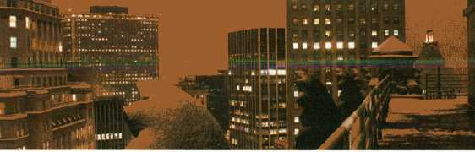
Global Rainbow, NYC 2009 by Yvette Mattern
On three evenings of transmediale.10 a rainbow will span the night sky of Berlin. This is thanks to the work From One to Many by Yvette Mattern, an enormous seven-colour laser projection reaching from the HKW to the TV Tower in Alexanderplatz. Connecting two emblematic architectural sites in the city’s former West and former East, From One to Many is both a formal exploration of projected light, and a reference to the traditional symbolism of rainbows as motifs of social diversity, peace and hope. From One to Many is the latest in a series of works by Mattern, collectively entitled Global Rainbow. The first of these was installed in New York City on Monday 19 January 2009, Martin Luther King Jr. Day, and the day before Barack Obama’s inauguration as President. It was projected from Downtown Manhattan on a span extending to Brooklyn Bridge to the east and the Hudson River to the west, directly over the fallen World Trade Centre Towers.
An drei Abenden währenddertransmediale.10 wird mitYvetteMatternsFrom One To Many ein Regenbogen die Berliner Nacht erhellen: Eine gigantische Laserkanone projiziert einen siebenfarbigen Laserstrahl vom HKW zum Fernsehturm und verbindet so zwei wichtige architektonische Sehenswürdigkeiten im alten Ost-, bzw. Westteil der Stadt. Mehr als nur eine aufwendige Spielerei mit projiziertem Licht, ruft From One To Many ganz bewusst die Bedeutungdes Regenbogens als traditionelles Symbol für gesellschaftliche Pluralität, Frieden und Hoffnung auf. Zum ersten Mal versetzte ein solcher Regenbogen New York in Staunen: am Montag den 19. Januar 2009, dem Martin Luther Kingjr. Day und Vortag der Inamtierung von Präsident Barack Obama. Damals verlief er durch Downtown Manhattan genau über Ground Zero hinweg zwischen der Brooklyn Bridge im Osten und dem Hudson River im Westen.
From One to Many is sponsored by in cooperation with Kulturstiftung H
Produced in association with amino
70

Panoramic Wifi Camera (2008) Adam Somlai Fischer (hu) & Bengt Sjolen (se) with Usman Haque (uk)
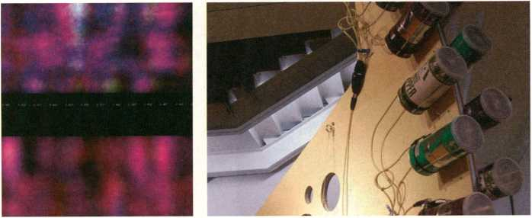
Panoramic Wifi Camera images at Light in Sight, curated by Yukiko Shikata (NTT/ICC 2008)
The Panoramic Wifi Camera takes ‘pictures’ of spaces illuminated by wireless radio signals, in much the same way that a traditional camera takes pictures through visible light. In effect, it is a camera which captures the invisible. Wireless radio networks are increasingly part of our daily lives throughout the developed world. The camera reveals the topology of this electromagnetic ecology, or ‘Hertzian space’and that even our bodies cast shadows within this space. Wifi uses wireless radio signals in the of 2.4 Ghz range which behave similarly to light waves, in that they are reflected off almost all solid objects. When we perceive colours, we see the light that is reflected off an object into our eyes. The Panoramic Wifi Camera allows us to perceive the radio environment in a similar manner. The Panoramic Wifi Camera is constructed from home-made directional antennae, which are placed in a careful array, each at a slightly different angle. This array rotates slowly, scanning, to build-up an image of a space. The work is a powerful example of how artists are creating new methods of visualisingthe intangible and atemporal environment which we exist within.
Die Panoramic Wifi Camera nimmt mit dem Licht von Radiowellen Räume auf - ganz ähnlich wie eine herkömmlichen Fotokamera Bilder auf der Basis von Tages- oder künstlichem Licht macht. Bei der Panoramic Wifi Camera handelt es sich allerdings um einen Apparat, der das Unsichtbare erfasst. In der entwickelten Welt sind wir im Alltag mehr und mehr von Drahtlosnetzwerken umgeben. Die Kamera macht die Topologie dieser unsichtbaren Wolke aus elektromagnetischer Strahlung für uns sichtbar und beweist, dass selbst unsere eigenen Körper eine Art Schatten in diesem sogenannten .Hertzianischen Raum“ werfen. Drahtlosnetze bestehen aus Radiowellen von 2,4 Ghz. Ähnlich wie Lichtwellen, werden sie von beinahe jeglichem festen Gegenstand reflektiert. Was wir als Farben sehen, ist das von einem Gegenstand zurückgeworfene Licht. Mit der Panoramic Wifi Camera können wir unsere Radio-Umgebung nun in ähnlicher Weise wahrnehmen. Gebaut haben die Künstler die Panoramic Wifi Camera mit selbstgemachten Richtungsantennen, die sorgfältig nebeneinander angeordnet sind, jede in einem etwas anderen Winkel. Diese Anordnung rotiert langsam. Nach und nach wird ein Panoramabild aufgenommen. Das Werk macht deutlich, wie Künstler neue Visualisierungsmöglichkeiten für unsere ungreifbare und zeitlose Umgebung maßgeblich mitgestalten.
9 Creativity as an Economic Resource, p. 24 9 Wifi Camera Workshop, p. 36 9 Invisible Cities, p. 28
71

Optofonica Capsule(2008) TeZ (it/nl)
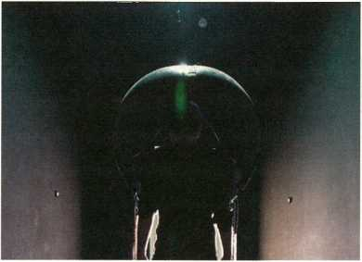
Optofonica Capsule by TeZ, Photo: Roel Backaert
The Optofonica Capsule creates a futuristic context for experiencing moving image and sound. It is both a visionary design object and an immersive environment in which a visitor can select from a programme of audiovisual works made by international artists and curated by TeZ. The shelllike shape of the capsule enfolds the body of the visitor to optimise the experience of surround and tactile sound. Low frequencies are fed through a specially constructed floor, directly into the human body, thereby converting the sound into hyper-perceivable vibration. The five panels of the capsule’s helmet are made from a specific material which reproduces the surround sound without any use of traditional speakers. A flat screen envelopes the visual field of the visitor. Individual artworks can be selected by means of a touch interface.
This highly technologically augmented audiovisual space suggests a future whereby our existing passive tropes of experiencing moving image and sound, have been upgraded substantially. One is reminded of the Phantoscope - an immersive audiovisual computer-operable display system Neal Stephenson described in his novel The Diamond Age.
Die Optofonica Capsule präsentiert bewegte Bilder und Klänge in einem futuristischen Kontext. Mit ihrer muschelartigen Form ist die Kapsel zunächst einmal ein ungewöhnliches Designobjekt. In ihrem Inneren aber kann das Publikum aus einer Palette audiovisueller Arbeiten von internationalen Künstlern wählen, die TeZ selbst kuratiert hat. Hier hallen durch den speziell konstruierten Boden tiefe Frequenzen direkt bis ins Innerste des menschlichen Körpers, wodurch der Klang zu einer hyperwahrnehmbaren Vibration wird. Auch die fünf Konsolen, aus denen der Helm der Kapsel besteht, sind aus speziellem Material und strahlen, ganz ohne herkömmliche Lautsprecher, einen Surround Sound aus. Ein Flachbildschirm nimmt das gesamte Blickfeld des Besuchers ein. Die einzelnen Programme können per Touch-Interface ausgewählt werden. Dieser hochtechnoto- gisierte, erweiterte audiovisuelle Raum suggeriert eine Zukunft, in der die sensorische Dimension unserer gewohnt passiven Bild- und Tonrezeption um ein Vielfaches nachgerüstet ist. Man muss nur an das Phantoscope denken, jenes immersive, audiovisuelle, computergesteuerte Displaysystem, das Neal Stephenson in Diamond Age - Die Grenzwelt beschrieben hat.
Created in collaboration with Janis Pönisch.
The programme of audiovisual works is also documented in a DVD released by LINE label in November 2009.
Supported by Mondriaan Stichting (Mondriaan Foundation)
72

The Inverted Cone (2010) Julien Maire (f/de)
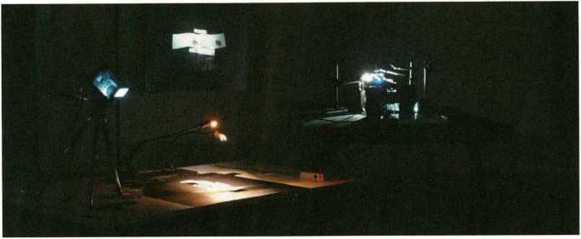
Memory Cone by Julien Maire, installation view, Courtesy Artefact Festival, Stuk Leuven 2009
The Inverted Cone is a new installation, premiering at transmediale.10, which uses a constellation of projection devices to create a condition of atemporality, where our memories of the past, and our experience of the present, collide. In this installation, digital and analogue images, pass through the same lens. What we see is not a video, nor a still, but a kind of disorientating electronic composite. The combination of temporally discrete visual sources provokes, in the viewer, an awareness of the historical continuum of image-making.
The work refers to the famous metaphor of the “memory cone”, described by Henri Bergson in his book Matter and Memory. Bergson explains that the base of the “memory cone” represents the entire collection of memories of our lived past, whilst the peak of the cone is our present condition, and our memory of the past at the time we interact with the world. At the heart of Maire’s installation is an ‘inverted light cone’, which is a literal translation of Bergson’s metaphor into an actual optical process. When participating in the heuristic process of engaging with this work, the viewer automatically becomes a media-archeologist, experiencing distinct chronologies simultaneously.
The Inverted Cone ist eine neue Installation, bei der mit Projektionsapparaten zeitlose Bedingungen geschaffen werden: Unsere Erinnerungen an Vergangenes und unser Erleben der Gegenwart brechen ineinander. Schuld sind digitale und analoge Bilder, die durch dieselbe Linse geworfen werden. Was man sieht, ist weder ein Video noch ein Still, sondern eine desorientierende, elektronische Verbindung aus beidem. Diese Kombination zeitlich ungleicher Bildquellen sensibilisiert den Betrachter für das Zeitkontinuum der Bildherstellung.
Die Arbeit verweist auf die berühmte Kegelmetapher, die Henri Bergson in seinem Buch Materie und Gedächtnis benutzt. Der Kegel stellt die Gesamtheit unserer Erinnerungen dar, wobei die Kegelbasis in der Vergangenheit liegt und die Spitze die Gegenwart symbolisiert. Hier werden gleichzeitig all jene Erinnerungbilder aktiviert, die zur Wahrnehmung der Gegenwart passen. Im Zentrum von Maires Installation steht ein umgedrehter Lichtkegel als direkte bildliche Übertragung von Bergsons Metapher. Indem der Betrachter an dem heuristischen Prozess Teil nimmt, wird er automatisch zum Medienarchäologen, der unterschiedliche Chronologien gleichzeitig wahrnimmt.
The Inverted Cone is a new iteration of Julien Maire’s memory station series of works. It was developed during a DOCK-Workstation residency, produced by [D Q.QMj Supported by the Hauptstadtkulturfonds
73

Paparazzi Bots (2009) Ken Rinaldo (us)
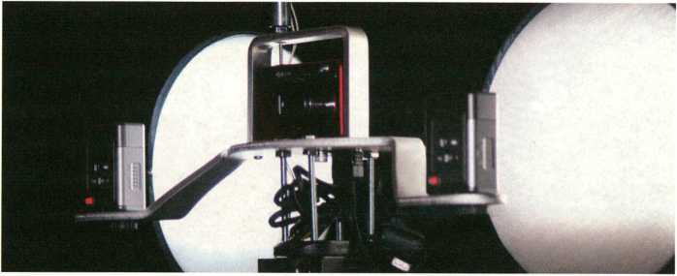
Paparazzi Bots by Ken Rinaldo
The installation features a series of Paparazzi Bots, each a tech-hybrid of camera and cameraman, which subtly stalks exhibition visitors. They seek one thing, which is to photograph these visitors, and make themselves famous.
Comprised of multiple cameras and sensors on a custom-built rolling platform, the Paparazzi Bots move at the speed of a walking human. They select a person to photograph, automatically stop, adjust their focus and record the moment with several flashes. The photos are then propagated using the press, the web, and social networking sites, elevating their subjects to ‘celebrities’ and ‘celebritising’ the Paparazzi Bots along with them.
As well as making a pointed statement on culture’s obsession with the ‘celebrity image’, the Paparazzi Bots refer to the increasing ubiquity of machine surveillance. We are often photographed by cellphones and hidden cameras and ‘celebritised’ without our knowledge. At the same time, social networking sites such as MySpace, Facebook and Twitter, have created a marked trend towards self-publicity. The line between self-publicity and surveillance will become ever more blurred in the conditional future, we find ourselves moving into.
Die Installation besteht aus einer Reihe von Paparazzi Bots, Tech-Hybriden aus Kamera und Kameramann, die die Besucher gekonnt stalken - mit einemeinzigen Ziel: diese zu fotografieren, um sich selbst berühmt zu machen.
Aus multiplen Kameras, Sensoren und einer eigens hergestellten Rollplatte gebaut, bewegen sich die Paparazzi Bots im gleichen Tempo fort wie wir Menschen. Sie suchen sich jemanden zum Fotografieren aus, stoppen, fokussieren und halten den Moment mit einem kurzen Blitzgewitter fest. Ihre Fotos werden dann in der Presse, per Internet und Social Networking Sites verbreitet. Die Porträtierten avancieren zu .Berühmtheiten* und so werden letztlich auch die Paparazzi Bots zu Stars.
Auf der einen Seite kommentieren die Paparazzi Bots spitzfindig den Hang unserer Kultur zu Ruhm und Öffentlichkeit. Auf der anderen Seite verweisen sie natürlich auch direkt auf die Allgegenwärtigkeit von Überwachungsapparaten. Jeden Tag werden wir, ohne es zu wissen, von Handys oder versteckten Kameras fotografiert. Gleichzeitig unterstützen Myspace, Facebook und Twitter den Trend zur öffentlichen Selbstdarstellung so maßgeblich, dass die Grenze zwischen Überwachung und Selbstdarstellung ständig unklarer wird.
» Futurity Long Conversation, p. 16
74

Artvertiser (2009-2010) Julian Oliver (nz), Clara Boj (es), Diego Diaz (es), Damian Stewart (nz/at)
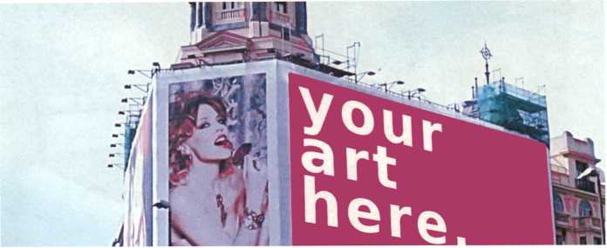
A detected advertisement, ready for substitution.
The Artvertiser imagines a near-future where advertising in public space can be replaced by art. It is an urban, augmented-reality project, consisting of custom-made handheld binocular devices and specially designed software. The Artvertiser considers Potsdamer Platz in Berlin, Puerta del Sol in Madrid, Times Square in New York, and other sites dense with advertisements, as potential exhibition space. The Artvertiser software recognises individual advertisements, each of which become a virtual ‘canvas’ displaying artworks when viewed through the Artvertiser binoculars, the art will appear when viewed through the binoculars regardless of the surface the corresponding advertisement is on. The Artvertiser allows artists to create a new visual layer onto the topology of the city, which can only be seen when viewed through a device which cogently blends the aesthetics of the past, with a futuristic functionality.
transmediale.10 presents the Artvertiser binoculars and video documentation of ‘artverts’ being placed into urban locations within Berlin.
Der Artvertiser kokettiert mit einer allzu fernen Zukunft, in der nicht mehr Werbung, sondern Kunstwerke den öffentlichen Raum pflastern werden. Mit spezialangefertigten Ferngläsern und eine passenden Software können wir schon jetzt in diese erweiterte urbane Realität eintreten.
Für den Artvertiser sind der Potsdamer Platz in Berlin, die Puerta del Sol in Madrid, der Times Square in New York und andere dicht beworbene Orte potentielle Ausstellungsräume. Indem die Artvertiser-Softvjare individuelle Werbung erkennen kann, wird sie zu virtuellen Leinwänden: Auf ihnen erscheinen die Kunstwerke, wenn man durch die Artverf/ser-Ferngläser schaut. Das allerbeste daran: Solange man die Ferngläser benutzt, erscheinen diese Kunstwerke immer, egal auf welcher Oberfläche sich die korrespondierende Werbung befindet.
Mit dem Artvertiser können Künstler die Topologie einer Stadt visuell neu überziehen. Zu sehen ist das allerdings nur mithilfe jener optischen Apparate, die in ihrer Ästhetik der Vergangenheit, in ihrer Funktion jedoch der Zukunft verschrieben sind.
Neben den Arfverf/ser-Ferngläsern zeigt eine Videodokumentation, wie verschiedene .Artverts' in Berlin verteilt werden.
3 Feb and 4 Feb, 11:15: Guided tour of Berlin Artverts For meeting place visit artvertiser.com
- Invisible Cities, p. 28
- Futurity Long Conversation, p. 16
75

' Chernobyl Project - The Invisible Stain (2008 - 2009) Alice Miceli (br)
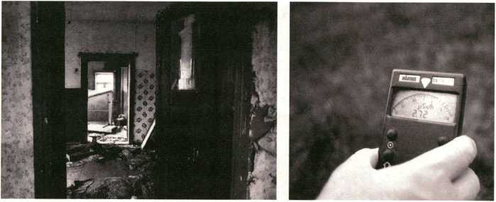
The Invisible Stain by Alice Miceli
The Invisible Stain is the third installment of Brazilian artist Alice Miceli’s ongoing Chernobyl Project. The project’s ambition is to create a radiographic series of images of the Chernobyl Exclusion Zone depicting the most affected regions located on the Belarusian side of the border. These stunning images are imprinted by the invisible radiation that has contaminated the area since the disaster on 26 April 1986.
Requiring the creation of specific technologies, including the development of auto-radiographic techniques and pinhole cameras, The Invisible Stain uses new processes in the field of photography to uncover haunting images of an abandoned place filled by an invisible matter and exposed only through Miceli’s documentation, enabling her to produce mimetic, life-size negative images of Chernobyl’s past.
transmediale festival was the first festival to present the project, showing the results of the initial laboratory experiments in 2008 and further material in 2009. For transmediale.10, this third presentation will present a completed negative series from the final, decisive stage of the work.
The Invisible Stain ist Alice Micelis dritter Teil ihres Tschernobyl-Projekts, einer Reihe radiografischer Bilder von den am schlimmsten betroffenen Regionen in der Sperrzone an der Weißrussischen Grenze. Diese eindrucksvollen Bilder entstanden allein durch die unsichtbare Strahlung, mit der das Gebiet seit dem Unglück vom 26. April 1986 kontaminiert ist.
The Invisible Stain erforderte die Entwicklung von spezifischen Technologien wie autoradiografische Techniken und Bleilochkameras.
Mit neuesten fotografischen Prozessen erstellt Miceli mimetische, lebensgroße Negativbilder von Chernobyls Vergangenheit, die die unsichtbare Materie, die diesen Ort beherrscht, sichtbar machen. Das Projekt debütierte auf der transmediale 2008 mit den Ergebnissen erster Laborexperimente. 2009 folgte weiteres Material, und im Rahmen der transmediale.io wird nun mit den fertigen Negativreihen der endgültige Stand der Arbeit präsentiert.
76

TEXTE

S
O

ICH

Y

SCHIC T

HS OR
AKTUELLE EDITIONEN:
ANGELA BULLOCH

S Hl TE

ST RY
JONATHAN MEESE
FLORIAN PUMHOSL

artp
WWW.ARTE JV ...
KULTUR DIGITAL
DAS ARTE ⁰ ^ KTR^{Z}0 N ISC H E
SSSÄnKÄecJSSlogien.
... . > • in Dcr.i FITEN WIR
MUbir\ uiNu
auch in diesem Jahr begleiten wir die transmediale.
77
www.textezurkunst.de


Gosotf&GtaMor&Ôfton'I'ChoFârciftrftrvonftUHK.SOtO -
W Ruhr^k-^ Ü1Ü
H«up(<[mnKKMI mn RUHR.8010 - - - -
ÊlîS- ô<m|Ruhn,« HANIEL vorweg GEHEN S Finanzgruppe
Sat 28-Sun 29 Public Art Projects and Symposium Duisburg
Sun 22
Day of Sound at ICEM, Folkwang Hochschule Essen
"3? a mu KUNSTSTIFTUNG O NRW
Mon 23-Frl 27
Conference, Keynotes, E-Culture Fair and Concerts Dortmund

www.isea2010ruhr.org
ISEA2010 RUHR, 16th International Symposium on Electronic Art, is a project of European Capital of Culture RUHR.2010, and is hosted by Medienwerk NRW. ISEA2010 RUHR is organised under the auspices of the ISEA Foundation and is funded ¡.a. by RUHR.2010, the State Chancellory of North Rhine Westfalio* tho City of Dortmund and the Arts Foundation of North Rhine-Westphalia.

RUHR.20I0
f'iiSlIpllBB - 'urtouptstiöt Europas
¡¡fliiSSS&t&K«:
ISEA
2010
I
!
Ruhr/Germany
16th
International Symposium on Electronic Art
20-29 August 2010
Fri 20-Sun 29
Exhibitions U-Centre, Dortmund
Fri 20-Sun 22
Performances and Workshops PACT Zollverein Essen
78


-
As leading international festivals for art and digital culture as well as for adven-_{s} turous music and related visual arts, respectively, transmediale and CTM received ca. 1,500 submissions to the transmediale Award and the Vilém Flusse Theory Award competitions. The transmediale Award 2010 jury, Yves Bernard (be)| Michelle Kasprzak (uk), José Luis de Vicente (es), Li Zhenhua (cn/ch) and Doreen Mende (de), nominated nine exceptional art works and projects that respond to the challenges of our rapidly changing digital, technological and net-worked cultures.
Reflecting the increasing significance of theoretical, research and critical practice based works the Vilém Flusser Theory Award, in collaboration with the _Vilém_Flusser_Archive at Berlin’s University of Arts, honours outstanding work that adopt Flusser’s legacy through their imaginative and analytic rigour. The Vilém Flusser Theory Award advisory group, Sabeth Buchmann (de / at),
Oliver Grau (de / at), Marcel René Marburger (de) has nominated 4 works for this year’s Award. Nominated artworks, artists and authors are presented with respect to their form of expression at the HKW and tm.10 Satellite locations.
Als führende Festivals für Kunst und digitale Kultur sowie adventurous music and related visual arts erhielten transmediale und CTM ca. 1.500 Einsendunger für die Wettbewerbe des transmediale Award und Vilém Flusser Theory Award. Die diesjährige Jury des transmediale Award 2010 Yves Bernard (be),
Michelle Kasprzak (uk), José Luis de Vicente (es), Li Zhenhua (cn / ch) und Doreen Mende (de) nominierten neun herausragende Kunstwerke, die auf die Herausforderungen unserer sich schnell verändernden digitalen, technologischen und netzwerkbasierten Kultur reagieren.
Um der wachsenden Bedeutung der theoretischen als auch der kritischpraktischen Arbeiten gerecht zu können, ehrt der Vilém Flusser TheoryAwa in Zusammenarbeit mit dem _Vilém_Flusser_Archiv der Berliner Universität der Künste hervorstechende Arbeiten, die durch ihre besondere Imagination und analytische Schärfe das intellektuelle Erbe Flussers antreten. Sabeth Buchmann (Berlin/Wien), Oliver Grau (Berlin/Krems), Marcel René Marburger (Berlin/Köln) haben als Jury des Vilém Flusser Theory Award 2010 vier Arbeiten nominiert. Die nominierten Kunstwerke, Künstler und Autoren w< im HKW, bzw. an Satellitenorten dertransmediale.10 präsentiert.

Jury Statement transmediale Award 2010
We look at the present through a rear-view mirror. We march backwards into the future.
Marshall McLuhan
The works nominated for the transmediale Award 2010 represent a wide range of experimental practice. Collectively, the works give us a snapshot of the realities of the world we live in now, and the possibilities of the near future. Like McLuhan’s rear-view mirror, each work enables us to interrogate versions of the future through what has been enabled by innovations of both recent and distant past. Certainly, some of the nominated works are possible only because of developments in the past few years. The massive popularity of online working and sharing is at the core of works such as Aaron Koblin and Daniel Massey’s Bicycle Built for Two Thousand and Michelle Teran’s Buscando al Sr. Goodbar. Distributed working, and the ongoing development of open content licences are also issues very much of the moment, and are central foci of Free Art and Technology Lab. Among the nominees, the political situation of the present and finding ways to make sense of it are strongly represented. Both The Exception and the Rule by Karen Mirza & Brad Butler and Reconstitution by Sosolimited examine, in very different ways, the nature of information dissemination and comprehension when political stakes are high. Imagined futures are perenially captivating and relevant, as we see in the sci-fi allegory of Chapter!: The Discovery by Félix Luque Sanchez and the speculative design of the Carnivorous Domestic Entertainment Robots by Auger- Loizeau & Zivanovic. These two works provide windows onto futures that are fanciful and practical, respectively. Coincidence Engines by [The User] and Artificial Moon by Wang Yuyang are works possessing extraordinary formal beauty. Considering time and sound, space and light, these two works delighted jury members with their aesthetics as well as their underlying stories.
The stories we tell about the past, and the projections we make for the future, are all here for us to discover in the present. Each of these nominated works inhabits a critical and speculative space that lets us make our own discoveries.
Die für den transmediale Award 2010 nominierten Werke spiegeln ein breites experimentelles Arbeitsfeld wider und liefern in ihrer Gesamtheit eine Momentaufnahme der Welt, in der wir heute leben, sowie der Möglichkeiten, die wir uns von der nahen Zukunft versprechen. Als wären sie McLuhans Rückspiegel, reflektieren die Arbeiten bereits veraltete bzw. neueste Innovationen - und somit unterschiedlich getaktete Zukunftversionen.
Selbstverständlich wurden einige der nominierten Arbeiten nur durch jüngste Entwicklungen überhaupt möglich gemacht. Die große Popularität, online zu arbeiten und Inhatte zu teilen, thematisieren sowohl Aaron Koblin und Daniel Masseys Bicycle Built for Two Thousand als auch Michelle Terans Buscando al Sr. Goodbar. Formen der Arbeitsteilung und die fortlaufende Entwicklung von Open Content Lizenzen sind derzeit ebenfalls heisse gesellschaftliche Themen und das, worauf sich Free Art and Technology Lab konzentrieren. Die Nominierten beschäftigen sich ausserdem auch stark mit den politischen Gegebenheiten der Gegenwart. So untersuchen die beiden Arbeiten The Exception and the Rule von Karen Mirza & Brad Butler und Reconstitution von Sosolimited auf unterschiedlichen Wegen, wie Informationen verbreitet und aufgefasst werden, wenn politisch viel auf dem Spiel steht. Zukunftsbilder können uns wirklich immer fesseln, wie wir anhand der von Science Fiction inspirierten Installation Chapter I: The Discovery von Félix Luque Sánchez und dem spekulativen Design der Carnivorous Domestic Entertainment Robots von Auger-Loizeau & Zivanovic beobachten können. Coincidence Engines von [The User] und Artificial Moon von Wang Yuyang sind zwei Werke von aussergewöhnlich schöner Formensprache, die Zeit und Klang, Raum und Licht thematisieren und die Jurymitgtieder nicht nur durch ihre Ästhetik, sondern auch durch die Geschichten, die sie erzählen, überzeugt haben.
Was wir über die Vergangenheit erzählen oder auf die Zukunft projizieren - spielt sich letztlich doch altes in der Gegenwart ab. Jedes nominierte Kunstwerk besetzt einen kritischen und spekulativen Raum, in dem wir selbst auf Entdeckungsreise gehen können.
Michelle Kasprzak, curator and writer
80

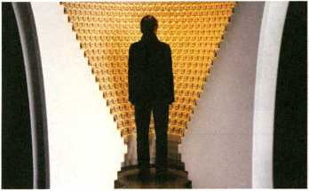
Coincidence Engines by [The User]
/ | \
/  / | \  \
\ | /
%-
Chapter I: The Discovery by Félix Luque Sánchez
Coincidence Engines I and II (2008-2009) 'MB QL [The User] (ca)
Coincidence Engines is a technological composition project by the Canadian artist duo [The User] (Emmanuel Madan/Thomas McIntosh) in which the mundane ticking of a clock is transformed into the source of complex acoustic structures in homage to the Hungarian composer György Ligeti and his Poème Symphonique, transmediale.10 are presenting an exhibition of Coincidence Engine One: Universal People’s Republic Time, and Coincidence Engine Two: Approximate Demar- cator of Constellations in Other Cosmos at the XHB in Mitte.
Coincidence Engines ist ein technologisches Kompositionsprojekt des Künstlerduos [The User] (Emmanuel Madan/Thomas McIntosh), in dem sich das tausendmal gehörte Ticken einer Uhr als Hommage an das Poème Symphonique des ungarischen Komponisten György Ligeti in eine reichhaltige Quelle komplexer akustischer Strukturen verwandelt.
Die Ausstellung von Coincidence Engine One: Universal People’s Republic Time und Coincidence Engine Two: Approximate Demarcator of Constellations in Other Cosmos findet im .CHB statt.
A co-production with the .CHB
Commissioned by PAVED Arts and co-produced by the /Undefine organisation with the support of the Canada Council for the Arts, le Conseil des arts et des lettres du Québec and le Conseil des arts de Montréal. Commissioning curator: Tim Dallett
® Collegium Hungaricum Berlin, p. 94

Chapter I.-The Discovery (2009) Félix Luque Sánchez (es)
in this audiovisual installation a ‘sci-fi geometric object’ tries to communicate with us by releasing a code of light and sound. Accordingly, the installation questions the limits of our notions of artificial intelligence and of Science Fiction, and questions the viewer’s perception about the truthfulness of what is shown, transmediale.10 are presenting the installation at The Cervantes Institute.
Bei dieser audiovisuellen Installation will ein geometrisches Objekt, das einem Science-Fiction Film entsprungen scheint, mittels Informationen aus Licht und Ton mit uns in Kommunikation treten. Luque Sánchez stellt sein Publikum vor die Frage nach der Wahrhaftigkeit des Sichtbaren und strebt ausserdem nach den Grenzen von künstlicher Intelligenz und Science-Fiction.
Zur transmediale.10 befindet sich die Installation im Instituto Cervantes in Mitte.
A co-production with the Cervantes Institute and
Supported by Communauté française de Belgique, secteur des Arts numériques
» Instituto Cervantes, p. 95
81


FuckGoogle by F.A.T. Lab

Free Art and Technology Lab
(«nt) m
Founded in 2007 by Evan Roth and James Powderly, and grown by 17 new members since, the F.A.T. network is a loose online collective working across several continents - and with a great amount of humour - on free software and other exciting projects supporting open values through the use of open licenses. F.A.T. Lab’s mission has been achieved through the insertion of open ideals into mainstream (and often non-technical) popular culture, including the New York Times, MTV, the front page of YouTube and the permanent collection of the Museum of Modern Art. transmediale.io are presenting F.A.T. Lab as part of the Salon.
F.A.T. Lab wurde 2007 von Evan Roth and James Powderly gegründet. Über die letzten zwei Jahre ist die Gruppe auf 19 Mitglieder angewachsen, die nun über das Internet von drei Kontinenten aus mit großem Humor gemeinsame Copy Left und Free Licence Projekte realisieren. F.A.T. Lab haben es bereits mehrere Male erfolgreich geschafft, ihre freien Ideale in der (oft technikfernen) Mainstream-Popkultur an prominenten Stellen unterzubringen: auf der New York Times, der Homepage von YouTube, bei MTV und sogar in der Sammlung des MoMA.
» Futures Exchange: FuckGoogle, p. 32
'Reconstitution (2008)
SOSOLIMITED (US)
Reconstitution by the art and design collective Sosolimited (Justin Manor / Eric Gunther / John Rothenberg) is a live remix of broadcast television, and a format originally configured for the 2008 presidential elections. Technically it is a software tool for datavisualisation allowingfor the extraction of video, audio, and closed captioned text from television broadcasts in real time. Sosolimited visually and sonically transform this data in front of a seated audience, creating an unpredictable, sometimes funny narrative by cataloguing the utterings and movements of the people on screen, transmediale.io are presenting a new work by Sosolimited - The Long Conversion.
ReConstitution wurde 2008 im Zuge der amerikanischen Präsidentschaftswahlen von dem Kunst- und Designkollektiv Sosolimited (Justin Manor / Eric Günther/ John Rothenberg) konzipiert: eine Performance, in der Fernsehinhalte live geremixt werden. Technisch handelt es sich um eine Datenvisualisierungssoftware, mit der Video-, Audio- und Textdaten im Augenblick ihrer Fernsehausstrahlung extrahiert werden können. Mit diesem Material kollagieren Sosolimited eine unvorhersehbare, manchmal komische Narrative, indem ihr System die Bewegungen und Äußerungen der Akteure sammelt und als Daten, visuell und akustisch transformiert, sogleich wieder abspielt. *
* The Long Conversion, p. 16
82

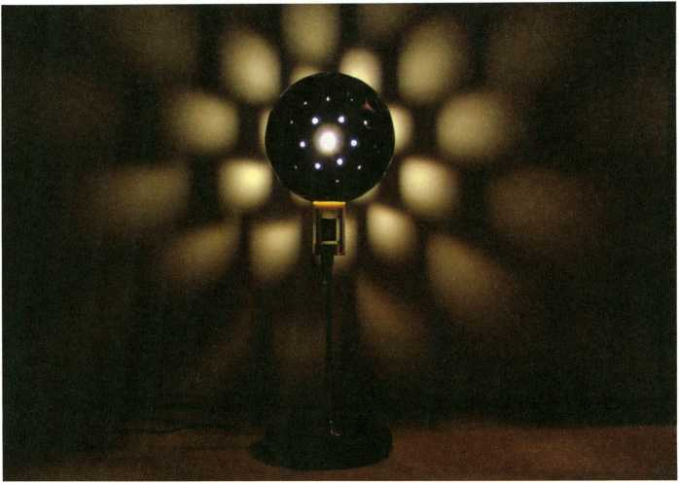
Carnivorous Domestic Entertainment Robots by Auger-Loizeau & Zivanovic

Carnivorous Domestic Entertainment Robots (2008).
Auger-Loizeau & Zivanovic (uk)
The artists contend that if robots are ever to be welcomed into people’s homes, they will need to fit in with the rest of the furniture, and earn their keep. The Carnivorous Domestic Entertainment Robots - including a sticky conveyor belt clock and moth-attracting death lamp - are unsettling apparati and bizarre hybrids between machine and living organism. As examples of‘critical’ or ‘speculative’ design these prototypes power themselves with special fuel cells that are able to produce electricity by processing the bodies of flies, and in one case, mice, transmediale.io are showing a series of Carnivorous Domestic Entertainment Robots at the HKW, including the Flypaper Robotic Clock, the Coffee Table Robot and the Lampshade Robot.
Oie britischen Künstler sind vollkommen davon überzeugt, dass Hausroboter nur dann Sinn machen, wenn sie wirklich nützlich sind. Ihre Prototypen fangen und verdauen deshalb zum eigenen Energiegewinn Fliegen und Mäuse. Herkömmliche Fliegenfänger mit Klebeband oder UV-licht sind somit endlich überholt - das lästige Aufräumen und Wegputzen von Überresten bleibt uns in Zukunft erspart. Im HKW zeigt transmediale.io einige dieser leicht beunruhigenden Geräte - ausgefallene Hybride zwischen Maschine und Lebewesen - darunter eine klebrige Fließbanduhr und eine Motten anziehende Todeslampe.
» Futurity Long Conversation, p. 16
83

Bicycle Built For Two Thousand (2009) Aaron Koblin & Daniel Massey (us) 9
The title of this online work refers to the song line “bicycle built for two” from the well-known Daisy Bell. Koblin & Massey’s piece is comprised of over 2,000 voice recordings collected via Amazon’s Mechanical Turk web service. Workers were asked to listen to a short sound clip, then record themselves imitating what they heard. The result is a reconstructed version of the song Daisy Bell - the first song to implement musical speech synthesis in 1962 - as rendered by a distributed system of human voices, transmediale.10 are showing the work at the HKW.
Der Titel dieses Netzkunstwerks verweist auf die Zeile „bicycle built for two“ aus dem Lied Daisy Bell. Mit Hilfe des Online-Programms Mechanical Turk von Amazon haben die Künstler 2000 Stimmaufnahmen gesammelt. Hierfür wurden Arbeiter in der ganzen Welt eingeladen, sich zunächst einen kurzen Tonausschnitt anzuhören, um sich daraufhin selbst beim Nachahmen aufzunehmen. Basierend auf einem weitläufigen System menschlicher Stimmen entstand als Ergebnis eine Rekonstruktion - eine Neueinspielung - von Daisy Bell, jenem ersten Lied mit musikalischer Sprachsynthese von 1962.
® ART 2.0, p. 25
Beamen wir uns per Anhalter durch die Galaxis und surfen wenn Berlin Calling?
Guter Plan!

tazplan für musik, kino, bühne und kultur.
5 Wochen taz mit täglich 4 Seiten Kultur & Programm für nur 10 Euro.
Bestellen Sie das unverbindliche Miniabo inklusive einer deutschsprachigen
Le Monde diplomatique.
T (030) 25 90 25 90 | abomail@taz.de | www.taz.de
¡t die tageszeitung
84

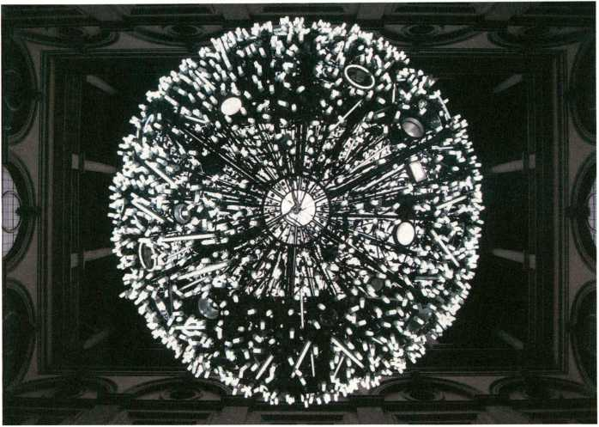
Artificial Moon by Wang Yuyang

Artificial Moon (2007-2009) WM (Ê Wang Yuyang (cn)
In this work, Wang Yuyang used a panoply of energy-saving light bulbs to create a vast incandescent four-metre sphere. In a poetic way Artificial Moon draws attention to the collision between the ‘natural’ and the ‘artificial’, commenting on how the timeless phenomena of the stars and the moon are becoming increasingly obscured by the light pollution common in many contemporary cities. In 2008, Artificial Moon was suspended, like a giant Chinese lantern, between the trees of a public park in the city of Xujiahui in China, one of the few green spots in an urban context in which the real moon is often eclipsed by the radiance of a brightly illuminated metropolitan sky. transmediale.10 are presentingvideo documentation of Artificial Moon.
Aus Energiesparbirnen schuf Wang Yuyang einen riesigen Leuchtball von 4m Durchmesser. Die Arbeit Artificial Moon thematisiert auf poetische Weise das Zusammenprallen von Natur und Künstlichkeit und kommentiert die Frage, wie die zeitlosen Phänomene Sterne und Mond immer mehr durch die Abstrahlung des künstlichen Lichts überleuchtet werden, das in vielen modernen Städten üblich ist. 2008 wurde Artificial Moon wie eine riesige Chinesische Laterne zwischen den Bäumen eines öffentlichen Parks in der chinesischen Stadt Xujiahui aufgespannt - also in einem der wenigen grünen Orte innerhalb eines solchen städtischen Umfelds, in dem der wirkliche Mond oft durch die Lichtverschmutzung des hell erleuchteten Großstadthimmels .verfinstert“ wird, transmediale.io zeigt eine Dokumentation über Artificial Moon. •
• Destination Moon, p. 27
85

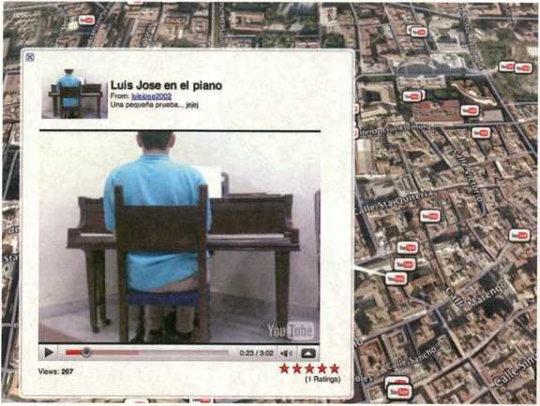
Buscando al Sr. Goodbar by Michelle Teran
iüE Buscando al Sr. Goodbar (2009)
Michelle Teran (ca) 9
ln her works Michelle Teran explores the interplay between social and media networks within urban environments. Her nominated piece consists of a threefold tour through the Spanish town Murcia: by bus, on Google Earth and YouTube. The search for places and authors of various YouTube videos shot in town - an intimate encounter between videomakers and audience, the overlapping of the real and the virtual, of past and present.
For transmediale.10 the artist will present a new remix of the original work as a two-channel video installation.
Michelle Teran thematisiert in ihren Arbeiten die sozialen und medialen Netzwerke, die das städtische leben heute ausmachen. Die diesjährige Nominierung erhielt sie für eine Tour durch die spanische Stadt Murcia auf drei Ebenen zugleich: mit dem Bus, auf Google Earth und YouTube. Die Suche nach den Orten und Autoren der YouTube Videos. In einer vertraulichen Begegnung zwischen Videomachern und Publikum überschneiden sich realer und virtueller Raum, Vergangenheit und Gegenwart.
Im Rahmen der transmediale.io wird Michelle Teran einen Remix der Arbeit als eine 2-Kanal- Videoinstatlation zeigen.
» ART 2.0, p. 25
86

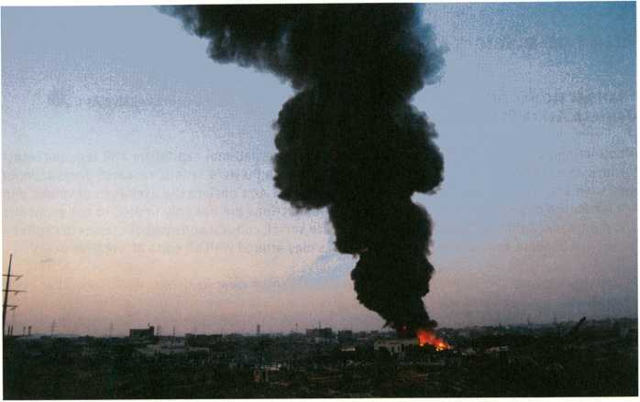
The Exception and the Rule by Brad Butler & Karen Mirza

The Exception and the Rule (2008) ' Brad Butler (uk) & Karen Mirza (uk)
Shot in Karachi as part of the project The Museum of Non Participation, this film thematises the problems of ethnographical cinema. The result is a highly idiosynchratic hybrid of several cinematic approaches which, rather than becoming entangled, are presented one after another quoting different methods. If The Museum of Non Participation can be read as a non-museum, The Exception and the Rule (UK 2008, 37min) is a non-documentary film. Just as the museum can’t really convey the live aspects of art (represented in mythology by the muses) the media are insufficient if you really want to learn about foreign cultures. The film constructs a complex pattern of the Other from a bricolage of quoted media. It insists on the intranslatability of experience by claiming an ‘uncomfortable’ encounter with the truly Other, transmediale.10 are showing the work in the Film & Video programme.
In Karachi als Teil des Projektes The Museum of Non Participation gedreht, thematisiert und hinterfragt diese Arbeit die Probleme des ethnografischen Films. Das Ergebnis ist ein höchst eigenwilliges Hybrid aus mehreren filmischen Formen, die sich nicht gegenseitig durchdringen, sondern als Methoden zitathaft hintereinander gestellt sind. Wenn das Museum of Non Participation ein Nicht-Museum ist, so ist The Exception and the Rule (UK 2008, 37min) ein Nicht-Dokumentarfilm. So wenig man über das lebendige Moment der Kunst (mythisch repräsentiert durch die Musen) in einem Museum erfährt, so wenig erfährt man über eine fremde Kultur durch die Medien. Der Film verwebt die Bilder des Anderen in ein komplexes Geflecht aus medialen Zitaten und formalen Brechungen; er beharrt auf dem Moment unvermittelbarer Erfahrung - und fordert somit vom Betrachter die direkte, die .unkomfortable’ Begegnung mit dem wirklich Anderen ein.
» Which Organisation are you Shooting the Film for?, p. 26 ® Long Distance Transfers, p. 44
87

Vilem Flusser Theory Award Jury Statements
Transactional Arts - interaction as transaction, a form of interactive art Daniela Alina Plewe (de)
Albeit being currently subjected to heavy criticism, international capitalism still remains intact for lack of alternatives. Before this background Daniela Plewe’s artistic research Transactional Arts seems to come at the right moment. Transactional Arts declare the exchange of values and the formation of social contracts works of art. Transactions are not only limited to our economic and monetary capital but purposefully incorporate social, cultural and symbolic forms of capital - incentives become aesthetic material and artists play around with all sorts of ‘creative deals’.
In Zeiten, in denen der internationale Finanzkapitalismus zwar kritisiert, doch scheinbar noch alternativlos unangetastet bleibt, erscheint die von Daniela Plewe propagierte künstlerische Forschung Transactional Arts zeitgemäß. Transactional Arts erheben den Austausch neuer Werte und den Vorgang, in dem etwa gesellschaftliche Verträge zustande kommen, zur Kunst. Transaktionen beschränken sich nicht nur auf ökonomisches oder monetäres Kapital, sondern beziehen gezielt soziale, kulturelle und symbolische Formen des Kapitals mit ein - Incentives werden ästhetisches Material, und Künstler erforschen innovative Spielarten .kreativer Deals“.
Oliver Grau (read full version of jury Statement online)
• Processual Media Art and Theory, p. 24

Ht There must be an Angel. On the Beginnings of Arithmetics of Rays 9 David Link (de)
With There Must Be An Angel, David Link re-vamped one of the first computer programmes ever, the programme Loveletters (1952) by one of Alan Turing’s colleagues Christopher Strachey. By convention Joseph Weizenbaum’s programme ELIZA (1966) is considered the first example of computer-generated text. One of Link’s achievements is to have advanced this premiere by 10 years. The nominated research is part of a larger project in which Link plans to revive the entire still remaining software that was developed with the Manchester Mark 1 and the Ferranti Mark 1 between 1948 and 1958. This touches upon the inception of crucial scientific developments such as meteorology, quantum chemistry and X-ray crystallography culminating in today’s genetics. Thus Link’s work is a crucial fundamental research in the field of media art history.
David Link hat mit There Must Be An Angel eines der ersten Computerprogramme überhaupt, das Programm Loveletters (1952) von Christopher Strachey, einem Kollegen Alan Turings, wieder zur Ausführung gebracht. Gemeinhin gilt Joseph Weizenbaums Programm ELIZA (1966) als erstes Beispiel von computerisierter Texterzeugung. David Link stellt dies in Frage und lenkt damit den Blick auf ein weitgehend vergessenes Kapitel der Computergeschichte: Die Manchster Mark 1 ist der erste Rechner, der der Definition einer vollelektronischen Universalmaschine mit Programmspeicher entspricht. Der nominierte Beitrag ist Teil eines größeren Projektes, in dem Link die gesamte noch erhaltene Software, die auf dem Manchester Mark 1 und dem Ferranti Mark 1 von 1948 bis 1958 entwickelt wurde, wieder zum Leben erwecken möchte. Es handelt sich hier um die Anfänge so wichtiger Wissenschaften wie der Meteorologie, der Quantenchemie und der Röntgenkristallo- graphie. Link leistet damit wichtige Grundlagenforschung der MedienKunstGeschichte.
Oliver Grau (read full version of jury Statement online) *
* Futurity Long Conversation, p. 16
88

Neuropower Warren Neidich (us)
The project Neuropower is a manipulation in the literal sense of the word. Departing from recent insights of brain research, the trained biologist Neidich searches for strategies to manipulate the process of ongoing cerebral reconstruction. Through artistic means - as for instance the performative gesture - Warren Neidich attempts to re-conquer those cognitive realms which are normally subjected to the effects and mechanisms of the mass media in a globalised world defined by neoliberalism. By joining scientific and aesthetic knowledge elegantly, Neidich’s work commences right there where reality is first of all constructed: in the neuronal networks of the brain.
Das Projekt Neuropower ist eine Manipulation im besten Sinne des Wortes. Von jüngeren Erkenntnissen der Gehirnforschung ausgehend, sucht der gelernte Biologe nach Strategien, auf den Rekonstruktionsprozess des Zentralnervensystems einzuwirken. Mit künstlerischen Mitteln - wie der performativen Geste - ist Warren Neidich bemüht, jene Bewusstseinsbereiche zurückzuerobern, die ansonsten den massenmedialen Wirkungsweisen einer globalisierten Welt neotibera- ler Prägung unterliegen. Naturwissenschaftliche und ästhetische Erkenntnisse vereinend, setzt seine Arbeit dort an, wo sich Wirklichkeit konstituiert: in den neuronalen Bahnen des Gehirns. Marcel René Marburger (read full version ofjury statement online)
» Futurity Long Conversation, p. 16

Syjettes €i Mina Lunzer (at)
Four speakers report about an accident which occurred a year before at Praterstern. For three weeks Lunzer’s radio play was installed inside a publicly accessible car, which had been driven into a facade at Praterstern. Together with samples of the noise of machines and people screaming three of these witness accounts were subsequently used as audio tracks of the film version [...] Syjettes can be read as a discourse analysis of the social, underpinned by media theory. Lunzer appropriates old and new media to explore how their inherent rules participate in determining a certain representation of reality. This does not mean however that artistic cinematographic practice were immediately to be seen as (media) theory. [...] At stake are the means of communication within which the comparabilities between theory and art articulate themselves as unsurmount- able differences. The disputable narratives presented in Syjettes mirror the processes of social inclusion and exclusion which form the basis of the creation of a public sphere.
Vier Sprecher berichten in Interviews über einen Unfall, der sich ein Jahr zuvor am Praterstern ereignet hat. Lunzers Hörspielversion war drei Wochen lang in einem begehbaren Auto installiert, das zuvor gegen eine Fassade am Praterstern gefahren worden war. Mit Maschinengeräuschen und menschlichen Schreien gesampelt wurden in der anschließend entstandenen Filmversion drei der Zeugenprotokolle alsTonspurverwendet [...] Syjettes lässt sich als eine dokumentarisch-narrative Überschreibung medientheoretischer Diskurse lesen, die von jenen Wechselverhältnissen zwischen Ereignissen, Wahrnehmungsformen und Medien zeugen [...] In Syjettes ist es die Dissoziation von agierendem Körper und dokumentarischer Stimme, die das von den jeweiligen Figuren erzählte Geschehen konstituiert.!...] Es gelingt der Künstlerin, die im Film eingeschriebenen Übersetzungsprozesse als Vorgänge ansichtig werden zu lassen, die in wesentlicher Weise durch soziale Erfahrungsformen geformt und vermittelt sind.
Sabeth Buchmann (read full version ofjury Statement online)
» Processual Media Art and Theory, p. 24
89

CTFO
HT CTM.io - OVERLAP
CLUB TRANSMEDIALE - FESTIVAL FOR ADVENTUROUS MUSIC AND RELATED VISUAL ARTS BERLIN 28 January - 7 February 2010
With new venues and new themes, the 11th edition of CTM is set again to delve into the convergence zone of Out-Pop, experimental music, art and media technologies. With this year’s festival theme OVERLAP-Sound & Other Media CTM.io will pursue the discussion begun during the highly commended 10th anniversary edition in January 2009 on the present circumstances and future prospects of self-determined music production and experimental audiovisual cultures from a new angle. While the festival focus in 2009 was an analysis of the internal structures of independent music and media cultures, the CTM.io theme OVERLAP aims for a broader assessment of the various interfaces that exist between music and other creative and social arenas.
The festival serves up its mix of club nights and concerts in the legendary and recently reopened glam club WMF. Just a stone’s throw away, the daytime venue .HBC hosts a comprehensive programme of lectures, workshops, panel discussions and installations. And at Haus der Kulturen der Welt, CTM and transmediale cooperate even closer than before, as co-presenters of first-class audiovisual projects and the transmediale Award.
Mit neuen Spielorten und mit neuen Themen erkundet die 11. Ausgabe des CTM die undefinierbaren Konvergenzzonen zwischen Out-Pop, experimenteller Musik, Kunst und Medientechnologien. Mit dem Festivalthema OVERLAP - Sound & Other Media setzt CTM.io die mit der Jubiläumsausgabe 2009 begonnene Diskussion zu Situation und Zukunftsaussichten selbstbestimmten Musikschaffens und experimenteller audiovisueller Kulturen unter neuer Perspektive fort. Lag 2009 der Schwerpunkt auf der Analyse der Binnenstrukturen unabhängiger Musik- und Medienkulturen, erweitert CTM.io den Radius und nimmt aktuelle Schnittstellen zwischen Musik und anderen kreativen Feldern in den Blick.
In einem Mix aus Clubnächten und Konzerten bespielt das Festival die in neuem Glanz wieder- eröffnete Clublegende WMF. In unmittelbarer Nähe präsentiert sich der Tagesspielort .HBC mit einem dichten Programm aus Vorträgen, Workshops, Diskussionsrunden und Installationen. Das gemeinsame Programm mit der transmediale im Haus der Kulturen der Welt und die gemeinsame Ausrichtung des transmediale Award unterstreichen das Zusammenrücken beider Festivals.
The complete programme as well as information on the venues and ticket prices is to be found in the CTM.io catalogue and on the festival’s website.
Das komplette Programm und Informationen zu Spielorten und Eintrittspreisen finden sich im CTM.io-Katalog und auf der Festival- Webseite.
clubtransmediale.de
9 Performance, pp. 53 9 Award, pp. 79
90

ff CTM.io Selected Highlights HÜ
Esemplasticism: The Truth is a Compromise, 28 - 29 Jan, 15:00 - 22:00, Spandauer Strasse 2
Human perception and the strategic interweave of individual senses are the theme of an exhibition curated by Hicham Khalidi and produced by The Hague-based <TAG> in the temporary venue at Spandauer Strasse 2.
Die menschliche Wahrnehmung und die strategische Verschränkung der Einzelsinne sind das Thema der von Hicham Khalidi kuratierten und von <TAG> aus Den Haag produzierten Ausstellung in den temporären Räumen der Spandauer Strasse 2.
A MAZE. Interact - Music Games Exhibition, 29 Jan - 6 Feb, 15:00 - 22:00, .HBC
Within the CTM.io framework the A MAZE. Interact Festival presents a comprehensive programme on the convergence of sound and computer games. In cooperation with the UdK’s Sound Studies and the FH Potsdam’s European Media Sciences Departments, the exhibition presents commercial computer games in which music is the major theme or aim.
Das A MAZE. Interact Festival präsentiert innerhalb des CTM.io ein umfassendes Programm zur Konvergenz von Sound und Computer Games. In Zusammenarbeit mit UdK Sound Studies und den Europäischen Medienwissenschaften der FH Potsdam zeigt die Ausstellung kommerzielle Computerspiele, deren Thema oder Spielziel Musik ist.
> Forms of Cultural Organisation, p. 26
OM, 3 Feb, 22:00, WMF
Psychotropic Drone-Metal-Mantras from OM merge meditative repetition and minimalist dynamics with sheer physical intensity: psychedelic masterpieces on the wide-screen.
Die psychotropen Drone-Metal-Mantras von OM vereinen meditative Repetition und minimalisti- sche Dynamik mit ungeheurer physischer Intensität. Psychodelische Meisterwerke im Breitwand- Format.
FourTet, 5 Feb, 23:00, WMF
It took four years but now here it is: Kieran Hebden aka Four Tet presents his long-awaited new album at CTM.io. Free Jazz, Hip-hop, Electrónica, Garage, Kraut Rock and Folk, melded with inimitable style to a fluid and yet 100 per cent coherent sound - complex, addictive, shimmering and full of surprises.
Vier Jahre hat es gedauert: Beim CTM.io präsentiert Kieran Hebden aka FourTet sein brandneues Album. In einzigartiger Weise verschmilzt er Elemente aus Free Jazz, Hip Hop, Elektronika, Garage, Krautrock und Folk zu einem fluiden und doch 100% koherenten Sound - komplex, mitreissend, schimmernd, immer überraschend.
91


■ DIE WILDESTEN NACHTE DER
BERLINER BURLESQUE
JETZT FUR
NUR 9,90 €
IM HANDEU
»«w.zitty.de
- DER KURFURSTENDAMM NEU ENTDECKT
■ 60 JAHRE BERLINALE - EINE RETROSPEKTIVE
- VIELE WEITERE SPANNENDE GESCHICHTEN
AUS DER HAUPTSTADT
- EXTRA ZUM HERAUSNEHMEN:
Der Berlin-Atlas mit dem kompletten Straßen-
verzeichnis und den Kutturhighlights 2010
BERLIN IST, WAS SIE DARAUS MACHEN.
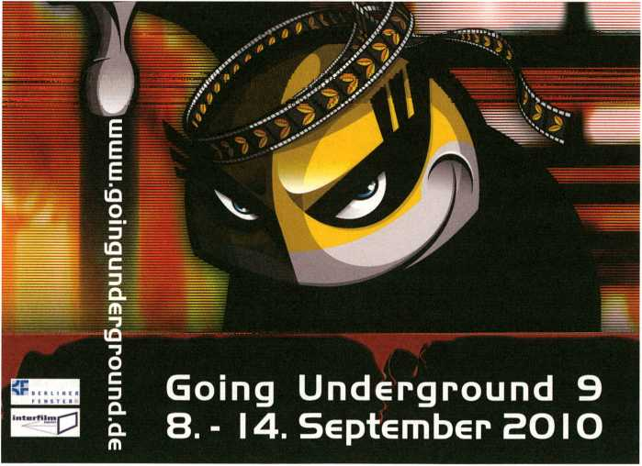
92

As part of FUTURITY NOW! transmediale.io presents and collaborates with a
number of partner organisations creating a network of satellite locations across
Berlin for showcasing the latest works in the realm of digital and electronic arts
Together with more established venues such as [DAMJBerlin, Galerie ZERO or
c-base, the Satellites programme is also meant to introduce new platforms for
media art including Substitut, ART CLAIMS IMPULSE or the Future Gallery to a
broad audience.This year, major transmediale Award nominated works will be
presented by two of our primary event partners, the Collegium Hungaricum
Berlin (.CHB) with The Coincidence Engines I & II by [The User], and the Instituto
Cervantes with Chapter l: The Discovery by Félix Luque Sánchez, while
INTERSECTION, a new site-specific interactive work by transmediale’s 2010
Marshall McLuhan Lecturer - robotics and telepresence pioneer Graham Smith
- can be seen at the Potsdamer Platz S-Bahn station and the Marshall McLuhan
Salon of the Canadian Embassy.
Als Teil von FUTURITYNOW! präsentiert die transmediale.io einige Partnerorga-
nisationen: ein Netzwerk von Satellitenorten überall in Berlin, das die neusten
Arbeiten der Digitalen und Elektronischen Kunst zeigt. Gemeinsam mit eta-
blierteren Einrichtungen wie [DAMJBerlin, c-base oder Galerie ZERO, werden im
Satellitenprogramm ausserdem neue Orte für Medienkunst wie Substitut,
ART CLAIMS IMPULSE oder The Future Gallery einem breiteren Publikum vorge-
stellt. In diesem Jahr werden zentrale, für den transmediale Award nominierte
Arbeiten bei zwei unserer engsten Partner gezeigt: Im Collegium Hungaricum
Berlin (.CHB) zu erleben ist The Coincidence Engines I & II von [The User] und im
Instituto Cervantes gibt es Chapteri: The Discovery von Félix Luque Sánchez. In
Zusammenarbeit mit der Kanadischen Botschaft präsentiert die transmediale.io
das ortsbedingte und interaktive Werk INTERSECTION von Graham Smith in der
S-Bahnstation Potsdamer Platz sowie im Marshall McLuhan Salon der
Kanadischen Botschaft, wo Graham Smith auch die diesjährige transmediale
Marshall McLuhan Lecture halten wird.
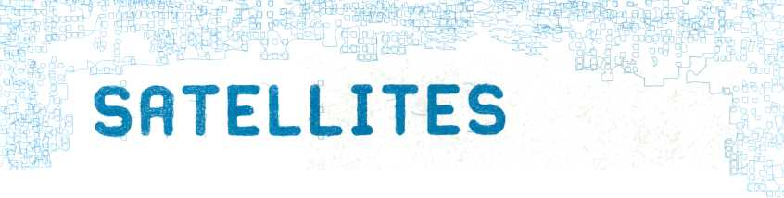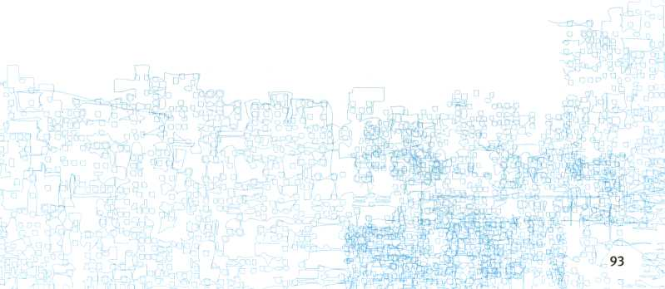

Coincidence Engine II by [The User]
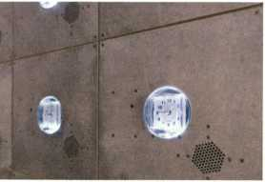
ÜHTCollegium Hungaricum Berlin - .CHB JH
- January - 28 February
Coincidence Engines I and II - [The User] (ca)
Long Night of the Museums/ Lange Nacht der Museen: Saturday 30 January 2010,18:00 - 02:00 Artist Talk by [The User]: Thursday 4 February, 12:45 - 13:30
At this year’s transmediale, .CHB will host and co-produce an exhibition of the installations, Coincidence Engines I and II by Canadian artist duo [The User], who are nominated for the trans- mediale Award. The exhibition will be open at the Long Night of the Museums on 30 January 2010. A special opening preview will take place at 17:00 that day.
The Collegium Hungaricum Berlin was established in 1924 and re-opened its doors on historical grounds in Berlin-Mitte, Dorotheenstraße 12, In November 2007. The new institute was designed in the style of Neobauhaus and demands for contemporary contents and forms of expression. Over the course of the past two years the .CHB has emerged as an excellent centre for art and media within the cultural landscape of Berlin-Mitte. Since 2008 Collegium Hungaricum Berlin has been hosting projects on the intersection of art, science and research in close conjunction with transmediale. Corpora in si(gh)te, Transitland and the Janos Neumann Salon have been successful collaborations of both institutions.
Zur diesjährigen transmediale ist das .CHB als Koproduzent bei der Verwirklichung des technologischen Kompositionsprojektes Coincidence Engines I und II des Award nominierten Künstlerduos [The User] (Emmanuel Madan und Thomas McIntosh aus Kanada) beteiligt. Die Vernissage findet als Preview der transmediale am 30. Januar 2010 ab 17:00 anlässlich der Langen Nacht der Museen statt.
Das bereits seit 1924 existierende Collegium Hungaricum Berlin öffnete seine Tore auf historischem Boden in der Dorotheenstraße 12 in Berlin-Mitte im November 2007 neu.
Das im Neobauhausstil errichtete neue Institut verlangte nach neuen zeitgenössischen Inhalten und Ausdrucksformen. In den vergangenen zwei Jahren entwickelte sich das .CHB in der Kulturlandschaft von Berlin-Mitte zu einem Zentrum für Kunst und Medien mit hervorragenden multimedialen Voraussetzungen. Das Collegium Hungaricum Berlin arbeitet seit 2008 eng mit der transmediale auf wissenschaftlich-künstlerischer Ebene zusammen. Corpora In si(gh)te, Transit- land und der Jänos Neumann Salon sind die bisher mit besonderem Publikumserfolg zu nennenden gemeinsamen Projekte unserer Einrichtungen.
.CHB, Dorotheenstraße 12,10117 Berlin, hungaricum.de Opening times: daily 10:00 - 19:00 •
• Coincidence Engines, p. 81
94

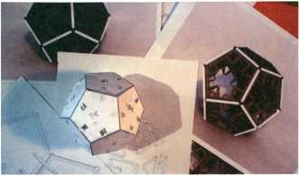
Chapter I: The Discovery by Félix Luque Sánchez
4Í Instituto Cervantes
31 January - 7 February
Chapter l:The Discovery - Félix Luque Sánchez (es)
Long Night of the Museums / Lange Nacht der Museen: Saturday 30 January 2010,18:00 - 02:00 Artist Talk by Félix Luque Sánchez: Wednesday 3 February, 12:45 - 13:30
During transmediale.io, Instituto Cervantes in Berlin will host the exhibition of Award nominee Félix Luque Sánchez. His installation Chapter I: The Discovery will open as part of the Long Night of the Museums on Saturday 30 January, and run for the duration of the festival. A special opening preview will take place at 16:00 that day.
The Instituto Cervantes is a cultural organisation concerned with spreading and promoting the Spanish language and culture around the world. With more than 70 centres, the Instituto Cervantes is not only focused on Spanish culture, but also on the different traditions and customs from more than 20 countries. The main purpose of the institution is bringing the excellence of the Spanish-speaking scene in terms of language, culture, arts, science and society to every corner of the world. Its Berlin building is in the heart of the city, a few minutes walk from Alexanderplatz.
Im Rahmen der transmediale.io präsentiert das Instituto Cervantes Berlin die Ausstellung des für den transmediale Award nominierten Spaniers Félix Luque Sánchez. Die Vernissage seiner Installation Chapter I: The Discovery findet als Preview der transmediale am 30. Januar 2010 ab 16:00 anlässlich der Langen Nacht der Museen statt.
Das Instituto Cervantes ist eine Kulturorganisation mit dem Ziel, die spanische Sprache zu fördern sowie das Kulturgut Spaniens und aller iberoamerikanischen Länder im Ausland zu verbreiten. Unser Kulturprogramm bietet einen Einblick in die Vielfalt dieses Kulturraums: mit Filmvorführungen in Originalversion, Konzerten, Vorträgen, wechselnden Ausstellungen und Lesungen spanischsprachiger Schriftsteller, Workshops und Kongressen. Inzwischen ist die gemeinnützige, öffentliche Stiftung mit 70 Instituten weltweit in 25 Ländern vertreten. In Berlin befindet sich das Institut mitten in Mitte, in einem historischen Gebäude direkt am Hackeschen Markt.
Instituto Cervantes Berlin, Rosenstr. 18-19,10178 Berlin, cervantes.de Openingtimes: 31 Jan - 7 Feb 12:00 - 18:00 & weekends 12:00 -17:00 *
* Chapter I: The Discovery, p. 83
95

Marshall McLuhan Salon of the Embassy of Canada 9
30 January - 7 February 2010
INTERSECTION - Graham Smith [An interactive video installation atS-Bahnhof Potsdamer Platz and Marshall McLuhan Salon]
Vernissage: 29 January, 19:00 S-Bahnhof Potsdamer Platz (Regionalbahnpasserelle Süd)
The Cold War was felt but never seen, a global conflict that shaped the world that always remained just below the surface of perception, like a horrific mirage.
INTERSECTION explores the symbolic nature of the Berlin Wall, the tangible element that brought the Cold War into focus, allowing the untouchable to be touched. Located underground at the Potsdamer Platz S-Bahn station, running below the former ‘Death Strip’ INTERSECTION transforms the static images from the past into a constantly morphing vista of the present. Above ground, where the former Wall dissected Berlin, the Marshall McLuhan Salon hosts Smith’s 4 screen video installation revealing the perspectives of people who tived in Berlin during the unique period between the fall of the Wall on 9 November 1989 and German reunification on 3 October 1990.
Der Kalte Krieg war zwar immer zu spüren doch kaum wirklich sichtbar - ein globaler Konflikt, der die Welt maßgeblich formte und doch stets wie ein schrecklich Trugbild gerade unterhalb der Wahrnehmungsoberfläche blieb.
INTERSECTION untersucht den symbolischen Gehalt der Berliner Mauer, die den Kalten Krieg als greifbar machte, indem sie das unantastbare anfassbar machte. In der S-Bahnstation Potsdamer Platz, direkt unterhalb des früheren Todesstreifens, verwandelt INTERSECTION die statischen Bilder der Vergangenheit in ein sich fortwährend wandelndes Bild der Gegenwart. Oberirdisch, genau dort, wo die Mauer einst Berlin teilte, zeigt der Marshall McLuhan Salon mit Smiths interaktiver Vierkanal-Videoinstallation unterschiedliche Perspektiven auf die politischen Ereignisse und Umbrüche zwischen dem Berliner Mauerfall am 9. November 1989 und der Deutschen Wiedervereinigung am 3. Oktober 1990.
Supported by the Canada Council for the Arts and the Embassy of Canada, Berlin
transmediale Marshall McLuhan Lecture - with Graham Smith (3 February, 18:00)
Graham Smith is an internationally acclaimed Canadian artist-inventor who has been exploring the boundaries between art and science since the early 1980’s. From 1993 to 1995 he directed the Virtual Reality Artist Access Program at the McLuhan Program in Culture and Technology at the University of Toronto, where he explored McLuhan’s theory that artists are a cultural DEW Line (Distant Early Warning) for society indicating future uses of new technologies. The McLuhan Salon features a unique collection of audio-visual material on the Canadian media theorist Marshall McLuhan, and has been a transmediale partner presenting distinguished projects since 2007.
Mit der transmediale Marshall McLuhan Lecture lädt die transmediale Persönlichkeiten der kanadischen Kulturszene ein, die - wie McLuhans zeitlose Medientheorie - zeitgenössische Kultur und Gesellschaft mit anderen Bereichen verknüpfen. Die Reihe wird in diesem Jahr von dem Künstler und Erfinder Graham Smith fortgesetzt. Von 1993 bis 1995 lehrte er am .McLuhan Program in Culture and Technology“ an der Universität Toronto. Dort untersuchte er McLuhans Theorie, nach der Künstler wie ein Frühwarnsystem für die Gesellschaft fungieren, da ihre Projekte eine Vorstellung von der zukünftigen Verwendung von neuen Technologien ermöglichen. Der Marshall McLuhan Salon umfasst eine bedeutende Sammlung von audiovisuellem Material über den kanadischen Medientheoretiker Marshall McLuhan und ist Partner der transmediale seit 2007.
Marshall McLuhan Salon, Botschaft von Kanada, Ebertstr. 14,10117 Berlin, mcluhan-salon.de
Opening times: 1-5 Feb: 10:00 - 18:00; 6-7 Feb: 14:00 - 18:00
S-Bahnhof Potsdamer Platz, Opening times 11:00 - 18:00 (Saturdays until 20:00)
96

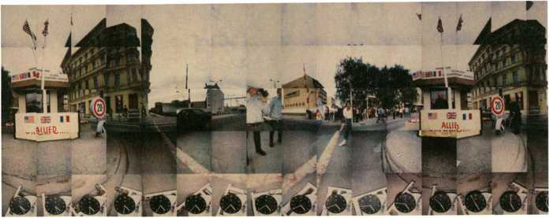
INTERSECTION by Graham Smith
4-7 February around the clock / rund um die Uhr 104.4 MHz London - Resonance FM 99.1 MHz Berlin - springradio
station melt is a collaboration of two radio stations in two metropolises broadcasting from the core of transmediale and CTM. Lasting for 4 days and nights this radio festival will air a special programme on Resonance 104.4 FM ¡^{n} London and the event frequency 99.1 FM in Berlin. A world spanning network of radio flow is created through international outpost events of transmediale and collaboration with the radia.fm network. Resonance 104.4 FM, the award winning artist run radio station based in London embraces all niches of sonic culture and has a worldwide community of active listeners.
A combination of live highlights of transmediale and CTM with on-air discussions from the Haus- radio studio at HKW is framed by co-produced shows of Berlin and London radio makers and artists. Hausradio hosts a one-day workshop with Resonance 104.4 FM about its design principles, targeted at radio producers and station managers, music and media journalists.
Als station melt werden zwei Radiosender in zwei Großstädten live von der transmediale und dem CTM senden: ein viertägiges Radiofestival auf Resonance 104.4 FM in London und der Event- Frequenz 99.1 FM in Berlin. In Zusammenarbeit mit dem internationalen radia.fm Netzwerk gelangt dieses exklusive Radioprogramm zudem in weltweite Kanäle. Resonance 104.4 FM ist ein preisgekröntes, für alle Nischen der Klangkuttur offenes Künstlerradio aus London mit einer weltweit eingeschworenen Hörerschaft.
Das Programm wird sich aus Live-Mitschnitten von beiden Festivals sowie Studiodiskussionen aus dem Hausradio des HKW zusammensetzen, umrahmt von koproduzierten Sendungen der Berliner und Londoner Radiomacher und Künstler. Hausradio wird einen eintägigen Workshop mit Resonance 104.4 FM zum Thema Design anbieten, der sich an Radiomacher, Redakteure, Musik- und Medienjournalisten wendet.
stationmelt.hausradio.de
resonancefm.com
® Longplayer, p. 33
97

Vilem Flusser Archiv.
5 February 2010,11:00 - 14:00: Doors open/Tag der Offenen Tür
The_Vilem_Flusser_Archiv is a repository for the works of cultural theorist Vilem Flusser (1920 - 1991), who was born in Prague, immigrated to Brazil in 1940, and returned to Europe in the early 1970s. The archive was established by his wife Edith Flusser in The Flague, 1992, and was given into the care of Siegfried Zielinski in 1998. In 2007 the archive moved with Professor Zielinski’s Chair of Archaeology and Variantotogy of Media from the Academy of Media Arts in Cologne to the University of Arts Berlin.
Das_Vilem_Flusser_Archiv bewahrt und pflegt das Werk des Kulturwissenschaftlers Vilem Flusser (1920 - 1991). Flusser wurde in Prag geboren, emigrierte 1940 nach Brasilien und kehrte in den frühen 1970er Jahren nach Europa zurück. Das Archiv wurde von seiner Frau Edith Flusser 1992 in Den Flaag eröffnet und 1998 in die Obhut von Siegfried Zielinski übergeben. 2007 zog das Archiv mit Professor Zielinskis Lehrstuhl für Archäologie und Variantologie der Medien von der Kunsthochschule für Medien Köln an die Universität der Künste Berlin um.
_Vilem_Flusser_Archiv, Universität der Künste Berlin, Grunewaldstr. 2-5,10823 Berlin flusser-archive.org
» Processual Media Art and Theory, p. 24 » Project Library, p. 37

ME Deutsches Technikmuseum ]$
- 14 February 2010 IT and Media Art
With its interdisciplinary competition Art of Engineering the Ferchau Engineering GmbH presents innovative new works bridging the two worlds of art and technology.
Mit dem interdisziplinären Wettbewerb Art of Engineering präsentiert die Ferchau Engineering GmbH kreativen Brückenschläge zwischen zwei Welten, die mehr verbindet, als trennt: Technik und Kunst.
Deutsches Technikmuseum, Trebbiner Straße 9,10963 Berlin, sdtb.de Openingtimes: Tue - Fri 9:00 -17:30; Sat/Sun 10:00 - 18:00
ARTor
Supported by ING*
1=
FERCHAU
ENGINEERING
98

C-BASE E. V.
i-6 February 2010 PHUTURITY NOW!
Vernissage: 1 February, 17.00
Underneath Berlin-Mitte, the relics of a space station from the future were discovered in 1995. Upon this revelation a group of researchers, activists, artists and enthusiasts founded the association known as c-base. Their aim is to promote the further examination and possible reconstruction of this presumably most unique cultural heritage of the future humankind. At transmediale.10 c-base will present PHUTURAMA - Salon Subkonferenz zu spekulativem und fiktionalem Design (in German). Within its own programme PHUTURITY NOW!, c-base presents examples of this vast field of design as a tm.10 Satellite.
Unterhalb von Berlin-Mitte wurden 1995 die Überreste einer aus der Zukunft stammenden Raumstation entdeckt. Mit dem c-base e.V. gründete sich eine Gemeinschaft von Forschern, Aktivisten, Künstlern und Enthusiasten, um die weitere Erforschung und mögliche Rekonstruktion des vermutlich bedeutendsten Kulturerbes der zukünftigen Menschheit voranzutreiben. Im Rahmen des transmediale.10 Salons veranstaltet die c-base PHUTURAMA - Salon Subkonferenz zu spekulativem und fiktionalem Design. Einen Ausschnitt dieses umfangreichen Spektrums präsentiert der c-base e. V. als diesjähriger Satellite in seinem eigenen Programm PHUTURITY NOW!.
c-base e. V., Rungestr. 20,10179 Berlin Daily 17:00 - open end
For a detailed schedule and description of events visit c-base.org or transmediale.de » PHUTURAMA, p. 23
Cbetahaus
4 February 2010, 20:00 - 21:30: The WAVE - Panel discussion
The WAVE is an initiative that provides mobile platforms around Europe for philosophers, economists, and artists to engage in alternative economic possibilities. In coordination with transme- diale, The WAVE will launch its first critical debate at the creative co-working hub betahaus in Berlin.
The WAVE ist eine mobile europäische Plattform, auf der Philosophen, Wirtschaftler und Künstler der Suche nach wirtschaftlichen Alternativmodellen nachgehen. In Zusammenarbeit mit der transmediale veranstalten The WAVE zum ersten Mal eine kritische Diskussionsrunde im Berliner betahaus.
betahaus, Prinzessinnenstraße 19-20,10969 Berlin, betahaus.de
The WAVE is coordinated by I-Wei Li, sidebysidestudio.net
» Futures Exchange: VALU€S, p. 31 »The Identity of Cultural Enterprises, p. 27
99

Galerie [DAMJBerlin 9
2 February - 24 March 2010 GaMe!
With France Cadet, Mark Essen, Joan Leandre, Jason Rohrer, Tale of Tales Vernissage: 30 January, 16:00 - 18:00
GaMe! presents artistic positions around video games and toys. The works range from artistic interactive computer games, a film collage of modified sequences of commercial games to interactive, smaller robots based on remodeled toy dogs.
The gallery [DAMJBerlin is part of an overall concept of imparting art that is exclusively dedicated to the influence of the computer and the digital in art and society. We are especially interested in the contextual examination of this medium and/or new artistic forms. Further components of the [DAM] project are the online-museum dam.org and the d.velop digital art award [ddaa] ddaa- online.org.
GaMe! zeigt künstlerische Positionen zu dem Thema Videogames und Toys. Das Spektrum umfasst interaktive, von Künstlern entwickelte Computerspiele, eine Filmcollage aus modifizierten Sequenzen kommerzieller Spiele, sowie interaktive, kleine Roboter, die auf umgebauten Spielzeughunden basieren.
Die Galerie [DAMJBerlin ist ein Teil eines Konzeptes der Kunstvermittlung, das sich ausschließlich dem Einfluss des Computers und des Digitalen auf Kunst und Gesellschaft widmet. Sie präsentiert zeitgenössische, junge Positionen und bedeutende Pioniere. Weitere Aktivitäten der [DAM] Projekte sind das Online-Museum dam.org, und der [ddaa], ein Preis für ein Lebenswerk eines Künstlers.
Galerie [DAMJBerlin, Tucholskystraße 37,10117 Berlin, dam-berlin.de Opening times: Tue - Fri, 12:00 - 18:00; Sat 12:00 - 16:00

.Substitut - Raum für Aktuelle Kunst aus der Schweiz
29 January - 27 February 2010
Esquisses
with Lilian Beidler, Joachim Budweiser, Kaspar Hochuli, Cyrill Lim, Timo Loosli, David Muther, Tobias Reber, Margrit Rieben, Daniel Werder Vernissage: 29 January, 19:00
Substitut - Raum für Aktuelle Kunst aus der Schweiz is a non-profit space and platform for art from Switzerland. On the occasion of transmediale.10 Subsitute will present an exhibition featuring work exploring FUTURITY NOW! - the theme of transmediale.10 - on the intersection of media art and music by students of the MA Contemporary Arts Practice at Bern University of Applied Sciences.
Das Substitut ist ein nicht profitorientierter Raum für Kunst aus der Schweiz. Die transmediale.10 ist für das Substitut Anlass, eine Ausstellung von Studierenden des MA Contemporary Arts Practice der Hochschule der Künste Bern zu organisieren, die an der Schnittstelle Medienkunst und Musik arbeiten. Inhaltlich orientiert sich die Ausstellung am Thema FUTURITY NOW! der transmediale.10.
Substitut: Raum für aktuelle Kunst aus der Schweiz, Torstraße 159,10115 Berlin, substitut-berlin.ch Opening times: Wed &Thur 16:00 - 19:00; Fri 16:00 - 21:00; Sat 14:00 - 18:00
100

Art Claims Impulse
20 January 20 - 13 February 2010
Reflective Interventions - Multimedia Installations
With Julius von Bismarck, Benjamin Maus, Tudor Bratu, Cecile Colle & Ralf Nuhn Vernissage and artist talk: 16 January, 19:00
Art Claims Impulse is a gallery in Berlin specialised in video art, performance, and new media installations. Its main interest is in art with an unusual approach, that are innovative from a thematic, technical and aesthetical point of view. The upcoming exhibition at Art Claims Impulse, Reflective Interventions, will show work by artists who combine analogue and digital media with other devices to create new objects, installations and interventions that both reflect the current digital age and engage with it critically.
Art Claims Impulse ist eine Galerie in Berlin, spezialisiert auf Videokunst, Performance und New Media Installationen. Ihr Interesse gilt Kunstwerken, die ungewöhnliche Ansätze verfolgen, thematisch, technisch und ästhetisch innovativ. Die nächste Ausstellung bei Art Claims Impulse, Reflective Interventions, zeigt Arbeiten von Künstlern, die analoge und digitale Medien und Geräte kombinieren, um daraus neue Objekte, Installationen und Interventionen zu kreieren, die das digitale Zeitalter reflektieren und sich gleichzeitig kritisch damit auseinandersetzen.
Galerie ART CLAIMS IMPULSE, Lübbener Straße 5,10997 Berlin, art-claims-impulse.com Opening times: Wed - Sat, 16:00 - 21:00
* The Space Beyond Me, p. 69
Cthe Future Gallery
30 January - 7 February 2010
Better Brain: Manifestations of Futurity
With Charles Broskoski, Martin Kohout, Rafaël Rozendaal.
Vernissage: 29 January, 19:00 - 22:00
This exhibition will explore the idea of a balance between our future and our past through a presentation of three distinct positions of manifested futurity. The Future Gallery is a temporary - potentially ‘future’ permanent - art space in Berlin-Kreuzberg and a platform for showcasing future oriented work. The gallery currently operates out of the living room of the Director, Anne Betting and Curator, Mike Ruiz.
Mit drei unterschiedlichen künstlerischen Positionen zum Thema Zukünftigkeit lotet die Ausstellung Better Brain: Manifestations of Futurity die Möglichkeiten einer Balance zwischen unserer Zukunft und Vergangenheit aus. The Future Gallery ist ein temporärer - möglicherweise zukünftiger - Ausstellungsraum für zukunftsorientierte Kunst in Berlin-Kreuzberg, der sich derzeit im Wohnzimmer von Leiterin Anne Betting und Kurator Mike Ruiz befindet.
The Future Gallery, Hasenheide 56,10967 Berlin, thefuturegallery.org Opening times: 12:00 - 17:00
101

Schering Stiftung 9
Wolken-Kern-Scanner: IM TROPOSPHAEREN-LABOR - Agnes Meyer-Brandis
Vernissage: 14 January, 19:00
The installation IM TROPOSPHAEREN-LABOR gives insights into material that artist Agnes Meyer- Brandis generated under conditions of extraterrestrial realisties. The work addresses and plays with the intersections of contemporary art and rather surreal branches of science (nanotechnology, meteorology etc.). The Ernst Schering Foundation is an independent, non-profit organisation founded in 2002 by Schering AG. Its objective is to support science and culture, especially the life sciences and contemporary art.
Die Installation IM TROPOSPHAEREN-LABOR ermöglicht Einblicke in das von Agnes Meyer-Brandis unter den Bedingungen einer erdfernen Realität erzeugte Material. Dabei thematisiert und mischt die Künstlerin Kommunikationsstrukturen der zeitgenössischen Kunst mit durchaus surrealen Formen der Wissenschaft (Nanotechnologie, Fluiddynamikforschung, Meteorologie). Die unabhängige und gemeinnützige Ernst Schering Stiftung wurde 2002 durch die Schering AG, Berlin errichtet und dient der Förderung von Wissenschaft und Kultur mit Schwerpunkt auf den Lebenswissenschaften sowie der zeitgenössischen Kunst.
Schering Stiftung, Unter den Linden 32-34,10117 Berlin, scheringstiftung.de Opening times: Mon-Sat, 11:00 - 18:00
MAKING CLOUDS oder VOM FEHLEN DER SCHWERE Performance by Agnes Meyer-Brandis
5 February, 18:00 (Premiere), 6 February, 18:30
As a combination of film, performance and lecture, MAKING CLOUDS oder VOM FEHLEN DER SCHWERE presents flying machines that were created on the basis of gravity and weightlessness and explores the cores of clouds. The audience is invited to join into a foray into the ambiguous realities of constructions, experiencing film as reality and reality as an artifice.
Das Wanderkino MAKING CLOUDS oder VOM FEHLEN DER SCHWERE ist eine Mischung aus Film, Performance und Vortrag. Es zeigt auf der Grundlage von Schwerkraft und Schwerelosigkeit basierende Flugmaschinen und untersucht Wolkenkerne. Das Publikum wird Zeuge einer Wanderschaft auf der Suche nach dem Realitätsgrad von Konstruktionen. Es erlebt die Realität im Film und den Trick in der Wirklichkeit.
Virchowsaal/Sophiensaele, Sophienstraße 18,10178 Berlin, sophiensaele.com
Both works are a production of DOCK e.V. in conjunction with the Schering Foundation and Sophiensaele
The experiment Wolken-Kern-Scanner was developed in cooperation with the German Aerospace Center, DLR (Deutsches Zentrum für Luft und Raumfahrt) and Filmstiftung NRW
» Studies in Light and Space, p. 45 ® Destination Moon, p. 27
102

Landesvertretung Nordrhein-Westfalen
2-7 February 2010 new talents - biennale köln
Vernissage: 1 February, 19:00
new talents - biennale köln is a platform of the FUHRWERKS WAAGE Kunstraum in Cologne presenting selected graduates of art and design academies from Cologne and Düsseldorf (Academy of Media Arts Cologne, International School of Design, ifs, Cologne University of Music and Dance and Academy of the Arts Düsseldorf). The Representation of the State of North Rhine-Westphalia in Berlin host the event as an outpost for emergent talent from North Rhine Westphalia.
new talents - biennale köln ist eine Plattform des FUHRWERKSWAAGE Kunstraums in Köln, die ausgewählte Absolventen künstlerischer und gestalterischer Hochschulen aus Köln und Düsseldorf (Kunsthochschule für Medien, Köln, International School of Design, ifs internationale filmschule, Hochschule für Musik und Tanz Köln und Kunstakademie Düsseldorf) mit ihren Arbeiten vorstetlt. Die Vertretung des Landes Nordrhein-Westfalen beim Bund in Berlin versteht sich nicht zuletzt auch als Bühne für die höchst lebendige Kunstszene und die Nachwuchstalente aus allen Bereichen der Kunst- und Kulturproduktion in Nordrhein-Westfalen.
Vertretung des Landes Nordrhein-Westfalen beim Bund, Hiroshimastraße 12-16,10785 Berlin, newtalents-cologne.de, mbem.nrw.de Opening times: daily 10:00 - 18:00
C^Gallery ZERO
- 11 February 2010
Hybrid Frequencies - Marko Batista and Prokop Bartonicek
Long Night of the Museums/Lange Nacht der Museen: Saturday 30 January 2010,18:00 - 02:00 Vernissage/Lecture/Performance SIPHON:SYS:SONIC: 30 January, 19:00
Alongside transmediale.10, Gallery ZERO will present the exhibition Hybrid Frequencies, featuring works by Slovenian mixed media and performance artist Marko Batista and experimental art by Czech artist Prokop Bartonicek. The exhibition opening will take place on the occasion of the Long Night of the Museums. Gallery ZERO is a platform focusing on Eastern European art and sound/music projects. ZERO is a network and a journalist office, aiming for cooperation between the Eastern and Western European cultures. Gallery ZERO has cooperated with transmediale since 2005, featuring independent projects and exhibitions of Award nominees.
Zeitgleich mit der transmediale.10 wird die Galerie ZERO die Ausstellung Hybrid Frequencies zeigen, die am Abend der Langen Nacht der Museen eröffnet wird. Gezeigt werden Werke des slovenischen Mixed Media und Performancekünstlers Marko Batista sowie experimentelle Kunst des Tschechen Prokop Bartonicek. Galerie ZERO ist eine Plattform, Interessenvertretung und Ausstellungsfläche mit osteuropäischem Schwerpunkt. Gleichzeitig ist ZERO ein Informationsnetzwerk und ein Journalistenbüro, die die künstlerische Tätigkeit der Galerie ZERO ergänzen. Galerie ZERO stellt seit 2005 als regelmäßiger Partner der transmediale unabhängige Projekte undfürden Award nominierte Künstler aus.
Galerie ZERO Berlin, Kopenicker Str. 4,10997 Berlin, zero-project.org, project-data.info, pebe.cz Opening times: Wed - Sat, 12:00 - 18:00
103

Lass nicht alles
henunliegen!
Das neue
JUBILÄUMS-DUMMY
zum Thema MAMA.
Mit viel Liebe und
dem Besten aus
25 DUMMY-Heften
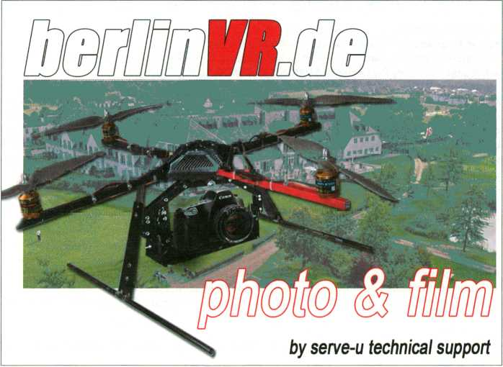
104
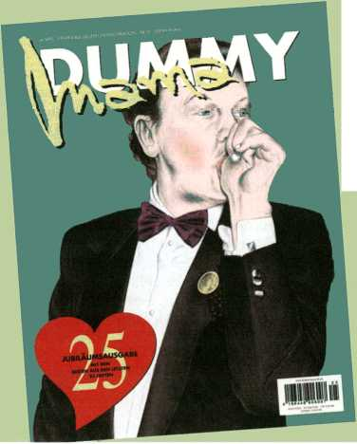
aaajiao(cn) 63
aaajiao is one of China’s foremost digital artists, bloggers and free culture developers, well known for establishing the Chinese edition of the blog ‘we-make-money-not-art’.
Ahtila, Ejia-Liisa (fi) 43
Filmmaker and video artist Eija-Liisa Ahtila began her career with photography, installation and performance art. Ahtila turned to film and video in the 1990s, with much of her work exploring questions of identity, group relations and scenarios of conflict.
al-Zobaidi, Sobhi (ps) 42
Sobhi al-Zobaidi, independent Palestinian filmmaker, artist and scholar. Since 1998 he has been an active member of the new and independent film movement in occupied Palestine.
Aman, Benjamin Laurent (fr) 53,55
Since musician Aman relocated from France to Berlin, he has become one of the rising stars of the capital's underground scene, marking himself as a performer dealing with texture, frequency and field recordings. He is the founder of the cult Razzle Dazzle label.
Participants
fl,B
Atom TM (de) 53,61
Over the past 20 years the pioneering electronic musician Uwe Schmidt has exerted great influence on contemporary music using more than 50 stage names, including Atom TM, Senor Coconut and Atom Heart.
Auger, James (uk) 81,86-87
James Auger and Jimmy Loizeau run London- based design partnership Auger-Loizeau combining disciplines that include product design, engineering, and fine art. For Carnivorous Domestic Entertainment Robots they collaborated with engineer Atexandar Zivanovic.
Barbrook, Richard (uk) 16-17
Richard Barbrook is Senior Lecturer of Politics at the University of Westminster and author of Imaginary Futures (2007). His essays focus on the clash between commerce and cooperation within the Internet.
Barqawi, Samer (sy) 42
Samer Barqawi graduated with a degree in business management from the University of Damascus and has directed several short films and television series.
Angerame, Dominic (us) 47
Dominic Angerame is an American experimental filmmaker, who has directed more than 35 films since 1969. He is executive director of Canyon Cinema, one of the largest distributors and promoters of avant garde and experimental film.
Antifinger, Mathias (de)
See Horner, Ute 47
artificiel (ca) 58
artificiel is a digital arts group based in
Montreal, featuring Alexandre Burton and
Julien Roy and a number of regular collabo-
rators. Together, they create performances
and installations, including works such as
bulbes (2003) and cubing (2006).
Bartana, Yael (ir) 49
Yael Bartana is an artist who focuses on the
relationship between ritual and identity in
Israeli society, especially in the context of
traditional and contemporary notions of
gender, place and ethnicity.
Bartholt, Aram (de)
see F.A.T. Lab 25
Batnji, Taysir (ps) 42
Taysir Batnji makes art which addresses
the political and historical events that have
shaped his country and their resulting im-
pact on humanity.
Beckedahl, Markus (de) 34
Media activist Markus Beckedahl is co-
founder of newthinking communications
GmbH, an agency for Open Source Strate-
gies based in Berlin. Since 2002 he runs the
acclaimed blog netzpolitik.org.
105

Benford, Steve (uk) 16-17
Steve Benford is Professor of Collabora-
tive Computing at Nottingham University’s
Mixed Reality Laboratory where he explores
novel communication technologies for rich
and dynamic social interaction.
Bernard, Yves (be) 79
Yves Bernard is founder and director of the
‘interactive Media Art Laboratory’ (iMAL),
Brussels. As an author and curator he ex-
plores how the Internet is merging with the
real world.
Bernier, Nicolas (ca)
see Messier, Martin 53, 60
Boj, Clara (es)
see Oliver, Julian 75
Brosolo, Marco (it)
see Fritsch, Matthias 56
Berthold, Oswald (de)
see Martin Howse 28, 36
Buchmann, Sabeth (at) 89,91
Sabeth Buchmann is professor for Modern
and post-Modern art at the Academy of Fine
Arts Vienna and director of the Institute of
Art Theory and Cultural Studies.
Bunz, Mercedes (de) 18
Mercedes Bunz is a New Media Strategist for
Journalism and a visionary writer and speak-
er on new technology, creative industries
and society. She recently moved to London
as a media and technology reporter for The
Guardian.
Butler, Brad (uk) 26,44,85, 86-87
Brad Butter, who has a MA in Documentary Filmmaking from the RCA London and a degree in Anthropology founded no.w.here in 2004 with Karen Mirza, who studied painting at the Camberwell College of Art and holds a MA in Film and Video from the RCA.
Cameron, Andy (uk) 16-17, 24
Andy Cameron is executive director of Fabrica, the Benetton research centre on communication. He investigates the nature of interactivity and is editor of the book The Art of Experimental Interaction Design.
Campbell, Duncan (ie) 40
Duncan Campbell is interested in the seductive power of stories. With a nod to Samuel Beckett’s humour, his work juxtaposes the inherent promise of storytelling with the breakdown of narrative and the inevitable disintegration of meaning.
Christov-Bakargiev, Carolyn (us) 16
Writer, art historian and curator Carolyn Christov-Bakargiev is director of the Museo di Arte Contemporánea di Torino, and will be artistic director of Documenta 13, taking place in Kassel in 2012.
Conrath, Martin (de) 50
Martin Conrath and Marion Kreifiter are curators and an artist duo whose work reflects political and media culture in Germany.
de Vicente, José Luis (es) 19,79
José Luis de Vicente is a researcher, curator and writer working around the edges of new media arts and innovation in design and culture. He’s Deputy Director of ArtFutura and associated curator of Sonar.
Debatty, Régine (be) 16-17
Régine Debatty is a blogger, curator, critic and lecturer whose work focuses on the intersection between art, science and social issues. She runs the blog we-make-money- not-art.com and contributes to European art and culture magazines.
Diaz, Diego (es)
see Oliver, Julian 75
Dolos, Neven (de) 23
Neven Dolos is the spokesperson of the
c-base Open-Moon-Project-Team for the
Googte-Lunar-X-Prize. He works as a high-
tech affairs consultant at the Agency for
Innovations and Technology Transfer of the
Berlin Senate.
106

Participants E, F, G
Edler, Tim (de) 16-17
Tim Edter is co-founder of realities:united, an agency for art and architecture. Specialized in digital and information technologies their work focuses on the communicative nature of architecture.
Eriksson, Ulf (se) 61
As DJ, label owner and events organiser, Ulf Eriksson has played an active role in the Swedish electronic music scene for many years.
eteam (us/de) 50
New York artists Franziska Lamprecht and Hajoe Moderegger formed the eteam in 2001. Their works on ownership and virtual realities on platforms such as Second Life have been shown at events internationally.
F.A.T. Lab (int) 21,25,32,80,86-87
The Free Art and Technology Lab (F.A.T. Lab) is a transnational collective operating via IRC, an internal email list-serve, blogs and shared internet server space. Founded in 2007 by Evan Roth and James Powderly, its members are dedicated to enriching the public domain through the research and development of creative technologies and digital media.
FM3_Zhang (cn) 63
Zhang Zian is one half of FM3, founded in 1999 with Christiaan Virant. As active members of the Beijing music scene, FM3 are considered pioneers of electronic music in China.
Franke, Herbert W. (at) 23
Herbert W. Franke is a scientist and futurologist, considered one of the most important science fiction writers in the German language. He is also a computer arts pioneer and one of the founders of Ars Electrónica Linz.
Fritsch, Matthias (de) 25,27,56
Matthias Fritsch is the artist behind the Net project Music From The Masses and the Landschaft film series, which he performs live at transmediale.10 with Japanese artist Shingo Inao, who creates a sonification of body movement, and Marco Brosolo, an Italian visual and sound artist living in Berlin.
Gagnon, Dominic (ca) 41
Dominic Gagnon is an inventor, director, installer and active performer on the international scene. He considers cinema a technique for measuring the immeasurable or as a discipline of chaos.
Feng, Mengbo (cn) 53,63
Having been invited to Documenta twice, Feng Mengbo is recognised as one of China’s leading artists. As well as expressing socio-political critiques his work negotiates intensely personal subject matter.
Finer, Jem (uk) 16-17,33
Artist and mathematician Jem Finer is the creator of the 1000 year long musical composition Longplayer, a work that represents a convergence of many of his concerns, particularly those relating to systems, long-durational processes and extremes of scale in both time and space.
Fishbone, Doug (us) 50
London based American artist Doug Fishbone is perhaps best known for his project 30,000 Bananas - a huge mountain of ripe bananas installed in the middle of London’s Trafalgar Square.
Gaycken, Sandro T. (de) 23
Sandro T. Gaycken organises and initiates cultural and political actions within the Chaos Computer Club, and is currently working on a professorial dissertation on Security.
Ghossein, Ahmad (lb) 42
Ahmad Ghossein graduated from the Lebanese University with a diploma in theatre, and works in film and video as well as contemporary dance.
Giannacchi, Gabriella (it) 16-17
Gabriella Giannachi is Professor in Performance and New Media, Director of the Centre for Intermedia at the University of Exeter, and an investigator in the RCUK funded Horizon Digital Economy Research Hub.
107

Girardet, Christoph (de) 43
Christoph Girardet is a video artist working primarily with the masterful reworking of found footage narratives. His work has been shown at acclaimed venues and festivals worldwide, and he recently concluded a residency at the German Academy Villa Massimo, Rome.
Gramelsberger, Gabriele (de) 18
Gabriele Gramelsberger is artistic and academic associate at the KHM Cologne, where her research focuses on the restructuring of computational sciences, particularly in the fields of climate research and biology.
Grau, Oliver (de) 24,89,90
Oliver Grau is an art historian, media theorist and professor of Visual Cultures and head of department at the Danube University Krems. He’s also Founding Director of the International Conference Series on the Histories of Media Art, Science and Technology.
Handlos, Oliver (de) 23
Oliver Handlos is Creative Director at Scholz & Friends Berlin and, according to the Big Won Report 2009, the second most successful creative director worldwide.
Haring, Chris (at) 46
Chris Haring is a choreographer and dancer whose pieces are influenced by science fiction films and explore the body in cybernetic landscapes.
Harriman Iskandar, Gustaff (id) 16-17
Gustaff Harriman iskandar is an artist, writer and curator from Indonesia. He is co-founder of the Bandung Center for New Media Arts and developed Common Room in 2003, an open platform for art, culture and ICT/ Media.
Haschka-Heimer, Regine (de) 27
18 years of experience and more than 900 successfully realised international projects make Regine Haschka-Heimer a pioneer and leading expert in the German multimedia scene.
Haque, Usman (uk)
see Somlai-Fischer, Adam 71
Helmcke, Aline (de) 50
Aline Helmcke is a filmmaker working in animation, drawing and new media. She is also a guest lecturer at UdK and a visiting tutor at the Royal College of Art in London.
Heller, Christian (de) 23
Futurist and film critic Christian Heller defines himself as a multi-fragmented stiver of net intelligence, whose interests include internet memes, conference tweeting, and trash-humanism. Heller offers www.plom- lompom.de as a general entry into his so- called ‘wiki-brain’.
Hemment, Drew (uk) 16-17
Drew Hemment is an artist, curator and researcher. He is director and founder of the FutureEverything Festival in Manchester, and Assistant Director of Imagination Lancaster at Lancaster University.
Heur, Bas van (nl) 26
Bas van Heur is currently a Postdoctoral Researcher on the relations between the creative industries, policy regulation and urban change at Maastricht University.
Hojeij, Mahmoud (lb) 42
Mahmoud Hojeij is a Lebanese video artist, filmmaker and writer. He studied communication at the European Graduate School in Switzerland and Media Studies at the New School University, New York.
Hörner, Ute (de) 47
Ute Hörner is an artist and former director of the Videonale 8 at Bonner Kunstverein. She is professor for Transmedia Space at the KHM, Cologne together with artist Mathias Antifinger, whom she collaborates with since 1991.
Howse, Martin (uk/de) 28
Media theorist and artist Martin Howse works coltaborativety at transmediale.10 with programmer and artist Oswald Berthold, professor of Visual Cultures at Goethe University Verena Kuni, and the computer artist Danja Vasiliev on developing an interdisciplinary mobile research laboratory devoted to the use of free software and open hardware within the field of psychogeophysics.

Huang, Ben (cn) 63
Ben Huang is one of the most in-demand DJs in China and a pioneer of Beijing’s club scene. His creative expression comprises varying styles ranging from Classic, Nu jazz, Funky Groove to House, Electronic.
Hwang, Eunjung (kr) 46
Eunjung Hwang makes animations and new
media works that have been featured in ex
hibitions and festivals internationally.
Hyde, Adam (de/nz) 37
Adam Hyde is the founder of FLOSS Manuals, a non-profit foundation creating free manuals about free software. FLOSS Manuals is pioneering the Book Sprint - a collaborative methodology for producing comprehensive text in short periods of time. Recent sprints have produced manuals on Inkscape, Pure- Data, How to Bypass Internet Censorship, and an Introduction to the Command Line.
Ikeda, Ryoji (jp) 53,57,66
Ryoji Ikeda is one of the world’s finest and most acclaimed electronic artists and composers, authoring stunning performances, audiovisual installations and seminal music.
Inao, Shingo (jp)
see Fritsch, Matthias 56
Participants H, I, 3, K
Juarez, Geraldine (mx)
see F.A.T. Lab
*5
Kagel, Ela (de) 21,28
Ela Kagel is an independent cultural producer and curator. She is a member of Public Art Lab, initiator of Upgrade! Berlin, co-initiator of Mobile Studios and curator of the tmio Free Culture Incubator project.
Kalandides, Ares (de/gr) 26
Ares Kalandides is CEO of the Agentur Inpo- lis UCE GmbH, director of CREATE BERLIN and one of the initiators of Governance of Creative Industries at the Georg Simmel Centre for Metropolitan Studies.
Kasprzak, Michelle (ca) 28,79,86-87
Michelle Kasprzak is a writer and curator working at the Scottish Arts Council. Her curatorial projects have been presented in galleries, artist-run spaces, international film festivals, and on key cultural websites.
Kempinas, Zilvinas (It) 65,68
New York based visual artist Zilvinas Kempinas creates installations in which invisible forces of gravity and air circulation reshape architectural spaces into totally new environments. In 2009, he represented Lithuania at the 53rd Venice Biennale.
Inagaki, Tomoko (jp) 41
Tomoko Inagaki works primarily with installations with interests in performance art, contemporary Asian art and conceptual art.
jaromil(it) 16-17
Denis Rojo aka jaromil is an Amsterdam- based artist, theorist and programmer. Besides important contributions to the development of the GNU /Linux platform, he is author of dyne:bo!ic and several other software projects including MuSE.
Jaschko, Susanne (de) 24
Susanne Jaschko is an independent curator of digital and contemporary art. From 1997 to 2004 she was curator and deputy director of transmediale.
Kera, Denisa (cz) 16-17
Denisa Kera (cz) is a curator and assistant professor at the National University of Singapore where she researches various technologies from STS and interactive media design perspectives.
Khaimzon, Michael (ru) 23
Michael Khaimzon is an Art Director (Far Cry and Crysis) at Crytek who is currently focussed on the new soon-to-be-announced Crytek IP in Kiev.
Khalili, Bouchra (fr/ma) 42
Video artist Bouchra Khatili deals with displacement and relationships between physical and imaginary geographies. She is a co-programmer and member of the Board of Directors of the Cinémathèque de Tanger.
109

Kjellmark, Tove (se) 46
Tove Kjellmark is an artist exploring contradictions in human experience with relation to the machine, as well as conflicts between feeling and intellect in the context of psychological defense mechanisms.
Kleiner, Dmytri (ca) 22
USSR born Dmytri Kleiner is a Berlin based software developer and cultural producer. As co-founder of the Telekommunisten he wrote the Telekommunist Manifesto.
Koblin, Aaron (us) 25,82,86-87
Artist Aaron Koblin takes social and infrastructural data using these to examine cultural trends and emergent net-based patterns. Together with artist Daniel Massey their projects seek to instigate new modes of collaboration, creation, and transformation.
Kogler, Claudia (at) 35
Software developer Claudia Kogler is cofounder and CTO of the online game community Papermint. She is involved in the Vienna-based technology start-up Avaloop.
Koner, Thomas (de) 53,57
Thomas Koner is a media artist and musician who focuses on combining visual and auditory experiences. His sound works, released on labels such as Mille Plateauxand Barooni, are densely layered, and subtle, encouragingly intensive and physical listening.
Kreiftler, Marion (de)
see Conrath, Martin 50
Kühn, Markus (de) 24
Markus Kühn has a vast background in mu-
sic management and distribution. After his
management activities at Universal Records,
he shifted into the independent music sec-
tor. Since 2004 he is CEO of the broadcast-
ing service Motor FM in Berlin.
Kuni, Verena (de) 28,36
Verena Kuni is a scholar in the fields of art theory and media cultures. As professor for Visual Culture at Goethe University, Frankfurt/Main, she dedicates her research to technologies of transformation, DIY cultures, games, play and toys as toots.
Kuzmanovic, Maja (hr/be) 16-17
Maja Kuzmanovic is founder of FoAM, a transdisciplinary organisation guided by the motto ‘grow your own worlds’. With an academic background in Design Forecasting and Interactive Media, she was named by MIT as one of the world’s top 100 ‘Young Innovators’ in 1999.
La Frenais, Rob (uk) 27
Rob La Frenais is curator and critic for the art and technology agency Arts Catalyst in London. He has a PhD in curatorial practice and is an honorary Doctor of Arts at Darlington College of Arts.
Laboratoire Deberlinisation (de) 22,30
Laboratoire Deberlinisation was founded in Berlin in 2001 by Mansour Ciss Kana- kassy with Baruch Gottlieb and Christian Hanussek. Laboratoire Deberlinisation has exhibited and presented throughout Europe and three times at the Dakar Biennale, the 2008 edition of which Mansour Ciss was awarded first prize.
Lambert, Steve (us) 20
Steve Lambert is founder of the Anti-Advertising Agency and a Senior Fellow at the Eyebeam Center for Art and Technology in New York. He recently made international news with the The New York Times ‘Special Edition’, announcing the end of the wars in Iraq and Afghanistan and other spectacular good news.
Lang,Pe(ch) 53, 56
Artist and musician Pe Lang uses kinetics and sound to create intricate installations and performances. He is also known for Untitled Sound Objects, a collaborative series of art works created with Zimoun.

Participants
Lange, Andrea (de) 60
Andrea Lange explores the meaning of
technologies in relation to our fragile world
in audiovisual performances and installa-
tions. She studied fine art at UdK and lives
in Berlin.
Leech, Adam (us) 40
Adam Leech is a painter and video artist
combining these two techniques to create
a fruitful interaction between complex aes-
thetic paradigms.
Leingruber, Tobias (de)
see F.A.T. Lab 31
Lerche, Clemens (de) 27
Clemens Lerche is an independent commu-
nications consultant, advising businesses,
institutions and festivals including trans-
mediale and re:publica on social media and
viral marketing.
Li, I-Wei (ca / de) 22,31
Born in Taiwan and raised in Canada, i-Wei
Li worked as a banker in Kenya until 2002.
After her studies in art at Goldsmiths College
in London she moved to Berlin to establish
SideBySide Studio exploring the values of
cultural work in her projects.
Li, Zhenhua (cn) 27, 28,79
Li Zhenhua is a multi-media artist, cura-
tor and producer working with Chinese and
international contemporary art and culture
since 1996. Li is a key curator of the Shang-
hai eARTS festival.
Lichtenberger, Grischa (de) 61
Grischa Lichtenberger is an artist and musi-
cian working in various media. In 2009 his
second album -Treibgut was released on
Raster-Noton, as part of the Unun series.
Liebe, Michael (de) 26
Michael Liebe is founding director of the A MAZE Festival and part of ‘Mediality of Computer Games’ at the German Research Foundation (DFG). He is working on his PhD dissertation on the rules of computer games.
Link, David (de) 16-17, 9°
David Link is an artist, theorist and programmer who holds the new Chair for Experimental Technologies in the Art Context at the Academy of Visual Arts Leipzig.
Lippe, Barbara (at) 24
Barbara Lippe aka Dr Babsi is Art Director of Papermint in London, coordinator of the Nordic Game Conference & Campus Party Europe and a consultant at Track-Record.net.
Liu, Wei (cn) 49
Liu Wei an artist whose works are closely related to personal experience and memory, as well as the reality and rapidly changing history of contemporary China.
Lobo, Sascha (de) 20
Sascha Lobo is a blogger, writer, journalist
and copywriter from Berlin, with a main fo
cus on internet and new technologies and their impact on social development.
Logemann, Holger (de) 23
‘Perry Rhodan’ fan Holger Logemann is founder of the Korvettenprojekt343s A.D.. In 1994 he dedicated himself to solving one of the great technical deficits in the SciFi world by reconstructing a legendary ‘Star Trek’ inspired starship using 3D CAD software.
Loizeau, Jimmy (uk)
see Auger, James 16-17,81, 86-87
Lord Cry Cry (uk/de) 58
Lord Cry Cry writes and produces electronic and contemporary classical music. Signed to Blunt Force Trauma Records he has recently released the 7”single One Step Two. He moved to Berlin 10 years ago where he is now composing his first classical symphony.
Lunzer, Mina (at) 24,91
Artist and freelance writer Mina Lunzer studied Film and Video Installation, as well as Cultural Studies at the Academy of Fine Arts Vienna, the University of Sydney and the UdK Berlin.
111

Maetzig, Kurt (de) 39,43,48
As one of the founding fathers of DEFA Kurt Maetzig is one of the most significant film makers from East Germany.
Maire, Julien (fr/de) 65,73
Julien Maire is an artist whose work confronts immobility and movement, reality and fiction. His exhibitions and performances interrogate the notion of time and memory embedded within the film image.
Marburger, Marcel René (de) 89,91
Marcel René Marburger graduated in art history, German literature and philosophy from Cologne University. He is a co-editor of the International Flusser Lectures and managing researcher of the _Vilém_Flusser_Archive at the University of Fine Arts in Berlin.
Massey, Daniel (us)
see Koblin, Aaron 25,82,86-87
Mattem, Yvette (us/de) 55,70
Puerto Rico born artist and filmmaker Yvette
Mattern’s performances, videos, public art
works and sculptures explore the concept of
Minimality’ as a metaphysical and subjective
conscious state of being.
Mattuschka, Mara (bg/at) 43,46
Vienna based artist Mara Mattuschka is pro-
fessor at the College of Fine Arts in Braun-
schweig, a member of the Austria Filmmak-
ers Coop and of ASIFA Austria.
Medvedev, Pavel (ru) 27,45
Pavel Medvedev is a Russian documentary
filmmaker who won the Oberhausen Grand
Prize in 2007. Since 2000 he is a film direc-
tor at the St. Petersburg Documentary Film
Studio.
Melhus, Bjorn (de) 41,43
Bjorn Melhus is a Berlin based video art-
ist and filmmaker whose film Murphy has
recently been awarded with the 55. Inter-
nationale Kurzfilmtage Oberhausen Prize
(2009).
Mende, Doreen (de) 26,79
Curator, writer and researcher Doreen Mende who, as a co-founder of the Berlin arts organisation General Public, has curated a number of exhibitions focusing on sound.
Meessen, Vincent (be) 40
Vincent Meessen studied journalism and cultural policy, and was active as a social worker and photographer. His artistic production focuses on the idea of “disputed spaces”, dealing with territory as a political issue.
Messier, Martin (ca) 53,60
Martin Messier isa musician whose aesthetic can be defined as a complex and leftfield sound amalgam. Nicolas Bernier’s love of experimentation has inspired him to develop acousmatic composition, live electronics and video art. Together the duo will be performing La Chambre Des Machines.
Meyer-Brandis, Agnes (de) 27,45
Agnes Meyer-Brandis is an artist who creates works on the fringes of science, fiction and fabulation. In 2009 she was artist in residence at the National Center for Contemporary Art (NCCA) in Moscow.
Miceli, Alice (br) 76
Alice Miceli creates conceptual visualisations for extreme, often socio-political issues dealing with subjects such as time, memory and death.
Mirza, Karen (uk)
see Butler, Brad 26,44,85,86-87
Miiller, Matthias (de) 43
Film and video artist Matthias Müller is Professor for Experimental Filmmaking at the KHM, Köln. His film Home Stories from 1990 is a classic in the genre of the serial found- footage film, and in 2004 he was awarded the Marler Video Art Award together with Christoph Girardet.
Murphy, J. J. (us) 43
J. J. Murphy is an American filmmaker and currently Professor of Film in the Department of Communication Arts at the University of Wisconsin-Madison, USA.
112

Nyein, Chan Su (mm) 26,44
Nyein Chan Su aka NCS works in the fields of painting, performance and video art. One of the few Burmese media artists, he cofounded Studio Square Art Gallery, Yangon, and received a Certificate of Recognition at the ASEAN Art Awards.
Neidich, Warren (us/de) 16-17,91
Warren Neidich is an artist, theorist and trained biologist exploring the creative processes that underpin the production of subjectivity and knowledge.
Neiman, Susan (us/de) 16-17
Susan Neiman is Director of the Einstein Forum, Potsdam. Born in Atlanta, Georgia, Neiman studied philosophy at Harvard and the Freie Universität Berlin, and taught philosophy at Yale and Tel Aviv University.
Oliver, Julian (nz/de) 16-17,28,75
Julian Oliver is a Berlin based artist, educator, writer and computer programmer whose work explores artistic game-development, virtual architecture, interface design, augmented reality, data forensics and open source development practices. His new work Artvertiser is a collaboration with Clara Boj, Diego Diaz and Damian Stewart.
Palestine, Charlemagne (us) 53,54,59
Charlemagne Palestine is a pioneering experimental minimalist composer, performer and visual artist. Unique amongst his peers, Palestine is a trained carillonneur, and his early compositional work focused on the instrument. He was a bell ringer at St Thomas Church in New York in the 1960s.
Pasquinelli, Matteo (it/nl) 20, 24
Matteo Pasquinelli is an Amsterdam-based writer and researcher at the Queen Mary University of London and has an activist background in Italy. Since 2000, he has been editor of the mailing list Rekombinant.
Participants il, 0, P, Q, R
Peternäk, Miklös (hu) 24
Writer, lecturer, curator and video artist Miklös Peternäk is director of C3, Centre for Culture & Communication in Budapest. A Vilem Flusser expert he recently published a DVD-compilation of the numerous interviews he conducted with the Czech media philosopher.
Plewe, Daniela Alina (de/sg) 24,90
Investigating the transactional uses of media Daniela Alina Plewe is a PhD candidate at the Sorbonne while lecturing at the Communications and New Media Program at the National University of Singapore.
Pohland, Hansjürgen (de) 47
Hansjiirgen (Jason) Pohland is an renowned filmmaker, director and producer whose most successful work is the film adaptation of Günther Grass’ Katz und Maus.
Pong, Elodie (ch) 40
Elodie Pong is a Swiss artist and filmmaker known for her subtle, analytic works, often built as cycles or in series, which focus on human relationships, cultural codes and their impact on contemporary society.
Pop, Susa (de) 32,35
Since 2002 Susa Pop is Managing Director of Public Art Lab Berlin. She has realised a number of large-scale projects in the public sphere, such as Mobile Museums and is currently preparing the Media Facades Festival Europe 2010.
Rasdjarmrearnsook, Araya (th) 44
Araya Rasdjarmrearnsook is an acclaimed visual artist whose works address the tension between cultural obligations and the desire for individuality especially in relationship to women.
Reble, Jürgen (de) 53,57
Jürgen Reble is an artist working with film, performance and installation, often rooted in manual processing of film footage using mechanic and chemical influences.
113


Rey, George (fr) 47
George Rey is an experimental filmmaker, photographer and curator of extensive exhibitions on cinema, video and digital culture. He is also the founder of the video department of l’Espace Lyonnais d’Art Contemporain.
Rotzer, Florian (de) 18
Telepolis chief editor Florian Rotzer is a German publisher and curator of art and technology. With a specialisation in philosophy and media theory, he published a.o. What if - an evaluation of techno-utopias in the 21st century.
Reynolds, Reynold (us/de) 46
Berlin based American filmmaker Reynold Reynolds has developed a luscious filmic grammar based on transformation, consumption and rich decay.
Rich, Kate (au) 21,22,30
Artist and activist trader Kate Rich’s practice includes sound and video art, social practice, hospitality, and sport art. With Natalie Jeremijenko she co-founded the Bureau of Inverse Technology (BIT).
Rudnitskaya, Alina (ru) 49
Directorand script writer Alina Rudnitskaya’s short films describe the new Russian society. She has received awards at international festivals including Documentamadrid, Ober- hausen, Interfilm among others.
Salti, Rasha (Ib/us) 39
Rasha Salti is an independent curator and free-lance writer, working and living between Beirut and New York City. She is a guest curator of tm. 10 Film & Video Programme.
Rinaldo, Ken (us) 16-17,74
Ken Rinaldo is an artist creating interactive pieces that explore the intersection between natural and technological systems. Autopoi- esis, an a-life robotic installation exploring the idea of group consciousness, and Augmented Fish Reality, a series of fish-driven robots are among his best known works.
Rose, Alexander (us) 19
Alexander Rose is the Executive Director of The Long Now Foundation, an organisation devoted to promoting long-term thinking. He has facilitated projects such as the 10,000 Year Clock with Danny Hillis, The Rosetta Project, and the Long Now’s Seminars About Long Term Thinking.
Rose, Peter (us) 45
Peter Rose is a filmmaker and video artist addressing the nature of time, space, light, and perception. Rose has been widely exhibited, both nationally and internationally, and has been awarded many fellowships.
Rotich, Juliana (ke) 18
TED Fellow Juliana Rotich is a Kenyan blogger, digital activist and environment editor of Global Voices Online, with special interests in digital activism, renewable energy, Africa and non-profit work that involves technology.
Sánchez, Félix Luque (es/be) ... 83,86-87,97
Félix Luque Sánchez is a digital artist who has presented installations at ¡MAL, CCCB, LABoral and MACBA. He is also engaged with sound design and the development of hardware and software.
Sandbothe, Mike (de) 19
Mike Sandbothe is Professor for Media Culture Studies at the Jena University and for Media Philosophy at the University of Fine Arts in Berlin and at the Aalborg University in Denmark.
Scholz, Trebor (de/us) 16-17, 26
Media critic, writer and organiser Trebor Scholz founded the Institute for Distributed Creativity in 2004. He is presently engaged with The New School University in New York with research focusing on digital labour issues.
Schreiner, Volker (de) 50
Volker Schreiner is a renowned German video artist with works in the collections of several art institutions worldwide.
114

Participants
Semiconductor (uk) 45
Founded in 1997 by Ruth Jarman and Joe Gerhardt, Semiconductor make moving image works which reveal our physical world in flux; cities in motion, shifting landscapes and systems in chaos.
Sengmuller, Gebhard (at) 65, 67
Gebhard Sengmiiller is an artist who is best known for his installations which focus on the history of electronic media, such as Vinyl Video and Very Slow Scan TV having shown work at Ars Electrónica and the Venice Biennale among other major venues.
Senking(de) 61
Cologne-based electronic musician Jens Massel aka Senking is well known for his exceptional electronic music, which has been released on the German labels Karaoke Katk and Raster-Noton.
Shapiro, Alan N. (us) 16-17, ³3
Alan N. Shapiro is a trans-disciplinary thinker who studied science-technology at MIT and philosophy-history-literature at Cornell University. The author of Star Trek: Technologies of Disappearance is working on a fractal coding system for a new computing science.
Sjiilén, Bengt (se)
see Somlai-Fischer, Adam 28,36,71
Smith, Graham (ca) 98
2010 Marshall McLuhan Guest Lecturer Gra-
ham Smith is an artist/inventor who has
been exploring the boundaries between art
and science since the early 1980’s through
robotics, virtual reality, photographic and
telepresence artworks.
Somlai-Fischer, Adam (hu) 24,28,36,71
Adam Somlai-Fischer is an artist, entrepreneur and architect interested in the cultural qualities of new technologies. Fie collaborates on interactive art works with software designer and hardware hacker Bengt Sjolen as well as architect and Flertzian space artist Usman Haque.
Sosolimited (us) 53, 59,80,86-87
Sosolimited is an art and design collective founded by Justin Manor, Eric Gunther and John Rothenberg specialising in interactive installation and audiovisual performance. Sosolimited create immersive performances often drawing from live media sources to manipulate the material in real time, seamlessly blending it with their own soundtracks.
Spengter, Isabell (de) 43
Isabel! Spengler is a filmmaker, textile designer, film editor and curator teaching film and video in L.A. Since 2004 she is Artistic Assistant at UdK, Berlin.
Stapleton, Jaime (uk) 22
Jaime Stapleton (uk) is an Associate Research Fellow of the School of Law, Birkbeck College, University of London and a core research participant in the AHRC network ‘Intermedia: New Media Art, Performativity and Authenticity’ based at Tate Modern.
Stephan, Rania (lb) 42
Rania Stephan graduated with a degree in Cinema Studies from Latrobe University in Melbourne, Australia and a graduate degree in Cinema Studies from Paris VIII University.
Sterling, Bruce (us / it) 19
Bruce Sterling aka Bruno Argento is a renowned science fiction author who helped define the cyberpunk genre. He is commentator for technology and design, and professor at the European Graduate School. His latest research focuses on the notion of atemporality.
Stewart, Damian (nz/at)
see Oliver, Julian 75
Stoyanov, Kamen (bg) 49
Kamen Stoyanov is a prize-winning video
artist whose work was shown in a number of
international group exhibitions.
Sun-Ju, Choi (de / kr) 26
Sun-Ju Choi is a filmmaker and writer. She is currently the director of the Asian Women’s Film Festival in Berlin and board member of korientation e.V.
«5

s, T, U, U, Ul Participants
Sun, Xun (cn) 49
Sun Xun represents a younger generation of Chinese artists combining traditional and new media. His metilculous hand-drawn animations have been screened internationally. His subjects range from elements found in world history and politics, to natural organisms.
Takamasa, Aokl (jp) 61
The Japanese electronic musician Aoki Takamasa has released numerous albums on Japanese labels before he recently joined the label Raster-Noton.
Tang, Joy(tw) 16-17
Joy Tang is the Founder of oneVUlage Foundation, a global nonprofit using innovative approaches to deliver the power of technology and information to people in the developing countries.
Tazeoglu, Mustafa (de/tr) 26
Mustafa Tazeoglu currently directs the project Creative.Quarters for the European Capital of Culture RUHR.2010 and is a member of the collective Medien-Bunker Marxloh.
[The User] (ca) 81,86-87,96
[The User] is an art collective comprised of architect and artist Thomas McIntosh and composer and sound artist Emmanuel Madan. The duo takes its name from a term employed by our technocratic society, especially in design-related fields such as engineering and software development.
Teran, Michelle (ca/de) 25,82,86-87
Michelle Teran is an artist who explores the interaction between media and social networks in urban environments. She develops performances, with the audience often participating via the staging of urban interventions such as guided tours and walks, participatory installations and happenings.
Terranova, Tiziana (it) 20
Tiziana Terranova is currently an Associate Professor in Sociology of Communications at the University of Naples, L’Orientale. Her research focuses on the culture, science, technology and political economy of new media.
116
TeZ (it/nl) 72
Founder of the Optofonica laboratory Mau- rizio Martinucci aka TeZ is an Italian media artist, musician and producer based in Amsterdam. He uses technology to explore synesthesia and the relationship between sound, light and space.
Thorne, Michelle (us/de) 34
Michelle Thorne is the international Project Manager for Creative Commons. She coorganises Open Everything Berlin and the global festival atoms&bits.
Triscott, Nicola (uk) 16-17
Cultural produce Nicola Triscott works in the performing, interdisciplinary and visual arts. In 1993 she founded The Arts Catalyst, a British interdisciplinary arts organisation commissioning artists’ projects that experimentally and critically engage with science.
Verbunt, Camille (nl)
Camille Verbunt is a multimedia artist who makes mosaic-films deconstructing a total image or object into a determined amount of basic elements.
von Bismarck, Julius (de) 28,65,69
Julius von Bismarck grew up in Germany and Saudi-Arabia. Considered one of the most innovative young artists in the field he received the 2008 Ars Electrónica Golden Nica, for the Image Fulgurator.
Vasiliev, Danja (de/ru)
see Howse, Martin 28,36
Vree, Dewi de (nl)
see Ziani, Rachida 58
Wang, Yuyang (cn) 27,83,86-87
Wang Yuyang is a Chinese visual artist interested in obsolete technology, an aesthetics of the broken, and material waste. His practice involves conceptual installation, photography, and video, with works having been shown in major exhibitions and festivals across China and Europe, including Ciña! Ciña! Cina! in Italy in 2008.
Watson, Theo (us/nl)
see F.A.T. Lab 25

Wellmann, Inga (de) 27
Inga Wellmann works on the intersection of art, economy and research. Since 2004 she is Managing Director of the Einstein Forum in Potsdam.
Wetter, Tonia (de) 27
Tonia Welter is a product designer with a particular focus on high-tech products. She co-founded betahaus in Berlin-Kreuzberg in early 2009 in order to explore new methods of co-working and shared creativity.
Participants UJ, X, Y, Z
Zielinski, Siegfried (de)
Siegfried Zielinski is a media theorist focusing on art theory, history, media archeology and variantology. Since 2007 he is professor of Media Theory at the Institute for Time Based Media at UdK Berlin, and founder of the _Vilem_Flusser_Archive.

Zivanovic, Alexandar (uk)
see Auger, James 81, 86-87
Whitney, James (us) 43
James Whitney (1921 - 1982) was a filmmaker influenced by Jungian psychology, alchemy, yoga, Tao, and Krishnamurti.
Wilkinson, Jamie (us)
see F.A.T. Lab 25
Wolfram, Conrad (uk) 18
Conrad Wolfram is Director of Strategic and International Development at the prominent software company Wolfram Research Inc. Wolfram Research was founded by his brother, Stephen Wolfram and is the maker of Mathematica software and the Wolfram Alpha knowledge engine.
Wunderling, Jens (de) 25,33
Jens Wunderling is a media artist with a background in graphic design. His projects explore human-computer interactivity beyond standard user interfaces. His latest projects incorporate social media platforms such as Twitter.
Zhang, Zian (cn)
see FM3_Zhang 63
Ziani, Rachida (fr/nl) 58
Rachida Ziani, who, together with Dewi de Vree developed Elektrolab, a series of sound installations and performances based on electrochemical principles.
The index reflects confirmed participants as per 1 December 2009. Artist and project groups are generally listed as such, with individual artists referred back to the group. As changes are possible until the festival, we apologise for any errors or omissions!
117

118
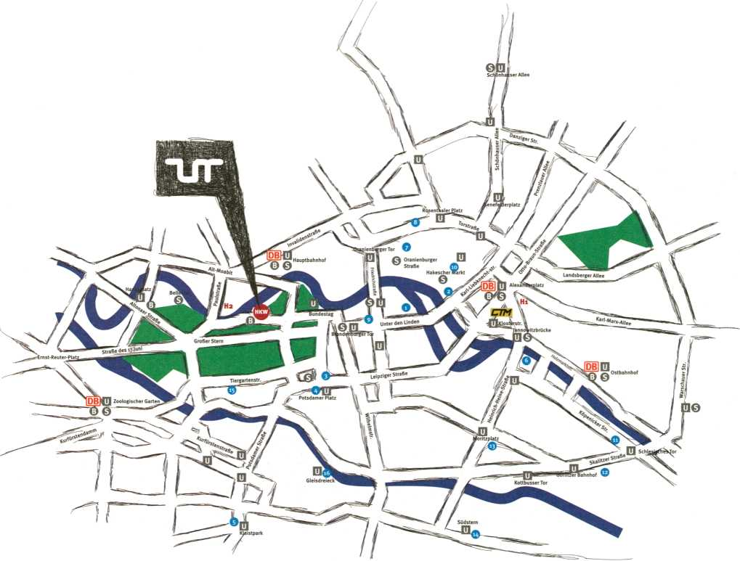

Main Location | Satellites and other Locations |  | Opening Hours HKW
Haus der Kulturen der Welt / HKW | 1 | Collegium Hungaricum Berlin (.CHB) | Festival Opening: 2 Feb, 18:00 Festival: 3-7 Feb, 10:00 - 23:00
)ohn-Foster-Dulles-Allee 10 |  | Dorotheenstraße 12 | Exhibition: 3-7 Feb, 10:00 - 20:00
 | 2 | Instituto Cervantes Berlin | CTM (club transmediale): 28 Jan - 7 Feb, 19:30 - late
Public Transport to HKW  S-Bahn, Hauptbahnhof / Main Station | 3 | Rosenstraße 18-19  Marshall McLuhan Salon, Embassy of Canada | Admission
(15 min. walk) |  | Ebertstraße 14 | Exhibition: 5 EUR/3 EUR
U-Bahn 55, Bundestag (10 min. walk) | A | S-Bahnhof Potsdamer Platz | Film & Video: 7 EUR / 5 EUR
Bus loo, Haus der Kulturen der Welt |  | Regionalbahnpasserelle Süd | Salon Talks: 5 EUR/3 EUR
 | 5 | _Vilem_Flusser_Archiv, Universität der Künste | Phuturama: 9 EUR/6 EUR
CTM - CLUB TRANSMEDIALE | 6 | Grunewaldstraße 2-5  c-base | Conference: Fri 81 Sat: 12 EUR / 8 EUR Conference: Sun: 6 EUR/4 EUR
WMF Club |  | Rungestraße 20 | Performances: Wed 81 Thu: 12 EUR/ 8 EUR
Klosterstraße 44 | 7 | [DAM]Berlin | Performance: Sun: 9 EUR/6 EUR
U-Bahn 2, Klosterstraße |  | Tucholskystraße 37 | Day Pass: 20 EUR/15 EUR
 | 8 | Substitut | Festival Pass: 70 EUR/40 EUR
Festival Hotels | 9 | Torstraße 159  Schering Stiftung | Kombi Pass transmediale 81 CTM: 95 EUR /75 EUR CTM (Night): 12 - 16 EUR
Hi Hotel Agon am Alexanderplatz | 10 | Unter den Linden 32-34 Virchowsaal, Sophiensaele | CTM 3-Day / Night Pass: 40 EUR CTM 3-Night Pass: 35 EUR
Mollstraße 4,10178 Berlin |  | Sophienstraße 18 | CTM Festival Pass: 70 EUR
+49 (0) 30 27 57 270 | 11 | Galerie ZERO | CTM Workshops: 10 EUR / 7 EUR
info@agon-alexanderplatz.de |  | Köpenicker Straße 4 | CTM After-Hour: 5 EUR
H2 Motel One Berlin-Bellevue | 12 | Art Claims Impulse Lübbener Straße 5 | Reservations:
Paulstraße 21,10557 Berlin | 13 | betahaus | +49 (0) 30 39 787 175, tickets@hkw.de
+49 (0) 30 390 63 340 berlin-bellevue@motel-one.com | 14 | Prinzessinnenstraße 19-20  The Future Gallery
 | 15 | Hasenheide 56  Landesvertretung Nordrhein-Westfalen | Guided Tours:  Wed - Fri: 15:00, Sat / Sun: 14:00 / 16:00
 | 16 | Hiroshimastraße 12-16  Deutsches Technikmuseum | Info and registration at the infocounter 2 EUR / person
Trebbiner Straße 9

Stephen Kovats artistic director
Christine Bernauer, Susanne Bernstein, Magdalena Rothweiler festival management
Markus Huber
programme coordinator, conference
Honor Harger guest curator
Adam Thomas
assistant guest curator, salon coordinator Filippo Gianetta
IT manager, programme assistant
Ela Kagel, Marcel Schwierin, Gregor Sedlag programme curators
Sophia Gräfe, Eleanor Jones,
Marieke de Roos, Anna Lena Seiser programme team interns
Anna-Sophie Springer editor, translator
Laleh Torabi design
Meik Mehlhorn assistant design
Sibylle Kerlisch production
Clemens Lerche marketing
Beckie Darlington guest services
Juliane Schulz infocounter coordinator
communications/press sally below cultural affairs
Sally Below, Antje Materna, Christine Florack, Thomas Deittert technical directors
serve-u: Phillip Siinderhauf, Andreas Buchholz assistants to the technical directors: Ludmila Demke,
Marc Klische
website
Redaktion und Alltag: Miez Flor einskommanull: Sebastian Göbel, Laura Oldenburg design: Laleh Torabi coordinator: Filippo Gianetta
festival architecture raumlaborberlin
Francesco Apuzzo, Andrea Hofmann, Christof Mayer,
Axel Timm
photography Jonathan Gröger
video trailer
Tom Freitag, Jan Goldfuß, Martin Wellens sound: Tetsuya Hori
Streaming
serve-u
transmediale advisory board Alex Adriaansens Dr. Marie Cathleen Haff Prof. Saskia Sassen Yukiko Shikata
thanks to
Kulturprojekte Berlin GmbH
Moritz van Dülmen, Katrin Dohne, Uta Belitz, Kien Nguyen thanks to
Haus der Kulturen der Welt
Dr. Bernd M. Scherer, Doris Hegner
transmediale ist ein Projekt der Kulturprojekte Berlin GmbH in Kooperation mit dem Haus der Kulturen der Welt
transmediale wird gefördert durch die Kulturstiftung des Bundes
transmediale is a project of Kulturprojekte Berlin GmbH in cooperation with Haus der Kulturen der Welt
transmediale is funded by the German Federal Cultural Foundation

*ur
transmediale.de
120

in Cooperation With
I KULTUR PROJEKTE BERLIN
HAUS
DER
KULTUREN
DER
WELT
PARTNERS

Bundeszentrale für |
politische Bildung
I medienboard!
\ Berlin-Brandenburg GmbH
• a «
M
Botschaft von Kanada
rSPONSORS
Allianz I
' Kulturstiftung I
VIDEOTECHNIK
j !?j K⁵ 1= FERCHAU
IINLd. I ENGINEERING
MEDIA PARTNERS
transmediale is funded by

«I
Í.CHBl
P SHANGHAI

eARTSO
Instituto
Cervantes
_{m}B e r I f
GEIER-TRONIC ^ lamerfabrlIt^Bllmmlliiiaasii
NETZPILOTEN LG serve-u
iwftRuriKB!, mJ möirnnarnE5TiT=T^5T=n «
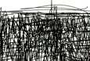
artptv
Deutschlandradio Kultur
FresHmiLc.tu radioens^{r}’
%■ dietageszeitung
DEBUG
www.de-bug.de
TELEPOLIS unlike.net zittu m<uK
SUPPORTERS
arnlno | Bocca di Bacco | Ecfioo Konferenz Dolmetschen | IN-Berlin | Vertretung der Regierung von Québec in Berlin | Werklèitz - Zentrum für Medienkunst | Goethe Institut Bejing |
Goethe Institut Jakarta | Goethe Institut Taipeh | Goethe Institut Kairo | Communauté Française de Belgique | Botschaft des Königreichs der Niederlande | Arts Catalyst | Pro Helvetia | Next

